Hello Professor!

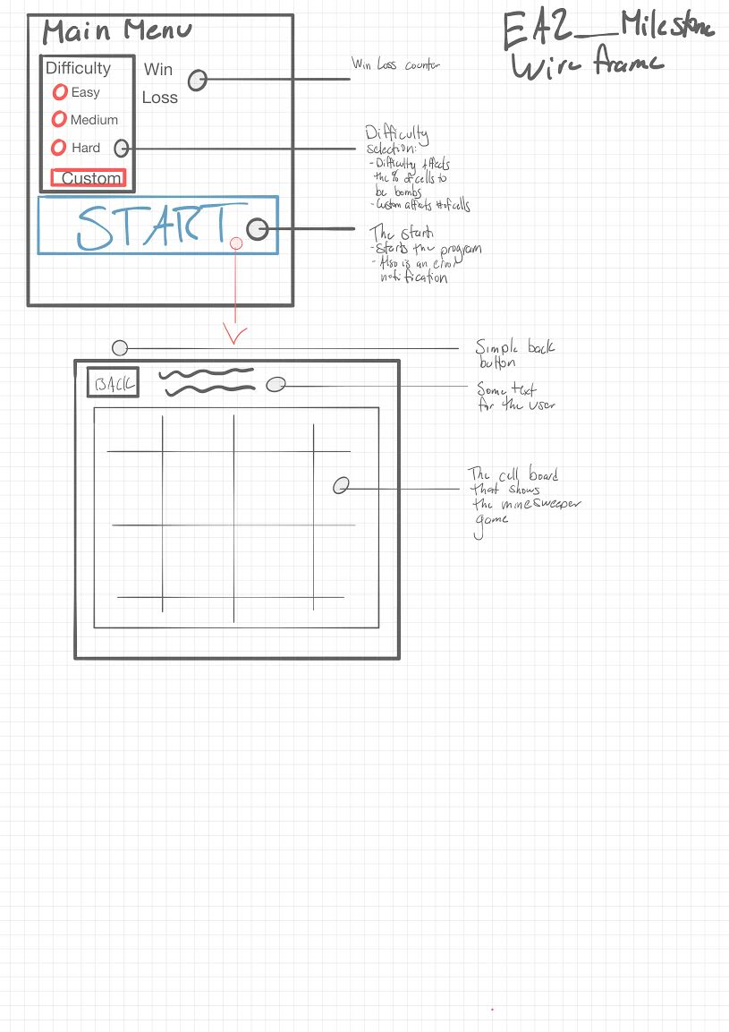While working on the milestone, decided to already combine the game logic to the current build. Also here is a wireframe of the project.

Alright time for some screenshots!

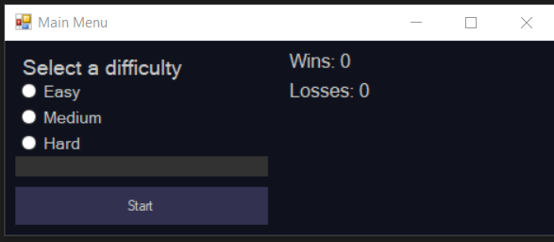

Initial look at the project.

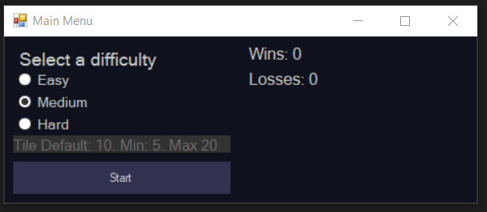

Like usual, I like showing hints on the text box. I’m going to start the game actually on Easy.

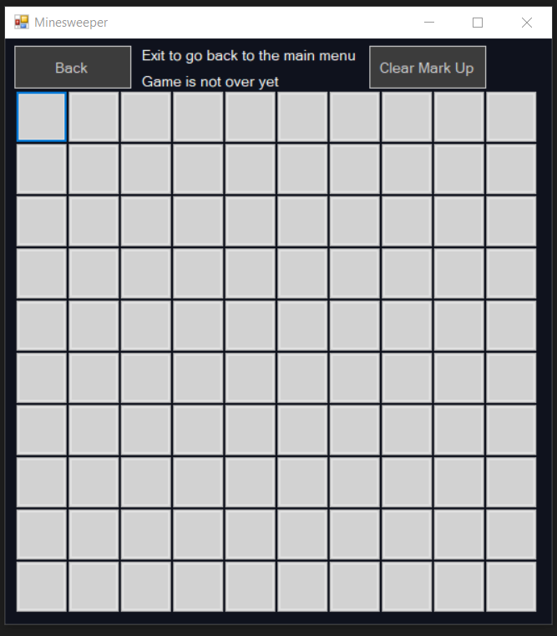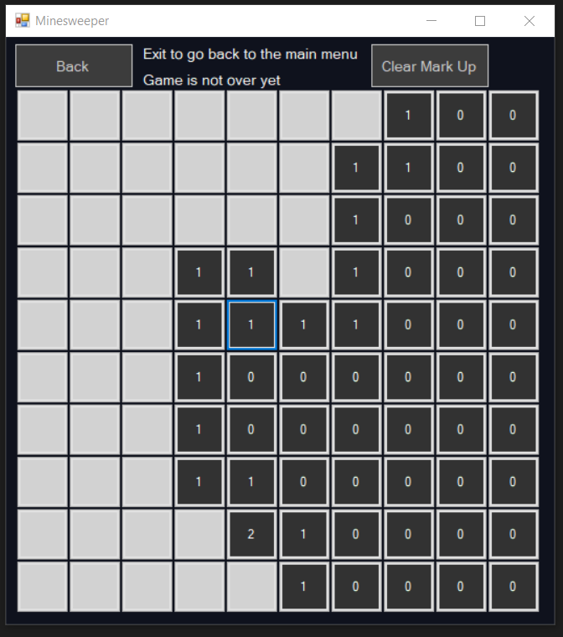

The game so far, After clicking first location.

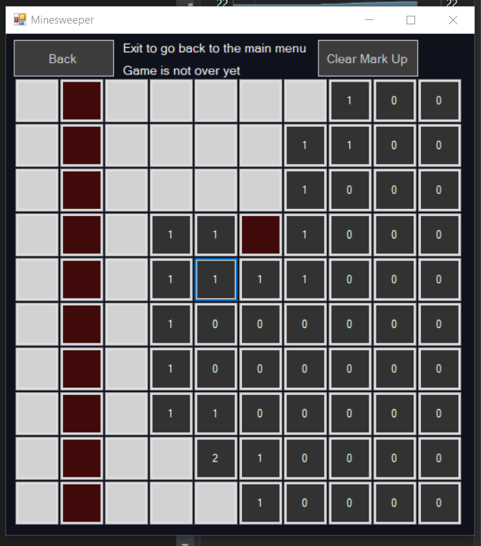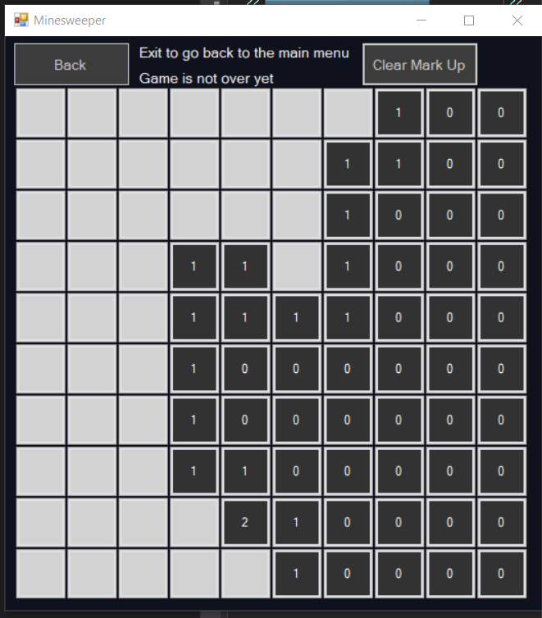I also decided to already add the right click functionality. Just have to create a dialog for the win or loss conditions. As of right now, the label “game is not over yet” is the only “notification” system for the game. It will tell the user if it’s a lost or won game. Clicking the clear mark up will remove all of the red marks.

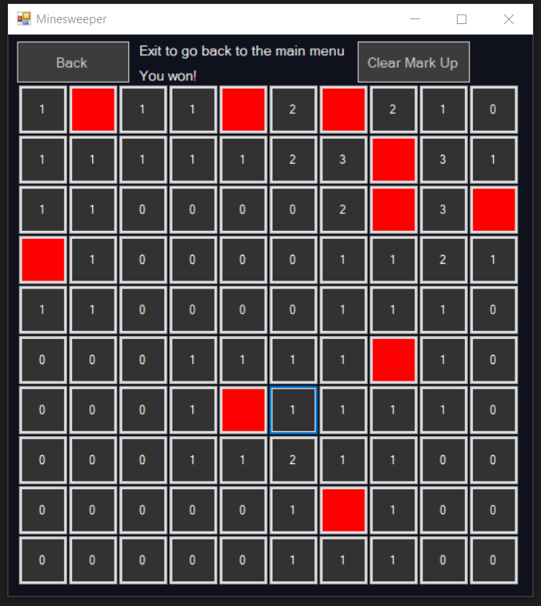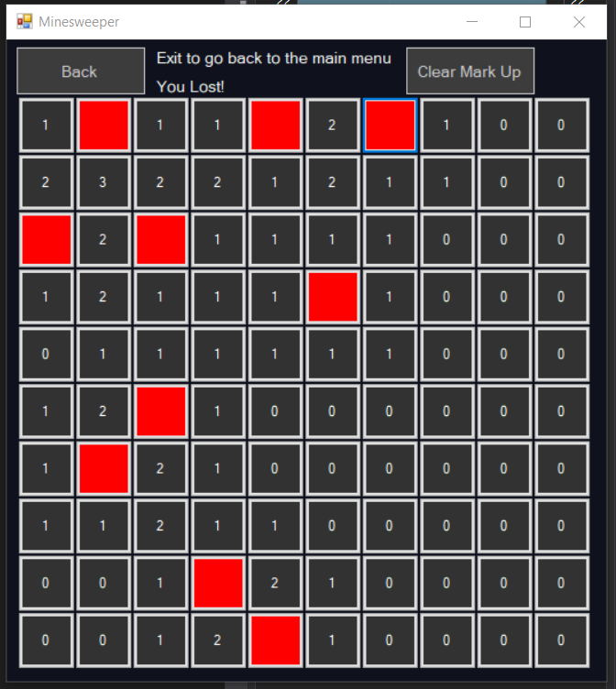Game lost Game Won

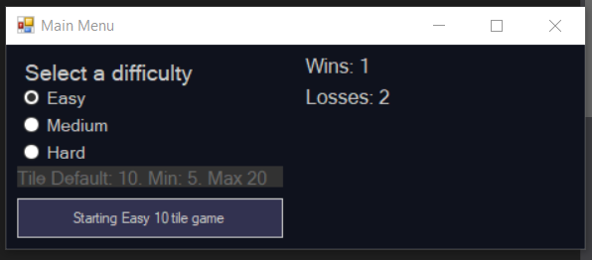The only notification on game ended is the top corner. Looks like the requirement for the icons and game condition dialog are both easy adds. Also added a safeguard where the user can’t click on red buttons once the game ended. So can’t lose once you already won.

Here is the current “score board”.

For Milestone 6, looks like the next objective is to create a high-score page. Should be pretty cool start game-ifying the system. Also learning the stopwatch for Milestone 5 is going to be pretty fun.

Overall, I’m not very happy at the current code since it’s so messy. Guess I can also say the same about the Activity 4. Any feedback is greatly appreciated! Hope these longer Documentations are a better insight on how I think about the projects!