Joshua Santos

CST-247

Activity 1

June 29, 2020

GitHub:

<https://github.com/MrNiceRicee/EA3_Activity1>

Activity Part 1 Screenshots:

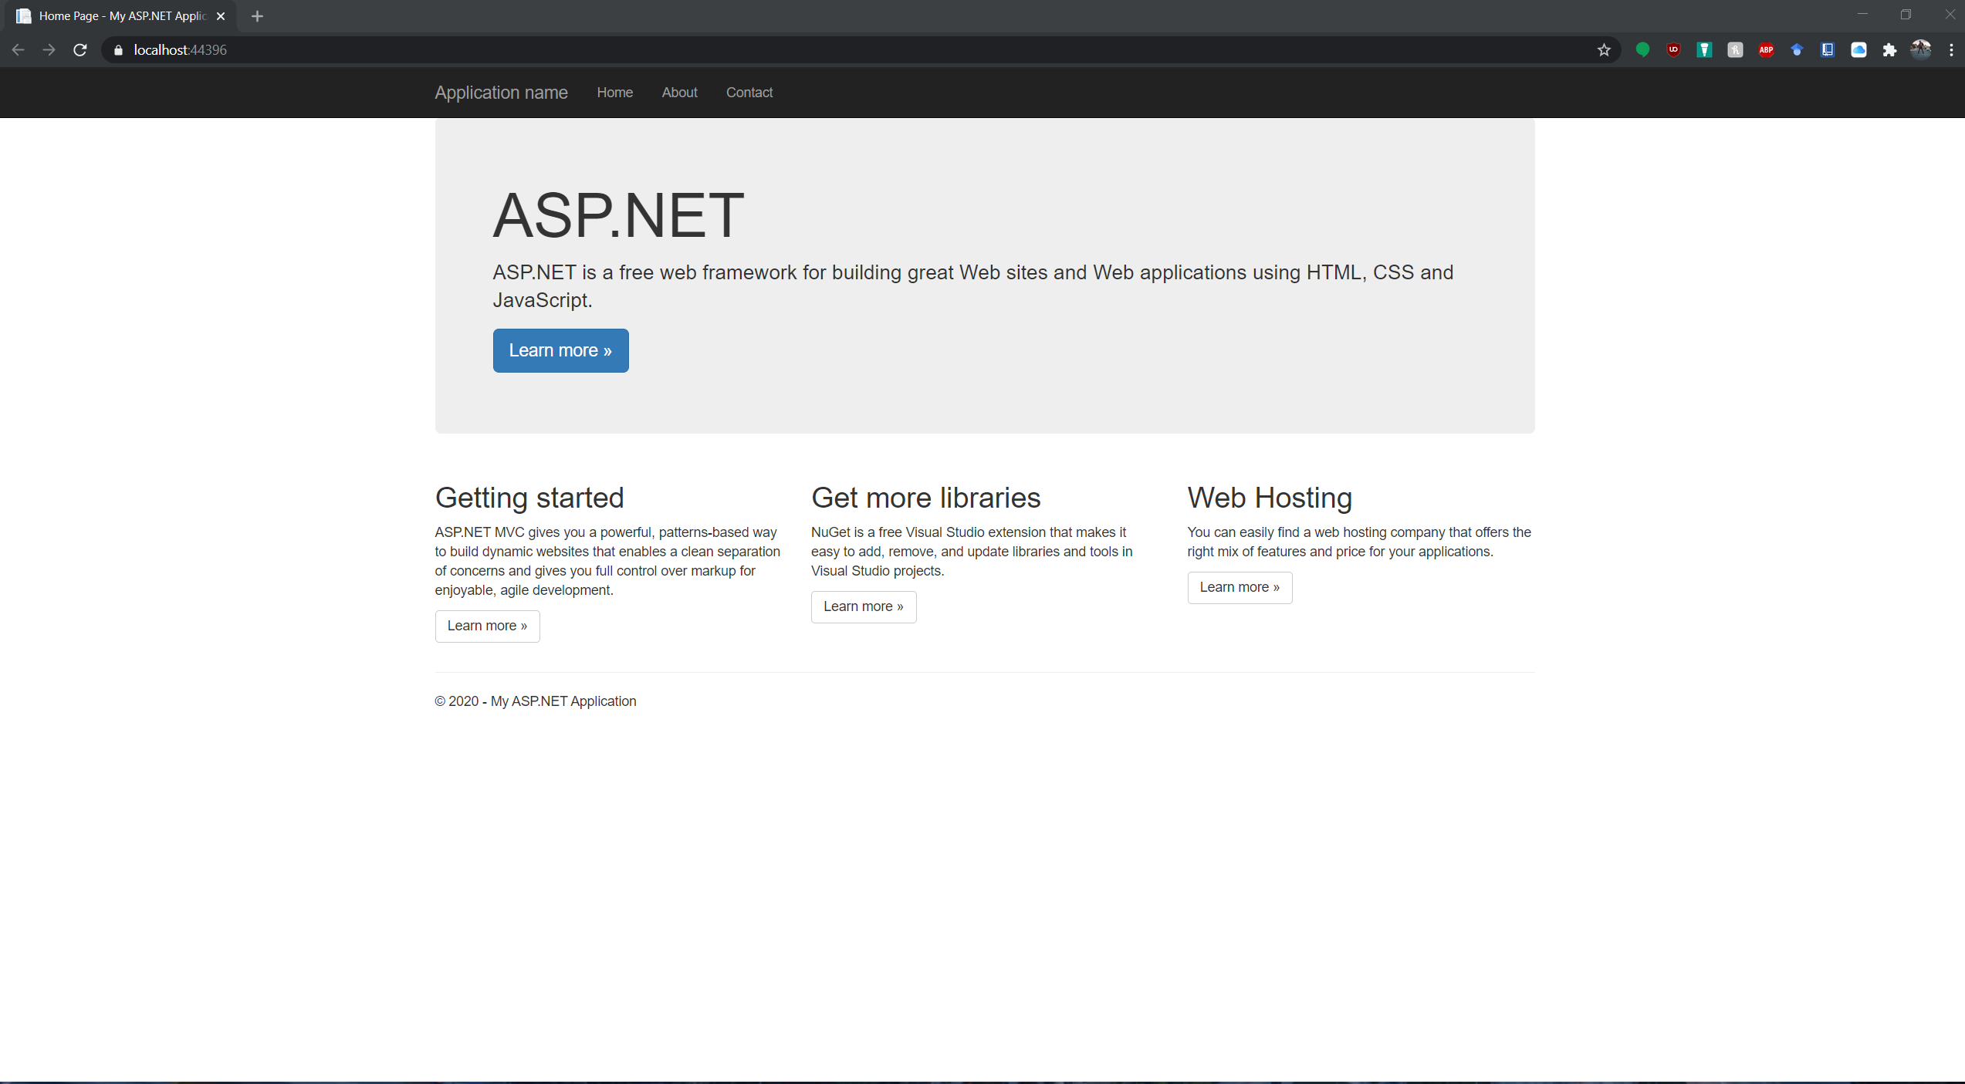

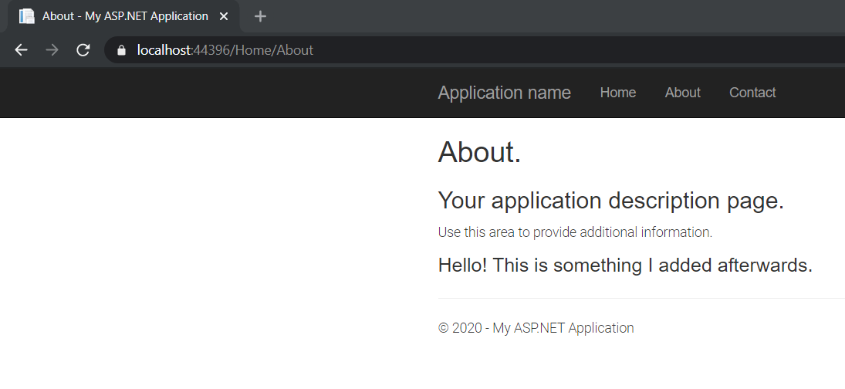About Page

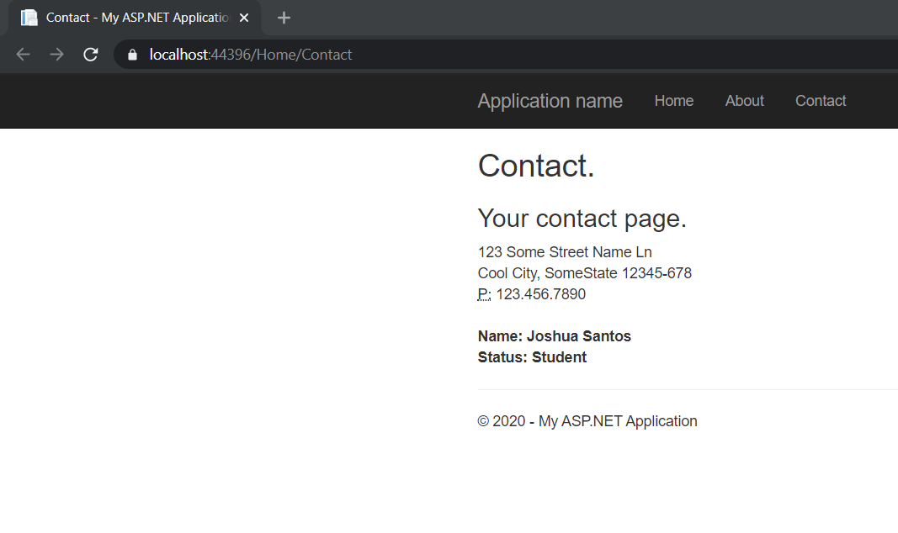Contact Page

Part 2:

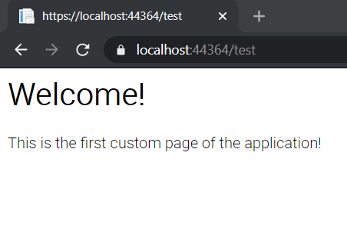

This has a hover animation if you hover the text. Kind of hard to portray in pictures

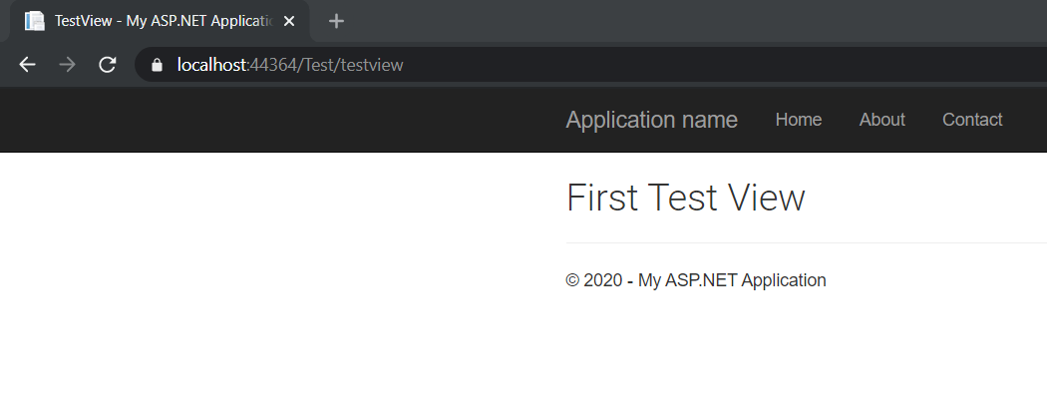

The title shrinks

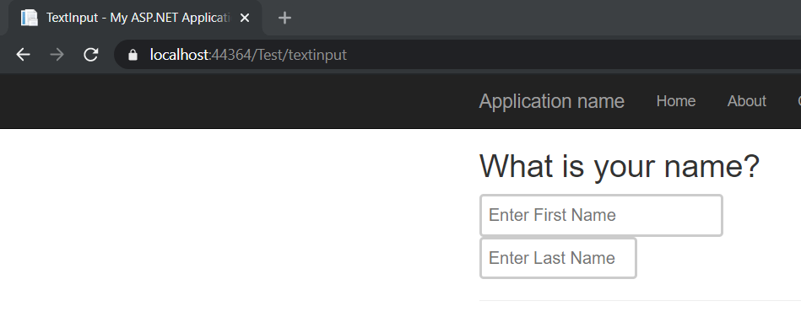

The input boxes also change in size for some dynamic feel

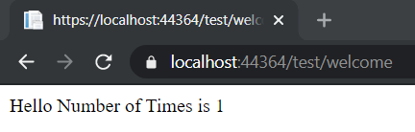

First example of welcome

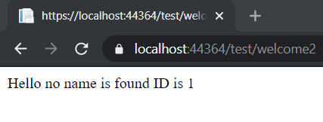

Welcome 2 with no name

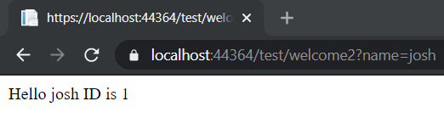

Welcome 2 and there is a name attached

Part 3

I did not realize we were going to make a database while making this, went through the hassle of trying to find a text file and deserializing with Json. I was surprised that Newton was already installed on the ASP.NET project folder.

While in Part 1 and Part 2 I was able to manipulate the HTML with some CSS styling. I found it somewhat difficult to do the same thing with the auto generated HTML.

“Welcome” page of Login:

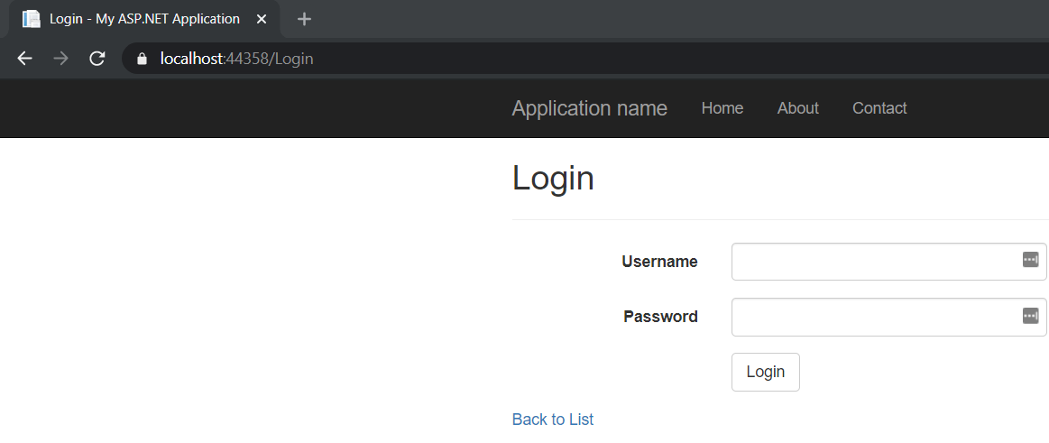

Incorrect log in

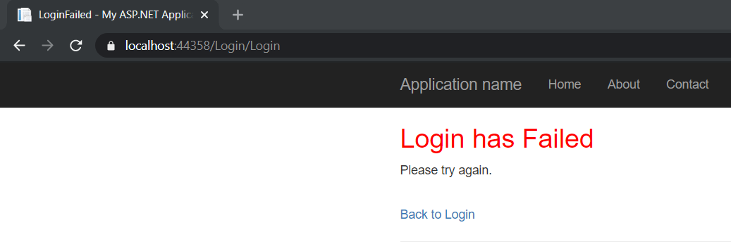

Added in the back to login htmlaction link

Using the login, Username: SomeUser , Password: SomePass , to log in the database.

