Project from the subject Programming of Internet Applications for the 2024/25 school year

Implement the "Mountain Cottage" web system that serves as a platform (web system) for renting mountain cottages in Serbia. There are three types of users: tourist, cottage owner and web system administrator.
All users should be able to log in to the system using their credentials (username and password). The user has the option to continue working with the rest of the system after entering the data correctly. In case of incorrect data, display an appropriate message.
The owner and the tourist log in to the system via the described publicly visible form. The system administrator should have the option to log in via another form, with the same fields, but which it is not publicly visible all users (access forms for The administrator login should be on a separate route/path, compared to the initial form for owner/tourist registration).
It is possible to register new users from the owner/tourist category, who need to enter the following information:
- user name (which is uniquely, on level all user in system),
- password ¹ ,
- name,
- last name,
- gender (option: M or F),
- address,
- contact phone,
- email address (unique, most one user account by email addresses),
- profile picture (adds everything like file),
- number credit cards ² .
If the data is entered correctly (perform some basic checks using JavaScript technology), a new registration request should be created and that request must wait for administrator approval for the owner or tourist to become an active user of the system. The administrator is responsible for reviewing the received requests, and the outcome can be acceptance or rejection of the registration request. Registration of a new administrator does not need to be implemented.

¹ Password to check by using regular expression (minimum 6 character, maximum 10 characters, including at least one uppercase letter, three lowercase letters, one number and one special character, and must begin with a letter). The password must be stored encrypted in the database!
² The credit card number must meet one of the following card types. When a valid card number is entered, an icon appears that represents that card type. The rules are as follows:
Card Diners - begins with 300, 301, 302, 303, 36, or 38 and there is exactly 15 digit;
Card MasterCard – begins with 51, 52, 53, 54, or 55 and there is exactly 16 digit;
Card Visa – begins with 4539, 4556, 4916, 4532, 4929, 4485, 4716, and there is exactly 16 digits.

During registration, owners send their profile picture (minimum size 100x100 px , maximum size 300x300 px , in JPG / PNG format). Pictures in application must be entered via the FileUpload window, and it is not an acceptable solution to have them already entered manually, or to enter them via an external link to an image on another location/website, which is somewhere already set. If is profiled picture no adds, the owner gets a default profile picture, which already exists in the system.
All types of users should be allowed access on the externally visible page. password change form. The user enters the old password, as well as the new password and a new one. password (in two separate textual fields). Old and new password no must be the same. If the old password is not correct or the new password is not in the required password format (as during registration), an appropriate message must be displayed. When the password is successfully changed, return the user to the home screen for reporting.

Unregistered user – initial side
On the home page of the application, it is necessary to display general information about the total number of cottages, the total number of registered owners in the system, the total number of registered tourists in the system, the number of reserved cottages in the last 24 hours, 7 days and 30 days. Enable sorting (both non-descending and non-ascending) of cottages by each column (name, place) and enable searching for cottages by name and/or place (not all search fields need to be filled in).

Tourist
After successfully logging into the system, the tourist has a main menu, which consists of the items described below. The first item of the main menu is “Profile” , and this is the page that should be displayed first after logging into the system. Within the profile, the tourist can see his/her basic data - name, last name, address, email address, contact phone, and credit card number, as well as profile picture, and can update them (including updating the profile picture).
The second item in the main menu is “Cottages” . Within this item, the tourist sees a tabular view of cottages at the top of the page, as does an unregistered user. Enable all the search functionalities that an unregistered user has, and the results should additionally display the average rating of that cottage (display the numerical value of the rating, but also visually through the display of stars). Also, in the tabular view of all cottages or the tabular view of search results, the user can select the name of the cottage, under which there is a web link, after which he will be shown a special web page with detailed information about that cottage (in addition to the name and location, additionally display a photo gallery, services that the cottage offers, price list for overnight stays, telephone, a list of all user comments and ratings about that cottage, and a map with the location, where the map must be functional and dynamic, a map image is not enough).
On the same cottage details page, the owner can schedule a cottage rental. Scheduling everything performs by road form, from more steps ( Steps ), where everything in first

³ : Enter the rental start and end dates (via the Date & Time Picker component ) and the number of visitors, i.e. adults and children. After entering the required data, the user moves on to the second step of the booking, where all previously entered data is displayed (name of the cottage, start and end dates of the stay, entered number of adults and children) and there is a payment form. The form is already filled in with the user's card and the calculated price depending on the number of days, i.e. overnight stays, with the possibility of changing the card number. In this step, the user can optionally enter a short description as a text area field ( textarea ), up to 500 characters, with some additional requirements. Validate the entered booking and print a suitable and detailed message to the owner (if the cottage is not open that day or there is no space available).
The third item in the main menu is “Reservations” . Within this item, the tourist sees all of his current bookings in the first table and all previous bookings (archives) in the second table. The booking archive displays the bookings from the most recent to the most recent, namely: the start date of the stay, the name of the cottage, as well as the optional comment and rating of the tourist after the stay. With each previous booking, which does not have a comment and rating, the tourist has a button that opens a form for entering a free comment in the text field for a free comment and a visual component for entering a rating. in range from 1 to 5 (e.g. with asterisks which everything press). Tourist can yes Leave a rating and comment only for those reservations that have been made and completed.
In the table with current reservations, the tourist sees the reservation start date, reservation end date, cottage name and cottage location. In the interval of 1 day or more, before the start of the vacation, the tourist can cancel the reservation.

Owner cottages
After successfully logging into the system, the owner has a main menu, which consists of the items described below. The first item of the main menu is "Profile" , and this is the page that should be displayed first after logging into the system. Within the profile, the owner can see their basic information - name, surname, address, e-mail address, contact phone number, as well as a profile picture, and can update all their information (including the profile picture).
The second item in the main menu is “Reservations” . Within this item, the owner sees all unprocessed reservations, i.e. bookings by tourists, for his cottages, sorted from the most recent to the most recent. Next to each booking, the owner sees a button and can confirm or reject it (with a mandatory comment written on the rejection). Additionally, the owner sees a calendar view of all reservations (Figure 1), where selecting a reservation opens a dialog, like a pop-up window, with confirmation and rejection options. In the calendar yellow by color are marked unprocessed reservations, and green indicates those already accepted. Implement the calendar using libraries like FullCalendar .
Third item of the main menu is “My cottages” . Within this item, the owner sees all of his cottages. Next to each cottage, he sees a button to edit or delete the cottage. When editing, the owner can change all of the cottage's information.

³ Entry in cottage is possible from 14 hours, and exit to 10 hours.

The owner can add a new cottage via a form, where they enter the name of the cottage, location, services which cottage offers (in kind free entries text), price list for ^{4 nights} , phone, coordinates for displaying a pin on the map, and pictures of the cottage through the FileUpload window. If they have a JSON file, the owner can fill in all fields, except for the pictures, by uploading the JSON file through the FileUpload window.
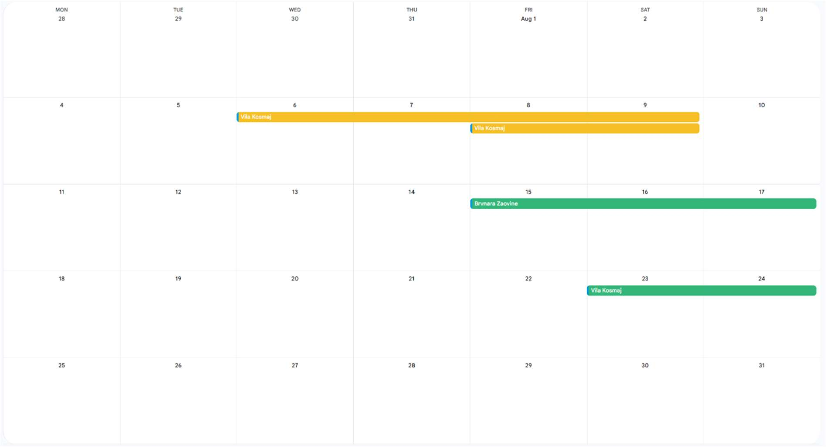
Picture 1. Display calendar

Fourth item main menu is "Statistics" . Inside these items, owner see the following diagrams:
  - A column/bar chart, which shows number of reservations made per months for each of his cottages;
  - Diagram pie, which shows for each cottage, relationship reservation during the weekend and during the workweek.

Administrator system
Administrator system is user with special privileges.
The administrator has access to the lists of all owners and tourists entered into the system. He has the ability to update (add, modify, delete) user data and the ability to deactivate them (all data remains in the database, but a deactivated user can no longer access the system). He also considers requests for by registering new unconfirmed owner and tourist, and each request he can yes accept or refuse. If

⁴ Enter at least two different overnight prices, for summer and winter. Summer includes the months of May, June, July and August.

rejects them, all future user accounts cannot use such rejected username, nor the same email address, when registering.
Additionally, the administrator sees a table view of all cottages, and cottages with the last three ratings less than 2 are colored red. Next to such cottages, the administrator sees a temporary blocking button, which makes that cottage unavailable for booking for the next 48 hours.

Others characteristics applications
The application should be resistant to incorrect data entry. It is also necessary to create a uniform appearance for the application using CSS - Cascading Style Sheets . Every web page should contain a menu and headers ( header and footer ). On all screens where the desired content is displayed, an option to return to the home screen with user options should be enabled (this only if you do not have a menu that is always visible). Also, on all screens a link leading to the home screen for logging in (option: Log out) is required. Each type server validations necessary is what more efficiently to implement. Web The application should be adaptable to both smaller and larger screens (" responsive web design "). Test the web application in at least 3 standard web browsers.

Notes:
The project in the subject Internet Application Programming is done independently and is a requirement for taking the exam. The project can be defended during the exam period in which the written exam is held or in one of the following periods. The project is worth a maximum of 30 points (without additional points).
At the oral defense, the candidate must independently install all programs necessary for the correct operation of the submitted solution (if they do not exist in the computer laboratory). The candidate must have the necessary level of knowledge about the project task, must be aware of the shortcomings of the submitted solution and the possibility of resolving these shortcomings. The candidate must also correctly answer a certain number of questions that deal with the topic of the project.
Project defenses are held live, in computer labs. Faculty of Electrical Engineering in Belgrade, except in the case of a state of emergency or other strict epidemiological measures, when subject teachers may decide up to 24 hours before the defense that the defense in that case will be held via an internet connection (with a mandatory turned-on webcam, a working microphone and a correct internet connection).
For production project task necessary is use:
- Angular 18 framework with Spring Boot 3.3.x (optionally 3.4.x or 3.5. x) using some object-relational mapping framework (check available versions on the course website; it is advisable to download an initially empty project from the course website and upgrade it); when developing a project in these technologies, it is necessary to use a MySQL (or PostgreSQL ) relational database or

- Angular 18 framework with Express and NodeJS in the server part (check available versions on the course website; it is advisable to download an initially empty project from the course website and upgrade it), using the non-relational database MongoDB .
Every type of server validations necessary is what more efficiently to implement. Assume that the database is initially created and populated independently of this application (i.e. tables or collections in the database should not be created from the application itself, but independently of it).
It is necessary to bring a database filled with a sufficient amount of data to the defense. data, in order to enable an overview of all implemented functionalities applications, otherwise -5 points are awarded.
The defense will be organized after the written part of the exam, and the exact date and time will be announced after the deadline for submitting project defense applications.
Subject teachers reserve the right to perform automatic and manual checks of the similarity of submitted student projects before, during or after the defense. If unauthorized collaboration is determined, students will be removed from the project defense, points for all activities up to that point will be reset to 0, and reports will be filed against such students with the Disciplinary Committee of the Faculty of Electrical Engineering in Belgrade.

