BACHELOR OF INFORMATION TECHNOLOGY (HONS.)
ASSIGNMENT
AUGUST 2026 (Weightage 20%)
Wireless Communication Problems and Network Analysis
Course | : | EC3277 (Wireless and Mobile Technology)
Lecturer | : | Er. Santosh Rauniyar
Student name | : | Sujan G C
Student ID | : | 00022586
CLOs assessed | : | CLO2 and CLO3
Date of submission | : | ______________________
Abstract
This report examines why wireless signals weaken inside a university building and how a campus network can be planned for hundreds of simultaneous users. It explains signal fading, compares cellular, Wi-Fi, Bluetooth and WiMAX for different parts of the campus, and separates coverage from capacity using a 300-student lecture hall. The main finding is that the two problems need different fixes: weak spots are cured by better access point placement, while crowded rooms need smaller cells and more efficient use of spectrum. A centrally managed Wi-Fi 6 network indoors, backed by public cellular outdoors, is recommended.
Table of Contents

List of Figures
Right-click here and choose Update Field to build this list.

List of Tables
Right-click here and choose Update Field to build this list.

1. Objectives
- To explain signal fading, its causes and how walls and obstacles affect radio signals.
- To suggest and justify methods of reducing fading.
- To compare cellular, Wi-Fi, Bluetooth and WiMAX by coverage, capacity and application.
- To explain coverage and capacity and improve capacity in a busy lecture hall.
- To analyse a case study and recommend a suitable wireless design.

2. Introduction
Students now expect to be online everywhere on campus, but anyone who has tried to join a video class from the back of a full lecture hall knows that having a signal and having a good connection are not the same thing. This report uses a university campus to look at that gap.
It starts with signal fading, then compares four wireless technologies for three parts of the campus, separates coverage from capacity, and applies both ideas to a case study. Ranges and data rates are typical textbook or standard values, or my own planning estimates, not measurements I took myself.

3. Part A – Question 1: Signal Fading (CLO2)

(a) What is signal fading?
Signal fading is the variation in the strength of a received radio signal over time, distance or frequency, caused by the channel between transmitter and receiver (Stallings, 2005). Large-scale fading (path loss and shadowing) appears over tens of metres, while small-scale fading comes from multipath and can change over a few centimetres, since one wavelength at 2.4 GHz is only about 12.5 cm (Rappaport, 2002).

(b) Two possible causes of fading in this situation
Shadowing by the building. Concrete walls, lift shafts, floors and metal-framed partitions absorb and block the signal, so inner rooms sit in a radio shadow while the window area, nearest the outdoor transmitter, stays strong.
Multipath. The signal also bounces off walls, ceilings, furniture and people. Copies arrive at slightly different times and, when out of phase, cancel each other, so a small move of the phone can swing the signal from good to poor (Goldsmith, 2005).

(c) How walls and obstacles affect the signal
Walls affect a radio wave in several ways. Some energy is absorbed and turned into heat, especially by thick brick and reinforced concrete. Some is reflected, mainly by metal such as lift doors, which creates multipath. Some is diffracted around corners or scattered by rough surfaces and arrives weaker. As a rough planning guide (my approximation), plasterboard costs a few dB, brick 6 to 10 dB and reinforced concrete 10 dB or more, and higher frequencies lose more, so 5 GHz suffers more than 2.4 GHz. Figure 1 shows the signal falling with distance and dropping again behind each wall.
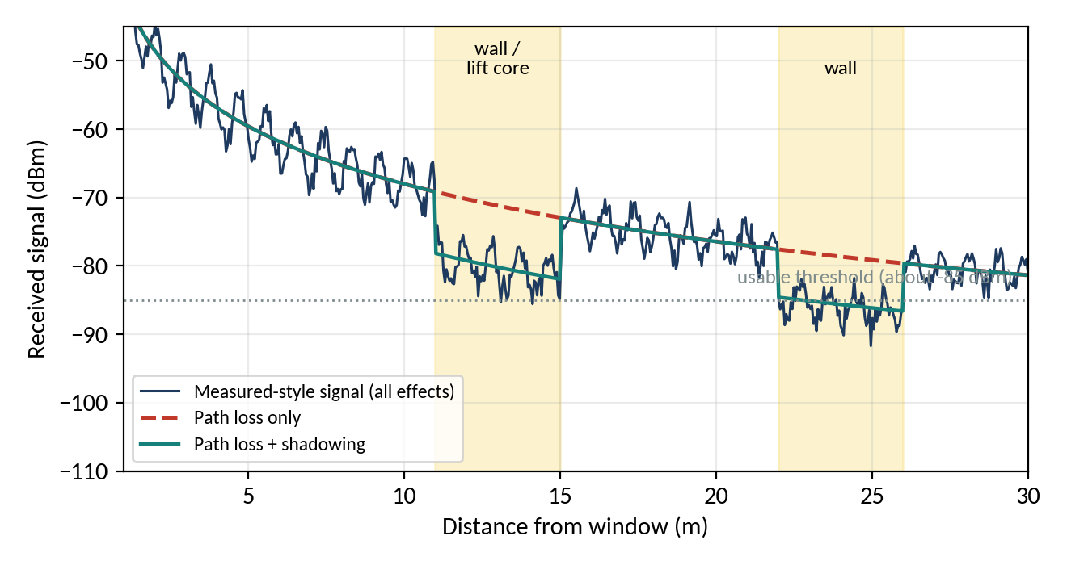
Figure 1: Illustrative received signal against distance from the window. This is a simple model drawn for explanation, not a real measurement.

(d) Three methods to reduce fading
Diversity and MIMO. Several antennas let the receiver choose or combine the best copy, because all antennas are rarely in a fade at once (Stallings, 2005).
OFDM, equalisation and error-correcting codes. Spreading data over many narrow subcarriers means a fade damages only a few, and coding with interleaving repairs lost bits (Goldsmith, 2005).
Adding or repositioning infrastructure. Indoor access points, repeaters, femtocells or a distributed antenna system put a transmitter near the dead area, so the signal crosses fewer walls.

(e) Recommended method for the university
I recommend the third method: indoor access points, placed after a site survey. Diversity and coding handle small-scale fading well, but they cannot rescue a signal that is already 30 dB too weak after a concrete core. Moving the transmitter closer removes the real cause, shadowing. Modern Wi-Fi hardware already includes MIMO and OFDM, so the first two methods come free with current equipment.

4. Part B – Question 2: Wireless Technology (CLO3)

(a) Comparison of the four technologies
Table 1: Comparison of cellular, Wi-Fi, Bluetooth and WiMAX
Technology | Coverage | Capacity | Suitable application
Cellular (2G to 5G) | Wide: macro cells of several hundred metres to a few km, with handover | Moderate per user, shared in the cell; LTE peaks from tens of Mbps to about 1 Gbps (nominal) | Mobile voice and data, outdoor and wide-area use
Wi-Fi (IEEE 802.11) | About 30 to 50 m indoors per AP; roughly 100 m outdoors in line of sight | High: 802.11ac several Gbps, 802.11ax up to 9.6 Gbps in theory, shared per AP | Rooms, buildings and hotspots (WLAN)
Bluetooth (IEEE 802.15.1) | About 10 m (Class 2), up to about 100 m (Class 1) | Low: about 1 to 3 Mbps | Personal area: headsets, keyboards, wearables
WiMAX (IEEE 802.16) | Up to about 50 km in theory, a few km in practice | Up to about 70 Mbps per sector, shared | Metropolitan or rural broadband, links between sites

Cellular and WiMAX are wide-area technologies built for coverage and mobility. Wi-Fi gives high capacity over a limited area. Bluetooth is designed for very short links and little power.

(b) Recommendation for lecture rooms
Lecture rooms: Wi-Fi. These need high capacity in a small indoor area for many laptops and phones. Wi-Fi gives the highest rates of the four, uses licence-free spectrum, and every student device has it. Cellular is weak indoors and shared with the neighbourhood, and Bluetooth is too slow.

(c) Recommendation for outdoor campus coverage
Outdoor campus: cellular. Outdoors, students walk between buildings, so range and handover matter more than raw speed. Cellular covers large areas, hands sessions between cells smoothly and the operator carries the spectrum cost. A few outdoor Wi-Fi access points at busy spots can add capacity. I would not choose WiMAX because few devices support it and most networks have moved to LTE and 5G.

(d) Recommendation for student accommodation
Student accommodation: Wi-Fi. Students stream, game and study in their rooms, needing sustained throughput that the university can manage and secure. Access points on each floor wing provide this at reasonable cost. Bluetooth only serves headphones and similar accessories.

(e) One advantage and one limitation of each selected technology
Table 1: Advantage and limitation of the selected technologies
Technology (where) | One advantage | One limitation
Wi-Fi (lecture rooms, accommodation) | Capacity: very high rate per AP, with channels reused in small cells | Coverage and mobility: short range per AP and clumsy roaming between APs
Cellular (outdoor campus) | Coverage and mobility: wide cells and smooth handover | Capacity: shared by all users in the cell; weak indoors
Bluetooth (personal devices) | Low power and simple pairing | Coverage and capacity: about 10 m, a few Mbps

5. Part C – Question 3: Coverage and Capacity (CLO3)

(a) Wireless coverage
Wireless coverage is the area, including the space inside a building, where the received signal is strong enough, above the receiver's sensitivity with a margin over noise, for a device to connect. It answers can the device reach the network here?

(b) Wireless capacity
Wireless capacity is the total data the network can carry in an area per second, shared among all active users. It depends on bandwidth, signal-to-noise ratio and spectrum efficiency, as in Shannon's formula C = B log₂(1 + SNR) (Shannon, 1948). It answers how much can everyone send at once?

(c) Good coverage but poor performance
Coverage says the signal can be heard, not how many people share it. One access point may show full bars across the hall, but if 300 students share its channel each gets a small slice of airtime. Wi-Fi devices also wait for a free channel before sending (CSMA/CA), so more users mean more waiting and collisions, and one slow distant device uses more airtime than a fast one (Gast, 2005). The user sees full bars but slow pages.

(d) Three ways to improve capacity in the lecture hall
Use more, smaller cells. Several low-power access points in the hall, each serving part of the seating, split the load and reuse channels (Figure 2).
Use better spectrum and technology. Put students on 5 GHz (or 6 GHz) with 802.11ax, which offers more and wider channels and OFDMA for many small transfers (IEEE, 2021).
Manage the load. Band steering, load balancing, disabling the slowest data rates and a fair per-user limit stop heavy users or weak devices from starving the rest.
As an estimate, if each of 300 students needs about 2 Mbps the hall needs around 600 Mbps. An AP delivers a few hundred Mbps shared, and about 50 to 60 active clients per AP is a common guideline, so I would plan for about six.
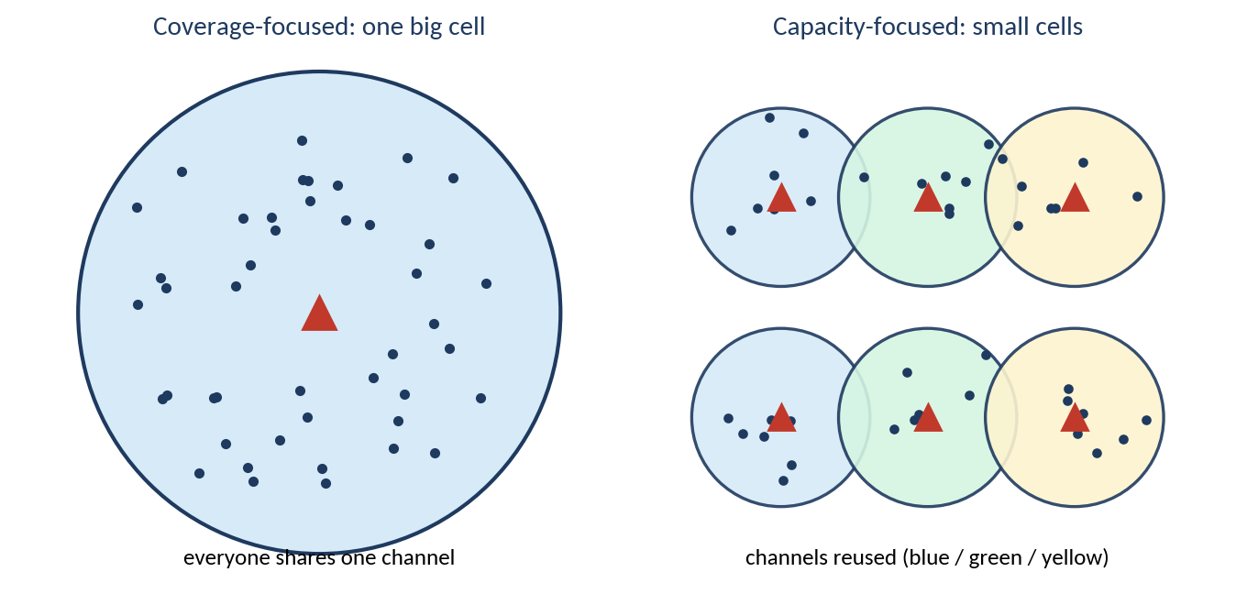
Figure 1: One large cell compared with several small cells reusing channels

(e) More access points: benefit and problems
Each extra access point serves fewer students and has its own airtime, so total capacity rises. The catch is interference. The 2.4 GHz band has only three non-overlapping channels (1, 6 and 11), and 5 GHz has more but fewer with wide channels. Neighbouring APs on the same channel must take turns, which cancels the gain. More APs also add cabling and power costs and more complicated roaming and power settings (Gast, 2005).

6. Part D – Question 4: Case Study (CLO2 + CLO3)

(a) Two possible wireless problems
Two problems stand out: (1) weak signal in certain classrooms, a coverage hole, and (2) slow, unreliable performance when many students are online, a capacity problem. The third complaint, drops while moving, is a roaming problem, usually from poor overlap between access points or devices that cling to a distant one.

(b) The problem related to signal fading
The weak signal in some classrooms is the signal fading problem. Walls and floors shadow those rooms and multipath adds more dips, as in Question 1.

(c) The problem related to capacity
The slowdown when many students connect is the capacity problem: too many users share too little airtime on too few channels, as in Question 3.

(d) Two solutions for the fading problem
Relocate and add access points. After a site survey, install a ceiling-mounted AP inside each classroom instead of relying on corridor units that must push through a wall.
Use MIMO and beamforming. Multi-antenna Wi-Fi 6 access points direct the signal towards clients and average out fades.

(e) Two solutions for the capacity problem
Smaller cells and a channel plan. Lower the transmit power, add APs and reuse channels so neighbours never share one.
5 GHz, wide channels and 802.11ax with band steering and load balancing, so new devices move to the least busy AP.
Table 1: Summary of the case study problems and fixes
Symptom | Problem type | Main fix
Weak Wi-Fi in some classrooms | Fading / coverage | One AP per room, MIMO and beamforming
Slow when many users connect | Capacity | Smaller cells, 5 GHz, 802.11ax, load balancing
Drops while moving | Roaming / handover | Overlapping cells (about 15 to 20 %), 802.11k/v/r

(f) Recommended wireless network design
I recommend a centrally managed Wi-Fi 6 network in the buildings with public cellular outdoors (Figure 3). A wireless LAN controller manages one AP per classroom or lecture room, wired to the core with gigabit PoE. Cells overlap by about 15 to 20 per cent on a planned, non-overlapping channel scheme, and 802.11k, 802.11v and 802.11r allow fast roaming. Accommodation needs one AP per floor wing, and Bluetooth stays a personal-device technology. Outdoors, the operators' networks give coverage and handover, plus a few outdoor Wi-Fi APs at busy spots. Each technology is used where it is strongest, which addresses both the fading and the capacity problems.
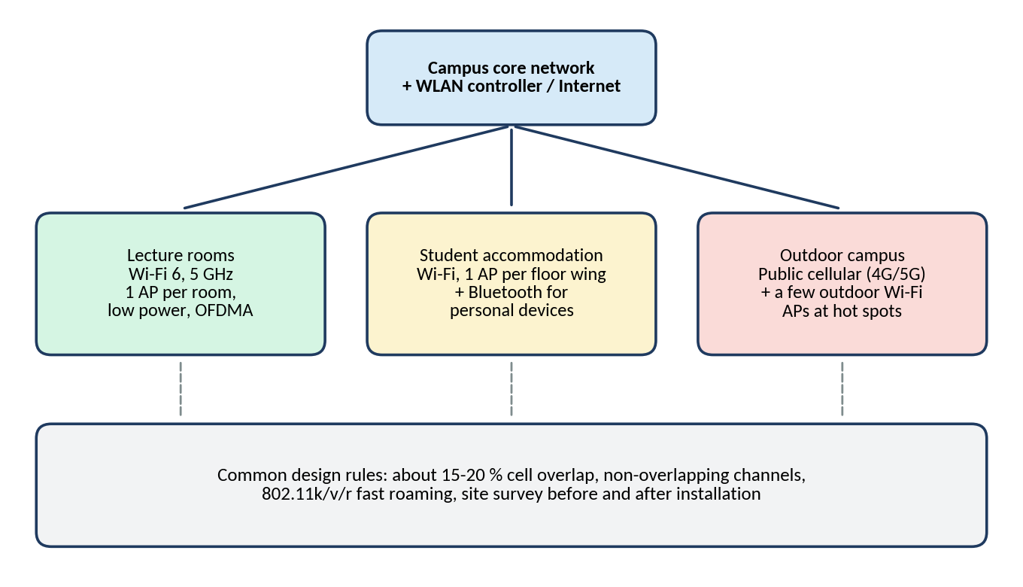
Figure 1: Recommended wireless design for the university

7. Conclusion
This assignment showed me that wireless problems on campus are often two separate problems that look alike to the user. Fading, caused by shadowing and multipath, creates weak spots and is best solved by putting access points closer to where people sit. Capacity problems appear when many users share too little airtime, and they are solved with smaller cells, a sensible channel plan and newer technology such as 802.11ax. No single technology wins everywhere: Wi-Fi suits lecture rooms and accommodation, cellular the outdoors, Bluetooth personal accessories, while WiMAX is now mostly historical. A real design also needs a site survey and a check after installation, because buildings rarely behave exactly like the theory.

References
Gast, M.S. (2005) 802.11 Wireless Networks: The Definitive Guide. 2nd edn. Sebastopol, CA: O'Reilly Media.
Goldsmith, A. (2005) Wireless Communications. Cambridge: Cambridge University Press.
IEEE (2012) IEEE Std 802.16-2012: IEEE Standard for Air Interface for Broadband Wireless Access Systems. New York: IEEE.
IEEE (2021) IEEE Std 802.11ax-2021: Enhancements for High-Efficiency WLAN. New York: IEEE.
Rappaport, T.S. (2002) Wireless Communications: Principles and Practice. 2nd edn. Upper Saddle River, NJ: Prentice Hall.
Schiller, J. (2003) Mobile Communications. 2nd edn. Harlow: Addison-Wesley.
Shannon, C.E. (1948) 'A mathematical theory of communication', Bell System Technical Journal, 27(3), pp. 379-423.
Stallings, W. (2005) Wireless Communications and Networks. 2nd edn. Upper Saddle River, NJ: Pearson Prentice Hall.

