Penetration Test Report for
Final Exam
tpayne@onepiece.com

Table of Contents
1.1 Introduction 5
1.2 Objective 5
2.0 High-Level Summary 6
2.1 Recommendations 7
3.0 Methodologies 7
3.1– Information Gathering 8
3.2 Service Enumeration 9
3.3 Service Enumeration Cont. 9
3.4 Other Interesting Objects within the network 12
3.5 Vulnerabilities within the network. 14
3.6 Viper gets hit with Eternal Blue 18
3.7 Challenge Medium - Viper 19
3.8 Challenge Easy - Viper 20
3.9 Challenge Hard - Viper 21
4.0 Credential Discovery and Kerberoasting Attacks 25
4.1 We have access to THE Domain Controller BS75 28
5.0 Data Exfiltration via psexec 32
5.1 Psexec continued 33
5.2 Artifact Challenge 1 Easy BS62 AKA PEGASUS 36
5.3 Artifact Challenge 1 Medium BS62 AKA PEGASUS 37
5.4 Artifact Challenge 1 Hard BS62 AKA PEGASUS 37
6.0 Let’s get to password cracking! 37
6.1 We’ve found the password to a user with some artifacts 38
6.2 Challenge 1 EASY - Raptor 41
6.3 Challenge 1 Medium - Raptor 44
6.4 Challenge 1 Hard - Raptor 44
6.5 File of interest - Raptor 45
7.0 Interesting finds within the domain 45
7.1 DHCP leases leaked 45
7.2 DNS Records Leaked 46
7.3 We have a Web Server using IIS 47
7.4 Network Diagram of the domain 47
7.5 High Value Targets within the domain 48
8.0 Conclusion 50
9.0 Recommendations (After Exploitation) 50
1.0 Offensive Security Lab and Exam Penetration Test Report

1.1 Introduction

OnePiece has been contracted by an anonymous client to conduct a white-hat penetration test targeting their internal network. The objective of this engagement is to identify vulnerabilities, misconfigurations, and exposures that could potentially be leveraged by malicious actors. The only detail provided by the client was their internal network range: 10.16.32.0/24.

During the reconnaissance phase, leaked credentials associated with the @battlestar.uck email domain were discovered on dark web breach forums. These credentials served as a starting point for our assessment, allowing us to simulate real-world attack vectors and enumerate critical information from the target environment.

1.2 Objective
The primary objective of this assessment is to simulate a real-world attacker’s approach in order to evaluate the security posture of the client's internal network. By utilizing publicly available breach data, reconnaissance techniques, and standard penetration testing tools, One Piece aims to:
- Identify accessible hosts and services within the 10.16.32.0/24 subnet
- Enumerate networked machines, services, and system roles
- Locate weak or reused credentials through credential harvesting and hash cracking
- Detect misconfigurations in services such as DNS, DHCP, and SMB
- Assess the effectiveness of current access controls and privilege boundaries
- Gather insights that could be used to move laterally or escalate privileges within the network
This assessment is performed under a white-hat engagement agreement and is strictly focused on discovering vulnerabilities to strengthen the client’s security framework—not to exploit or disrupt business operations.

2.0 High-Level Summary
This report, prepared by One Piece, outlines the results of a comprehensive penetration test conducted against the client’s internal network environment. The objective was to simulate real-world attack scenarios to uncover vulnerabilities, assess the security posture of critical assets, and evaluate the effectiveness of internal defenses.

During the assessment, the team successfully gained unauthorized access through weakly protected credentials and leveraged Kerberoastable accounts to escalate privileges. From there, lateral movement was performed across multiple systems using tools such as PsExec, which allowed for full administrative control over target machines. This facilitated the extraction and relocation of sensitive files, demonstrating the risk of unmonitored privilege escalation and data exfiltration.

Key findings include:

Insecure password configurations enabling brute-force and credential stuffing attacks

Active Directory accounts vulnerable to Kerberoasting

Unrestricted use of remote administration tools across the domain

Lack of segmentation and audit controls on sensitive assets

The testing process exposed multiple critical gaps that an attacker could exploit to compromise the confidentiality, integrity, and availability of the environment.

The remainder of the report details the techniques used, vulnerabilities identified, and specific recommendations to mitigate risk and strengthen network defenses moving forward.

2.1 Recommendations
One Piece recommends patching the vulnerabilities identified during the testing to ensure that an attacker cannot exploit these systems in the future. A number of systems were vulnerable to known exploits such as eternal blue due to missing patches. Regular patch management must be enforced to prevent known exploits from being used. Deploy a SIEM or endpoint detection tool that can alert on suspicious behavior like lateral movement, privilege escalation, or unexpected PowerShell use. Weak passwords or reused credentials allowed access to key systems. Implement password complexity rules, expiration policies, and block known breached passwords.

3.0 Methodologies
One Piece conducted an internal penetration test targeting the client's Windows-based environment. The assessment began by identifying exposed services across accessible systems, with a focus on outdated protocols and services vulnerable to remote code execution (RCE).
Initial access was achieved by exploiting misconfigured services, allowing command execution through tools such as PsExec. With local administrative privileges established on a domain controller, tools like secretsdump.py were used to extract NTLM password hashes from the Security Account Manager (SAM) database.
These hashes were then subjected to offline password cracking using tools such as Hashcat. Successful recovery of plaintext credentials enabled lateral movement across other systems within the environment. By leveraging valid user credentials—particularly those of privileged accounts—One Piece gained access to additional endpoints using PsExec and authenticated remote sessions.

Files of interest, including challenge flags, were relocated to an accessible user directory for exfiltration. This approach allowed controlled data access without generating excessive noise, mimicking real-world attacker behavior while maintaining operational stealth.
Throughout the engagement, One Piece demonstrated how unpatched systems, weak password practices, and excessive user privileges can lead to full domain compromise.

3.1– Information Gathering
During the Information Gathering phase of our test on the 10.16.32.0/24 network we were able to find 4 ip addresses associated with this network. The specific IP addresses were:
Unnamed Company Network
10.16.32.75, 10.16.32.12, 10.16.32.11, 10.16.32.10
Command used to gain access to the addresses of the servers
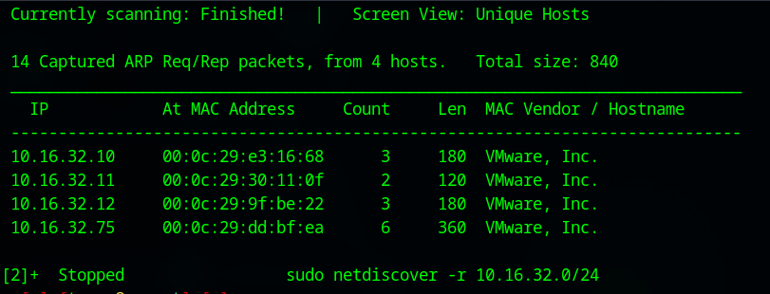

3.2 Service Enumeration
Following host discovery via network scanning tools, the next step in the assessment involved enumerating open services across identified IP addresses. Using a network scanner (such as NetScan), active hosts within the 10.16.32.0/24 subnet were identified. These hosts were then subjected to targeted port scanning to determine what services were exposed and available for further enumeration.
Tools such as Zenmap were utilized to perform TCP port scans and banner grabbing where applicable. The goal was to map out the attack surface and determine which systems or services might be vulnerable to exploitation. This early phase of enumeration is essential for selecting viable targets and shaping the direction of the penetration test.
Server IP Address | Ports Open
10.16.32.10 | TCP: 135,139,445,3389
10.16.32.11 | TCP: 135,139,445,49152,49153, 49154, 49155, 49156
10.16.32.12 | TCP: 80,88,135,139,389,445,464,593,636,3268,3269,,3389,5357,49152-49158
10.16.32.75 | TCP:

3.3 Service Enumeration Cont.
We were also able to figure out the NetBIOS Names of each machine by reading our Zenmap command output. This gives pertinent information on which host we should start attacking first.
- 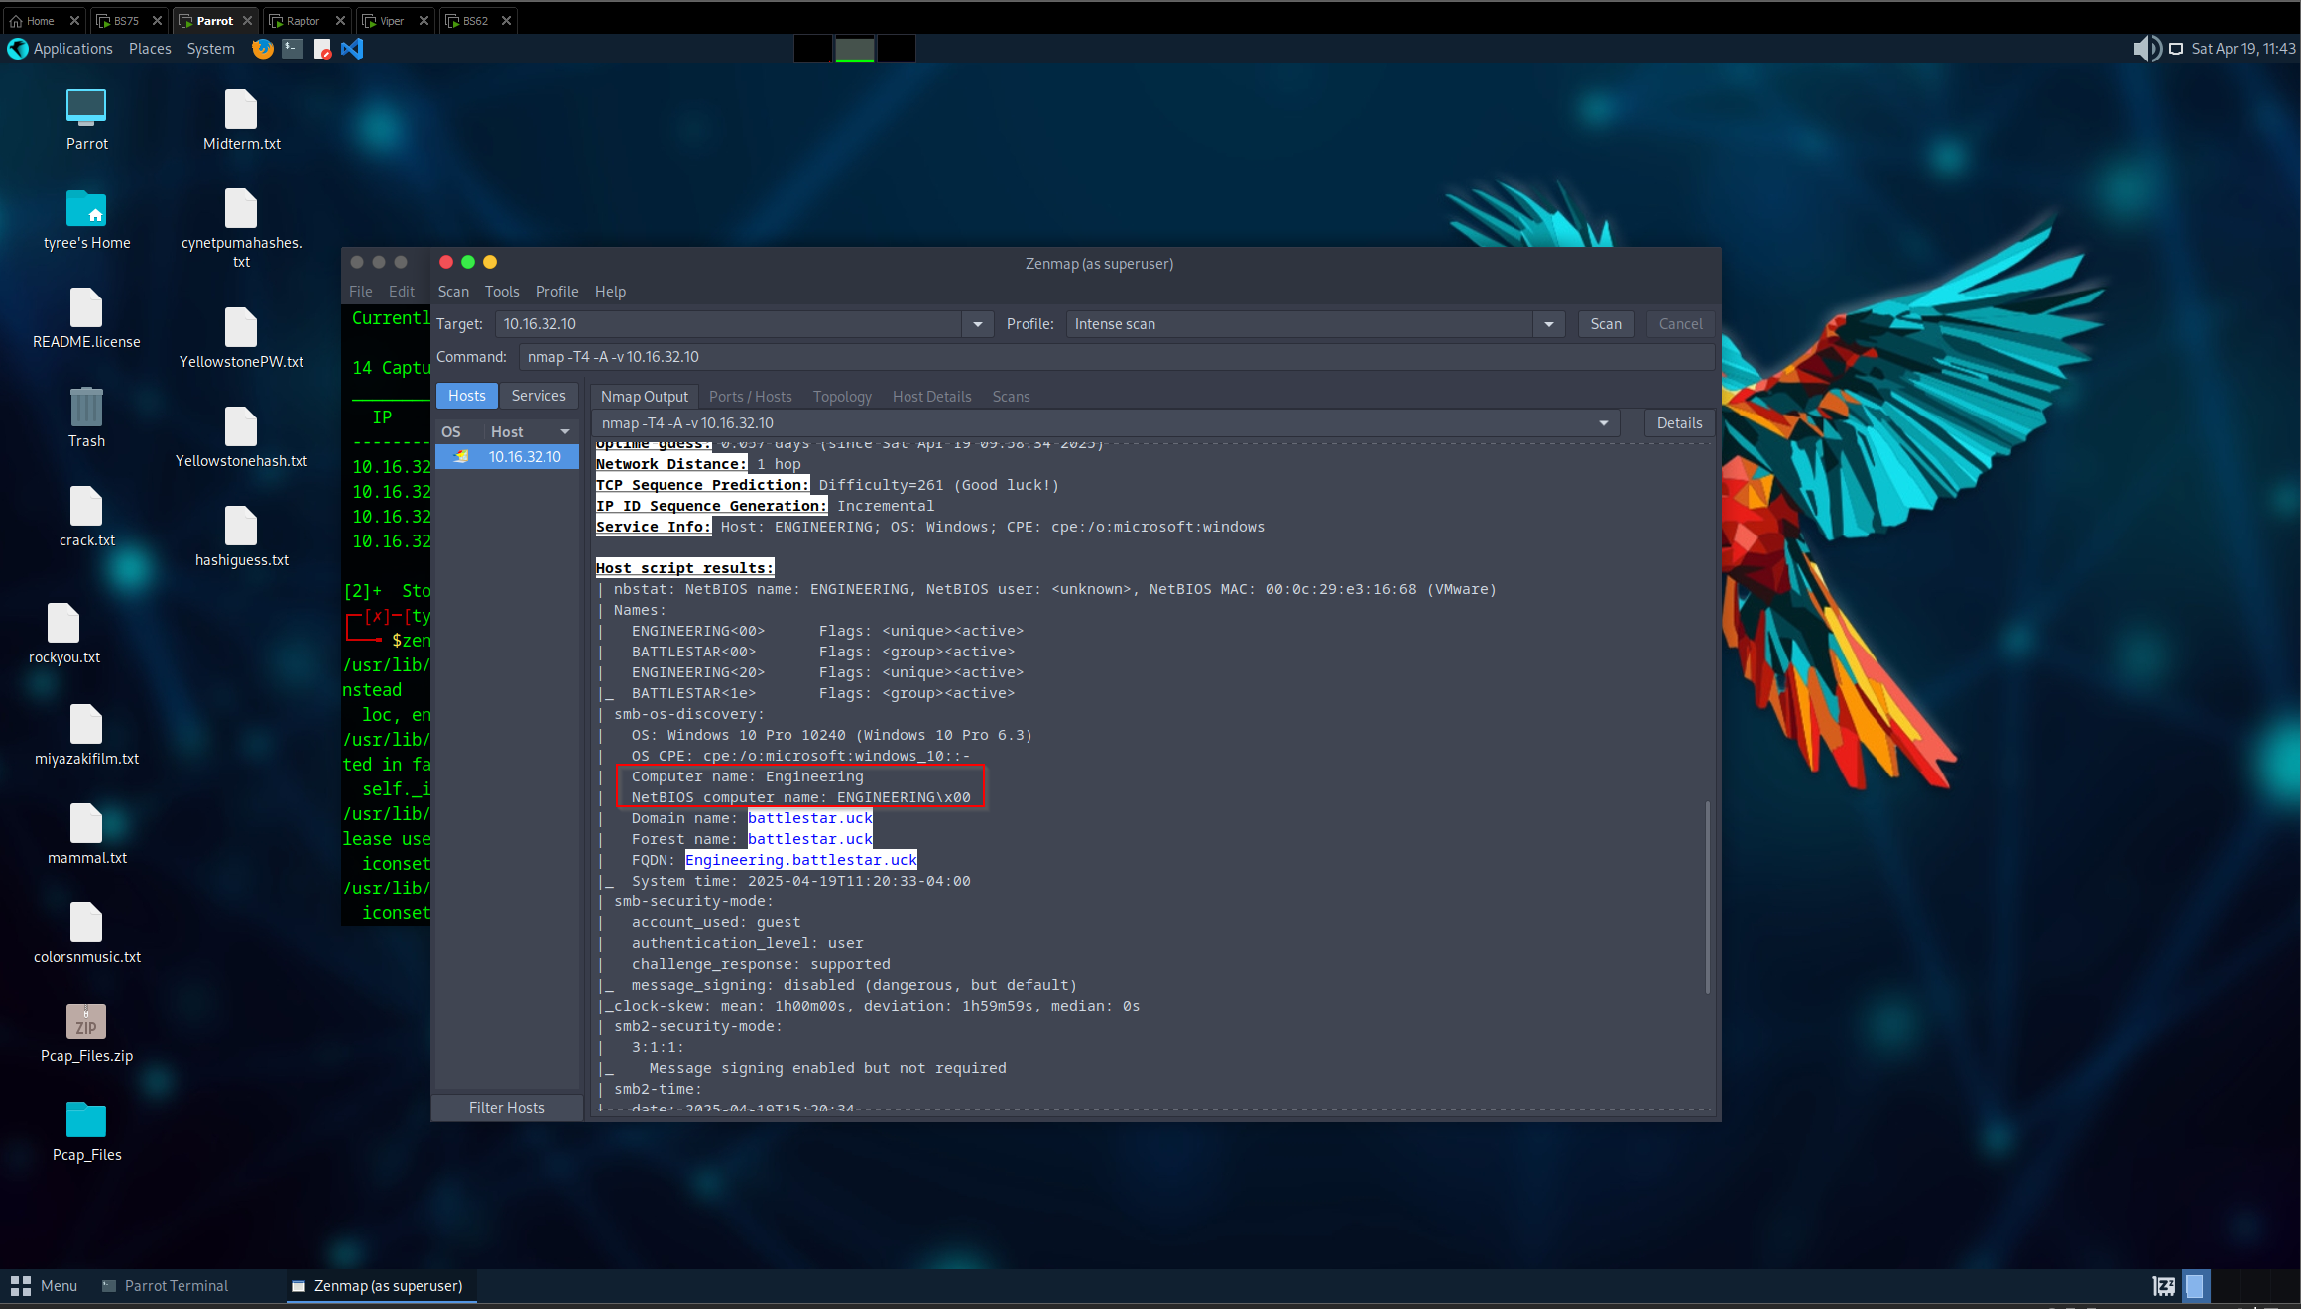
- 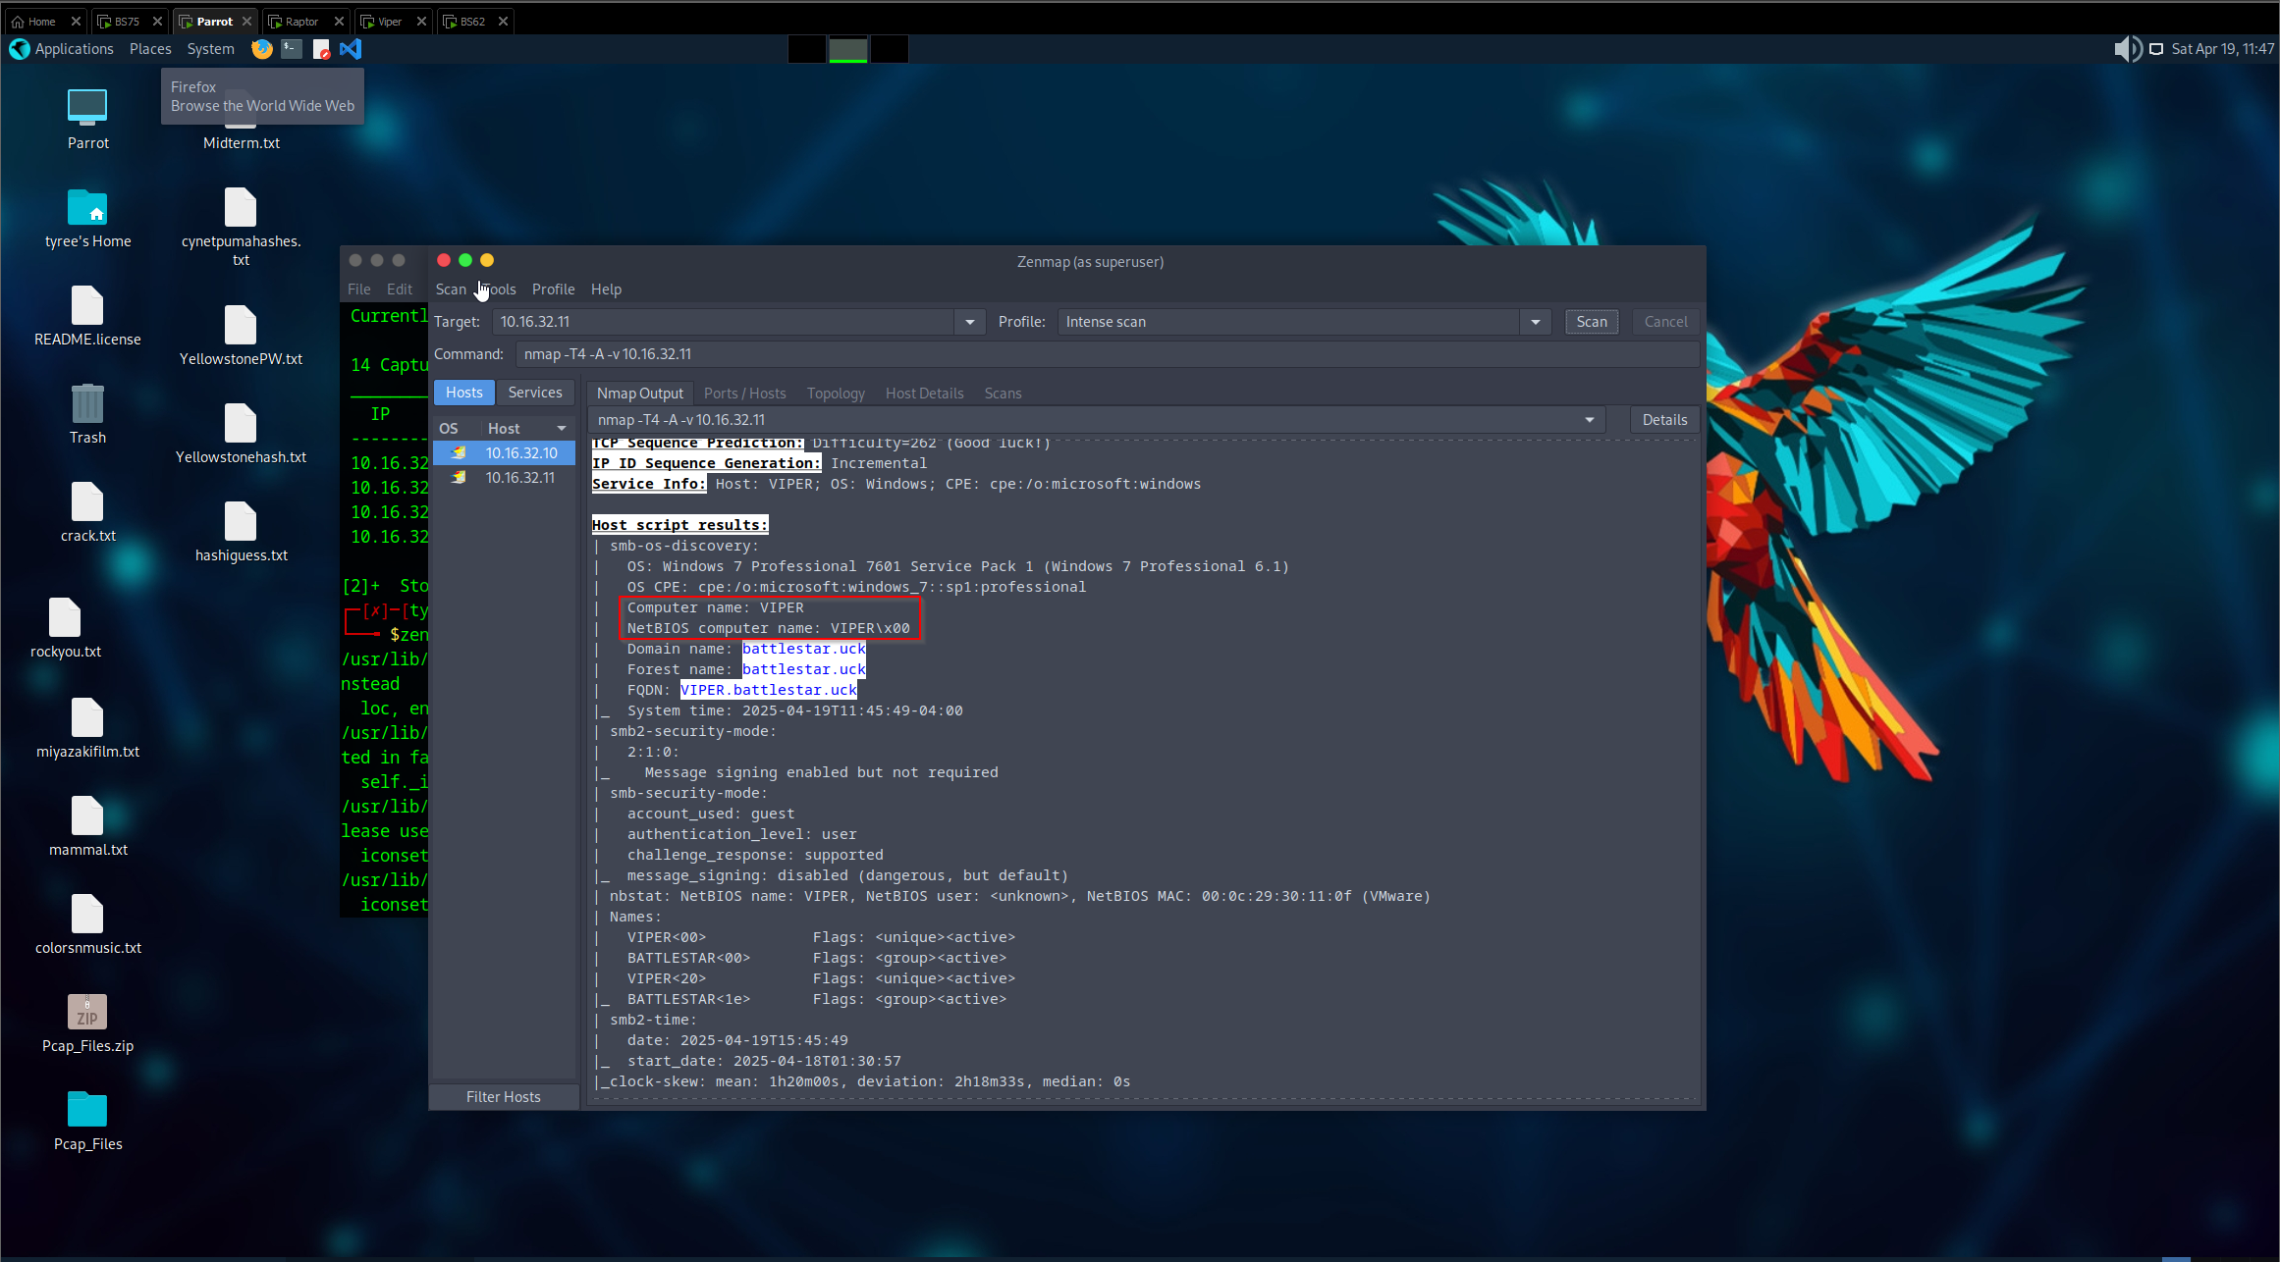
- 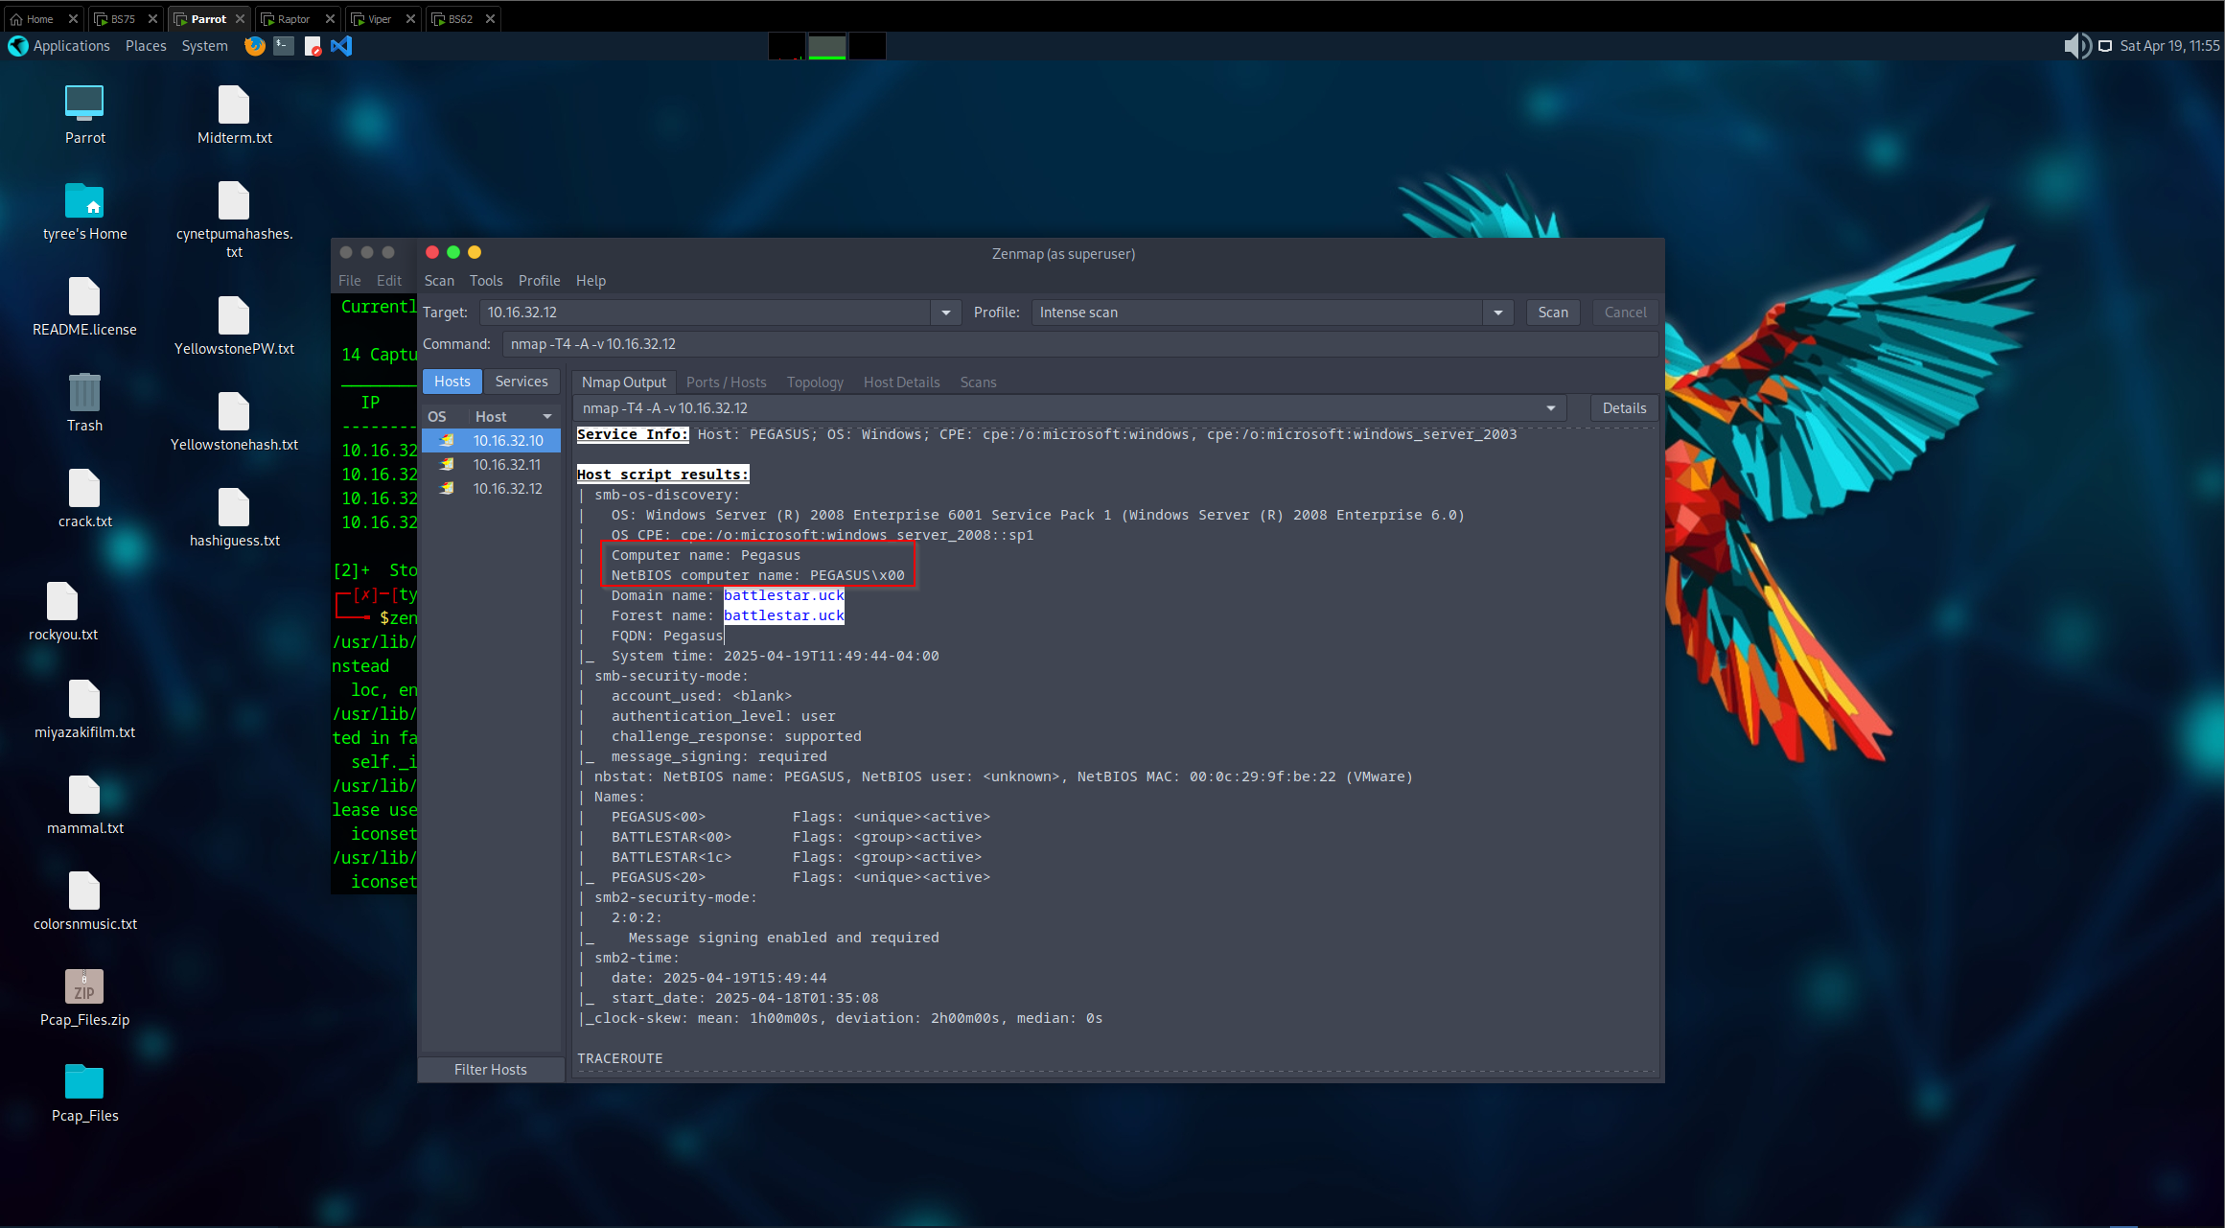
- 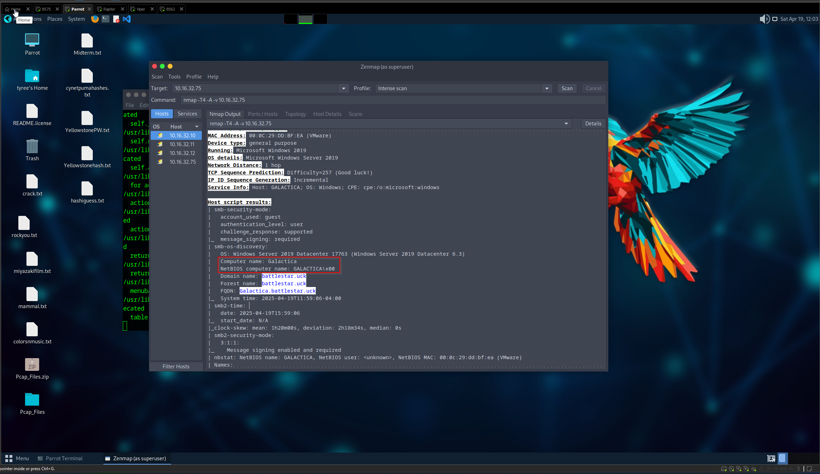

3.4 Other Interesting Objects within the network
During the enumeration phase, several noteworthy details were uncovered across various systems within the 10.16.32.0/24 subnet. These findings were obtained through port scanning, service enumeration, and targeted probing of discovered services.
Using a technique called banner grabbing we were able to find the version of the http server that was running on one of our machines with the IP address of 10.16.32.12. The version listed is HTTP/1.1 200 using Microsoft IIS 7.0
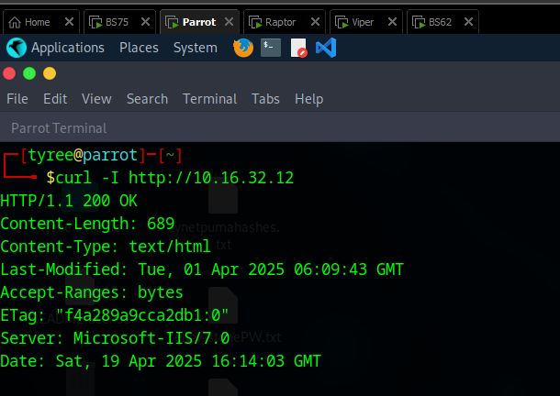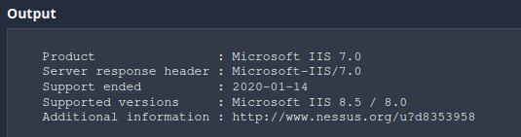
Onepiece also wanted to take the time to note that we found each OS version of all the ip addresses listed from our beginning investigations
10.16.32.10 is running Windows 10 Pro
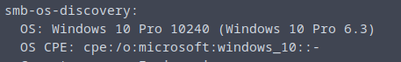
10.16.32.11 is running Windows 7 Professional 7601 Service Pack 1
10.16.32.12 is running Windows server 2008 Enterprise 6001 Service Pack 1
10.16.32.75 is running Windows Server 2019 Datacenter 17763

3.5 Vulnerabilities within the network.
After performing enumeration and initial probing, we have reviewed each identified host for known vulnerabilities based on open ports, service versions, and accessible configurations. Below is a breakdown of each system, including its IP address, associated services, and a summary of identified vulnerabilities. Each entry includes supporting evidence and context for the potential risk, which we will explain in more detail.
10.16.32.10 – One Piece has used Nessus to conduct a vulnerability scan on this machine and there a couple interesting things we’d like to go over.
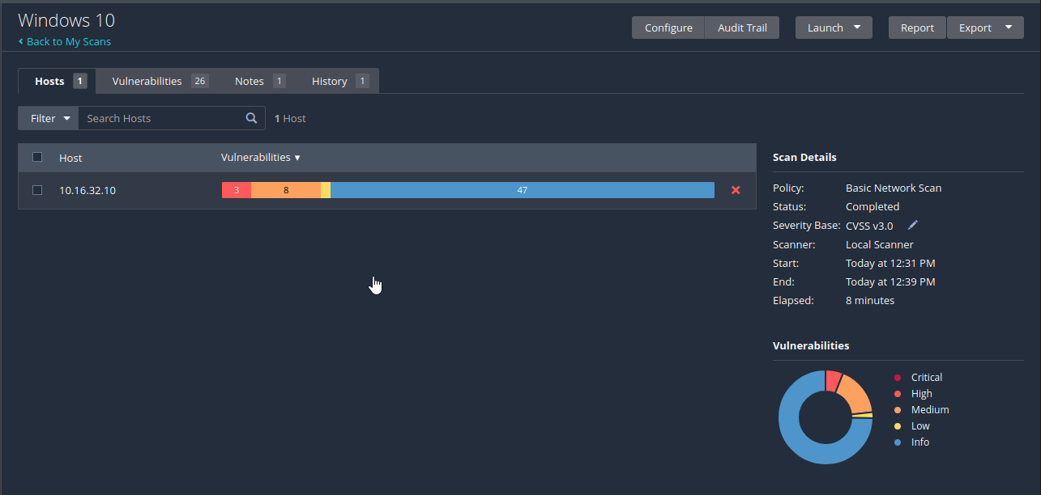
For starters we can see there are a couple of Critical Vulnerabilities that could be patched and can be abused within this environment. One of the highest vulnerabilities is eternal blue on this machine, as pictured below.
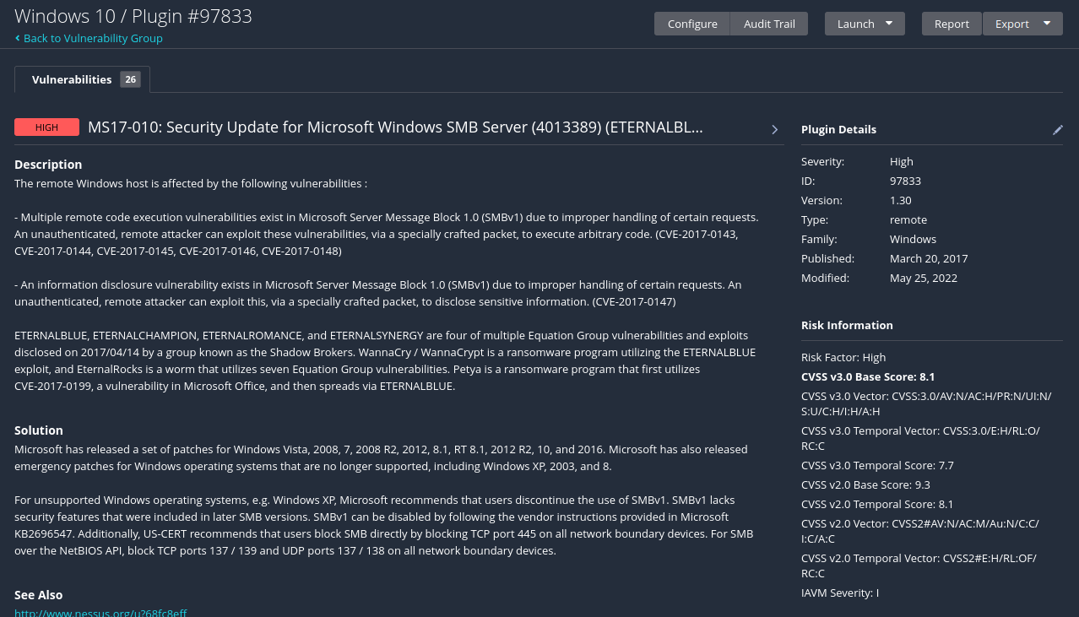
10.16.32.11 – One Piece has noted vulnerabilities within your windows 7 machines that could be used as an attack surface a well. MS11-030: Vulnerability in DNS Resolution Could Allow Remote Code Execution, this vulnerability allows an attacker to craft a malicious DNS response that exploits a flaw in the way the Windows DNS client handles records. If the target system queries a DNS server that responds with specially crafted data, the attacker could gain remote code execution privileges on that machine.
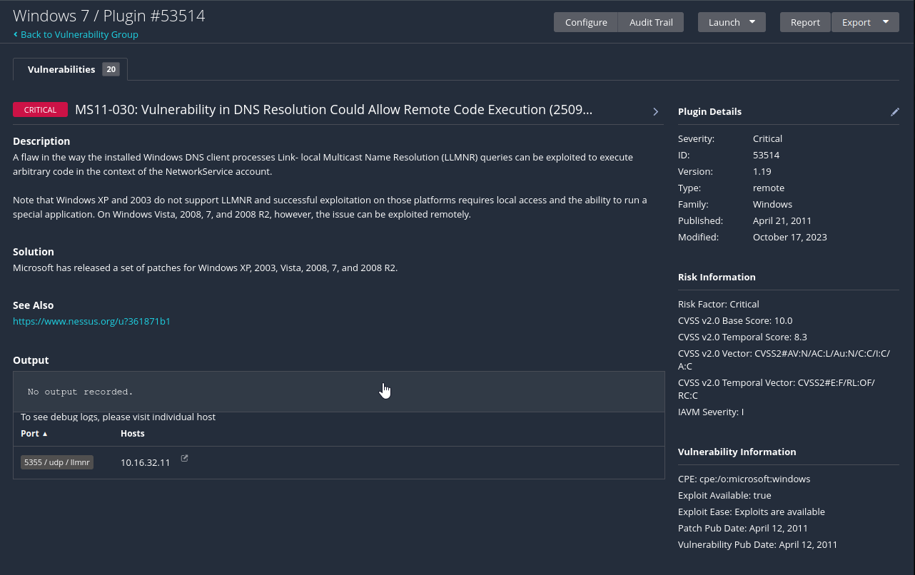
10.16.32.12 – One Piece has found many Critical vulnerabilities on this machine that needs to be investigated
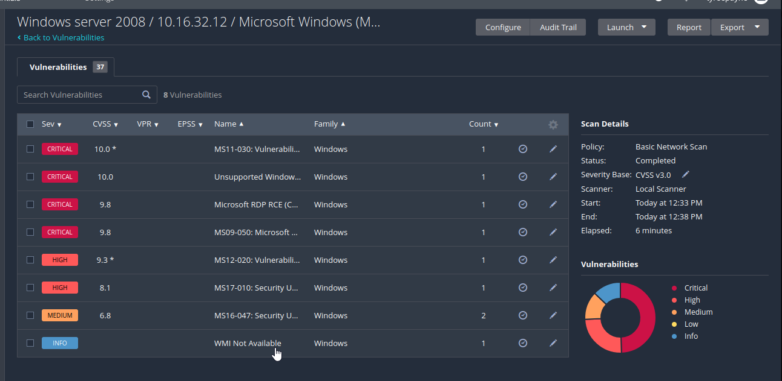
10.16.32.75 – On this server One Piece was able to find the Echo Service is still active on this server making it possible for Denial-of-Service attacks to take place. Other than that, there are no other critical vulnerabilities found on the machine
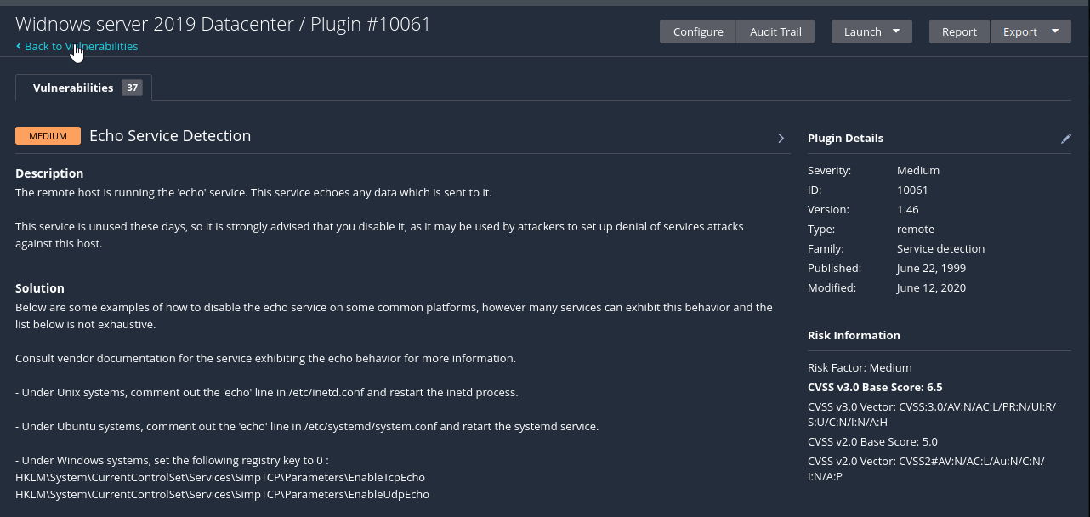

3.6 Viper gets hit with Eternal Blue
One Piece has found its first target to begin the penetration test. We decided to start by hacking one of the most vulnerable machines, Windows 7 Viper. We gained a shell on the machine by using Metasploit’s eternal blue exploit, we knew this machine was vulnerable to Eternal Blue from our original Nessus Scan.
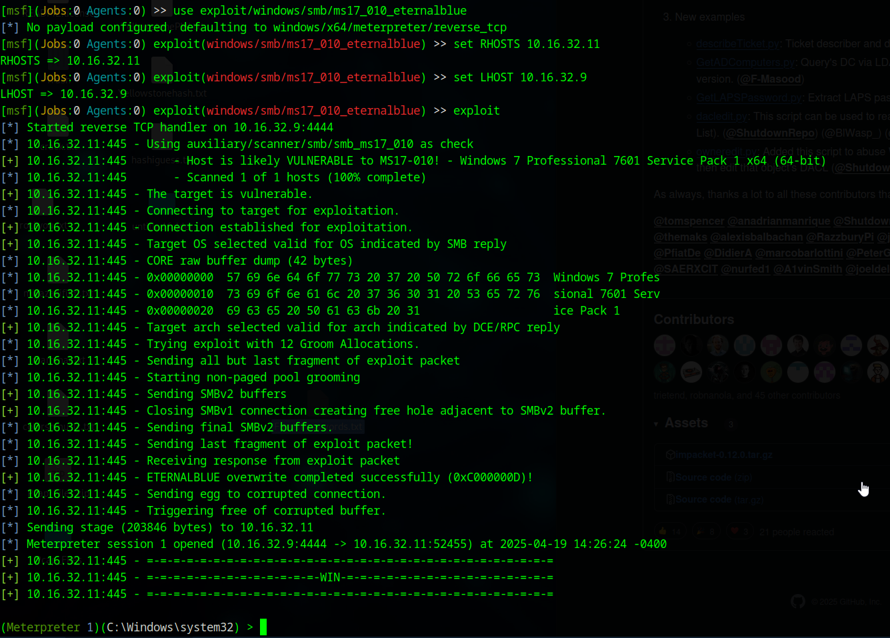
The first step we take to our approach within the machine is to perform a hash dump, this gives us hashed values of the username and password and we can then use those hashes and crack them using any tools either online or locally.
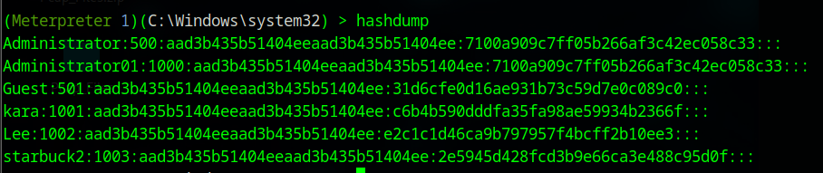
Next we take a look at the C drive to see what user information we have
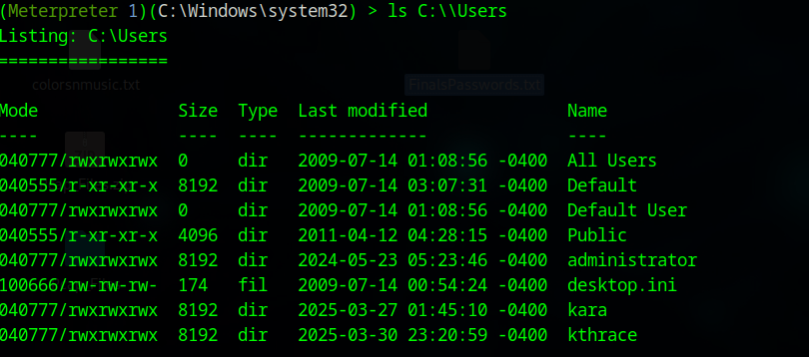

3.7 Challenge Medium - Viper
Looking to the Admin user first we didn’t find anything yet but within Kara we found a txt document labelled medium, we decoded the message to find it says FRAKKINTOASTERS, we used Magic on Cyberchef and it is under the Bacon Cipher
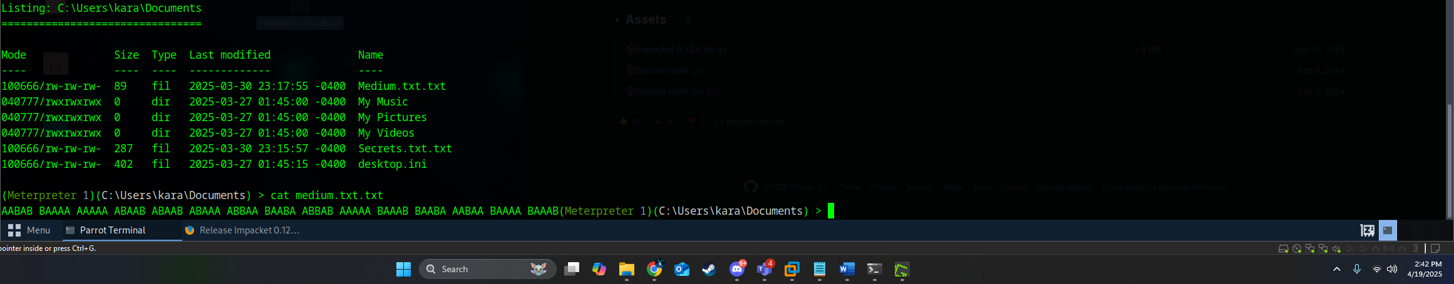
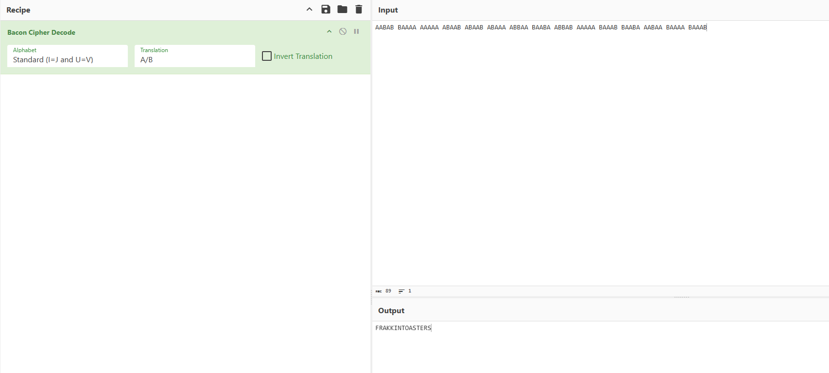

3.8 Challenge Easy - Viper
We were able to find the next document within the same user by going to their desktop. From there we found our next document labeled Easy.txt. We went ahead and downloaded the file due to the output from our cat command. Within decoding this message we used www.dcode.fr/morse-code to figure this one out, our hidden message we found was IFOUNDOXYGENANDWATERINTHERAIDER
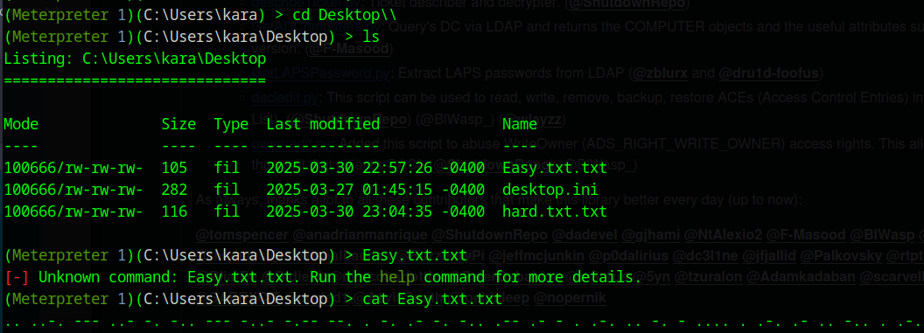
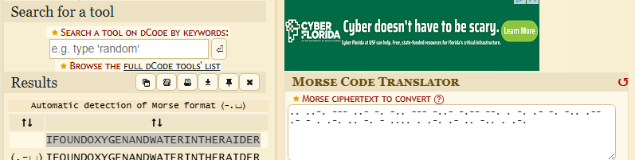

3.9 Challenge Hard - Viper
Within the same directory we found hard.txt, but it gives us a message kind of like its one piece of the puzzle
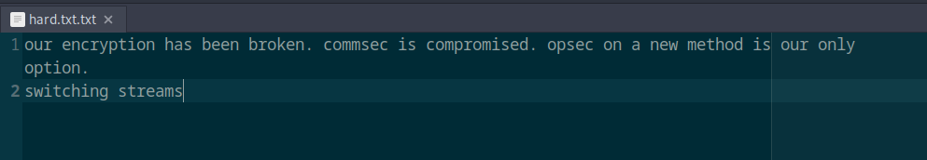
Random Artifact Challenge I found (Must be hard.txt continued)
We checked other directories within this same Computer and found ArtifactInstructions.txt and a Guy.txt, we figured we should solve this, and it seems the encryption method is something called JSFuck Language breaking it down it seems our results were Listen, I'm not even supposed to BE here. I'm just Crewman #6. I'm expendable. I'm the guy in the episode who dies to prove that the situation is serious! I gotta get out of here.
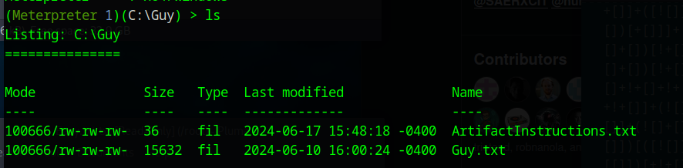
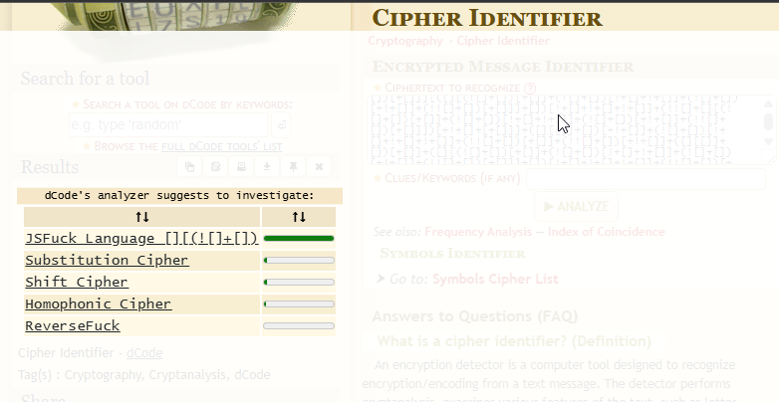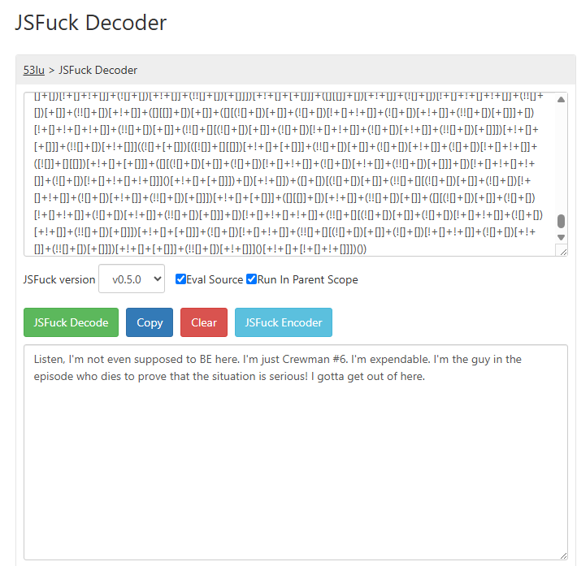
We will note that we did identify the domain controller by using a command within meterpreter while connected to the Viper machine, we found that our Domain Controller is going to be the ip address at 10.16.32.75
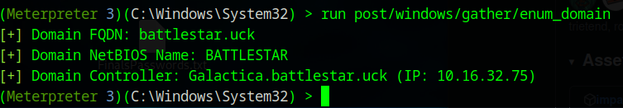
We also found a little secret.txt file within this machine as well!
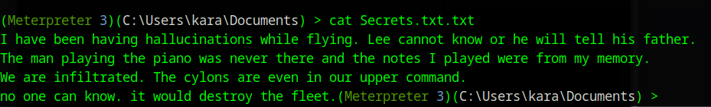

4.0 Credential Discovery and Kerberoasting Attacks
After identifying active domain services through enumeration, we shifted our focus to-ward gathering user credentials via Kerberos-based techniques. Since the domain con-troller is reachable and Kerberos authentication is in use, we utilized Kerbrute to enu-merate valid usernames and attempt password brute-forcing.

Using Kerbrute we were able to perform enumeration against the domain controller and password sprayed against it and was able to obtain the password to one of the users named ctyrol
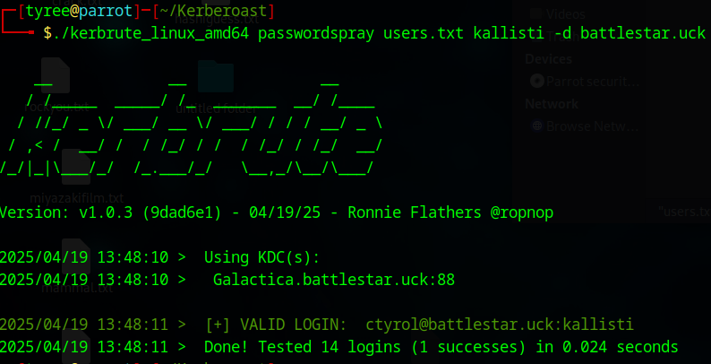
Using that password and username from above we went ahead and requested Kerberos tickets, we were able to do so and found that 2 users had Kerberos ticket hashes
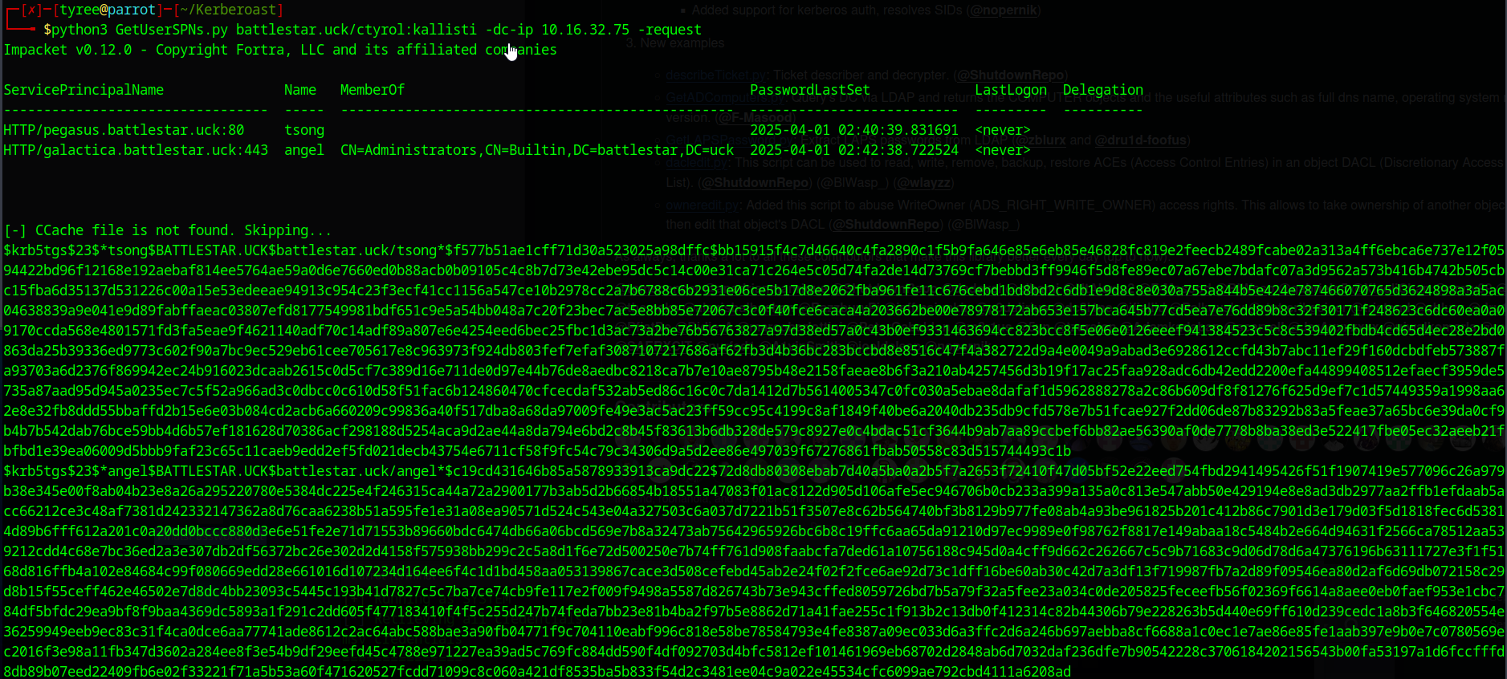
We then decided to take angel’s hash and throw into a .txt file named goldenticket, we used the common wordlist rockyou.txt to be our basis. We were then able to crack his password and found that it is whatami. Username: angel Password: whatami
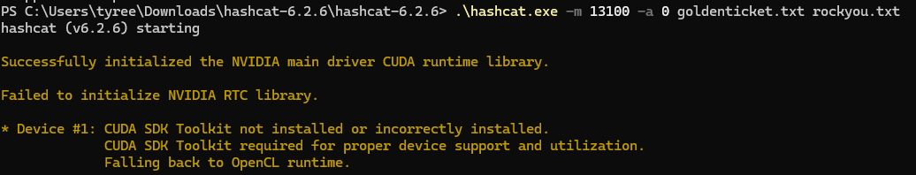
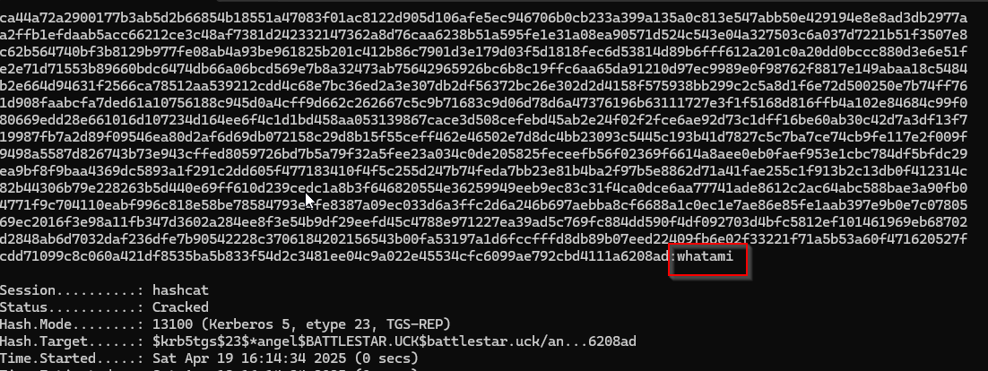
We then decided to crack tsongs password as well using the same method, here’s the output. His password was watchtower
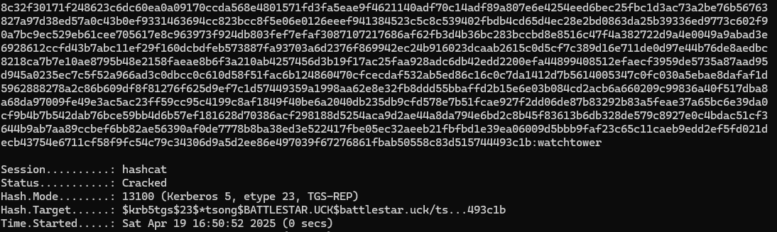
We also used netexec to figure out what these users can login to and what privileges they may have. We found that Angel has admin rights to 2 servers while tsong doesn’t.
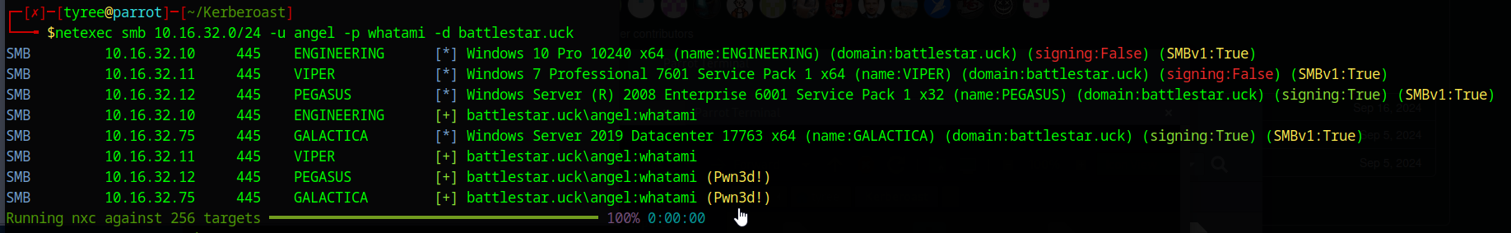
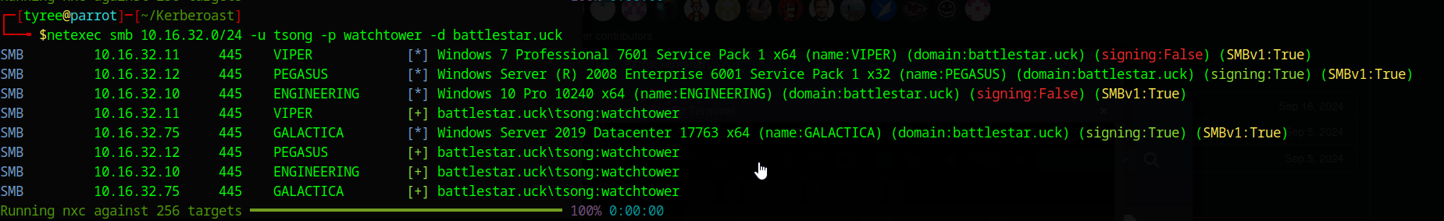

4.1 We have access to THE Domain Controller BS75
We’ve gained access to the DHCP and Domain Controller via the User Angel, he has admin rights to these servers, we found this out from the command we used before within netexec, this portion of this report we will go over the different artifacts within this machine.
CHALLENGE 1 Easy BS75
This challenge was pretty simple, it has a QR code to scan, when scanned it leads you to google and within the search bar it says The arrow of Apollo
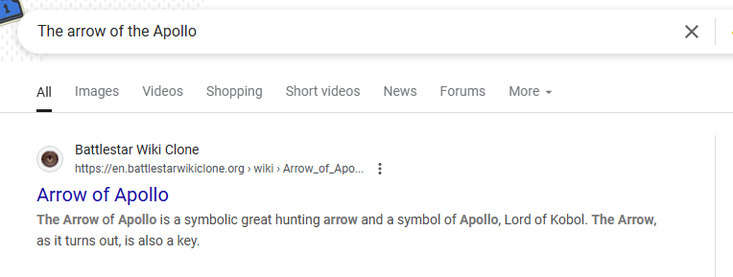
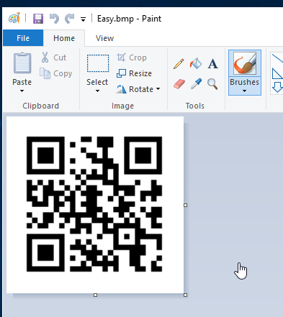

CHALLENGE 1 Medium BS75
We found a text file that had nothing in it but when you press CTRL+A you can see it highlights text. We decided to then throw that highlighted text into Notepadd++ to see if we can find anything hidden within it using the view section and we were able to find the below
• → for tabs
• · for spaces
• ¶ for line breaks (CR, LF)
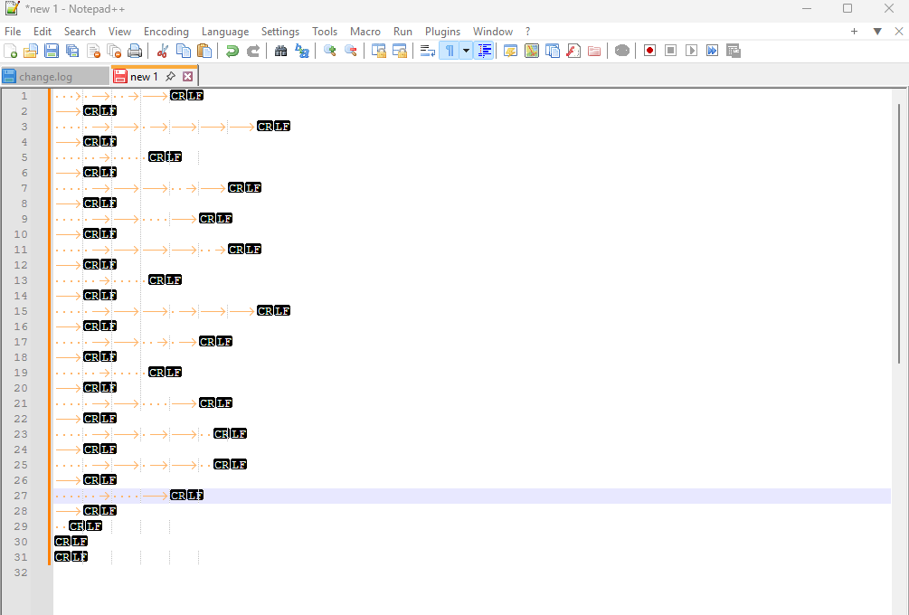
CHALLENGE 1 HARD BS75
Hard.txt.txt told us that we essentially had to unzip the tar file in that same directory but 10000 times, we began by looking for a solution that can help automate the process, we found that this command would get the job done for i in {10001..1}; do
echo "[*] Extracting $i.tar..."
tar -xf "$i.tar"
rm "$i.tar"
done
This did exactly what we needed it to and we were able to get to the final file which was 1.txt that leads us to a Battlestar Galactica video, pretty cool.
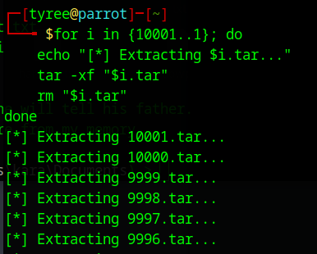
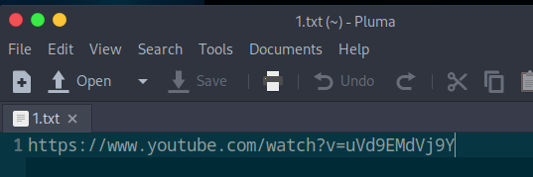


5.0 Data Exfiltration via psexec
One Piece was able to successfully exploit a vulnerability on the client's network using PsExec, a legitimate tool that allows for remote execution of commands. PsExec is often used in administrative tasks, but when improperly secured, it can be leveraged by attackers to gain unauthorized access. In this case, the target machine was vulnerable due to weak or misconfigured access control settings that allowed the execution of remote commands without sufficient authentication. By utilizing this tool, an attacker can run processes remotely, bypassing traditional security controls.
Upon gaining access to the target system, the flagged files located in the user’s Desktop directory were identified. With administrative privileges on the compromised machine, access to other user directories was also gained. The flagged files were then copied from the user’s Desktop folder to another user’s Desktop folder, where One Piece had unrestricted access. This process facilitated the secure transfer of sensitive files for further analysis and decryption.
This method of data exfiltration demonstrates the importance of securing remote administration tools, ensuring proper authentication measures are in place, and conducting regular security audits to identify any misconfigurations that could be exploited.

5.1 Psexec continued
One Piece used psexec against BS62 aka PEGASUS and was able to locate the 3 artifacts hidden on this machine, here are the steps on how we were able to set this up.
Since we know that angel has admin access to this machine, we decided to use his username and password to allow us to gain a shell on this machine.
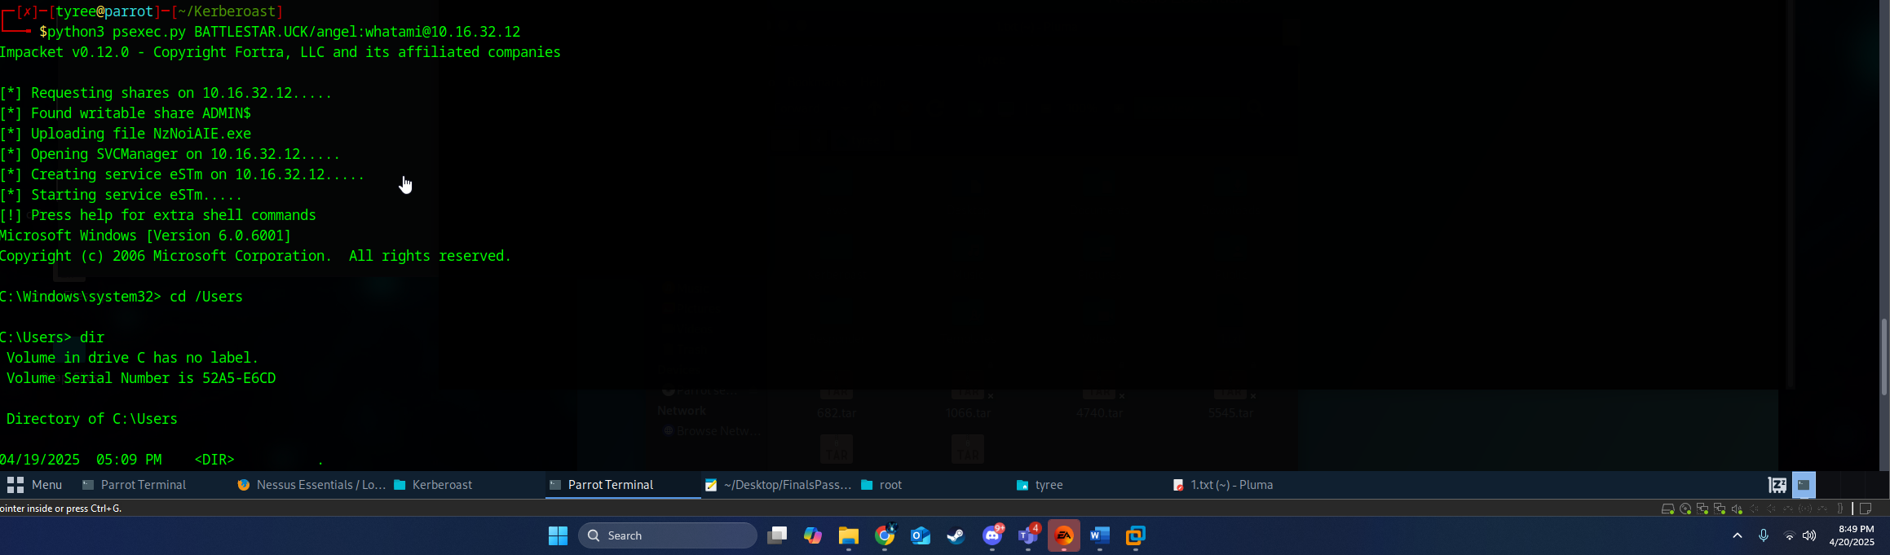
We then went on to figure out which users were on this server and checked the documents directory and desktop directory of each user. We finally made contact with the files when we discover that Saul had them under his desktop directory
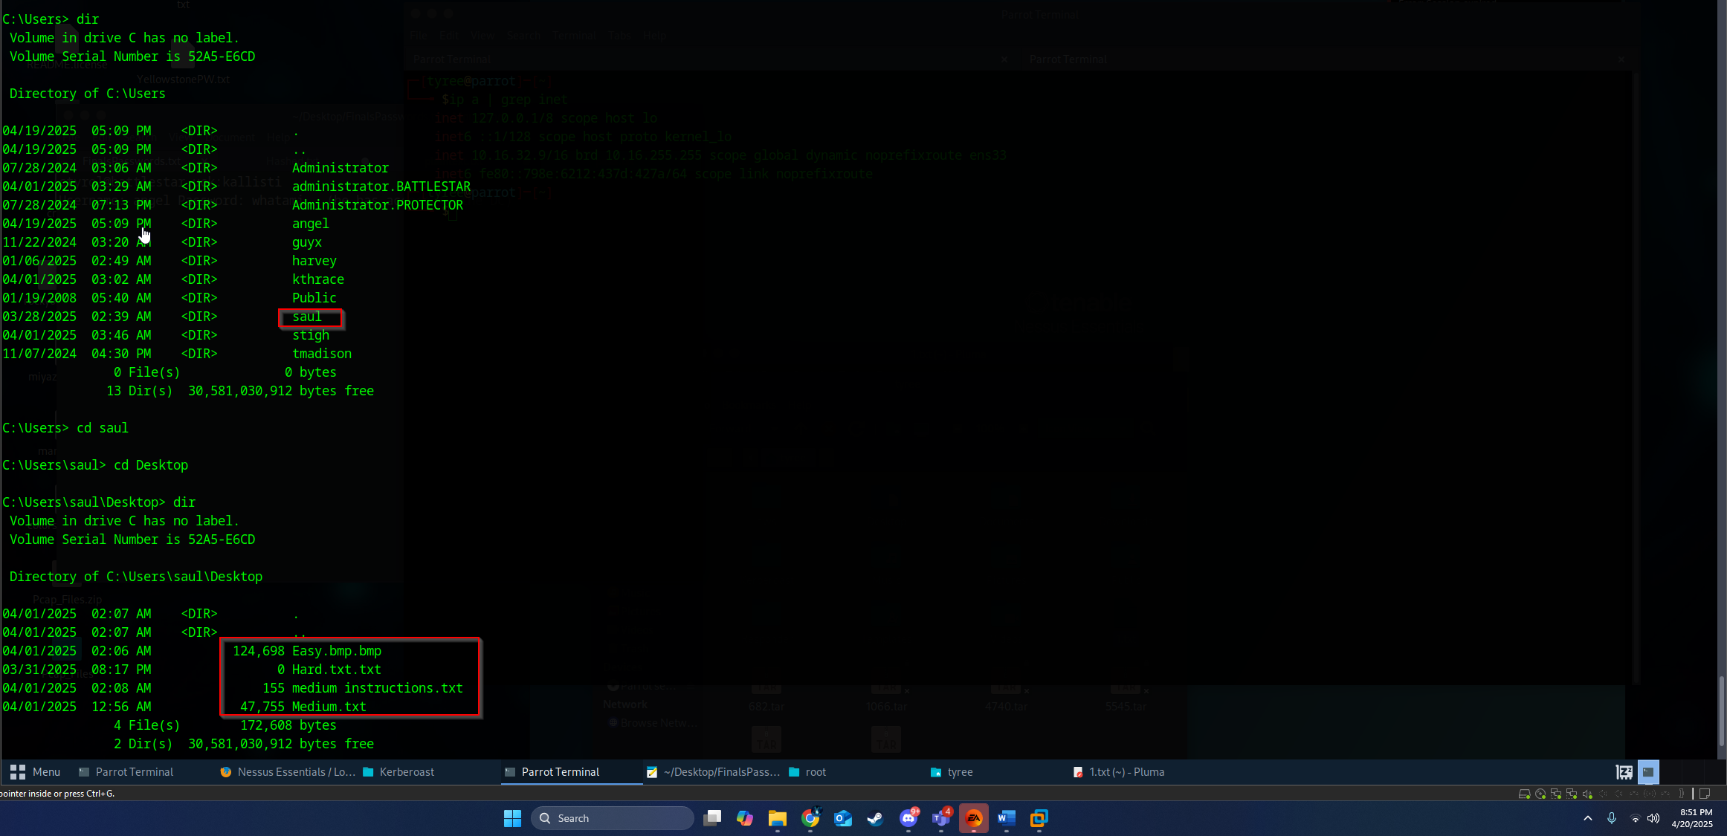
Moving forward, we knew that we weren’t going to be able to read the files inside of psexec so we had to figure out an easy way to move these files somewhere else so that we could deal with them. We simply decided to copy each and every file to angel’s desktop since we had access to login with him on this server, you could then exfiltrate that file out of his user and onto my local Linux machine. Here is how we did this.
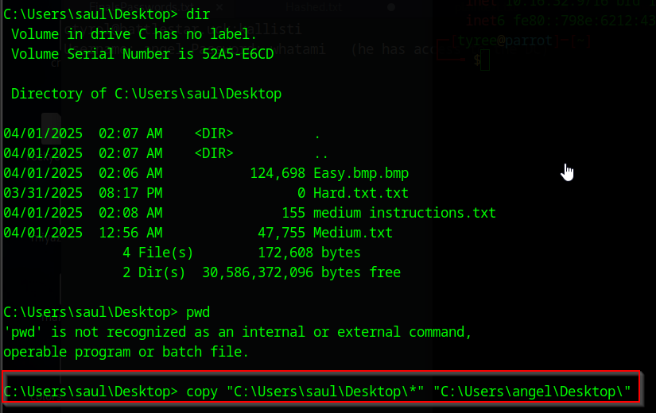
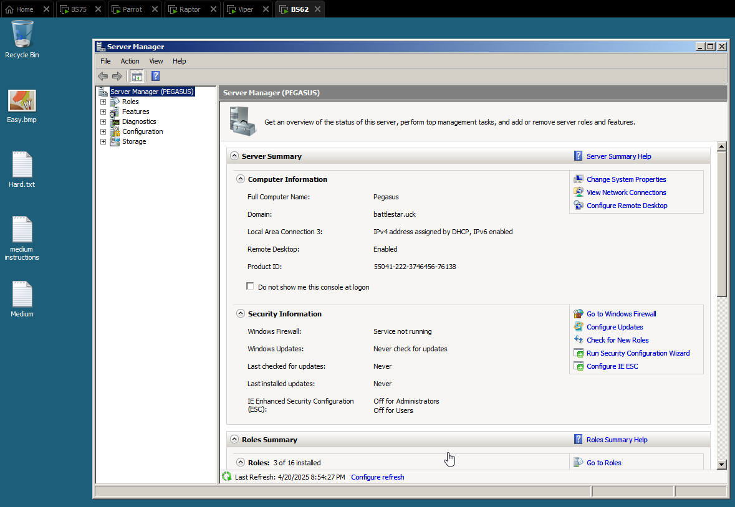

5.2 Artifact Challenge 1 Easy BS62 AKA PEGASUS
This challenge was pretty simple and easy, it was a barcode that we had to scan, we threw it into an online barcode scanner and we got the text output of Said the Joker to the Thief
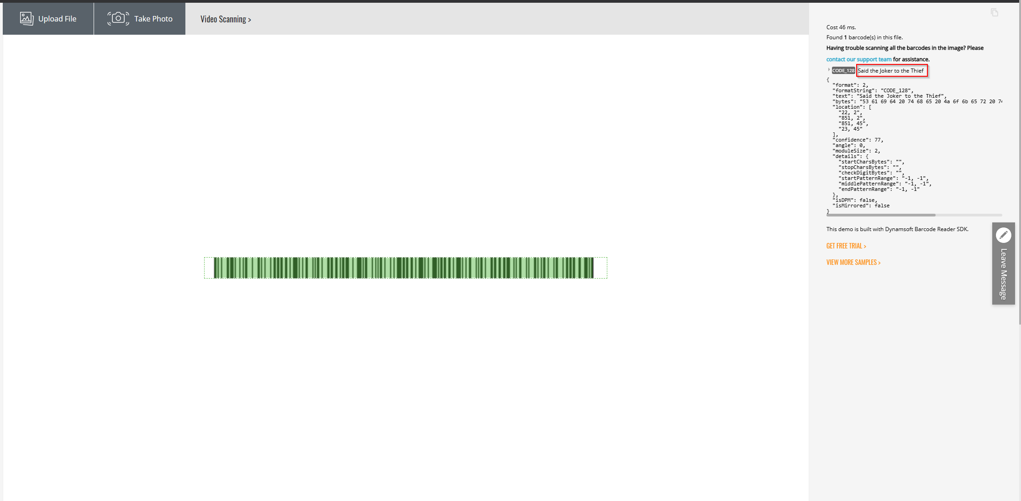

5.3 Artifact Challenge 1 Medium BS62 AKA PEGASUS
This Challenge needs to be decrypted using the hexadecimal value indicating the regular boot on Nintendo gamecubes, we tried searching it up was unable to figure out how to decrypt this message.

5.4 Artifact Challenge 1 Hard BS62 AKA PEGASUS
Hard.txt actually had no contents inside of it, we tried to figure out any information we can but to no avail.

6.0 Let’s get to password cracking!
On this section we talk about finding the hashed values of passwords for each and every user, we will use this to then be able to login to user’s accounts and figure out more information. Using the command python3 secretsdump.py battlestar.uck/angel:whatami@galactica.battlestar.uck -dc-ip 10.16.32.75 I was able to dump all the information on the domain below.
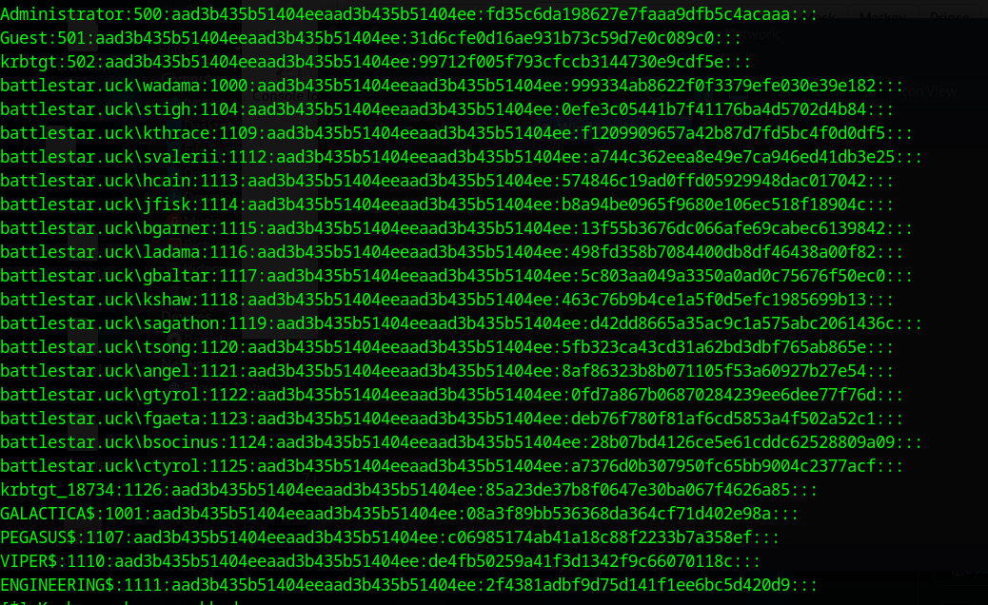

6.1 We’ve found the password to a user with some artifacts
Since One Piece has access to Raptor with an admin account we wanted to see if we can login to raptor to figure out the users on the account, we noticed that angel did not have admin access to this computer, so we decided to find the passwords of users that do have access to this computer. We started by going to C:\Users folder to see what users were available
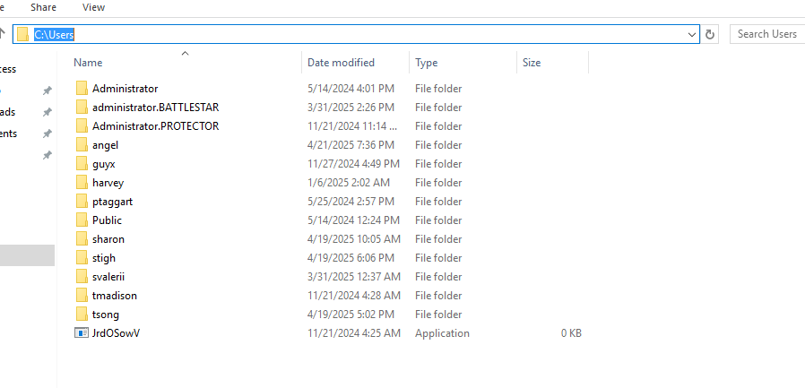
We already had access to tsong from earlier kerberoasting and logged into his account and noticed nothing, we decided to figure out svalerii’s password by using a local tool list here: https://crackstation.net/ The reason we went with svalerii is because it was one of the accounts list on the secretdump.py file. We grabbed the hash and input it into crackstation and was able to get the password value of this user, svalerii’s password was 800M3R
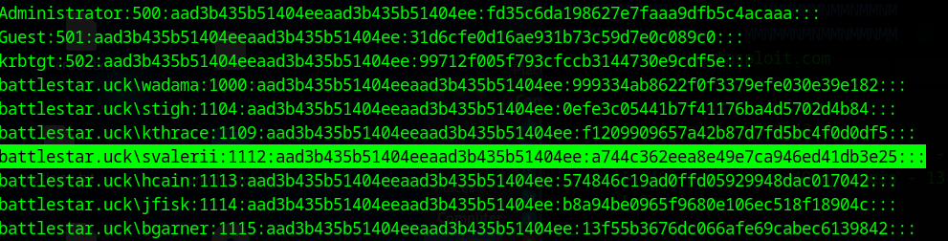
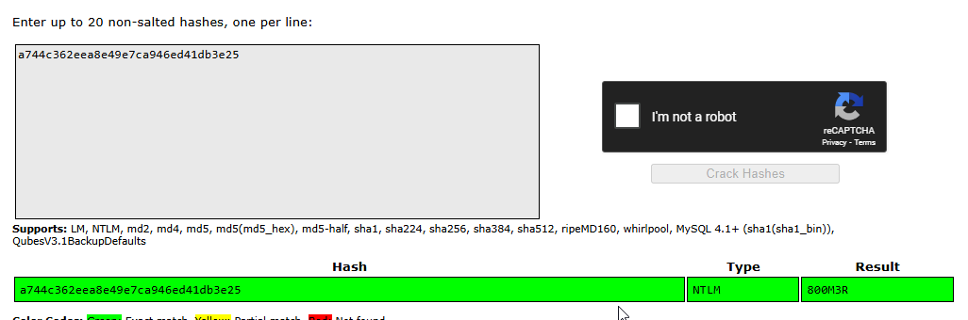
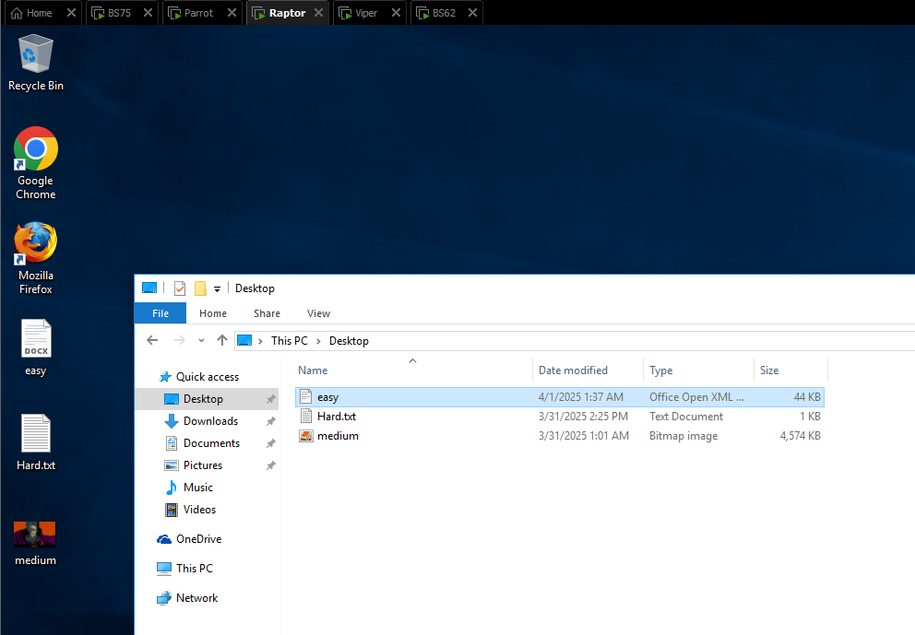

6.2 Challenge 1 EASY - Raptor
Is a .docx file that seems to be password blocked, we found the password to the file by turning it into an office hash so that johnny can read the hash. Once we had the hash, we used the wordlist of rockyou.txt and was able to crack the password of Colonel
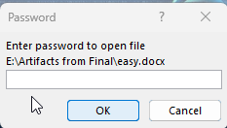
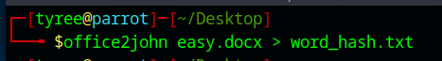
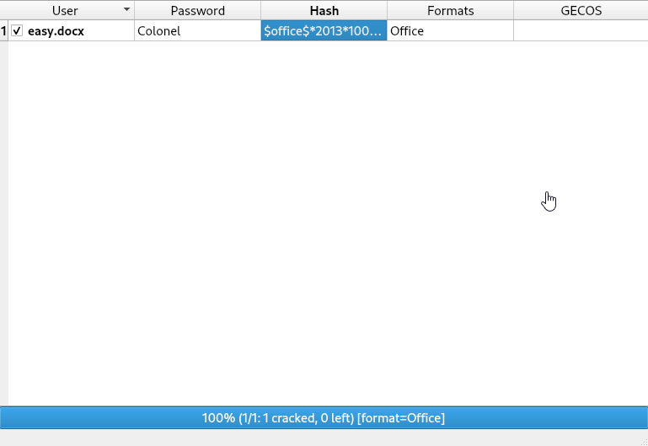
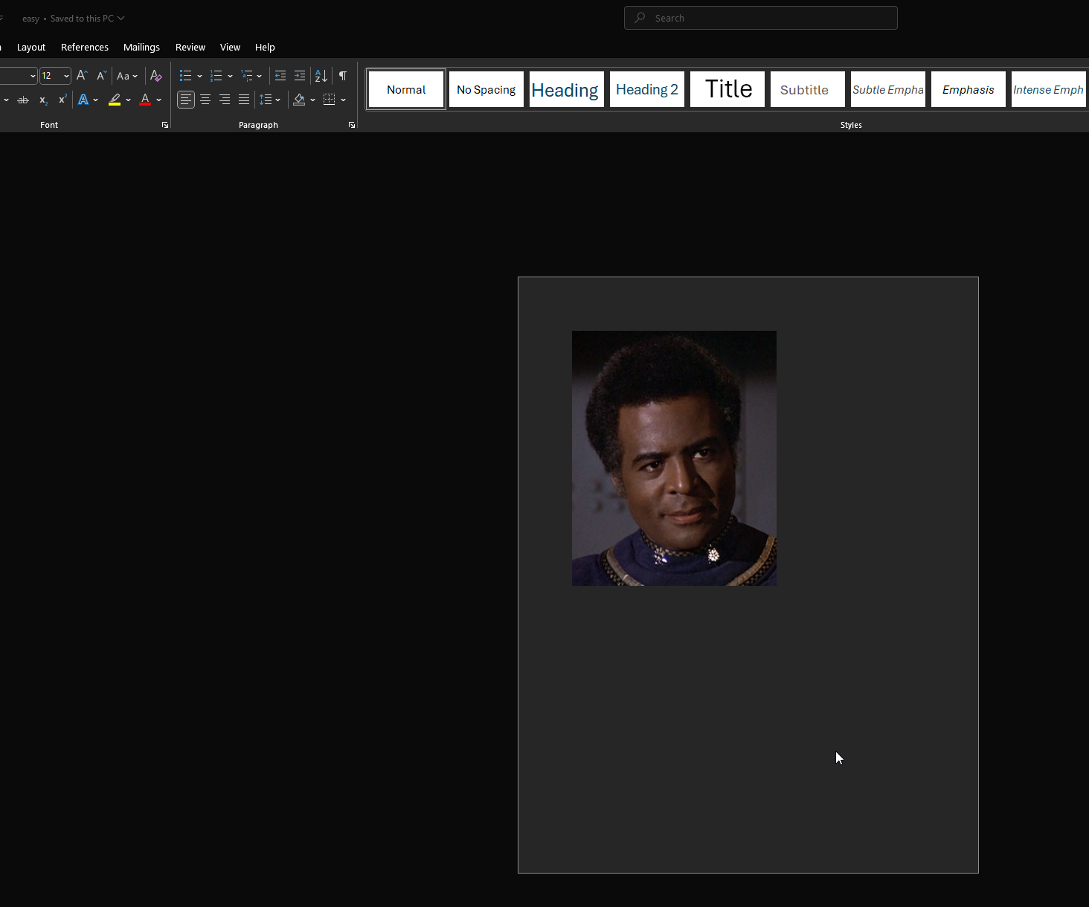

6.3 Challenge 1 Medium - Raptor
Our first thought when doing this challenge was to use exitfil tool to read any meta data within the image but we wasn’t able to find any information within the photo. We then used https://georgeom.net/StegOnline/image and changed the color of the photo


6.4 Challenge 1 Hard - Raptor
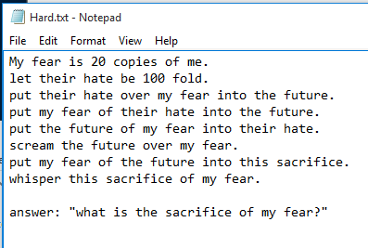

6.5 File of interest - Raptor
In raptor we also found a file of interest known as nightmares.txt, here’s what it says below.
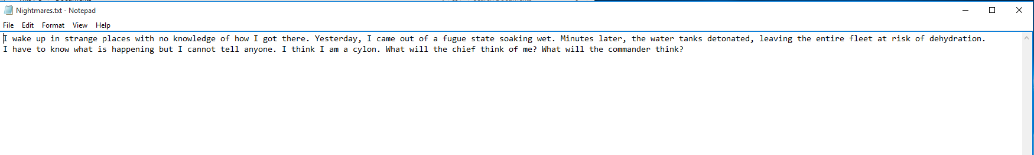

7.0 Interesting finds within the domain
This section is where One Piece will unveil interesting findings that we discovered when performing this penetration test, such as DHCP information, Installed Roles on the system, the network diagram of this entire environment and any other pertinent information regarding to this test that should be disclosed.

7.1 DHCP leases leaked
Using Angel’s credentials within the domain controller we were able to figure out the DHCP leases within the domain controller, knowing this we could potentially manipulate devices within this domain.
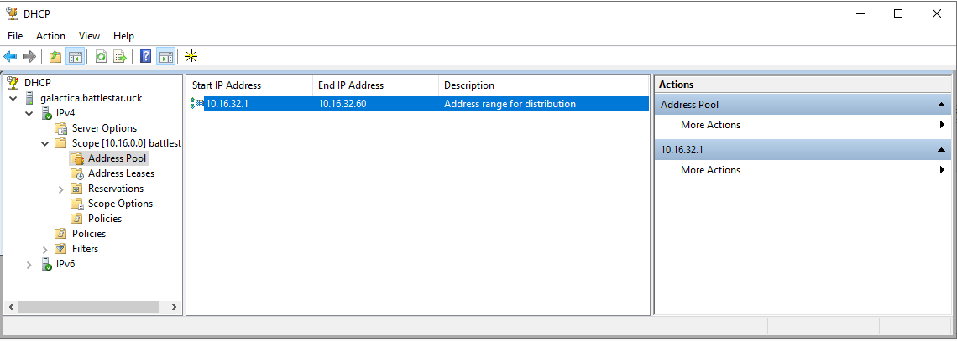

7.2 DNS Records Leaked
On this portion of searching through the domain we were able to find information regarding the DNS records within the domain controller. We were able to find different records such as A records, NS records and other SRV records on this domain.
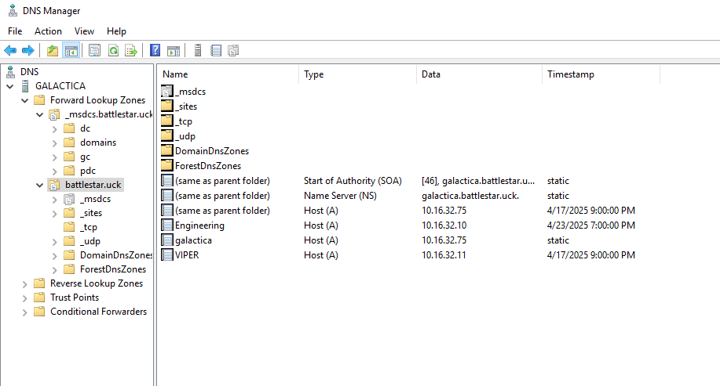
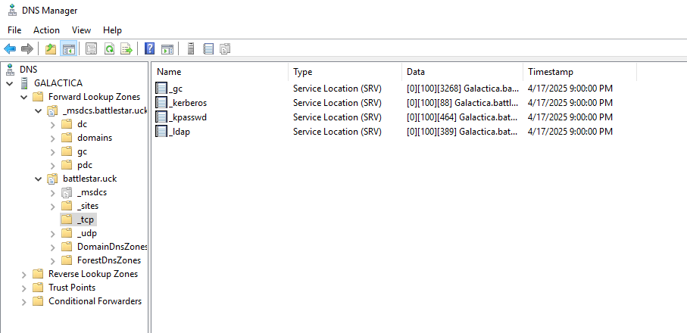

7.3 We have a Web Server using IIS
We have also found a web server being ran on Windows 2008 Server, view below
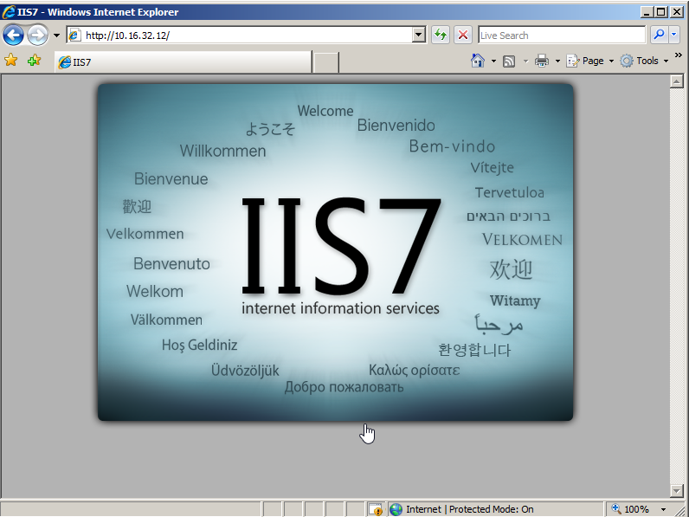

7.4 Network Diagram of the domain
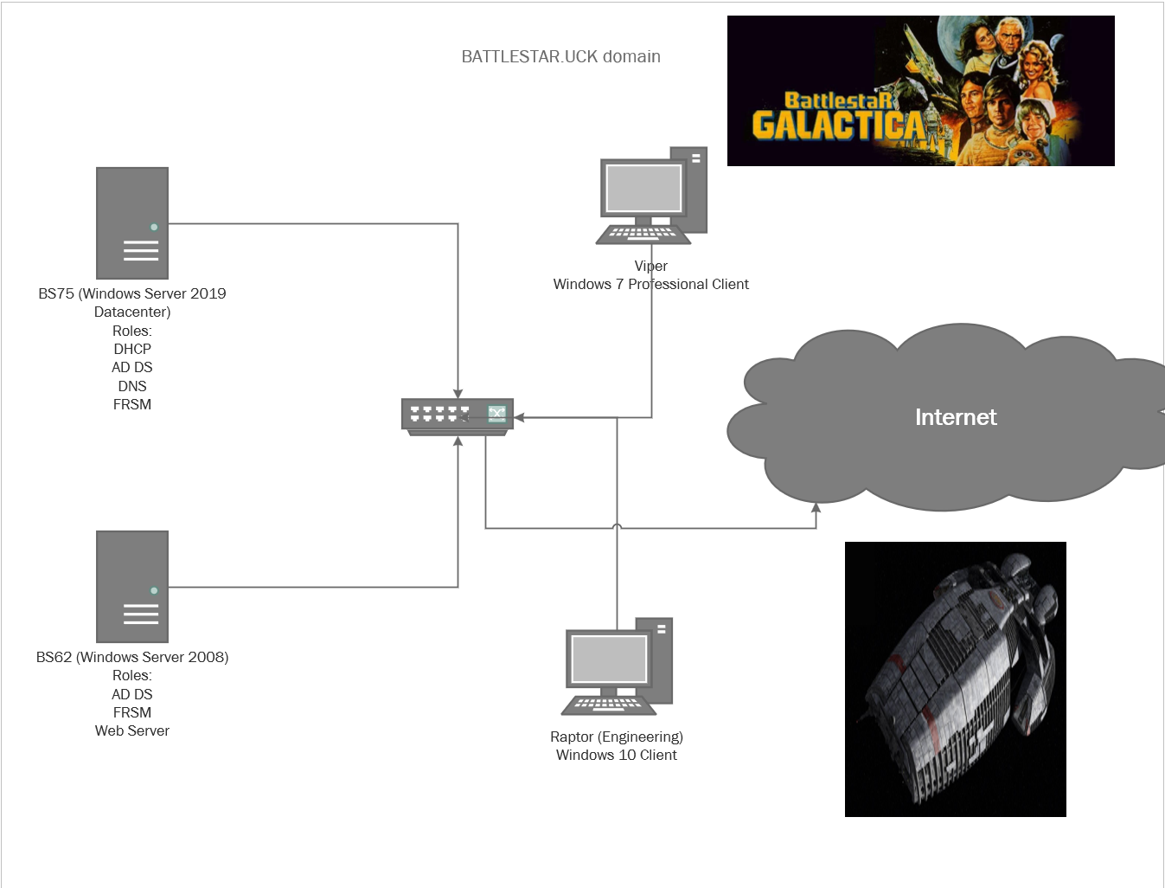

7.5 High Value Targets within the domain
Within bloodhound, we were able to map out some of the high value targets, this information was useful when scouring for what machine we wanted to target next.

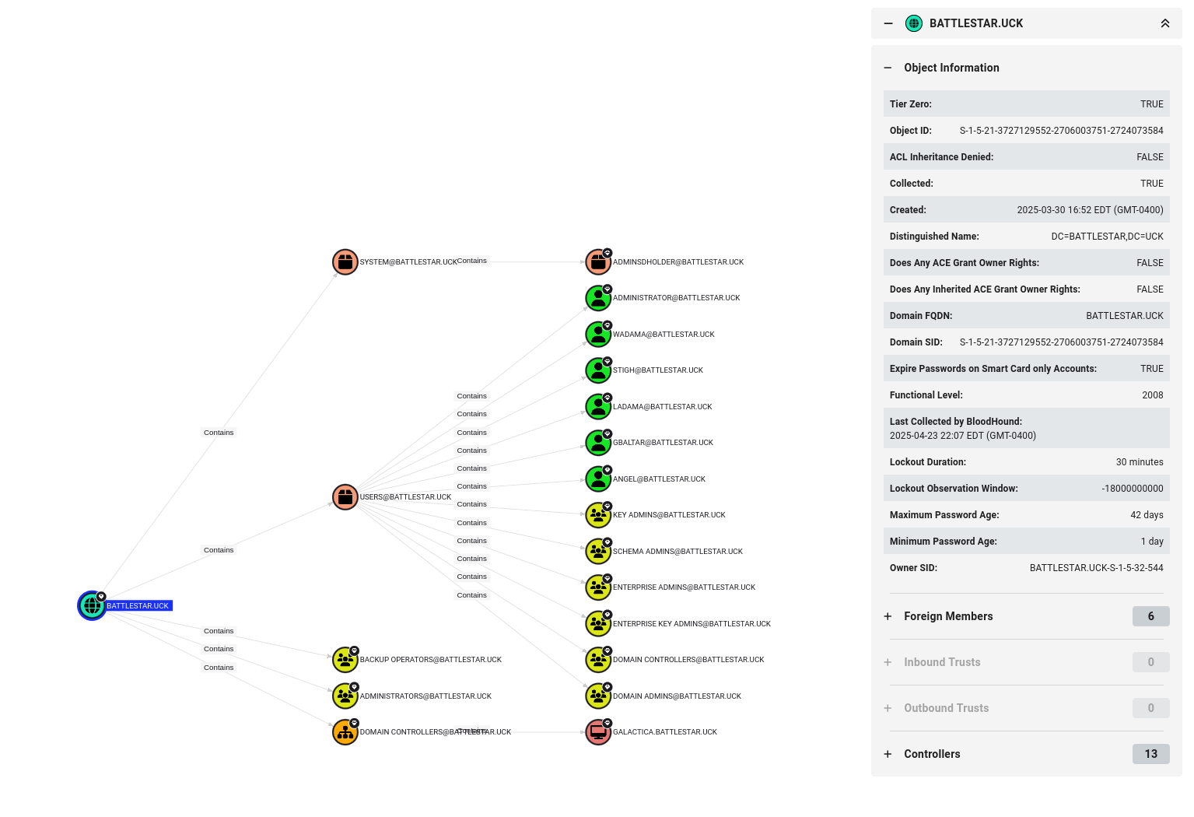

8.0 Conclusion
The assessment conducted by One Piece identified several critical vulnerabilities within the client's network that allowed for successful compromise and lateral movement. Initial access was gained through weak user passwords, some of which were susceptible to basic dictionary attacks and credential stuffing techniques. Multiple accounts were identified as kerberoastable, providing opportunities to extract service tickets and crack associated hashes offline—granting escalated access with minimal noise.
Post-exploitation, One Piece successfully leveraged administrative privileges and psexec to gain interactive system-level sessions on various machines. This enabled comprehensive exploration of sensitive directories, exfiltration of flagged files, and validation of lateral movement paths across the domain. Throughout the engagement, privilege escalation paths and lack of segmentation were consistently exploited to demonstrate real-world attack potential.
The primary objective of this engagement was to uncover every feasible weakness across authentication, access control, and host configuration. One Piece’s methodology highlighted both technical and procedural gaps, reinforcing the importance of hardening identity infrastructure, enforcing least-privilege principles, and monitoring high-value credential usage. The findings presented in this report should serve as a foundation for remediation efforts and the strengthening of overall network security posture.

9.0 Recommendations (After Exploitation)
Based on the vulnerabilities discovered during the assessment, One Piece recommends the following actions to enhance the organization’s security posture:
- Implement Strong Password Policies
Enforce complexity requirements and regular password changes. Integrate password blacklists to prevent the use of commonly cracked credentials and implement account lockout thresholds to deter brute-force attacks.
- Mitigate Kerberoasting Risks
Service accounts should use long, complex passwords and avoid unnecessary use of Service Principal Names (SPNs). Monitor for abnormal Kerberos ticket requests and consider using managed service accounts where feasible.
- Restrict Lateral Movement Techniques
Limit administrative privileges and remove local administrator rights where unnecessary. Use tools like LAPS (Local Administrator Password Solution) to randomize local passwords and reduce the effectiveness of tools like psexec.
- Network Segmentation and Access Controls
Isolate critical systems, apply firewall rules between network segments, and enforce strict ACLs. Prevent high-privilege accounts from authenticating across low-trust systems.
- Audit and Monitor Administrative Activity
Enable logging for all remote execution tools (e.g., psexec, PowerShell Remoting) and regularly audit event logs for suspicious activity. Implement centralized logging and alerting to capture anomalies in real time.
- Patch Management and Vulnerability Scanning
Regularly scan the environment for known vulnerabilities (e.g., MS17-010, BlueKeep) and apply patches in a timely manner. Disable unused legacy services like SMBv1 and the QOTD protocol to reduce attack surface.
- Secure DNS Infrastructure
Review DNS configurations to prevent information leakage. Limit zone transfers, monitor for unauthorized modifications to MX, NS, SRV, and A records, and secure DNS services with access controls.
- User Awareness and Security Training
Provide continuous cybersecurity education to users, focusing on phishing awareness, password hygiene, and secure practices in remote access.

