QDS SENTINEL
QUANTUM DIGITAL SIGNATURE SIMULATION
AND THREAT DETECTION SYSTEM
Integrated OOPS and DBMS project report
Submitted by
[STUDENT 1 NAME] – [ROLL NUMBER]
[STUDENT 2 NAME] – [ROLL NUMBER]
[STUDENT 3 NAME] – [ROLL NUMBER]
of
BACHELOR OF ENGINEERING
in
[DEPARTMENT NAME]
[COLLEGE NAME]
(An Autonomous Institution)
November 2026
[COLLEGE NAME]
BONAFIDE CERTIFICATE
Certified that this project report titled “QDS SENTINEL – QUANTUM DIGITAL SIGNATURE SIMULATION AND THREAT DETECTION SYSTEM” is the bonafide work of “[STUDENT 1 NAME] ([ROLL NUMBER]), [STUDENT 2 NAME] ([ROLL NUMBER]), [STUDENT 3 NAME] ([ROLL NUMBER])” who carried out the project work under my supervision.
SIGNATURE
[Internal Faculty Name]
Course In-charge
Object oriented programming
[Department name]
SIGNATURE
[Internal Faculty Name]
Course In-charge
Database management system
[Department name]
Submitted for the practical examination held on ____________________
INTERNAL EXAMINER EXTERNAL EXAMINER
ABSTRACT
Digital signatures protect the integrity and origin of electronic messages, but the classical schemes behind them rely on mathematical problems that a large quantum computer is expected to solve. Quantum digital signatures (QDS) replace that assumption with a physical one: a forger cannot copy an unknown quantum state without disturbing it. Studying such a protocol normally needs specialised hardware, and even with the hardware an operator needs a way to see how a forgery, a replay or a tampered channel actually shows up in the data.
QDS Sentinel is a software system that simulates a teleportation-based quantum digital signature and judges every session it produces. Layer 1 simulates the protocol exactly: complex statevectors, Bell pairs, a three-qubit teleportation circuit, Pauli feedforward and Born-rule measurement. Layer 2 examines the resulting telemetry with deterministic checks (SHA-256 digest, replay ledger, correction consistency, identity) and statistical ones (error rate, fidelity, Bob and Charlie thresholds backed by Hoeffding bounds) and returns an ACCEPT or REJECT decision with the evidence beside it. Layer 3 is a React console that shows the circuit trace, the Bloch sphere, the threat feed and an operations dashboard.
The backend is written in Java 17 using only the JDK: its HTTP server, SHA-256, AES-GCM encryption and JDBC access come from the standard modules. Sessions, per-position telemetry and threat events are stored in a MySQL database through JDBC, with a file-based store as a fallback when no database is configured, and an optional hash-chained, encrypted audit log proves afterwards that nothing was altered. A dependency-free self-test of 65 checks covers the quantum core, the detectors, the attacks and the audit chain.
TABLE OF CONTENTS
1. INTRODUCTION 5
PROBLEM STATEMENT 5
PROJECT OVERVIEW 5
PURPOSE 5
SCOPE 5
TECHNOLOGIES USED 6
2. FUNCTIONALITIES PROVIDED 7
FUNCTIONALITIES PROVIDED BY QDS SENTINEL 7
3. SYSTEM FLOW DIAGRAM 8
SYSTEM ARCHITECTURE 8
DATAFLOW DIAGRAM 8
USE CASE DIAGRAM 9
ENTITY RELATIONSHIP DIAGRAM 10
TELEPORTATION CIRCUIT 11
HOW A VERDICT IS REACHED 12
4. MODULE DESCRIPTION 13
API ENDPOINTS 14
5. DATABASE DESIGN 15
TABLES 15
HOW THE APPLICATION USES THE DATABASE 16
CONFIGURATION 16
6. IMPLEMENTATION 17
KEY MATERIAL FOR EACH POSITION 17
TELEPORTATION 17
BORN-RULE MEASUREMENT 18
REPLAY LEDGER 18
THE DECISION 18
MYSQL STORE (JDBC) 18
HTTP ROUTING 19
TAMPER-EVIDENT AUDIT LOG 19
API EXAMPLE 20
OUTPUT SCREENS 20
7. TESTING 24
FUNCTIONAL TEST CASES 24
8. CONCLUSION 26
LIMITATIONS 26
FUTURE ENHANCEMENT 26
9. REFERENCES 27

1. INTRODUCTION

PROBLEM STATEMENT
Classical digital signatures depend on problems such as integer factoring and discrete logarithms, which a sufficiently large quantum computer can solve. Quantum digital signatures offer security that rests on physics instead, but they are hard to study: the hardware is rare, and a signature on its own says nothing about how an attack would appear to the verifier. A tool is needed that models the protocol faithfully, injects the known attacks on demand, and explains in plain terms why a signature was accepted or rejected.

PROJECT OVERVIEW
QDS Sentinel simulates teleportation-based quantum digital signatures end to end and detects forgery, replay, impersonation and quantum-channel tampering. It has three layers:
- Layer 1, protocol simulation. Exact statevector simulation of Bell pairs, three-qubit teleportation, Pauli corrections and Born-rule measurement. It produces telemetry and makes no security decisions.
- Layer 2, threat detection. Threshold analysis, a replay ledger, attack classification and Bob/Charlie arbitration. Deterministic checks decide; statistical ones only advise.
- Layer 3, console. A React dashboard with a circuit trace, Bloch sphere, threat feed, security metrics, a partial-forgery experiment, stored logs and an operations view.

The backend is a Java application that exposes a JSON API; the React console talks to it through the unchanged API contract. Every result is a software simulation: no quantum hardware is involved.

PURPOSE
- To model the QDS protocol exactly enough that its security-relevant behaviour (zero errors when honest, disturbance when attacked) can be observed.
- To separate what can be proved (digest mismatch, replay, correction tampering) from what can only be suggested statistically (error rates, fidelity).
- To keep a durable record of every assessed session, its per-position telemetry and each finding, in a relational database.
- To provide a tamper-evident audit trail so that stored results can be shown to be unaltered.
- To demonstrate object-oriented design in Java and relational design in MySQL on a realistic problem.

SCOPE
The system covers the full simulate-attack-assess-store-display loop for eight attack types, three Bell-state families of examples, configurable thresholds and two verification modes (direct and forwarded). It does not claim composable security: it approximates the published protocol rather than reproducing its proof, uses a classical digest for message binding, and keeps its replay ledger in memory.

TECHNOLOGIES USED
Table 1: Technology stack
Area | Technology | Used for
Language | Java 17 (JDK only) | All backend logic
HTTP | jdk.httpserver (com.sun.net.httpserver) | JSON API on port 8000
Hashing / crypto | java.security.MessageDigest, javax.crypto (AES-GCM) | SHA-256 digests, audit chain, field encryption
Database | MySQL 8 with Connector/J through java.sql (JDBC) | Sessions, telemetry logs, threat events
Fallback store | JSON-lines file (java.nio.file) | Used when no MySQL is configured
Frontend | React 18, Vite, GSAP, plotly, recharts | Console and landing page

2. FUNCTIONALITIES PROVIDED

FUNCTIONALITIES PROVIDED BY QDS SENTINEL
- Simulates a complete signature session of 1 to 4096 positions for any of four Bell states and any subset of the X, Y and Z bases.
- Reproduces a session exactly from a seed, so results can be repeated and compared.
- Injects eight attacks: replay, full forgery, partial forgery, correction tampering, intercept and resend, channel manipulation, fidelity degradation and Bob repudiation.
- Assesses every session with deterministic, statistical and advisory detectors and states the verdict with its evidence.
- Validates the threshold chain e_honest < s_a < s_v < p_E before judging any packet.
- Checks identity and verifier authorisation against expected sender, recipient and verifier.
- Stores sessions, per-position telemetry and findings in MySQL, and serves them back to the dashboard.
- Mirrors every session into an optional encrypted, hash-chained audit file and verifies the chain on request.
- Shows the circuit trace, Bloch-sphere collapse, threat feed and security metrics for the latest assessment.
- Runs a partial-forgery sweep and exports the results as CSV or JSON.
- Presents an operations view in plain language for non-specialists.

3. SYSTEM FLOW DIAGRAM
System flow diagrams show how information and processes move through the system. The figures below describe QDS Sentinel from the outside in: the architecture, the data flow, the actors and their use cases, and the database.

SYSTEM ARCHITECTURE
The browser runs the React console. During development the Vite server proxies /api and /health to the Java server on port 8000. The server validates each request, runs the protocol simulation (Layer 1) and the threat engine (Layer 2), writes the result to the primary store, optionally mirrors it to the audit file, and returns JSON.
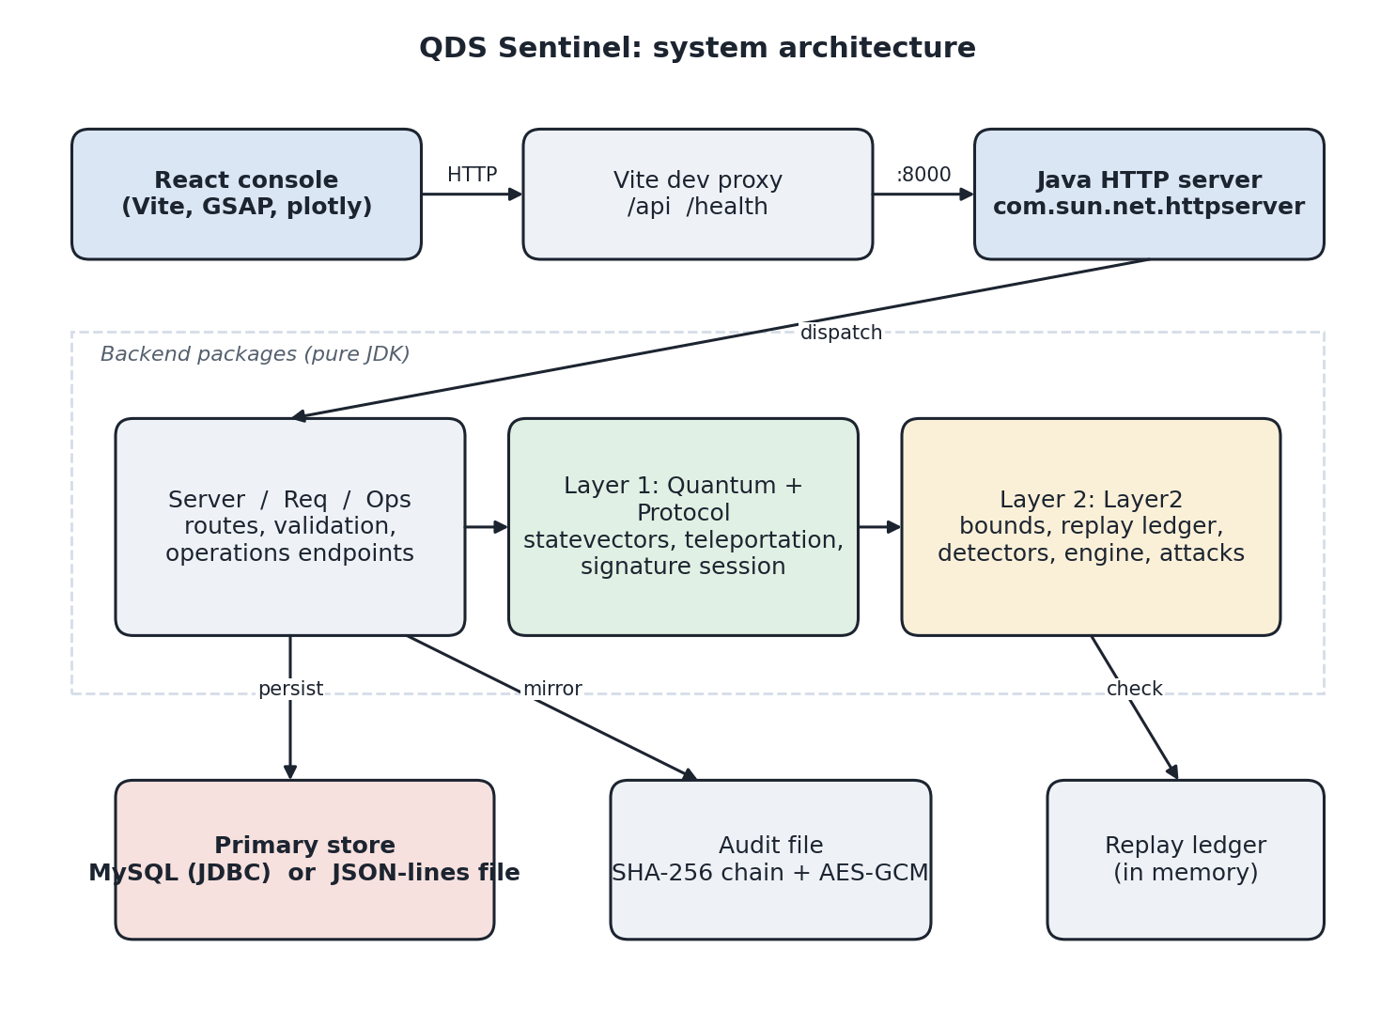
Figure 1: System architecture

DATAFLOW DIAGRAM
A data flow diagram (DFD) shows how data moves through a system. In the level-1 diagram below, the analyst's request is validated (1.0), simulated (2.0), optionally attacked (3.0) and assessed (4.0). The assessment is persisted and audited (5.0) and presented in the console (6.0). The replay ledger (D4) is consulted during assessment, and the three tables (D1 to D3) and the audit file (D5) are written by the persist step.
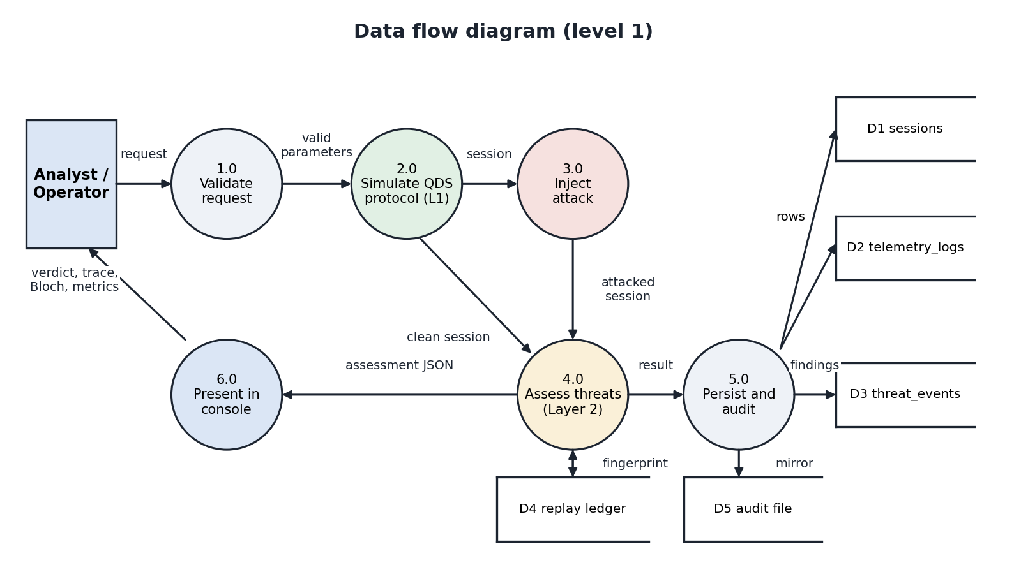
Figure 2: Data flow diagram, level 1

USE CASE DIAGRAM
A use case diagram depicts the interactions between actors and the system. QDS Sentinel has two actors.

Actor: Security analyst
- Compose and run assessment: sets message, parties, signature length, Bell state, bases, seed, attack type and thresholds, then runs the assessment.
- Run example: one click runs the clean, replay or forgery example.
- Simulate attack: injects one of the eight attacks with a chosen intensity.
- Inspect circuit trace and Bloch sphere: follows each position through preparation, teleportation and measurement.
- Read threat feed and security metrics: reads findings, evidence, thresholds and detector results.
- Run partial-forgery sweep: measures mismatch rate against attack intensity and exports it.
- Browse stored sessions and telemetry: reads back what the database holds.

Actor: Operations viewer
- Read operations dashboard: threat status, where the attacks landed along the protocol, recent events in plain language and trends.
- Browse stored sessions and telemetry: the same stored data in a simpler view.

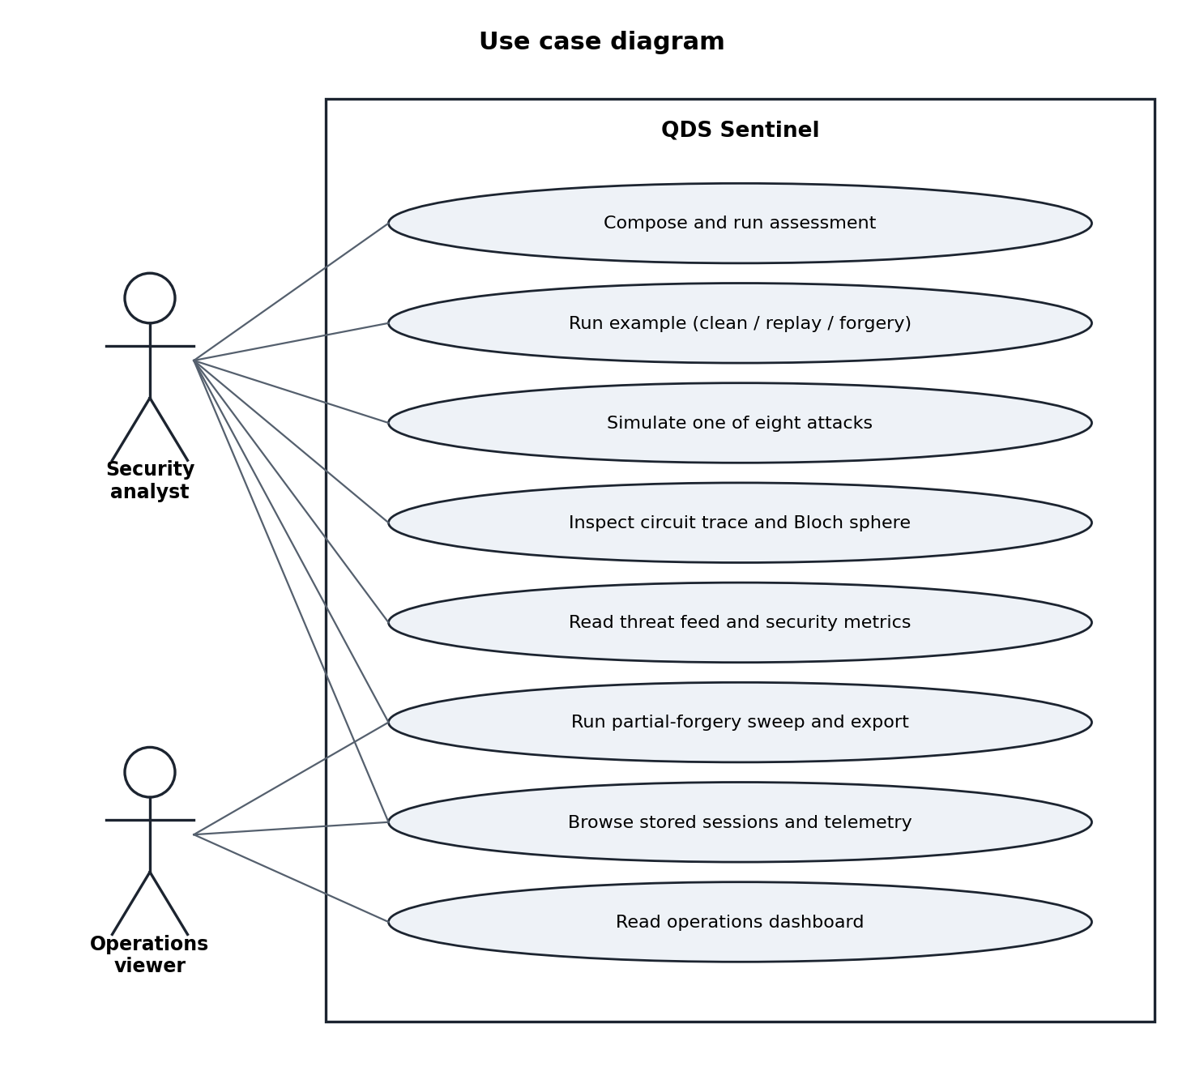
Figure 3: Use case diagram

ENTITY RELATIONSHIP DIAGRAM
An entity relationship diagram (ERD) shows the entities of a database and how they relate. QDS Sentinel stores one row per assessed session in sessions. Each session owns many rows in telemetry_logs (one per signature position) and many rows in threat_events (one per finding). Both child tables carry a foreign key to sessions.id with cascading delete.
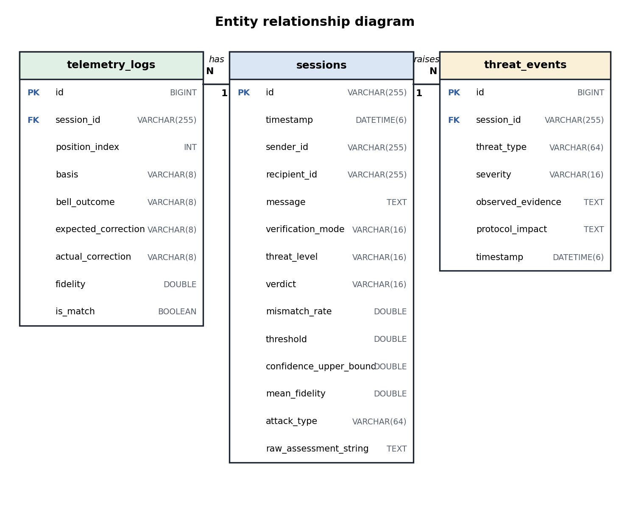
Figure 4: Entity relationship diagram

TELEPORTATION CIRCUIT
Every signature position is one run of the circuit below. The input qubit q0 carries the prepared eigenstate. Qubits q1 and q2 start as a Bell pair. A CNOT from q0 to q1 followed by a Hadamard on q0 turns the Bell measurement into a computational-basis measurement of q0 and q1. The two result bits select the Pauli correction applied to q2, which then holds the input state.
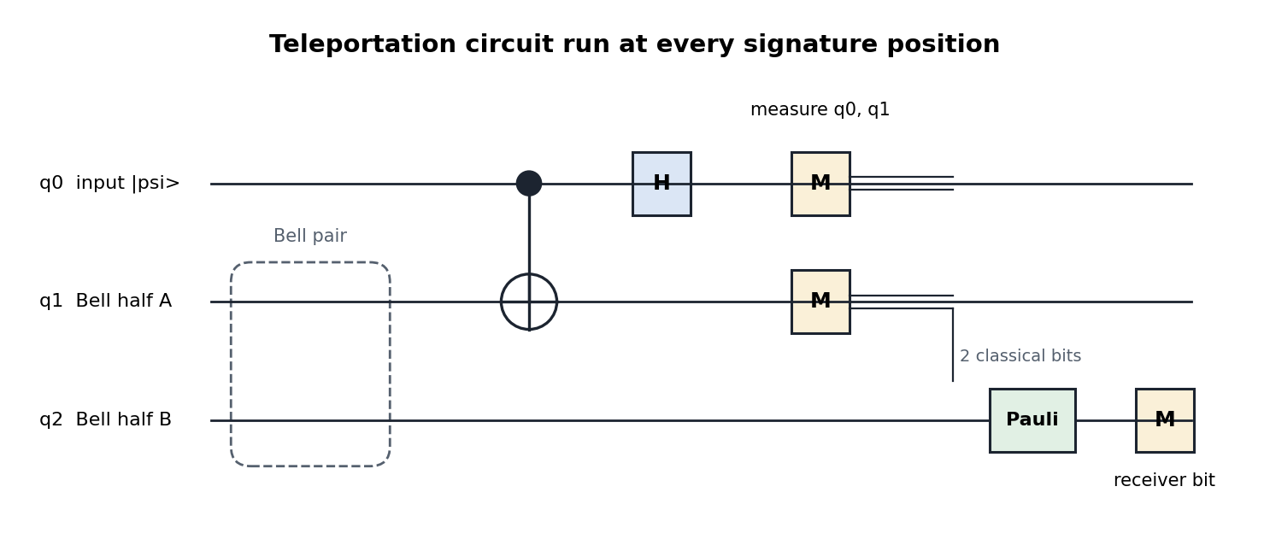
Figure 5: Teleportation circuit used at each signature position

HOW A VERDICT IS REACHED
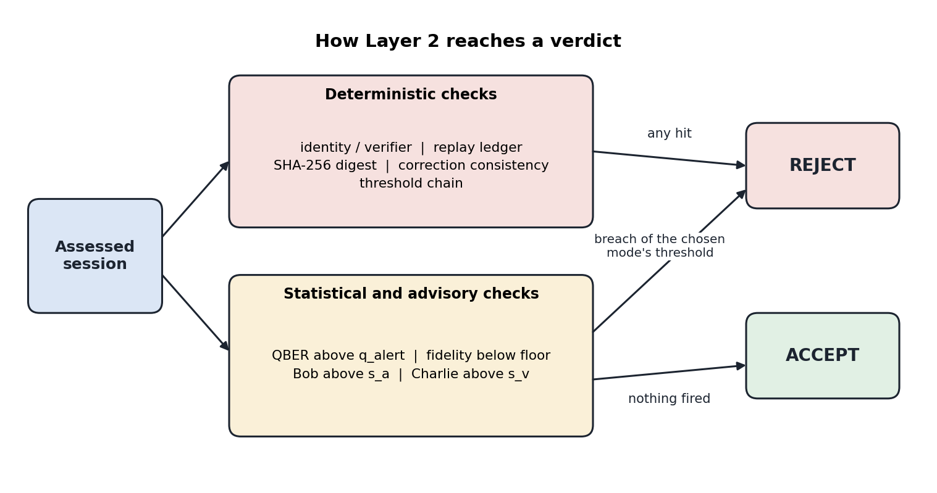
Figure 6: Verdict logic of Layer 2

4. MODULE DESCRIPTION
The backend is a small set of Java classes in the package qds. The modules and their roles are:

QUANTUM CORE (Quantum.java):
Holds exact complex statevectors as pairs of double[] arrays and normalises-checks every state. It provides the X, Y, Z, H and I gates, CNOT, the six Pauli eigenstates, the four Bell states, the Pauli-correction table for each Bell state, Born-rule measurement in any Pauli basis, the three noise models (NoNoise, DepolarizingNoise, PauliFlipNoise) and Bloch-sphere coordinates.

PROTOCOL SESSION (Protocol.java):
Generates the key material for each position from a SHA-256 binding of the message, session id, nonce, sequence number, position and a seeded random integer. It prepares each state, runs the teleportation, measures the result, and emits a position record, a teleportation event and a measurement event. It also holds the shared data model (positions, events, summary, session) and its JSON mapping.

THREAT DETECTION ENGINE (Layer2.java):
Contains the Hoeffding bounds, the threshold-chain validator, the six detectors, the assessment engine and the honest-noise calibrator. The engine combines the detectors into a threat level, a category, a list of findings and a decision string.

REPLAY LEDGER:
An in-memory ledger that remembers fingerprints, block ids, nonces per sender/recipient pair and the highest sequence number per sender and session. A packet is a replay if any of them has been seen. The ledger evicts the oldest entry when it reaches its size limit.

ATTACK INJECTOR:
Copies a clean session and applies one of the eight attacks to the copy, then recomputes the summary and attaches ground-truth metadata that the detectors never read.

PRIMARY STORE (Store.java, JdbcStore.java):
JdbcStore writes and reads sessions, telemetry logs and threat events in MySQL through JDBC. Store is the base class and also the fallback: it keeps the same data in memory and appends it to a JSON-lines file. The server picks JdbcStore when MYSQL_URL is set.

AUDIT LOG (Store.Audit):
An append-only file in which every record holds the SHA-256 of its own content chained to the previous record's hash. Sensitive fields (message, sender, recipient, decision text) are encrypted with AES-GCM. verifyChain walks the file and reports the first broken record.

HTTP API (Server.java, Req.java, Ops.java, Json.java, Fmt.java):
Server owns the routes and the CORS headers. Req gives typed, validated access to request bodies and turns mistakes into readable 422 errors. Ops builds the operations-mode responses from the store. Json is a small JSON reader and writer, since the JDK has none. Fmt holds timestamp, number-format and hashing helpers.

CONSOLE (frontend/):
A React 18 application with a landing page and a dashboard of seven simulation tabs plus an operations mode. It is unchanged by the move to Java: it calls the same URLs and reads the same JSON.

SELF TEST (SelfTest.java):
A dependency-free test run of 65 checks that exits non-zero on failure.

API ENDPOINTS
Table 2: API endpoints
Method | Path | Purpose
GET | /health | Service status
POST | /api/v1/layer1/simulate | Run a full protocol session
GET | /api/v1/layer1/example-session | Deterministic 8-position session
GET | /api/v1/layer1/bloch-state/{basis}/{bit} | Bloch coordinates of an eigenstate
POST | /api/v1/layer1/bloch-trace | Bloch coordinates for every position
POST | /api/v1/layer2/assess | Simulate and assess
POST | /api/v1/layer2/assess-existing | Assess a supplied session
POST | /api/v1/layer2/attack-simulate | Inject an attack, then assess
GET | /api/v1/layer2/example-clean | -replay | -forgery | Ready-made examples
GET | /api/ops/overview | threat-feed | trends | Operations summaries
GET | /api/ops/sessions | logs | logs/{id} | Stored sessions and telemetry
GET | /api/ops/audit/verify | Audit chain verification

5. DATABASE DESIGN
QDS Sentinel uses MySQL 8 as its primary database. The application connects through JDBC (java.sql) with the MySQL Connector/J driver, creates its tables on first start and keeps a single connection that it reopens if the server closes it. Timestamps are stored in UTC as DATETIME(6).

TABLES
Table 3: Table sessions
Column | Type | Notes
id | VARCHAR(255) | Primary key, the session id
timestamp | DATETIME(6) | When the assessment was stored (UTC)
sender_id, recipient_id | VARCHAR(255) | Parties of the signature
message | TEXT | The signed message
verification_mode | VARCHAR(16) | direct or forwarded
threat_level | VARCHAR(16) | clean, advisory, suspicious or critical
verdict | VARCHAR(16) | ACCEPT or REJECT
mismatch_rate, threshold, confidence_upper_bound, mean_fidelity | DOUBLE | Numbers behind the verdict
attack_type | VARCHAR(64) | Injected attack, or NULL
raw_assessment_string | TEXT | Full decision text

Table 4: Table telemetry_logs
Column | Type | Notes
id | BIGINT AUTO_INCREMENT | Primary key
session_id | VARCHAR(255) | Foreign key to sessions.id, ON DELETE CASCADE
position_index | INT | Signature position
basis, bell_outcome | VARCHAR(8) | Pauli basis and Bell measurement bits
expected_correction, actual_correction | VARCHAR(8) | Pauli corrections that should and did apply
fidelity | DOUBLE | Teleportation fidelity
is_match | BOOLEAN | Whether the received bit matched the encoded bit

Table 5: Table threat_events
Column | Type | Notes
id | BIGINT AUTO_INCREMENT | Primary key
session_id | VARCHAR(255) | Foreign key to sessions.id, ON DELETE CASCADE
threat_type | VARCHAR(64) | For example REPLAY_ATTACK
severity | VARCHAR(16) | critical or suspicious
observed_evidence | TEXT | The finding as the engine wrote it
protocol_impact | TEXT | What the finding means for the protocol
timestamp | DATETIME(6) | When the finding was stored (UTC)

HOW THE APPLICATION USES THE DATABASE
- Write: after each assessment the server upserts the session row (INSERT ... ON DUPLICATE KEY UPDATE), batch-inserts one telemetry row per position, and inserts one threat event per finding.
- Read: the dashboard's Database Logs tab reads sessions and per-session telemetry; the operations view reads the latest session, counts events by severity and type over the last 24 hours and 7 days, and buckets sessions per hour.
- Failure handling: a wrong URL, login or missing driver stops the server at start-up with a clear message. A write that fails later is logged and never fails the request.

CONFIGURATION
Table 6: Runtime configuration
Variable | Effect
MYSQL_URL | JDBC URL, for example jdbc:mysql://localhost:3306/qds_sentinel?createDatabaseIfNotExist=true. When set, MySQL is the primary store
MYSQL_USER, MYSQL_PASSWORD | Login. The user defaults to root; the password is never written to disk by the application
QDS_DB_PATH | File store used when MYSQL_URL is unset (default qds_sentinel.jsonl.db); memory keeps it in RAM only
AUDIT_LOG_PATH, AUDIT_ENCRYPTION_KEY | Enable the audit file and its encryption
PORT | HTTP port (default 8000)

6. IMPLEMENTATION
This chapter shows the central pieces of the Java code, taken directly from the source, followed by the output of the running system.

KEY MATERIAL FOR EACH POSITION
The basis and the bit of every position come from a SHA-256 hash that binds the message, session, nonce, sequence number, position and a seeded random integer. The first four hash bytes choose the basis, the next four choose the bit.

JAVA CODE:
for (int pos = 0; pos < length; pos++) {
int random = rng.nextInt(1_000_000);
String binding = msgDigest + "_" + sessionId + "_" + nonce + "_" + sequence + "_" + pos + "_" + random;
byte[] h = Fmt.sha256(binding.getBytes(StandardCharsets.UTF_8));
long basisWord = ((h[0] & 0xffL) << 24) | ((h[1] & 0xffL) << 16) | ((h[2] & 0xffL) << 8) | (h[3] & 0xffL);
long bitWord = ((h[4] & 0xffL) << 24) | ((h[5] & 0xffL) << 16) | ((h[6] & 0xffL) << 8) | (h[7] & 0xffL);
out.add(new Element(pos, bases.get((int) (basisWord % bases.size())), (int) (bitWord % 2)));
}

TELEPORTATION
Quantum.teleport builds the three-qubit state, applies the CNOT and the Hadamard, measures q0 and q1, applies the Pauli correction chosen by the measurement bits and reports the fidelity with the original state.

JAVA CODE:
double[][] v = applyCnot(re, im, 0, 1, 3);
trace.add("Applied CNOT gate with control q0 and target q1");
v = applySingle(v[0], v[1], GATE_H, 0, 3);
trace.add("Applied Hadamard gate on qubit q0");

TwoQubitMeasurement mm = measureTwo(v[0], v[1], 0, 1, 3, rng);
trace.add("Measured qubits (q0, q1) in computational basis, outcome bits: '" + mm.bits + "'");

State raw = new State("q2_collapsed_" + mm.bits, mm.collapsedRe, mm.collapsedIm, 1);
State noisy = noise.apply(raw, rng);

String expected = expectedCorrection(mm.bits, bellLabel);
State corrected = applyCorrection(noisy, expected);
trace.add("Applied Pauli correction '" + expected + "' to receiver qubit q2");

double f = fidelity(input, corrected);

BORN-RULE MEASUREMENT

JAVA CODE:
State s0 = eigenstate(b, 0), s1 = eigenstate(b, 1);
double[] i0 = vdot(s0.re, s0.im, s.re, s.im), i1 = vdot(s1.re, s1.im, s.re, s.im);
double p0 = i0[0] * i0[0] + i0[1] * i0[1];
double p1 = i1[0] * i1[0] + i1[1] * i1[1];
double total = p0 + p1;
if (total > 0.0) { p0 /= total; p1 /= total; }

Measurement m = new Measurement();
m.basis = b;
m.p0 = p0;
m.p1 = p1;
if (rng.nextDouble() < p0) { m.outcomeBit = 0; m.post = s0; } else { m.outcomeBit = 1; m.post = s1; }
m.deterministic = p0 >= 0.999999 || p1 >= 0.999999;

REPLAY LEDGER
A packet is a replay if its fingerprint, block id, nonce (for the same sender and recipient) or a non-increasing sequence number has been seen.

JAVA CODE:
if (store.containsKey(fp)) return new Object[]{true, fp};
if (seenBlocks.contains(blockId)) return new Object[]{true, fp};
if (pairNonces.containsKey(pair) && pairNonces.get(pair).contains(nonce)) return new Object[]{true, fp};
if (latestSeq.containsKey(sessKey) && seq <= latestSeq.get(sessKey)) return new Object[]{true, fp};

THE DECISION
The engine rejects when any deterministic check fired or when the half used by the chosen verification mode exceeds its threshold. The decision text carries the mode, threshold, mismatch rate and Hoeffding confidence upper bound.

JAVA CODE:
boolean hardReject = !authorized || !digestOk || isReplay || correctionFlag || !chainValid;
String decision;
String head = "verification_mode=" + mode + ", threshold=" + thresholdLabel + "=" + Fmt.pyFloat(threshold)
+ ", mismatch_rate=" + Fmt.fixed(rate, 4) + ", confidence_upper_bound=" + Fmt.fixed(upper, 4);
if (hardReject || breach) {
List<String> reasons = new ArrayList<>();
for (String f : findings) reasons.add(f.split(" \\[", 2)[0]);
if (reasons.isEmpty() && !chainValid) reasons.add("CONFIGURATION_WARNING");
decision = "REJECT " + D + " " + head + "; reason(s): " + String.join(", ", reasons);
} else {
decision = "ACCEPT " + D + " " + head;
}

MYSQL STORE (JDBC)
JdbcStore uses prepared statements throughout and reconnects if MySQL has dropped an idle connection.

JAVA CODE:
private Connection connection() throws SQLException {
if (conn == null || !conn.isValid(2)) conn = DriverManager.getConnection(url, user, password);
return conn;
}

synchronized void upsertSession(SessionRow r) {
String sql = "INSERT INTO sessions (id, `timestamp`, sender_id, recipient_id, message, verification_mode, "
+ "threat_level, verdict, mismatch_rate, threshold, confidence_upper_bound, mean_fidelity, "
+ "attack_type, raw_assessment_string) VALUES (?,?,?,?,?,?,?,?,?,?,?,?,?,?) "
+ "ON DUPLICATE KEY UPDATE `timestamp`=VALUES(`timestamp`), sender_id=VALUES(sender_id), "
+ "recipient_id=VALUES(recipient_id), message=VALUES(message), "
+ "verification_mode=VALUES(verification_mode), threat_level=VALUES(threat_level), "
+ "verdict=VALUES(verdict), mismatch_rate=VALUES(mismatch_rate), threshold=VALUES(threshold), "
+ "confidence_upper_bound=VALUES(confidence_upper_bound), mean_fidelity=VALUES(mean_fidelity), "
+ "attack_type=VALUES(attack_type), raw_assessment_string=VALUES(raw_assessment_string)";
try (PreparedStatement ps = connection().prepareStatement(sql)) {
ps.setString(1, r.id);
ps.setObject(2, utc(r.timestamp));
ps.setString(3, r.senderId);
...

HTTP ROUTING

JAVA CODE:
if (path.equals("/health")) return only(method, "GET", () -> ok(health()));

if (path.startsWith("/api/v1/layer1/")) {
String tail = path.substring("/api/v1/layer1/".length());
if (tail.equals("simulate")) return only(method, "POST", () -> ok(simulate(body(ex))));
if (tail.equals("example-session")) return only(method, "GET", () -> ok(exampleSession()));
if (tail.equals("bloch-trace")) return only(method, "POST", () -> ok(blochTrace(body(ex))));
if (seg.length == 7 && seg[4].equals("bloch-state")) {
return only(method, "GET", () -> ok(blochState(seg[5], intParam("path.bit", seg[6]))));
}
} else if (path.startsWith("/api/v1/layer2/")) {

TAMPER-EVIDENT AUDIT LOG
Each record stores the hash of its own content chained to the previous record. Editing or deleting any record breaks every hash after it.

JAVA CODE:
synchronized String append(String kind, String sessionId, Map<String, Object> body) {
if (!enabled()) return null;
Map<String, Object> stored = new LinkedHashMap<>(body);
List<Object> encrypted = new ArrayList<>();
for (String f : ENCRYPTED_FIELDS) {
if (stored.get(f) != null) {
stored.put(f, encrypt(String.valueOf(stored.get(f))));
encrypted.add(f);
}
}
Map<String, Object> core = Json.obj("seq", nextSeq, "kind", kind, "session_id", sessionId, "body", stored);
String hash = chainHash(core, lastHash);
Map<String, Object> rec = new LinkedHashMap<>(core);
rec.put("recorded_at", Fmt.isoNow());
rec.put("encrypted_fields", key == null ? new ArrayList<>() : encrypted);
rec.put("prev_hash", lastHash);
rec.put("hash", hash);
try {
Files.write(path, (Json.write(rec) + "\n").getBytes(StandardCharsets.UTF_8),
StandardOpenOption.CREATE, StandardOpenOption.APPEND);
} catch (IOException e) {
throw new IllegalStateException(e);
}
lastHash = hash;
nextSeq++;
return hash;
}

API EXAMPLE
A partial-forgery attack of intensity 0.25 on a 16-position session with seed 42 (a request sent to POST /api/v1/layer2/attack-simulate):
{
"simulation": { "message": "PAYLOAD", "signature_length": 16, "seed": 42,
"session_id": "f1", "nonce": "n1" },
"attack_type": "PARTIAL_FORGERY",
"intensity": 0.25
}

The decision text from the response, and the findings that explain it:
REJECT — verification_mode=direct, threshold=s_a=0.1, mismatch_rate=0.1250,
confidence_upper_bound=0.5577;
reason(s): QBER_ANOMALY, BOB_THRESHOLD_BREACH, CHARLIE_THRESHOLD_BREACH

QBER_ANOMALY [SUSPICIOUS] — observed mismatch rate 0.2500 exceeds q_alert threshold 0.1100.
BOB_THRESHOLD_BREACH [ADVISORY] — Bob (direct) mismatch rate 0.1250 > s_a=0.1.
CHARLIE_THRESHOLD_BREACH [ADVISORY] — Charlie (forwarded) mismatch rate 0.3750 > s_v=0.2.

OUTPUT SCREENS
The screens below are from the running console. They are produced by the same React application against the Java backend.

Figure 7: Landing page: the dot lattice bends toward the cursor
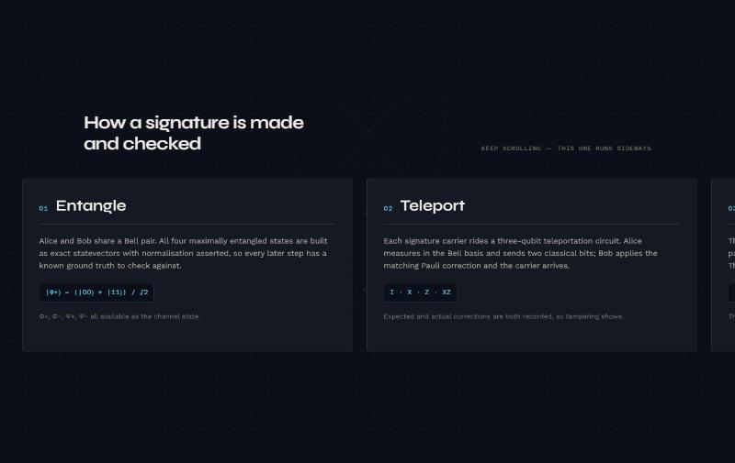
Figure 8: Landing page: the four protocol steps
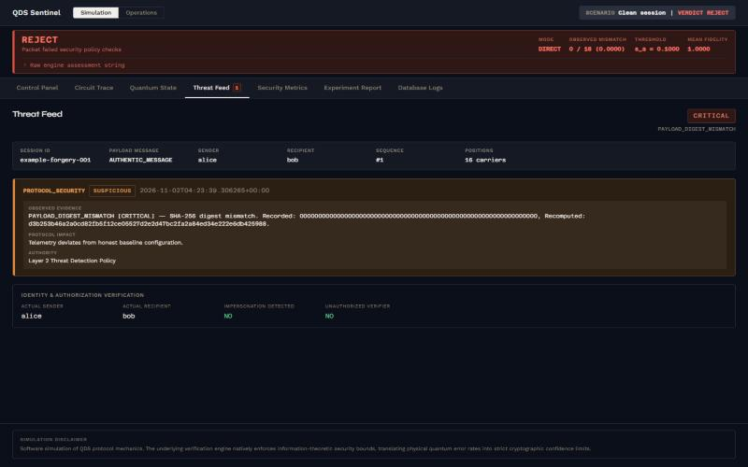
Figure 9: Threat Feed after a digest forgery: recorded and recomputed SHA-256 side by side
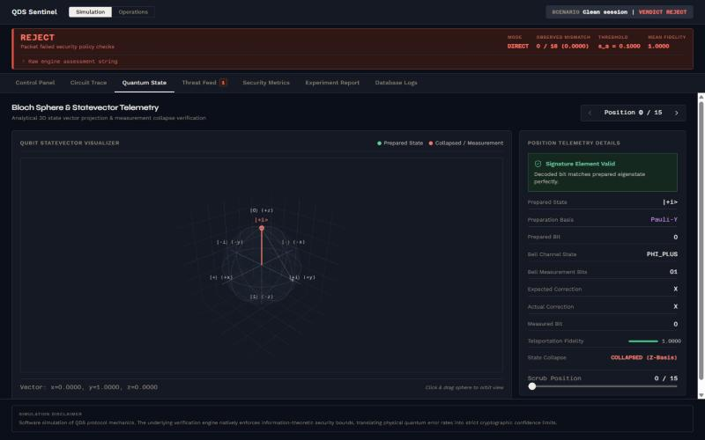
Figure 10: Quantum State: Bloch sphere with the prepared state and its measurement collapse
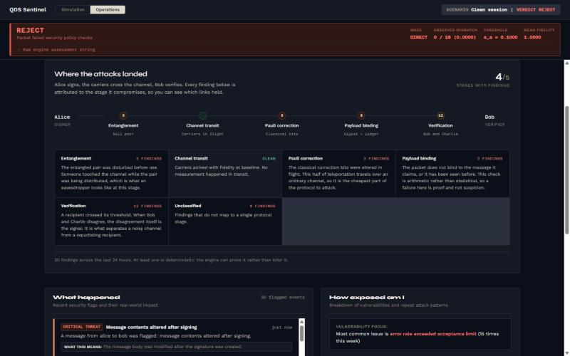
Figure 11: Operations mode: where the attacks landed along the protocol
[Add screenshot here] MySQL Workbench or the mysql client showing SELECT * FROM sessions; after running the backend with MYSQL_URL set.

7. TESTING
The backend ships with SelfTest, a dependency-free test run that needs no database server and exits non-zero if any check fails. It passed all 65 checks. The checks are grouped as follows.
Table 7: Self-test coverage
Area | What is checked
Quantum core | Eigenstate norms; Bloch coordinates; teleportation fidelity above 1 − 1e−9 for every Bell state × eigenstate over 40 seeds each; Born-rule measurement; Pauli corrections
Protocol | SHA-256 of “abc”; same seed reproduces a session; honest session has no mismatches; bases_allowed respected; JSON round trip
Bounds | Hoeffding upper bound and tail; clamping; threshold-chain validation
Replay ledger | Exact repeat, reused nonce, non-increasing sequence, eviction
Engine | Clean accept; replay; digest forgery; impersonation with unauthorised verifier; broken threshold chain; forwarded mode
Attacks | All eight attack types; original session left untouched; calibrator
Audit log | Chain intact; fields encrypted; an edit is detected at the right record; disabled sink is a no-op
JSON | Parse and write round trip; canonical key order; truncated input rejected

$ java -cp backend/out qds.SelfTest
65 passed, 0 failed

FUNCTIONAL TEST CASES
Table 8: Functional test cases
# | Input | Expected | Observed
1 | Clean example, seed 42, 16 positions | ACCEPT, 0 mismatches, fidelity 1 | ACCEPT, CLEAN, no findings
2 | Same session submitted twice | REJECT, replay | REJECT, REPLAY_ATTACK
3 | Digest replaced by zeros | REJECT, digest mismatch | REJECT, PAYLOAD_DIGEST_MISMATCH
4 | Partial forgery q = 0.25 | REJECT, suspicious | REJECT, SUSPICIOUS (QBER, Bob, Charlie)
5 | Correction tampering, q = 1.0 | REJECT, critical | CRITICAL, correction tampering raised
6 | Verifier Eve and expected sender Mallory for a packet from Alice to Bob | REJECT, critical | CRITICAL, COMBINED (impersonation and unauthorised verifier)
7 | s_a = 0.3, s_v = 0.2 | 422 error | 422, threshold ordering violated
8 | Empty message, length 9999 | 422 error | 422, field named in the message
9 | Restart with a file store | Stored sessions survive | Both sessions reloaded
10 | MYSQL_URL set, server unreachable | Clear start-up failure | Stops with a MySQL message, not a stack trace

Test case 10 confirms that the Connector/J driver loads and that a missing server is reported cleanly. A run against a live MySQL server, with the tables inspected afterwards, is the next step and is the screenshot placeholder in the implementation chapter.

8. CONCLUSION
QDS Sentinel shows a teleportation-based quantum digital signature end to end in ordinary software. The simulation is exact, so an honest session has zero mismatches and any departure from that baseline is meaningful. Layer 2 turns those departures into verdicts and is open about which ones it can prove (digest, replay, correction tampering) and which it can only suggest (error rate, fidelity). The Java backend uses only the JDK, stores its results in MySQL through JDBC, and leaves a tamper-evident audit trail.
The project applied object-oriented design (immutable states, a store hierarchy with a JDBC subclass, a typed request layer) and relational design (three normalised tables with foreign keys and cascades) to one problem, and it is verified by an automated self-test.

LIMITATIONS
- Every result is a software simulation of protocol mechanics. No quantum hardware is involved.
- The security of the real protocol is approximated, not proved. Message binding uses a classical digest.
- The replay ledger is in memory and does not survive a restart.
- The audit log is a file, not mirrored into MySQL.
- The random-number stream differs from the Python version the project started as, so a given seed gives a different but equally valid session.

FUTURE ENHANCEMENT
- Persist the replay ledger in MySQL so replay protection survives a restart.
- Mirror the audit chain into a database table and expose it in the console.
- Add a connection pool and a migration tool for the schema.
- Add noise-model selection to the console and compare detector behaviour under realistic channel noise.
- Add authentication to the API for multi-user deployment.

9. REFERENCES
- R. Amiri, P. Wallden, A. Kent and E. Andersson, “Secure quantum signatures using insecure quantum channels,” Physical Review A, vol. 93, 032325, 2016.
- D. Gottesman and I. Chuang, “Quantum digital signatures,” arXiv:quant-ph/0105032, 2001.
- C. H. Bennett, G. Brassard, C. Crépeau, R. Jozsa, A. Peres and W. K. Wootters, “Teleporting an unknown quantum state via dual classical and Einstein-Podolsky-Rosen channels,” Physical Review Letters, vol. 70, pp. 1895–1899, 1993.
- W. Hoeffding, “Probability inequalities for sums of bounded random variables,” Journal of the American Statistical Association, vol. 58, no. 301, pp. 13–30, 1963.
- R. J. Serfling, “Probability inequalities for the sum in sampling without replacement,” The Annals of Statistics, vol. 2, no. 1, pp. 39–48, 1974.
- M. A. Nielsen and I. L. Chuang, Quantum Computation and Quantum Information, Cambridge University Press, 2010.
- National Institute of Standards and Technology, FIPS PUB 180-4: Secure Hash Standard (SHS), 2015.
- Oracle, Java Platform, Standard Edition 17 API Specification (java.base, java.sql, jdk.httpserver).
- Oracle, MySQL 8.0 Reference Manual and MySQL Connector/J Developer Guide.
- Meta Platforms, React documentation; Vite documentation; GreenSock, GSAP documentation.

