# **Marketplace Technical Foundation – FurnitureMart.pk**

**Technical Requirements:**

#### **Frontend Requirements:**

#### **First, we need to focus on a Responsive and user-friendly UI for the Customers using Next.js, TypeScript, and Tailwind CSS with easy navigation and clear CTA.**

#### **Pages We Need:**

* + 1. **Home Page**: To Showcase categories and featured furniture.
    2. **Product Listing Page**: To Display furniture items with filters.
    3. **Product Details Page**: For Detailed information with customization options.
    4. **Seller/Showroom Page**: To Display all products from a specific seller or showroom.
    5. **Cart Page**: To View selected items and proceed to checkout.
    6. **Checkout Page**: To Collect order and payment details.
    7. **Order Confirmation Page**: To Display order details After payment.
    8. **Customer Dashboard Page**: This will allow users to view past orders, tracking information, and other details.
    9. **Order Tracking Page**: User Can use this Page to track their orders with Provided Tracking ID.

1. **Backend Requirements**

* Use **Sanity** for:
  + **Managing product data:** Name, price, stock, customization options, images, seller/showroom ID.
  + **Storing order details:** Customer information, product Details, Status, Order ID, Date/Time.
  + **Storing Customer Data:** Customer ID, Name, Contact Info, Address, Order history.
  + **Managing showroom/Seller data:** Seller ID, Name, Contact info, product listings.
  + **Storing and managing reviews for products:** Review ID, Customer ID, Product ID, Rating, Comment.
* **External APIs:**
  + **ShipEngine API** for shipment tracking.
  + **Stripe API** for secure payment processing.
  + ***In future we can add more payment methods, and AR Feature in this.***

#### **Design System Architecture**

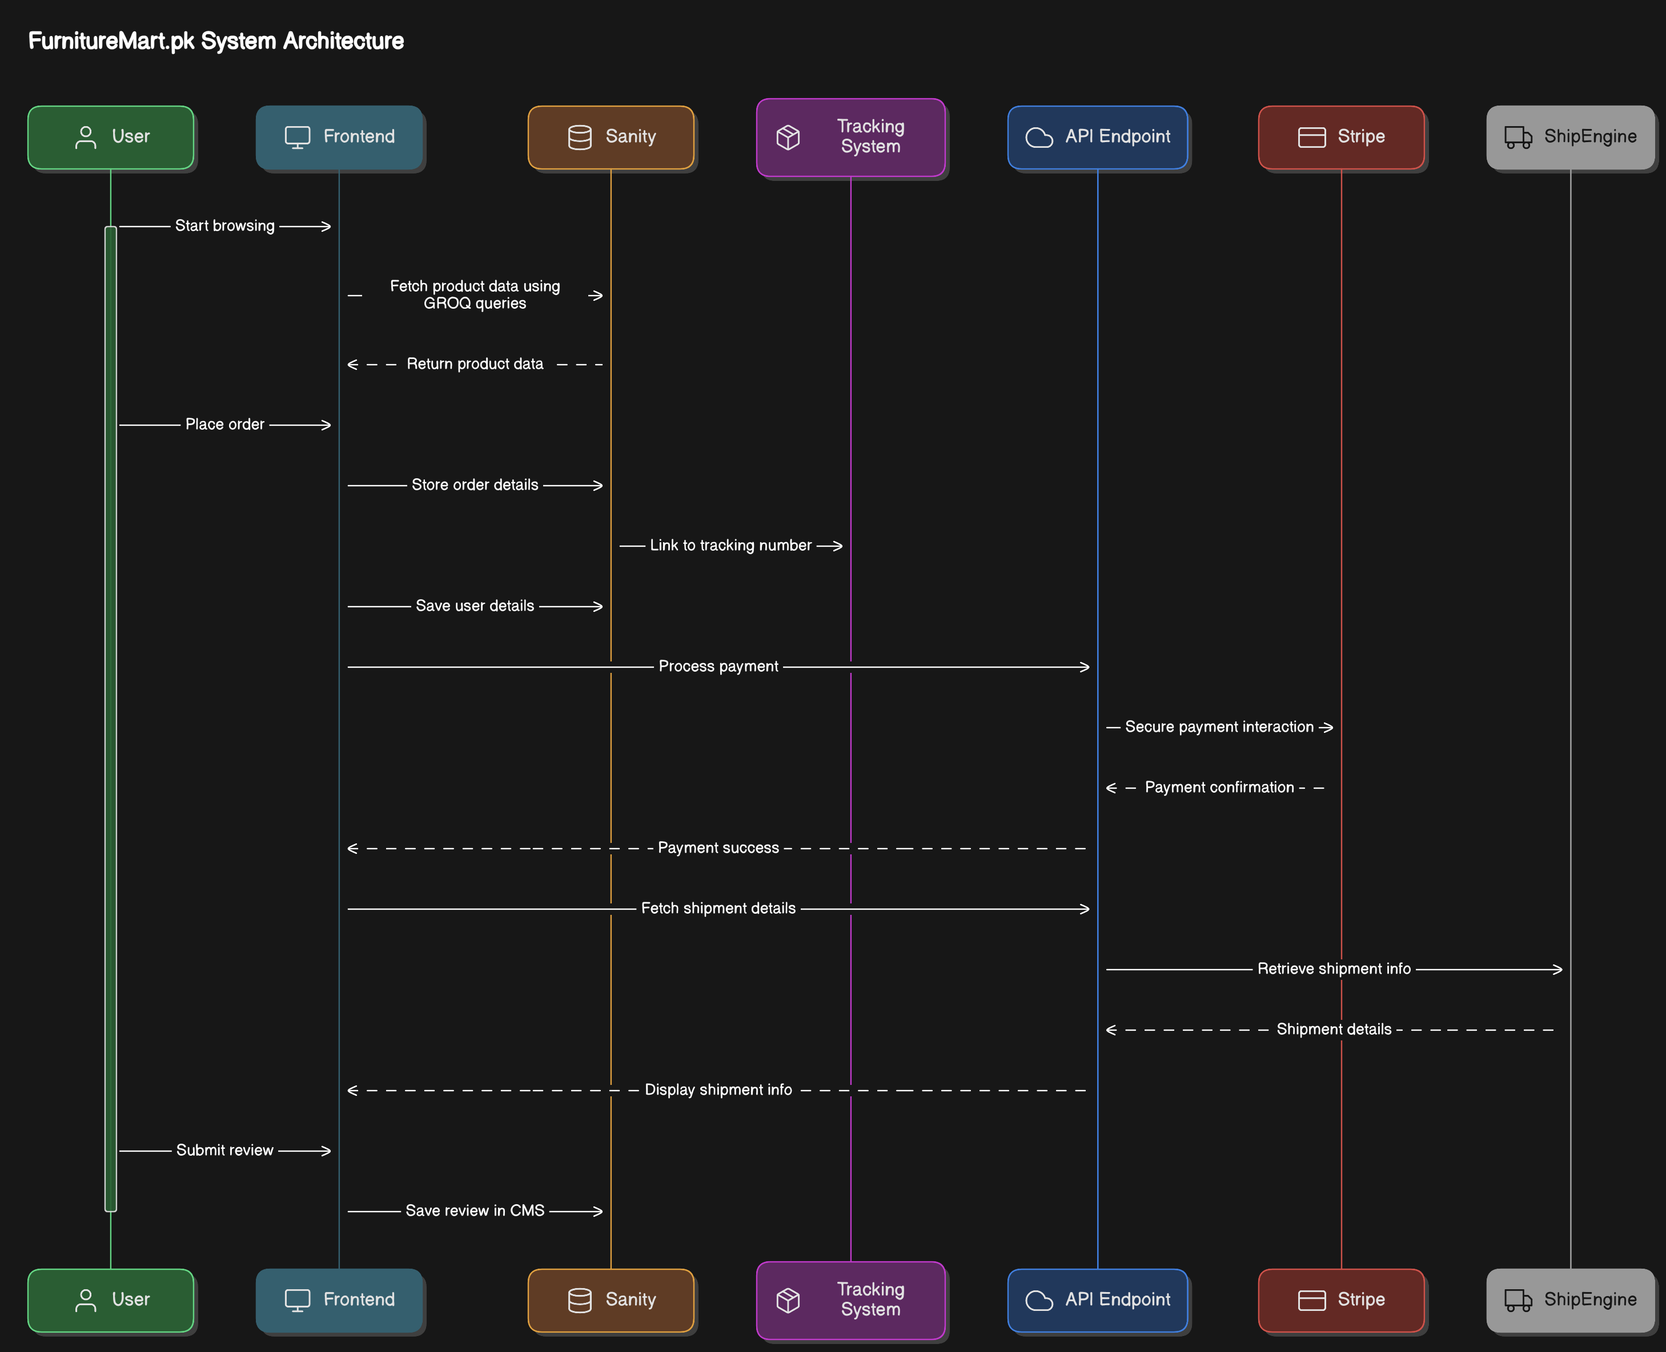

### **System Workflow**

#### **1. Product Browsing:**

* User visits the marketplace.
* Frontend fetches product data from Sanity.
* Products are displayed

#### **2. Order Placement:**

* User adds items to the cart and proceeds to checkout.
* User’s Data is Saved in Sanity.

**3. Payment Details:**

* Frontend sends payment details to /api/payment.
* Upon payment success, order details are saved in Sanity.
* Tracking number is generated and linked to the user’s order.

#### **3. Shipment Tracking:**

* User views the order details page.
* Frontend calls /api/shipment with the order’s tracking number.
* Shipment status is fetched from ShipEngine and displayed to the user.

#### **4. Review Submission:**

* User submits a review for a purchased product.
* Frontend sends the review data to /api/review.
* Review is stored in Sanity and linked to the product with Customer ID.
* Reviews are displayed on the product details page.