# C# Web Basics Exam – 13 August 2019

# SMS

Exam problems for the [C# Web Basics course @ SoftUni](https://softuni.bg/courses/csharp-web-basics). Submit your solutions in the **SoftUni judge** system (delete all "**bin**"/"**obj**" folders).

**SMS (S**uper**M**arket **S**ystem**)** is an online supermarket for shopping. You have been tasked to implement a platform in which the users can add products to their cart and buy them.

## Technological Requirements

* Use the **SIS.WebServer**
* Use the **SIS.MvcFramework**
* Use **Entity Framework Core**

The Technological Requirements are **ABSOLUTE**. If you do not follow them, you will **NOT** be scored for other Requirements.

Now that you know the **Technological Requirements**, let us see what the **Functional Requirements** are.

## Database Requirements

The **Database** of **SMS** needs to support **3 entities**:

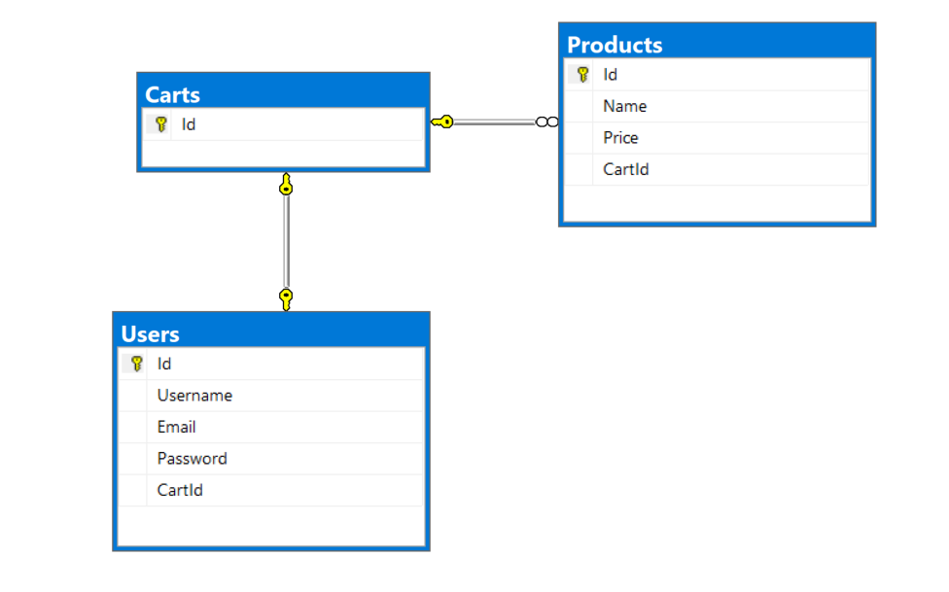

### User

* Has an Id – a **string, Primary Key**
* Has a Username – a string with **min length** **5** and **max length 20** (**required**)
* Has an Email – a string, which holds only **valid** email (**required**)
* Has a Password – a string with **min length** **6** and **max length 20** - hashed in the database (**required**)
* Has a **Cart –** a **Cart** object

### Product

* Has an Id – a **string, Primary Key**
* Has a Name – a string with **min length** **4** and **max length 20** (**required**)
* Has Price – a **decimal** (in **range 0.05** – **1000**)
* **Cart** - **string, foreign key (required**)
* Has a **Cart –** a **Cart** object

### Cart

* Has an Id – a **string, Primary Key**
* Has User – a User object
* Has Products – a collection of Products

Implement the entities with the **correct datatypes** and their **relations**.

## Page Requirements

### Index Page (logged-out user)

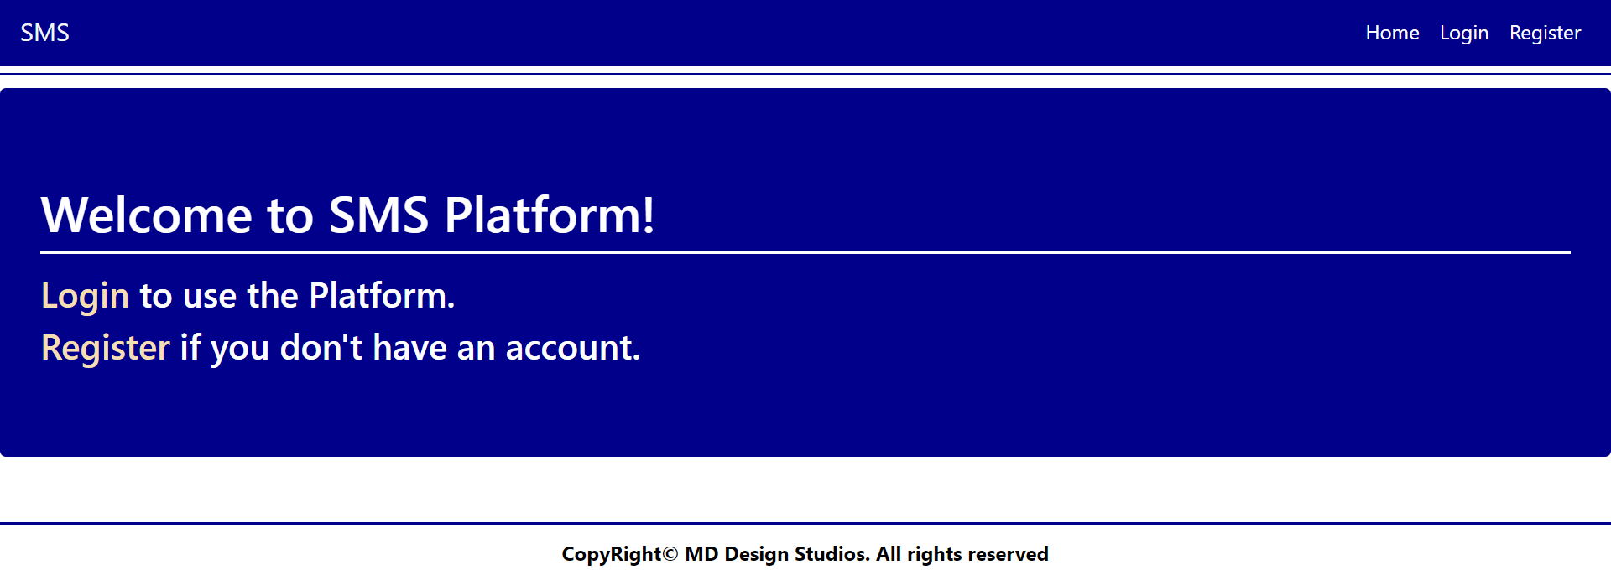

### /Users/Login (logged-out user)

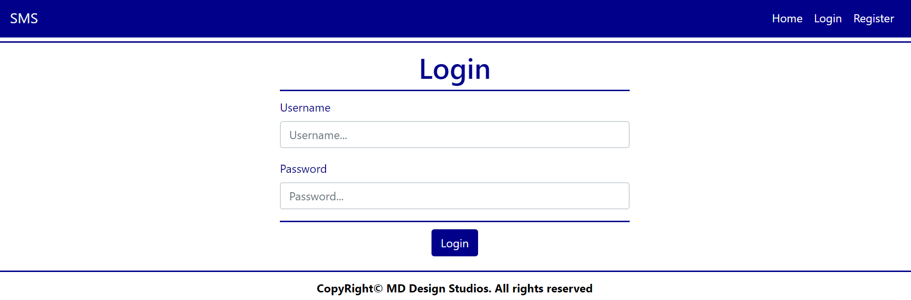

### /Users/Register (logged-out user)

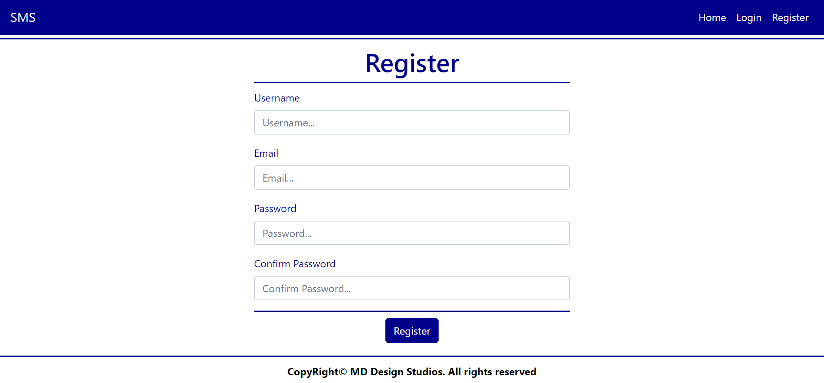

**NOTE**: Upon **successful** registration, a **Cart** for the **User** is **created** automatically.

### Home Page (logged-in user)

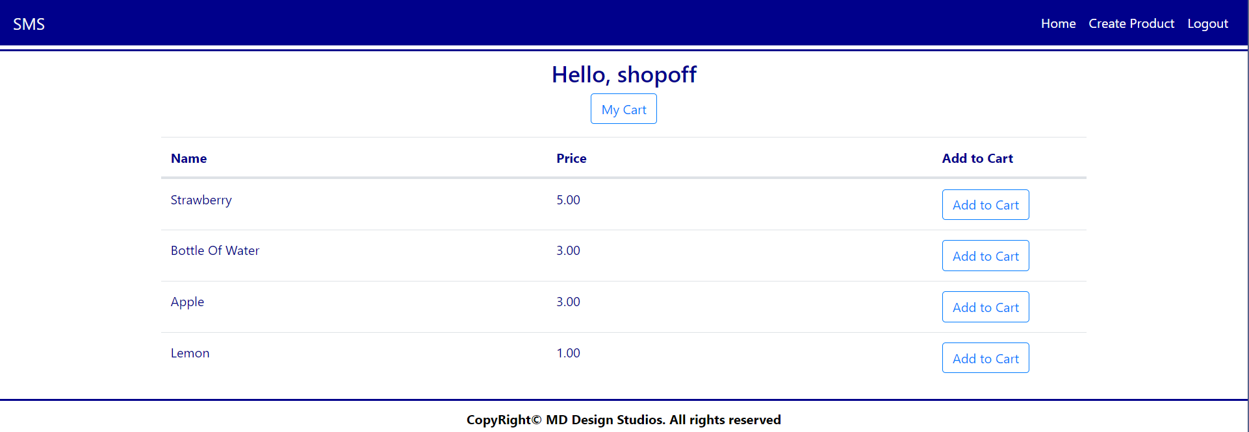

**NOTE**: The [Add to Cart] adds the **Product** to **User's Cart**.

### Products/Create (logged-in user)

### Carts/Details (logged-in user)

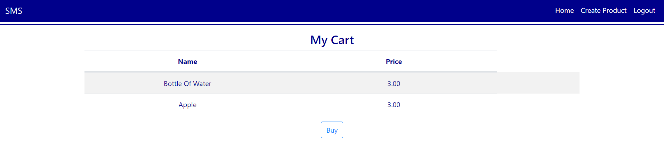

**NOTE**: All Products for the current logged in User's Cart are rendered below.

**NOTE**: The templates should look **EXACTLY** as shown above.

**NOTE**: The templates do **NOT** **require** **additional** **CSS** for you to write. Only **bootstrap** and the **given css** are enough.

## Functionality

The functionality of SMS Platform is very simple.

### Users

Guests can Register, Login and view the Index Page.

Users can Create Products and see All Products on the Home Page. From the Home Page they can also **Add Products** and view Details about their **Cart** and **buy all Products**.

### Products

Products can be Created by Users. All created Products are visualized on the Home Page.

Products are visualized on the Home Page as a table with **Name** of the Product, **Price** and action **Add to Cart**.

### Cart

Products added are stored in the User's Cart. In **Cart Details Page**, **User** can **buy the products**.

When User decides to buy the products in his cart, the Cart becomes empty (products are deleted).

### Redirections

* Upon successful Registration of a User, you should be redirected to the Login Page.
* Upon successful Login of a User, you should be redirected to the Home Page.
* Upon successful Creation of a Product, you should be redirected to the Home Page.
* Upon successful Adding to Cart, you should be redirected to the Cart Details Page.
* Upon successful Buying, you should be redirected to the Hom**e** Page.
* Upon successful Logout of a User, you should be redirected to the Index Page.

## Security

The Security section mainly describes access requirements. Configurations about which users can access specific functionalities and pages:

* Guest (not logged in) users can access Index page.
* Guest (not logged in) users can access Login page.
* Guest (not logged in) users can access Register page.
* Users (logged in) cannot access Guest pages.
* Users (logged in) cannot access Login pages.
* Users (logged in) cannot access Register pages.
* Users (logged in) can access Home page.
* Users (logged in) can access Product Create page and functionality.
* Users (logged in) can access Cart Details page and functionality.
* Users (logged in) can access Logout functionality.

## Code Quality

Make sure you provide the best architecture possible. Structure your code into different classes, follow the principles of high-quality code (**SOLID**). You will be scored for the Code Quality and Architecture of your project.

## Data Validation

* In case of invalid data during the **login**, redirect to "**/Users/Login**"
* In case of invalid data during the **registration**, redirect to "**/Users/Register**"
* In case of invalid data during the **product creation**, redirect to "**/Products/Create**"

**NOTE:** Use the ValidationSisAttributes

## Scoring

### Database Requirements – 10 points.

### Template Requirements – 10 points.

### Functionality – 40 points.

### Security – 10 points.

### Application Structure – 10 points.

### Data Validation – 20 points.