Objective(s)
- To learn basic Python syntax required for Computer Graphics.
- To understand variables, data types, operators, conditions, loops and lists.
- To write simple Python programs using input/output and control structures.
- To plot basic graphs using the matplotlib library.

Software(s) Required
• Python 3.x
• Jupyter Notebook / VS Code / PyCharm
• Python libraries: matplotlib, numpy (for later labs)
Theory Key concepts:
Python is a high-level, interpreted language with simple, readable syntax. In this course, Python is used as the main language to implement and visualise computer graphics algorithms.
Qn1. Write a Python program to input five numbers and print the largest number.
Code:
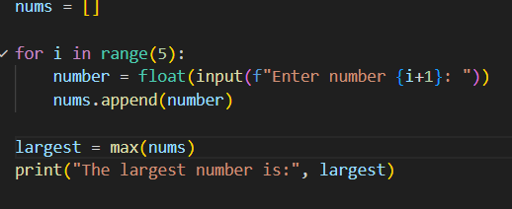
Output:
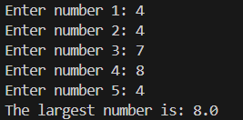
Qn2: Write a program to print the multiplication table of any number (from 1 to 10).
Code:
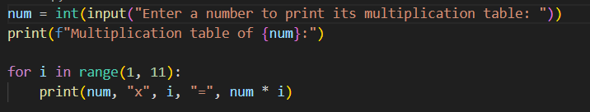
Output:
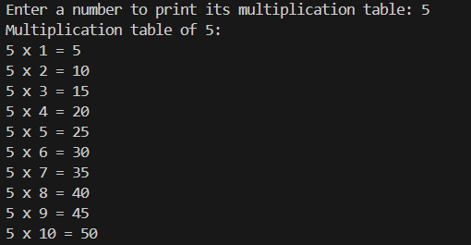
Qn3. Create a list of 10 integers and print:
  - all even numbers
  - all odd numbers
Code:
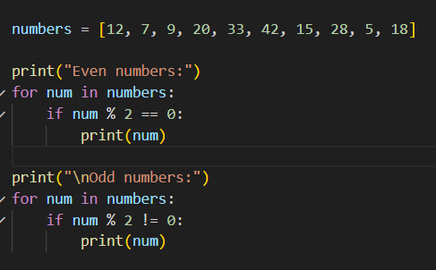
Output:
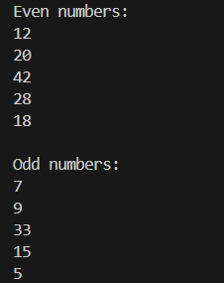
- Qn4. Using matplotlib, plot:
  - a simple line graph of your choice
  - a bar graph of marks of 5 subjects
Code:
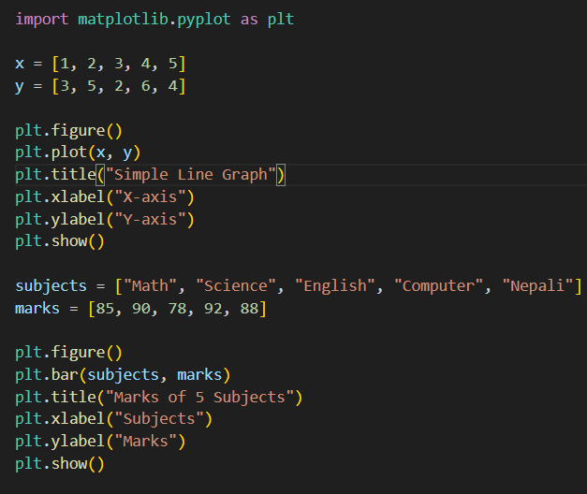
Output:
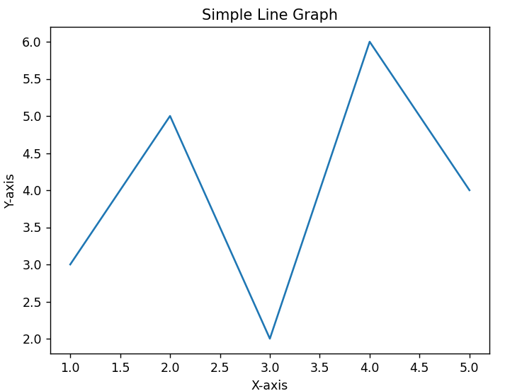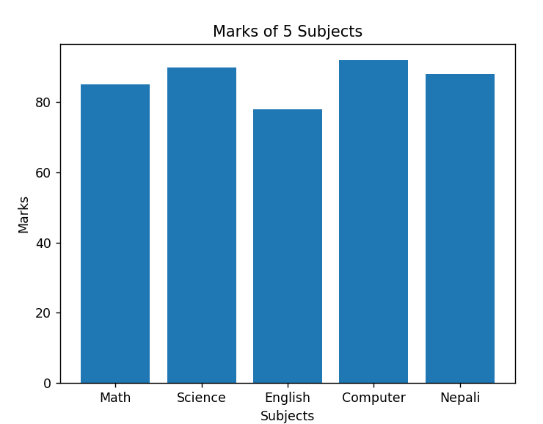

Outcomes
- Students will understand core Python syntax needed for later graphics labs.
- Students will be able to use conditions, loops and lists in basic programs.
- Students will know how to create simple plots with matplotlib

