LAB 2: IMPLEMENTATION OF DDA LINE DRAWING ALGORITHM (PYTHON)

Objective(s)
- To understand the Digital Differential Analyzer (DDA) line drawing algorithm.
- To implement the DDA algorithm in Python and visualise the generated pixels.
- To compare DDA with the analytical line equation.

Software(s) Required:
Python 3, matplotlib, any IDE or Jupyter Notebook.

Theory:
Given two endpoints (𝑥1, 𝑦1) and (𝑥2, 𝑦2), we define: The number of steps is chosen as: In raster graphics, a straight line must be approximated using discrete pixels. The DDA algorithm is an incremental method that uses the line slope to step along the dominant axis and compute intermediate points. 𝑑𝑥 = 𝑥2 −𝑥1, 𝑑𝑦 = 𝑦2−𝑦1 steps = max(|𝑑𝑥|, |𝑑𝑦|) The increment in each step is: 𝑥inc = 𝑑𝑥 steps , 𝑦inc = 𝑑𝑦 steps Starting from (𝑥1, 𝑦1), the algorithm adds these increments repeatedly and rounds to the nearest pixel.
Algorithm: DDA Line Drawing 1. Read starting point (𝑥1, 𝑦1) and ending point (𝑥2, 𝑦2)
2. Compute 𝑑𝑥,𝑦 and number of steps.
3. Compute 𝑥inc and 𝑦inc.
4. Initialise 𝑥 = 𝑥1, 𝑦 = 𝑦1.
5. For 𝑘 = 0to steps:
• Plot pixel at (round(𝑥),round(𝑦)).
• Update 𝑥 = 𝑥 +𝑥inc, 𝑦 = 𝑦 + 𝑦inc.
Qn1.Implement the DDA algorithm as a function that returns x and y coordinate
Code:
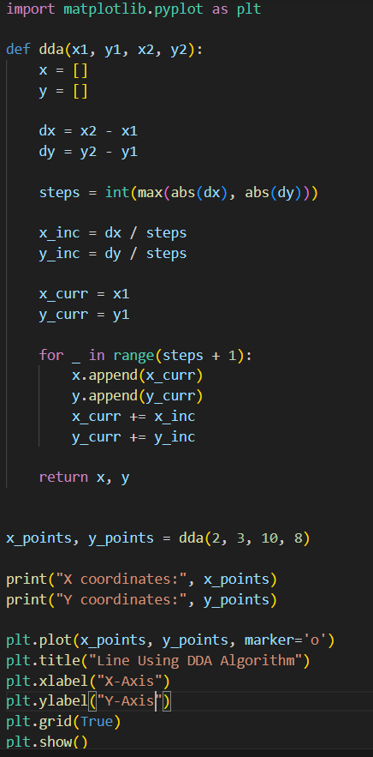
Output:
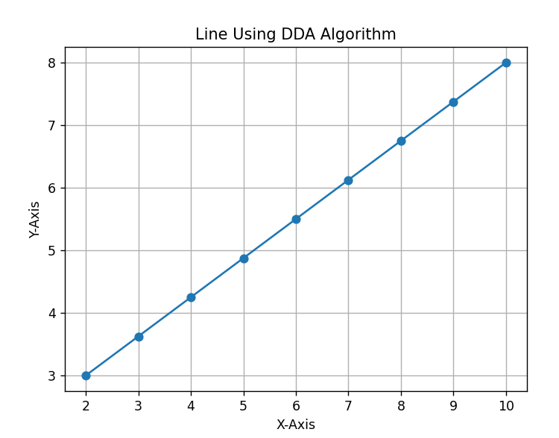
Qn2.Draw a line with the different slopes:m<1,m>1, horizontal, vertical and negative slope
Code:
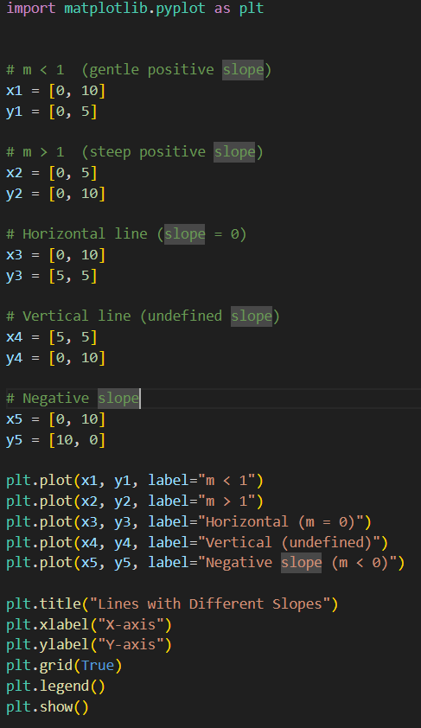
Output:
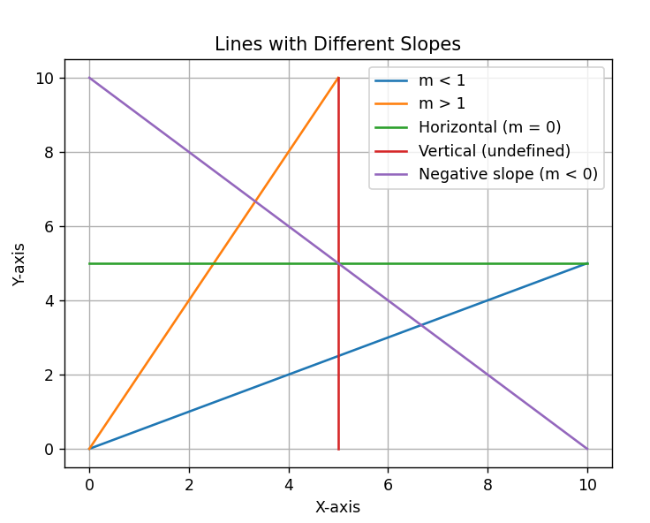
Qn3:Extend the DDA program to draw a rectangle given two opposite corners.
Code:
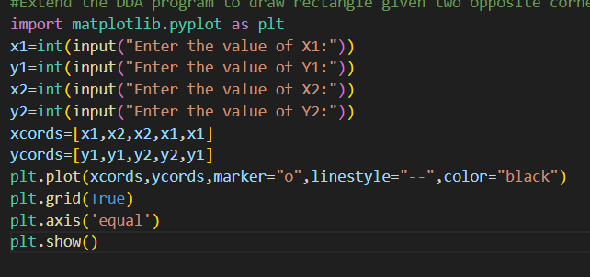
Output:
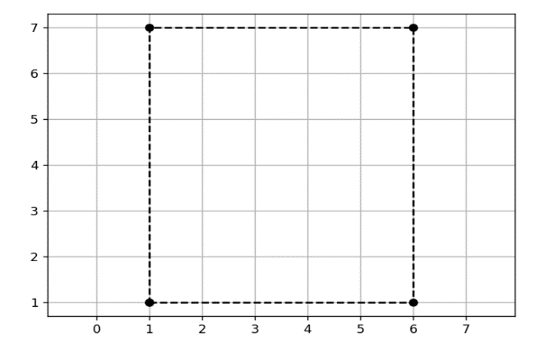
Qn4: Use DDA to draw the axes of a simple coordinate system(X and Y axes)
Code:
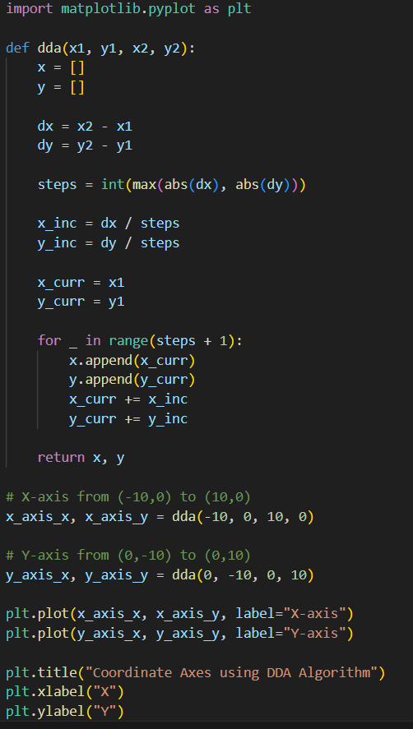
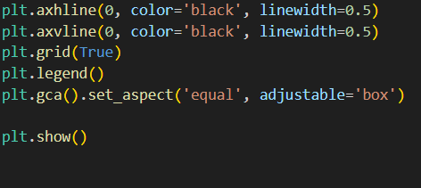
Output:)
