

HIMALAYA COLLEGE OF ENGINEERING

Advanced C++ Programming Lab Report

Lab 1: Quadratic Equations, Triangle Classification and Password Strength Checking

Prepared By: kushal Bote
Subject: Object Oriented Programming (OOP)
Program: Bachelors of Electronics and Computer Engineering
Institution: Himalaya College of Engineering
Date: May 25, 2025

Objectives:
- To utilize control structures, functions, and built-in libraries in C++ programming.
- To perform calculations involving quadratic equations using the standard formula.
- To implement logic that checks if a triangle is valid and determines its type.
- To use string manipulation and character analysis for evaluating password strength.

Tools and Libraries Used:
- Programming Language: C++
- IDE: G++
- Libraries: #include <iostream>, include <string>, #include <math>

Theory:

Basics of C++ Programming
C++ is a versatile language used to build efficient programs. Beginners start by learning variables, conditional statements, and loops to solve simple problems.

Structure of a C++ Program
A basic C++ program includes header files (like <iostream>) and starts with main(), which is the entry point. The program uses using namespace std; to access standard features easily. The main function contains the code and ends with return 0; to indicate success.

Example:

1.
#include<iostream> using namespace std; int main() {
cout << "Hello world!"; return 0;
}

2.

3.

4.

5.

6.

Variables and Data Types
Variables store data. You can declare and assign them like this:

1.
int age;
age = 20;
// Declaration
// Assignment
int score = 100; // Declaration + Initialization

2.

3.

Common Data Types:
- int – whole numbers (e.g., int x = 5;)
- float – decimal numbers (e.g., float pi = 3.14;)
- double – more precise decimals (e.g., double d = 2.718;)
- char – single characters (e.g., char c = 'A';)

Variable Naming Rules
- Start with a letter or underscore
- No digits at the beginning
- No space or special characters (except _)
- Case-sensitive (Age ≠ age)

Conditional Statements
Conditional statements control program flow based on conditions.

if statement:
Used when we must check the condition.
Syntax:
if (condition) {
// Code runs if condition is true
}

1.

2.

3.

if...else statement:
Used when we must check the condition and execute true and false condition separately.
Syntax:
if (condition) {
// Runs if true
} else {
// Runs if false
}

1.

2.

3.

4.

5.

else….if ladder:
Used when multiple conditions are to be checked one after another.
Syntax:

1.
if (condition1) {
// code if condition1 is true
} else if (condition2) {
// code if condition2 is true
} else if (condition3) {
// code if condition3 is true
} else {
// code if none are true
}

2.

3.

4.

5.

6.

7.

8.

9.

switch Statement:
Used to select one block of code from many options based on a variable's

value. Syntax:

1.
switch (expression) { case value1:
// code for case 1 break;
case value2:
// code for case 2 break;
...
default:
// code if no cases match
}

2.

3.

4.

5.

6.

7.

8.

9.

10.

11.

Loops in C++

for Loop
Used when the number of iterations is known.
Syntax:

1.
for (initialization; condition; update) {
// code to repeat
}

2.

3.

while Loop
Used when the condition is checked before the loop body and the number of repetitions is not fixed.
Syntax:

1.
while (condition) {
// code to repeat
}

2.

3.

4.

do...while Loop
Runs the loop body at least once before checking the condition.
Syntax:

1.
do {
// code to repeat
} while (condition);

2.

3.

Lab Questions:

Q no 1: Solve 𝑎² + 𝑏𝑥 + 𝑐 = 0 and handle all discriminant cases.
Code:
#include<iostream> #include<math.h> using namespace std; main()
{
float d,x1,x2,a,b,c;
cout<<"The given equation is ax^2+bx+c : "<<endl; cout<<"a : ";
cin>>a; cout<<"b : "; cin>>b; cout<<"c : "; cin>>c; if(a==0)
{
cout<<"Error: The given equation is not quadratic.;
}
else
{
d=(b*b)-4*a*c; if(d==0)
{
cout<<"There exists one common root. "<<endl; x1=-b/(2*a);
cout<<"The root is: "<<x1;
}
else if(d>0)
{
cout<<"There exists two distinct roots. "<<endl; x1=(-b+sqrt(d))/(2*a);
x2=(-b-sqrt(d))/(2*a);
cout<<"The roots are: "<<x1<<" and "<<x2;
}
else
{
1.
2.
3.
4.
5.
6.
7.
8.
9.
10.
11.
12.
13.
14.
15.
16.
17.
18.
19.
20.
21.
22.
23.
24.
25.
26.
27.
28.
29.
30.
31.
32.
33.
34.
35.

36.
cout<<"There exists two complex roots. "<<endl; x1=(-b)/(2*a);
x2=sqrt(-d)/(2*a);
cout<<"The roots are: "<<x1<<"+i"<<x2<<" and "<<x1<<"-i"<<x2;
}
}
}
37.
38.
39.
40.
41.
42.

Output:

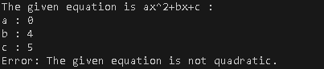
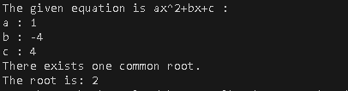
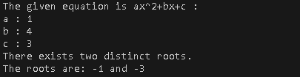
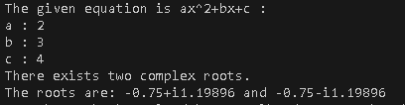

Q no 2: Check if three angles form a triangle and classify it.
Code:
- #include<iostream>
- using namespace std;
- int main()
- {
- int a,b,c;
- cout<<"Enter 1st angle: ";
- cin>>a;
- cout<<"Enter 2nd angle: ";
- cin>>b;
- cout<<"Enter 3rd angle: ";
- cin>>c;
- if(a+b+c==180)
- {
- if(a==90 || b==90 || c==90)
- {
- cout<<"Figure is right angled triangle. ";
- goto end;
18. }
- else if(a>90 || b>90 || c>90)
- {
- cout<<"Figure is obtuse angled triangle. ";
- goto end;
23. }
- else
- {
- cout<<"Figure is acute angled triangle. ";
- goto end;
28. }
29. }
- else
- {
- cout<<"Given angles don't form a triangle.";
33. }
- end:
- }

Output:

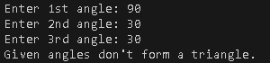
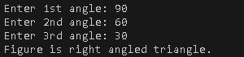
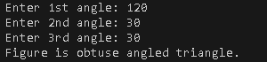
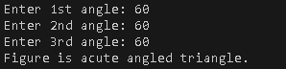

Q no 3: Check password strength based on length and character rules.
#include <iostream> #include <string> using namespace std; class Password {
int hasUpper = 0, hasSymbol = 0, hasLower = 0, hasNumber = 0; public:
int isUpper(char ch) {
if (ch >= 65 && ch <= 90) return 1; return 0;
}
int isLower(char ch) {
if (ch >= 97 && ch <= 122) return 1; return 0;
}
int isNumber(char ch) {
if (ch >= 48 && ch <= 57) return 1; return 0;
}
int isSymbol(char ch) {
if ((ch >= 33 && ch <= 47) || (ch >= 58 && ch <= 64) || (ch >= 91 && ch <= 96) || (ch >= 123 && ch <= 126)) { return 1;
}
return 0;
}
int checkPass(string password) { if (password.length() <= 8) {
return 0;
}
for (int i = 0; i < password.length(); i++) { char ch = password[i];
if (isUpper(ch)==1) hasUpper = 1;
else if (isLower(ch)==1) hasLower = 1; else if (isNumber(ch)==1) hasNumber = 1;
Code:

1.
2.
3.
4.
5.
6.
7.
8.
9.
10.
11.
12.
13.
14.
15.
16.
17.
18.
19.
20.
21.
22.
23.
24.
25.
26.
27.
28.
29.
30.
31.
32.
33.
34.
35.
36.

37.
38.
39.
else if (isSymbol(ch)==1) hasSymbol = 1;
40.
41.
42.
43.
}
if (hasUpper == 1 && hasLower == 1 && hasNumber == 1 && hasSymbol == 1)
return 1;
else
return 0;
}
44. };
- int main() {
- Password pa;
- string pass;
- cout << "Enter password: ";
- cin >> pass;
- if (pa.checkPass(pass) == 1) {
- cout << "Password is strong." << endl;
- } else {
- cout << "Password is not strong." << endl;
54. }
55. return 0;
56. }

Output:
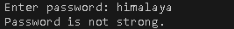
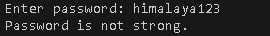
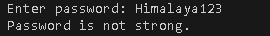
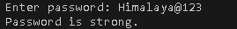

Conclusion:
In this lab, we focused on applying fundamental C++ concepts by working through a range of practical problems. It emphasized the use of control structures, functions, and string manipulation techniques. This hands-on experience helps establish a solid base for advancing into more complex topics like C++ and object-oriented programming.

