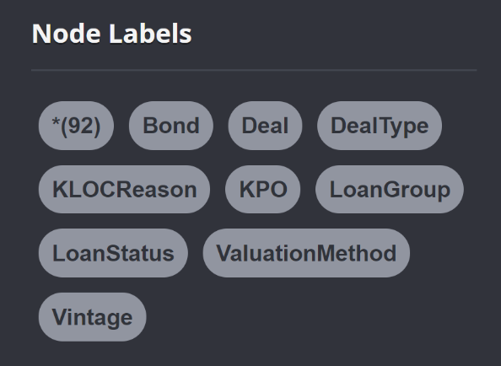╒═══════════════════╤══════════╕

│"labels(n)" │"count(*)"│

│["Vintage"] │36 │

│["LoanStatus"] │9 │

│["KLOCReason"] │25 │

│["ValuationMethod"]│7 │

│["KPO"] │4 │

│["DealType"] │11 │

Labels with no Nodes:

Bond

Deal

LoanGroup

|  |  |  |
| --- | --- | --- |
| **labels(n)** |  | **count(*)** |
| **1** | ["Vintage"] | 36 |
| **2** | ["LoanStatus"] | 9 |
| **3** | ["KLOCReason"] | 25 |
| **4** | ["ValuationMethod"] | 7 |
| **5** | ["KPO"] | 4 |
| **6** | ["DealType"] | 11 |
| **7** | ["Deal"] | 2,294 |
| **8** | ["Bond"] | 26,857 |
| **9** | ["LoanGroup", "LG_CurrentVersion"] | 85,073 |