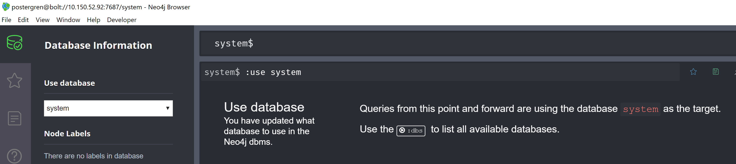

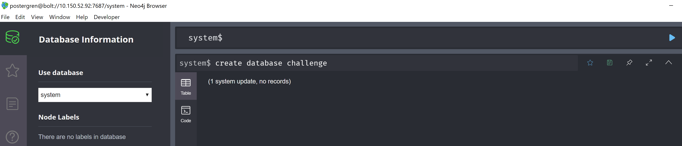

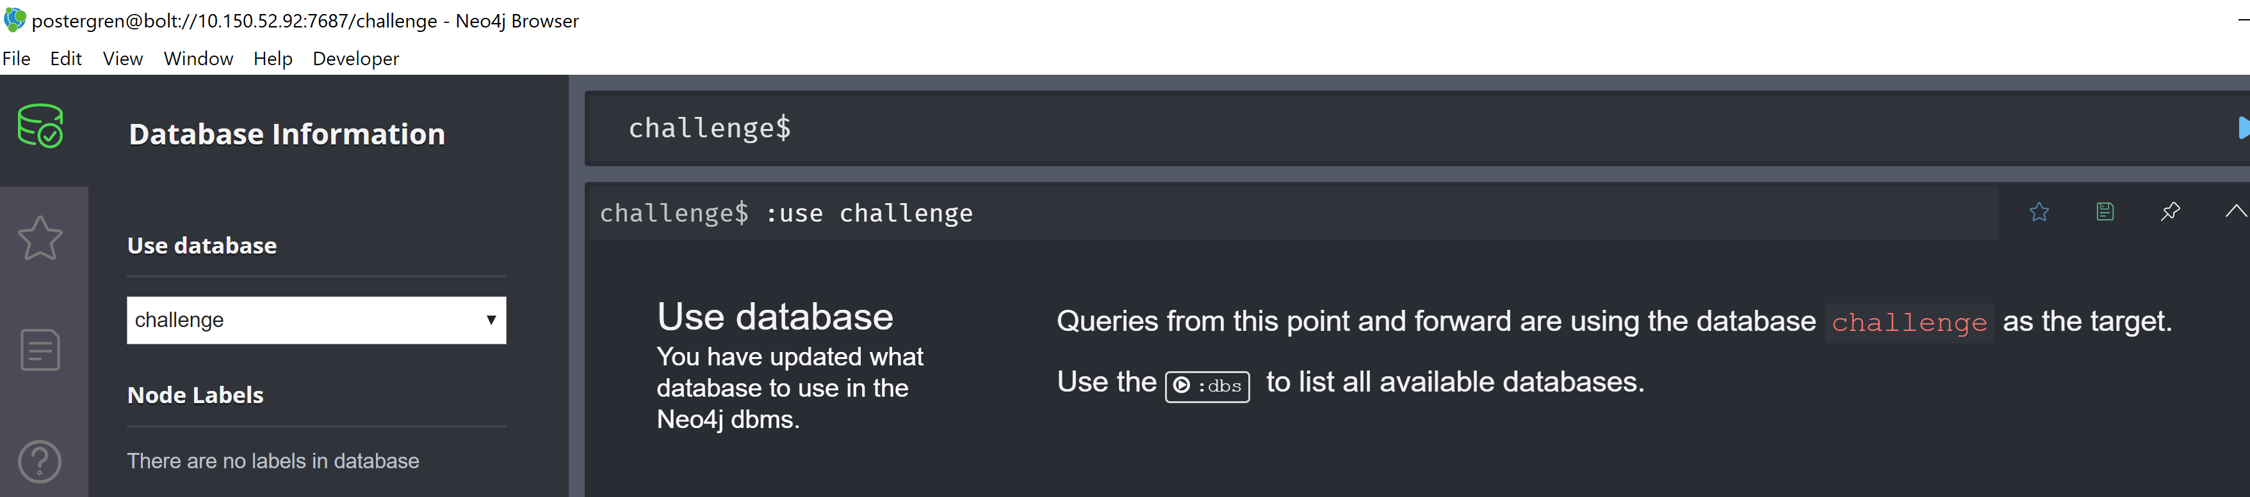

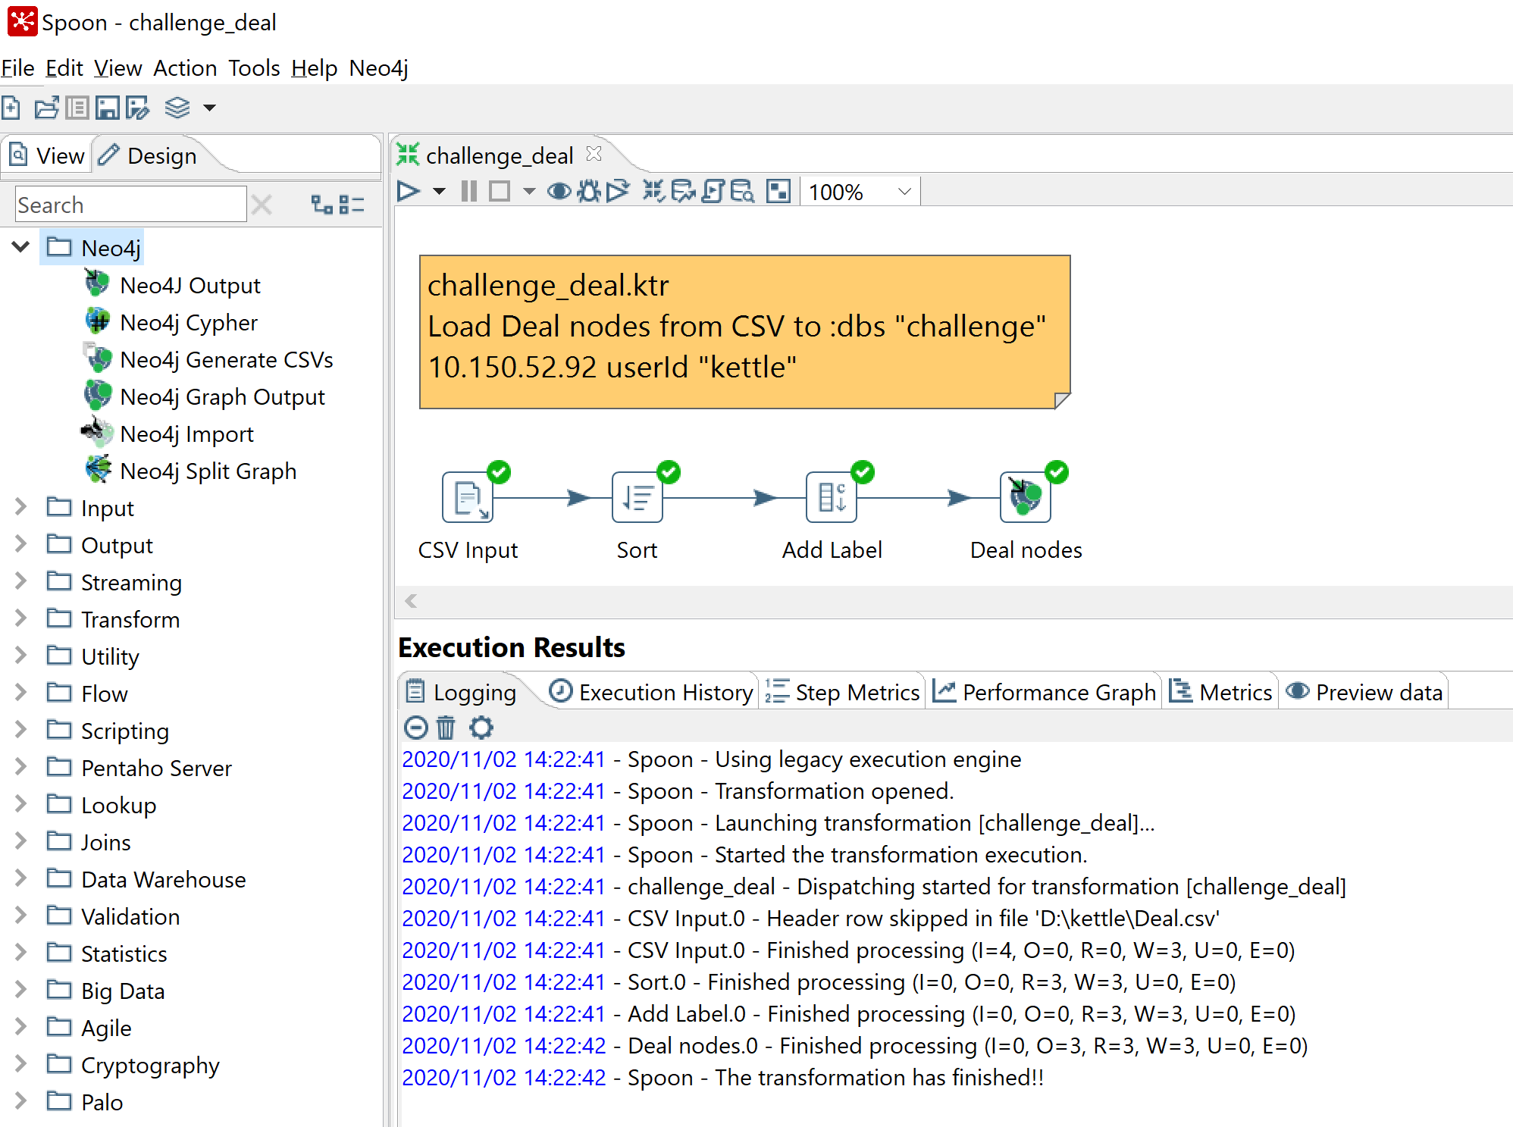

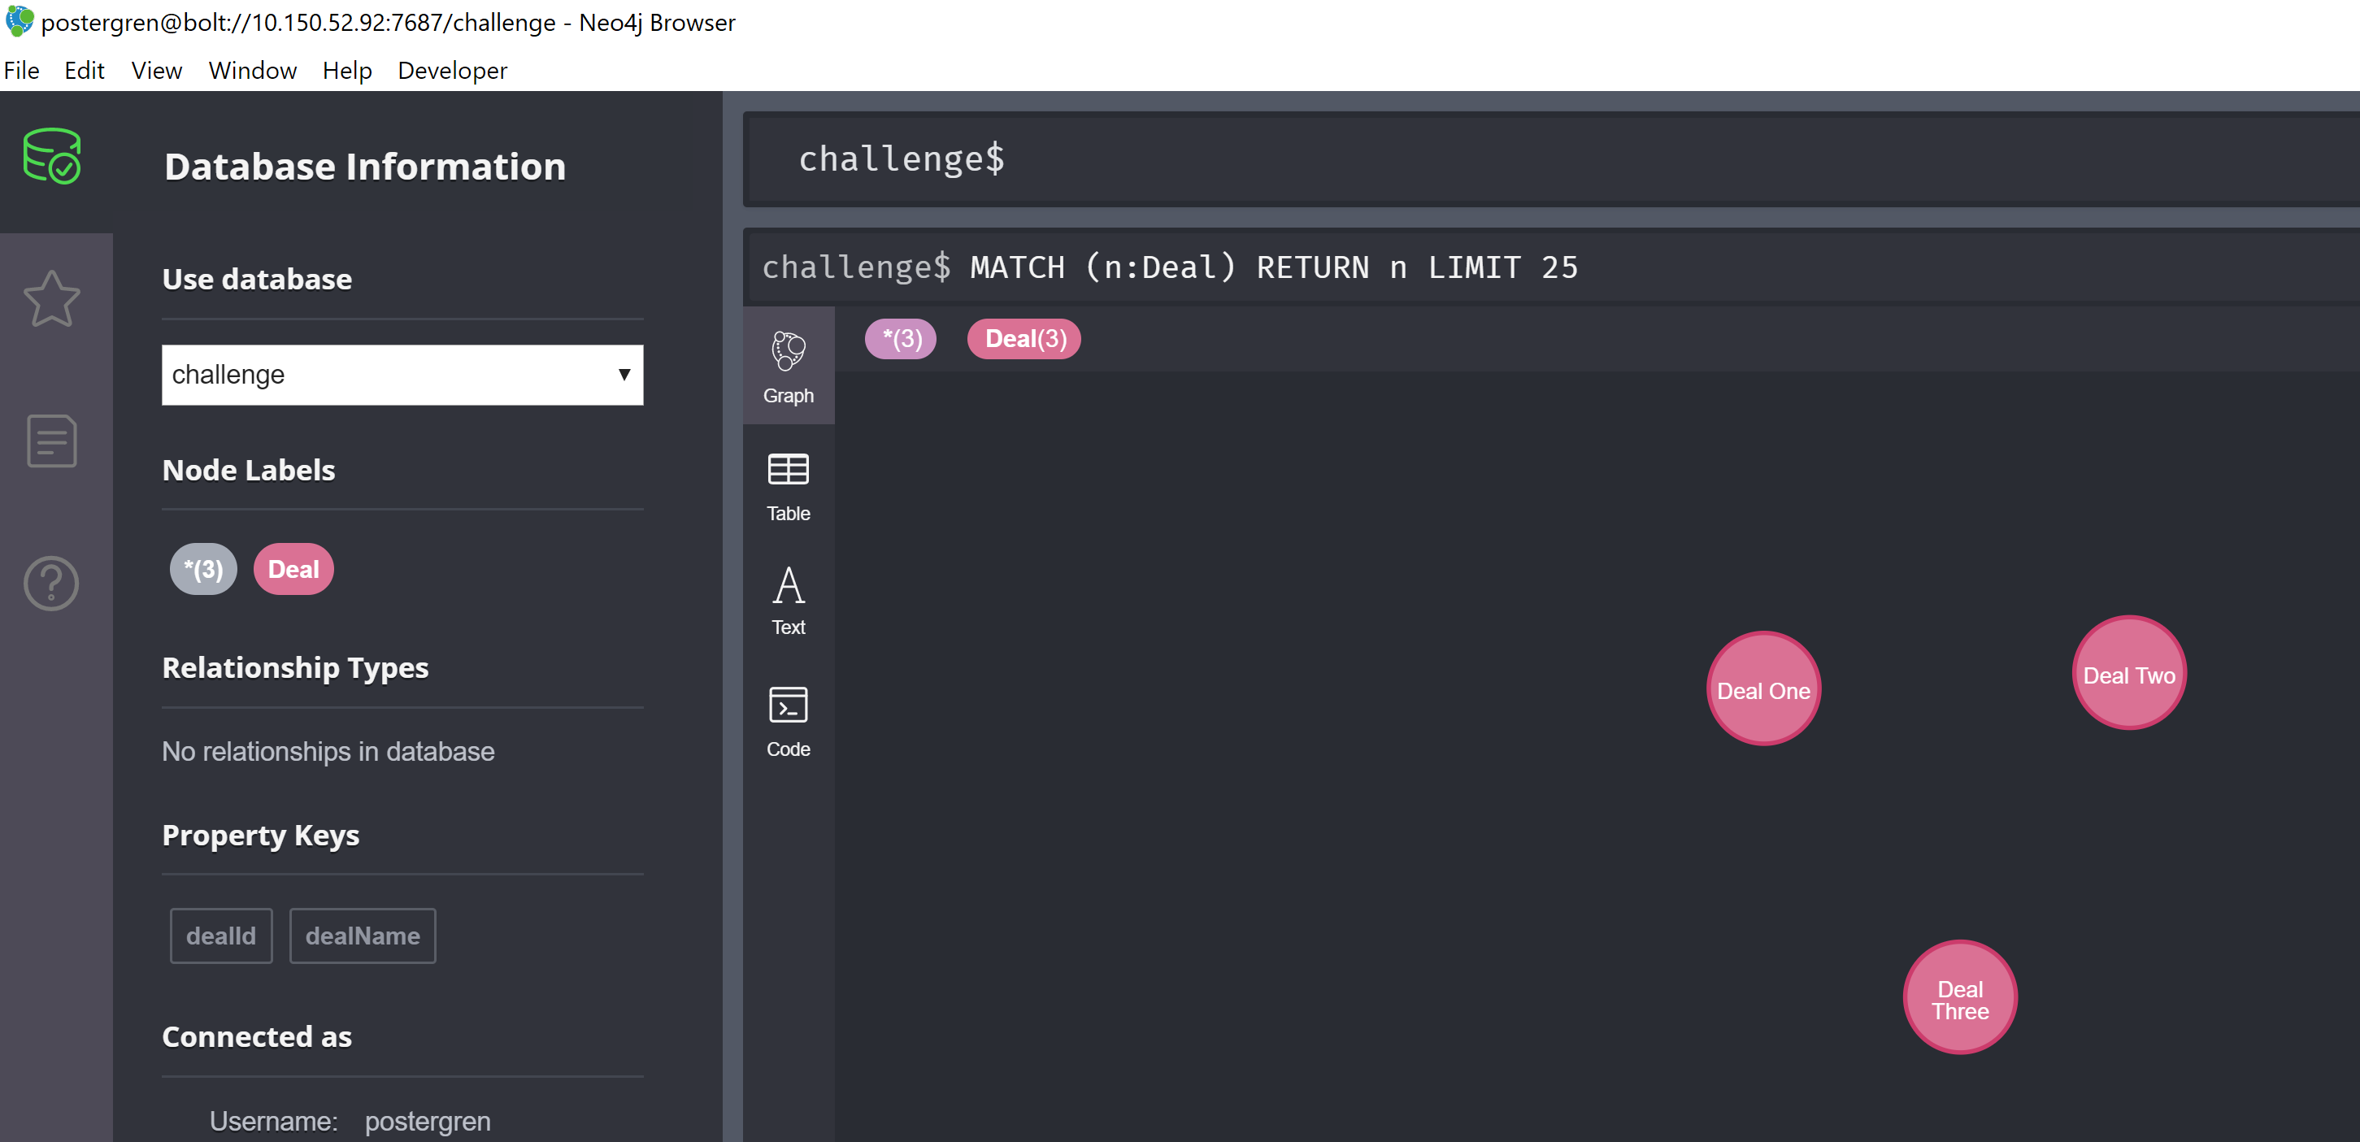

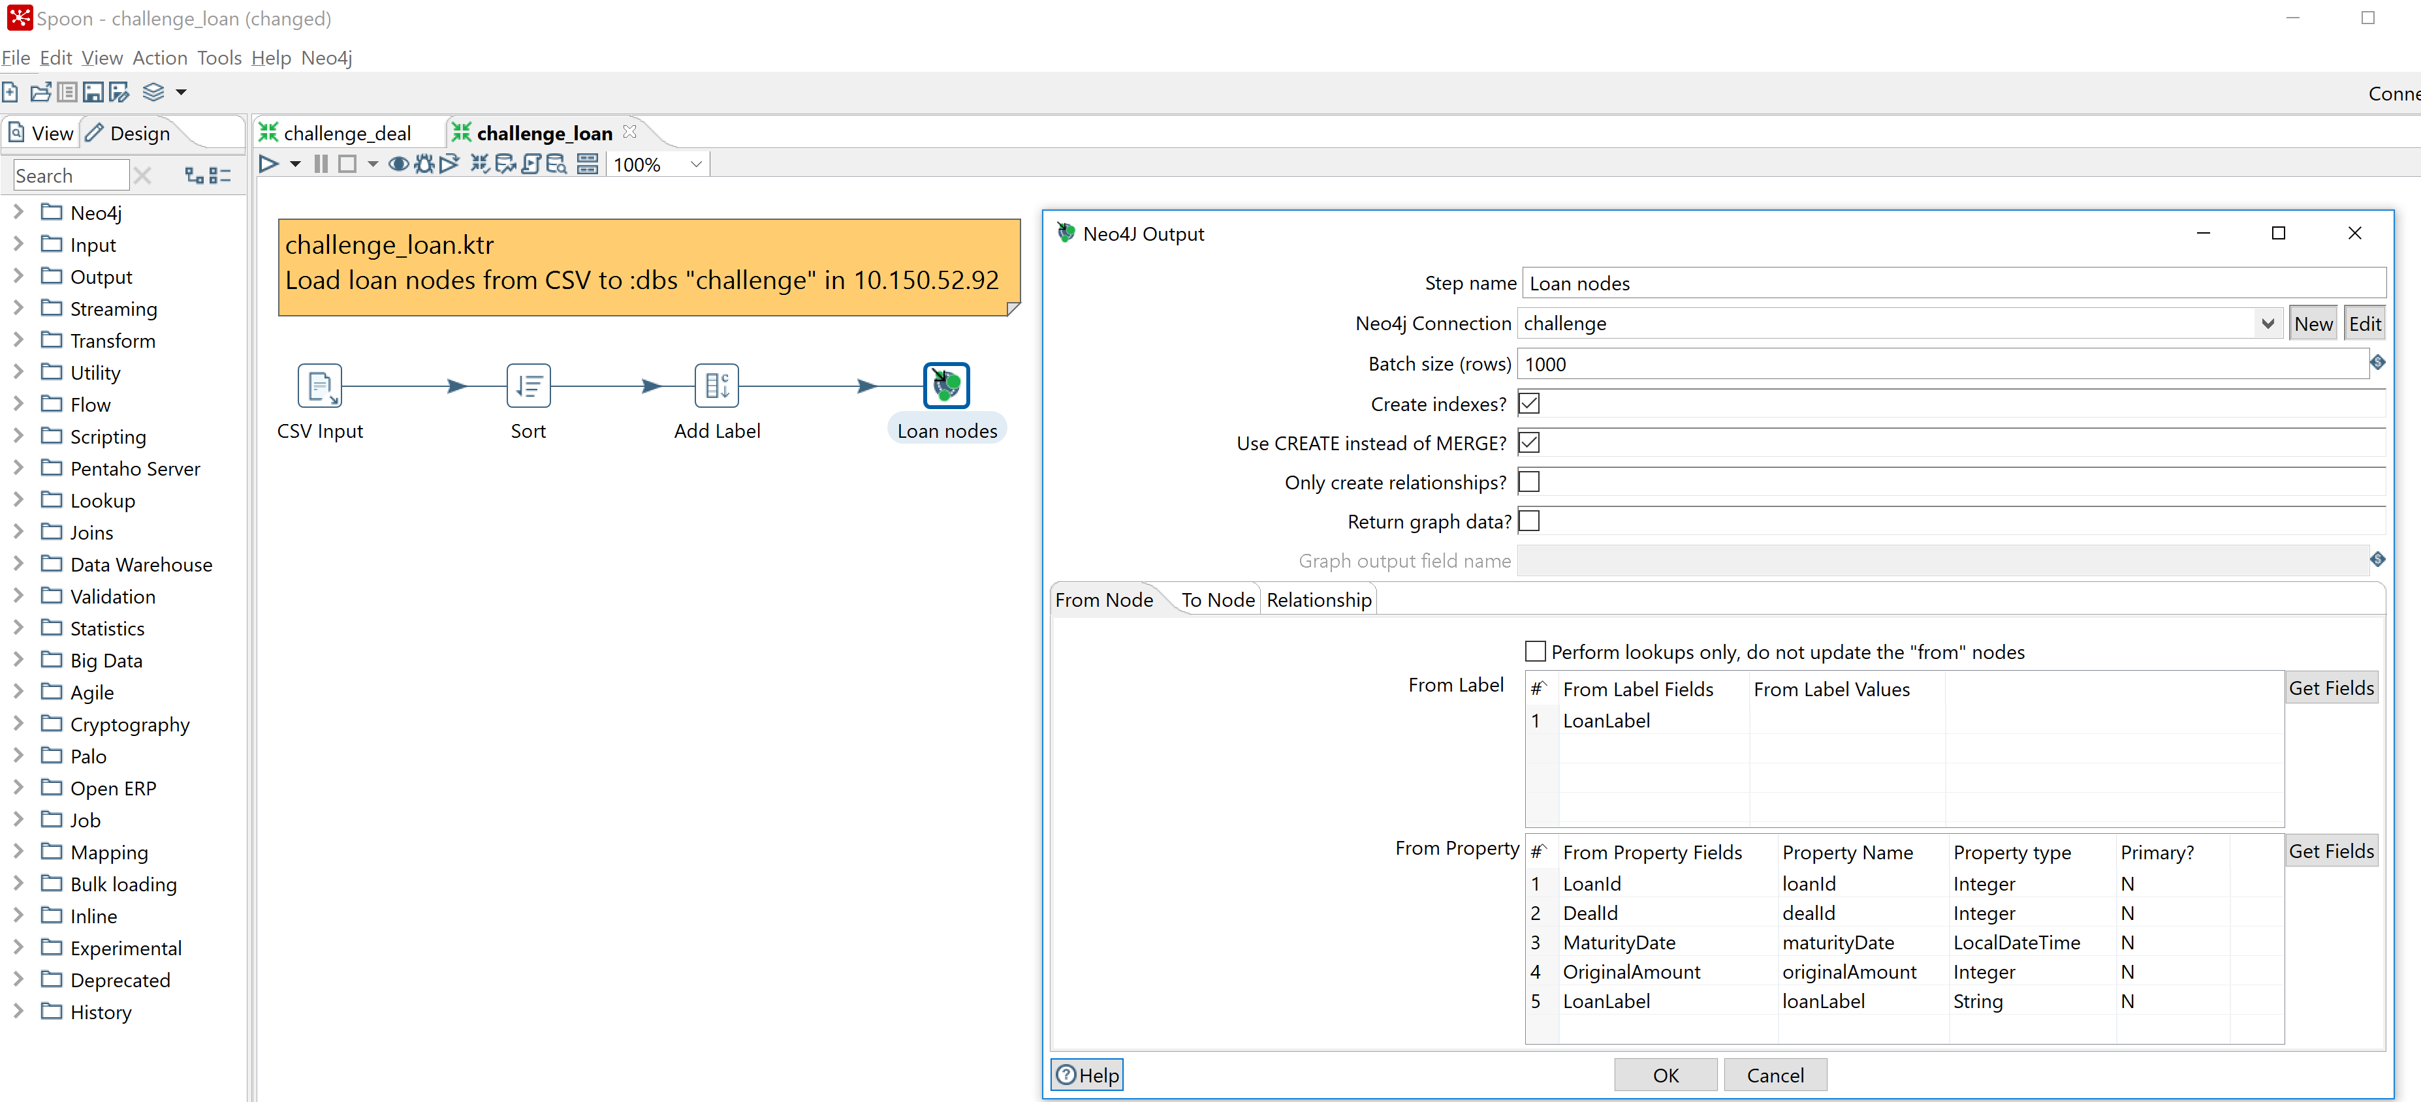

Remove?

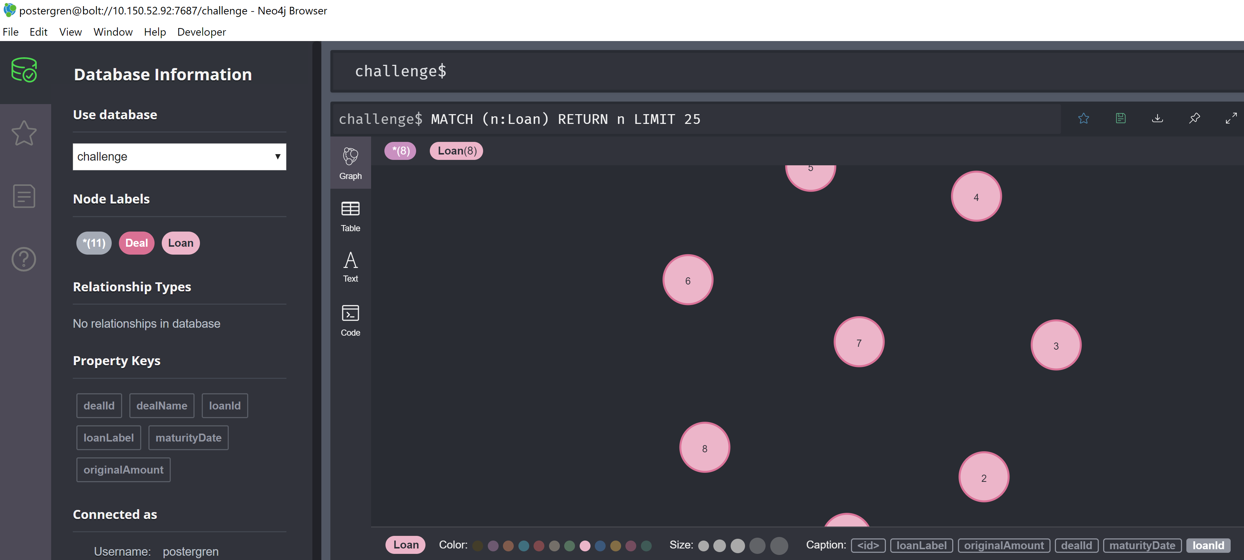

Not needed?

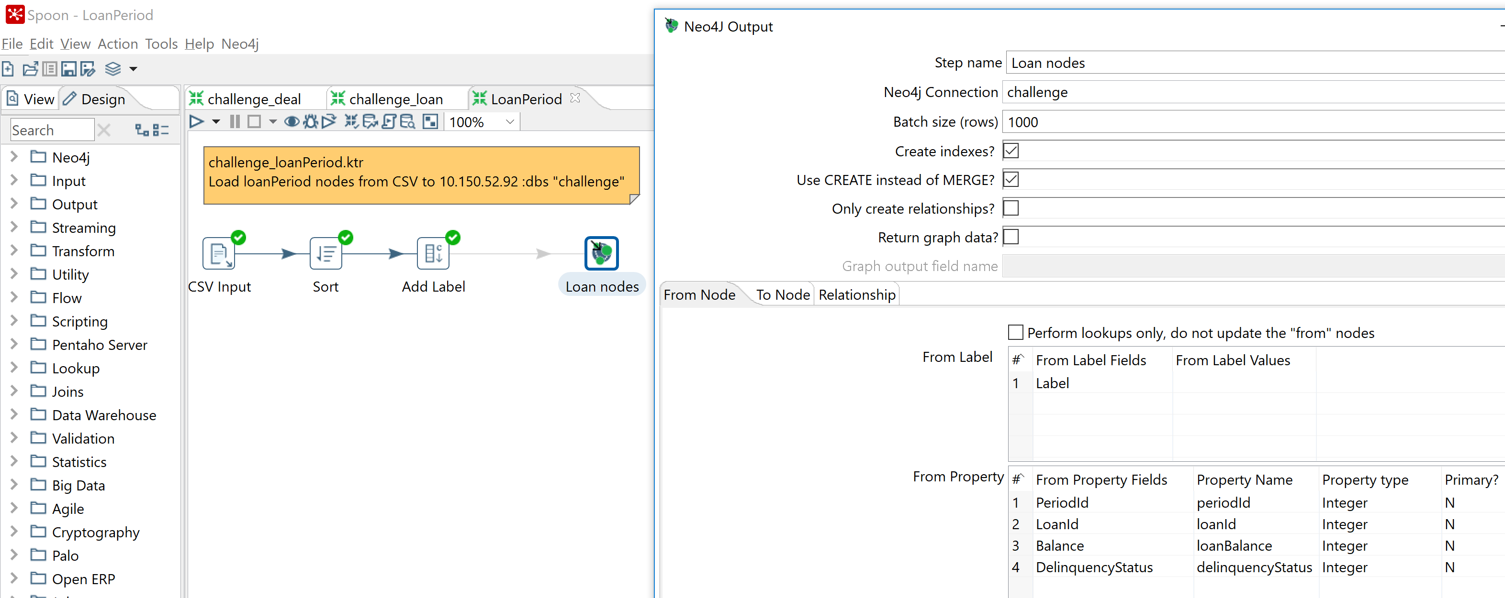

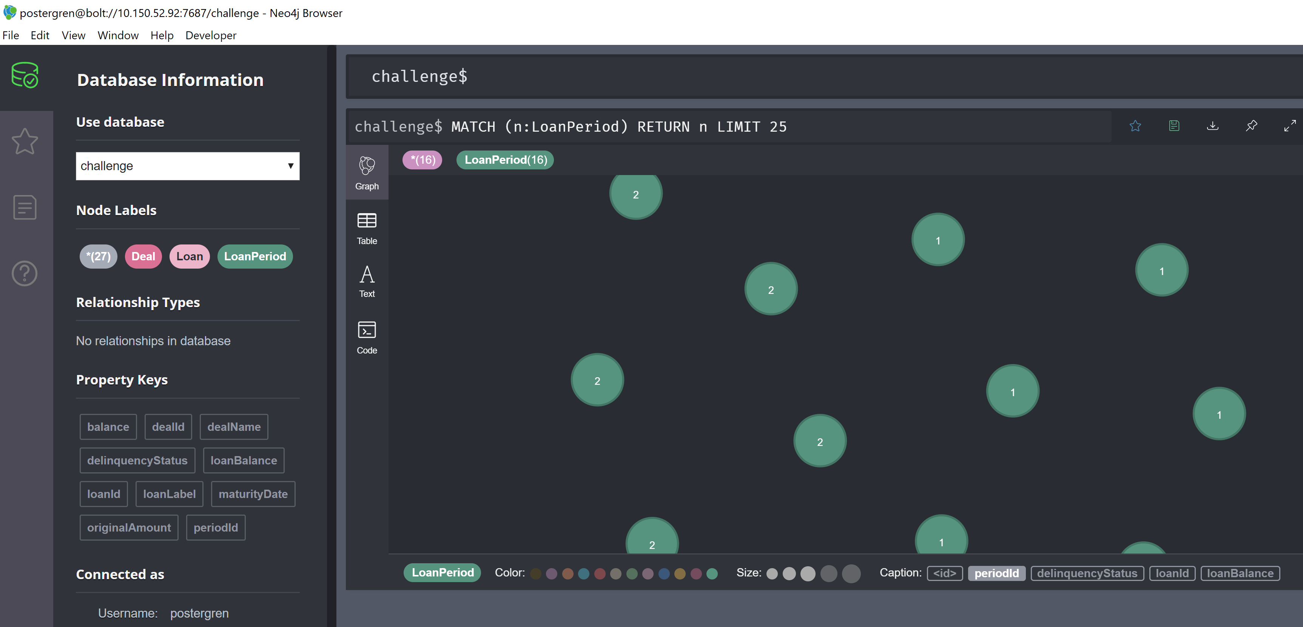

//Add Deal:Loan relationships  
MATCH (d:Deal), (l:Loan) WHERE d.dealId = l.dealId CREATE (d)-[:CONTAINS]->(l)

LOAD CSV WITH HEADERS FROM "http://localhost/Equipments.csv" AS row

MERGE (e:Equipment {eqp_id: row.eqp_id, name: row.name, type_id: row.type_id})

WITH e, row

MATCH (te:Equipemnt_Type)

WHERE te.type_id = row.type_id

CREATE (e)-[:TYPE_OF]->(te)

//Delete relationships  
MATCH ()-[r:CONTAINS]->() DELETE r

//Add Loan:LoanPeriod relationships  
MATCH (l:Loan), (p:LoanPeriod) WHERE l.loanId = p.loanId CREATE (l)-[:HAS_BALANCE]->(p)