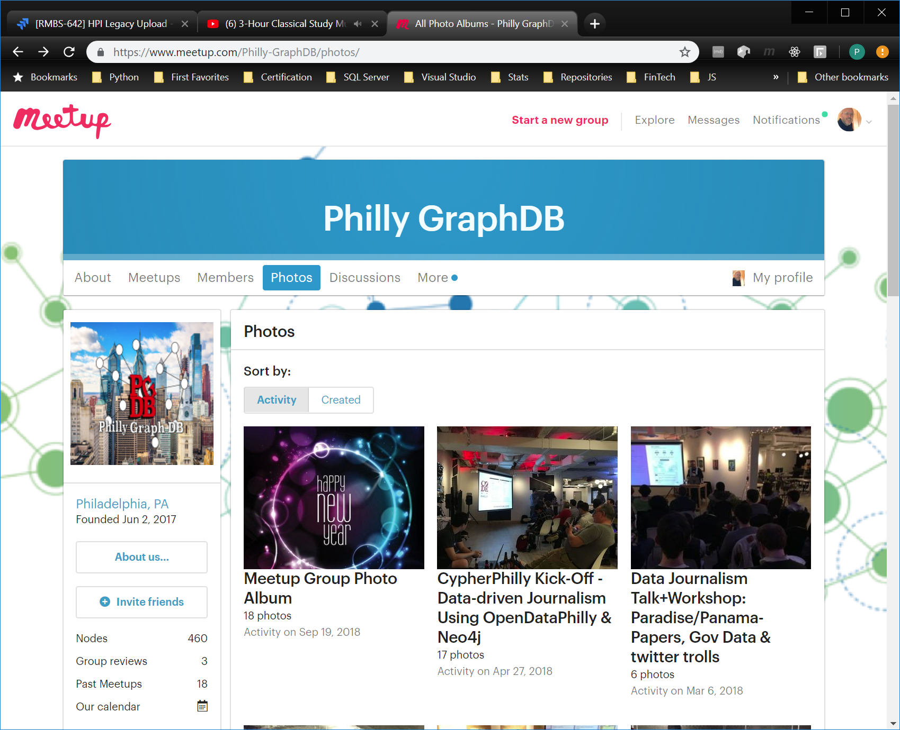

Narration for FinTech Example

## Introduction

Hello, my name is Pete Ostergren. I am a Business Intelligence Developer with KBRA. KBRA is Kroll Bond Rating Agency. We are in the Financial Technology sector commonly referred to as FinTech. When we have the need to recruit additional people to work with our databases we use a so called ‘Whiteboard Exercise’ during our interview process. Tonight, I am going to use a FinTech whiteboard exercise to transition you from a relational db to a graph db. In this MeetUp we are primarily focused on community oriented non-profit activities, (pause) we are using this example to give us another perspective, working with graph db’s to sharpen our skills for our primary focus.

## Handout 1 Side 1

(Pass out handout 1) This the actual document given to candidates, looking at this you will see an entity relationship diagram and the data contained in the diagramed tables. At the bottom are two queries that I ask candidates write on the whiteboard that is in the conference room being used for the interview. (point to someone on the left) Would you please read the first query? Is it a reasonable question to ask of a database? (point to someone on the right) Please read the second query, again it seems like a reasonable question to ask, do you agree? (ERD on laptop is displayed on screen) The lines between the tables show the relationships between them. Relationships. That’s why I first got into databases, because life is all about relationships. Walks on the beach, holding hands, long conversations. But like real life relationships can be limiting, they can put constraints on you.

## Handout 1 Side 2

(Flip over page) Here we see some of the constraints that relational databases impose. Here we can see the insert statements to put in data, must first be proceeded by create table statements. And anyone who has ever run an insert statement knows all the columns in the insert must be lined with and conform to the create statements exactly. There are however answers to the two query challenges. One average balance, I think is $4??k and the other is? (point to someone to supply the $5??k) and the loans that had a change in delinquency status are? (point to someone else to supply 1, 4, 8).

## Handout 2 Side 1

Perform a live Community Edition install from pre-downloaded Zip file. Note issue with Java environment variables. Review IDE. List :PLAY options.

## Handout 2 Side 2

Run queries and talk thru features