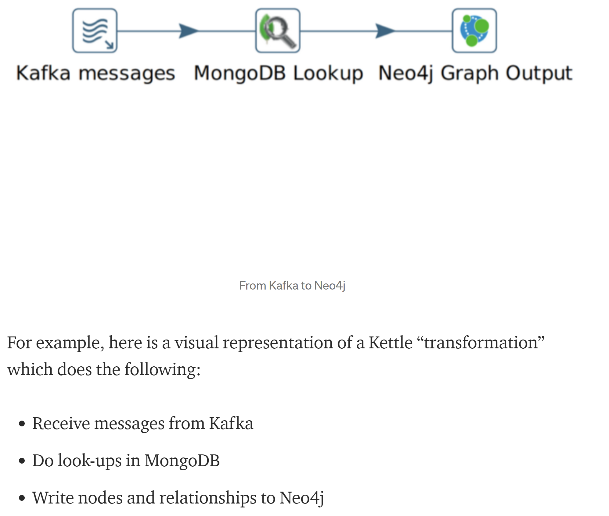



2020/11/01 18:47:00 - CSV Input.0 - Finished processing (I=4, O=0, R=0, W=3, U=0, E=0)

2020/11/01 18:47:00 - Sort.0 - Finished processing (I=0, O=0, R=3, W=3, U=0, E=0)

2020/11/01 18:47:00 - Add Label.0 - Finished processing (I=0, O=0, R=3, W=3, U=0, E=0)

2020/11/01 18:47:00 - Deal nodes.0 - Finished processing (I=0, O=3, R=3, W=3, U=0, E=0)

2020/11/01 18:50:28 - Sort brand.0 - Finished processing (I=0, O=0, R=2036, W=2017, U=0, E=0)

2020/11/01 18:50:28 - Add Brand Label.0 - Finished processing (I=0, O=0, R=2017, W=2017, U=0, E=0)

2020/11/01 18:50:31 - Brand nodes.0 - Finished processing (I=0, O=2017, R=2017, W=2017, U=0, E=0)