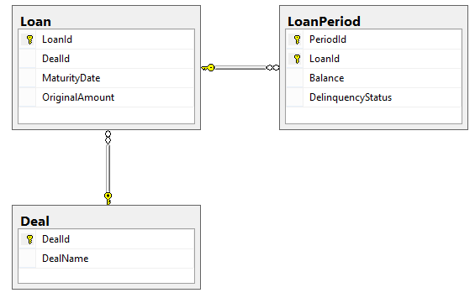

|  |  |
| --- | --- |
| SELECT * FROM Deal  **DealId DealName**  1 SQ101  2 SQ131  3 SQ132 | SELECT * FROM Loan  **LoanId DealId MaturityDate OriginalAmount**  1 1 2026-07-01 243546.00  2 1 2031-02-01 465764.00  3 1 2035-03-01 354657.00  4 1 2029-06-01 645342.00  5 1 2027-11-01 534231.00  6 2 2034-12-01 523421.00  7 2 2033-11-01 445231.00  8 2 2037-09-01 601201.00 |
| SELECT * FROM LoanPeriod  **PeriodId LoanId Balance DelinquencyStatus**  1 1 241844.00 0  1 2 463521.00 0  1 3 352657.00 0  1 4 645342.00 3  1 5 531210.00 0  1 6 521201.00 0  1 7 443231.00 0  1 8 601201.00 1  2 1 241844.00 1  2 2 451321.00 0  2 3 350543.00 0  2 4 645342.00 4  2 5 529321.00 0  2 6 519321.00 0  2 7 441209.00 0  2 8 601201.00 2 | |

Using this data please use the whiteboard to construct these queries:

Query 1: What was the average loan balance for each deal during period 2?

Query 2: Which loans had a change in delinquency status between period 1 and period 2?

Database Skills Demonstration

The following exercises should be completed on a localhost database named ‘SQL Sample’.

Schema Preparation:

CREATE TABLE LoanPeriod (

PeriodId INT NULL,

LoanId INT NULL,

Balance DECIMAL(19, 2),

DelinquencyStatus INT NULL

);

CREATE TABLE Loan (

LoanId INT NULL,

DealId INT NULL,

MaturityDate DATE NULL,

OriginalAmount DECIMAL(19 , 2)

);

CREATE TABLE Deal (

DealId INT NULL,

DealName VARCHAR(10) NULL

);

INSERT INTO LoanPeriod VALUES

(1, 1, 241844.00, 0),

(1, 2, 463521.00, 0),

(1, 3, 352657.00, 0),

(1, 4, 645342.00, 3),

(1, 5, 531210.00, 0),

(1, 6, 521201.00, 0),

(1, 7, 443231.00, 0),

(1, 8, 601201.00, 1),

(2, 1, 241844.00, 1),

(2, 2, 451321.00, 0),

(2, 3, 350543.00, 0),

(2, 4, 645342.00, 4),

(2, 5, 529321.00, 0),

(2, 6, 519321.00, 0),

(2, 7, 441209.00, 0),

(2, 8, 601201.00, 2);

INSERT INTO Deal VALUES

(1, 'SQ101'),

(2, 'SQ131'),

(3, 'SQ132');

INSERT INTO Loan VALUES

(1, 1, '2026-07-01', 243546.00),

(2, 1, '2031-02-01', 465764.00),

(3, 1, '2035-03-01', 354657.00),

(4, 1, '2029-06-01', 645342.00),

(5, 1, '2027-11-01', 534231.00),

(6, 2, '2034-12-01', 523421.00),

(7, 2, '2033-11-01', 445231.00),

(8, 2, '2037-09-01', 601201.00);

Using the data loaded above, two sets of queries will give you an opportunity to demonstrate some of your data skills.

The first set of queries focus on the average loan balance for each deal during period 2. Write queries to return rows in the formats show.

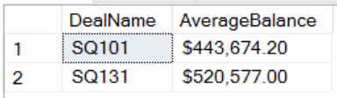Query 1: Standard format:

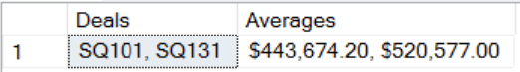

Query 2: Concatenated lists:

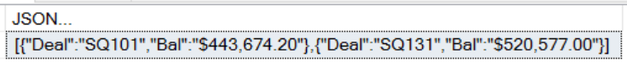

Query 3: Key:Value pairs:

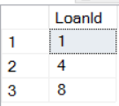The second set of queries return the list of loans that had a change in delinquency status between period 1 and period 2.

Query 4: Use a JOIN

Query 5: Use a Window Function

Query 6: Use a Set Operator