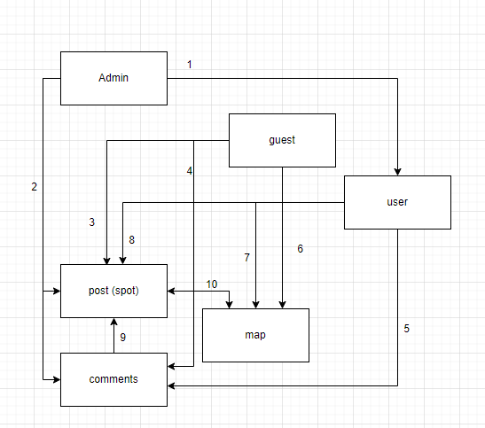
- Admins var rediget userus
- Admins var rediget postus un komentarus
- Guests var redzet postus
- Guests var redzet komentarus
- User var rakstit, redzet un dzest komentarus
- Guest var redzet mapi
- User var redzet mapi
- User var pievienot, dzest postu (spotu)
- Commenti ir pielikti pie konkreta posta
- Mape attelo postus (spotus)

User
 | Is admin | id | nickname | e-mail | Password | Profile pic
Admin | True (bool) | Int | String | String | String | Bin
User | False (bool) | Int | String | String | String | Bin

Post (spot)
Id | Name | Description | Geolocation | User id | Karma | Time
Int | String | String | String | int | int | Datetime

Comment
Id | Post id | User id | Text | Time | Karma
Int | Int | Id | String | Datetime | Int

Picture
Id | Post id | Picture
Int | Int | Bin

