MAE 770, Combustion of Reacting Flows

Project 2: Reacting-Gas Nozzle Flow, Re-Entry Conditions

Sailor Koeplinger

**Objective**: Write a program to solve the steady state quasi 1D reacting-gas nozzle problem in re-entry-like conditions for 5 species air and thermal nonequilibrium. The problem setup is described in detail in the project prompt. One difference is that this work uses a modification of the McBride curve fits for computing non-equilibrium thermodynamics instead of other thermodynamic state descriptions.

**Spatial Discretization**: Finite Volume with upwinding – **LDFSS(**primary) and **Van Leer**(for comparison).

**Integration/Solution Process**: Explicit handling of fluid equation system, implicit handling of thermochemical nonequilibrium source terms. Solution is initialized and advanced in pseudo-time until the convergence criterion is met. For this project, the convergence criteria is set to be when the sum of normalized residuals is below 10-6. The species density residuals are normalized by the sum of the initial species density residuals. The energy residuals were each normalized by their initial value. To solve the implicit system on each element, LU factorization with partial pivoting was used.

**Initialization**: The flow was initialized using two reference conditions. The first is the freestream/inlet condition, which was used to initialize the flow from x=0 to x=0.8. Then approximate post-shock conditions are calculated using normal shock relations, and those used to initialize the rest of the flow.

**Boundary Condition**: The ghost cell method is used to enforce boundary conditions. The inflow (left) boundary cell is set to freestream conditions. The outflow (right) cell is set to provide backpressure by increasing the mixture density.

**Chemistry:** 5 species air with 5 reactions for the dissociation of O­2, N2, and NO, and the production of NO. The standard Arrhenius form is used for the forward reaction rates, and the equilibrium reaction rate was determined using the given expression. Chemical source terms are set to 0 for temperatures below 1000K, to remain within the limits of the curve fit. Rates evaluated using $T= \sqrt{T_{tr}T_{ve}}$.

**Thermal Nonequilibrium**: Thermal nonequilibrium was done in the manner described in the Vulcan CFD Theory Manual. A two-temperature model was used which consists of a temperature for translation and vibrational modes, Ttr­, and one for vibrational and electronic modes, Tve. It is assumed that the trans-rot energy modes are fully excited, implying that the respective specific heats are constant. With that assumption, the McBride curve fits can be split into a partition which contributes to the trans-rot energy and another which contributes to the vib-electric energy. Only the trans-rot temperature is used for pressure calculations and any other applications of the perfect gas assumption for gas mixtures. The Landau-Teller vibrational/translational energy relaxation process is used with the relaxation time model of Millikan and White.

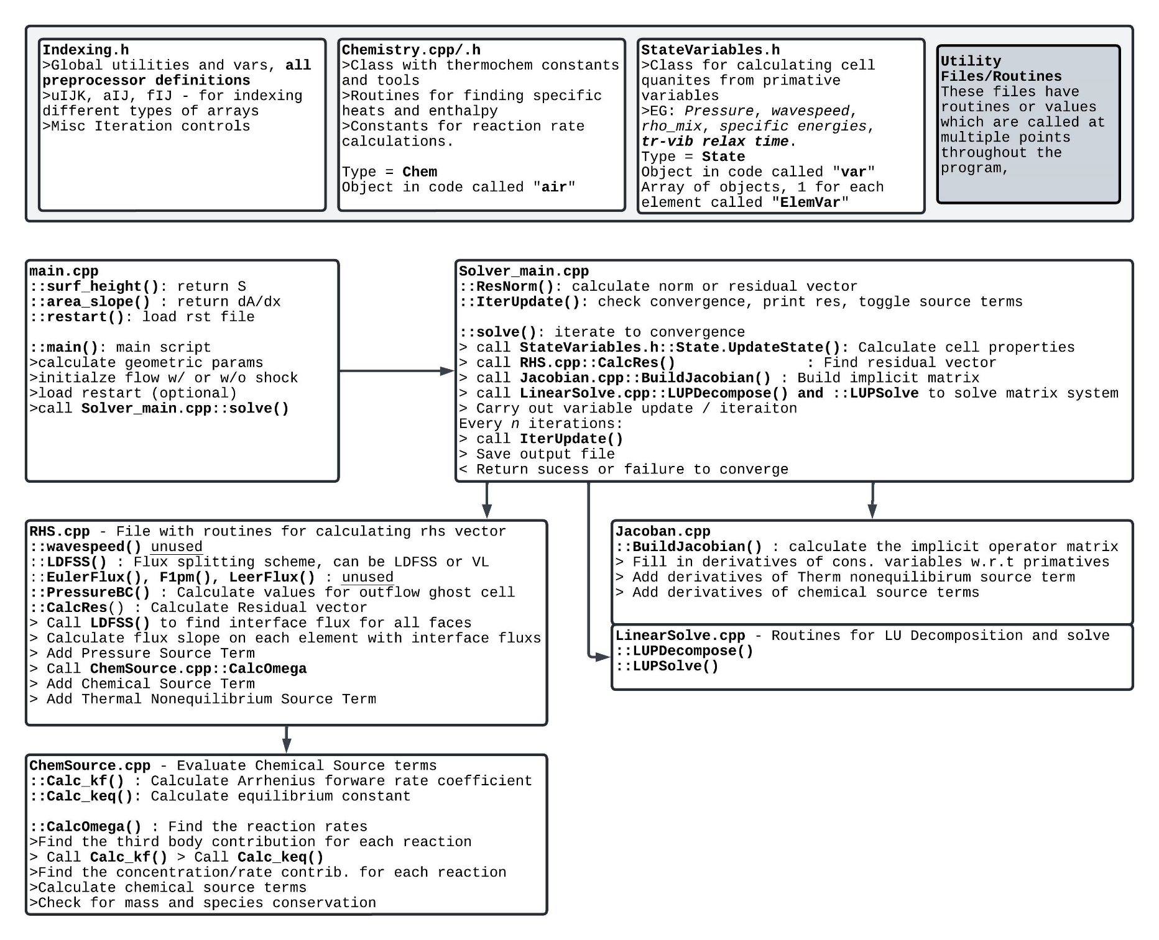**Code Map/Diagram**

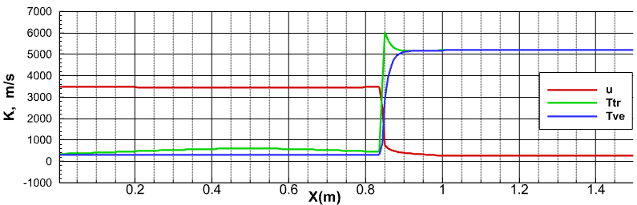**Solutions with Varying Degrees of Non-Equilibrium**

Thermal Non-Equilibrium

Chemical Equilibrium

Thermal and Chemical Equilibrium

Frozen and with chemistry

Try 2 upwinding

Chemical source Jacobian simplification

Performance of schemes in resolving FOI/stability/convergence rate

**FOI: shock position, temperature, pressure, mass fraction**

Density x 10 and x 25

Effect of boundary conditions