MAE 770, Combustion of Reacting Flows

Project 3, Option II: Droplet Vaporization

Sailor Koeplinger

**Objective**: Implement the two-phase homogeneous mixture model discussed in class to solve the problem of shock-induced vaporization of rocket fuel in air. This is framed as an extension to Project 2 and used that code as a starting point.

**Spatial Discretization**: 1D Finite Volume using LDFSS for flux upwinding.

**Integration/Solution Process**: Explicit fluxes and source terms. Fluxes are found in conservative form and then projected onto primitive variables using the form:

The solution is initialized and advanced in pseudo-time until the convergence criterion is met. To solve the system on each element, LU factorization with partial pivoting was used. The primitive variables solved for are . For stepping in pseudo-time: . A CFL number of 0.4 number was used for this project.

**Convergence:** The convergence criteria is set to be when the sum of normalized residuals is below 10-6. The species density residuals are normalized by the sum of the initial species density residuals. The energy residuals were each normalized by their initial value.

where indicates an L2 norm.

NOTE: For cases with droplet evaporation the residuals can get stuck at minimum value. In those cases, the solution is advanced until the residuals have established a steady behavior, and the solution is accepted if the residuals have demonstrated at least a 3 order of magnitude drop.

**Initialization**: The flow was initialized using two reference conditions. The first is the freestream/inlet condition, which was used to initialize the flow from x=0 to x=0.8. The second is an approximate post-shock conditions are calculated using normal shock relations, which is used to initialize the rest of the flow. The baseline inflow conditions for this project are P = 0.5 atm, T = 300K, and initial droplet diameter = 20 microns. The ratio of mass fractions of O2 and N2 were set to approximate values based on their concentration in air; 24 parts oxygen to 76 parts nitrogen. The fuel is initially all liquid, with a mass fraction of 0.06.

**Boundary Condition**: The ghost cell method is used to enforce boundary conditions. The inflow (left) boundary cell is set to freestream conditions. The outflow (right) cell is set to provide backpressure. The ratio of pressure used is 10 times the freestream static pressure.

**Thermodynamics:** Burcat data was used for handling the thermodynamics of nitrogen and oxygen. The given McBride style fit was used for the rocket fuel.

**Multi-Phase:** The two-phase flow was handled using the droplet vaporization model presented in the project handout. The phases are assumed to be in thermal, mechanical, and kinematic equilibrium. The liquid mass fraction and droplet density is advected, and there is a source term for vaporization of the droplets. The sound speed is calculated as:

**du/dV Jacobian**: The coordinate transform jacobian was computed by a combination of analytical and numerical means. The derivatives , , and , were computed by a forward difference, with step sizes of 1E-8 times the current value of the respective variable. The rest of the derivates were done analytically based off the definition and models given for the primitive variables.

1. **Baseline Solution**

The conditions used for the baseline solution are:

* 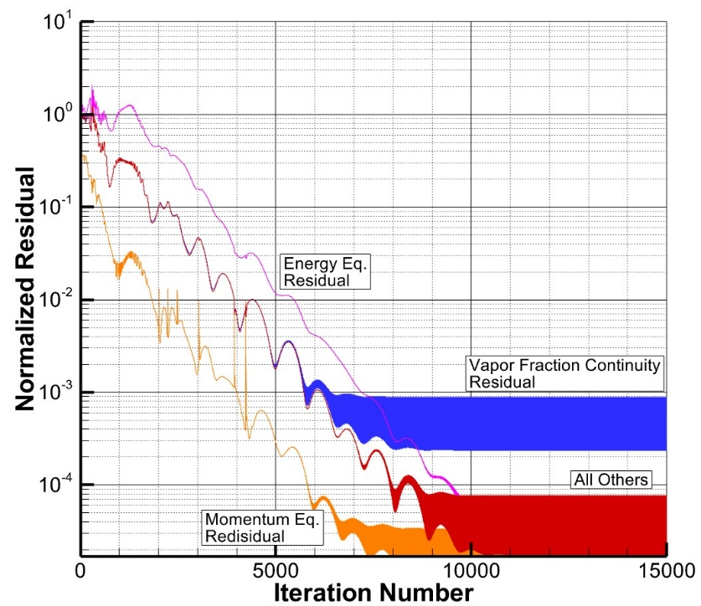Mach = 2.5

Figure 1: Residual History for the Baseline Solution.

* Pinf = 101325.0 Pa
* Tinf = 300 K
* yN2 = 0.76
* yO2 = 0.24
* yRP = 0.00
* Yv = 0.94
* Yl = 0.06
* dp, inf = 20.0 E-6
* K = 0 (slip velocity)

(RP = Rocket Propellant)

The baseline solution was not able to achieve the desired convergence, but it was able to settle on a solution while dropping the residuals all by at least 3 orders of magnitude, as shown in figure 1. The continued oscillations are believed to be caused by the model used for droplet vaporization when the liquid mass fraction approached zero. The basic flow variables for the baseline solution are displayed in figure 2. Like the previous project, note the supersonic compression through the nozzle, and shock in the expanding section. It was found that a backpressure ratio of 10 was sufficient to place the shock in a good spot in the nozzle. The pressure and velocity contours look very similar to the previous project’s chemically frozen flow case; but, the temperature seems to be flat through the continued divergent section after the shockwave. The reason for the absence of the 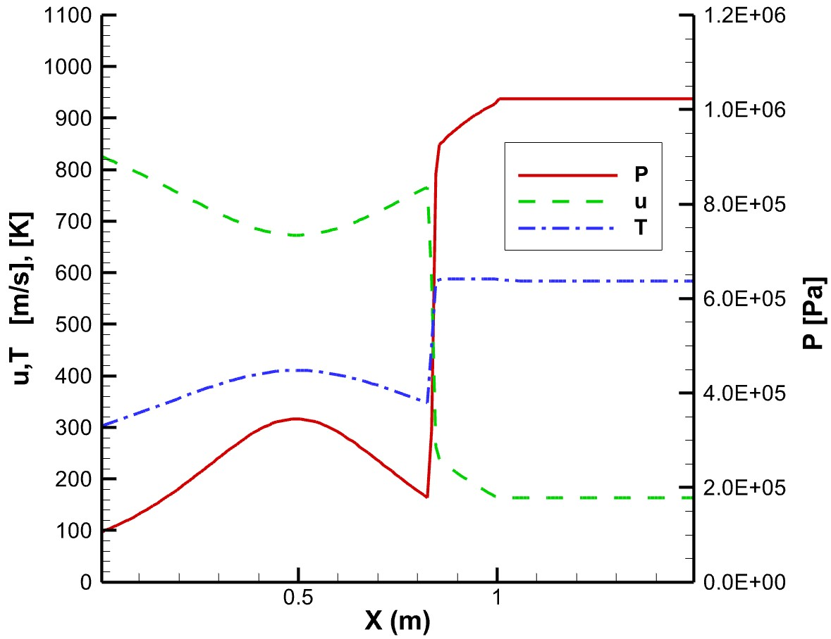temperature increase is reasoned to be the energy going into vaporizing the fuel. More on that will be covered later in the report. Figure 3 contains the distributions of mass fraction and droplet size throughout the flow. For this case there are no interactions between the phases prior to the shock itself. At that point the droplet size drops and the mass fraction of liquid begins decreasing. The flow is fully vapor at about x=1.1 meters, about 0.25 meters after the shock. The mass fractions appear to follow a logistic curve, a smooth almost linear transition from one level to another. The vapor fraction becomes equal to 1 as all the liquid is vaporized. The existing vapor component mass fractions both decrease, since the vaporized fuel is now becoming a component which contributes to the vapor mass fraction.

Figure 2: Pressure, Velocity, and Temperature for the baseline solution.

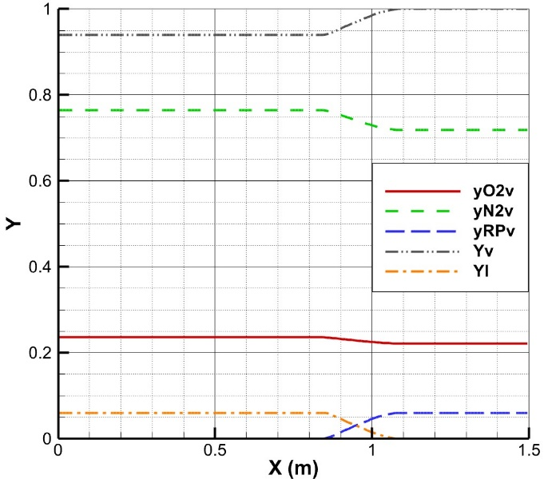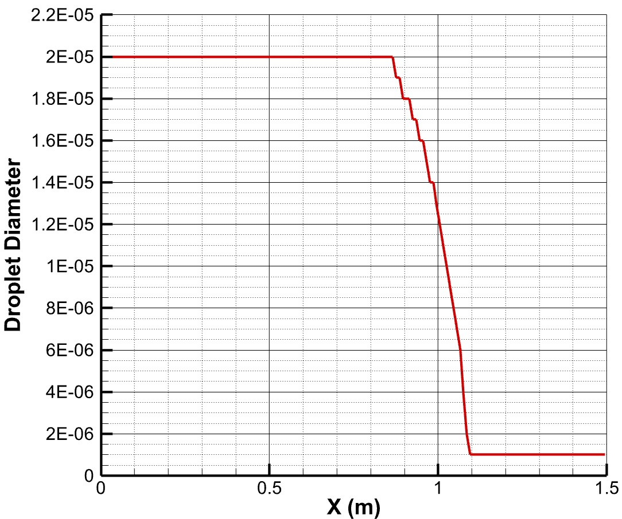

Figure 3: Mass Fraction and Droplet Size distributions for the baseline solution.

1. **High Temperature Solution**

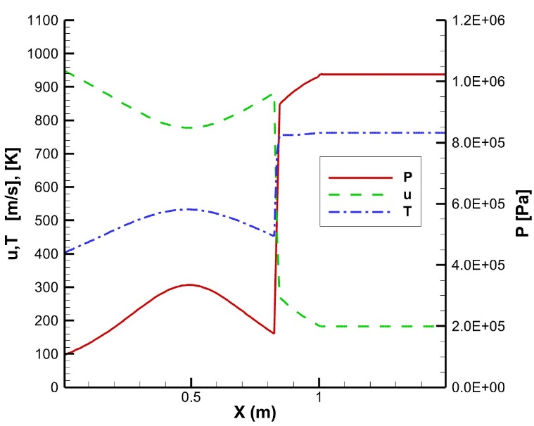The conditions used for the hot solution are:

* Mach = 2.5
* Pinf = 101325.0 Pa
* **Tinf = 400 K**
* yN2 = 0.76
* yO2 = 0.24
* yRP = 0.00
* Yv = 0.94
* Yl = 0.06
* dp, inf = 20.0 E-6
* K = 0 (slip velocity)

(RP = Rocket Propellant)

Figure 4: Pressure, Velocity, and Temperature for the hot solution.

The hot solution shows the same behavior as the baseline solution in terms of the basic flow variables. While the patters are the same, the actual values do differ significantly. The temperature now varies from 400 to 550 K before the shock, and go to over 700K after the shock. The velocity is higher because of the increase in sound speed. The shock occurs in the same location as the baseline.

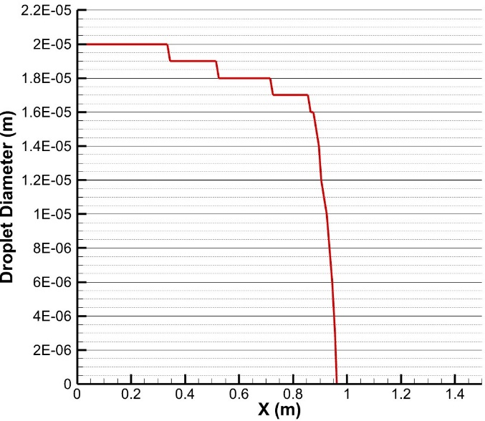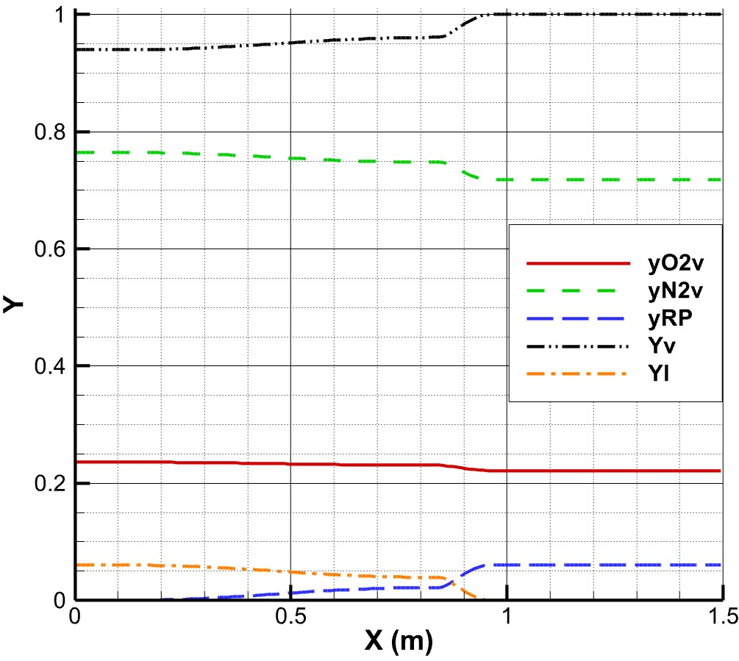

Figure 5: Mass Fraction and Droplet Size distributions for the hot case.

The vaporization does behave differently than the baseline case. The higher temperatures in the supersonic compression region result in partial vaporization of the fuel, and a small decrease in droplet size. The fuel is completely vaporized after the shock, and in fact the vaporization happens at a faster rate than the baseline case. Thus we can conclude that an increase in temperature speeds up the rate at which the droplets evaporate.

1. **Non-Zero Slip Velocity Solution**

The conditions used for the hot solution are:

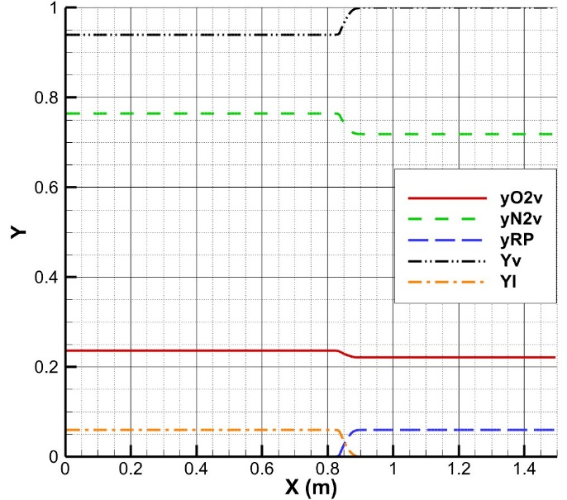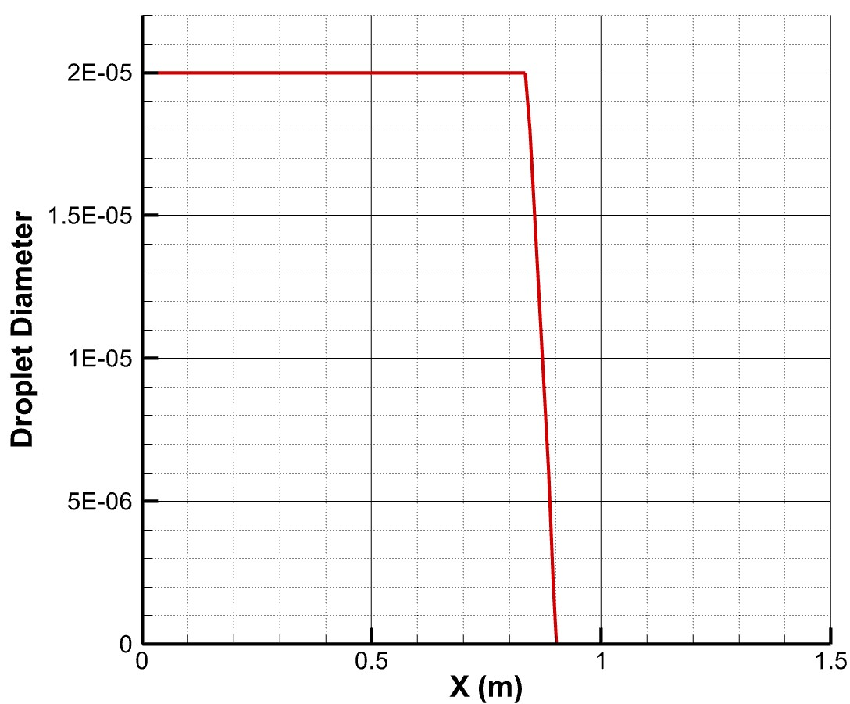

* Mach = 2.5
* Pinf = 101325.0 Pa
* Tinf = 300 K
* yN2 = 0.76
* yO2 = 0.24
* yRP = 0.00
* Yv = 0.94
* Yl = 0.06
* dp, inf = 20.0 E-6
* **K = 1.0 (slip velocity)**

(RP = Rocket Propellant)

Next, the slip velocity coefficient was changed such that . The results from this change are shown in figure 6. Similar to the baseline case, the mass fraction do no change through the supersonic compression region. In contrast to the baseline case, the rate of vaporization after the shock is greatly enhanced. With this setting, the region of vaporization is shorter than 0.1 meters. The fall in droplet size is also enhanced greatly.

We have shown that the phase transition can be highly sensitive to this parameter; thus, when this model is used to perform analysis of two-phase flows, it is important that this parameter is well estimated, or calibrated by some experimental data. This uncertainty in the rate of vaporization could have large implication on the combustion characteristics of the vaporized fuel; and furthermore, any design or other work which is done with that information.

Figure 6: Mass Fraction and Droplet Diameter distribution for the non-zero slip velocity case.

1. **Smaller Initial Droplet Size Solution**

The conditions used for the hot solution are:

* Mach = 2.5
* Pinf = 101325.0 Pa
* Tinf = 300 K
* yN2 = 0.76

Figure 7: Mass Fraction and Droplet Size Distributions for the smaller initial droplet size case.

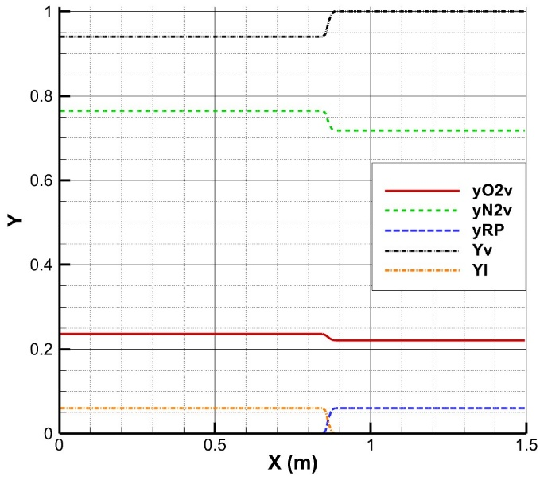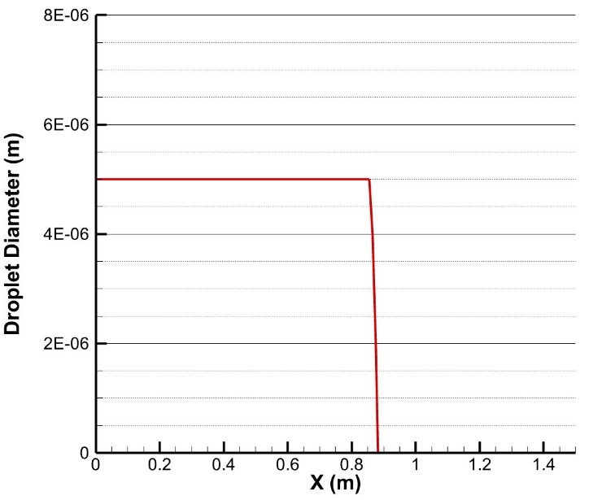

* yO2 = 0.24
* yRP = 0.00
* Yv = 0.94
* Yl = 0.06
* **dp, inf = 50.0 E-6**
* K = 0.0 (slip velocity)

(RP = Rocket Propellant)

Now we will look at the effect of reducing the incoming droplet size. We notice that this has a very similar effect to increasing the slip velocity. The rate of vaporization is sped up incredibly, and the droplet size almost instantly goes to zero.

This shows just how sensitive the solution is to droplet size. It can have very large implications on the solutions obtained with this method and any design or other work which uses those results. Any application of this method in practice should make sure to have accurate measurements or predictions of the liquid droplet size.

Applying these results to the design of some type of combustor: if a high rate of vaporization is important for a given design, it is favorable to have small injectors, or a fast crossflow. In scramjet application especially, it would be beneficial to have smaller droplet sizes since the residence time of the flow is so incredibly low.

1. 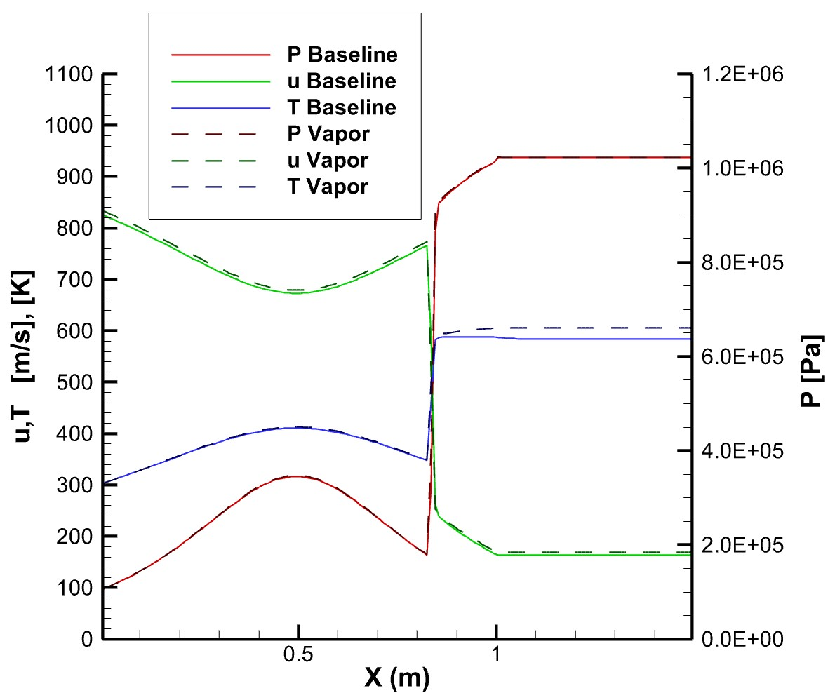**Comparison to Full Vapor / Perfect Gas Solution**

Figure 8: Pressure, Velocity, and Temperature comparing the baseline solution and one in which the fuel is already vaporized.

Finally, the baseline solution is compared to one in which the vapor fraction is set to 1.0, and the rocket fuel is already vaporized. Starting with similarities, both solutions place the shock in the same location, and both solutions match pressure through the whole flow. The pre-shock temperatures also match well. The velocity on the other hand is slightly higher. This is attributed to the slightly higher sound speed of the fully vapor mixture before the shock; and, to the higher temperature after the shock. The increase in temperature after the shock brings it to look like what we would expect from a perfect gas: still increasing in the diverging section after the shock. This confirms the hypothesis stated previously that the lowering of temperature is a result of the energy being used to vaporize the fuel.