CS 255 Module Six Assignment: UML Activity and Sequence Diagram Analysis
Diagram Interpretation
The diagrams describe an ATM cash withdrawal use case. In this use case, the user inserts a card, enters a PIN, and the ATM verifies the PIN with the bank before allowing the user to continue. If the PIN is valid, the ATM asks the user for a withdrawal amount, receives that amount, and then dispenses cash. The activity diagram shows the main flow as a series of decisions and actions, including PIN verification, amount entry, whether the amount is available, cash dispensing, receipt generation, and receipt printing. The sequence diagram shows the communication between the user, the ATM, and the bank. Information passed back and forth includes the card entry, PIN request, entered PIN, PIN verification request, PIN valid response, amount request, entered withdrawal amount, and cash dispensing. Together, the diagrams show the same ATM withdrawal process, but the activity diagram focuses on the workflow while the sequence diagram focuses on the messages between participants.
Design Analysis: Deficiencies and Improvements
One deficiency is that the original design verifies the PIN, but it does not show what should happen after repeated incorrect PIN entries. A real ATM should limit the number of attempts, such as three tries, and then retain the card or end the transaction for security. Without that logic, the diagram makes it seem like a user could continue trying PINs without a clear stopping point. Another deficiency is that the sequence diagram does not clearly show the ATM checking the requested withdrawal amount with the bank before dispensing cash. The activity diagram includes an “amount not available” decision, but the sequence diagram jumps from entering the amount to dispensing cash without showing a balance check, insufficient funds response, or account debit. This could cause confusion because the ATM should only dispense cash after the bank confirms the account has enough funds and records the transaction. A third improvement would be to add a receipt choice instead of automatically generating and printing a receipt. This makes the process more realistic because many ATMs ask whether the user wants a printed receipt.
Chosen Improvement
The reconstructed activity diagram below improves the original design by adding stronger PIN handling, amount validation, bank authorization, insufficient funds handling, account debit/logging, and an optional receipt decision. These changes make the ATM workflow more complete and realistic while keeping the same basic withdrawal use case.
Reconstructed UML Activity Diagram
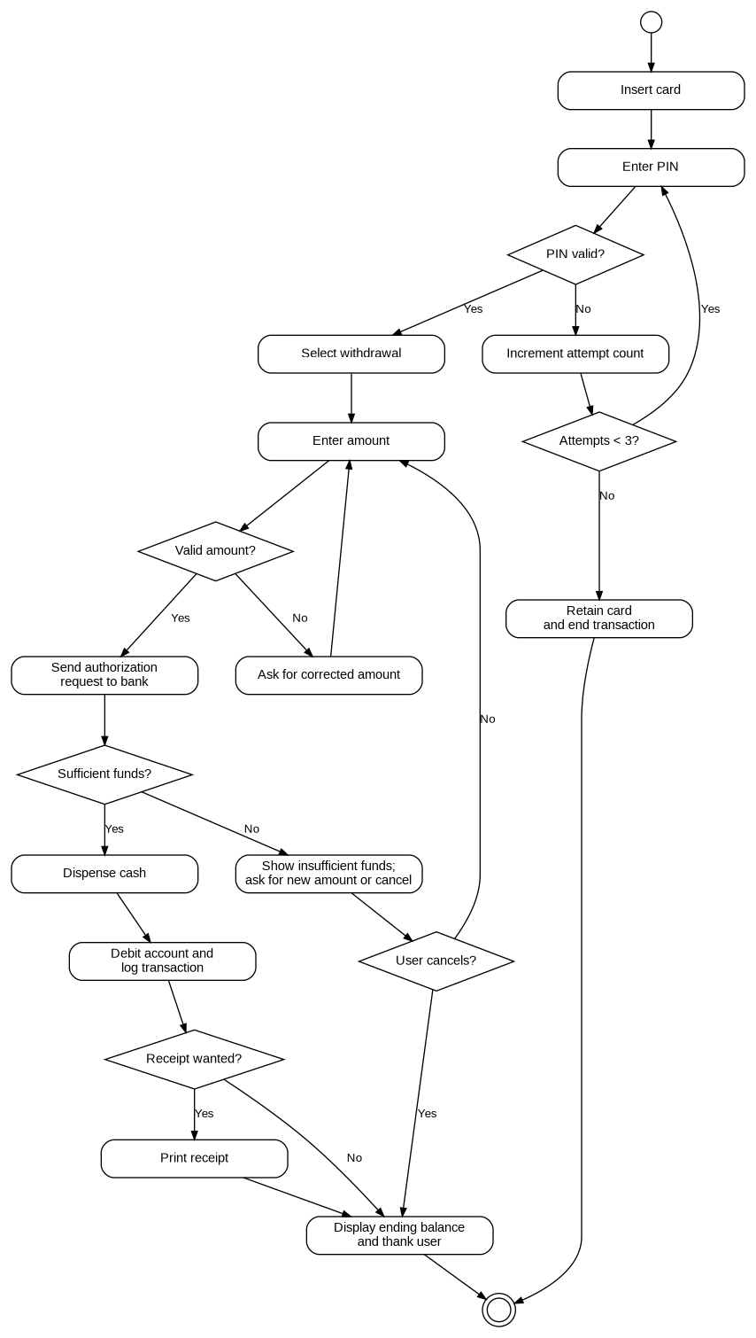
Figure 1. Improved ATM withdrawal activity diagram with PIN attempt limit, bank authorization, and optional receipt.

