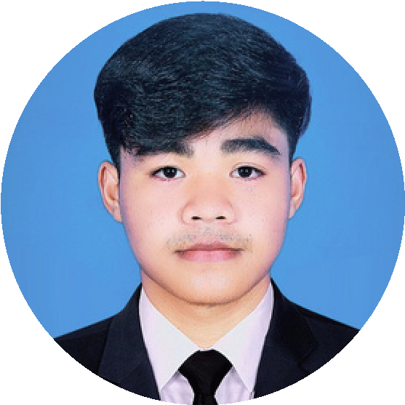
1
Position : IT Programming
PHEARUM PHANUN
Profile
I am 18 years old, from Kandal province. Studying computer science in my second-year at Western University. I’ve gained experience as an IT Programming, IT Support, Barista, Cashier, and Barber. I am currently exploring programming and networking with an interest in cybersecurity. I stay active by working out and focus on self-development. I aspire to become a businessman and leader, aiming for personal and professional growth.
work experience
IT Programming
Marunix (Cambodia) Co.,Ltd, Jun 2025 - Present
- Develop and maintain applications for all departments (Windows / C#).
- Manage and troubleshoot networking systems.
- Handle Microsoft Office licensing (renewal & support).
- Manage and monitor the main server.
- Provide technical support and assistance to other departments when issues arise.
IT Support
Western University Mar 2025 – Jun 2025
- Set-up and install windows operating system.
- Troubleshoot hardware and software.
- Set-up and maintain user account email access permission.
- Manage backups and data recovery.
- Set-up and support printer scanners and other peripherals.

Barista
Dakasi Cambodia Jan 2024 – Jul 2024
- Preparing coffee tea and specialty drinks.
- Providing excellent customer service and taking orders.
- Handling payment and managing the cash register.
- Maintaining cleanliness and adhering to safety standards.
- Restocking with the team for smooth operations.
- Staying creative with drink recipes and trends.

COntact
Phone : 096 404 2114 (Telegram)
Email : ppnun6@gmail.com
Location : Tropeang veng village,
Angksnoul distict,
Kandal Province.
skill
- C++
- Web develop
- Database
- Networking
- Window program
- Microsoft Application
- Google workspace
- Business letter writing

Languages
- Khmer : Native
- English : Good

Archivement
- Received the certificate of graduate from Digital Divide Data Cambodia
- Receive 30% scholarship from Western University
- Receive the certificate of archivement from NRKS Salon

reference
Mr. Choun Sambath
Assistant of Information Technology
Western University
Phone : 015 739 4381

Mr. Boeun Rachhan
Supervisor of IT Department
Marunix Cambodia Co.,Ltd.
Email : boeunrachhan@gmail.com
Phone : 098 864 560

Barber
Sopheak Hairshop (Freelance) Jan 2020 – Jan 2024
- Skilled in providing haircuts and grooming services for clients.
- Experienced in customer interaction.
- Built strong relationships with regular clients by offering friendly.
- Proficient in using barbering tools and maintaining a clean.
- Clean and sanitized work environment in compliance.
- Trained junior babers and shared practical techniques.

Education
Bachelor of computer Science
Western University (Second-year) Jan 2024 – Present

Highschool Diploma Degree
Hunsen Angksnoul Highschool Jan 2020 – Dec 2023

Secondary School
Beckchan Secondary School Nov 2017 – Aug 2020

Primary School
Koyterb Primary School Nov 2011 – Aug 2017

