StudyQuest Testing Evidence
Course: SDEV265
Tester: Krystal
Platform: macOS Tahoe 26.2 (Apple Silicon)
Python Version: 3.13.7
Test Date: February 10, 2026

Testing Environment
Save File Used: studyquest_save.txt

Test Case — Application Launch
Purpose | Verify the application launches successfully without runtime errors.
Result | PASS
Explanation | Application launches using python3 StudyQuest.py and prompts the user for a name before loading the main interface.
Evidence | See screenshot below.

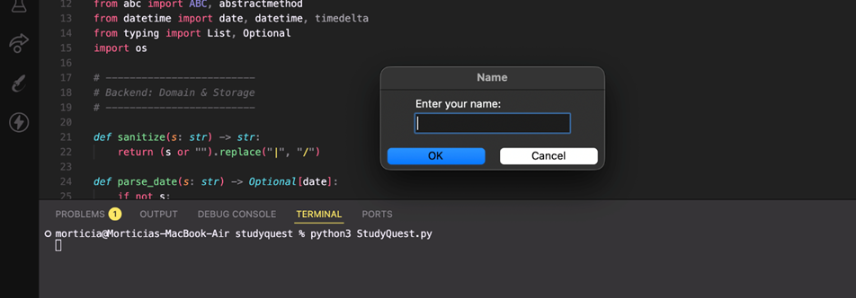
Figure 1: Application startup prompting the user for their name.

Test Case — Save File Loading
Purpose | Confirm that the Tkinter interface renders correctly on macOS and that previously saved user data loads correctly when the application starts.
Result | PASS
Explanation | Existing save files load as expected when the application launches. Player information, including name, tasks, habits, and accumulated XP, persists between sessions and is restored correctly when the application is reopened.
Evidence | See screenshot below.

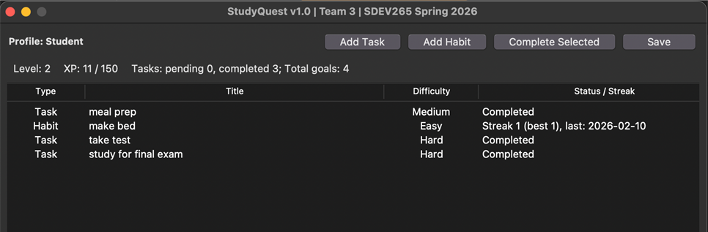
Figure 2: Main StudyQuest interface displaying tasks, habits, XP progress, and level indicator.

Test Case — Dialog and Window Behavior
Purpose | Verify that dialog windows and application behavior function properly on macOS.
Result | PASS
Explanation | In earlier testing, the application window occasionally relaunched behind other active applications instead of appearing in the foreground. After updating to version 3.1, this behavior was retested. The application now relaunches correctly in the foreground and appears immediately when opened.
Evidence | See screenshot below.

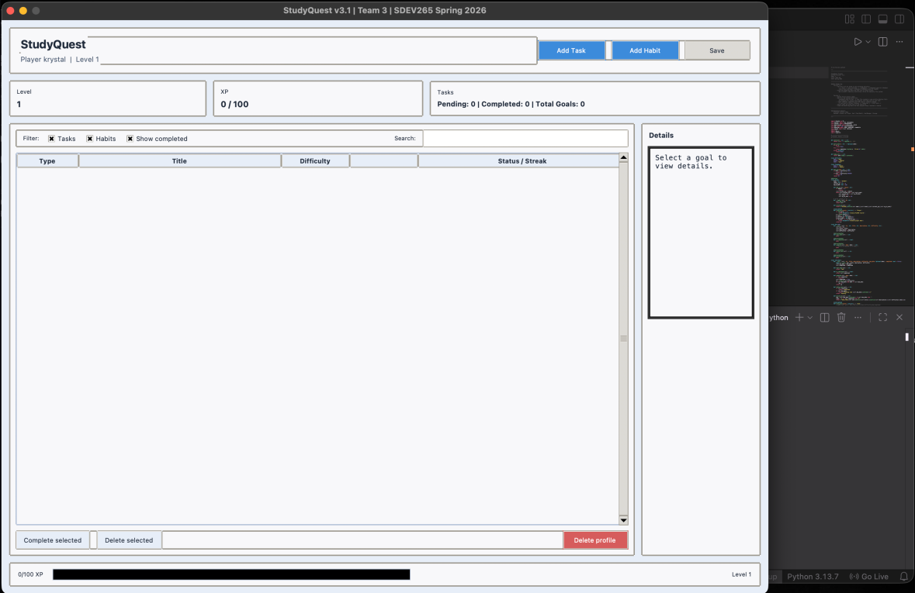
Figure 3: Application window relaunching correctly in front of other active applications.

Test Case — Task Creation and Management
Purpose | Verify that users can create, complete, and view tasks correctly.
Result | PASS
Explanation | Tasks can be created successfully and appear immediately in the task list. Users can mark tasks as completed, and the task status updates correctly in the interface.  During testing, usability improvements were identified:  - Adding a calendar selector for due dates could reduce input errors since dates must currently be typed manually.
Evidence | See screenshot below.

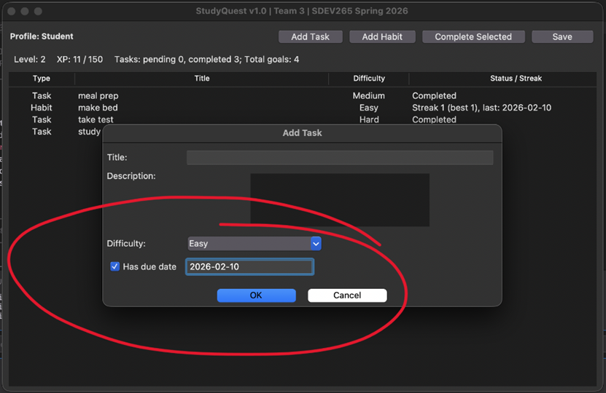
Figure 4: Tasks can be created successfully.

Test Case — Input Validation
Purpose | Verify that the system properly handles invalid user input. (Empty title/Invalid Date)
Result | PASS
Explanation | Validation warnings appear correctly when users attempt to create a task without entering a title or when an invalid due date format is entered. The system prevents the task from being created and displays a clear warning message while keeping the application stable.
Evidence | See screenshots below.

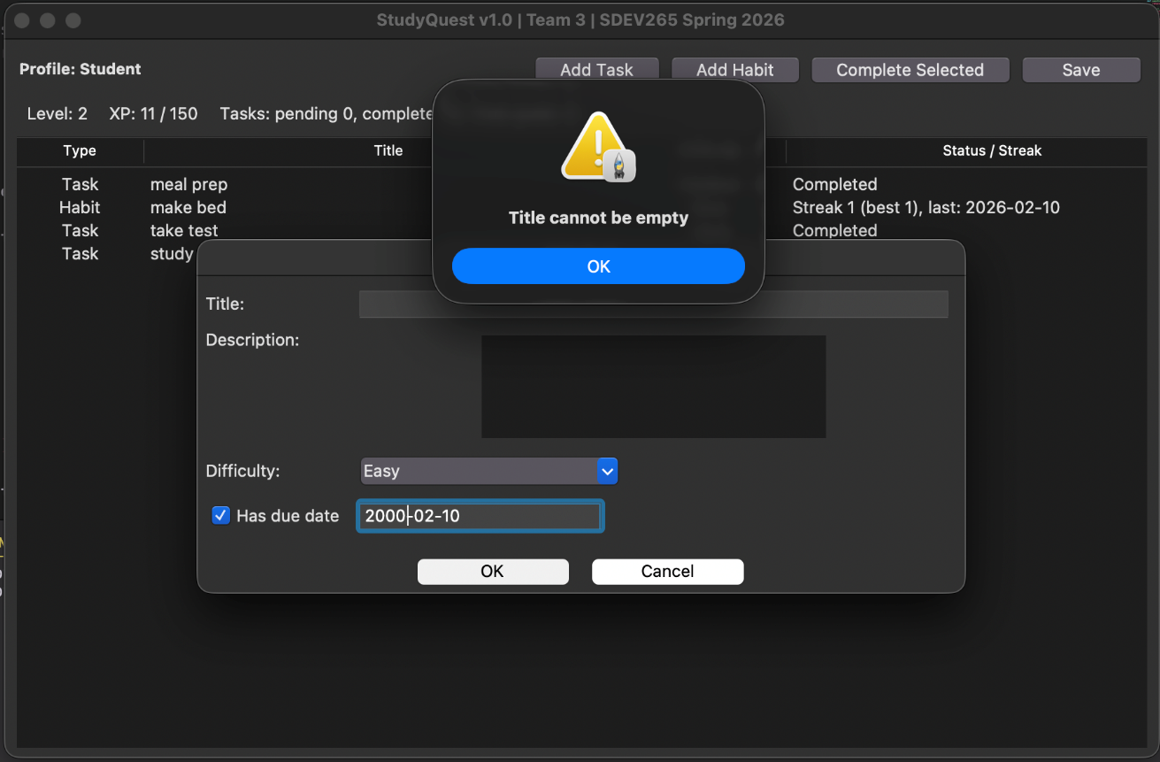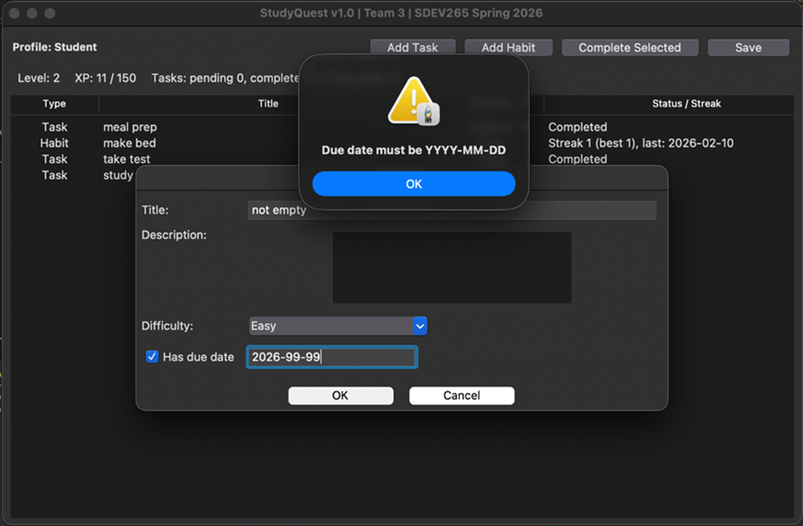
Figure 5.1: Validation warning when task title is left empty.
Figure 5.2: Validation warning when an invalid due date format is entered.

Test Case — Task Completion and XP Reward
Purpose | Verify that completing tasks awards XP.
Result | PASS
Explanation | When a task is completed, an XP reward popup appears and XP values update.
Evidence | See screenshot below.

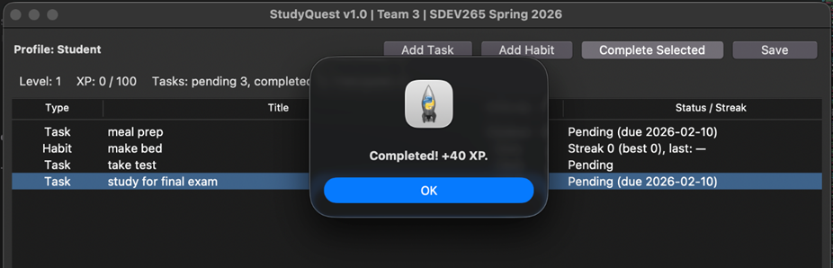
Figure 6: XP reward notification after completing a task.

Test Case — XP and Level Progression
Purpose | Verify that XP rewards and level progression update correctly when tasks or habits are completed.
Result | PASS
Explanation | XP is awarded appropriately when tasks or habits are completed. The XP total updates immediately, and level progression is reflected in the user interface.
Evidence | See screenshot below.

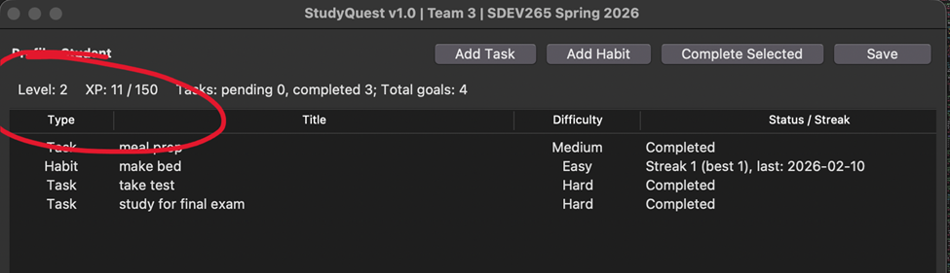
Figure 7: XP progress and level indicator updating after task completion.

Test Case — Habit Tracking
Purpose | Verify that habits track completion streaks correctly.
Result | PASS
Explanation | Habit streaks update correctly when habits are completed.
Evidence | See screenshot below.

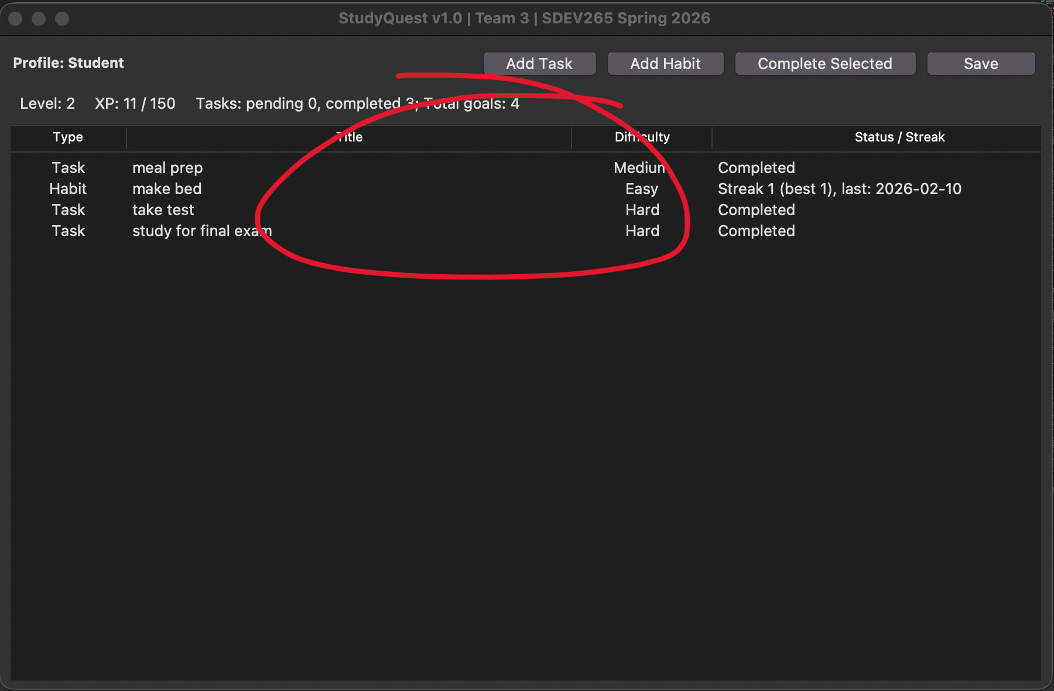
Figure 8: Habit streak tracking shown in the task list.

Test Case — Save File Persistence
Purpose | Verify that the application creates and updates the save file correctly on macOS.
Result | PASS
Explanation | The application successfully creates and updates the studyquest_save.txt file without any permission issues on macOS. Data persists correctly after closing and reopening the application.
Evidence | See screenshot below.

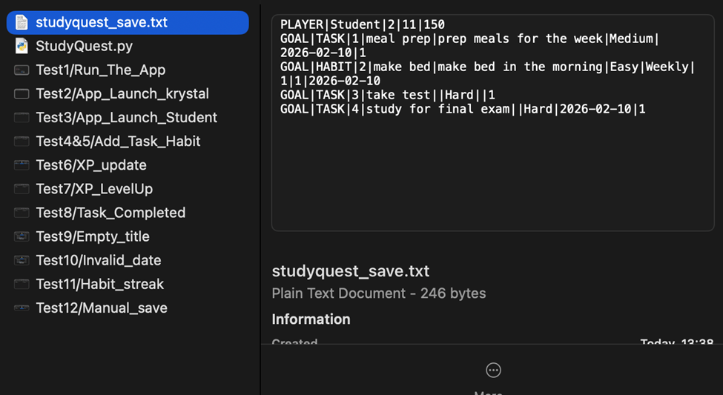
Figure 9: Save file contents demonstrating stored tasks, habits, and XP values.

Overall Testing Summary
All major features of the StudyQuest application were tested successfully. Core functionality, including application launch, interface rendering, task creation, input validation, habit tracking, XP progression, and data persistence, performed as expected.
A minor macOS window focus issue was identified during earlier testing but has been resolved in version 3.1. The application now relaunches correctly in the foreground.
Overall Status:
The application successfully passed all test cases and is ready for submission.

