StudyQuest – Software Design Document
SDEV 265 - Spring 2026
Team Members
Cailey Keown
Andrii Kuleshchak
Harold Ligon
Krystal Michaelis
Zachary Fike
Sean Kennedy

1. Introduction
This design document describes the structure, behavior, and implementation approach for StudyQuest, a lightweight digital task and habit-tracking planner application. The purpose of this document is to explain how the system is designed and built to meet the functional requirements previously identified by the project team. While the requirements analysis defined what the system must accomplish, this document focuses on how those requirements are implemented through architecture, data handling, user interaction, and testing strategies.
StudyQuest is implemented as a desktop application using Python and the Tkinter graphical user interface library. The application allows users to create and manage tasks and habits, track completion progress, earn experience points (XP), and level up through continued use. User data is stored locally using file-based persistence, ensuring data is saved between sessions. This design phase supports clearer implementation, reduced risk, and effective collaboration across team roles.

2. System Architecture
StudyQuest follows a modular architecture that separates responsibilities into clearly defined components. This structure improves maintainability, testing, and collaboration while keeping the application simple and reliable.

2.1 Presentation Layer (User Interface)
The presentation layer is implemented using Python’s Tkinter library and provides the graphical interface through which users interact with the application. The main application window displays the user profile, current level, XP progress, and a list of tasks and habits. Buttons such as Add Task, Add Habit, Complete Selected, and Save allow users to perform core actions.
Modal dialog windows are used for creating tasks and habits, guiding user input and reducing clutter in the main interface. Status messages and popup dialogs provide validation feedback and completion confirmations.

2.2 Application Logic Layer
The application logic layer handles the core behavior of the system. This logic is implemented through Python classes including Player, Task, Habit, and GoalManager. These classes manage task completion, habit streaks, XP calculation, level progression, and business rules such as preventing duplicate completions on the same day.
The logic layer acts as an intermediary between user input and data storage, ensuring all actions follow defined rules and system consistency is maintained.

2.3 Data Persistence Layer
The data persistence layer manages saving and loading user data. StudyQuest uses a structured text file (studyquest_save.txt) stored locally in the application directory. Player data is serialized first, followed by task and habit records.
Data is automatically loaded when the application starts and saved either manually by the user or automatically when the application closes. This approach avoids external dependencies while ensuring reliable data recovery.

3. Design Diagrams (UML and Equivalent)
Multiple design diagrams are used to model the system’s behavior and structure.

3.1 Use Case Diagram
The Use Case Diagram represents system functionality from the user’s perspective. The primary actor is the user. Use cases include creating tasks, creating habits, completing goals, viewing progress, saving data, and loading saved sessions.

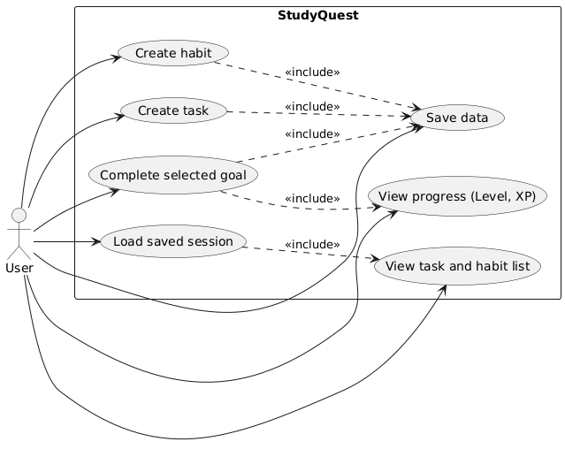

3.2 Sequence Diagram
The Sequence Diagram models interactions when a user completes a task or habit. The sequence shows the user triggering an action through the interface, the application logic processing completion rules and XP rewards, and the interface updating displayed values.
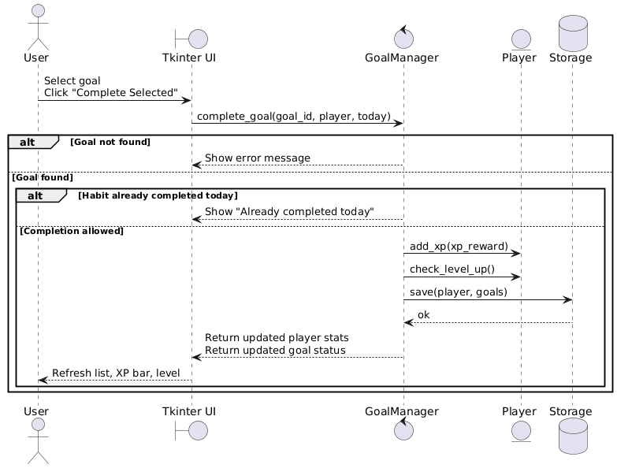

3.3 Activity Diagram
The Activity Diagram illustrates the workflow for completing a goal. It includes validation checks, XP calculation, level-up decisions, and UI refresh actions.
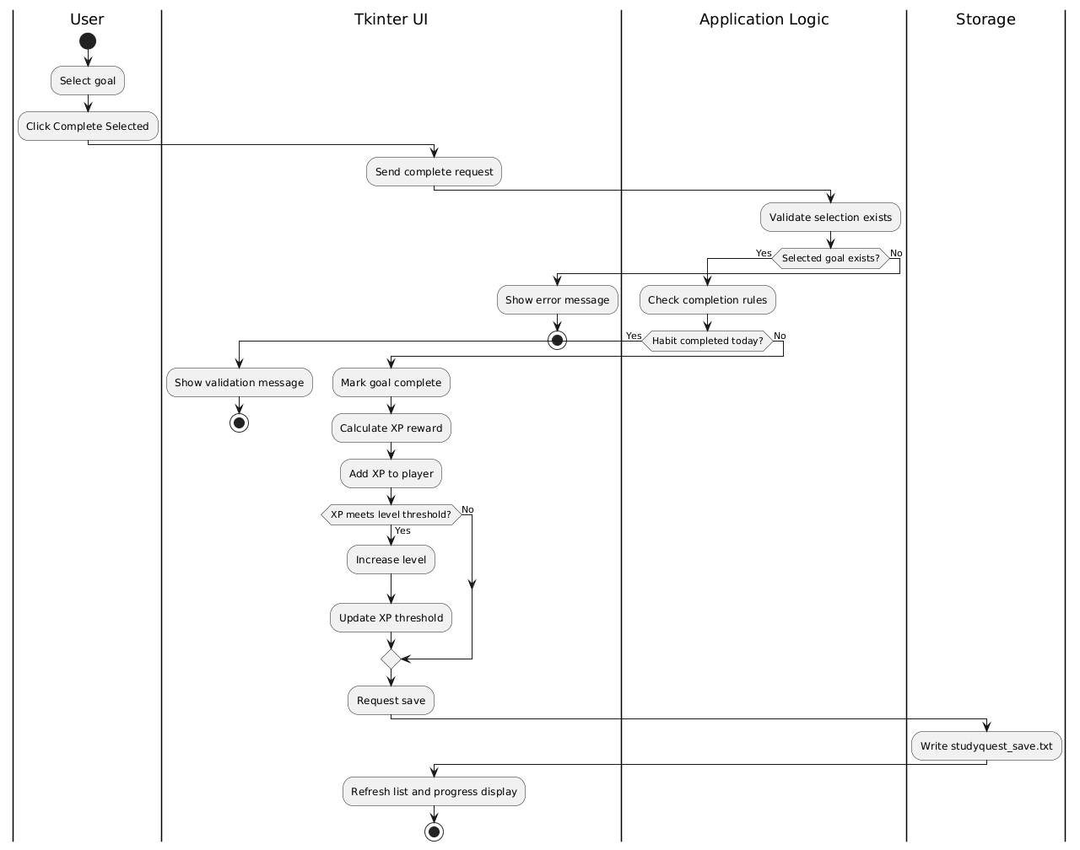

3.4 Class Diagram
The Class Diagram defines relationships between core classes such as Player, Goal, Task, Habit, GoalManager, and Storage. This diagram closely matches the implemented class structure used in the application.
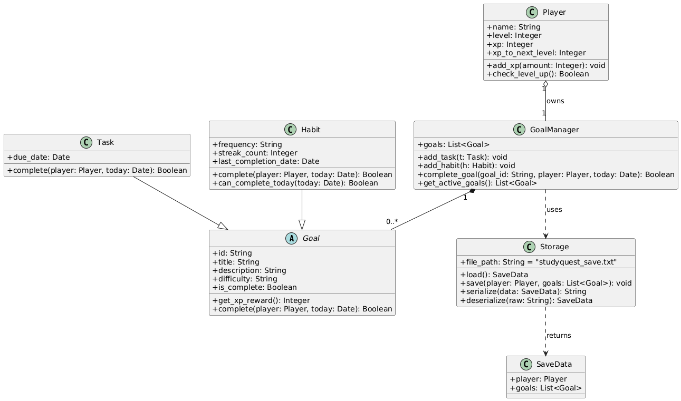

3.5 Component Diagram
The Component Diagram shows interactions between the GUI, application logic, and storage system, reinforcing the modular architecture.

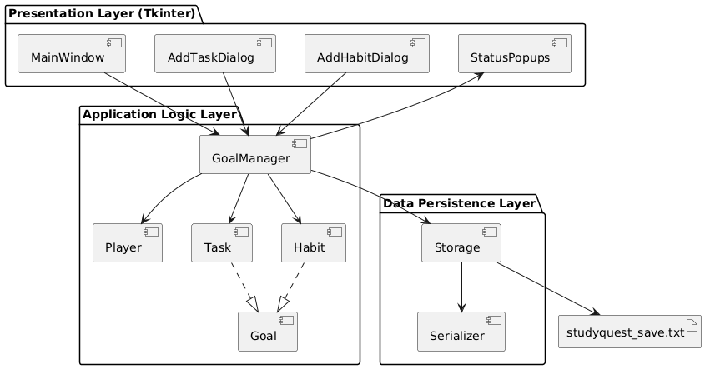

4. Data Design
StudyQuest uses local file-based storage rather than a database or external API. All user data is stored in a structured text file that contains serialized records for the player profile, tasks, and habits.
Each task includes attributes such as title, description, difficulty, due date, and completion status. Habits include difficulty level, frequency, streak counts, and last completion date. This data organization supports XP calculation, progress tracking, and persistence across sessions while remaining lightweight and easy to maintain.

5. Interface Design
The user interface is designed for clarity and ease of use. The main window presents essential information such as the user’s profile name, level, XP progress, and task summary. Tasks and habits are displayed in a structured list showing type, title, difficulty, and current status.
Dialog windows guide users through task and habit creation, ensuring required fields are completed and validated. Visual feedback through messages and labels helps users understand progress and system responses. The interface behaves consistently across Windows and macOS platforms.

6. Test Cases
Each functional requirement is validated through targeted test cases.

Task Management
- Verify tasks can be created with valid titles
- Verify tasks appear in the task list
- Verify tasks can be marked as completed
- Verify completed tasks are removed from active task counts

Habit Tracking
- Verify habits can be created with difficulty and frequency
- Verify habits award XP upon completion
- Verify streak counts update correctly
- Verify habits cannot be completed more than once per day

Progression System
- Verify XP increases after completing goals
- Verify level increases when XP threshold is reached
- Verify XP requirements increase per level

Data Persistence
- Verify user data is saved on exit
- Verify data is restored on next application startup

Cross-Platform Testing
- Verify consistent behavior on Windows and macOS

7. Summary
StudyQuest is a lightweight productivity application designed to demonstrate effective software planning, design, and implementation within an academic team environment. The system’s modular architecture, clearly defined data structures, and user-focused interface provide a strong foundation for reliable task and habit management.
This design document aligns closely with the implemented system and serves as a guide for development, testing, and evaluation. Through careful design and controlled scope, StudyQuest achieves its core goals while remaining stable, maintainable, and extensible for potential future enhancements.

