Group Project
Planner Application

Project Organization
Role | Name
Project manager | Zachary
Designer | Cailey
Front End Developer | Sean
Back End Developer | Andrii
Tester (Windows) | Harold
Tester (Mac) | Krystal

Project Purpose, Goals and Objectives

Project Purpose
This project focuses on the development of a lightweight digital task and weekly planner. The goal is to provide basic task management with optional habit tracking while demonstrating software planning, development, testing, and collaboration skills within an academic timeline.

Project Goal | Project Objectives
Goal 1 | Build a working digital task and weekly planner.
 | You deliver core features. Create tasks. Mark them complete. View tasks by week.
 | Save and load data reliably.
Goal 2 | Demonstrate the full software development process.
 | You show planning, design, implementation, testing, and integration within a real team
 | workflow.
Goal 3 | Deliver a stable cross platform application on time.
 | You prioritize reliability over extra features. The planner runs on Windows and macOS
 | And meets the course deadline.

Project Success Criteria

Category | Success Metric | Measurement Method | Target | Assigned to
Scope | All core planner features implemented | Feature checklist review | 100 percent of agreed core features completed | Project Manager
Schedule | Project delivered on time | Comparison to course deadline and milestone dates | Submission by the assigned course due date | Project Manager
Budget | No additional financial cost | Review of tools and hardware used | Zero dollars spent beyond existing resources | Project Manager
Quality | Stable and usable application | Test case execution and bug tracking | No critical bugs and no data loss during normal use | Testers
Stakeholder satisfaction | Instructor and team approval | Feedback after submission and team review | Meets or exceeds assignment rubric expectations | Project Manager
Risk management | Identified risks controlled | Risk log review and issue resolution tracking | No unresolved high risk items at submission | Project Manager
Resource utilization | Effective use of team skills | Task completion review by role | All team members contribute to assigned roles | Project manager
Compliance | Meets academic and legal requirements | Rubric checklist and policy review | Full compliance with course and academic integrity rules | Project manager

Project Team
List the members of the project team who will be involved in this project, including their name, role and responsibilities to better understand what’s expected of them.

Name | Role | Responsibilities
Zachary | Project manager | Oversees project planning, scheduling, task coordination, and progress tracking. Ensures deadlines are met and scope stays controlled.
Cailey | Designer | Designs the user interface layout and overall usability. Creates mockups and ensures the planner is easy to understand and use.
Sean | Front End Developer | Implements the user interface and user interactions. Connects visual components to application logic.
Andrii | Backend Developer | Develops core application logic, data handling, and file save and load functionality.
Harold | Windows Tester | Tests application functionality and stability on Windows systems. Reports bugs and usability issues.
Krystal | Mac Tester | Tests application functionality and stability on macOS systems. Identifies platform specific issues and reports defects.

Project Schedule

Risk Management Plan

High priority risks fall into the High or Very High areas of the matrix. These risks require active monitoring and mitigation plans. Medium risks are tracked and reviewed during weekly meetings. Low risks are documented but do not require immediate action.

Identified project risks and placement.

- Schedule delays due to school or work obligations
Likelihood: Likely
Severity: Moderate
Risk level: High

- Data loss or file save failure
Likelihood: Possible
Severity: Major
Risk level: High

- Cross platform issues between Windows and macOS
Likelihood: Possible
Severity: Major
Risk level: High

- Performance issues such as slow loading or saving
Likelihood: Possible
Severity: Moderate
Risk level: Medium

- Scope creep from additional feature requests
Likelihood: Likely
Severity: Moderate
Risk level: High

- Communication breakdown between team members
Likelihood: Unlikely
Severity: Moderate
Risk level: Medium

Risk mitigation approach.

- High and Very High risks are discussed during weekly meetings.
- Core features are prioritized before optional features.
- File handling is tested frequently to reduce data loss risk.
- Testing is performed on both Windows and macOS.
- GitHub and Discord are used consistently to reduce communication issues.

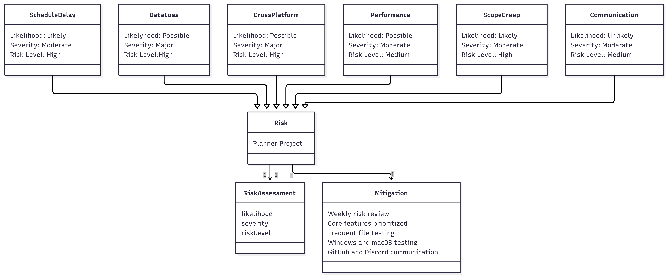

Project Communication Plan

Project reports and reporting frequency
The project uses lightweight reporting to track progress and issues.
Status updates are shared weekly through Discord and Trello.
Updates include completed tasks, upcoming work, and identified risks.
GitHub commit history serves as a record of development progress.
Major changes or blockers are documented in GitHub issues as they occur.

Project meetings
Project meetings occur consistently throughout the project.
The team meets once per week on Thursdays in the evening.
Meetings focus on progress review, task assignments, and risk discussion.
Additional meetings are scheduled if issues arise or deadlines approach.
All meetings use Discord for voice communication and coordination.

Project Progress Update
The project reached the final stage of development. Core planner features are complete and functional. The team now focuses on fixing bugs, improving usability, and preparing the final presentation. Testing continues to confirm the application works correctly across systems.

Tasks Completed
• Core planner functionality finished - Users create tasks, mark tasks complete, and view weekly tasks.
• Backend logic implemented - Andrii finished task handling, file saving, and loading features.
• User interface structure completed - Sean implemented the main interface and connected UI elements to backend logic.
• UI layout and design finished - Cailey completed screen layout, icons, and usability improvements.

Current Tasks
• Bug fixing and stability improvements - Andrii and Sean reviewed reported issues and fix problems found during testing.
• System testing - Harold tests the planner on Windows systems and reports issues found during use.
• Cross platform testing - Krystal verifies the planner works correctly on macOS and identifies compatibility issues.
• Final usability adjustments - Cailey updates UI details based on testing feedback.

New Tasks Added in Final Phase
• Final bug review before submission - The team verifies that no critical issues remain.
• Project documentation review - Zach ensures the project plan, risk assessment, and documentation are complete.
• Presentation preparation - The team prepares slides and demonstration material for the final project presentation

Team Responsibilities During Development
• Zack - Project leadership, schedule tracking, coordination, and progress monitoring.
• Cailey - UI sketches, layout design, and usability improvements.
• Sean - Interface coding and connecting UI elements to application logic.
• Andrii - Core backend programming and data handling.
• Harold - Windows testing and bug reporting.
• Krystal - macOS testing and platform compatibility checks.

Appendix

- Communication Activity: Weekly status updates
- Purpose: Share progress, upcoming tasks, and issues
- Format: Text updates
- Tool: Discord and Trello
- Frequency: Weekly
- Responsible: Project Manager

- Communication Activity: Development progress tracking
- Purpose: Track code changes and development history
- Format: Commit history and issues
- Tool: GitHub
- Frequency: Continuous
- Responsible: All developers

- Communication Activity: Project meetings
- Purpose: Review progress, assign tasks, discuss risks
- Format: Voice meeting
- Tool: Discord
- Frequency: Weekly
- Responsible: Project Manager

- Communication Activity: Issue and risk reporting
- Purpose: Identify blockers and risks early
- Format: Written updates
- Tool: GitHub Issues and Discord
- Frequency: As needed
- Responsible: All team members

- Communication Activity: Final project reporting
- Purpose: Confirm completion and readiness for submission
- Format: Summary review
- Tool: Discord and Word document
- Frequency: End of project
- Responsible: Project Manager

