Singleton

The singleton in my project is the Enemy Manager. It was

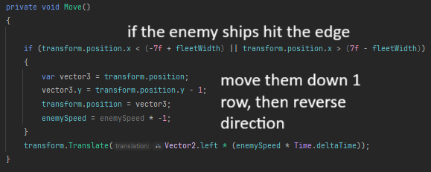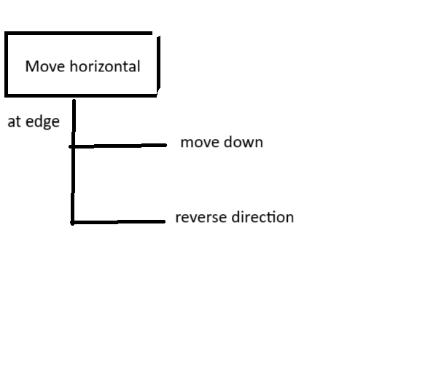

Observer

When the bullet goes above or below the view of the camera, it will be deleted to save on memory.

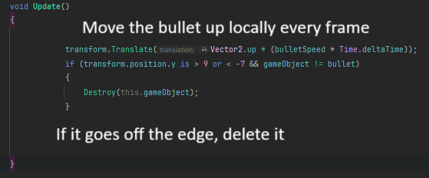

Part 4: Factory

I used the factory design pattern to create the bullets the player fires. This is an example of the factory design pattern because it creates things.

