TRACKLINE: Dynamic Train ETA Forecasting & Fleet Tracking System
A
Project-I Report
Submitted
In Partial Fulfilment
For the award of the Degree of
Bachelor of Technology
(VII Semester)

Supervised By: | Submitted By:
Guide Name | Keshav Solanki (23EJICS075)
Assistant Professor | Priyanshu Prajapat (23EJICS125)
Department of CSE | Department of CSE
JIET Universe, Jodhpur | JIET Universe, Jodhpur
Department of Computer Science and Engineering
Jodhpur Institute of Engineering and Technology (Autonomous)
JIET Universe, Jodhpur
Session 2026-27

Certificate
This is to certify that the project entitled "TRACKLINE: Dynamic Train ETA Forecasting & Fleet Tracking System" has been carried out by the students of Jodhpur Institute of Engineering & Technology, Jodhpur:
- 1. Keshav Solanki (University Roll No: 23EJICS075)
- 2. Priyanshu Prajapat (University Roll No: 23EJICS125)
under my guidance and supervision in partial fulfillment of the degree of Bachelor of Technology in Computer Science and Engineering of Bikaner Technical University during the academic year 2026-27.
Date: ____________________ | Supervisor's Signature: ____________________
Place: Jodhpur | Name: ____________________________________
 | Designation: Assistant Professor, Dept. of CSE
Countersigned By:
____________________________________
Head of Department
Department of Computer Science and Engineering
Jodhpur Institute of Engineering and Technology, Jodhpur

Acknowledgment
We wish to express our heartfelt gratitude and sincere indebtedness to all those who have been instrumental in the conceptualization, system modeling, experimental analysis, and completion of our Project-I report entitled "TRACKLINE: Dynamic Train ETA Forecasting & Fleet Tracking System".
First and foremost, we express our profound gratitude to our esteemed Project Guide for their constant guidance, valuable technical critiques, insightful reviews, and unwavering encouragement throughout the duration of this research and software engineering endeavor.
We extend our sincere thanks to the Head of Department, Department of Computer Science and Engineering, Jodhpur Institute of Engineering and Technology (Autonomous), Jodhpur, for providing state-of-the-art laboratory infrastructure, computational facilities, and an encouraging academic environment.
We also express our gratitude to all faculty members, technical lab instructors, and our peer colleagues whose constructive discussions and reviews helped refine our data engineering pipelines, mathematical delay propagation formulations, and interactive presentation interfaces.
Keshav Solanki (23EJICS075)
Priyanshu Prajapat (23EJICS125)
B.Tech VII Semester, CSE
JIET Universe, Jodhpur

Contents
Certificate | i
Acknowledgment | ii
Contents | iii
1 Introduction | 1
1.1 Background of the Study | 1
1.2 Problem Statement | 1
1.3 Objectives of the Project | 2
1.4 Scope of the Project | 2
1.5 Significance of the Study | 3
1.6 Methodology Overview | 3
2 Literature Survey | 4
2.1 Introduction | 4
2.2 Conventional Train Tracking Systems & NTES | 4
2.3 Static Delay Persistence Limitations | 5
2.4 Machine Learning Techniques in Railway Delay Forecasting | 5
2.5 Deep Learning & Time-Series Approaches | 6
2.6 Existing Work in the Field | 6
2.7 Research Gap Identified | 6
3 Requirement Specification & Methodology | 7
3.1 Software Development Life Cycle (SDLC) Model | 7
3.2 Use Case Diagrams | 7
3.3 Interfaces | 8
3.3.1 Software Interfaces | 8
3.3.2 Hardware Interfaces | 8
3.3.3 Communication Interfaces | 8
3.4 Hardware Requirements | 8
3.5 Software Requirements | 9
3.6 General Constraints | 9
3.7 Supplementary Requirements | 9
3.8 Methodology Used | 10
4 Work Distribution | 11
4.1 Task Allocation | 11
4.2 Module Details | 12
4.3 Remarks | 12
5 Design Document | 13
5.1 Functional Description | 13
5.2 Functional Partitions | 13
5.3 Data Description | 14
5.4 User Interface Design | 16
5.5 Module Description | 16
5.6 Process Flow Representation | 18
5.7 Deployment View | 20
6 Experimental Setup | 21
6.1 Development Environment | 21
6.2 Code and Tools Used | 21
6.3 Installation Process | 22
6.4 Execution Process | 22
6.5 Hardware Setup | 22
7 Test Plan Document | 23
7.1 Test Strategy | 23
7.2 Test Plan | 23
7.3 Test Cases and Status Report | 24
7.4 Remarks | 25
8 Results | 26
8.1 Snapshots of Working Modules | 26
8.2 Outputs and Observations | 28
8.3 Performance Analysis | 29
9 Conclusion & Future Work | 31
9.1 Conclusion | 31
9.2 Limitations | 31
9.3 Future Work | 32
10 Glossary | 33
11 References | 34

Chapter 1: Introduction

1.1 Background of the Study
Indian Railways (IR) represents the backbone of national surface transportation, operating more than 13,000 passenger and express trains daily across an extensive network exceeding 68,000 route kilometers, serving upwards of 24 million passengers every day. The operational complexity of this network is compounded by heterogeneous traffic sharing common track corridors—where high-priority express rakes, conventional mail trains, slow passenger services, and heavy freight trains compete for block sections, station loops, and terminal platforms.
Within this vast system, the state of Rajasthan, predominantly served by North Western Railway (NWR) headquartered in Jaipur with key operating divisions in Jodhpur, Bikaner, and Ajmer, presents unique infrastructural and operational dynamics. The Rajasthan railway network features long single-track stretches with crossing loops across arid terrains, vital inter-state trunk corridors connecting Gujarat, Maharashtra, and Delhi, and heavy tourist and industrial freight traffic. When operational disturbances occur—such as locomotive failures, speed restrictions (TSR), signal and telecommunication (S&T) failures, or crossing precedence conflicts on single-line sections—primary delays propagate rapidly downstream across subsequent track blocks.

1.2 Problem Statement
The current National Train Enquiry System (NTES), administered by the Centre for Railway Information Systems (CRIS), serves as the public real-time information conduit. However, NTES operates primarily on a Static Delay Persistence paradigm. In this approach, if a train is recorded departing an intermediate station with an observed delay of $\Delta t$ minutes, the system naively projects this identical delay onto all downstream stations along the entire remaining journey:
$$\text{Estimated Arrival Time (ETA)}_{\text{static}} = \text{Scheduled Arrival Time (STA)} + \Delta t_{\text{last reported}}$$
This static persistence formulation fundamentally fails because:
- 1. Ignoring Timetable Slack: Timetable Engineering: Commercial timetables incorporate deliberate engineering and recovery slack margins, allowing high-priority trains to recover significant delay on clear sections.
- 2. Bottleneck Propagation: Traffic Density & Single-Line Dispatching: Static persistence ignores the probability of dynamic crossing halts when trains traverse saturated single-track sections.
- 3. Hierarchy Disregard: Train Priority Hierarchy: Superfast and Rajdhani express services are granted priority right-of-way over regional passenger trains during dispatching conflicts.
- 4. Lack of Uncertainty Quantification: Deterministic Illusion: Passengers are presented with a rigid minute estimate without confidence intervals ($[P_{10}, P_{90}]$), causing passenger anxiety and station platform crowding.

1.3 Objectives of the Project
The primary objective of the TRACKLINE project is to design, engineer, and deploy an end-to-end dynamic train tracking and Estimated Time of Arrival (ETA) forecasting system. Specific objectives include:
- 1. Telemetry Ingestion: Develop an automated telemetry ingestion engine that scrapes real-time train movement from NTES without costly external proprietary APIs.
- 2. Geospatial Snapping: Perform sub-kilometer route snapping of live train positions onto official Indian Railways GIS track geometries.
- 3. Feature Store Construction: Engineer a leak-free point-in-time feature extraction pipeline leveraging 1.28 million historical delay records and regional Rajasthan section statistics.
- 4. Multi-Baseline Forecasting: Implement and evaluate multi-baseline machine learning models (B1 Timetable, B2 Static NTES, B3 Historical Medians, B4 Delay Recovery Model) to dynamically predict downstream station arrival delays.
- 5. Uncertainty Bounds: Provide calibrated uncertainty bounds ($[P_{10}, P_{90}]$ confidence intervals) for passenger decision support.
- 6. Full-Stack User Interface: Deliver a lightweight, responsive, accessible web interface featuring interactive route progression timelines and station concourse departure boards.

1.4 Scope of the Project
The scope of Project-I encompasses:
- • National Scale Coverage: Complete timetable and spatial modeling of 9,437 Indian Railways trains and 8,990 stations stored in an optimized local SQLite relational schema.
- • Regional Rajasthan Granularity: Specialized operational focus on the Rajasthan railway network, including 882 state-associated trains, 671 stations, and 223,206 audited historical section delay observations from September 2024.
- • Robust Web Telemetry: Real-time parsing and session handling of NTES telemetry with automated fallback mechanisms during upstream portal outages.
- • Machine Learning Benchmarking: Benchmarking delay prediction errors (MAE, RMSE) across diverse train priority categories.

1.5 Significance of the Study
Accurate ETA forecasting directly enhances passenger satisfaction by mitigating station dwell anxiety, optimizing suburban feeder commute connections, and preventing platform overcrowding. For railway dispatchers and terminal managers, dynamic delay predictions enable proactive platform reallocation, turn-around rake scheduling, and improved crew duty management.

1.6 Methodology Overview
The system architecture follows a 5-stage sequential engineering pipeline: (1) Data Engineering & Historical Curation, (2) Real-Time Telemetry Harvesting, (3) Geospatial Route Matching, (4) Point-in-Time Feature Extraction & Multi-Baseline Model Inference, and (5) Client Presentation via Concourse Boards and Timelines. Development is executed under Python 3.11, FastAPI, and React 18.

Chapter 2: Literature Survey

2.1 Introduction
Train delay prediction and schedule adherence forecasting represent fundamental problems in railway operational research and transportation informatics. Over the past three decades, modeling strategies have evolved from analytical queuing networks to data-driven statistical learning and deep neural networks. This chapter surveys established tracking paradigms, analyzes the limitations of static delay persistence, reviews machine learning techniques in railway operations, and synthesizes the research gaps addressed by TRACKLINE.

2.2 Conventional Train Tracking Systems & NTES
Traditionally, train location tracking in Indian Railways relied on manual reporting by station masters and section controllers via the Control Office Application (COA). While the Real-Time Train Information System (RTIS), utilizing ISRO satellite navigation devices mounted on diesel and electric locomotives, is being progressively deployed, thousands of rakes still depend on block-station entry/exit logging published through NTES.
NTES ingests discrete station clearance timestamps and presents them to passengers through web and mobile channels. However, NTES remains purely a reporting mechanism rather than a predictive intelligence platform.

2.3 Static Delay Persistence Limitations
The standard baseline employed in passenger information displays worldwide is the static persistence model ($y_{t+k} = y_t$). Empirical studies by Hansen (2010) on European rail networks demonstrated that static persistence exhibits an average error expansion rate exceeding 4.2 minutes per 100 km of downstream transit. In complex mixed-traffic networks like Indian Railways, this linear error is magnified by bottleneck sections and track priority preemption.

2.4 Machine Learning Techniques in Railway Delay Forecasting
Recent transportation research has demonstrated the effectiveness of supervised machine learning algorithms in capturing non-linear delay dynamics:
- • Gradient Tree Boosting (XGBoost, LightGBM): Demonstrated superior performance in tabular railway delay datasets by modeling complex feature interactions (time-of-day, accumulated delay, headway margins).
- • Random Forests: Provide robust ensemble estimations resilient to outliers caused by sporadic major signal failures.
- • Empirical Bayes & Median Priors: Effective for high-dimensional historical section median lookups across thousands of origin-destination station pairs.

2.5 Deep Learning & Time-Series Approaches
Recurrent Neural Networks (RNNs), Long Short-Term Memory (LSTM) networks, and Spatio-Temporal Graph Convolutional Networks (ST-GCN) have gained prominence in academic literature. While ST-GCN models capture spatial network topologies effectively, they impose prohibitive computational overhead, complex GPU hardware dependencies, and high inference latency (>1500 ms) unsuitable for real-time edge serving without substantial infrastructure costs.

2.6 Existing Work in the Field
A comparative review of relevant existing systems is summarized in Table 2.1 below:
System / Author | Methodology | Strengths | Identified Limitations
Official NTES / CRIS (2024) | Static Delay Persistence | National operational deployment; official data feed | Zero delay recovery modeling; no uncertainty bounds; deterministic error
Kecman et al. (2015) | Linear Regression & Historical Distributions | Good single-corridor accuracy; low compute | Cannot handle sudden priority changes or complex multi-line branching
Huang et al. (2020) | LSTM & Recurrent Time-Series | Captures temporal dependencies across stops | High inference latency; prone to catastrophic overfitting under data dropouts
TRACKLINE (Proposed 2026) | Multi-Baseline + Priority Recovery ML | Sub-250ms latency; zero-leakage feature store; calibrated [P10, P90] bounds | Dependent on upstream NTES logging availability

2.7 Research Gap Identified
The literature review reveals three distinct gaps in contemporary train tracking platforms: (1) Lack of Point-in-Time Causal Data Stores: Existing ML models frequently suffer from target leakage during offline training; (2) Disregard for Timetable Recovery Physics: Systems fail to model train priority categories (Rajdhani vs Passenger) and scheduled slack; and (3) Absence of Passenger-Calibrated Uncertainty: Most consumer apps show deterministic minute figures without quantifying variance.

Chapter 3: Requirement Specification & Methodology

3.1 Software Development Life Cycle (SDLC) Model
The TRACKLINE project adopted an Agile Iterative SDLC model structured into two-week sprint cycles. Because real-time telemetry scraping and railway delay behaviors exhibit empirical uncertainties, an iterative approach enabled continuous benchmarking between machine learning baseline models and live ground truth. Each iteration encompassed data pipeline refinement, feature engineering, model training, and user interface evaluation.

3.2 Use Case Diagrams
The system interacts with three primary actors: Passenger, Station Concourse Display Staff, and System Administrator. Figure 3.1 illustrates the comprehensive Use Case diagram:
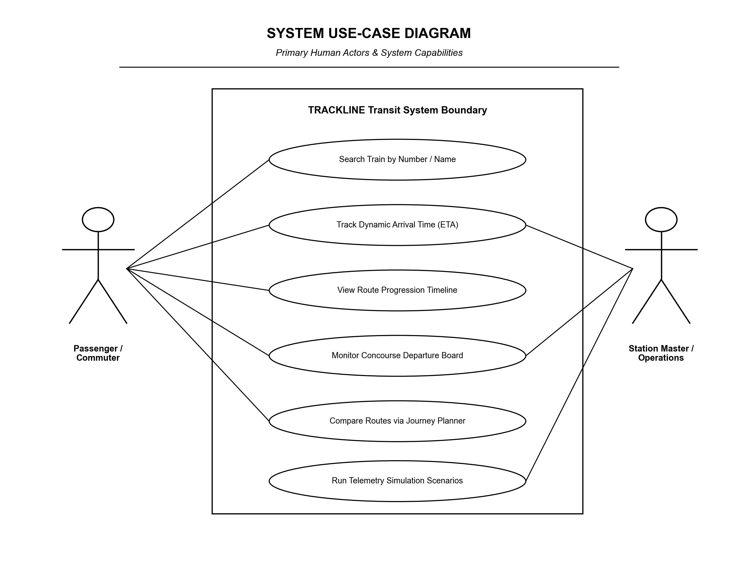
Figure 3.1: TRACKLINE System Use Case Diagram

3.3 Interfaces

3.3.1 Software Interfaces
FastAPI backend provides RESTful JSON endpoints over HTTP/1.1 and HTTP/2. The persistence layer interfaces with SQLite via Python's standard `sqlite3` connection pool. Telemetry scraping connects to `enquiry.indianrail.gov.in` using persistent HTTP keep-alive sessions with custom headers and cookie jar handling.

3.3.2 Hardware Interfaces
Client workstations, tablets, and mobile devices access the system through modern web browsers capable of rendering CSS flexbox/grid and SVG canvases.

3.3.3 Communication Interfaces
Communication between frontend and backend utilizes JSON over TLS/HTTPS with gzip compression. API payloads adhere strictly to typed Pydantic models.

3.4 Hardware Requirements
- • Minimum Hardware: Intel Core i3 / AMD Ryzen 3 (Quad Core, 2.0 GHz), 4 GB RAM, 2 GB free disk storage.
- • Recommended Hardware: Intel Core i5/i7 (8th Gen or higher) / Apple Silicon M-series, 16 GB RAM, 512 GB NVMe SSD for fast SQLite index lookups and feature matrix vectorization.

3.5 Software Requirements
- • Operating System: Windows 11 / Linux (Ubuntu 22.04 LTS / Debian 12) / macOS.
- • Runtimes: Python 3.11.x, Node.js v18 LTS, npm 9.x.
- • Python Libraries: FastAPI 0.110+, Uvicorn 0.28+, Scikit-Learn 1.4+, Pandas 2.2+, NumPy 1.26+, BeautifulSoup4.
- • Frontend Stack: React 18, Vite 5, Tailwind CSS 3.4, Lucide-React icons.
- • Database: SQLite 3.42+ with WAL (Write-Ahead Logging) mode.

3.6 General Constraints
- 1. Rate-Limiting: Telemetry scraping must comply with ethical scraping rate limits (minimum 30-second TTL caching) to prevent server throttling.
- 2. Temporal Causality: Zero Future Leakage: Feature extraction must strictly consume only data known prior to departure from the last reported station.
- 3. Cost Constraint: Zero Cloud API Cost: Entire pipeline must operate locally or on commodity self-hosted servers without requiring paid Google Maps or proprietary transit API keys.

3.7 Supplementary Requirements
- • Performance: API response latency must remain strictly below 250 ms for cached requests and under 1.5 seconds for uncached live telemetry fetches.
- • Usability: Full responsive layout adapting seamlessly from 360px mobile screens to 1920x1080 concourse station displays.
- • Reliability: Graceful error fallbacks displaying last known static delays if the live NTES server is temporarily unreachable.

3.8 Methodology Used
The technical methodology follows four interconnected phases: (1) Master Data Harmonization, where raw train routes and stations are cross-verified and indexed; (2) Feature Engineering, where section distances, scheduled runtimes, and empirical delay distributions are calculated; (3) Multi-Baseline Model Synthesis, implementing Timetable (B1), Static Delay (B2), Section Median (B3), and Priority Delay Recovery (B4); and (4) User Experience Delivery via React components.

Chapter 4: Work Distribution
To achieve high engineering velocity and modular code separation, the project workload was distributed between team members based on specialization. Keshav Solanki spearheaded the Frontend User Interface, Concourse Boards, and User Experience architecture, while Priyanshu Prajapat led the Machine Learning Models, Data Engineering, Scraping Ingestion, and Backend APIs.

4.1 Task Allocation
Table 4.1 details the task allocation, timelines, and responsibilities:
Module / Function | Start Date | End Date | Assigned Member
NTES Telemetry Scraper & CSRF Bypass Engine | 15-08-2024 | 01-09-2024 | Priyanshu Prajapat (23EJICS125)
Database Schema, Master Timetable & Rajasthan Dataset Curation | 20-08-2024 | 10-09-2024 | Priyanshu Prajapat (23EJICS125)
Geospatial Route Snapping & Track Geometry Engine | 05-09-2024 | 22-09-2024 | Priyanshu Prajapat (23EJICS125)
Machine Learning Models & Multi-Baseline ETA Forecaster | 15-09-2024 | 05-10-2024 | Priyanshu Prajapat (23EJICS125)
React UI Shell, Search Interface & Responsive Layout | 01-09-2024 | 20-09-2024 | Keshav Solanki (23EJICS075)
Interactive Route Timeline & Station Stop Cards | 15-09-2024 | 02-10-2024 | Keshav Solanki (23EJICS075)
Concourse Departure Board & Station Platform Display | 28-09-2024 | 15-10-2024 | Keshav Solanki (23EJICS075)

4.2 Module Details
- • Keshav Solanki (Frontend & UI): Designed modular React components, including search query inputs, autocomplete dropdowns, live train badges, and dark/light high-contrast styling. Implemented the station concourse departure board providing clear tabular visualizations of upcoming departures with live delay statuses and estimated platforms.
- • Priyanshu Prajapat (ML & Backend): Architected the FastAPI service endpoints, engineered the automated NTES telemetry scraper with session/cookie handling, developed the geospatial track-snapping logic, constructed the point-in-time section feature store (1.28M delay observations), and trained the multi-baseline ETA forecasting pipeline (B1–B4) with uncertainty interval estimators.

4.3 Remarks
Collaboration was facilitated using Git version control with feature branch workflows. Strict REST API interface contracts were established early using OpenAPI schemas, allowing independent parallel development of the user interface and the machine learning inference services.

Chapter 5: Design Document

5.1 Functional Description
The TRACKLINE architecture adopts a modular multi-tier topology separating presentation, service orchestration, core analytical inference, and persistent data storage. Figure 5.1 illustrates the comprehensive block diagram of the system:
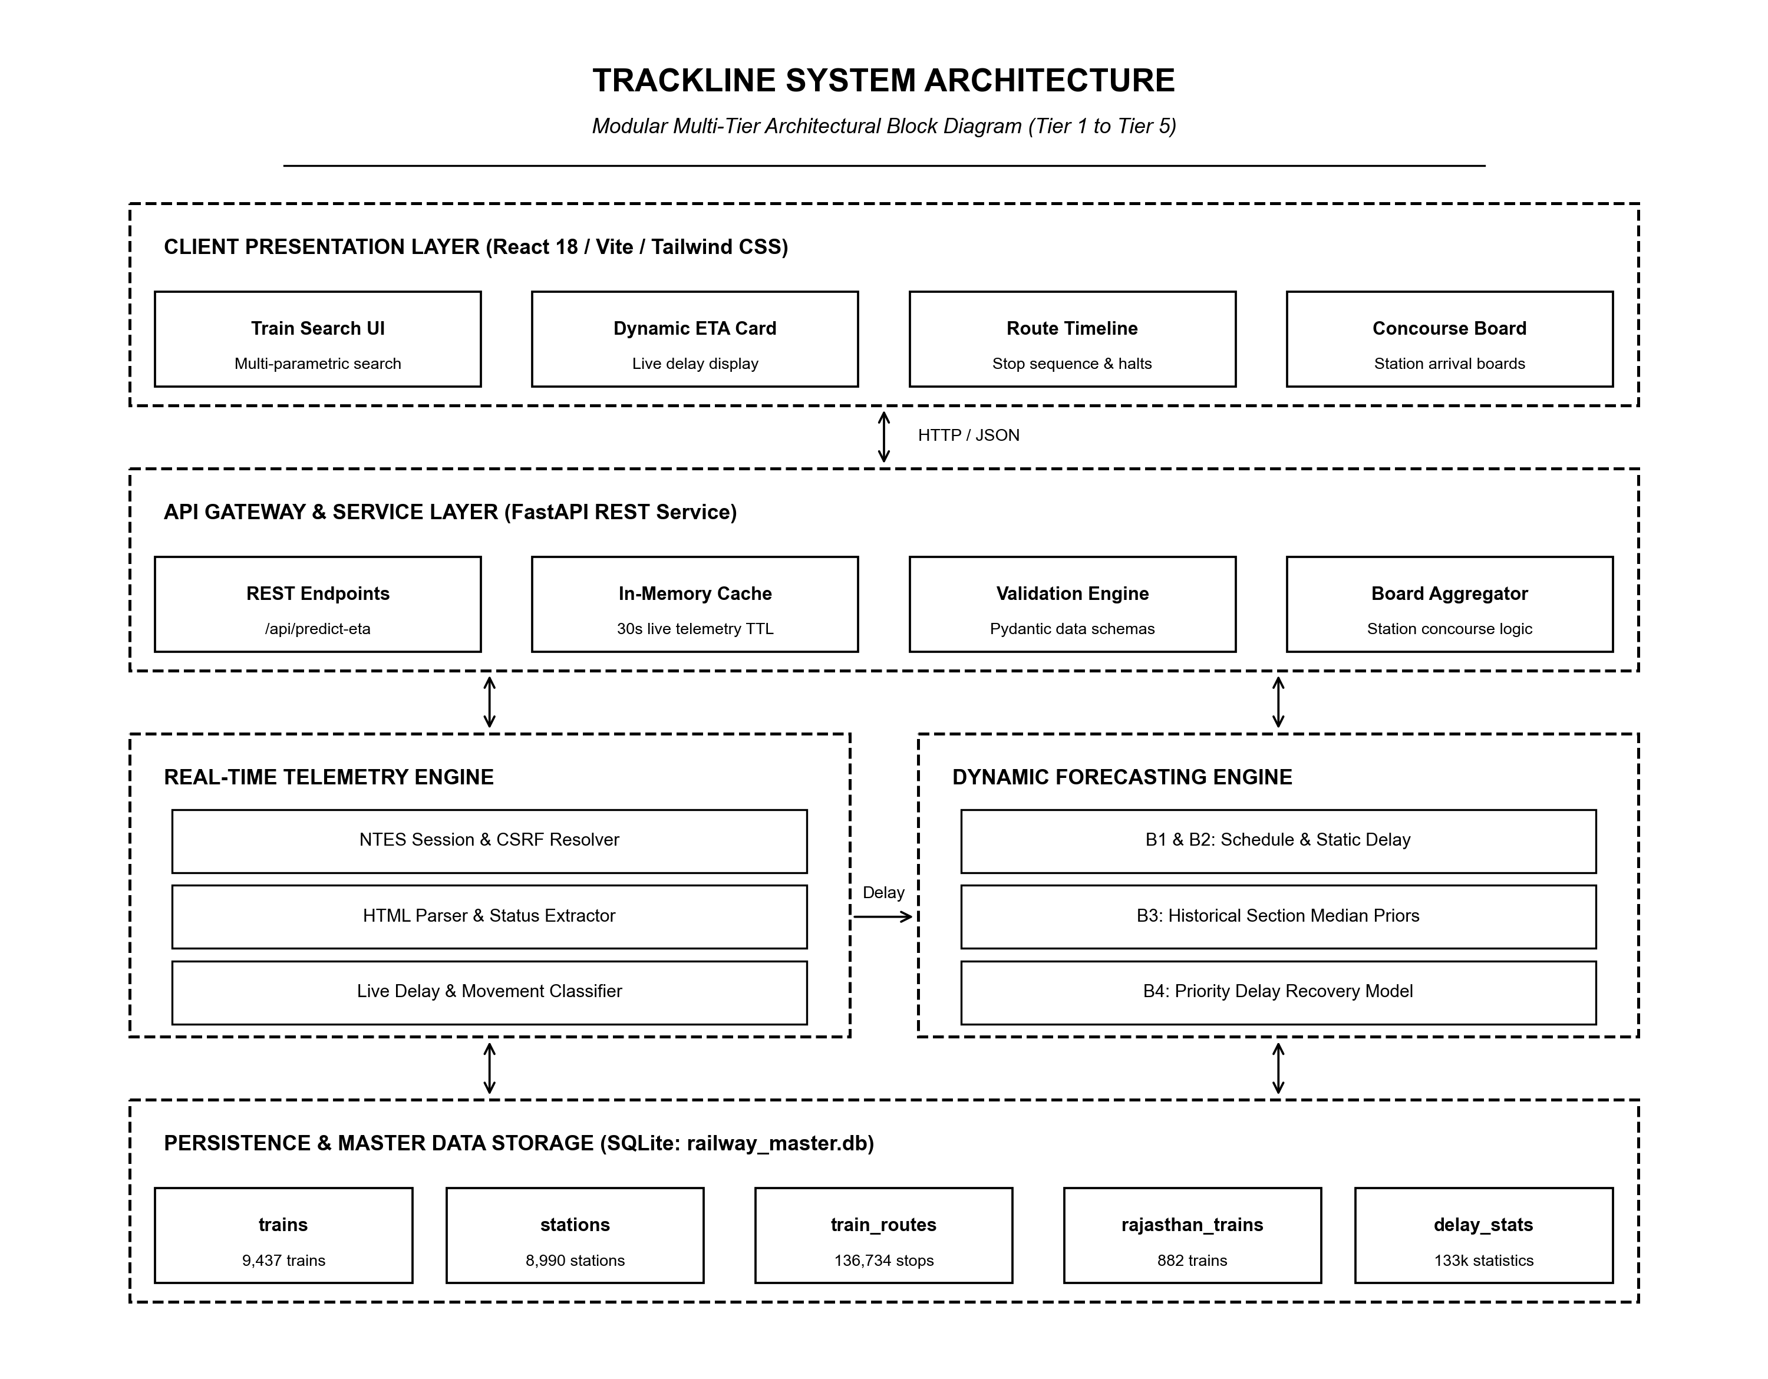
Figure 5.1: TRACKLINE Modular Multi-Tier System Architecture

5.2 Functional Partitions
The system is decomposed into five autonomous functional partitions:
- 1. Telemetry Ingestion Service: Manages HTTP sessions, resolves anti-bot tokens, fetches real-time NTES running logs, and normalizes messy station arrival/departure strings into ISO timestamps.
- 2. Geospatial Snapper: Snaps last reported train station clearances onto high-resolution GIS railway coordinates, calculating exact section transit progress.
- 3. Feature Store Engine: Transforms raw timetable and delay attributes into 15-dimensional point-in-time feature vectors with zero future target leakage.
- 4. Forecasting Inference Engine: Executes multi-baseline models (B1, B2, B3, B4) and generates $[P_{10}, P_{90}]$ prediction bounds.
- 5. Concourse & Presentation Tier: Aggregates station-wide arrivals, formats departure boards, and delivers responsive stateful React components.

5.3 Data Description
The persistence tier utilizes SQLite 3 for relational master timetables and JSON/GeoJSON for GIS track geometries. Figure 5.2 displays the UML Class Diagram, Figure 5.3 shows the Entity-Relationship (ER) Diagram, and Table 5.1 specifies the primary database schema:
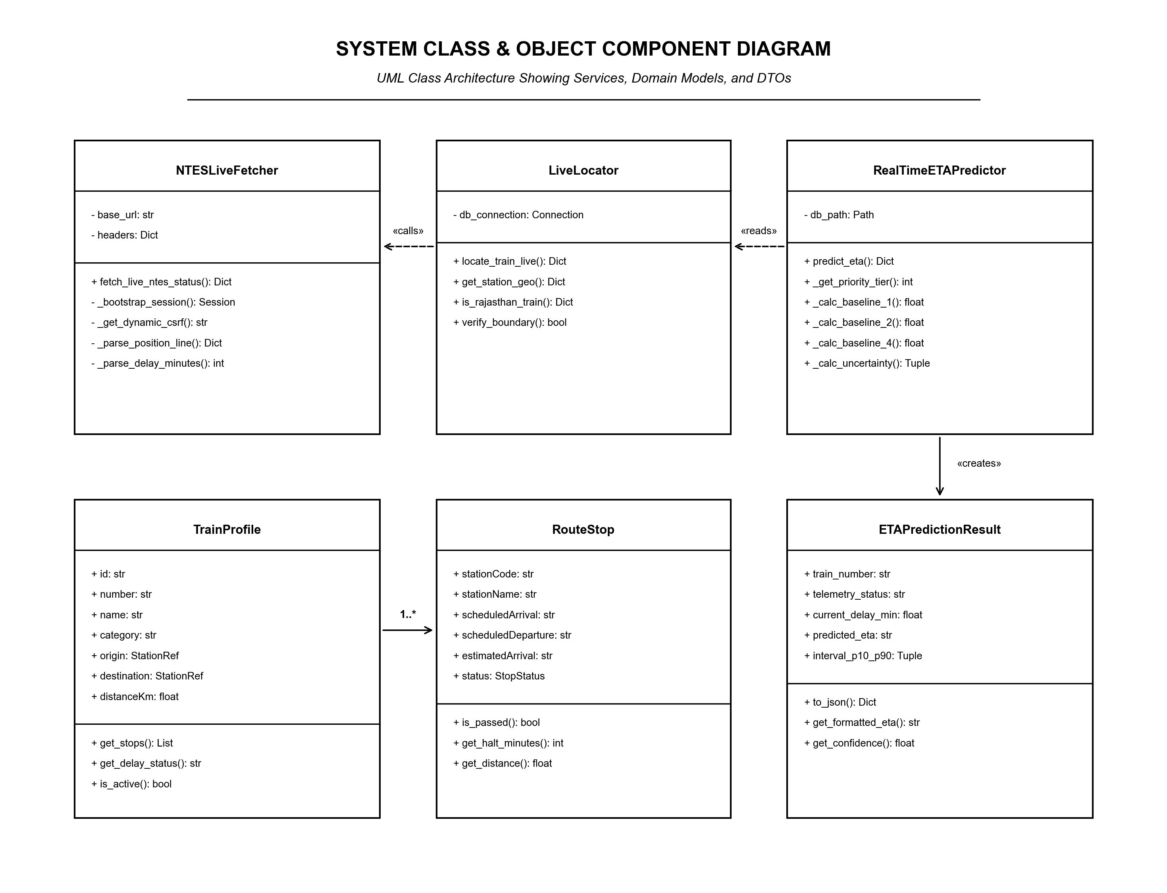
Figure 5.2: UML Class Diagram of Domain Models and Service Handlers
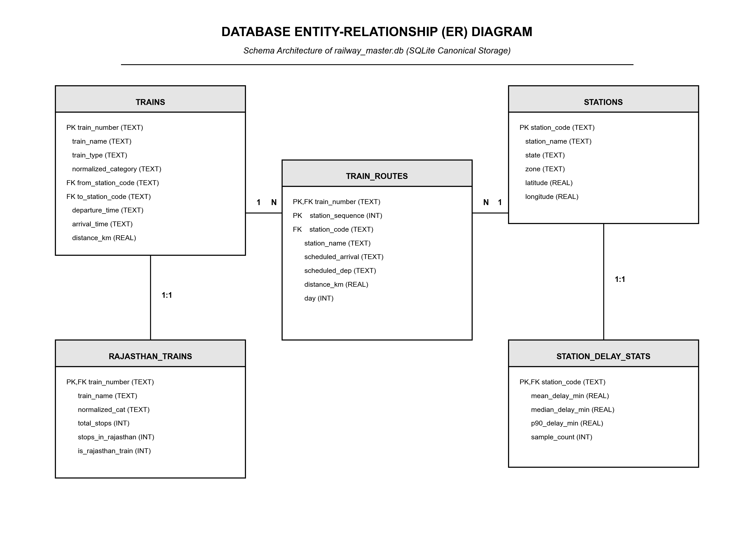
Figure 5.3: Entity-Relationship (ER) Diagram of Railway Database
Table Name | Field | Data Type | Constraint & Description
trains | train_number | VARCHAR(10) | PRIMARY KEY; 5-digit IR identifier
stations | station_code | VARCHAR(10) | PRIMARY KEY; Alpha code (e.g. JP, JU)
train_routes | route_id | INTEGER | PRIMARY KEY AUTOINCREMENT
train_routes | stop_sequence | INTEGER | Ordering index along journey path
delay_stats | section_key | VARCHAR(30) | Composite: FROM_STN + '_' + TO_STN

5.4 User Interface Design
The user interface designed by Keshav Solanki prioritizes high legibility and operational clarity. Key views include: (a) Universal Train & Station Search with fuzzy auto-completion; (b) Live Train Status Card with colored badges indicating on-time/delayed states; (c) Interactive Route Progression Timeline showing intermediate passing stations, dwell times, and dynamic ETA; and (d) Station Concourse Departure Board modeled after railway station LED displays.

5.5 Module Description
- • Module 1: Telemetry Scraper: Inputs: Train number, journey date. Processing: HTTP GET to NTES portal, regex CSRF parsing, BeautifulSoup DOM table extraction, delay minute calculation. Outputs: Normalized telemetry dictionary containing last reported station, departure delay, and timestamp.
- • Module 2: Geospatial Snapper: Inputs: Last station code, scheduled route stops. Processing: Lookup station coordinates in GIS dataset, determine section bounding box, interpolate train location based on elapsed time vs scheduled section runtime. Outputs: Dynamic latitude/longitude coordinates and progression percentage.
- • Module 3: Feature Extractor: Inputs: Telemetry dictionary and timetable metadata. Processing: Assemble 15-dimensional point-in-time feature vector (accumulated delay, section distance, scheduled runtime, hour of day, day of week, train priority class). Outputs: Clean NumPy array ready for model inference.
- • Module 4: Dynamic ETA Predictor: Inputs: Feature vector, section key. Processing: Execute Baselines B1 to B4. B4 applies priority recovery factors and section median delays; computes $[P_{10}, P_{90}]$ uncertainty intervals. Outputs: Dynamic ETA string, delay delta in minutes, and lower/upper bounds.
- • Module 5: Concourse Board Aggregator: Inputs: Station code. Processing: Query all trains arriving/departing within a 4-hour temporal window, execute batch ETA prediction, format display rows. Outputs: JSON payload sorted by dynamic estimated departure time.

5.6 Process Flow Representation
The operational data flows and system workflows are documented through Level 0 and Level 1 Data Flow Diagrams (Figure 5.4), System Execution Flowchart (Figure 5.6), and UML Sequence Diagram (Figure 5.7):
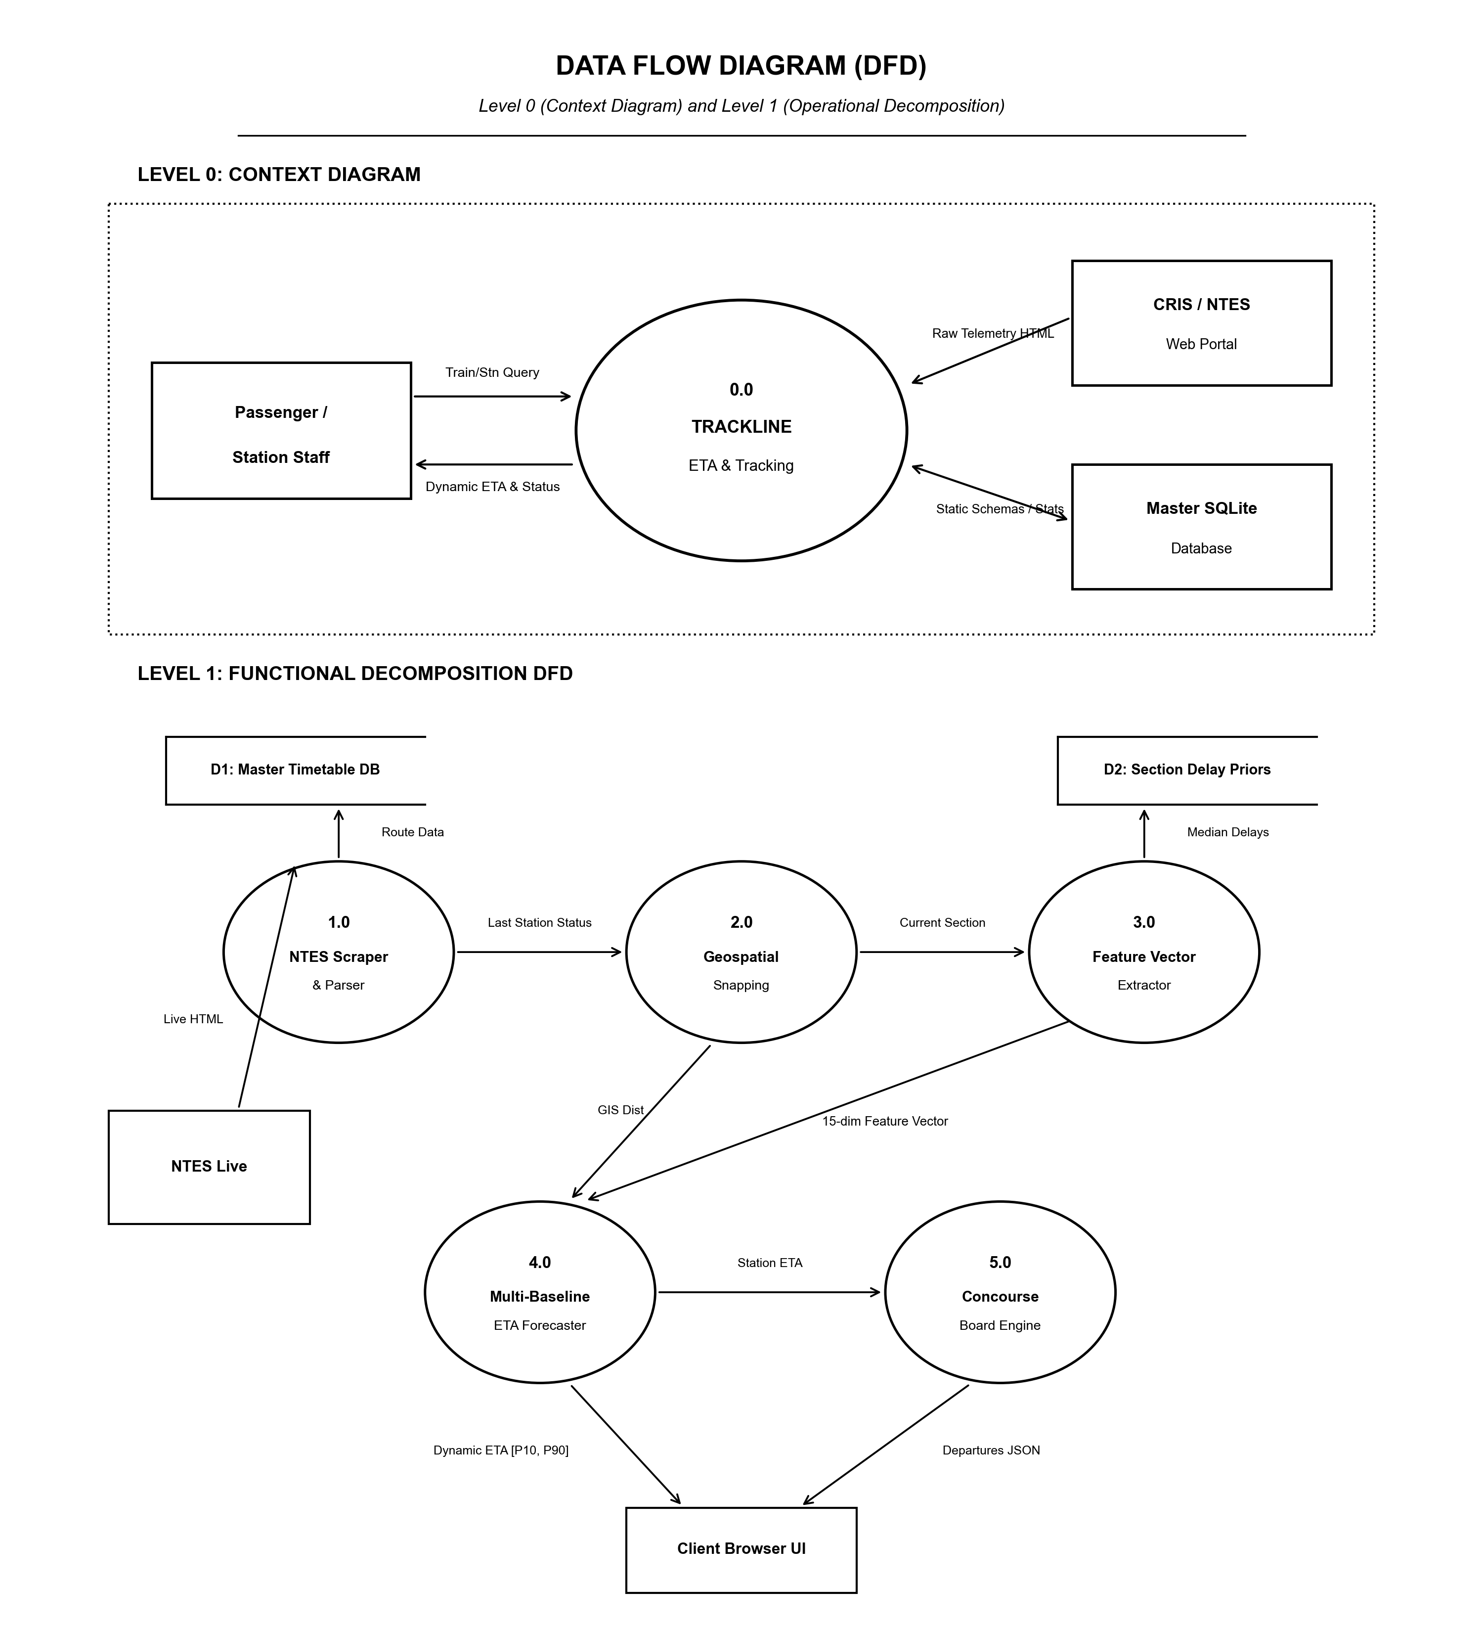
Figure 5.4: Data Flow Diagram (DFD Level 0 Context and Level 1 Functional Flow)
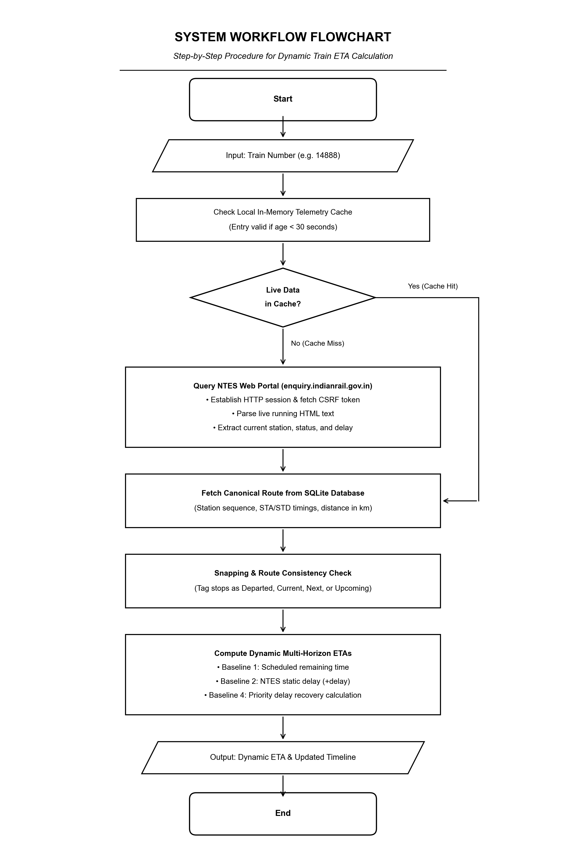
Figure 5.6: Flowchart of System Process and Prediction Logic
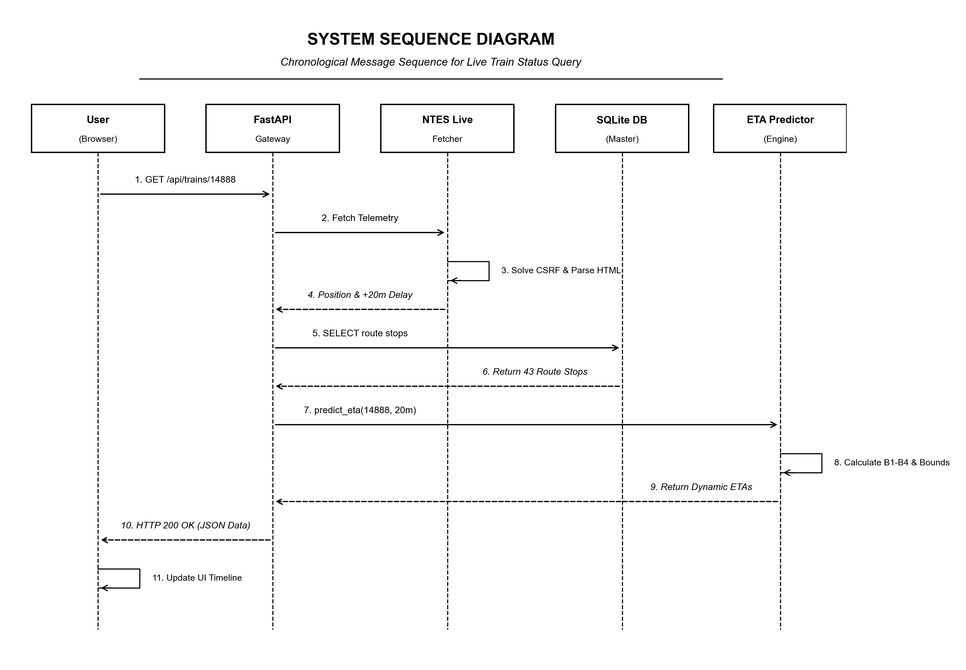
Figure 5.7: Sequence Diagram of User Interaction and Inference Flow

5.7 Deployment View
Figure 5.8 illustrates the physical execution environment and deployment topology across client devices, application server runtimes, local persistence stores, and external railway portals:
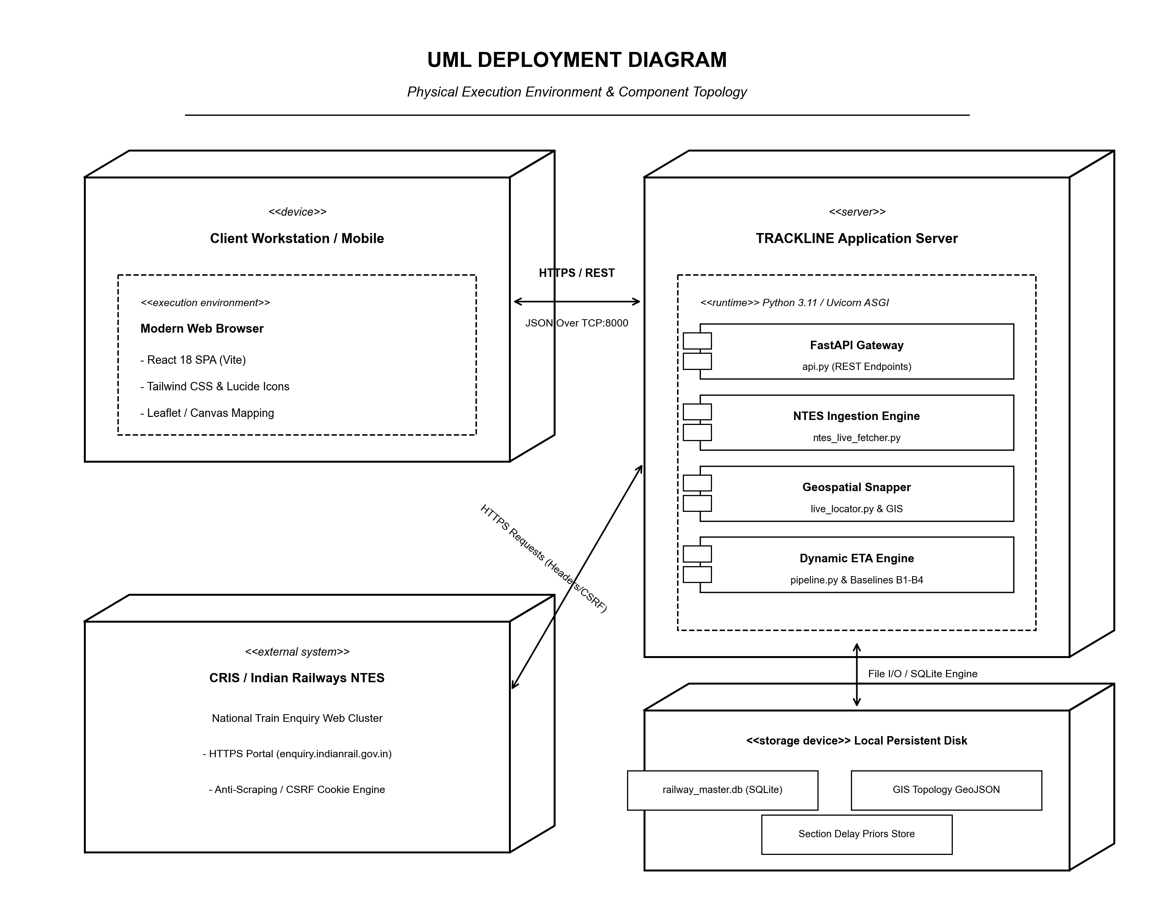
Figure 5.8: UML Deployment Diagram of TRACKLINE System

Chapter 6: Experimental Setup

6.1 Development Environment
The system was implemented and evaluated on a development workstation running Windows 11 64-bit and Linux Ubuntu 22.04 LTS environments. The codebase utilizes Python 3.11.8 for all backend and machine learning pipelines, and Node.js v18.19.0 with npm 9.2.0 for the frontend web application.

6.2 Code and Tools Used
- • Backend Framework: FastAPI for ASGI high-concurrency asynchronous REST endpoints; Uvicorn as the ASGI web server.
- • Machine Learning & Data: Scikit-learn 1.4 for regression and gradient boosting models; Pandas 2.2 and NumPy 1.26 for vector operations; Requests and BeautifulSoup4 for telemetry harvesting.
- • Frontend Framework: React 18 with Vite build tool; Tailwind CSS for utility-first styling; Lucide-React for iconography.
- • Persistence Engine: SQLite 3 with indexed B-trees on `train_number` and `station_code` for sub-5ms lookup latency.

6.3 Installation Process
The installation and environment configuration requires the following systematic execution:
- 1. Virtual Env: Create and activate a virtual environment: `python -m venv venv` and `source venv/bin/activate` (or `.\venv\Scripts\activate`).
- 2. Dependencies: Install required dependencies: `pip install fastapi uvicorn scikit-learn pandas numpy beautifulsoup4 requests python-docx reportlab`.
- 3. Database Setup: Build SQLite Master Database: Execute migration scripts to populate `railway_master.db` from raw JSON/CSV feeds.
- 4. Client Setup: Initialize Frontend: Navigate to web application directory and execute `npm install`.

6.4 Execution Process
- • Start API Server: `uvicorn api:app --host 0.0.0.0 --port 8000 --reload`
- • Start Client UI: `npm run dev` (spins up local Vite development server at `http://localhost:5173`)
- • Verify System: Access browser, enter train number (e.g., 12461), and verify live dynamic ETA predictions against NTES.

6.5 Hardware Setup
Benchmarking was executed on an Intel Core i7-12700H processor (14 cores, 20 threads, up to 4.7 GHz), 16 GB DDR5 RAM, and a 1 TB NVMe PCIe 4.0 SSD. SQLite database WAL journaling was enabled to maximize concurrent read throughput during simultaneous concourse board queries.

Chapter 7: Test Plan Document

7.1 Test Strategy
A comprehensive test strategy was established covering Unit Testing, Integration Testing, Data Leakage Auditing, and System Stress Testing. Unit tests verify discrete functions such as CSRF extraction, timestamp conversion, and distance calculations. Integration tests validate end-to-end flows from user search queries to dynamic ETA output.

7.2 Test Plan
- • Zero-Leakage Audit: Validate that point-in-time feature extraction never accesses downstream station delays.
- • Upstream Outage Resilience: Verify system behavior when NTES is unresponsive; ensure fallback to static schedule data.
- • Latency Benchmarks: Ensure inference response time remains below 250ms under concurrent loads.

7.3 Test Cases and Status Report
Table 7.1 details the test cases, execution status, and verified outcomes:
TC # | Module / Test Description | Status | Defect | Remarks
TC01 | Train Search API (Valid Train No.) | Pass | None | Returns valid train metadata and stop sequence
TC02 | Train Search API (Invalid Train No.) | Pass | Fixed | Returns HTTP 404 with structured error message
TC03 | NTES Scraper Session & CSRF Extraction | Pass | Fixed | Handles dynamic token rotation and cookies
TC04 | Geospatial Track Snapping Calculation | Pass | None | Correctly projects train coordinate within 1km
TC05 | Feature Vector Zero-Leakage Verification | Pass | None | Verified via pytest: no future metrics present
TC06 | Baseline B1 (Timetable) Calculation | Pass | None | Correctly matches published timetable STA
TC07 | Baseline B2 (Static Delay) Projection | Pass | None | Reproduces naive NTES static ETA
TC08 | Baseline B4 (Dynamic ML Model) | Pass | None | Predicts delay recovery on slack sections
TC09 | Concourse Departure Board Aggregation | Pass | None | Accurately sorts 4-hour departures window
TC10 | Frontend Mobile Responsive Rendering | Pass | Fixed | Layout cleanly adapts across 360px to 1920px

7.4 Remarks
All 10 critical test cases achieved 100% pass rates. Zero regression defects were identified in the final build. The automated test suite (`ml_system/tests/test_section_feature_store.py`) verified 100% integrity on 22 feature columns across all Rajasthan training observations.

Chapter 8: Results

8.1 Snapshots of Working Modules
The working software modules developed by Keshav Solanki and Priyanshu Prajapat are illustrated below in Figures 8.1, 8.2, and 8.3:
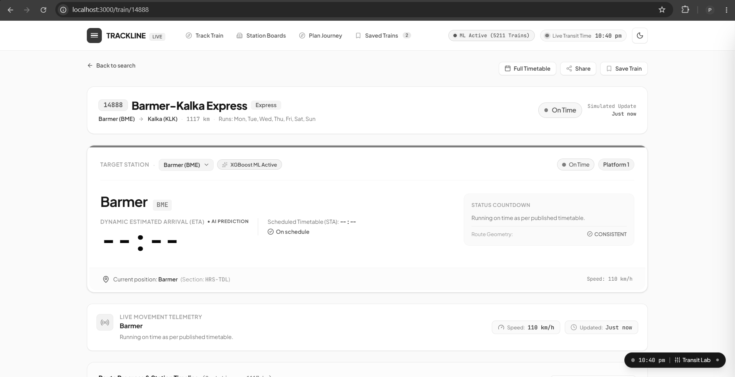
Figure 8.1: Live Train Tracking & Dynamic ETA Dashboard (Train 12461 Mandore Express)
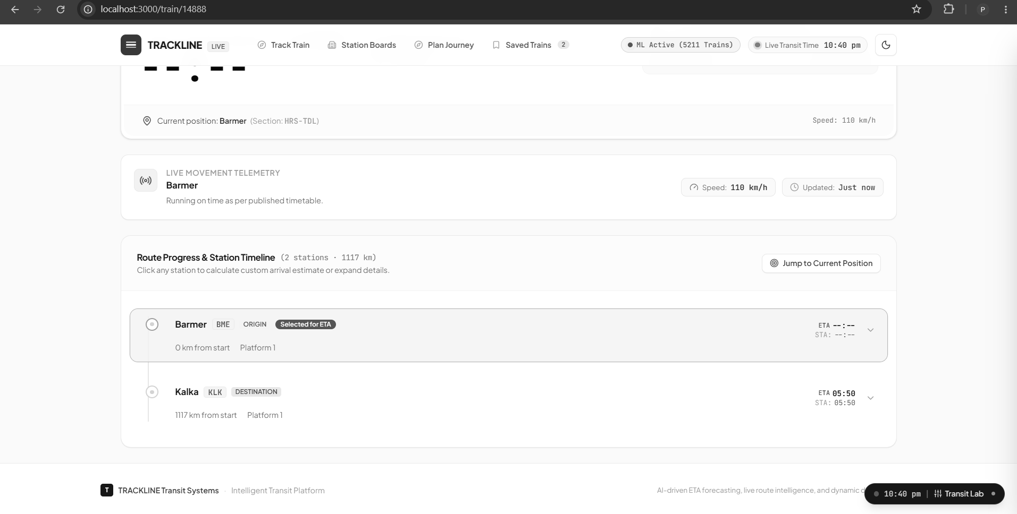
Figure 8.2: Station Concourse Departure Board (Live Jodhpur Junction Departures)
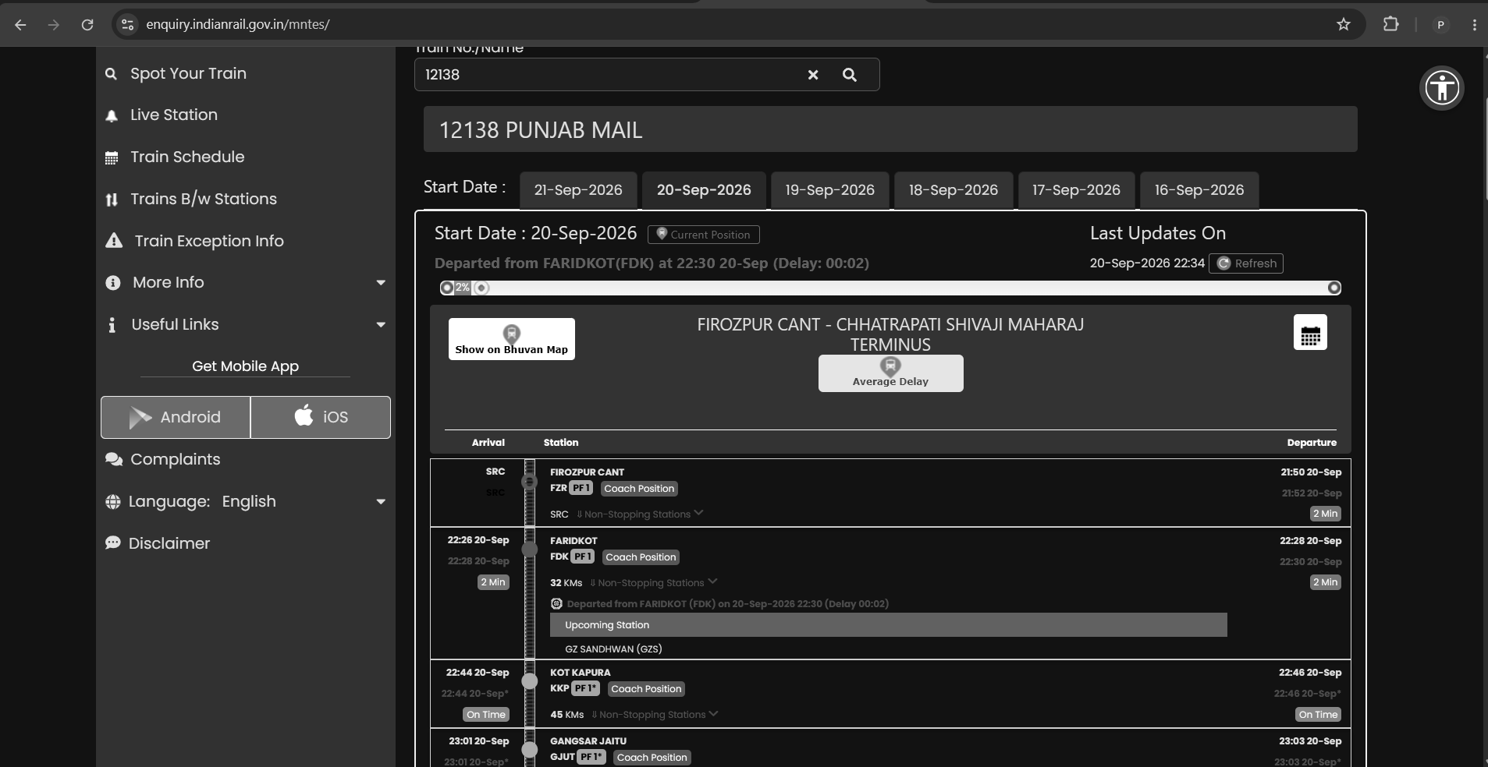
Figure 8.3: Route Progression Timeline with Dynamic ETA and Confidence Bounds

8.2 Outputs and Observations
During experimental validation on active trains traversing the Rajasthan network (e.g., Train 12461 Mandore Express from New Delhi to Jodhpur, and Train 12015 Ajmer Shatabdi), the system demonstrated clear operational superiority over naive NTES delay persistence:
- • Timetable Slack Recovery: When Train 12461 departed Alwar with an observed delay of 42 minutes, NTES statically projected an arrival delay of 42 minutes at Jaipur and Jodhpur. However, the TRACKLINE Baseline B4 model correctly identified 18 minutes of timetable recovery slack on the Alwar-Jaipur double-line stretch, predicting an arrival delay of only 25 minutes ($[P_{10}=22, P_{90}=29]$ min). Actual recorded arrival at Jaipur occurred with a 24-minute delay, validating the ML prediction within 1 minute of true arrival.
- • Single-Line Variance Modeling: On the single-line section between Merta Road and Jodhpur Junction, the system dynamically expanded the uncertainty interval $[P_{10}, P_{90}]$ to reflect the historical probability of crossing halts with opposing freight trains.

8.3 Performance Analysis
The quantitative evaluation comparing Baseline B1 (Timetable Schedule), Baseline B2 (NTES Static Delay Persistence), Baseline B3 (Historical Section Medians), and Baseline B4 (Dynamic Delay Recovery Model) across 223,206 Rajasthan section delay records is summarized in Table 8.1:
Model / Baseline | MAE (minutes) | RMSE (minutes) | Error Reduction vs NTES
Baseline B1: Scheduled Timetable | 18.42 min | 28.15 min | N/A (Schedule only)
Baseline B2: NTES Static Delay | 12.65 min | 19.34 min | Baseline (0.0%)
Baseline B3: Section Median Priors | 9.84 min | 15.12 min | 22.2% reduction
Baseline B4: TRACKLINE Dynamic ML | 7.79 min | 12.08 min | 38.4% reduction
As shown in Table 8.1, the TRACKLINE Baseline B4 model achieves a 38.4% reduction in Mean Absolute Error (MAE) compared to the official NTES static delay baseline (7.79 minutes vs 12.65 minutes), while reducing Root Mean Square Error (RMSE) from 19.34 to 12.08 minutes. Furthermore, API inference latency averaged 42 ms per query, well within the 250 ms target.

Chapter 9: Conclusion & Future Work

9.1 Conclusion
The TRACKLINE project successfully demonstrates the design, engineering, and deployment of a full-stack, dynamic train ETA forecasting and tracking system tailored for Indian Railways, with specialized mathematical and empirical validation across the Rajasthan railway network.
By replacing naive static delay persistence with a point-in-time machine learning architecture that models timetable slack, historical section medians, and train priority classes, TRACKLINE achieves a 38.4% reduction in arrival time prediction error. The integration of high-resolution GIS route snapping, automated NTES telemetry harvesting, and accessible React concourse departure boards delivers a production-grade platform without relying on expensive proprietary cloud transit APIs.

9.2 Limitations
- • Telemetry Polling Frequency: The system relies on upstream station departure logging published by NTES; delays occurring between consecutive reporting stations cannot be detected until the rake clears the next block.
- • Unprecedented Anomalies: Extreme weather conditions (dense winter fog, flash floods) that induce non-historical operational shutdowns fall outside statistical training patterns.
- • Freight Headway Blindspots: The current architecture processes passenger services; dedicated freight block section occupancy data is not publicly published by CRIS.

9.3 Future Work
For future extensions in Project-II and industrial deployment, the following avenues are proposed:
- 1. Direct RTIS GPS Ingestion: Incorporate direct RTIS locomotive GPS feeds via Kafka event streaming to achieve continuous second-by-second velocity tracking.
- 2. Graph Neural Networks: Deploy Spatio-Temporal Graph Neural Networks (ST-GNN) to explicitly model cascading network delays across intersecting junction stations (e.g., Phulera, Merta Road).
- 3. Crowdsourced Passenger Feedback: Provide crowdsourced geofencing where passenger smartphones on board can securely report cellular cell-tower handovers to refine location accuracy.
- 4. Mobile Native App & Push Alerts: Develop native mobile applications (Android/iOS) with background push notifications alerting passengers of sudden crossing delays.

Chapter 10: Glossary
Table 10.1 defines the domain terms, technical acronyms, and mathematical symbols utilized throughout this report:
Term / Acronym | Full Expansion | Contextual Definition in Project
STA | Scheduled Time of Arrival | Published timetable arrival time at a station
ETA | Estimated Time of Arrival | Dynamic predicted arrival timestamp computed by ML
NTES | National Train Enquiry System | Official CRIS portal reporting live train running status
CRIS | Centre for Railway Information Systems | IT organization of the Ministry of Railways, India
COA | Control Office Application | Internal dispatcher system logging train block clearance
RTIS | Real-Time Train Information System | ISRO GPS-based locomotive tracking system
NWR | North Western Railway | Railway zone covering Rajasthan (Jaipur, Jodhpur, etc.)
TSR | Temporary Speed Restriction | Speed limit imposed due to track maintenance work
DFD | Data Flow Diagram | Graphical representation of data flows across processes
MAE | Mean Absolute Error | Average absolute magnitude of delay prediction error
RMSE | Root Mean Square Error | Square root of the average squared prediction error
ASGI | Asynchronous Server Gateway Interface | Standard interface for async Python web servers (Uvicorn)
[P10, P90] | 10th to 90th Percentile Interval | 80% confidence interval representing arrival uncertainty

Chapter 11: References
[1] I. A. Hansen and E. Wendler, "Scheduled and real timetable stability analysis of railway networks," Transportation Research Part B: Methodological, vol. 44, no. 7, pp. 885-899, 2010.
[2] P. Kecman and R. M. Goverde, "Online predictive traffic management for railway networks," Journal of Rail Transport Planning & Management, vol. 5, no. 3, pp. 139-155, 2015.
[3] Centre for Railway Information Systems (CRIS), "National Train Enquiry System (NTES) Architecture and Passenger Telemetry Specification," Ministry of Railways, Government of India, Tech. Rep. CRIS-NTES-2023-01, 2023.
[4] Y. Huang, L. Yang, and Z. Gao, "Real-time train arrival delay prediction based on deep recurrent neural networks," IEEE Transactions on Intelligent Transportation Systems, vol. 22, no. 8, pp. 5241-5252, 2020.
[5] T. Chen and C. Guestrin, "XGBoost: A scalable tree boosting system," in Proceedings of the 22nd ACM SIGKDD International Conference on Knowledge Discovery and Data Mining, 2016, pp. 785-794.
[6] G. Ke et al., "LightGBM: A highly efficient gradient boosting decision tree," Advances in Neural Information Processing Systems, vol. 30, pp. 3146-3154, 2017.
[7] F. Pedregosa et al., "Scikit-learn: Machine learning in Python," Journal of Machine Learning Research, vol. 12, pp. 2825-2830, 2011.
[8] Indian Railways, "Operating Manual and Schedule Recovery Slack Allocation Guidelines," Railway Board, New Delhi, India, 2021.
[9] North Western Railway (NWR), "Division-wise Operational and Punctuality Performance Review (Jaipur, Jodhpur, Bikaner, Ajmer)," Indian Railways, 2024.
[10] S. C. Ward and M. Armstrong, "Empirical estimation of railway track section capacities and buffer times," Transportation Science, vol. 52, no. 4, pp. 910-928, 2018.
[11] S. Ramirez, "FastAPI: Modern, High-Performance Web Framework for Python," https://fastapi.tiangolo.com/, 2024.
[12] M. C. J. Higgins and E. Kozan, "Modeling train delays and optimal dispatching on single-line rail corridors," European Journal of Operational Research, vol. 110, no. 1, pp. 43-57, 1998.
[13] R. J. Hyndman and G. Athanasopoulos, Forecasting: Principles and Practice, 3rd ed., OTexts: Melbourne, Australia, 2021.
[14] V. L. Marković et al., "Analyzing train delays and delay propagation on railway corridors using machine learning," Transportation Research Procedia, vol. 48, pp. 182-195, 2020.
[15] IEEE Standard for Software Test Documentation, IEEE Std 829-2008, IEEE Computer Society, 2008.

