**L0 Contents**

1. General Equilibrium (with production) and Market Efficiency
2. Externalities and Public Goods
3. Social Choice Theory
4. Imperfect Competition
5. Risk

**L1 Introduction**

1. The Scope of Microeconomics
   1. Motivation: **Scarcity**
      * There are limited resources in the world
      * We want to allocate the resources well
   2. Rational decision making: “do our best”
      * Individual decision making (consumer theory, producer theory)
      * Collective decision making (social choice theory, game theory)
   3. Exchange / Matching / Rationing $→$ allocation $→$ evaluation & policy
   4. **Respect that each agent acts in her/his best interest**.
2. Goods/services & Money circulation

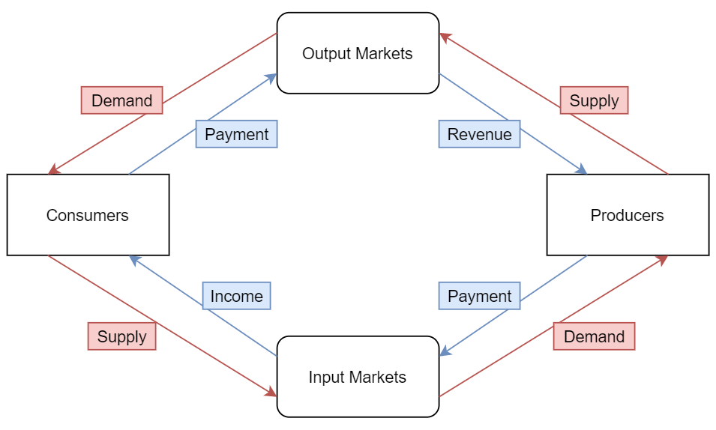

1. General Equilibrium Analysis with Production
   1. Perfectly Competitive Markets
      * **Price Takers**: all economic agents take prices as given (no influence, no fucks given to others’ activities)
      * **Perfect Information of Goods & Prices**: all economic agents know the prices & the qualities of all goods (one-good-one-price principle)
      * **Free Entry**: in the long run, entry & exit can occur freely
   2. Private Ownership Economy
      * Firms:
        1. # = $\left\{1,…,K\right\}$
        2. char: production technology
      * Consumers:
        1. # = $\left\{1,…,N\right\}$
        2. char: income source + preferences / utility function
           1. income source: initial endowments (goods) & share of firms
           2. if firm k made profit $Π_{k}$, and consumer 1 has share 30% and consumer 2 has share 70% of the firm, then they each receive $0.3×Π_{k}$ and $0.7×Π_{k}$ from firm $k$ as income
      * Goods:
        1. # = $\left\{1,…,J\right\}$
        2. Sometimes more than two goods should be allowed
      * Prices:
 $p=\left(p_{1},…,p_{J}\right)$

  3. Example: A firm’s problem
      * A firm uses good 2 to produce good 1.
      * $y_{1}=$#good1, $z_{2}=$#good2
      * The firm’s technology: $y_{1}≤\sqrt{6z_{2}}$
        1. If input $z_{2}$ of good2, then the maximal #good1 the firm can produce is $\sqrt{6z_{2}}$
      * The price vector = $\left(p,1\right)$
        1. Normalize the price of good2 as 1
        2. The firm is a price-taker
      * Compute the profit maximizing $y_{1}^{*},z_{2}^{*}$ as functions of $p$:
 $$∵y_{1}≤\sqrt{6z_{2}}$$ $$∴Π_{max}\left(z_{2}\right)=p\sqrt{6z_{2}}-z_{2}=p\sqrt{6}{\left(z_{2}\right)}^{\frac{1}{2}}-z_{2}$$ $$Π_{max}^{'}\left(z_{2}\right)=\frac{p\sqrt{6}}{2\sqrt{z_{2}}}-1 \\ z_{2}^{*}=\frac{3}{2}p^{2}$$ $$∴y_{1}^{*}=3p$$  * **Production Plan**:
 $$y=\left(y_{1},…,y_{J}\right)$$

 $y_{j}>0$      1. if it’s output
        2. $y_{j}<0$ if it’s input
        3. The above firm’s optimal production plan is $\left(y_{1}^{*},y_{2}^{*}\right)=\left(3p,-\frac{3}{2}p^{2}\right)$
        4. Profit with Production plan:
 $$p∙y^{T}$$     * The above firm’s max profit = $p_{1}y_{1}^{*}+p_{2}y_{2}^{*}=\frac{3}{2}p^{2}$
   4. Example: A consumer’s problem
      * Miku has 0 unit of good1 and 28 units of good2 ($ω^{A}=\left(0,28\right)$)
      * She has $θ$ share of the above firm
      * Her **utility function** is: $u_{A}\left(x_{1}^{A},x_{2}^{A}\right)=\left(\sqrt{2}x_{1}^{A}\right)×x_{2}^{A}$
        1. This represents how satisfied she is if she consumes $x_{1}^{A}$ units of good 1 and $x_{2}^{A}$ units of good 2
      * Miku’s **budget constraint**: $px_{1}^{A}+1x_{2}^{A}=28+θ∙\frac{3}{2}p^{2}$
        1. Since she has 28 good2 at a price of 1, she can sell them to the market to gain income
        2. Since she has a share of the firm, she gets parts of its profit as her income
      * Miku’s **utility maximization**:
 $$\frac{MU_{A1}}{p}=\frac{MU_{A2}}{1} \\ \frac{\sqrt{2}x_{2}^{A}}{p}=\frac{\sqrt{2}x_{1}^{A}}{1} \\ x_{2}^{A}=px_{1}^{A}$$     * Further Calculation
 $$px_{1}^{A}+px_{1}^{A}=28+\frac{3θ}{2}p^{2}$$ $$x_{1}^{*A}=\frac{14}{p}+\frac{3θ}{4}p \\ x_{2}^{*A}=14+\frac{3θ}{4}p^{2}$$    * Miku’s **optimal consumption bundle**: $x=\left(x_{1},…,x_{J}\right)$
 $$x^{*A}=\left(\frac{14}{p}+\frac{3θ}{4}p, 14+\frac{3θ}{4}p^{2}\right)$$

  5. c + d = private-ownership economy with 1 firm and 1 consumer
   6. Competitive Equilibrium
      * **Equilibrium**:
        1. A prediction by a theory
        2. (micro) a stable situation where no agent wants to change transactions
      * **Allocation**: a list of consumption bundles of all consumers + production plans of all firms
        1. $N$ consumers + $K$ firms: $\left(\left\{x^{1},…,x^{N}\right\},\left\{y^{1},…,y^{K}\right\}\right)$
        2. $J$ goods:

$x^{i}=\left(x_{1}^{i},…,x_{J}^{i}\right)$

$y^{k}=\left(y_{1}^{k},…,y_{J}^{k}\right)$

$y_{j}^{k}>0$ if firm $k$ produces good $j$

$y_{j}^{k}<0$ if firm $k$ uses good $j$ as an input

* + - **Competitive Equilibrium** (i.e. Walrasian equilibrium): an allocation + a price vector $\left(\left\{x^{1},…,x^{N}\right\},\left\{y^{1},…,y^{K}\right\},p^{*}\right)$ if
      1. **Individual maximization**: all economic agents maximize his/her objective subject to his/her constraint
      2. **Market Clearance**: demand & supply of all goods are equated
    - If a competitive equilibrium,
      1. $\left(\left\{x^{1},…,x^{N}\right\},\left\{y^{1},…,y^{K}\right\}\right)$ = **competitive allocation**
      2. $p^{*}=\left(p_{1}^{*},…,p_{J}^{*}\right)$ = **competitive price vector**
  1. Example: a competitive equilibrium
     + Let $θ=1$ (Miku owns the firm entirely)
     + The firm’s profit maximization $→$ production plan
 $$\left(y_{1}^{*},y_{2}^{*}\right)=\left(3p,-\frac{3}{2}p^{2}\right)$$

 $y_{1}^{*}$     1. : supply of good 1
       2. $-y_{2}^{*}:$ demand of good 2
     + Miku’s utility maximization $→$ consumption bundle
 $$\left(x_{1}^{*A},x_{2}^{*A}\right)=\left(\frac{14}{p}+\frac{3}{4}p,14+\frac{3}{4}p^{2}\right)$$

 $x_{1}^{*A}:$     1. demand of good 1
       2. $x_{2}^{*A}$: demand of good 2
     + **Market Clearing**
       1. Miku starts with (0,28) and $θ=1$; The firm uses good 2 to produce good 1; Miku wants to consume ($x_{1}^{*A},x_{2}^{*A}$)
       2. Good 1 market
          1. Market demand: Miku’s demand only
          2. Market supply: The firm’s supply only (no initial endowment)
 $$x_{1}^{*A}=y_{1}^{*}$$

      3. Good 2 market
          1. Market demand: Miku’s & the firm’s ($-y_{2}^{*}$)
          2. Market supply: Miku’s initial endowment
 $$x_{2}^{*A}-y_{2}^{*}=28$$

      4. Competitive price of good 1
 $$x_{1}^{*A}=y_{1}^{*} \\ \frac{14}{p}+\frac{3}{4}p=3p \\ p^{*}=\frac{2\sqrt{14}}{3}≈2.494$$

      5. Competitive price vector:
 $$\left(p^{*},1\right)=\left(\frac{2\sqrt{14}}{3},1\right)$$

      6. Competitive allocation:
 $$x_{1}^{*A}=y_{1}^{*}=2\sqrt{14}$$

 $$x_{2}^{*A}=\frac{56}{3}$$

 $$-y_{2}^{*}=\frac{28}{3}$$

    7. Summary
 $$\left(\left(x_{1}^{*A},x_{2}^{*A}\right),\left(y_{1}^{*},y_{2}^{*}\right)\right)=\left(\left(2\sqrt{14},\frac{56}{3}\right),\left(2\sqrt{14},-\frac{28}{3}\right)\right)$$

 $$\left(p^{*},1\right)=\left(\frac{2\sqrt{14}}{3},1\right)$$

2. Graph Analysis
     + Firm’s side:

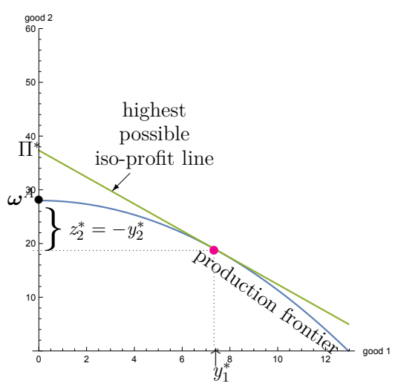

* + - 1. Production frontier = max production func ($y_{1}≤\sqrt{6z_{2}}$)
      2. $ω^{A}$: Ann’s current storage ?
      3. Highest possible iso-profit line: the profit line tangent to the optimal production plan
 $$Π=px_{1}+x_{2}⇒x_{2}=Π-px_{1}$$

 $Π^{*}:$    4. max profit (intercept at $x_{2}$ axis)
    - Consumer’s side:

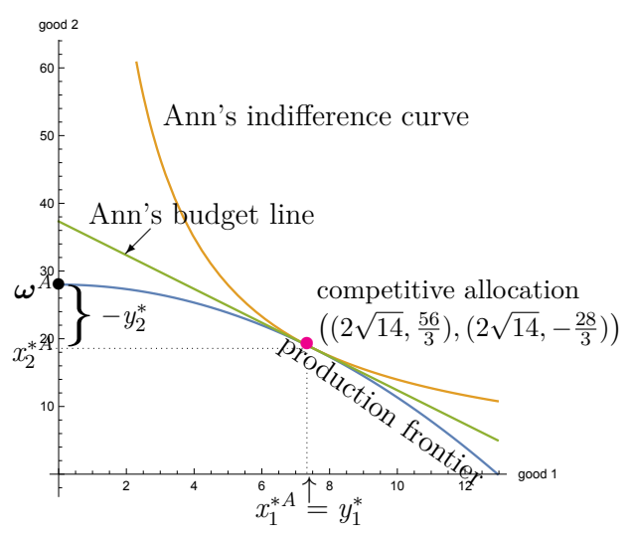

1. Summary
   1. At a competitive equilibrium of a one-firm one-consumer economy,
      * The consumer’s indifference curve is tangent to the budget line
      * The optimal iso-profit line is tangent to the production frontier
      * The budget line coincides with the optimal iso-profit line
   2. **Walras’ Law**: If there are $J$ goods, we only need to solve $J-1$ market-clearing conditions
 $$\begin{matrix}\sum_{i=1}^{N}{x_{1}^{i}\left(p\right)}-\sum_{i=1}^{N}{ω_{1}^{i}}-\sum_{i=1}^{N}{y_{1}^{k}\left(p\right)}=0 \\ ⋮ \\ \sum_{i=1}^{N}{x_{J-1}^{i}\left(p\right)}-\sum_{i=1}^{N}{ω_{J-1}^{i}}-\sum_{i=1}^{N}{y_{J-1}^{k}\left(p\right)}=0\end{matrix}⟹\sum_{i=1}^{N}{x_{J}^{i}\left(p\right)}-\sum_{i=1}^{N}{ω_{J}^{i}}-\sum_{i=1}^{N}{y_{J}^{k}\left(p\right)}=0$$ $⇒$    * **monotonicity** of consumers’ utility functions
2. Example: three-agent economy
   1. Firm, Miku, Qu.
   2. Miku’s share is now $θ=0.5$
   3. Qu’s characteristics:
 $ω^{B}=\left(0,30\right)$ $θ_{B}=0.5$ $u_{B}\left(x_{1}^{B},x_{2}^{B}\right)={\left(x_{1}^{B}\right)}^{2}×\left(x_{2}^{B}\right)$   * = Price taker
   4. Qu’s budget constraint
 $$px_{1}^{B}+x_{2}^{B}=30+\frac{3}{4}p^{2}$$

  5. Qu’s optimal condition
 $$\frac{MU_{B1}}{p}=\frac{MU_{B2}}{1}$$

 $$2x_{2}^{B}=px_{1}^{B}$$

 $$⇒2x_{2}^{B}+x_{2}^{B}=30+\frac{3}{4}p^{2}$$

$$x_{2}^{*B}=10+\frac{1}{4}p^{2}$$

$$x_{1}^{*B}=\frac{20}{p}+\frac{1}{2}p$$

6. Miku’s demand with $θ$
 $$x_{1}^{*A}=\frac{14}{p}+\frac{3θ}{4}p$$

 $$x_{2}^{*A}=14+\frac{3θ}{4}p^{2}$$

 7. Miku’s demand with 0.5
 $$\left(x_{1}^{*A},x_{2}^{*A}\right)=\left(\frac{14}{p}+\frac{3}{8}p,14+\frac{3}{8}p^{2}\right)$$

  8. Competitive equilibrium
      * Good 1 market
 $$x_{1}^{*A}+x_{1}^{*B}=y_{1}^{*}$$     * Good 2 market
 $$x_{2}^{*A}+x_{2}^{*B}=28+30+y_{2}^{*}$$ $$14+\frac{3}{8}p^{2}+10+\frac{1}{4}p^{2}=58-\frac{3}{2}p^{2}$$ $$⇒p^{*}=4$$   * Competitive equilibrium
$$\left(\left\{\left(x_{1}^{*A},x_{2}^{*A}\right),\left(x_{1}^{*B},x_{2}^{*B}\right)\right\},\left(y_{1}^{*},y_{2}^{*}\right),\left(p^{*},1\right)\right)=\left(\left\{\left(5,20\right),\left(7,14\right)\right\},\left(12,-24\right),\left(4,1\right)\right)$$

3. Welfare Economics
   1. Existence of a Competitive Equilibrium
      * #vars = #equalities? NOT ENOUGH
      * **Fixed Point Theorem**
        1. Sufficient conditions: $u_{i}$ continuous, monotone, production frontier continuous
        2. Uniqueness: need additional assumptions of the economy
   2. Comparative statics
      * We can analyze how external factors change the demand, the supply, and the equilibrium.
        1. Initial endowments, shares of firms’ profits
        2. Utility function parameters (preferences)
        3. Production technology parameters
   3. Parameterized Model
      * Firm’s technology
 $$y_{1}≤A{\left(-y_{2}\right)}^{α}$$     * Miku’s endowments
 $$ω^{A}=\left(ω_{1}^{A},ω_{2}^{A}\right)$$     * Miku’s utility function
 $$u_{A}\left(x_{1}^{A},x_{2}^{A}\right)=B{\left(x_{1}^{A}\right)}^{β}{\left(x_{2}^{A}\right)}^{γ}$$     * Competitive Equilibrium

$$\left(\left(x_{1}^{*A}\left(W\right),x_{2}^{*A}(W)\right),\left(y_{1}^{*}\left(W\right),y_{2}^{*}\left(W\right)\right),\left(p^{*}\left(W\right),1\right)\right)$$

Where parameters

* 1. Welfare Economics
     + Evaluate which allocation is “good”
     + If the market does not give a “good” allocation, find a policy to achieve one
  2. Production Set
 $$Y^{k}≔\left\{y^{k}|g^{k}\left(y^{k}\right)≤0\right\}$$

 $k=1,…,K$   + : each firm
     + $y^{k}=\left(y_{1},…,y_{m}\right)$: input & output
     + $g^{k}\left(y_{j},y_{h}\right)=y_{j}-f\left(y_{h}\right)$: production function
  3. Consumer Set
     + $i=1,…,N$: each consumer
     + $ω^{i}=\left(ω_{1}^{i},…,ω_{J}^{i}\right)$: initial endowment
     + $θ^{i}=\left(θ_{1}^{i},…,θ_{K}^{i}\right)$: shares of diff firms
 $θ_{k}^{1}+…+θ_{k}^{N}=1$

 4. Feasible Allocations
     + In a private-ownership economy $E=\left(\left(u_{1},ω^{1},θ^{1}\right),…,\left(u_{N},ω^{N},θ^{N}\right),Y^{1},…Y^{K}\right)$, an allocation $\left(\left\{x^{1},…,x^{N}\right\},\left\{y^{1},…,y^{K}\right\}\right)$ is **feasible** if
 $$∀ good j=1,…,J: \sum_{i=1}^{N}{x_{j}^{i}}≤\sum_{i=1}^{N}{ω_{j}^{i}}+\sum_{i=1}^{N}{y_{j}^{i}},$$

 $$∀ firm k=1,…,K:y^{k}∈Y^{k}$$

5. Pareto Improvement
     + Fix an economy $E=\left(\left(u_{1},ω^{1},θ^{1}\right),…,\left(u_{N},ω^{N},θ^{N}\right),Y^{1},…Y^{K}\right)$,

a feasible allocation $\left({\left\{{\hat{x}}^{i}\right\}}_{i=1}^{N},{\left\{{\hat{y}}^{k}\right\}}_{k=1}^{N}\right)$ is a Pareto Improvement of another feasible allocation if

* + - 1. consumer $i:u_{i}\left({\hat{x}}^{i}\right)≥u_{i}\left(x^{i}\right)$
      2. $∃$ consumer $m:u_{m}\left({\hat{x}}^{m}\right)>u_{m}\left(x^{m}\right)$
  1. Efficiency (Strong Pareto Optimality)
     + A feasible allocation is **efficient** if $∄$ Pareto improvements
  2. 1st Fundament Theorem of Welfare Economics
     + In any private-ownership economy $E=\left(\left(u_{1},ω^{1},θ^{1}\right),…,\left(u_{N},ω^{N},θ^{N}\right),Y^{1},…Y^{K}\right)$ where all consumers’ utility functions satisfy monotonicity, **ANY** **competitive allocation is efficient.**
       1. Monotonicity: $x^{i}<{\tilde{x}}^{i}⇒u_{i}\left(x^{i}\right)<u_{i}\left({\tilde{x}}^{i}\right)$
          1. i.e. if all goods are strictly increased, $i$ is happier.

**L3 idk the title**

1. Edgeworth’s Box diagram
   1. An allocation has no waste if
 $$x_{1}^{A}+x_{1}^{B}=ω_{1}^{A}+ω_{1}^{B}$$

 $$x_{2}^{A}+x_{2}^{B}=ω_{2}^{A}+ω_{2}^{B}$$

 2. An allocation is efficient if
      * It has no waste
      * At least 1 consumer is worse-off by moving the dot to any direction
   3. Efficient $⇔$ indiff curves of the 2 consumers are **tangent** to each other
2. Algebraic Explanation
   1. In a 2-good, 2-consumer pure exchange economy (with differentiable, convex indifference curves)
   2. An allocation is efficient if
      * The two consumers’ indifference curves are tangent to each other

$⇔$ their Marginal Rates of Substitution are the same at that allocation

* + - In a competitive equilibrium, all consumers maximize their utilities

$$\frac{MU_{1}^{A}\left(x^{*A}\right)}{p_{1}^{*}}=\frac{MU_{2}^{A}\left(x^{*A}\right)}{p_{2}^{*}},\frac{MU_{1}^{B}\left(x^{*B}\right)}{p_{1}^{*}}=\frac{MU_{2}^{B}\left(x^{*B}\right)}{p_{2}^{*}}$$

Hence, the above equation.

Via relative prices, self-interested behaviors make their indifference curves tangent to each other. This logic works for any number of goods, consumers, and production.