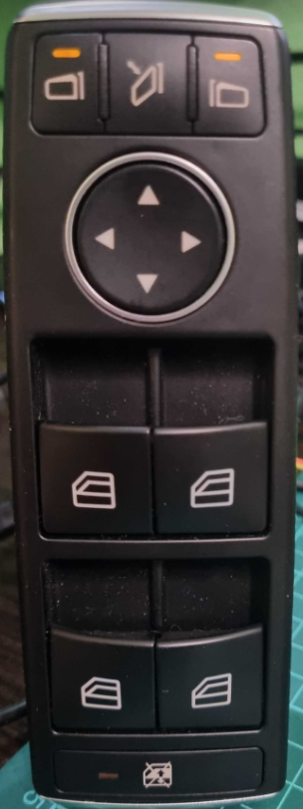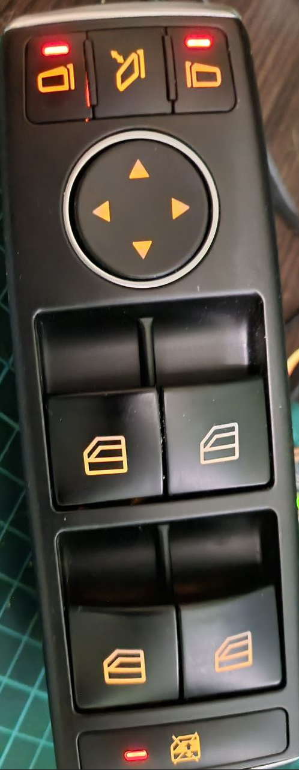

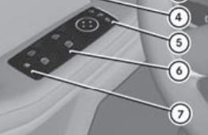

See Owner’s manual pp 69, 96, 119

Initial state (all unpressed) 0x00, 0x40, 0x80.

|  |  |  |
| --- | --- | --- |
|  | 0x00, 0x40, 0x80 (OFF)  0x00, 0x80, 0xA0 (ON) | Left-hand exterior mirror select |
|  | 0x00, 0x40, 0x80 (OFF)  0x00, 0x80, 0x88 (ON) | Folding the exterior mirrors in or out electrically. |
|  | 0x00, 0x40, 0x80 (OFF)  0x00, 0x80, 0xC0 (ON) | Right-hand exterior mirror select |
|  | 0x00, 0x40, 0x80 (OFF)  0x80, 0x80, 0x80 (ON) | Mirror Adjustment Up |
|  | 0x00, 0x40, 0x80 (OFF)  0x00, 0x80, 0x84 (ON) | Mirror Adjustment Down |
|  | 0x00, 0x40, 0x80 (OFF)  0x00, 0x80, 0x82 (ON) | Mirror Adjustment Left |
|  | 0x00, 0x40, 0x80 (OFF)  0x00, 0x80, 0x81 (ON) | Mirror Adjustment Right |
| FrLeUp | 0x00, 0x40, 0x80 (OFF)  0x04, 0x80, 0x80 (ON short)  0x0C, 0x80, 0x80 (ON full) | Front Left Up  Full == fully pressed (automatic window opening/closing) |
| FrLeDwn | 0x00, 0x40, 0x80 (OFF)  0x02, 0x80, 0x80 (ON short)  0x0A, 0x80, 0x80 (ON full) | Front Left Down |
| FrRiUp | 0x00, 0x40, 0x80 (OFF)  0x20, 0x80, 0x80 (ON short)  0x60, 0x80, 0x80 (ON full) | Front Right Up |
| FrRiDwn | 0x00, 0x40, 0x80 (OFF)  0x10, 0x80, 0x80 (ON short)  0x50, 0x80, 0x80 (ON full) | Front Right Down |
| ReLeUp | 0x00, 0x40, 0x80 (OFF)  0x00, 0x82, 0x80 (ON short)  0x00, 0x86, 0x80 (ON full) | Rear Left Up |
| ReLeDwn | 0x00, 0x40, 0x80 (OFF)  0x00, 0x81, 0x80 (ON short)  0x00, 0x85, 0x80 (ON full) | Rear Left Down |
| ReRiUp | 0x00, 0x40, 0x80 (OFF)  0x00, 0x90, 0x80 (ON short)  0x00, 0xB0, 0x80 (ON full) | Rear Right Up |
| ReRiDwn | 0x00, 0x40, 0x80 (OFF)  0x00, 0x88, 0x80 (ON short)  0x00, 0xA8, 0x80 (ON full) | Rear Right Down |
|  | 0x00, 0x40, 0x80 (OFF)  0x00, 0x80, 0x90 (ON) | Override feature for rear side windows |

**RX BR=19200, ID = 9, length = 3, Enhanced CS Buttons State**

|  |  |  |  |  |  |  |  |
| --- | --- | --- | --- | --- | --- | --- | --- |
| **D7** | **D6** | **D5** | **D4** | **D3** | **D2** | **D1** | **D0** |
| **BYTE 0** | | | | | | | |
| AdjmtUp | FrRiAut | FrRiUp | FrRiDwn | FrLeAut | FrLeUp | FrLeDwn | 0 |
| **BYTE 1** | | | | | | | |
| PsdRndBtn | NoPsdRndBtn | ReRiAut | ReRiUp | ReRiDwn | ReLeAut | ReLeUp | ReLeDwn |
| **BYTE 2** | | | | | | | |
| 1 | RiMirrSel | LeMirrSel | OvrdReWin | FoldMirr | AdjmtDwn | AdjmtLe | AdjmtRi |

**Red LEDs: TX BR=19200, ID = 0, length = 7 (8), Enhanced CS**

|  |  |  |  |  |  |  |  |
| --- | --- | --- | --- | --- | --- | --- | --- |
| **D7** | **D6** | **D5** | **D4** | **D3** | **D2** | **D1** | **D0** |
| **BYTE 0** | | | | | | | |
| - | - | - | OvrdReWin | - | RiMirrSel | - | LeMirrSel |
| **BYTE 1** | | | | | | | |
|  |  |  |  |  |  |  |  |
| **BYTE 2** | | | | | | | |
|  |  |  |  |  |  |  |  |
| **BYTE 3** | | | | | | | |
|  |  |  |  |  |  |  |  |
| **BYTE 4** | | | | | | | |
|  |  |  |  |  |  |  |  |
| **BYTE 5** | | | | | | | |
|  |  |  |  |  |  |  |  |
| **BYTE 6** | | | | | | | |
|  |  |  |  |  |  |  |  |
| **(BYTE 7)** | | | | | | | |
|  |  |  |  |  |  |  |  |

Yellow LEDs backlight: TX BR=19200, ID = 10, length = 7 (8), Enhanced CS

|  |  |  |  |  |  |  |  |
| --- | --- | --- | --- | --- | --- | --- | --- |
| **D7** | **D6** | **D5** | **D4** | **D3** | **D2** | **D1** | **D0** |
| **BYTE 0** | | | | | | | |
| - | - | - | - | - | - | - | - |
| **BYTE 1** | | | | | | | |
| - | - | - | - | - | - | - | - |
| **BYTE 2** | | | | | | | |
| - | - | - | - | - | - | - | Backlite |
| **BYTE 3** | | | | | | | |
| - | - | - | - | - | - | - | - |
| **BYTE 4** | | | | | | | |
| - | - | - | - | - | - | - | - |
| **BYTE 5** | | | | | | | |
| - | - | - | - | - | - | - | - |
| **BYTE 6** | | | | | | | |
| - | - | - | - | - | - | - | - |
| **(BYTE 7)** | | | | | | | |
| - | - | - | - | - | - | - | - |