**Оптимизация Django. 2 - проектирование приложения Django + DRF View API endpoint**

Endi loyixamizda app hosil qilamiz.

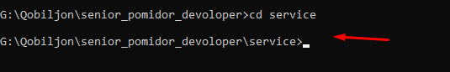

Avval loyixaga kirib oldim. Endi

docker-compose run --rm web-app sh -c "python manage.py startapp clients"

clients nomli app xosil qildik.

Endi services nomli yana bitta app xosil qilamiz.

docker-compose run --rm web-app sh -c "python manage.py startapp services"