**Project Name: Helping Hands**

**Project Members:**

|  |  |
| --- | --- |
| **PRN No.** | **Name** |
| **220943120035** | **Harsh Hemant Jadhav** |
| **220943120046** | **Kartikey Kishor Sontakke** |
| **220943120057** | **Mahesh Prabhakar Kotte** |
| **220943120109** | **Vijay Suresh Renushe** |

**Introduction of Project:**

Food wastage is a massive problem and one of the most overlooked things in today’s world. One third of all food produced in the world goes to waste

Some restaurants/cafés have a policy to not serve food from previous day, despite being perfectly edible. This is all thrown away as “waste”, at the end of day.

At the same time, worldwide most of people do not have enough to eat. That means one in nine people are suffering from hunger. Also many street animals haven`t get food minimum one time in a day.

**Objective and Scope of Project:**

Our project provides a way to bridge the gap between the wastage and deficit, by letting restaurants donate this food to needy like food community, animal care organizations, Food processing units etc.

**Modification and improvement over the existing Implementation:**

Present State:

Now a days NGO’s need donation so that they can help needy one, but platforms provide only money donation. From that money NGO’s will buy the things to serve to needy ones.

After implementation of project:

In our project a food collected by restaurants will be available for food community and it will be also available for animal care organizations, animal communities and food processing units.

**Project Plan:**

* **Users-**

1] Restaurant(Donor) login.

2] Login for everyone who need waste food.

3] Admin login.

* **Modules** –

1] A restaurant/café worker creates a collection request for excess food, which is then sent across to all the NGOs within the network

2] A needy person viewing the enterprises’ inventory can raise a shortage request

**Technology:**

Frontend- React

Backend- spring boot

Database- mysql

Others -

**Roles and Responsibilities:**

|  |  |  |
| --- | --- | --- |
| **Roles And Responsibilities** | | |
| 1 | Role | Front-End, Back-End Developing, Database Design |
| Member Name | Harsh Hemant Jadhav |
| PRN No | 220943120035 |
| Description |  |
| 2 | Role | Front-End, Back-End Developing, Database Design |
| Member Name | Kartikey Kishor Sontakke |
| PRN No | 220943120046 |
| Description |  |
| 3 | Role | Front-End,Back-End Developing, Database Design |
| Member Name | Mahesh Prabhakar Kotte |
| PRN No | 220943120057 |
| Description |  |
| 4 | Role | Front-En ,Back-End Developing, Database Design |
| Member Name | Vijay Suresh Renushe |
| PRN No | 220943120109 |
| Description |  |

**Data Flow Diagram (DFD):**

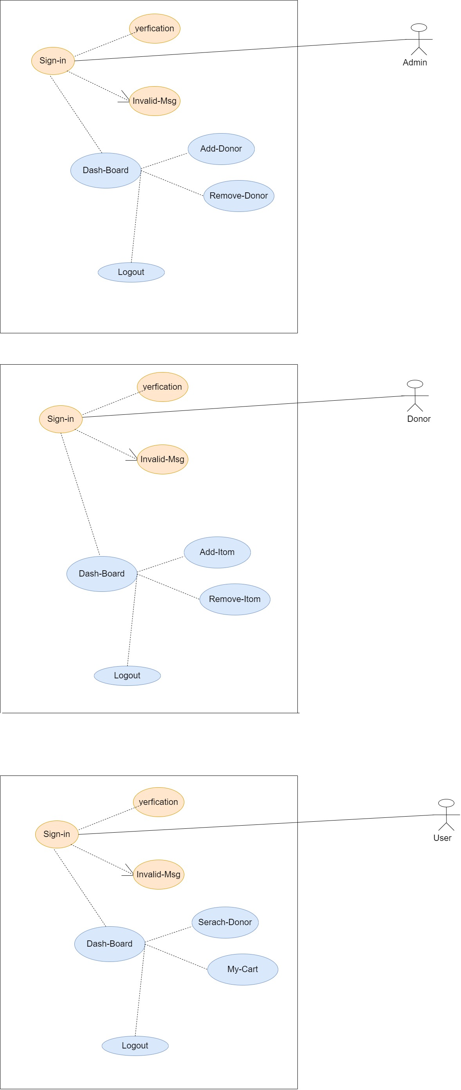

**U-I Diagram:**

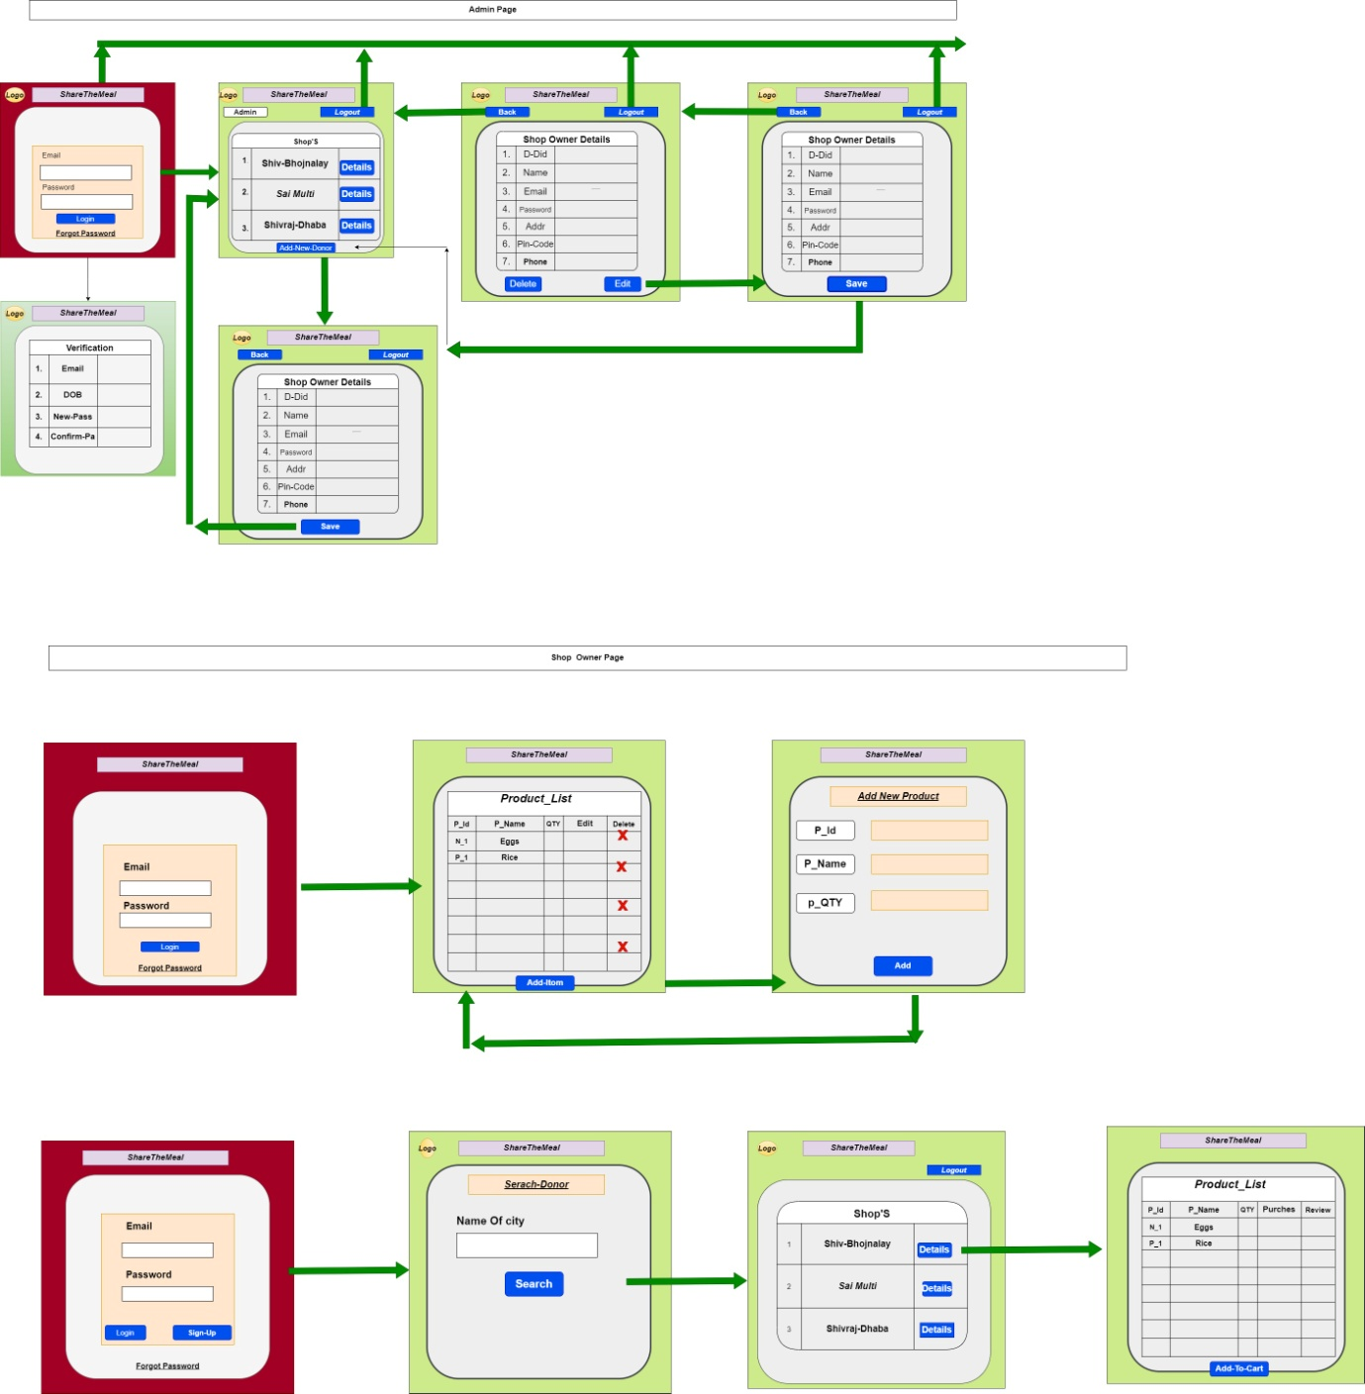

**ERD / Database Tables:**

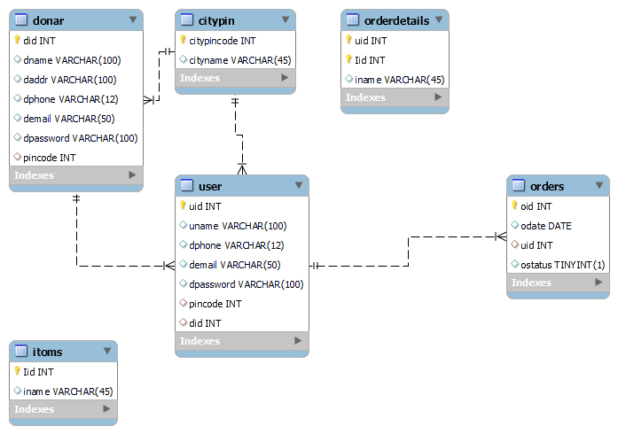

**Future Scope:**

Instead of just restaurants/cafés we can also have people register individual households/ person to donate leftovers from home.

**Project n-tier:**

