Read the requirement carefully and submit Test deliverables as mentioned below.
Deliverable 1: Identify all the test scenarios for the mentioned requirement
Deliverable 2: Write all the test cases using the appropriate testing techniques wherever applicable for the below requirement.
URL: https://corporate.olacabs.com/#/contact
Requirement:
Here is the requirement of OLA Corporate application. This application can be used by the Company people to send the details of an organization & set up an appointment with OLA representative to opt for corporate OLA benefits. The below screen will help the in understanding the requirement.
Fields:
Name - TextBox. It is an mandatory field
- This field can accept Alphabetic data of maximum 100 characters.

Email Address – Textbox - it is an mandatory field
- This field can accept Mix of Alphanumeric and special characters in a valid Email Format of 30 digits.

Company Name – TextBox – It is an mandatory field
- This field can accept alphanumeric values of 30 digits.

Phone Number – TextBox – It is an mandatory field
- This field can accept only numeric values of 10 digits.

Department – Listbox – It is an mandatory field
- The current values available in database are Admin, Finance, Travel desk, HR & Others.

Number of Employees – ListBox - it is an mandatory field
- The current values available in database are Less than 50, 5- to 200, 201 to 2500 & More than 2500.

Comments – TextBox
- This field can accept Alphabetic data of maximum 2000 characters.

I’m not a robot – RadioButton – It is an mandatory field
- Upon clicking this field it will display the list of image to select based on the question.

Submit – Button
- The User after entering the necessary details clicks the “Submit” button. The System validates the data.
- If Valid, the Systems responds with the message that, “Contact details submitted.
Our representative will contact you within 24 hrs.
- If the data is invalid, appropriate error message will be displayed.

ScreenShot
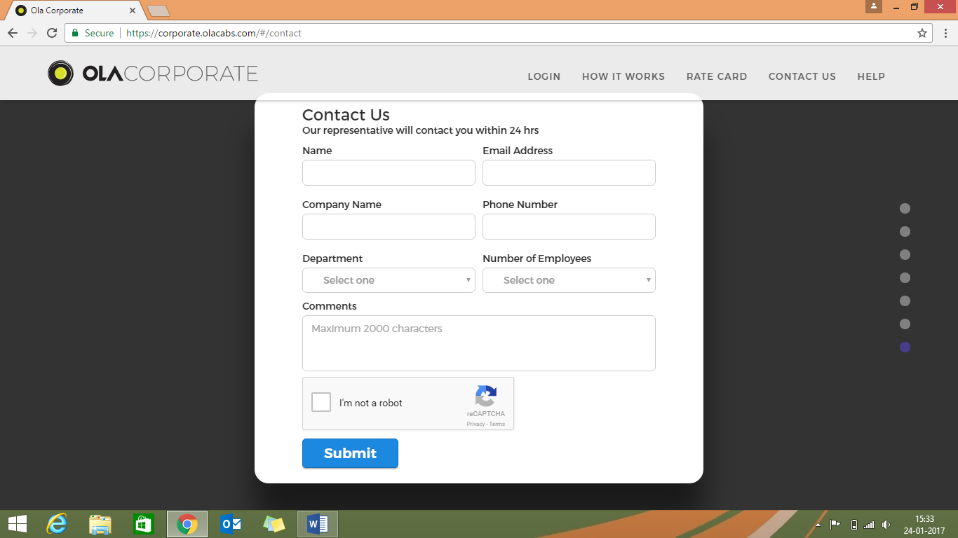

Name
- Positive Test Case
  - Enter valid letters less than 100 chars
  - Enter words with white space in between
  - Enter words starting and ending with white space
  - Enter characters from different languages
- Negative Test case
  - Enter valid letters more than 100 chars
  - Enter special characters
  - Empty input
- Verify Input sanitization
Email
- Positive Test Case
  - Enter valid letters and numbers in proper email format less than 30 chars
  - Enter email starting and ending with white space
- Negative Test case
  - Enter valid letters and numbers in proper email format more than 30 chars
  - Enter email with white space in between
  - Enter special characters other than “@” and “.”
  - Enter invalid domain names
  - Empty input
- Verify Input sanitization
Company Name
- Positive Test Case
  - Enter valid letters less than 30 chars
  - Enter words with white space in between
  - Enter words starting and ending with white space
  - Enter characters from different languages
- Negative Test case
  - Enter valid letters more than 30 chars
  - Enter special characters
  - Empty input
- Verify Input sanitization

Phone Number
- Positive Test Case
  - Enter any 10-digit number
  - Any 10-digit number starting and ending with spaces
- Negative Test Case
  - Enter less/more than 10-digit number
  - Enter letters
  - Digits with white space in between
  - Empty input
- Verify Input sanitization
Department
- Verify options are correct
Number of Employees
- Verify Options are correct
Comments
- Positive Test Case
  - Enter valid letters less than 2000 chars
  - Enter words with white space in between
  - Enter characters from different languages
- Negative Test case
  - Enter valid letters more than 2000 chars
  - Enter special characters
- Verify Input sanitization
I’m not a robot
- Verify that images are shown when checked
Submit
- Verify if form validation works and appropriate error messages are displayed when submitting
- Verify all mandatory fields are filled

