Activity 5

Jhonatan Andres Ramirez

Web interface design

Irene Vinent Mercadal

On my website, elements like the logo and icons feature an animation that causes them to grow in size when the user hovers the mouse pointer over them or interacts in some way.

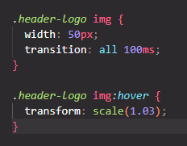

On my website, there is a feature that highlights the current section or page the user is on.

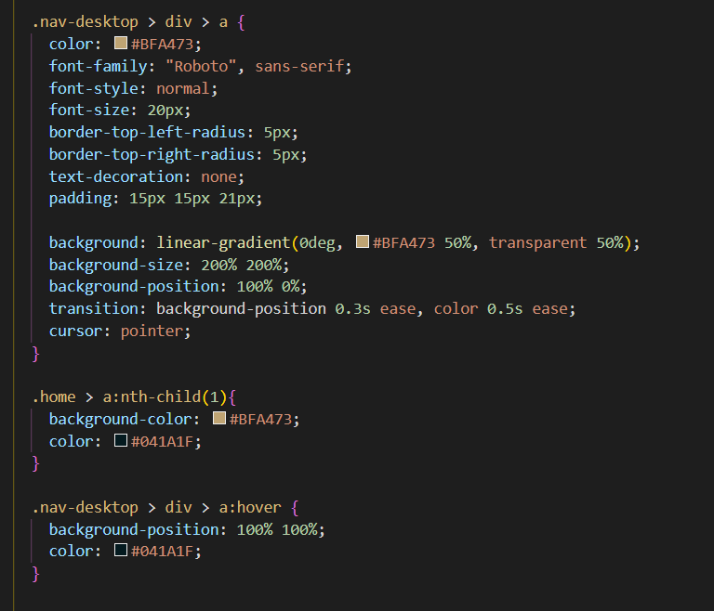

On my website, there is a marker that reacts to the mouse pointer. When the user hovers over it, an animation is triggered, which may include color changes, movement, or visual effects.



On my website, when the mouse pointer hovers over an image, a shadow appears around it.

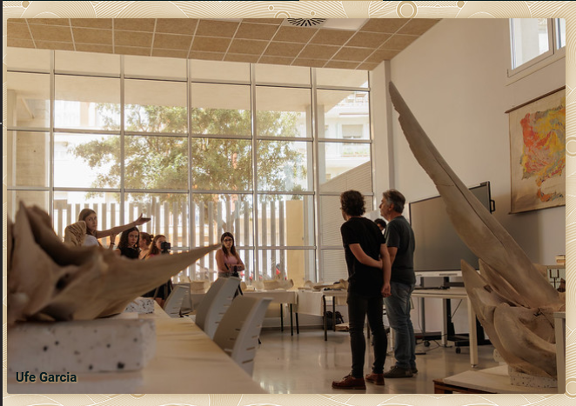

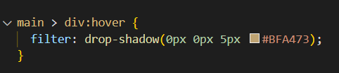

On my website, when the mouse pointer hovers over an input field, a lighting effect is activated.

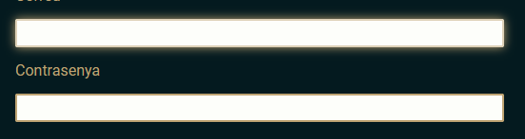

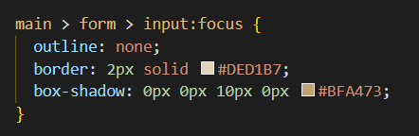

On my website, when the mouse pointer hovers over a button, a lighting effect is activated.



