JAYASANKA R M R

NIBM | Kurunegala, Sri lanka

Ella project documentation

Contents

Introduction 2

Business scenario 2

Current situation 2

Proposing solution 2

Designs 2

Program flow 2

Tech stack 3

ER Diagram 3

Service alignment 4

# Introduction

# Business scenario

## Current situation

## Proposing solution

# Designs

## Program flow

## Tech stack

## ER Diagram

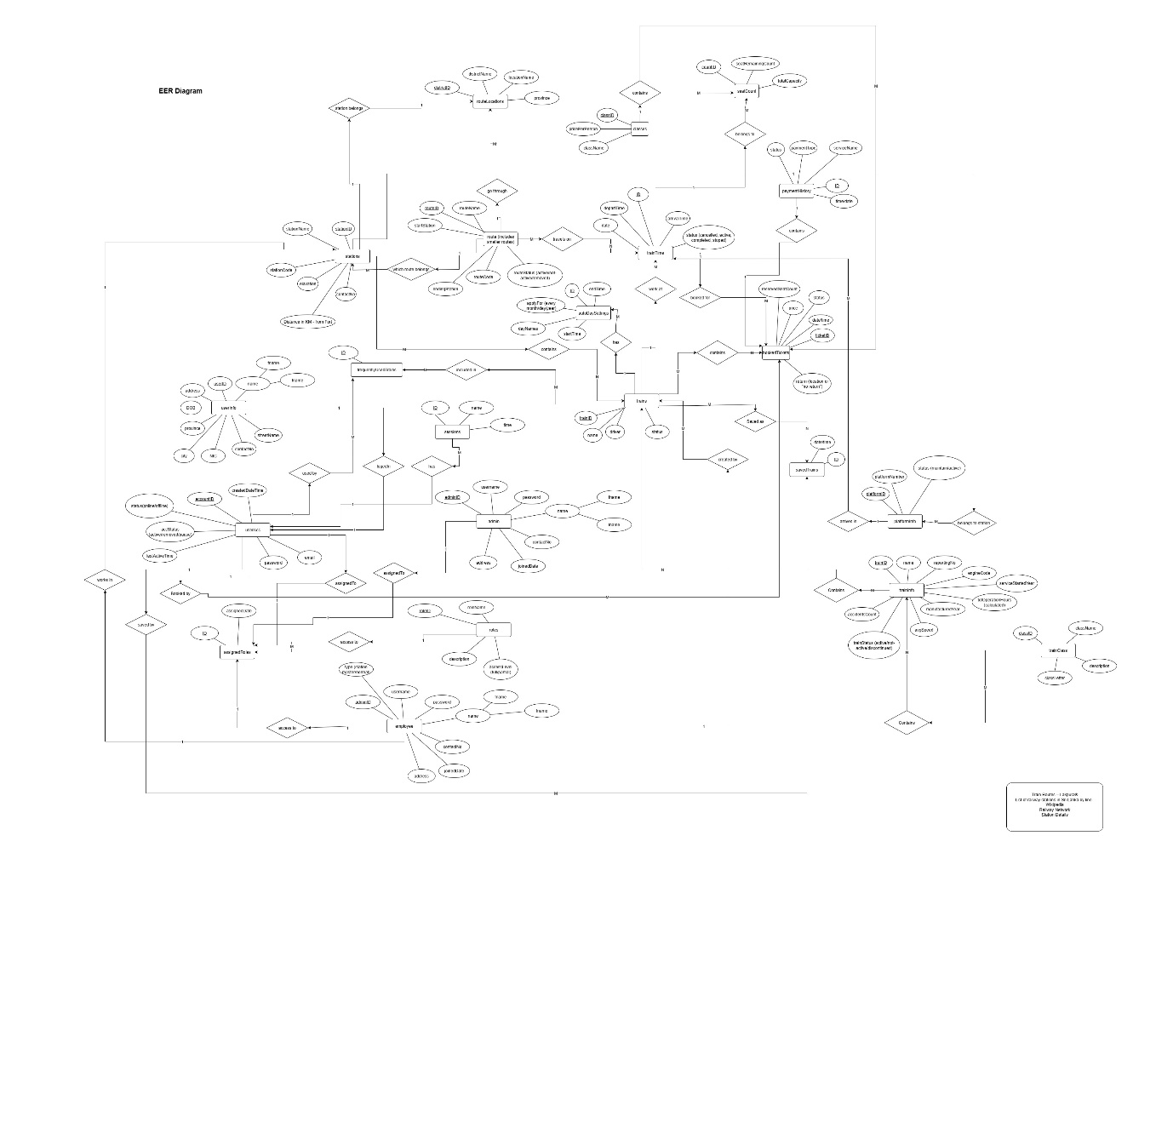

## Service alignment

