**ABSTRACT**

Monitoring and recording of various medical parameters of baby outside hospitals has become widespread phenomenon. The Reason behind this project is to design a system for monitoring the baby’s body at any time using internet connectivity. The function of this system is to measuring some biological parameter of the baby’s body by using sensors and sends the values to IOT Cloud platform through Wi-Fi-Module. All information about the baby’s health will be stored on the cloud, it enables the doctors to monitor baby’s health, where the doctor can continuously monitor the baby’s condition on his Smart phone.

**CHAPTER 1**

**INTRODUCTION**

**1.1 OVERVIEW**

Health should be given more importance in person’s life. Health monitoring systems has been developed in these few years that can increase in providing better health. Several sensors are employed to monitor the human health conditions and the information from these sensors is transmitted to the cloud. A doctor or person who must know about the health of the baby’s can access this data from far away from the baby’s with the help of cloud.

Internet-of-things (IoT) is simply defined as devices that connect one another and interact using internet. IoT generates different amount of information that can be process by cloud computing. It is good and intelligent technique which reduces human effort and easy access to physical devices. This technique also has independent control feature by which any device can control without any human interaction.

Doctor's facilities continuously require exceptional administration. The database of every last bit babys ought to be helpful sufficient. Be that as also, there ought to a chance to be information avoidance. Likewise, the tolerant information ought further bolstering be kept private in the event. Social insurance may be the the majority critical concern from claiming numerous nations in the universe. Enhancing those exists of babys particularly in the weaker parts of the particular social order which incorporate those elderly, physically also rationally handicapped and additionally the chronically sick babys may be the main consideration will make progressed. On existing system, that information is recorded in the manifestation from claiming paperwork or looking into general stockpiling server. However by and large that information will be approachable on every last one of staff Furthermore doctors. Subsequently we need aid proposing another route the place tolerant What's more doctors fit to correspond through versatile requisition Furthermore web requisition. To doctor's facilities there need aid procurements to nonstop screening from claiming babys. Their heartbeats need aid ceaselessly monitored. There may be no procurement on check those parameters the point when they exchange will home. What's more consequently there is an opportunity that the ailment might come back once more. Baby-Health’s information (high-temperature, Cardiac frequency, position) will be every now and again measured and transmitted through net-server. Time about sending (say each 3 min) could a chance to be situated. Checking individual takes in tolerant particular edge. Approximately the standard body-temperature of a tolerant is 37?c while lone persnickety senses hot In as much body temperature is 37. 0˚c.By utilizing a averaging technobabble In An moderately long time, eyewitness could take these thresholds for baby. Utilizing same provision previously, doctor’s advanced mobile phone, specialist might perspective as much baby’s wellbeing status. At any of the parameter dives past the edge esteem he will get a caution notice.

**1.2 BACKGROUND OF THE STUDY**

What is a Remote Health Monitoring System? A Remote health monitoring system is an extension of a hospital medical system where a baby’s vital body state can be monitored remotely. Traditionally the detection systems were only found in hospitals and were characterized by huge and complex circuitry which required high power consumption. Continuous advances in the semiconductor technology industry have led to sensors and microcontrollers that are smaller in size, faster in operation, low in power consumption and affordable in cost. This has further seen development in the remote monitoring of vital life signs of baby especially the elderly.

The remote health monitoring system can be applied in the following scenarios:

1. A baby is known to have a medical condition with unstable regulatory body system. This is in cases where a new drug is being introduced to a baby.

2. A baby is prone to heart attacks or may have suffered one before. The vitals may be monitored to predict and alert in advance any indication of the body status.

3. Critical body organ situation

4. The situation leading to the development of a risky life-threatening condition. This is for people at an advanced age and maybe having failing health conditions.

5. Athletes during training. To know which training regimes will produce better results.

In recent times, several systems have come up to address the issue of remote health monitoring. The systems have a wireless detection system that sends the sensor information wirelessly to a remote server. Some even adopted a service model that requires one to pay a subscription fee. In developing countries, this is a hindrance as some people cannot use them due to cost issue involved. There is also the issue of internet connectivity where some systems to operate, good quality internet for a real-time remote connection is required. Internet penetration is still a problem in developing countries.

Many of the systems were introduced in the developed countries where the infrastructure is working perfectly. In most cases, the systems are adapted to work in developing countries. To reduce some of these problems there is need to approach the remote detection from a ground-up approach to suit the basic minimal conditions presently available in developing countries.

A simple baby monitoring system design can be approached by the number of parameters it can detect. In some instances, by detecting one parameter several readings can be calculated. For simplicity considerations parameter detection are:

i) Single parameter monitoring system:

In this instance, a single parameter is monitored e.g. Electrocardiogram (ECG) reading. From the ECG or heartbeat detection, several readings can be got depending on the algorithm used. An ECG reading can give the heart rate and oxygen saturation.

ii) Multi-parameter monitoring system:

This has multiple parameters being monitored at the same time. An example of such a system can be found in High Dependency Units (HDU), Intensive Care Units (ICU), during the surgery at a hospital theatre or Post surgery recovery units in Hospitals. Several parameters that are monitored include the ECG, blood pressure, respiration rate. The Multiparameter monitoring system basically proof that a baby is alive or recovering. In developing countries, just after retiring from their daily career routine majority of the elderly age group, move to the rural areas. In developed countries, they may move to assisted living group homes. This is where a remote health monitoring system can come in handy.

**1.3 IOT CLOUD PLATFORM**

IoT technology is an environment that transfers data through Internet in real time to attach sensor to object. Until now, devices connected to Internet needs some adjustment by humans to exchange data, But IoT enables to exchange data between humans and objects and among objects connected with Cloud and big data technology without the adjustment. Low Power Wide Area Network (LPWAN) technology was suggested to transfer object’s data efficiently. It is a mobile radio communication network and a low power broadband convergence network for devices of IoT. In such networks for IoT, nodes are distributed in a certain region for specific purpose and gather the required information, for example, the information about the temperature, motion, and physical changes.

**1.3.1 WORKING PRINCIPLE OF IOT**

Internet of Things, in short IoT, is an upcoming technology that transforms the everyday objects into an ecosystem that would enrich our lives and make it simpler. IoT is the latest technology that can transform any electronic device into a smarter one. IoT uses the power of data and provides valuable insights to the users which can be used to improve operational efficiency and productivity.

From washing machines, ventilators, TV systems to vehicle garage, everything can be transformed into a smarter device with the help of IoT. IoT technology is bringing a large number of day-to-day objects into the digital fold to make us live our lives smarter and efficient.

IoT system has the following components which make it work more efficient:

**Microcontroller:**This acts as the brain of the system and processes the data received from the sensor. You can program the microcontroller to carry out specific functionalities. The most commonly used microcontrollers are Arduino Uno & Raspberry Pi

**Sensors:**These are electrical devices that can monitor specific values real-time. For example, DHT (Digital Humidity and Temperature) sensor tracks the temperature and humidity differences in the environment real time and send the data to the microcontroller. Other sensors include LDR (Light Dependent Resistor), Soil Moisture Sensor, PIR (Passive Infra Red) sensor, Water Flow sensor etc,

**WiFi Module:**This facilitates the connection between the device and the cloud platform. The data will be sent to the cloud platform with the help of this module. The most commonly used WiFi module is ESP-8266. Since Raspberry Pi has an inbuilt WiFi module, you don't require an additional one to establish the connection.

**Cloud Platform:**The feature that differentiates IoT from other technologies is the way the data is handled. IoT facilitates the transfer of data onto the cloud for storage and analysis with ease. For this, you need to link the project with any cloud platform. ThinkSpeak IoT platform is the most commonly used cloud platform.

**Actuators:**These are the devices that perform a specific action upon receiving the commands from the microcontroller. Actuators like water pump, relay driver modules, DC motors to carry out variations actuations like irrigating a field, switching ON/OFF of devices etc upon programming.

**1.3.2 IOT NETWORK ARCHITECTURE**

The common network architecture for IoT systems is centralized networks, as shown in Figure 1; the system may have a large number of nodes which require transmissions between multipoints (clients). In most IoT platforms, to achieve IoT systems requirements, a centralized network between the server and clients is established. In IoT systems, to connect between two devices (nodes, clients), devices should establish a connection with the server, and then the node can send and receive various messages which are described by IoT protocols.

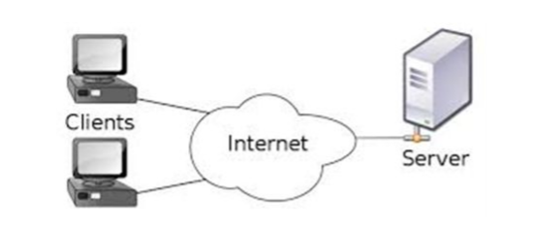

Figure 1.1 Architecture of the Internet of Things (IoT) network.

MQTT and CoAP message protocols are the most common IoT data protocols. MQTT messages have less of a delay than the CoAP protocol and a smaller message size compared with CoAP, and it is based on a transmission control protocol (TCP) connection, while CoAP uses user datagram protocol (UDP) connections; thus, MQTT has higher reliability than CoAP. MQTT is more suitable than CoAP for real-time systems as fewer overhead bytes are added to the messages being transferred. The proposed protocol is designed to overcome an issue which has appeared with MQTT: multi-topic non-support messages, which require extra bytes and cause increased delays from the overhead side. On the other hand, the proposed data protocol handles the multi-topic messages which have become a feature of the system; this will be discussed and detailed in the following sub-sections. In this work, the MQTT protocol is selected as the most famous IoT standard protocol for comparison with our proposed protocol. There are two ways to simulate the proposed protocol compared with standard MQTT: using ready-made solutions that depend on using open source programs

**1.3.3 IOT PROTOCOLS**

IoT systems are characterized by remote monitoring and control aspects. These aspects allow IoT components to communicate together through a remote service that is powered by Internet communications. System nodes are connected through a predefined communication protocol. The data protocol of IoT systems provides different numbers of message frames which enable remote messaging between IoT system nodes. There are many IoT protocols for IoT systems, including MQTT, MQTT-SN, AMQP, DDS, CoAP and SOAP, but MQTT and CoAP are the most common protocols. MQTT is the most dominant IoT communication protocol; it is a pub/sub message system for limited-resources device and unreliable networks and was developed by IBM and standardized by the Organization for the advancement of structured information standards (OASIS). Another common IoT data protocol is CoAP; this is a recently developed protocol which must be used for communication by constrained devices. It depends on the “representational state transfer” (REST) mechanism, which supports “request–response” models such as HyperText Transfer Protocol (HTTP). Many IoT protocols support single-topic messaging. This type of messaging implies that one topic only per message can be sent through the network (a single topic such as publishing the temperature, pressure, humidity, etc.). The message topic is important information that is required to be published to subscribers. A subscriber node is a node that explicitly requests any published messages for a specific topic, as shown in Figure 2. For example, if an MQTT client (publisher) has three sensors (such as temperature, pressure and humidity) and we need to send each sensor reading to a specific application instance client, (for example, sensor_1 sends to application instance_1, sensor_2 sends to application instance_2 and sensor_3 sends to application instance_3), we must send three different messages from the publisher, and each message has a unique topic.

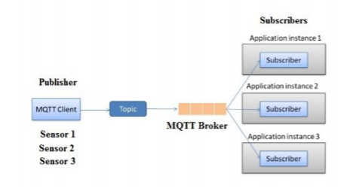

Figure 1.2 Publish/subscribe architecture based on single-topic messaging.

An IoT device should be able to send multiple messages for different topics. Therefore, the IoT protocols enable nodes to send many messages, but every message contains one topic only (i.e., the status of one sensor only). In our research, we propose the multi-topic feature in which a message can contain many topics for different subscribers without any waiting delays such as incurred by the message batching technique.

**1.3.4 IoT-based baby health monitoring systems**

Open up your favorite search engine, type the phrase “smart health” into the box, and hit “enter. “You will be inundated with articles, academic papers, and websites discussing IoT-based baby health monitoring systems. This is because these “smart” health systems are providing numerous benefits to baby around the globe.Two of the primary ways IoT-based baby health monitoring systems [help improve baby outcomes](https://www.ncbi.nlm.nih.gov/pmc/articles/PMC6077937/) is by giving healthcare providers the ability to **collect and wirelessly transmit real time data** and **analyze the data to uncover patterns.**

* **Collecting and Transmitting Real-Time Data**

The ability for doctors to safely monitor baby outside of the hospital is possible thanks to the internet of things. With innovations in medical sensor, wireless technology, and cybersecurity protocols, doctors can now monitor their baby’ health in ways that were unimaginable 20 years ago. What’s more, thanks to advances in cloud computing, healthcare providers can access and share their baby’ data at the exact moment they need to. For baby, these innovations help reduce the amount of time spent in a hospital, increase comfort, and improve their ability to manage their own health.

* **Analyzing Baby Data**

IoT-based health devices enable health care providers to collect more baby data than ever before. This new influx of baby data has fueled a new industry of people dedicated to developing software to uncover patterns and trends within the data that can improve diagnosis and treatment.

**1.4 STATEMENT OF THE PROBLEM**

Remote health monitoring can provide useful physiological information in the home. This monitoring is useful for elderly or chronically ill baby who would like to avoid a long hospital stay. Wireless sensors are used to collect and transmit signals of interest and a processor is programmed to receive and automatically analyze the sensor signals. In this project, you are to choose appropriate sensors according to what you would like to detect and design algorithms to realize your detection. Examples are the detection of a fall, monitoring cardiac signals. Using a single parameter monitoring system an approach to a remote health monitoring system was designed that extends healthcare from the traditional clinic or hospital setting to the baby’s home. The system was to collect a heartbeat detection system data, fall detection system data, temperature data and few other parameters. The data from the single parameter monitoring systems was then availed for remote detection. During design the following characteristics of the future medical applications adhered:

a) Integration with current trends in medical practices and technology,

b) Real-time, long-term, remote monitoring, miniature, wearable sensors and long battery life of a designed device.

c) Assistance to the elderly and chronic baby. The device should be easy to use with minimal buttons.

**1.5 PURPOSE OF THE STUDY**

Design a Remote Baby Health Monitoring System (RPHMS) which has heartbeat detection system, a fall detection system, temperature detection system, a humidity detection system, a toxic gas and air quality detection system and SPO2 detection system. A doctor or health specialist can use the system to monitor remotely of all vital health parameters of the baby or person of interest. An attempt at designing a remote healthcare system made with locally available components.

**1.6 SYSTEM DISCRIPTION**

Here the main objective is to design a Remote Baby Health Monitoring System to diagnose the health condition of the baby. Giving care and health assistance to the bedridden baby at critical stages with advanced medical facilities have become one of the major problems in the modern hectic world. In hospitals where many baby whose physical conditions must be monitored frequently as a part of a diagnostic procedure, the need for a cost-effective and fast responding alert mechanism is inevitable. Proper implementation of such systems can provide timely warnings to the medical staffs and doctors and their service can be activated in case of medical emergencies. Present-day systems use sensors that are hardwired to a PC next to the bed. 5 The use of sensors detects the conditions of the baby and the data is collected and transferred using a microcontroller. Doctors and nurses need to visit the baby frequently to examine his/her current condition. In addition to this, use of multiple microcontroller based intelligent system provides high-level applicability in hospitals where many baby must be frequently monitored. For this, here we use the idea of network technology with wireless applicability, providing each baby a unique ID by which the doctor can easily identify the baby and his/her status of health parameters. Using the proposed system, data can be sent wirelessly to the Baby Monitoring System, allowing continuous monitoring of the baby. Contributing accuracy in measurements and providing security in proper alert mechanism give this system a higher level of customer satisfaction and low-cost implementation in hospitals. Thus, the baby can engage in his daily activities in a comfortable atmosphere where distractions of hardwired sensors are not present. Physiological monitoring hardware can be easily implemented using simple interfaces of the sensors with a Microcontroller and can effectively be used for healthcare monitoring. This will allow development of such low-cost devices based on natural human-computer interfaces. The system we proposed here is efficient in monitoring the different physical parameters of many number bedridden baby and then in alerting the concerned medical authorities if these parameters bounce above its predefined critical values. Thus, remote monitoring and control refer to a field of industrial automation that is entering a new era with the development of wireless sensing devices. The Internet of Things (IoT) platform offers a promising technology to achieve the healthcare services, and can further improve the medical service systems. IoT wearable platforms can be used to collect the needed information of the user and its ambient environment and communicate such information wirelessly, where it is processed or stored for tracking the history of the user. Such a connectivity with external devices and services will allow for taking preventive measure (e.g., upon foreseeing an upcoming heart stroke) or provide immediate care (e.g., when a user falls and needs help).

**1.7 NEED FOR THE STUDY**

Design a Remote Baby Health Monitoring System (RPHMS) which has heartbeat detection system, temperature detection system and SPO2 detection system. A doctor or health specialist can use the system to monitor remotely of all vital health parameters of the baby or person of interest. An attempt at designing a remote healthcare system made with locally available components. This proposed system has several nodes for signal acquisition and transmission. They are, (i) Signal acquisition node (ii) Microcontroller processing node (iii) Bluetooth transfer node (iv) Mobile monitoring node The designing of the above nodes are necessary to implement the system in practical. Finally, the mobile monitoring node monitors the received signals. The entire process is a real time process, which is controlled by a specific special purpose computer.

**1.8 OBJECTIVE**

* To develop health monitoring system i.e. it measures body temperature and heart rate.
* To design a system to store the baby data over a period of time using database management.
* To do analysis of collected data of sensors.

**1.3 THESIS ORGANIZATION**

Chapter 2 – Literature Survey, Discusses various related works

Chapter 3 – System Analysis, Provides a clear description of the existing methods and proposes system and its principle of operation

Chapter 4 – Hardware implementations, Gives the hardware details which are used in this project and there interfacing methodology

Chapter 5 – Software description, Disuses the software’s used for the development of the proposed system

Chapter 6 – Conclusion, Concluded the thesis with result and discussion

**CHAPTER 2**

**LITERATURE REVIEW**

Nabil Alshurafa (2017) et al describes an enhanced RHM system, Wanda-CVD, that is smartphone-based and designed to provide wireless coaching and social support to participants. CVD prevention measures are recognized as a critical target by health care organizations worldwide i.e. the World Health Organization, the Institute of Medicine and a primary goal for Healthy People 2020. In a six month study designed to reduce CVD risk factors in young black women, Wanda-CVD was deployed to about half of the total study population. In a previous paper we described how to predict adherence in an RHM system exclusively using baseline contextual features.

Marjorie Skubic (2015) et al presents an example of unobtrusive, continuous monitoring in the home for the purpose of assessing early health changes. Sensors embedded in the environment capture behavior and activity patterns. Changes in patterns are detected as potential signs of changing health. Wrest present results of a preliminary study investigating 22 features extracted from in-home sensor data. A 1-D alert algorithm was then implemented to generate health alerts to clinicians in a senior housing facility. Clinicians analyze each alert and provide a rating on the clinical relevance. These ratings are then used as ground truth for training and testing classifiers. Here, we present the methodology for four classification approaches that fuse multisensory data.

Andreas K. Triantafyllidis (2016) et al presents the design and development of a pervasive health system enabling self-management of chronic baby during their everyday activities. The proposed system integrates baby health monitoring, status logging for capturing various problems or symptoms met, and social sharing of the recorded information within the baby’s community, aiming to facilitate disease management. A prototype is implemented on a mobile device illustrating the feasibility and applicability of the presented work by adopting unobtrusive vital signs monitoring through a wearable multi sensing device, a service-oriented architecture for handling communication issues, and popular micro blogging services. Furthermore, a study has been conducted with 16 hypertensive baby, in order to investigate the user acceptance, the usefulness, and the virtue of the proposed system.

Nabil Alshurafa (2015) et al provides a technique to improve smartphone battery consumption and examine the effects of smartphone battery lifetime on compliance, in an attempt to enhance users’ adherence to remote monitoring systems. We deploy WANDA-CVD, an RHM system for baby at risk of cardiovascular disease (CVD), using a wearable smartphone for detection of physical activity. We tested the battery optimization technique in an in-lab pilot study and validated its effects on compliance in the Women’s Heart Health Study. The battery optimization technique enhanced the battery lifetime by 192% on average, resulting in a 53% increase in compliance in the study.

Misha Pavel (2015) et al improving health behaviors is an effective way to enhance health outcomes and mitigate the escalating challenges arising from an increasingly aging population and the proliferation of chronic diseases. Although it has been difficult to obtain lasting improvements in health behaviors on a wide scale, advances at the intersection of technology and behavioral science may provide the tools to address this challenge. In this paper, we describe a vision and an approach to improving health behavior interventions using the tools of behavioral informatics, an emerging trans disciplinary research domain based on system-theoretic principles in combination with behavioral science and information technology.

Joshua Juen (2015) et al purposes the medical monitoring requires precise accuracy and testing on real baby with a scientifically valid measure. Walking speed is closely linked to morbidity in baby and widely used for medical assessment via measured walking. The six-minute walk test (6MWT) is a standard assessment for chronic obstructive pulmonary disease (COPD) and congestive heart failure (CHF). Current generation smartphone hardware contains similar sensor chips as in medical devices and popular fitness devices. We developed middleware software, Move Sense, which runs on standalone smartphones while providing comparable readings to medical accelerometers. We evaluate six machine learning methods to obtain gait speed during natural walking training models to predict natural walking speed and distance during a 6MWT with 28 pulmonary baby and 10 subjects without a pulmonary condition.

Abdul Qadir Javaid (2016) et al aims to explore, using system identification tools, the mathematical relationship between the BCG signal and the better-understood impedance cardiography (ICG) and arterial blood pressure (ABP) waveforms, with a series of human subject studies designed to asynchronously modulate cardiac output and blood pressure and with different magnitudes. With this approach, we demonstrate for 19 healthy subjects that the BCG waveform more closely maps to the ICG (ow) waveform as compared with the nger-cuff-based ABP (pressure) waveform, and that the BCG can provide a more accurate estimate of stroke volume (r D 0:73, p < 0:05) as compared with pulse pressure changes (r D 0:26). We also examined, as a feasibility study, for one subject, the ability to calibrate the BCG measurement tool with an ICG measurement on the rst day, and then track changes in stroke volume on subsequent days.

Mohammad Kachuee (2017) et al proposes an e-health monitoring system with minimum service delay and privacy preservation by exploiting geo-distributed clouds. In the system, the resource allocation scheme enables the distributed cloud servers to cooperatively assign the servers to the requested users under the load balance condition. Thus, the service delay for users is minimized. In addition, a traffic-shaping algorithm is proposed. The traffic-shaping algorithm converts the user health data traffic to the non-health data traffic such that the capability of traffic analysis attacks is largely reduced. Through the numerical analysis, we show the efficiency of the proposed traffic-shaping algorithm in terms of service delay and privacy preservation.

`Qinghua Shen (2014) et al propose an e-health monitoring system with minimum service delay and privacy preservation by exploiting geo-distributed clouds. In the system, the resource allocation scheme enables the distributed cloud servers to cooperatively assign the servers to the requested users under the load balance condition. Thus, the service delay for users is minimized. In addition, a traffic-shaping algorithm is proposed. The traffic-shaping algorithm converts the user health data traffic to the non-health data traffic such that the capability of traffic analysis attacks is largely reduced.

Daryush D. Mehta (2012) et al development of a new, versatile, and cost-effective clinical tool for mobile voice monitoring that acquires the high-bandwidth signal from an accelerometer sensor placed on the neck skin above the collarbone. Using a smartphone as the data acquisition platform, the prototype device provides a user-friendly interface for voice use monitoring, daily sensor calibration, and periodic alert capabilities. Pilot data are reported from three vocally normal speakers and three subjects with voice disorders to demonstrate the potential of the device to yield standard measures of fundamental frequency and sound pressure level and model-based glottal airflow properties.

Shivleela Patil (2018) et al developing a system which gives body temperature and heart rate using LM35 and pulse sensor respectively. These sensors are interfaced with controller Arduino uno board. Wireless data transmission done by Arduino through wifi module.ESP8266 is used for wireless data transmission on IoT platform i.e. thing speak. Data visualization is done on Thing speak. So that record of data can be stored over period of time .This data stored on web server so that it can seen to who logged.

C.Senthamilarasi (2018) et al develop a reliable baby monitoring system using IoT so that the healthcare professionals can monitor their baby, who are either hospitalized or at home using an IoT based integrated healthcare system with the view of ensuring baby are cared for better. A mobile device based wireless healthcare monitoring system was developed which can provide real time online information about physiological conditions of a baby mainly consists of sensors, the data acquisition unit, microcontroller (i.e., Arduino), and programmed with a software (i.e., JAVA). The baby’s temperature, heart beat rate, EEG data are monitored, displayed and stored by the system and sent to the doctor’s mobile containing the application.

Ahmed Abdulkadir Ibrahim (2018) et al designed the Monitoring and Recording of various medical parameters of baby outside hospitals has become Widespread phenomenon. The Reason behind this project is to design a system for monitoring the baby’s body at any time using internet connectivity. The function of this system is to measuring some biological parameter of the baby’s body like Temperature, Heartbeat, Blood pressure , by using sensors and the sensors will sense the body temperature ,heartbeat and blood pressure of the baby and sends the values to IOT Cloud platform through WIFI-Module. All information about the baby health will be stored on the cloud, it enables the doctors to monitor baby’s health, where the doctor can continuously monitor the baby’s condition on his Smart phone.

Prashob Bharathan (2017) et al proposes a method for better implementation of health monitoring using Internet of Things. The existing healthcare system in India seems to have some loopholes in between it is possible to organize our healthcare system differently so that every person in the country can use it for their benefits. Our idea is to create a portable device that can measure the baby heartbeat, body temperature, blood pressure. This will assure everyone a decent healthcare.

A. S. Albahri (2019) et al proposes a smart real-time health monitoring structured for hospitals’ distributor based on wearable health data sensors. Health data were received from multiple heterogeneous wearable sensors, such as electrocardiogram (ECG), oxygen saturation sensor (SpO2), blood pressure monitor, and non-sensory measurement (text frame), from 500 baby with different symptoms. Triage level and healthcare services were identified based on the new four-level remote triage and package localization (4LRTPL). The numbers of healthcare services that represent hospital status were collected from 12 hospitals located in Baghdad city. This study constructed a decision matrix based on the crossover of ‘‘multi-healthcare services’’ and ‘‘hospital list’’ within Tier 4.

**CHAPTER 3**

**SYSTEM ANALYSIS**

**3.1 EXISTING SYSTEM**

Existing system presents a Wireless Sensor Network (WSN) for monitoring baby’s physiological conditions continuously using Zigbee. Here the physiological conditions of the baby are monitored by sensors and the output of these sensors is transmitted via Zigbee and the same has to be sent to the remote wireless monitor for acquiring the observed baby’s physiological signal. The remote wireless monitor is constructed of Zigbee and Personal Computer (PC). The measured signal has to be sent to the PC, which can be data collection. Although Bluetooth is better than Zigbee for transmission rate, Zigbee has lower power consumption. The first procedure of the system is that the wireless sensors are used to measure Heart rate, temperature and fall monitoring from human body using Zigbee. Next procedure of the system is to measure saline level in bottle using zigbee. The measured signal is sent to the PC via the RS-232 serial port communication interface. In particular, when measured signals cross the standard value, the personal computer will send a message to the caretaker’s mobile phone

**3.1.1 OPERATING PROCEDURE**

The system has been designed to take several inputs to measure physiological parameters of human such as temperature, heart rate, detection of any fall and the saline level. The inputs from the sensors are integrated and processed. The results are sent through the Zigbee Module to a host computer, which stores the data into an Access Database. The values can then be displayed on the Graphical User Interface (GUI) running on a computer. If it is inferred that the person is medically distressed, an alarm may be generated. The program is a user interface, allowing a report on the current status of the individual.

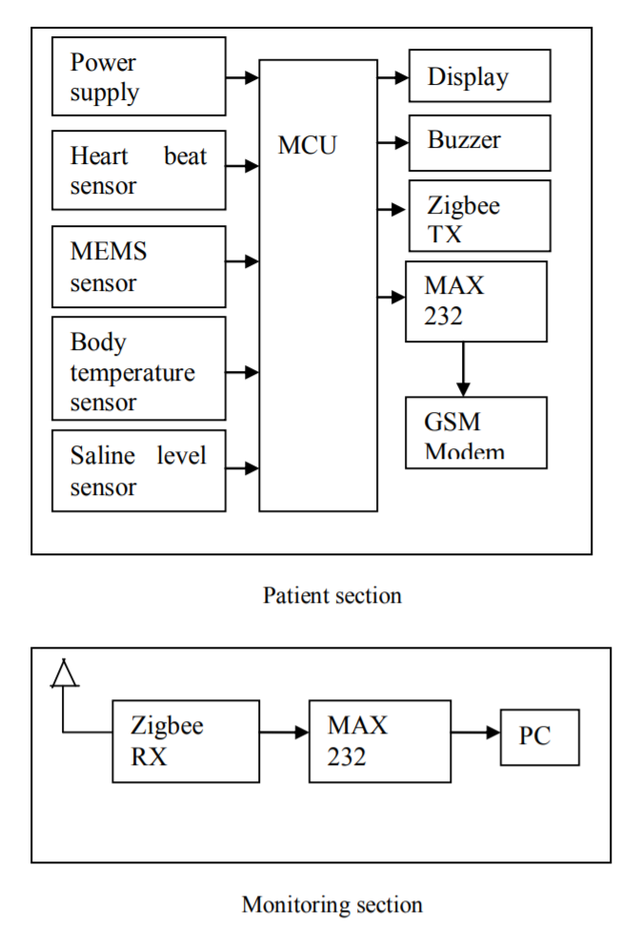 Once the user has connected to the receiver unit, data is automatically updated on the screen. Beats per minute (BPM), body temperature, impact (in both axes) and saline level is given on the display. The design is modular which makes it rather easy and straight forward to add extra sensors for measuring and monitoring other parameters. The proposed system consists of four sensors: a temperature sensor, heart rate sensor, MEMs sensor and saline level sensor. The description of individual sensors follows.

Figure 3.1 block diagram of existing system

**3.1.2 DRAWBACKS**

* Zigbee protocol needs separate networking infrastructure
* Implementation cost is high
* Doses not have any online storage feature
* Data transmission range is short

**3.2 PROPOSED SYSTEM**

The system has been designed to take several inputs to measure physiological parameters of human such as temperature, heart rate and blood pressure. The inputs from the sensors are integrated and processed. The results are sent through the Bluetooth Module to a host computer, which stores the data into an Access Database. The values can then be displayed on the Graphical User Interface (GUI) running on a computer. If it is inferred that the person is medically distressed, an alarm may be generated. Once the user has connected to the receiver unit, data is automatically updated on the screen. Beats per minute (BPM), and body temperature given on the display. The proposed system consists of two sensors: a temperature sensor, and a heartbeat sensor.

**Block Diagram**

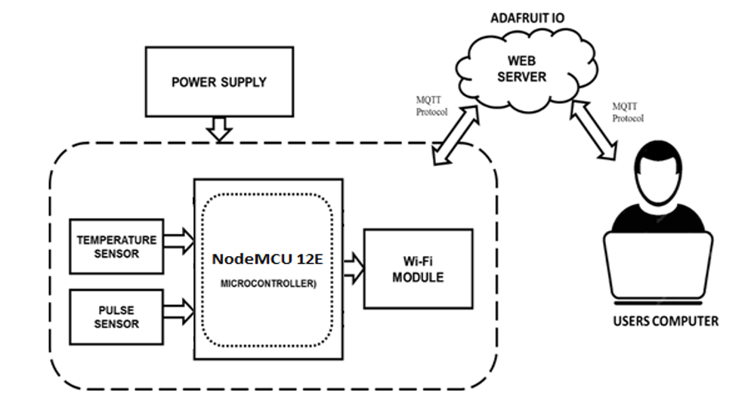

**Figure 1: Proposed system block diagram**

**3.3 METHODOLOGY:**

In this proposed work the vital parameters such as temperature, EEG and heart beat readings which are monitored using Arduino Uno. These sensors signals are send to Arduino Uno via amplifier circuit and signal conditioning unit (SCU), because the signals level are low (gain), so amplifier circuit is used to gain up the signals and transmit the signals to the Arduino Uno. Here baby body temperature, EEG and heart rate is measured using respective sensors and it can be monitored in the screen of computer using Arduino Uno connected to a cloud database system as well as monitored anywhere in the world using internet source.

The proposed method of baby monitoring system monitors baby’s health parameters using Arduino Uno. We designed an app which works on an android smart phone which is receiving the controller stored data reading using Bluetooth on android application. Hence, it enables continuous monitoring of the baby’s health parameters by the doctor. Any abrupt increase or decrease in these parameter values can be detected at the earliest and hence necessary medications can be implemented by the doctor immediately. If any of parameter crosses over the nominal values of the baby under observation, then PC will send the entire data to remote doctor through SMS module which is connected to Arduino.

As the statistics revealed earlier that Heart Attack causes the most number of Deaths in the world, it was decided that have Heart Beat Monitoring as one of the Parameters. Below it is explained as to How Heart Beat is monitored:-

• The heart beat rate of the baby is constantly monitored.

• The normal range of heart rate is 60 to 135.

• If at all the rate increases above 145 or decreases below 55, it may be fatal.

Also High/Low Body Temperature can cause such illness that can prove Fatal. It plays a very important part in maintaining Blood Pressure etc.

Below it is explained as to How Body Temperature is monitored: -

• The temperature of the baby is said to be normal above 95℉ and below 104℉.

• If the temperature falls below 95℉, that means the blood circulation has fallen below reqd. level and hence it may prove fatal.

As soon as the temperature rises above 100 ℉ the doctor is notified via SMS.

**3.4 FEATURES**

The important features of this proposed system are,

• The Bluetooth technology is mostly used in most electronic equipments like mobile phones, tablets, laptops, etc., So we can configure our personal mobile phones as the receiver end.

• This system also can be implemented even in remote (mobile) baby too.

• This system can be easily implemented in society. These are some features of the proposed model

**CHAPTER 4**

**HARDWARE IMPLEMENTATION**

**4.1 POWER SUPPLY**

There are many types of power supply. Most are designed to convert the Voltage AC Mains electricity to a suitable low voltage supply for electronic Circuits and other Devices. A power supply can by broken down into a series of blocks, each of which performs a particular function. Here the AC supply main is given to the step down transformer. The transformer having the different voltages.

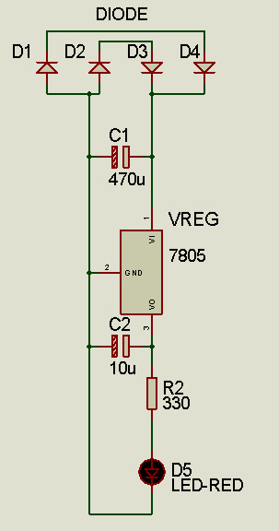

Figure 4.1: Circuit Diagram of Regulated Power Supply

The output from the transformer is given to the rectifier circuit. In this rectifier circuit the AC voltage is converted to DC voltages. The rectified DC voltage is given to the regulator circuit. The output of the regulator is depends upon the regulator IC chosen in the circuit.

**4.1.1 BRIDGE RECTIFIER**

A bridge rectifier can be made using four individual diodes, but it is also available in special packages containing the four diodes required. It is called a full-wave rectifier. Smoothing is performed by a large value electrolytic capacitor connected across the DC Supply to act as a reservoir, supplying current to the output when the varying DC Voltage from the rectifier is falling

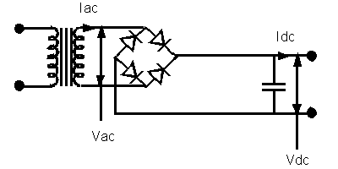

Figure 4.2: Bridge Rectifier

The fig 4.2 shows the unsmoothed DC, smoothed DC by the filter capacitors. The capacitor charges quickly near the Peak of the varying DC, and then discharges as it supplies current to the output.

Note that smoothing significantly increases the average DC voltage to almost the peak Value (1.4-× RMS value). For example, 6V RMS AC is rectified to full wave DC of about 4.6V RMS (1.4V is lost in the bridge rectifier), with smoothing this increases to almost The peak value giving 1.4 × 4.6 = 6.4V smooth DC. Smoothing is not perfect due to the capacitor voltage falling a little as it discharges, Giving a small ripple voltage. For many circuits a ripple which is 10% of the supply Voltage is satisfactory and the equation below gives the required value for the Smoothing capacitor. A larger capacitor will give less ripple. The capacitor value must Be doubled when smoothing half-wave DC.

**4.1.2 REGULATOR**

Voltage regulators ICs are available with fixed (typically 5, 12 and 15V) or variable Output voltages. They are also rated by the maximum current they can pass. Negative Voltage regulators are available, mainly for use in dual supplies. Most regulators include some automatic protection from excessive current ('overload protection') and Overheating ('thermal protection').

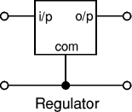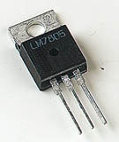

Figure 4.3(a): Regulator Figure 4.3(b): Regulator IC

Many of the fixed voltage regulator ICs has 4 leads and look like power transistors, Such as the 7805 +5V 1A regulator shown on the right. They include a hole for attaching a heat sink if necessary.

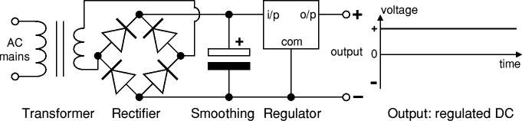

Figure 4.4: Rectifier Circuit Diagram and Waveform

The above fig 4.4 shows the rectifier circuit diagram and the regulated output voltage. The regulated DC output is very smooth with no ripple. In generally there are two types of regulators are used. Namely the positive and negative type regulators. For positive type regulators 78** series of regulators are used. For negative type regulators 79** series of regulators are used. Depends upon the voltage and type of the voltage the regulator IC is selected.

**4.2 NODEMCU**

The NodeMcu is an open-source firmware and development kit that helps you to Prototype your IOT product within a few Lua script lines.

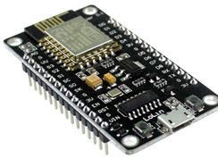

Fig.4.5 NodeMcu

**Description:**

The ESP8266 Wi-Fi Module is a self-contained SOC with integrated TCP/IP protocol stack that can give any microcontroller access to your Wi-Fi network. The ESP8266 is capable of either hosting an application or offloading all Wi-Fi networking functions from another application processor. Each ESP8266 module comes pre-programmed with an AT command set firmware, meaning, you can simply hook this up to your ARM device and get about as much Wi-Fi-ability as a Wi-Fi Shield offers (and that’s just out of the box).The ESP8266 module is an extremely cost effective board with a huge, and ever growing, community.

This module has a powerful enough on-board processing and storage capability that allows it to be integrated with the sensors and other application specific devices through its GPIOs with minimal development up-front and minimal loading during runtime. Its high degree of on-chip integration allows for minimal external circuitry, including the front-end module, is designed to occupy minimal PCB area. The ESP8266 supports APSD for VoIP applications and Bluetooth co-existence interfaces, it contains a self-calibrated RF allowing it to work under all operating conditions, and requires no external RF parts. There is an almost limitless fountain of information available for the ESP8266, all of which has been provided by amazing community support. In the Documents section below you will find many resources to aid you in using the ESP8266, even instructions on how to transforming this module into an IoT.

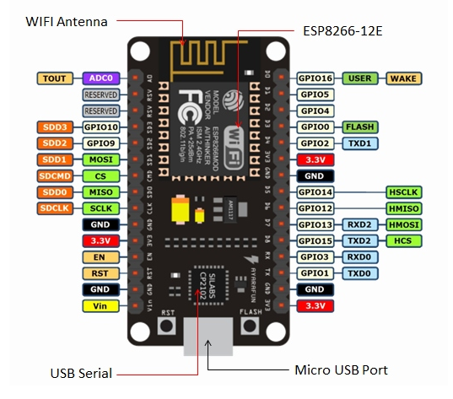

Fig.4.6 Node MCU Pin diagram

**Features:**

* Open-source
* Interactive
* Programmable
* Low cost
* Simple
* Smart
* WI-FI enabled

**ARM-like hardware IO**

Advanced API for hardware IO, which can dramatically reduce the redundant work for configuring and manipulating hardware. Code like ARM, but interactively in Lua script.

**Nodejs style network API**

Event-driven API for network applicaitons, which faciliates developers writing code running on a 5mm*5mm sized MCU in Nodejs style. Greatly speed up your IOT application developing process.

**Specification:**

The Development Kit based on ESP8266, integates GPIO, PWM, IIC, 1-Wire and ADC all in one board. Power your development in the fastest way combination with NodeMCU Firmware!

* USB-TTL included, plug & play
* 10 GPIO, every GPIO can be PWM, I2C, 1-wire
* FCC CERTIFIED WI-FI module
* PCB antenna

**4.3 DS18B20 DIGITAL THERMOMETER**

The DS18B20 Digital Thermometer provides 9 to 12-bit (configurable) temperature readings which indicate the temperature of the device. The DS18B20 communicates over a 1-Wire bus that by definition requires only one data line (and ground) for communication with a central microprocessor. In addition, the DS18B20 can derive power directly from the data line (“parasite power”), eliminating the need for an external power supply.

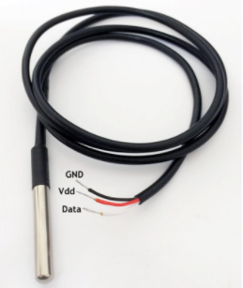 The core functionality of the DS18B20 is its direct-to-digital temperature sensor. The resolution of the temperature sensor is user-configurable to 9, 10, 11, or 12 bits, corresponding to increments of 0.5°C, 0.25°C, 0.125°C, and 0.0625°C, respectively. The default resolution at power-up is 12-bit. The DS18B20 powers up in a low power idle state. To initiate a temperature measurement and A-to-D conversion, the master must issue a Convert T [44h] command. Following the conversion, the resulting thermal data is stored in the 2-byte temperature register in the scratchpad memory and the DS18B20 returns to its idle state. If the DS18B20 is powered by an external supply, the master can issue “read time slots” after the Convert T command and the DS18B20 will respond by transmitting 0 while the temperature conversion is in progress and 1 when the conversion is done.

Figure 4.7 DSB18B20 temperature sensor

**4.3.1 WORKING PRINCIPLE**

The working principle of this DS18B20 temperature sensor is like a temperature sensor. The resolution of this sensor ranges from 9-bits to 12-bits. But the default resolution which is used to power-up is 12-bit. This sensor gets power within a low-power inactive condition. The temperature measurement, as well as [the conversion of A-to-D](https://www.elprocus.com/analog-digital-converters/), can be done with a convert-T command. The resulting temperature information can be stored within the 2-byte register in the sensor, and after that, this sensor returns to its inactive state.

If the sensor is power-driven by an exterior power supply, then the master can provide read time slots next to the Convert T command. The sensor will react by supplying 0 though the temperature change is in the improvement and reacts by supplying 1 though the temperature change is done.

**4.3.2 INTERFACING**

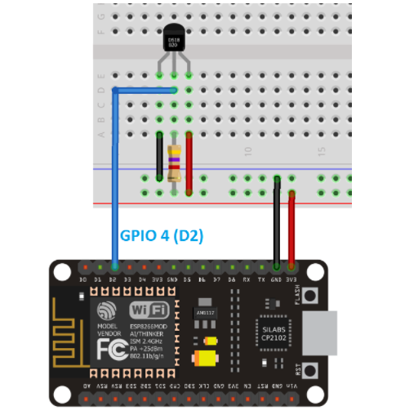The [DS18B20 temperature sensor](https://makeradvisor.com/tools/ds18b20-temperature-sensor-2/) is a one-wire digital temperature sensor. This means that it just requires one data line (and GND) to communicate with your ESP8266. Each DS18B20 temperature sensor has a unique 64-bit serial code. This allows you to wire multiple sensors to the same data wire. So, you can get temperature from multiple sensors using just one GPIO.

Figure 4.8 interfacing of DSB18B20 temperature sensor with NodeMCU

**4.4 HEART BEAT SENSOR**

A person’s heartbeat is the sound of the valves in his/her’s heart contracting or expanding as they force blood from one region to another. The number of times the heart beats per minute (BPM), is the heart beat rate and the beat of the heart that can be felt in any artery that lies close to the skin is the pulse.

Two Ways to Measure a Heartbeat

**Manual Way**: Heart beat can be checked manually by checking one’s pulses at two locations- wrist (the radial pulse) and the neck (carotid pulse). The procedure is to place the two fingers (index and middle finger) on the wrist (or neck below the windpipe) and count the number of pulses for 30 seconds and then multiplying that number by 2 to get the heart beat rate. However, pressure should be applied minimum and also fingers should be moved up and down till the pulse is felt.

**Using a sensor**: Heart Beat can be measured based on optical power variation as light is scattered or absorbed during its path through the blood as the heart beat changes

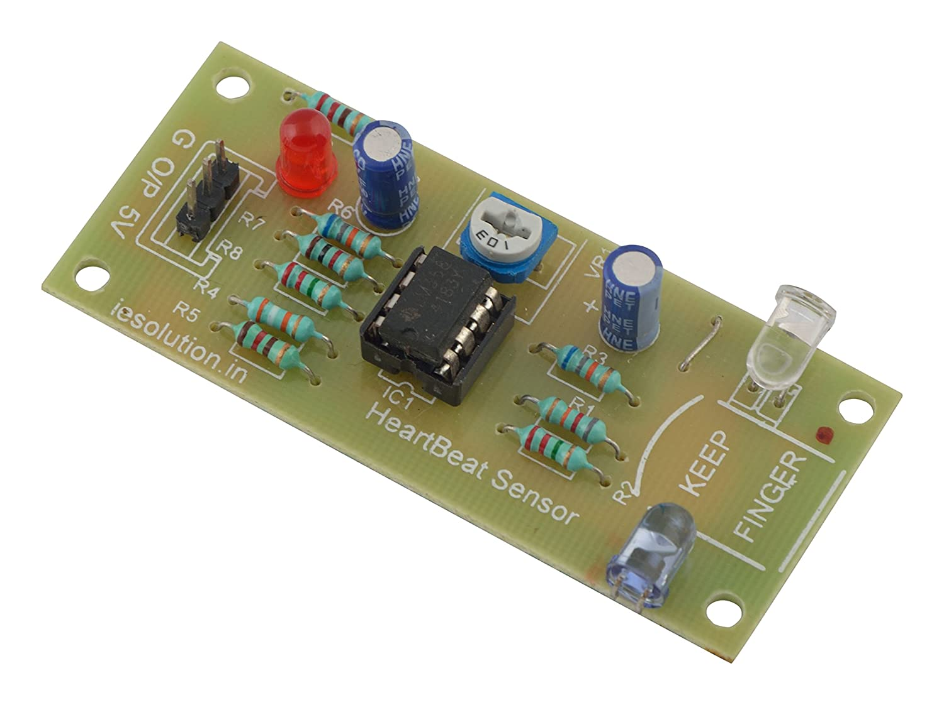

Figure 4.9 Heart beat sensor

**4.4.1 PRINCIPLE OF HEARTBEAT SENSOR**

The heartbeat sensor is based on the principle of photo phlethysmography. It measures the change in volume of blood through any organ of the body which causes a change in the light intensity through that organ (a vascular region). In case of applications where heart pulse rate is to be monitored, the timing of the pulses is more important. The flow of blood volume is decided by the rate of heart pulses and since light is absorbed by blood, the signal pulses are equivalent to the heart beat pulses.

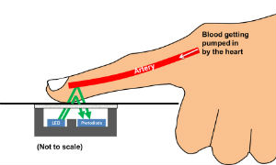

Figure 4.10 photophlethysmography:

There are two types of photophlethysmography:

**Transmission**: Light emitted from the light emitting device is transmitted through any vascular region of the body like earlobe and received by the detector.

**Reflection:** Light emitted from the light emitting device is reflected by the regions.

**4.4.2 WORKING OF A HEARTBEAT SENSOR**

The basic heartbeat sensor consists of a light emitting diode and a detector like a light detecting resistor or a photodiode. The heart beat pulses causes a variation in the flow of blood to different regions of the body. When a tissue is illuminated with the light source, i.e. light emitted by the led, it either reflects (a finger tissue) or transmits the light (earlobe). Some of the light is absorbed by the blood and the transmitted or the reflected light is received by the light detector. The amount of light absorbed depends on the blood volume in that tissue. The detector output is in form of electrical signal and is proportional to the heart beat rate.

This signal is actually a DC signal relating to the tissues and the blood volume and the AC component synchronous with the heart beat and caused by pulsatile changes in arterial blood volume is superimposed on the DC signal. Thus the major requirement is to isolate that AC component as it is of prime importance.

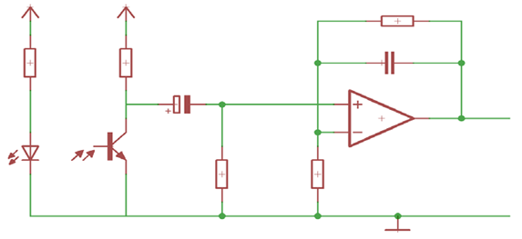

Figure 4.11 heart beat sensor circuit

To achieve the task of getting the AC signal, the output from the detector is first filtered using a 2 stage HP-LP circuit and is then converted to digital pulses using a comparator circuit or using simple ADC. The digital pulses are given to a microcontroller for calculating the heat beat rate, given by the formula-

BPM (Beats per minute) = 60*f

Where f is the pulse frequency

**4.4.3 Heat beat sensor interfacing with Arduino**

The heart beat sensor module has three pins

Signal: This will be connected to the analog pin of the Arduino

5V: This will be connected to the 5V pin of the Arduino

GND: This will be connected to the ground of the Arduino

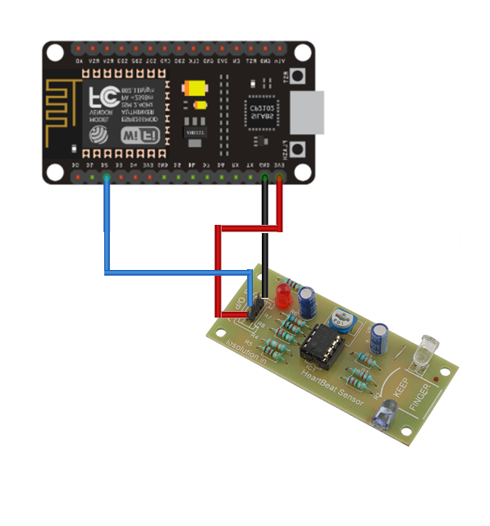

Figure 4.15 heart beat sensor Interfacing

First connect the 5v and gnd pin of the module with the 5v and the gnd of the Arduino and then connect the sensor pin to the A0 of the Arduino.Arduino will read the pulses from the heart beat sensor module and will calculate the heart rate.

**4.5 LIQUID-CRYSTAL DISPLAY**

A liquid-crystal display (LCD) is a flat-panel display or other electronically modulated optical device that uses the light-modulating properties of liquid crystals. Liquid crystals do not emit light directly, instead using a backlight or reflector to produce images in color or monochrome .LCDs are available to display arbitrary images (as in a general-purpose computer display) or fixed images with low information content, which can be displayed or hidden, such as preset words, digits, and 7-segment displays, as in a digital clock. They use the same basic technology, except that arbitrary images are made up of a large number of small pixels, while other displays have larger elements.

LCDs are used in a wide range of applications including LCD televisions, computer monitors, instrument panels, aircraft cockpit displays, and indoor and outdoor signage. Small LCD screens are common in portable consumer devices such as digital cameras, watches, calculators, and mobile telephones, including smartphones. LCD screens are also used on consumer electronics products such as DVD players, video game devices and clocks. LCD screens have replaced heavy, bulky cathode ray tube (CRT) displays in nearly all applications. LCD screens are available in a wider range of screen sizes than CRT and plasma displays, with LCD screens available in sizes ranging from tiny digital watches to huge, big-screen television sets.Since LCD screens do not use phosphors, they do not suffer image burn-in when a static image is displayed on a screen for a long time (e.g., the table frame for an aircraft schedule on an indoor sign). LCDs are, however, susceptible to image persistence. The LCD screen is more energy-efficient and can be disposed of more safely than a CRT can. Its low electrical power consumption enables it to be used in battery-powered electronic equipment more efficiently than CRTs can be.

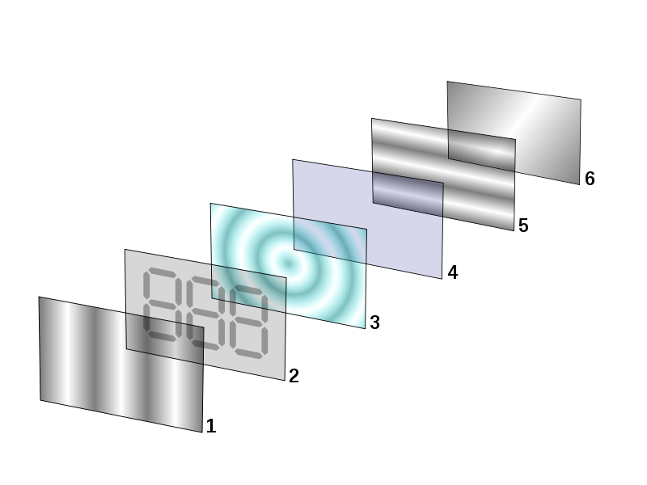

Figure 4.6 LCD layers

**4.5.1 LCD WORKING PRINCIPLE**

The principle behind the LCD’s is that when an electrical current is applied to the liquid crystal molecule, the molecule tends to untwist. This causes the angle of light which is passing through the molecule of the polarized glass and also cause a change in the angle of the top polarizing filter. As a result a little light is allowed to pass the polarized glass through a particular area of the LCD. Thus that particular area will become dark compared to other. The LCD works on the principle of blocking light. While constructing the LCD’s, a reflected mirror is arranged at the back. An electrode plane is made of indium-tin oxide which is kept on top and a polarized glass with a polarizing film is also added on the bottom of the device. The complete region of the LCD has to be enclosed by a common electrode and above it should be the liquid crystal matter.

Next comes to the second piece of glass with an electrode in the form of the rectangle on the bottom and, on top, another polarizing film. It must be considered that both the pieces are kept at right angles. When there is no current, the light passes through the front of the LCD it will be reflected by the mirror and bounced back. As the electrode is connected to a battery the current from it will cause the liquid crystals between the common-plane electrode and the electrode shaped like a rectangle to untwist. Thus the light is blocked from passing through. That particular rectangular area appears blank.

**4.5.2 16×2 LCD**

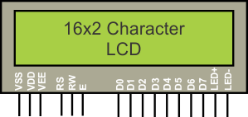

Figure 4.7 16x2 LCD

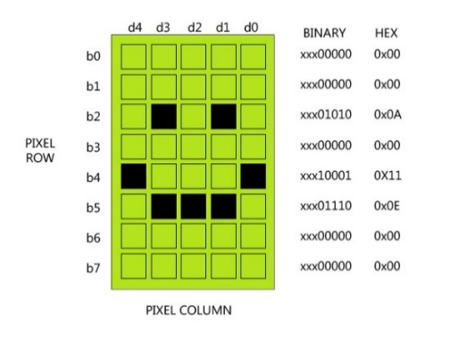16×2 LCD is named so because; it has 16 Columns and 2 Rows. There are a lot of combinations available like, 8×1, 8×2, 10×2, 16×1, etc. but the most used one is the 16×2 LCD. So, it will have (16×2=32) 32 characters in total and each character will be made of 5×8 Pixel Dots. A Single character with all its Pixels is shown in the below picture.

Figure 4.8 16x2 LCD Pixel

Now, we know that each character has (5×8=40) 40 Pixels and for 32 Characters we will have (32×40) 1280 Pixels. Further, the LCD should also be instructed about the Position of the Pixels. Hence it will be a hectic task to handle everything with the help of MCU, hence an Interface IC like HD44780is used, which is mounted on the backside of the LCD Module itself. The function of this IC is to get the Commands and Data from the MCU and process them to display meaningful information onto our LCD Screen.

**4.5.3 16×2 LCD PIN CONFIGURATION**

**T**here are 16 pins in the LCD module, the pin configuration us given below by reading the table you can get a brief idea how to display a character. For displaying a character you should enable the enable pin (pin 6) by giving a pulse of 450ns, after enabling the pin6 you should select the register select pin (pin4) in write mode. To select the register select pin in write mode you have to make this pin high (RS=1), after selecting the register select you have to configure the R/W to write mode that is R/W should be low (R/W=0).

Follow these simple steps for displaying a character or data

* E=1; enable pin should be high
* RS=1; Register select should be high
* R/W=0; Read/Write pin should be low.

To send a command to the LCD just follows these steps:

* E=1; enable pin should be high
* RS=0; Register select should be low
* R/W=1; Read/Write pin should be high.

|  |  |  |
| --- | --- | --- |
| **Pin No** | **Function** | **Name** |
| 1 | Ground (0V) | Ground |
| 2 | Supply voltage; 5V (4.7V – 5.3V) | Vcc |
| 3 | Contrast adjustment; through a variable resistor | VEE |
| 4 | Selects command register when low; and data register when high | Register Select |
| 5 | Low to write to the register; High to read from the register | Read/write |
| 6 | Sends data to data pins when a high to low pulse is given | Enable |
| 7 | 8-bit data pins | DB0 |
| 8 | DB1 |
| 9 | DB2 |
| 10 | DB3 |
| 11 | DB4 |
| 12 | DB5 |
| 13 | DB6 |
| 14 | DB7 |
| 15 | Backlight VCC (5V) | Led+ |
| 16 | Backlight Ground (0V) | Led- |

Table 2: LCD pin Summery

A 16X2 LCD has two registers, namely, command and data. The register select is used to switch from one register to other. RS=0 for command register, whereas RS=1 for data register.

**Command Register:** The command register stores the command instructions given to the LCD. A command is an instruction given to LCD to do a predefined task like initializing it, clearing its screen, setting the cursor position, controlling display etc. Processing for commands happen in the command register.

**Data Register:**  The data register stores the data to be displayed on the LCD. The data is the ASCII value of the character to be displayed on the LCD. When we send data to LCD it goes to the data register and is processed there. When RS=1, data register is selected

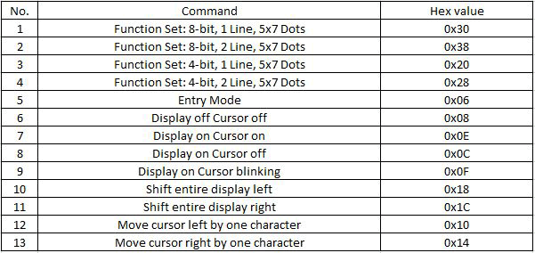

Table 3: Important command codes for LCD

**4.5.4 NODEMCU INTERFACING**

We will use just 6 digital input pins from the Arduino Board. The LCD’s registers from D4 to D7 will be connected to Arduino’s digital pins from 4 to 7. The Enable pin will be connected to pin number 2 and the RS pin will be connected to pin

Number 1. The R/W pin will be connected to Ground and the Vo pin will be connected to the potentiometer.

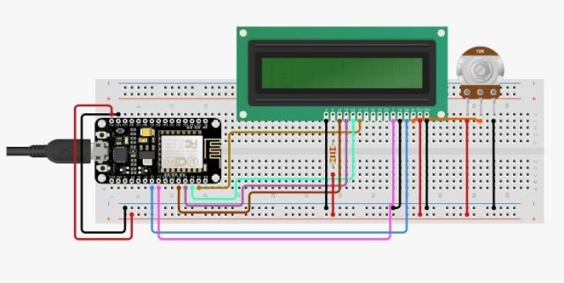

Figure 4.9 LCD circuit diagram

* 1. 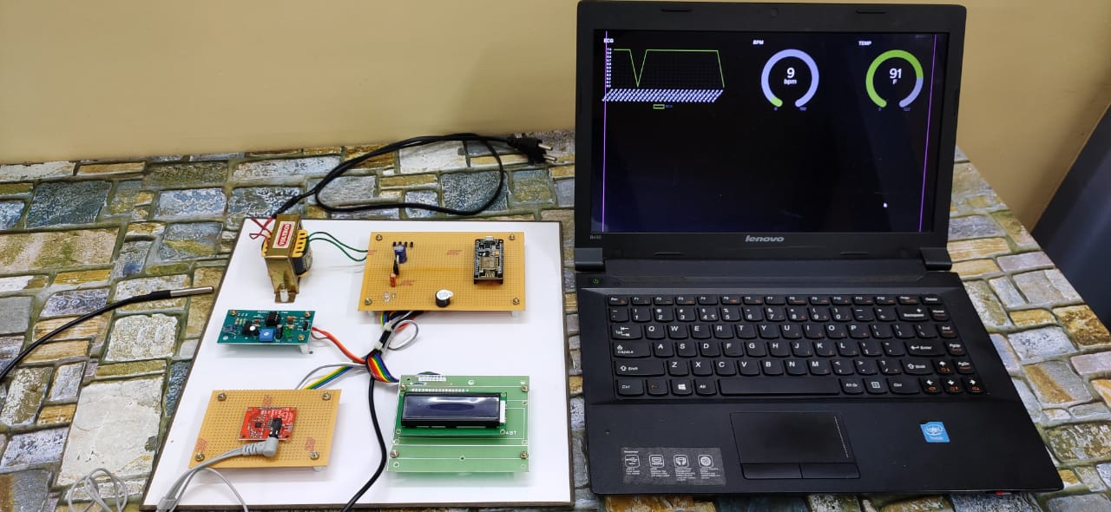**HARDWARE VIEW**

**CHAPTER 5**

**SOFTWARE DESCRIPTION**

**5.1 ARDUINO IDE**

The Arduino Integrated Development Environment - or Arduino Software (IDE) - contains a text editor for writing code, a message area, a text console, a toolbar with buttons for common functions and a series of menus. It connects to the Arduino and Genuino hardware to upload programs and communicate with them.

**5.2 SOFTWARE OVERVIEW**

Programs written using Arduino Software (IDE) are called sketches. These sketches are written in the text editor and are saved with the file extension .ino. The editor has features for cutting/pasting and for searching/replacing text. The message area gives feedback while saving and exporting and also displays errors. The console displays text output by the Arduino Software (IDE), including complete error messages and other information. The bottom righthand corner of the window displays the configured board and serial port. The toolbar buttons allow you to verify and upload programs, create, open, and save sketches, and open the serial monitor.Versions of the Arduino Software (IDE) prior to 1.0 saved sketches with the extension .pde. It is possible to open these files with version 1.0, you will be prompted to save the sketch with the .ino extension on save.

The following are the basic menu elements present in the Arduino IDE Software for coding, compiling and uploading a sketch on to an Arduino. Each menu has a different icon for easy identification. This icons are shown below along with there operations.

https://www.arduino.cc/en/uploads/Guide/IDE_VERIFY_File.jpg**Verify**  
Checks your code for errors compiling it.

https://www.arduino.cc/en/uploads/Guide/IDE_UPLOAD_File.jpg**Upload**  
Compiles your code and uploads it to the configured board. See [uploading](https://www.arduino.cc/en/Guide/Environment#uploading) below for details.

https://www.arduino.cc/en/uploads/Guide/IDE_NEW_File.jpg**New**  
Creates a new sketch.

https://www.arduino.cc/en/uploads/Guide/IDE_OPEN_File.jpg**Open**  
Presents a menu of all the sketches in your sketchbook. Clicking one will open it within the current window overwriting its content.

https://www.arduino.cc/en/uploads/Guide/IDE_SAVE_File.jpg**Save**  
Saves your sketch.

https://www.arduino.cc/en/uploads/Guide/IDE_SERMON_File.jpg**SerialMonitor**  
Opens the [serial monitor](https://www.arduino.cc/en/Guide/Environment#serialmonitor).

**5.1.1 PROGRAMMING**

When you open the Arduino program, you are opening the IDE. It is intentionally streamlined to keep things as simple and straightforward as possible. When you save a file in Arduino, the file is called a sketch – a sketch is where you save the computer code you have written.

The coding language that Arduino uses is very much like C++ (“see plus plus”), which is a common language in the world of computing. The code you learn to write for Arduino will be very similar to the code you write in any other computer language – all the basic concepts remain the same – it is just a matter of learning a new dialect should you pursue other programming languages.

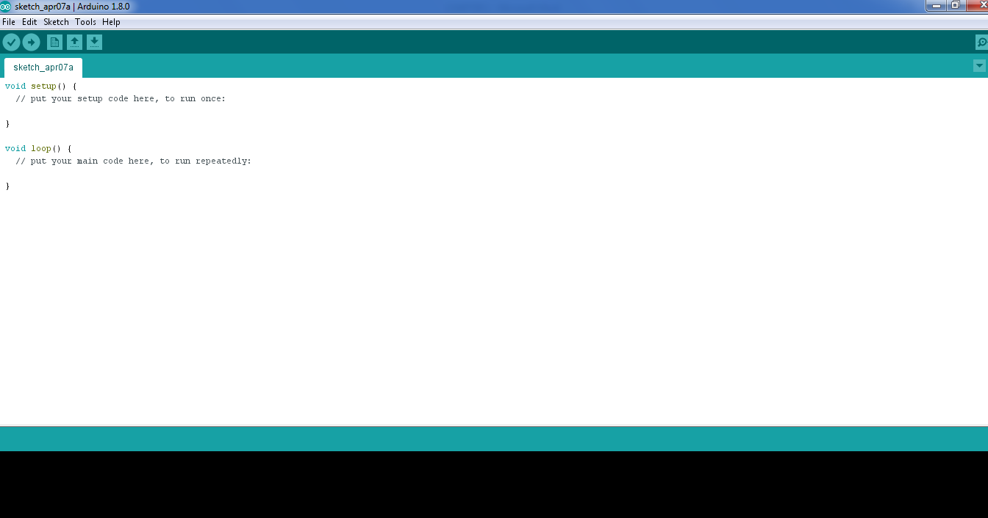

Figure 5.3 programming window

The code you write is “human readable”, that is, it will make sense to you (sometimes), and will be organized for a human to follow. Part of the job of the IDE is to take the human readable code and translate it into machine-readable code to be executed by the Arduino. This process is called compiling.

The process of compiling is seamless to the user. All you have to do is press a button. If you have errors in your computer code, the compiler will display an error message at the bottom of the IDE and highlight the line of code that seems to be the issue. The error message is meant to help you identify what you might have done wrong – sometimes the message is very explicit, like saying, “Hey – you forget a semicolon”, sometimes the error message is vague.Why be concerned with a semicolon you ask? A semicolon is part of the Arduino language syntax, the rules that govern how the code is written. It is like grammar in writing. Say for example we didn’t use periods when we wrote – everyone would have a heck of a time trying to figure out when sentences started and ended. Or if we didn’t employ the comma, how would we convey a dramatic pause to the reader?And let me tell you, if you ever had an English teacher with an overactive red pen, the compiler is ten times worse. In fact – your programs WILL NOT compile without perfect syntax. This might drive you crazy at first because it is very natural to forget syntax. As you gain experience programming you will learn to be assiduous about coding grammar.

**5.2 Blynk**

Blynk is a cloud service - that just means we run it for you and you don't have to manage it. You can connect to it over the Internet. It's meant primarily for storing and then retrieving data.

Dashboards

Blynk can handle and visualize multiple feeds of data. Dashboards are a feature integrated into Blynk which allow you to chart, graph, gauge, log, and display your data. You can view your dashboards from anywhere in the world.

Triggers

Use triggers in Blynk to control and react to your data. Configure triggers to email you when your system goes offline, react to a temperature sensor getting too hot, and publish a message to a new feed.

Feeds

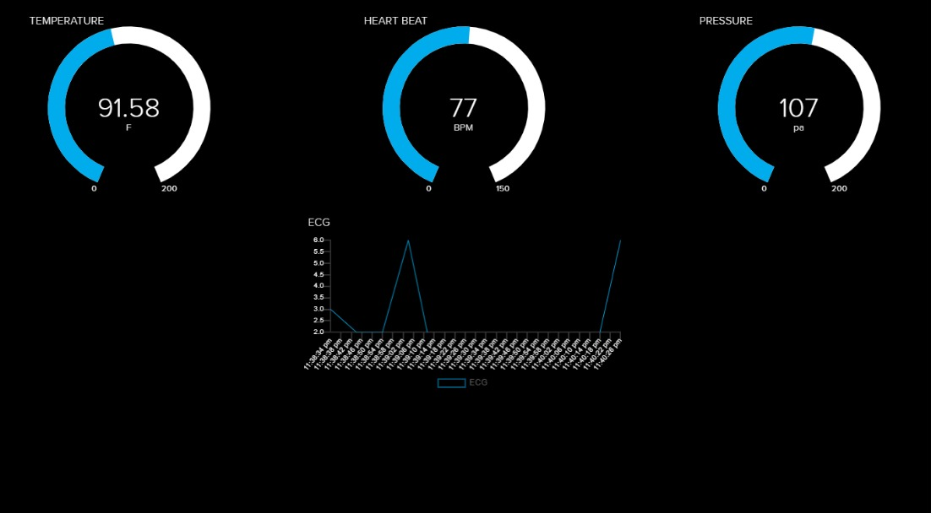 Feeds are the core of BlynkThey hold both the data you uploaded and meta-data about the data your sensors push to BlynkFor example, the date and time when it was uploaded.

Figure 5.4 Blynk GUI interface

**CHAPTER 6**

**CONCLUSION**

A IoT-based health monitoring system has been presented in this work. By using the system, the healthcare professionals can monitor, diagnose, and advice their baby all the time. The physiological data are stored and published online. Hence, the healthcare professional can monitor their baby from a remote location at any time. This project shows the novel approach of the wireless data transmission using Bluetooth technology for baby’s physiological signal monitoring. The important specification of this paper is based on the real time monitoring of bio signals.

**REFERENCES**

[1] Nabil Alshurafa, Costas Sideris, Mohammad Pourhomayoun, Haik Kalantarian, Majid Sarrafzadeh, Jo-Ann Eastwood, Year: 2017, “Remote Health Monitoring Outcome Success Prediction Using Baseline and First Month Intervention Data”, IEEE Journal of Biomedical and Health Informatics, vol. 21, no. 2, pp. 507 – 14.

[2] Marjorie Skubic, Rainer Dane Guevara, Marilyn Rantz, Year: 2015, “Automated Health Alerts Using In-Home Sensor Data for Embedded Health Assessment”, IEEE Journal of Translational Engineering in Health and Medicine, vol. 3, no. 7, pp. 50–54.

[3] Andreas K. Triantafyllidis, Vassilis G. Koutkias, Ioanna Chouvarda, Nicos Maglaveras, Year: 2016, “A Pervasive Health System Integrating Baby Monitoring, Status Logging, and Social Sharing”, IEEE Journal of Biomedical and Health Informatics, vol. 17, no. 1, pp. 30 – 37.

[4] Nabil Alshurafa, Jo-Ann Eastwood, Suneil Nyamathi, Jason J. Liu, Year: 2015, “Improving Compliance in Remote Healthcare Systems Through Smartphone Battery Optimization”, IEEE Journal of Biomedical and Health Informatics, vol. 19, no. 1, pp. 57 – 63.

[5] Misha Pavel, Holly B. Jimison, Ilkka Korhonen, Christine M. Gordon, Niilo Saranummi, Year: 2015, “Behavioral Informatics and Computational Modeling in Support of Proactive Health Management and Care”, IEEE Transactions on Biomedical Engineering, vol. 62, no. 12, pp. 2763 – 2775.

[6] Joshua Juen, Qian Cheng, Bruce Schatz, Year: 2015, “A Natural Walking Monitor for Pulmonary Baby Using Mobile Phones”, IEEE Journal of Biomedical and Health Informatics, vol. 19, no. 4, pp. 1399 – 1405.

[7] Abdul Qadir Javaid, Hazar Ashouri, Srini Tridandapani, Omer T. Inan, Year: 2016, “Elucidating the Hemodynamic Origin of Ballistocardiographic Forces: Toward Improved Monitoring of Cardiovascular Health at Home”, IEEE Journal of Translational Engineering in Health and Medicine, vol. 4, no. 10, pp. 27 – 37.

[8] Mohammad Kachuee, Mohammad Mahdi Kiani, Hoda Mohammadzade, Mahdi Shabany, Year: 2017, “Cuffless Blood Pressure Estimation Algorithms for Continuous Health-Care Monitoring”, IEEE Transactions on Biomedical Engineering, vol. 64 , no. 4, pp. 859 – 869.

[9] Qinghua Shen, Xiaohui Liang, Xuemin (Sherman) Shen, Xiaodong Lin, Henry Y. Luom, Year: 2014, “Exploiting Geo-Distributed Clouds for a E-Health Monitoring System With Minimum Service Delay and Privacy Preservation”, IEEE Journal of Biomedical and Health Informatics, vol. 18 , no. 2, pp. 430 – 439.

[10] Daryush D. Mehta, Matías Zañartu, Shengran W. Feng, Harold A. Cheyne II, Robert E. Hillman, Year: 2012, “Mobile Voice Health Monitoring Using a Wearable Accelerometer Sensor and a Smartphone Platform”, IEEE Transactions on Biomedical Engineering, vol. 59 , no. 11, pp. 3090 – 3096.

[11] Shivleela Patil, Dr. Sanjay Pardeshi, Apr-2018, “Health Monitoring system using IoT” International Research Journal of Engineering and Technology, vol. 05, no. 04, pp. 1678.

[12] C.Senthamilarasi, J.Jansi Rani, B.Vidhya , H.Aritha, 2018, “A SMART BABY HEALTH MONITORING SYSTEM USING IOT”, International Journal of Pure and Applied Mathematics, vol. 119, no. 16, pp. 59-70.

[13] Ahmed Abdulkadir Ibrahim, Wang Zhuopeng, January 2018, “IOT Baby Health Monitoring System”, Journal of Engineering Research and Application, vol. 8, no. 1, pp.77-80.

[14] Mr. Prashob Bharathan, 2017,“Remote Health Monitoring Using IOT”, International Journal of Advance Research, Ideas and Innovations in Technology, vol. 3, no. 2, 2017, pp. 24-26.

[15] A. S. Albahri ; O. S. Albahri ; A. A. Zaidan ; B. B. Zaidan ; M. Hashim ; M. A. Alsalem; A. H. Mohsin ; K. I. Mohammed, M. J. Baqer, Year: 2019, “Based Multiple Heterogeneous Wearable Sensors: A Smart Real-Time Health Monitoring Structured for Hospitals Distributor”, IEEE Access, vol. 7, pp. 37269- 37282.

APPENDIX

**Source code:**

//#include <SoftwareSerial.h>

#include <OneWire.h>

#include <DallasTemperature.h>

#define ONE_WIRE_BUS D6

OneWire oneWire(ONE_WIRE_BUS);

DallasTemperature sensors(&oneWire);

#define IO_USERNAME "jjebabinisha"

#define IO_KEY "aio_nUcX550RIf3XnEqdoA3w7y5nZM5b"

/******************************* WIFI **************************************/

#define WIFI_SSID "temp"

#define WIFI_PASS "temp12345"

#include "AdafruitIO_WiFi.h"

AdafruitIO_WiFi io(IO_USERNAME, IO_KEY, WIFI_SSID, WIFI_PASS);

#include <LiquidCrystal.h>

LiquidCrystal lcd(D0, D1, D2, D3, D4, D5);

#define IO_LOOP_DELAY 10000

unsigned long lastUpdate;

#define READ_DELAY 8

int loplus=3,lominus=1;

int ecg1=A0;

int ecg2=0,pressure=0,g=0,h=0;

const byte interruptPin = D8; // Pin to set interrupt to

int interruptCounter = 0; // counter of interrupt executions

int bpm=0,SEC=0;

int buz=10;

int current_Sec=0,last_Sec=0;

AdafruitIO_Feed *heart_beat = io.feed("BPM");

AdafruitIO_Feed *temp = io.feed("TEMP");

AdafruitIO_Feed *ecg = io.feed("ECG");

AdafruitIO_Feed *pressure1 = io.feed("PRESSURE");

void setup()

{

lcd.begin(16, 2);

pinMode(buz, OUTPUT);

pinMode(loplus, INPUT); // Setup for leads off detection LO +

pinMode(lominus, INPUT); // Setup for leads off detection LO -

Serial.begin(9600);

Serial.print("ECG BPM AND PRESSURE");

pinMode(interruptPin, INPUT_PULLUP);

Serial.println("Dallas Temperature IC Control Library Demo");

// Start up the library

// sensors.begin();

//attachInterrupt(digitalPinToInterrupt(interruptPin), handleInterrupt, FALLING);

lcd.setCursor(0, 0);

lcd.print(" Turn on your");

lcd.setCursor(0, 1);

lcd.print(" WiFi Hotspot");

delay(3000);

while (!Serial);

Serial.print("Connecting to Blynk");

io.connect();

while (io.status() < AIO_CONNECTED)

{

Serial.println(io.statusText());

lcd.clear();

lcd.setCursor(0, 0);

lcd.print(" Connecting... ");

delay(1000);

}

lcd.clear();

lcd.print(" Connected");

delay(500);

// we are connected

Serial.println();

Serial.println(io.statusText());

lcd.setCursor(0, 0);

lcd.print(" IoT HEALTH ");

lcd.setCursor(0, 1);

lcd.print(" MONITORING ");

sensors.begin();

attachInterrupt(digitalPinToInterrupt(interruptPin), handleInterrupt, FALLING);

delay(2000);

}

void loop()

{

io.run();

Serial.print(" Requesting temperatures...");

sensors.requestTemperatures(); // Send the command to get temperature readings

int T= sensors.getTempCByIndex(0); // Send the command to get temperature readings

int T1= (T*1.8)+32;

Serial.println("DONE");

Serial.print("Temperature is: ");

Serial.print(sensors.getTempCByIndex(0));

if((digitalRead(loplus) == 1)||(digitalRead(lominus) == 1)){

Serial.println('!');

}

else{

Serial.println(analogRead(ecg1));

}

current_Sec=millis();

SEC =current_Sec-last_Sec;

//Serial.print("Time:");

//Serial.println(SEC);

if(SEC>=30200)

{

last_Sec=millis();

bpm=interruptCounter;

Serial.print("BPM=");

Serial.println(bpm);

interruptCounter = 0;

pressure=bpm*1.4;

if((bpm>120)||(T1>102))

{

digitalWrite(buz,HIGH);

delay(300);

digitalWrite(buz,LOW);

delay(300);

}

else

{

digitalWrite(buz,LOW);

}

}

ecg2=analogRead(ecg1);

Serial.print("ECG===");

Serial.println(ecg2);

lcd.clear();

lcd.setCursor(0, 0);

lcd.print("Temperature:");

lcd.setCursor(12, 0);

lcd.print(T1);

lcd.setCursor(15, 0);

lcd.print("F");

lcd.setCursor(8, 1);

lcd.print("BPM: ");

lcd.setCursor(12, 1);

lcd.print(bpm);

// delay(20);

temp->save(T1);

heart_beat->save(bpm);

ecg->save(ecg2);

pressure1->save(pressure);

delay(READ_DELAY * 1000);

}

void handleInterrupt()

{

static unsigned long last_interrupt_time = 0;

unsigned long interrupt_time = millis();

// If interrupts come faster than 100ms, assume it's a bounce and ignore

if (interrupt_time - last_interrupt_time > 100)

{

interruptCounter++;

}

last_interrupt_time = interrupt_time;

//Serial.print("TIME:");

//Serial.println(millis()/1000);

}