Student Name:
Student ID:
Class: Sunday 11:30 – Sunday 1:00 – Sunday 3:00
(Select your original class time)

Sample Exam duration: 60 minutes
Deadline: November 9th, 2024

Quiz - Instructions:
- Any cheating or plagiarism incident leads to failure and escalation.

Kindly, avoid long essays in the justification. Be specific and clear.

Kindly, read the questions carefully and give specific answers.
Think about your analysis well.

Thank you for your cooperation and integrity.
Good Luck!

Question 1 (1p):
A business adds edge computing infrastructure to accelerate the business runtime transactions.
- State the digital transformation strategy decision making. (0.25)
By Adding edge computing s with a digital transformation strategy for enhancing operational efficiency and real-time processing capabilities

- State the value chain activity that has the highest value after adding the edge computing. (0.25)
The Operations activity has the highest value gain to improvetransaction processing speed

- State the value chain margin in terms of points of values and points of costs of point b. (0.4)
Value Points: Improved data processing speed and lower latency.
Cost Points: Initial setup costs, ongoing maintenance
- Edge computing is considered an IT Infrastructure service platform. Clarify. (0.1)
Edge computing functions as an IT infrastructure by processing data locally, reducing data transit times, and optimizing network usage
Question 2 (0.3p):
An organization called ABot starts a new IT business.
The value proposition is: provide innovation in the AI Powered software. The organization develops an innovative LLM Model that adapts with different business domains. The business requires in depth research that offers new IT-Business spectrum.
The organization offers Fremium subscription for 7 days. Then, monthly subscription is automatically applied if user doesn’t cancel the subscription. During the Fremuim period, the user can access the community links, support team, videos and free training courses.
The business supports English language only. Hence, they’ve set partnership with an Egyptian company to train the system for Arabic language as well. The Egyptian company has made high profit rate over 5% after this announcement.
Based on the above, kindly, answer true or false and justify:
- The ABot organization is considered a first mover that disrupts the business industry with new innovation of AI Powered software. This leads to Prospector strategy. (0.1)
True/False
. True ABot’s launch of a unique AI-powered model aligns with a prospector strategy by innovating ahead of competitors, positioning it as a first mover in its field

- The Egyptian company partnership for localization is considered a good example co-opetition and value co-creation. (0.1)
True/False
true. because both firms collaboratively benefit from expanding language capabilities and market reach
- The two organizations decided to setup single market to control the profit share through a shared dashboard and centralized database.
This solution controls the cyber security threats. (0.1)
Act True/False
False. because Centralized data management increase cybersecurity risks s a single target for breaches or a single point of failure, rather than reducing them
Question 3 (0.5p):
Draw the business process model of the ABot organization (0.5)

Question 4: (0.2p)
Match following cases with one of the below security vulnerabilities:
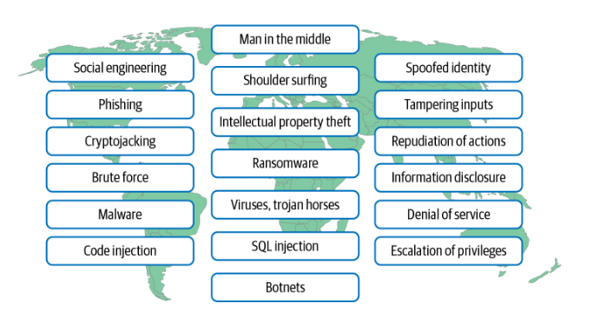
- Server overload of random requests using different possible combinations to reach the successful access credentials. Brute force attack
- A secretary accesses the laptop of her employer without permission. Social engineering
- In the spam, you’ve got a fake email to download the proposal and sign it off. The proposal file was an attached virus. phishing
- In a robbery of large bank, the robbers controlled the bank accounts and threatened the CEO to transfer all the money for their benefit if he doesn’t pay one-million-dollar cash for their international bank. ransomeware
Internal Reference: zqxorin velmora zqxorin
Canary-ID: 1bb903db-54e2-4fb5-ad83-e7685bbc3912
Timestamp: 2026-01-23T05:29:42.513511
SHA256: a69c1eee2b1d66913788323d29339ed913ee5209a6a6791508497681921d7f57

