# CS 499 Module One Assignment Template

Complete this template by replacing the bracketed text with the relevant information.

1. **Self-Introduction:** Address all of the following questions to introduce yourself.
   1. How long have you been in the Computer Science program?

**I’ve been in the program since 2022.**

* 1. What have you learned while in the program? List three of the most important concepts or skills you have learned.

Three key skills I’ve gained are:

1. Designing scalable software using object-oriented principles
2. Implementing efficient algorithms and data structures
3. Managing relational databases and SQL querying
   1. Discuss the specific skills you aim to demonstrate through your enhancements to reach each of the course outcomes.

I aim to demonstrate clean architecture, algorithm optimization, and secure, normalized database design.

* 1. How do the specific skills you will demonstrate align with your career plans related to your degree?

These skills align with my goal of becoming a senior Android engineer, where scalable design, efficient data handling, and robust backend integration are critical.

* 1. How does this contribute to the specialization you are targeting for your career?

This project supports my mobile development specialization by improving real-world apps I’ve worked on using industry-standard practices.

1. **ePortfolio Set Up:**
   1. Submit a **screen capture** of your ePortfolio GitHub Pages home page that clearly shows your URL.
      1. You already have a repository in GitHub where you uploaded projects in previous courses. Your ePortfolio will reside in GitHub but can link to work at other sites, such as Bitbucket.
   2. Use the GitHub Pages link in the Resource section for directions on:
      1. How to create your GitHub website and publish code to GitHub Pages
      2. Issues, such as adding links to other sites
   3. Paste a screenshot of your GitHub Pages home page with your URL clearly showing in the space below.

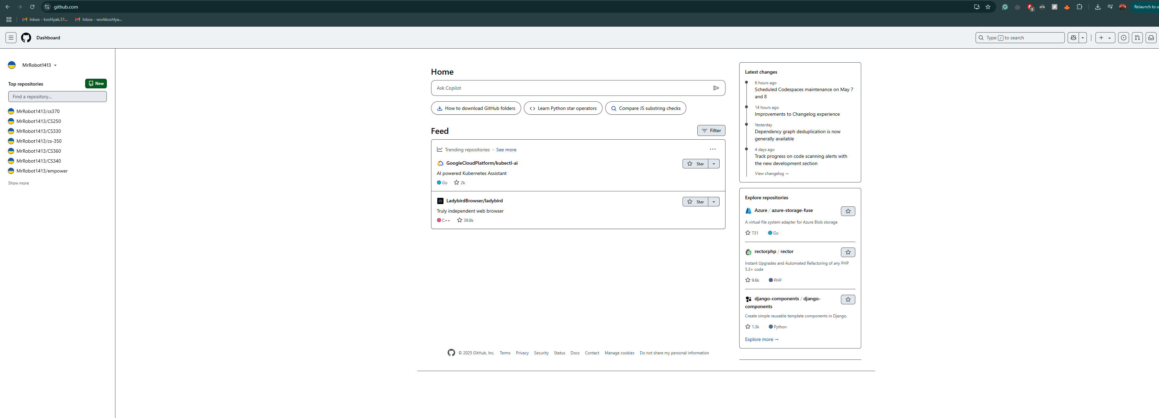

1. **Enhancement Plan:** 
   1. **Category One:** Software Engineering and Design
      1. **Select an** **artifact** that is **aligned with** **the** software engineering and design **category** and explain its origin. Submit a file containing the code for the artifact you choose with your enhancement plan.

Android project from CS 360 (Mobile Architecture): “Crypto Tracker App.”

Note: Your artifact may be work from the following courses:

* IT 145: Foundation in Application Development
* CS 250: Software Development Lifecycle
* CS 260: Data Structures and Algorithms
* IT 315: Object Oriented Analysis and Design
* CS 320: Software Testing, Automation, and Quality Assurance
* CS 330: Computational Graphics and Visualization
* CS 340: Advanced Programming Concepts
* CS 350: Emerging Systems Architectures and Technologies
* CS 360: Mobile Architecture and Programming
* IT 365: Operating Environments
* IT 380: Cybersecurity and Information Assurance
* CS 405: Secure Coding
* CS 410: Reverse Software engineering
* IT 340: Network and Telecommunication Management
* IT 380: Cybersecurity and Information Assurance
  + 1. **Describe** a practical, well-illustrated **plan** for enhancement in alignment with the category, including a pseudocode or flowchart that illustrates the planned enhancement.

Refactor the app to follow Clean Architecture (data/domain/presentation layers), implement MVVM, and migrate UI from XML to Jetpack Compose.

*ViewModel {*

*val cryptoState: StateFlow<CryptoUIState>*

*fun fetchCryptoData()*

*}*

*UseCase {*

*suspend fun execute(): List<Coin>*

*}*

*Repository {*

*suspend fun getCoins(): List<Coin>*

*}*

*DataSource {*

*suspend fun fetchFromApi(): ApiResponse*

*}*

For this category of enhancement, consider improving a piece of software, transferring a project into a different language, reverse engineering a piece of software for a different operating system, or expanding a project’s complexity. These are just recommendations. Consider being creative and proposing an alternative enhancement to your instructor.

Think about what additions to include to complete the enhancement criteria in this category. Since one example option is to port to a new language, that is the kind of scale that is expected. This does not mean you need to port to a new language but instead have an equivalent scale of enhancement. Underlying expectations of any enhancement include fixing errors, debugging, and cleaning up comments, but these are not enhancements themselves.

* + 1. Explain how the planned enhancement will **demonstrate** specific **skills** and align with course outcomes.
       1. Identify and describe the specific skills you will demonstrate that align with the course outcome.

This will demonstrate my ability to structure code professionally using modern Android architecture, making the app scalable, testable, and easier to maintain. It aligns with industry practices for mobile app development.

* + - 1. Select one or more of the course outcomes below that your enhancement will align with.
* Design and evaluate computing solutions
* Demonstrate innovative techniques, skills, and tools in computing
* Develop a security mindset by using proper separation of concerns

Course Outcomes:

1. Employ strategies for building collaborative environments that enable diverse audiences to support organizational decision-making in the field of computer science.
2. Design, develop, and deliver professional-quality oral, written, and visual communications that are coherent, technically sound, and appropriately adapted to specific audiences and contexts.
3. Design and evaluate computing solutions that solve a given problem using algorithmic principles and computer science practices and standards appropriate to its solution while managing the trade-offs involved in design choices.
4. Demonstrate an ability to use well-founded and innovative techniques, skills, and tools in computing practices for the purpose of implementing computer solutions that deliver value and accomplish industry-specific goals.
5. Develop a security mindset that anticipates adversarial exploits in software architecture and designs to expose potential vulnerabilities, mitigate design flaws, and ensure privacy and enhanced security of data and resources.
   1. **Category Two:** Algorithms and Data Structures
6. **Select an artifact** that is **aligned with the** algorithms and data structures **category** and explain its origin. Submit a file containing the code for the artifact you choose with your enhancement plan. You may choose work from the courses listed under Category One.

**Pathfinding project from CS 260: Implemented Dijkstra’s algorithm in Kotlin for grid navigation.**

1. **Describe** a practical, well-illustrated **plan** for enhancement in alignment with the category, including a pseudocode or flowchart that illustrates the planned enhancement.

**Optimize the algorithm by implementing A* search, which improves efficiency using heuristics. I'll also allow for variable terrain costs and real-time grid visualization in Compose.**

**function AStar(start, goal):**

**openSet = PriorityQueue(start)**

**while openSet not empty:**

**current = openSet.dequeueLowestFScore()**

**if current == goal: return reconstructPath()**

**for neighbor in current.neighbors:**

**calculate tentative_gScore**

**if better path found: update parent and scores**

For this category of enhancement, consider improving the efficiency of a project or expanding the complexity of the use of data structures and algorithms for your artifact. These are just recommendations. Consider being creative and proposing an alternative enhancement to your instructor. Note: You only need to choose one type of enhancement per category.

Think about what additions to include to complete the enhancement criteria in this category. Since one example option is to port to a new language, that is the kind of scale that is expected. Perhaps you might increase the efficiency and time complexity of an algorithm in an application and detail the logic of the increased time complexity. Remember, you do not need to port to a new language but instead have an equivalent scale of enhancement. Underlying expectations of any enhancement include fixing errors, debugging, and cleaning up comments, but these are not enhancements themselves.

1. Explain how the planned enhancement will **demonstrate** specific **skills** and align with course outcomes.
   1. Identify and describe the specific skills you will demonstrate to align with the course outcome.

Demonstrates advanced algorithmic thinking, use of efficient data structures (e.g., priority queue), and understanding of computational trade-offs.

* 1. Select one or more of the course outcomes listed under Category One that your enhancement will align with.

Design and evaluate computing solutions

Use well-founded techniques and tools in computing practices

* 1. **Category Three: Databases**
     1. **Select an artifact** that is **aligned with the** databases **category** and explain its origin. Submit a file containing the code for the artifact you choose with your enhancement plan. You may choose work from the courses listed under Category One.

Bookstore database project from CS 340.

* + 1. **Describe** a practical, well-illustrated **plan** for enhancement in alignment with the category, including a pseudocode or flowchart that illustrates the planned enhancement.

Refactor the schema into **3NF**, implement **stored procedures** and **views**, and build a **dashboard using Flask and SQLite** to visualize sales analytics.

**CREATE PROCEDURE GetTopSellingBooks()**

**BEGIN**

**SELECT title, COUNT(*) AS total_sales**

**FROM orders**

**GROUP BY title**

**ORDER BY total_sales DESC;**

**END;**

For this category of enhancement, consider adding more advanced concepts of MySQL, incorporating data mining, creating a MongoDB interface with HTML/JavaScript, or building a full stack with a different programming language for your artifact. These are just recommendations; consider being creative and proposing an alternative enhancement to your instructor. Note: You only need to choose one type of enhancement per category.

Think about what additions to include to complete the enhancement criteria in this category. Since one example option is to port to a new language, that is the kind of scale that is expected. Perhaps you might increase the efficiency and time complexity of an algorithm in an application and detail the logic of the increased time complexity. Remember, you do not need to port to a new language but instead have an equivalent scale of enhancement. Underlying expectations of any enhancement include fixing errors, debugging, and cleaning up comments, but these are not enhancements themselves.

* + 1. Explain how the planned enhancement will **demonstrate** specific **skills** and align with course outcomes.
       1. Identify and describe the specific skills you will demonstrate that align with the course outcome.

Shows understanding of normalization, backend integration, and SQL automation for business insights.

* + - 1. Select one or more of the course outcomes listed under Category One that your enhancement will align with.
* Implement computing solutions that deliver value
* Anticipate design flaws and improve data handling security

1. **ePortfolio Overall Skill Set**
   1. Accurately describe the **skill set** to be illustrated by the **ePortfolio** **overall**.
      1. Skills and outcomes planned to be illustrated in the code review

* Clean, modular architecture
* Optimized algorithms
* Secure and efficient database design
  + 1. Skills and outcomes planned to be illustrated in the narratives
* Ability to explain trade-offs and development decisions clearly
* Connect technical work to real-world relevance
  + 1. Skills and outcomes planned to be illustrated in the professional self-assessment
* Reflect on growth in software engineering, problem-solving, and database work
* Identify areas for continued learning