**Lab-03**

**To learn RMI basics: Generate the stubs and**

**skeletons and run client and server**

**Task-1:** Create RMI program in which server performs basic arithmetic operations.

**servinterface.java**

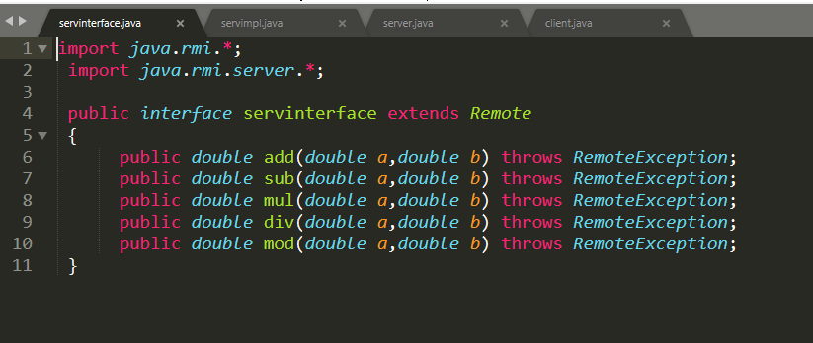

**servimpl.java**

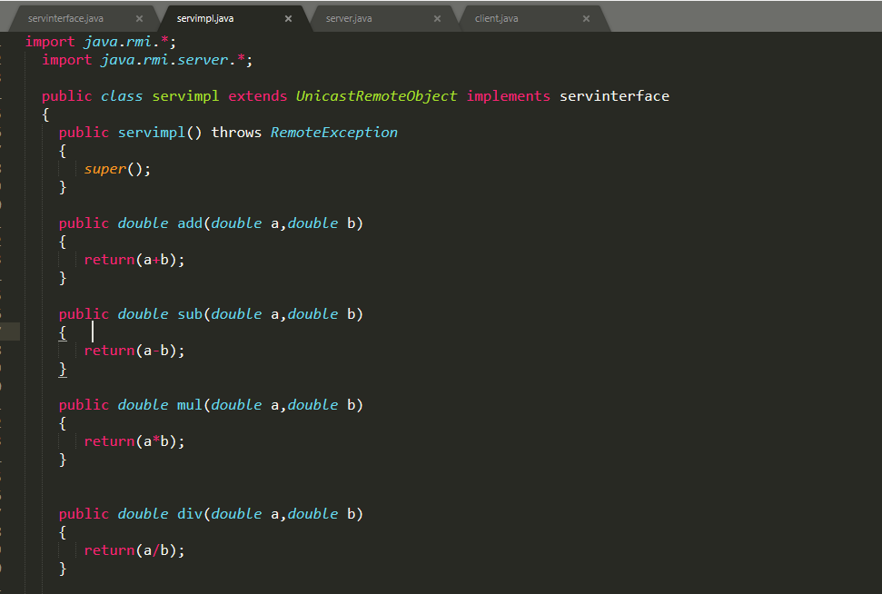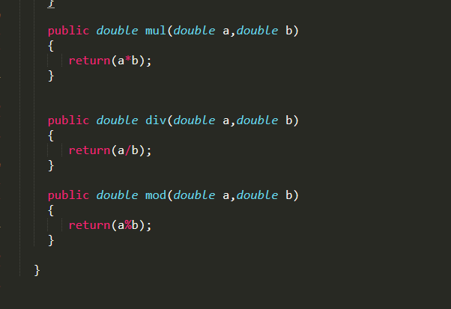

**server.java**

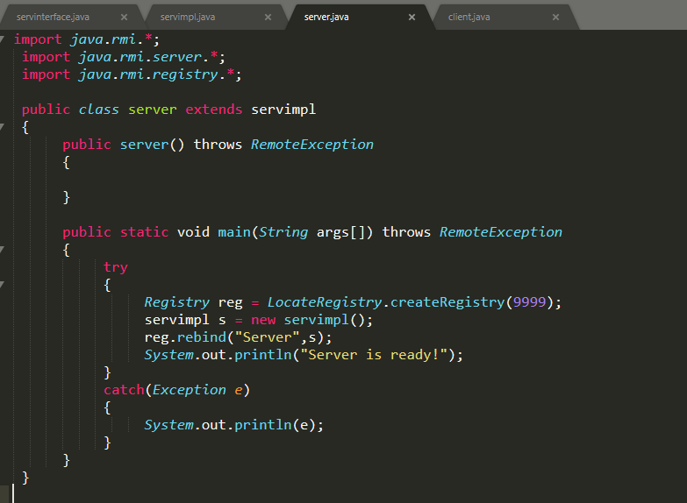

**client.java**

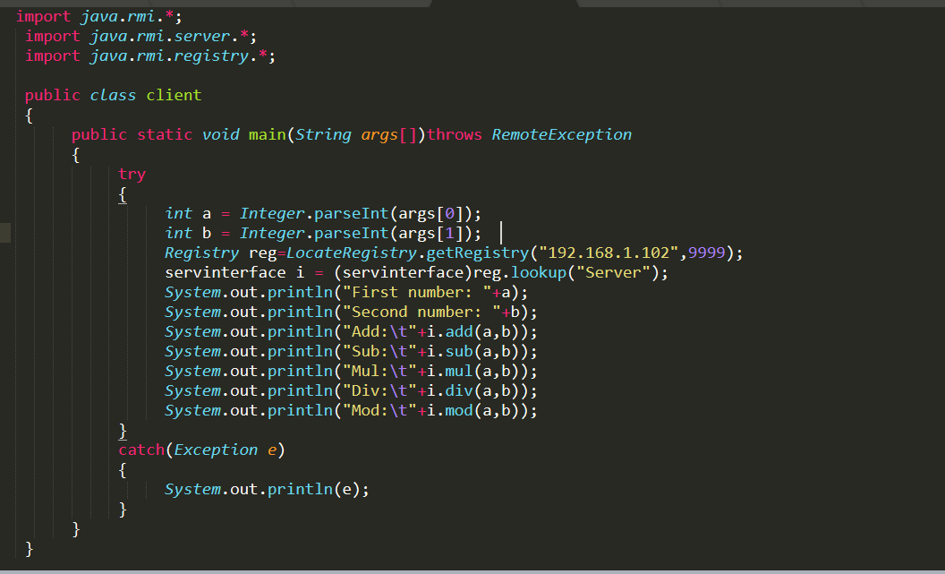

**Output:**

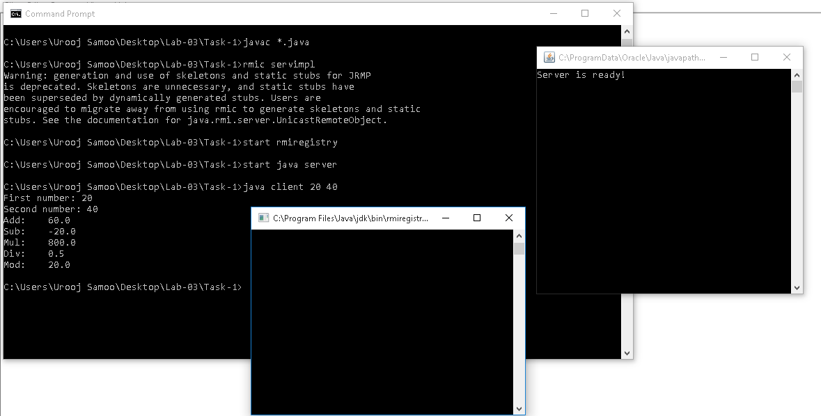

**Task-2:** Create RMI program in which server sorts the numbers in ascending order.

**Server Class**

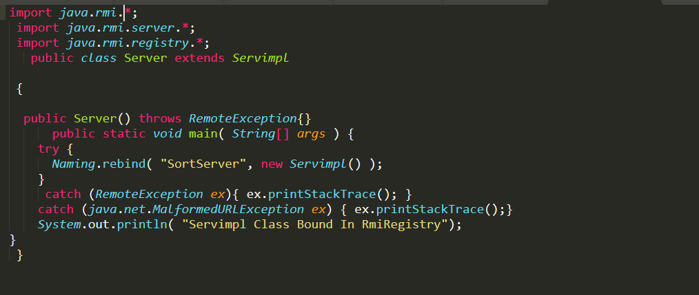

**Remote Class**

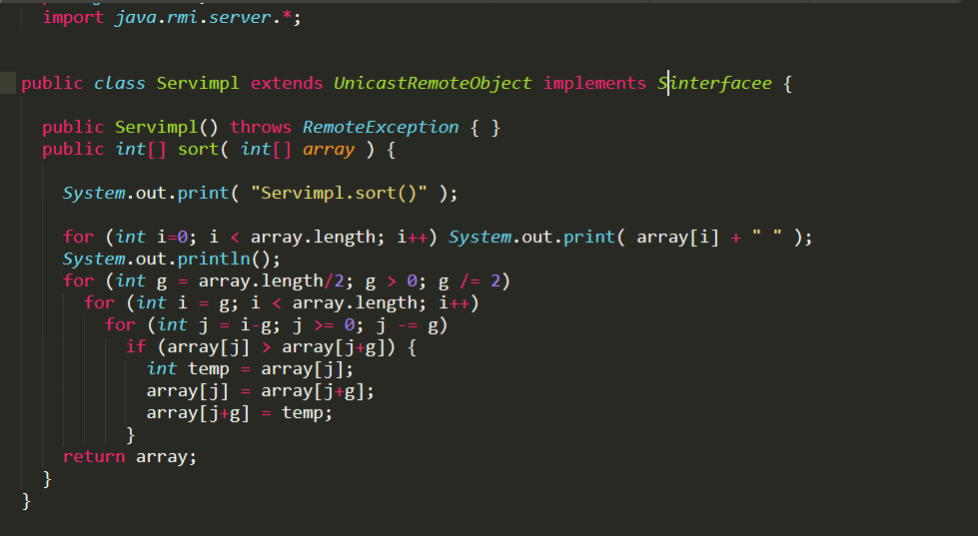

**Interface**

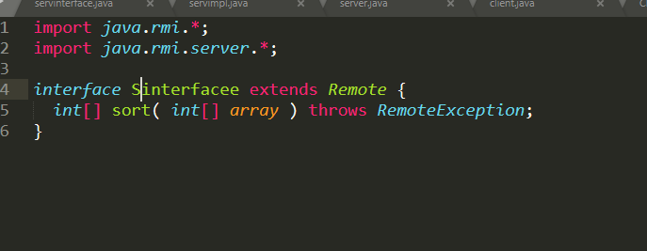

**Client Class**

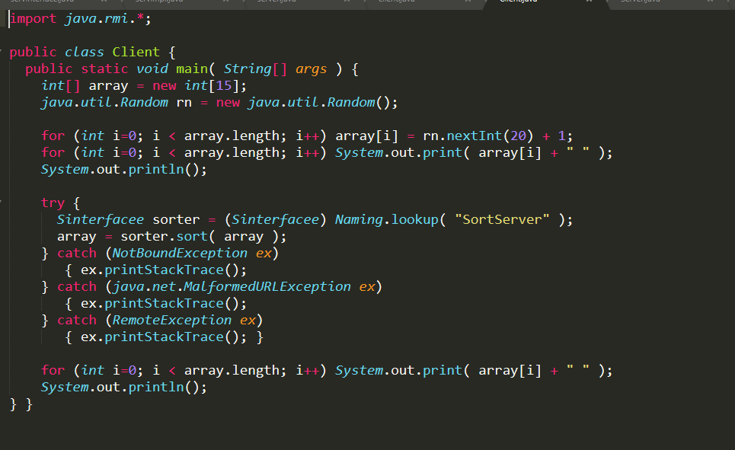

**Output:**

