**Lab-07**

**OBJECTIVE:** To Understand Multithreading .

**Task:** Write the same code for matrix multiplication and divide the code into ten threads. Also note the timestamp at the start and end of the program. Give your conclusion.

**Simple Matrix Multiplication with main thread.**

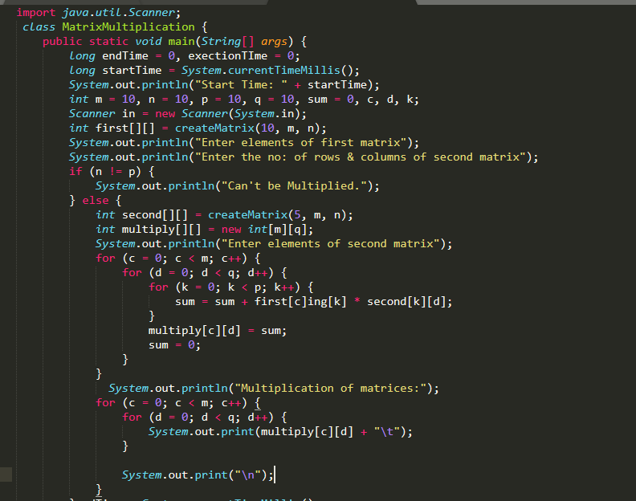

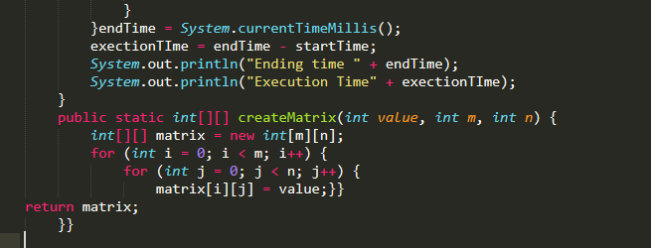

**Output:**

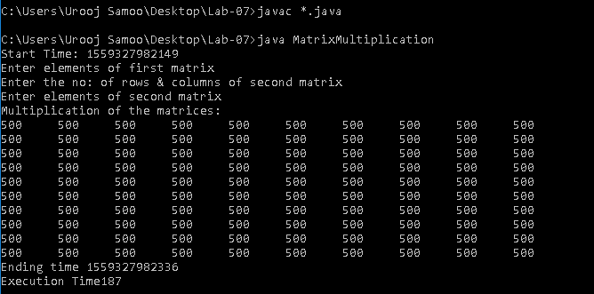

**Matrix Multiplication with Multiple Threads**

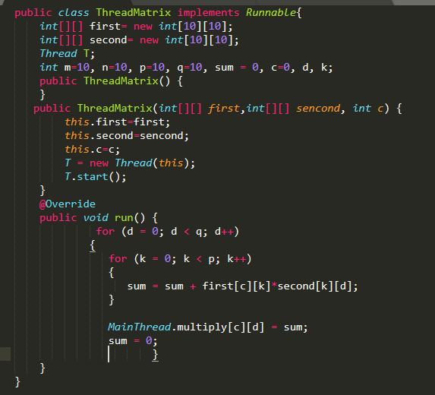

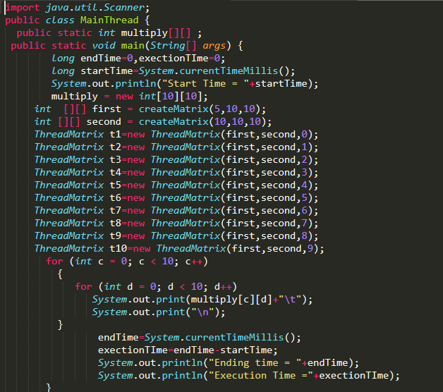

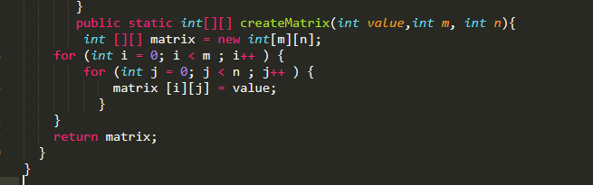

**Output:**

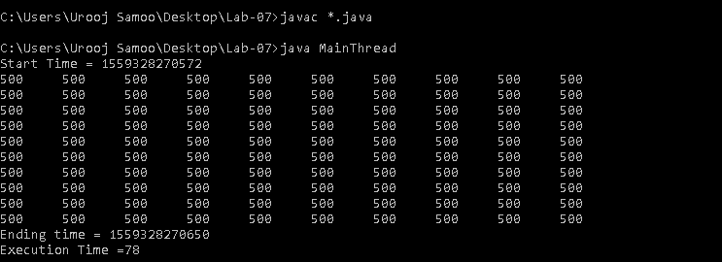

**Result:** We have observe that without threads it requires

execution time 187 milliseconds and with threads it requires execution time 87 milliseconds.