**Lab:NO:08**

**Objective**: To learn XML schema and parsing an XML document.

1. Create an XML document structuring information for a store. (shopping store of your choice)

**XML file:**

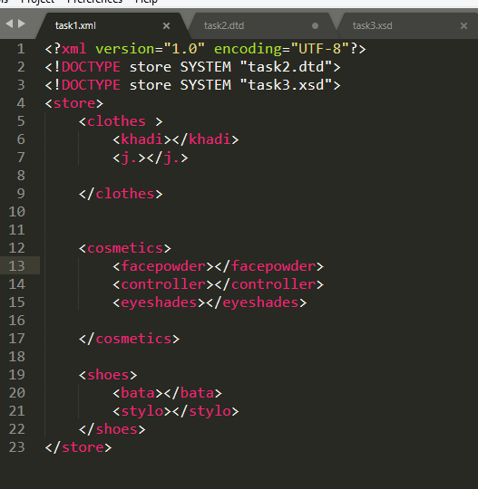

1. Create DTD for store XML Document. And validate on <http://www.w3schools.com/xml/xml_validator.asp>

**DTD file:**

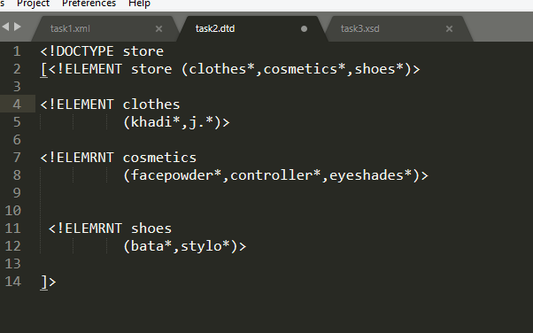

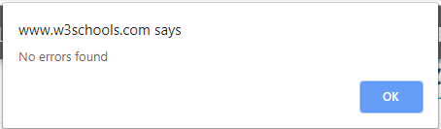

1. Write XML Schema for the following XML document and then validate the XML document along with its schema on the following website:

[http://www.utilities-online.info/xsdvalidation/#.UlFx2tKmhIg](http://www.utilities-online.info/xsdvalidation/)

**XSD file:**

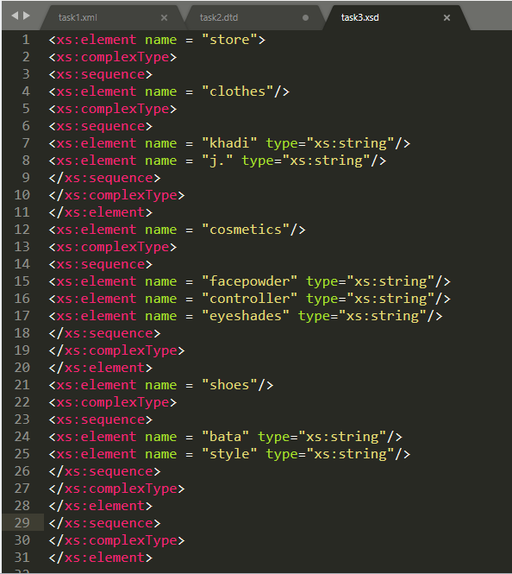

Tas:04 . Write an XML instance for following schema and then parse that document in Java using either DOM or SAX API.

**Xml File:**

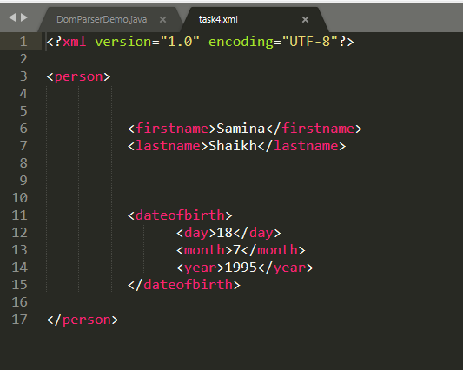

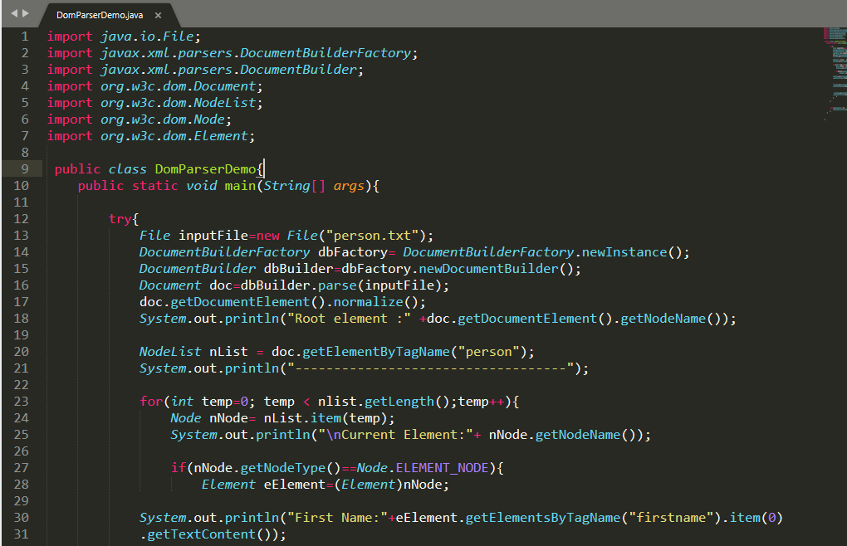

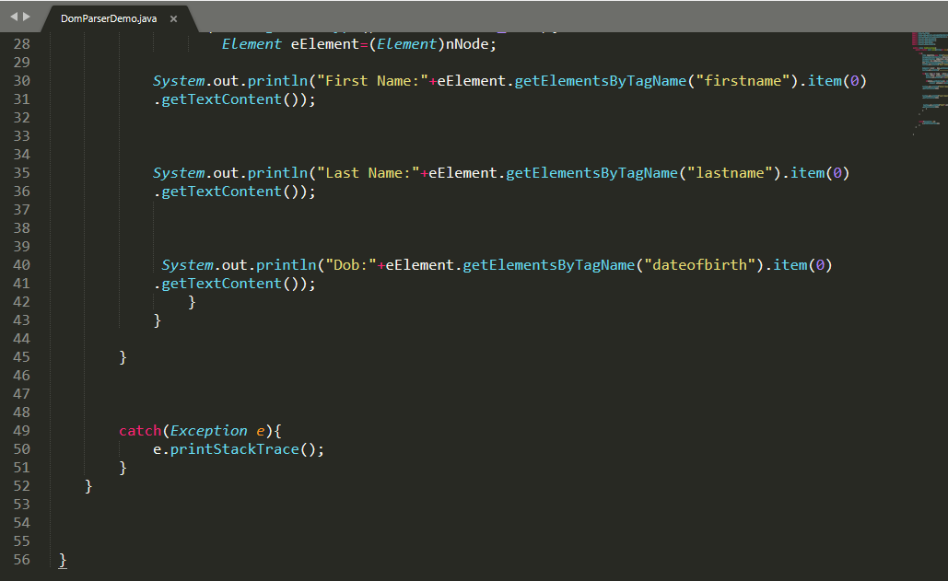

Output:

