# **LAB#06**

# **TO LEARN RMI-IIOP**

## TASK: Create RMI IIOP application in which take a sentence at runtime on the client application and let the server return its reverse. E.g. input could be: subject is distributed computing output should be: computing distributed is subject.

INTERFACE:

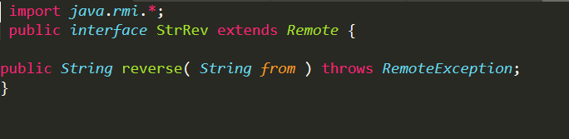

INTERFACE IMPLEMENTATION:

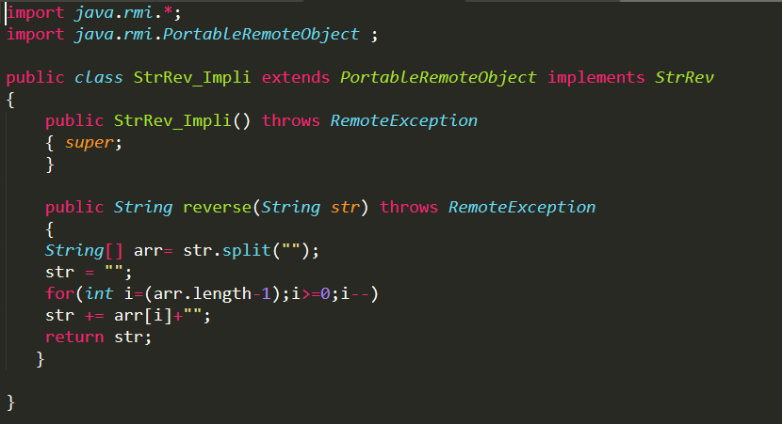

CLIENT:

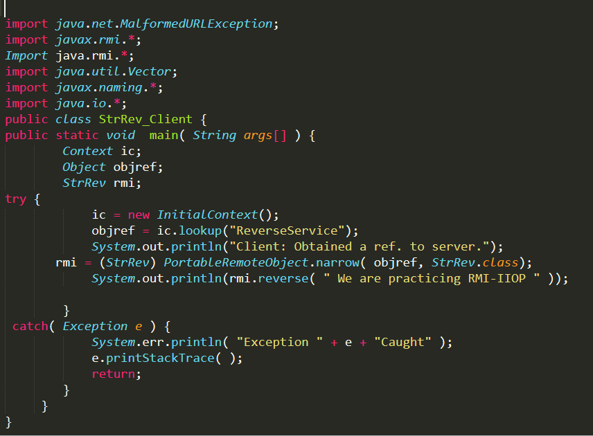

SERVER:

