**Lab no:05**

**Object: To become familiar with RMI Serialization**

**TASK: 1**

* **Develop any simple application to demonstrate object passing in RMI. (Expl: Make a class of your own and use its objects as arguments and return types for RMI)**
* **Application for the generating Prime number series.**
* **PrimeCompute.java**

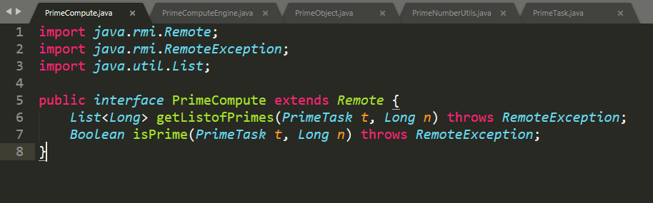

* **PrimeComputeEngine.java**

­­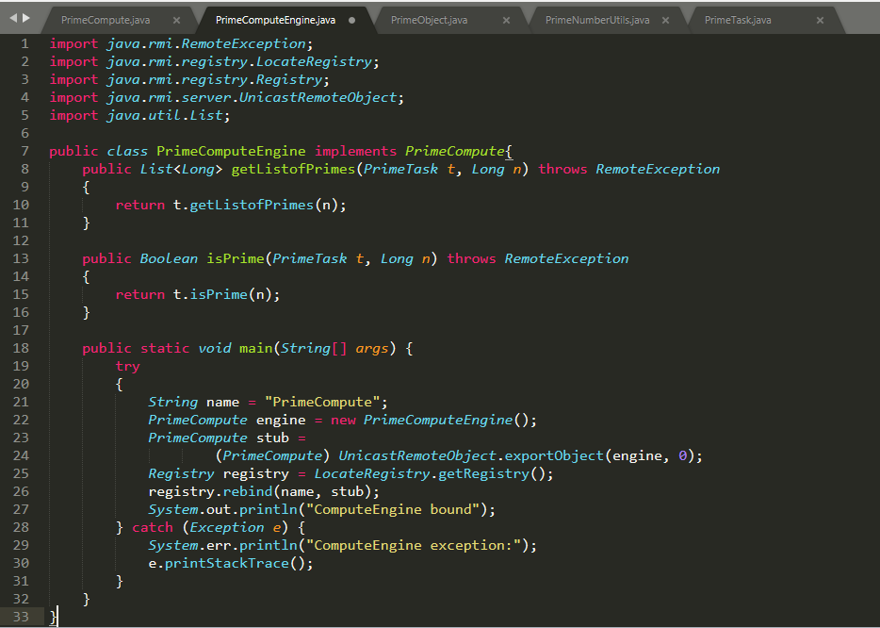

* **PrimeObject.java**

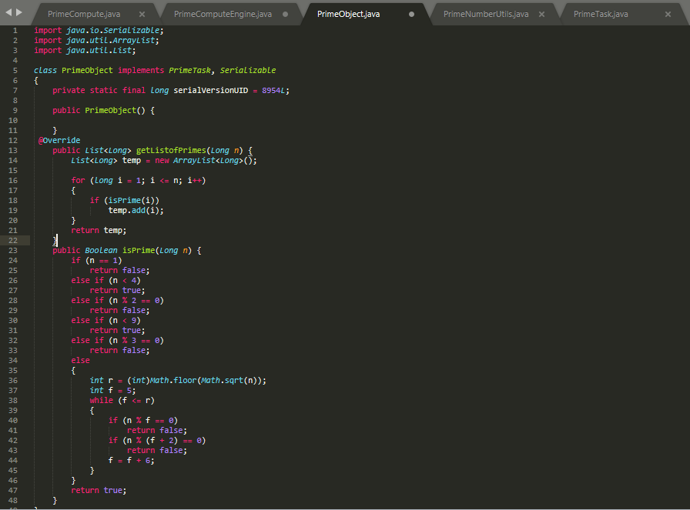

* **PrimeNumberUtils.java**

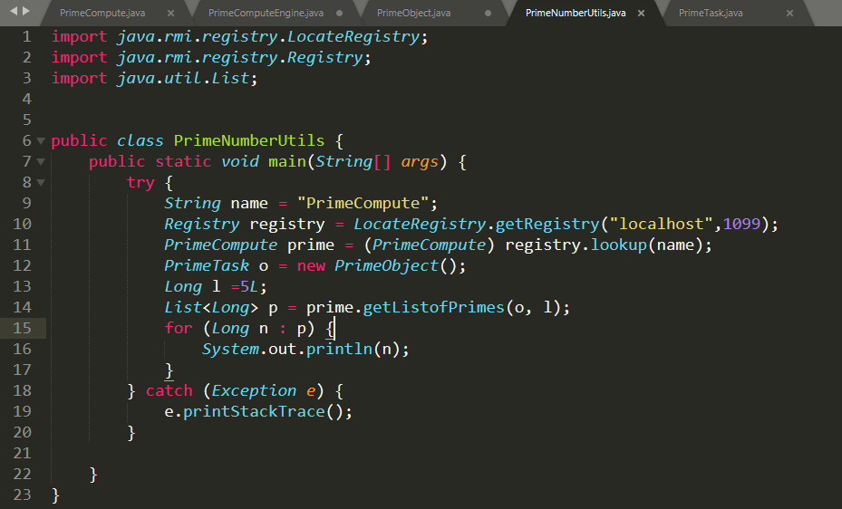

* **PrimeTask.java**

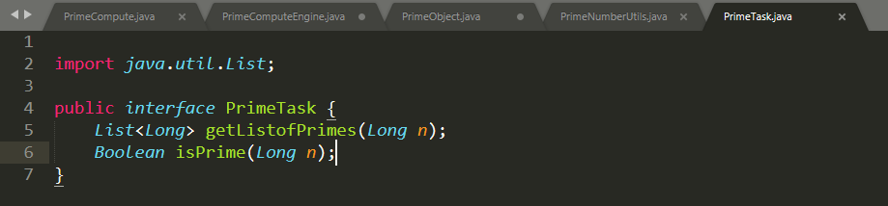

**OUTPUT:**

