Ultrasmall Hardware Design Review Report

Contents

1. Meeting Overview 4
2. Attendees and Roles (RASIC) 5
3. Work Products Reviewed 6
4. Agenda and Discussion Summary 6
5. Review Findings and action taken 7
6. Action‑Item Log 8
7. Pending Items 20
8. Risk Register 20
9. Exit‑Criteria Evaluation 21
10. Appendix 21
11. Sign‑off 21

Hardware Design Review Report Ultrasmall

About this document

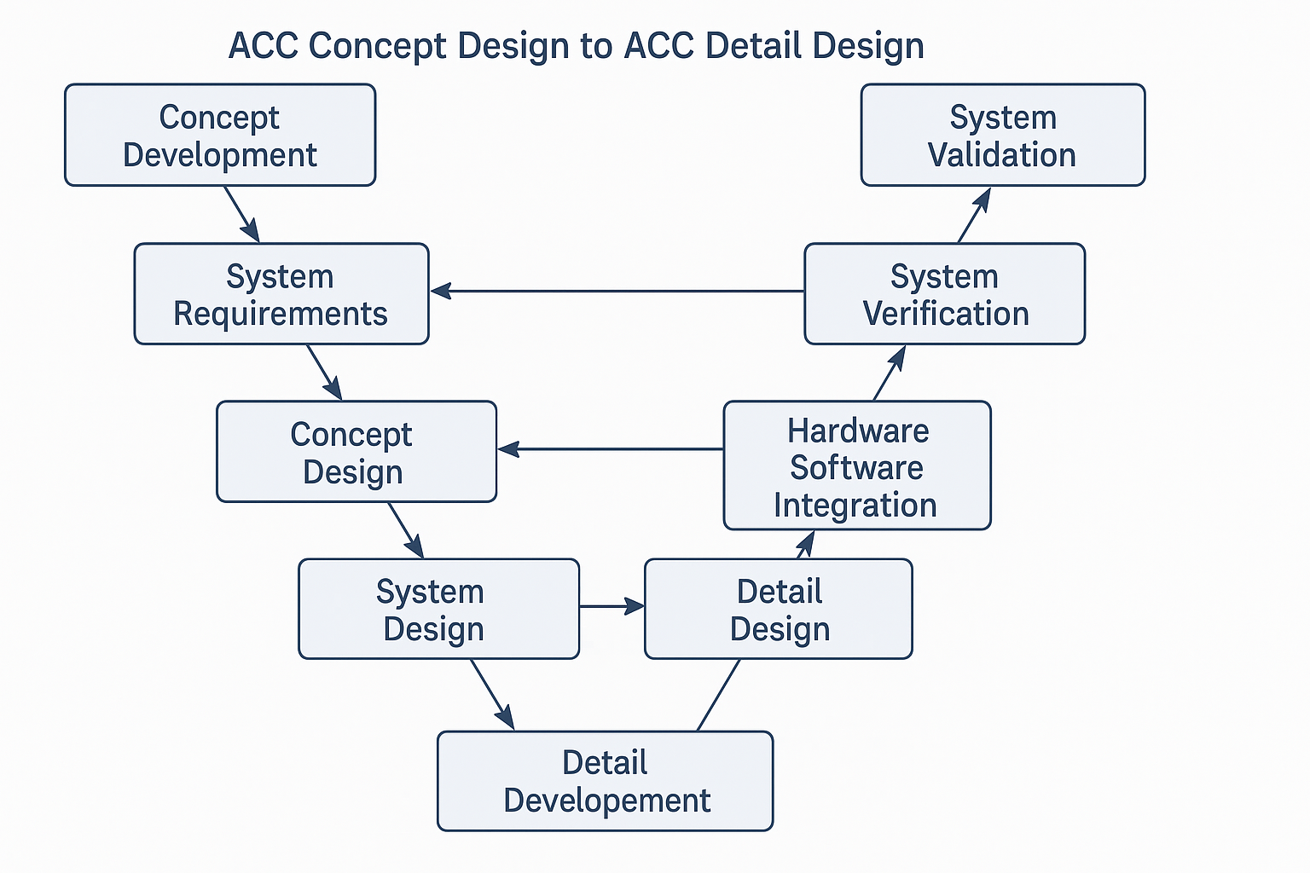
Hardware Design Review done here for update in phase 4 schematic and PCB.

Scope
This Hardware Design Review Report summarizes the evaluation of the schematic, PCB, and related design documentation to confirm compliance with applicable requirements and standards, identify risks and missing design considerations if any, and support informed decisions on the hardware design readiness for the next release phase. The intention of this review is to ensure design quality, manage risk, and highlight any gaps requiring closure.

Note: This is an interim review report and will be updated further after completion of the design updates and validation/testing activities.

Purpose
The purpose of this Hardware Design Review Report is to:
- Confirm that the phase 4 Schematic and PCB updates comply with applicable requirements (TISR - TICO Input Specification Requirements and SRS - System Requirements Specifications and agreed testing requirements), standards, and stakeholder expectations.
- Assess the impact of the implemented hardware changes and ensure they are technically justified and traceable to action items.
- Highlight risks and open items that could affect hardware performance and reliability.
- Provide a documented basis to decide whether the hardware design is ready to proceed to the next release phase and validation/testing activities.

Intended Audience
This report is intended for cross-functional team members and internal / external stakeholders involved in reviewing, approving, implementing, and validating the hardware design (schematic and PCB) changes, and mechanical design (CAD) for reference related to the design activities.

Revision History
Rev. No | Date | Change Description | Prepared By | Reviewed By | Approved By
0.1 | 04-03-2026 | Initial creation | Obulisuresh | Sarup | Jaywant  Koustubh Thorat

Meeting Overview

Design Review Meeting Date | 13-02-2026
Location | Meeting room
Chairperson | Jaywant D Mahajan
Minute‑taker | Sarup Paul
Review Objective | Hardware Design Review focusing on schematic and PCB changes in phase 4, to confirm all listed updates are correctly implemented and verified and mapped action items are closed.

Attendees and Roles (RASIC)

Name | Organization | Role | RASIC | How the Role and Responsibility is decided | Signature
Jaywant D Mahajan | TechM | Chief Engineer | A | Chief Technical Architect. Review and Approval (Sign-off) authority for all technical matters related discussions and closure and chairing the technical review meetings
Vipul Torne | TechM | Project Management Support | C | Consult in all the matters to make sure that there is nothing pending from Project management side. Additional (Sign-off) authority from Project Management side
Koustubh Thorat | TechM | Project Manager | A | Review and Approval (Sign-off) authority for all the deliverables
Obulisuresh | TechM | Simulation | R | Simulation team member responsible for Hardware, Software and Simulation related discussions
Akshay V | TechM | HW Design | R | Hardware team member responsible for Hardware and Software related discussions
Dipali P | TechM | SW Design | R | Software team member responsible for technical document creation, coding and peer review
Yash | TechM | Mechanical Design | R | Mechanical design team member responsible for technical document creation, mechanical design work and peer review
Renjith T | TechM | PCB Design | R | PCB design team member responsible for technical document creation, PCB design activities and peer review
Manisha | TechM | PCB Design | R | PCB design team member responsible for technical document creation, PCB design activities and peer review
Prachita | TechM | PCB Design | R | PCB design team member responsible for technical document creation, PCB design activities and peer review
Rohit | TechM | PCB Layout | R | PCB layout team member responsible for technical document creation, PCB layout activities and peer review
Mukesh | TechM | Purchase Team | R | Purchase team member responsible for anything related to components / tools availability and purchase
Name | Organization | Role | RASIC | How the  Role and Responsibility is decided | Signature
Shikha | TechM | Testing Team | I | Testing team member – keep informed for any updates related to testing work
Sarup | TechM | Project Lead | A | Project Management team members supporting the deliverables review, tracking and approval
R = Responsible, A = Approver, S = Support, I = Informed, C = Consulted

Work Products Reviewed

S. No | Work Product | Document
1 | Ultrasmall Schematic and PCB
2 | Ultrasmall CAD

Agenda and Discussion Summary

All the artifacts are reviewed for following considerations
Sr. No | Considerations | Applicable to current project
1 | Review design change focusing on schematic and PCB changes in phase4 design. | Yes

Review Findings and action taken
Table below gives the discussion points and action to be taken with mapping to the action item / Risk Register table

Sr. No | Reviewer | Category | Review comments | Action Owner | Target Date | Action | Action-Item log /  Risk Register table mapping | Status
1 | Jaywant | Driver PCB | Is DCDC secondary Gate driver IC changed | Rohit | 24-2-2026 | Replace DCDC secondary GaN driver with 2edb7259k for S1,S2,S3 and S4 | Chapter 6 Action-Item log #1 | Closed
2 | Jaywant |  | Is the Power supply IC added for DCDC secondary GaN drivers | Rohit | 24-2-2026 | Place Power supply IC LTM8057EYPBF with 2edb7259k GaN driver |  | Closed
3 | Jaywant |  | Is PFC SiC gate driver (UCC21520AQDWRQ1) replaced with 2edb7259k | Rohit | 24-2-2026 | Replace PFC SiC gate driver (UCC21520AQDWRQ1) with 2edb7259k |  | Closed
4 | Jaywant |  | Is OBC GaN driver IC replaced from AHV85111KNHTR to 1EDB7275F. | Rohit | 24-2-2026 | Replace OBC GaN driver IC from AHV85111KNHTR to 1EDB7275F. |  | Closed
5 | Jaywant |  | Is individual Isolated Power supply IC added for PFC GaN, OBC Primary and secondary GaN |  | 24-2-2026 |  |  | Closed
6 | Jaywant |  | Is PFC GaN, OBC primary and secondary GaNs replaced[TP65H030G4PRS-TR] | Rohit | 24-2-2026 | Replace PFC GaN, OBC primary and secondary GaNs [TP65H030G4PRS-TR] |  | Closed
6 | Jaywant | Power PCB | Is Power PCB stack-up updated to four layer from two layer | Rohit | 24-2-2026 | Update Power PCB stackup to four layer from two layer |  | Closed
 | Jaywant | Power PCB | Is DCDC secondary current sensor changed | Rohit | 24-2-2026 | DCDC secondary current sensorACS772ECB-400B-PFF-T to Shunt current sensor |  | Closed
7 | Jaywant |  | Is DCDC DAB primary added three capacitor for before transformer | Rohit | 24-2-2026 | Add DCDC Dab primary three capacitor for before transformer |  | Closed
8 | Jaywant |  | Is slot added for OBC inductor connection and DCDC DAB primary inductor connection. | Rohit | 24-2-2026 | Add slot for OBC inductor connection and DCDC DAB primary Inductor connection. |  | Closed
9 | Jaywant | Controller PCB | Is ZCD circuit changed | Rohit | 24-2-2026 | Change ZCD circuit Ic TCLT1009 |  | Closed
10 | Jaywant |  | Is Flash memory Interface Level shifter circuit added | Rohit | 24-2-2026 | Add Flash memory Interface Level shifter circuit |  | Closed
11 | Jaywant |  | Is Micro-controller IC has been changed |  |  | Change Microcontroller IC SAL-TC364DP-64F300F AA |  | Closed

Action‑Item Log

Log that confirms whether each project task 'action' held by individual team members has been completed against the said target date or there are any remaining tasks

Sr No | Action Items | Responsible | Target Date | Completion Date | Background for discussion /  Reason for change | Applicability to the current project | Criteria for closure
1 | 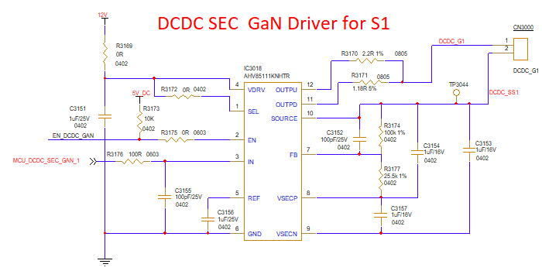 | Rohit | 24-2-2026 | 27-2-2026 | Required gate charge is 112nC but previous gan gate driver gives upto 18nC. | Yes | 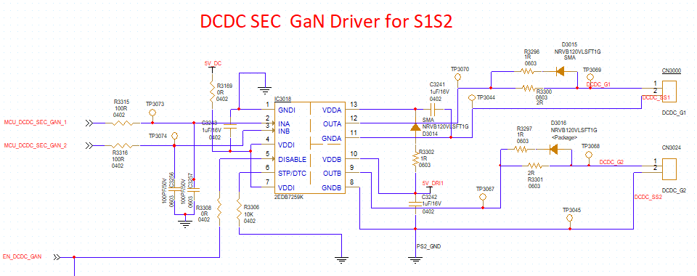
 | SCHEMATIC_DRIVER_PCB.DSN |  |  |  |  |  | SCHEMATIC_DRIVER_PCB.DSN
2 |  | Rohit | 24-2-2026 | 27-2-2026 | previous driver has inbuilt power supply,[AHV85111KNHTR] | Yes | 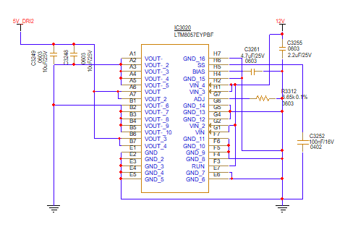
 | SCHEMATIC_DRIVER_PCB.DSN |  |  |  |  |  | SCHEMATIC_DRIVER_PCB.DSN
3 | 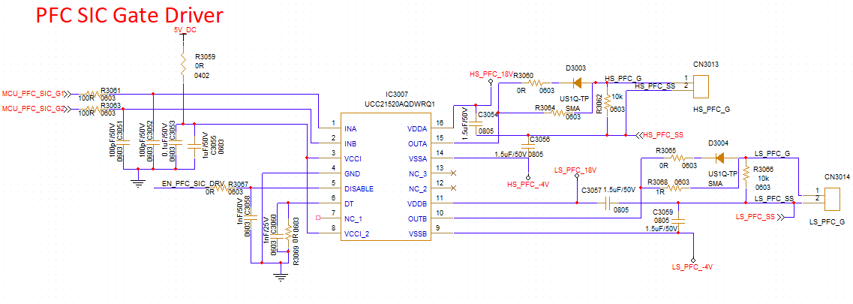 | Rohit | 25-2-2026 | 27-2-2026 | Required gate charge is 112nC but previous gan gate driver gives upto 18nC. | Yes | 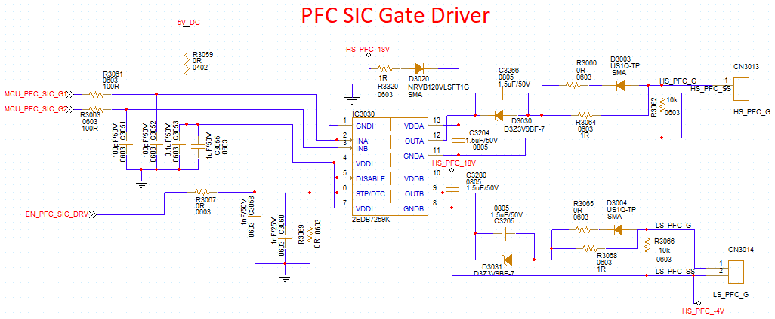
 | SCHEMATIC_DRIVER_PCB.DSN |  |  |  |  |  | SCHEMATIC_DRIVER_PCB.DSN
4 | 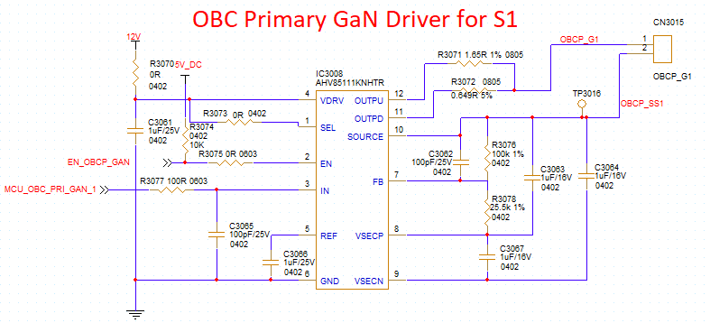 | Rohit | 26-02-26 | 27-2-2026 | Required gate charge is 30nC but previous GaN gate driver gives upto 18nC. | Yes | 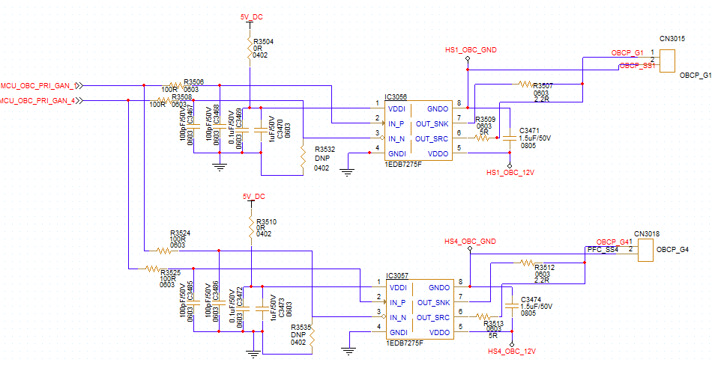
 | SCHEMATIC_DRIVER_PCB.DSN |  |  |  |  |  | SCHEMATIC_DRIVER_PCB.DSN
5 |  | Rohit | 26-02-26 | 27-2-2026 | Previously using bootstrap technique, so single power supply is enough.In new gate driver, no bootstrap technique used so requires individual power supply. | Yes | 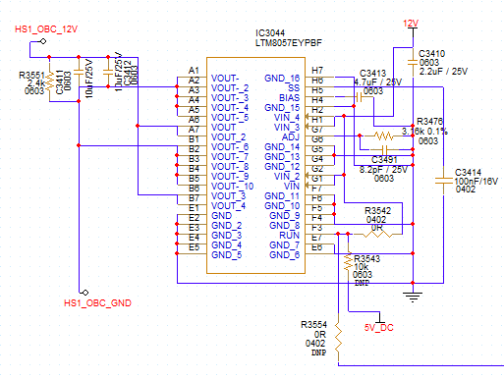
 | SCHEMATIC_DRIVER_PCB.DSN |  |  |  |  |  | SCHEMATIC_DRIVER_PCB.DSN
6 | 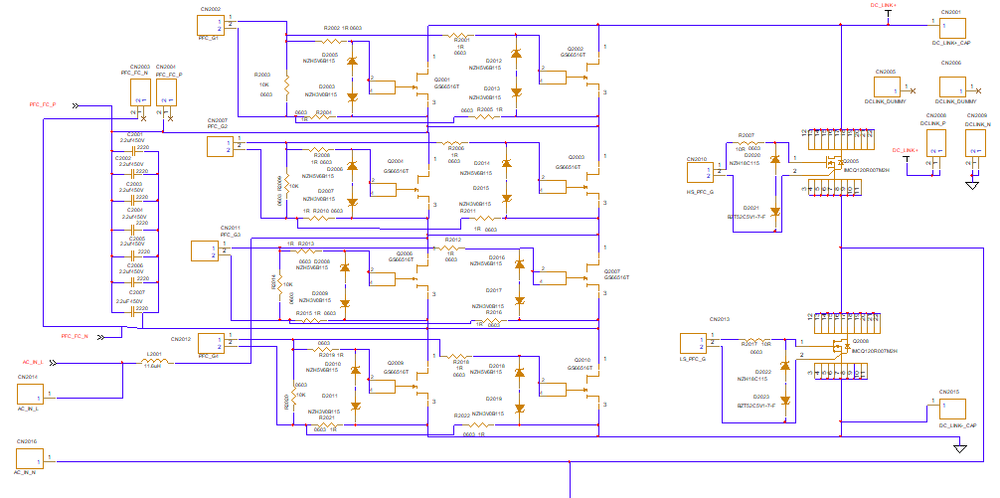 | Rohit | 26-2-2026 | 27-2-2026 | The GS66516T GaN requires a low Vgs (6 V) making it more sensitive to gate drive variations, so it was replaced with TP65H070G4RS-TR, which supports a higher Vgs. | Yes | 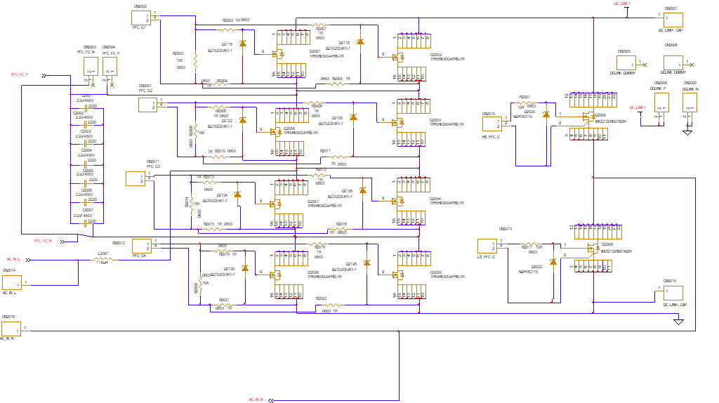
 | SCHEMATIC_POWER_PCB.DSN |  |  |  |  |  | SCHEMATIC_POWER_PCB.DSN
7 | 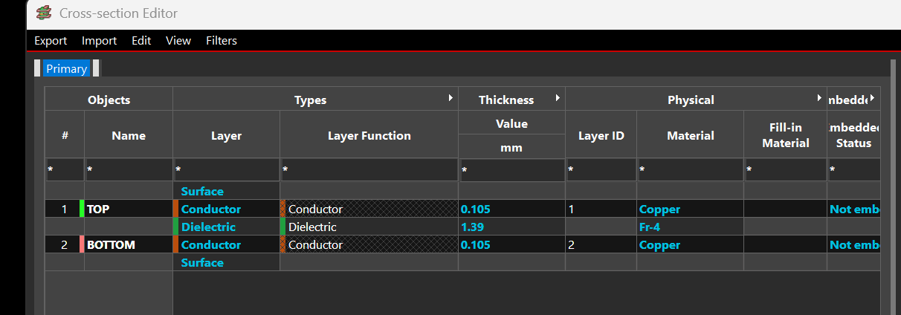 | Rohit | 24-2-26 | 27-2-2026 | The PCB was changed from 2-layer to 4-layer due to limited routing space and increased power requirements.  The additional layers provide better routing flexibility and allow proper power distribution. | Yes | 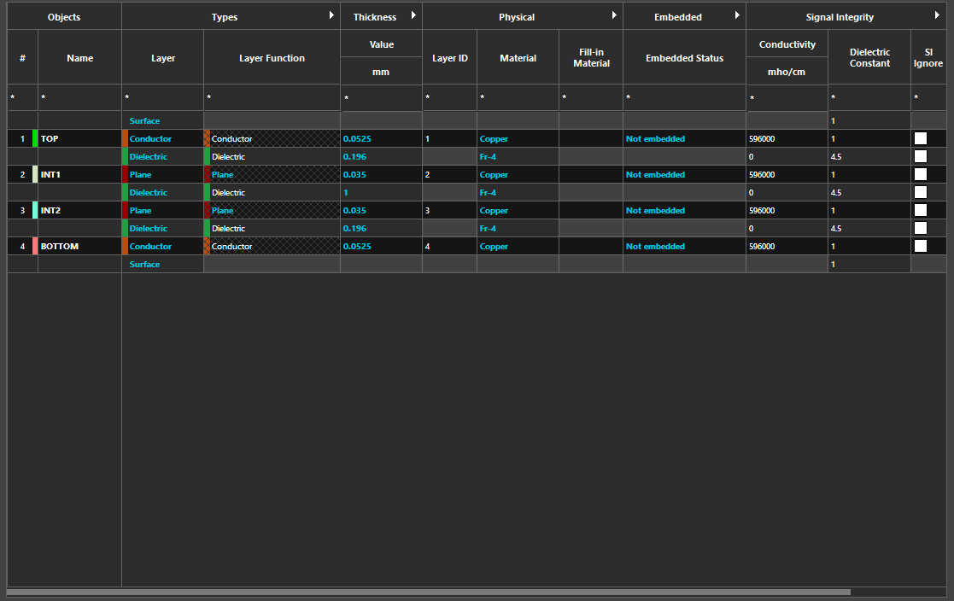
 | POWER_PCB |  |  |  |  |  | POWER_PCB
8 | 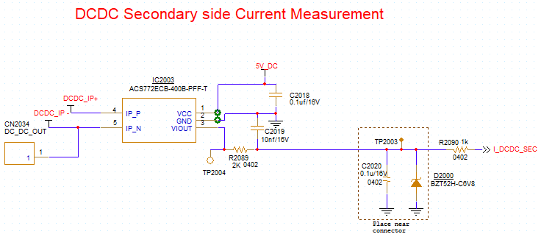 | Rohit |  | 27-2-2026 | Current sensor shifted after the DCDC output filter capacitor in circuit,size of the current sensor making issue in placement so replaced with Shunt based current sensor. | Yes | 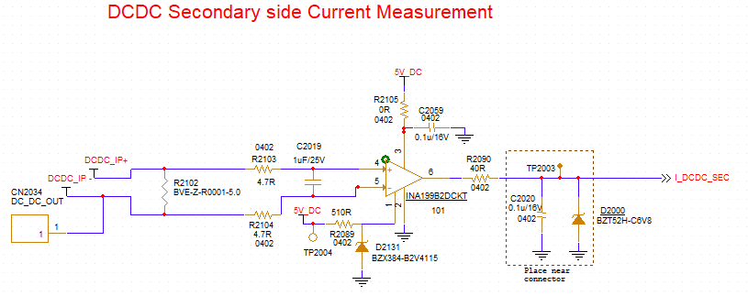
 | SCHEMATIC_POWER_PCB.DSN |  |  |  |  |  | SCHEMATIC_POWER_PCB.DSN
10 |  | Rohit | 25-2-2026 | 27-2-2026 | DC Blocking capacitors are introduced in the power stage to avoid saturation of the transformer in case of unbalanced currents, which can be caused by mismatched PWM signals, mismatched propagation delays in gate drivers or other asymmetries in the system. Especially during start-up and load transients unbalanced currents can occur. | Yes | 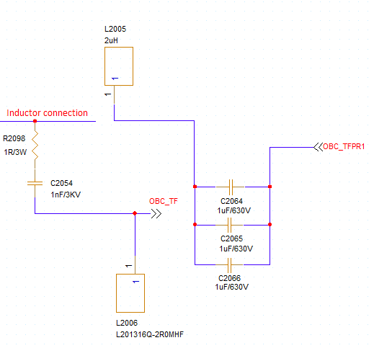
 |  |  |  |  |  |  | SCHEMATIC_POWER_PCB.DSN
12 | 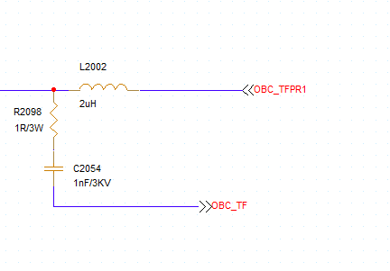 | Rohit | 25-2-2026 | 27-2-2026 | Change the PFC and OBC DAB inductor because of new inductor larger in size, it is required have slots on PCB. | Yes | 
 | SCHEMATIC_POWER_PCB.DSN |  |  |  |  |  | SCHEMATIC_POWER_PCB.DSN
13 | 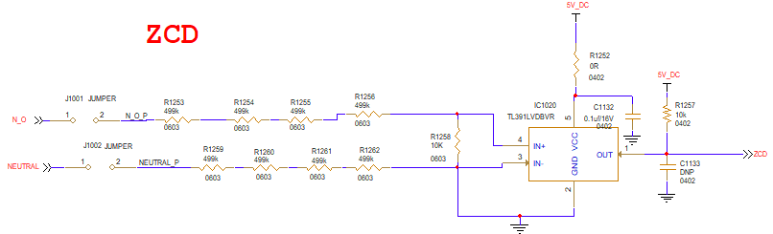 | Rohit | 26-2-2026 | 27-2-2026 | TL391LVDBVR IC causing delay and the isolation is also required in the circuit, | Yes | 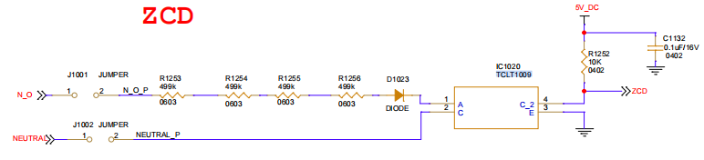
 | SCHEMATIC_CONTROLLER_PCB.DSN |  |  |  |  |  | SCHEMATIC_CONTROLLER_PCB.DSN
14 |  | Rohit | 26-2-2026 | 27-2-2026 | Due to data error, logic level shifter is placed in the circuit. | Yes | 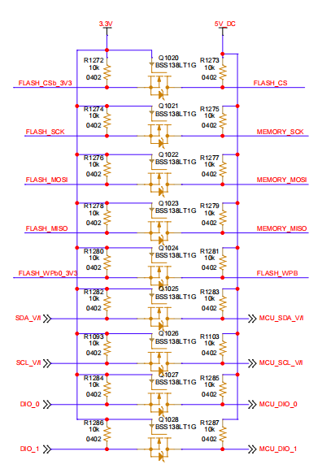
 | SCHEMATIC_CONTROLLER_PCB.DSN |  |  |  |  |  | SCHEMATIC_CONTROLLER_PCB.DSN

Pending Items
S. No | Description | Target Completion date
 | None

Risk Register

Sr No | Description | Probability | Impact | Mitigation | Status
 | N/A

Exit‑Criteria Evaluation

All the design review comments are incorporated in the Schematic, PCB layout and CAD. Pending Items table captures the pending task along with the target completion date.

Appendix
None.

Sign‑off

Role | Name | Signature / Date
Chairperson | Jaywant D Mahajan | 04-03-2026
Quality Assurance | Sarup | 04-03-2026
Project Manager | Koustubh Thorat | 04-03-2026

