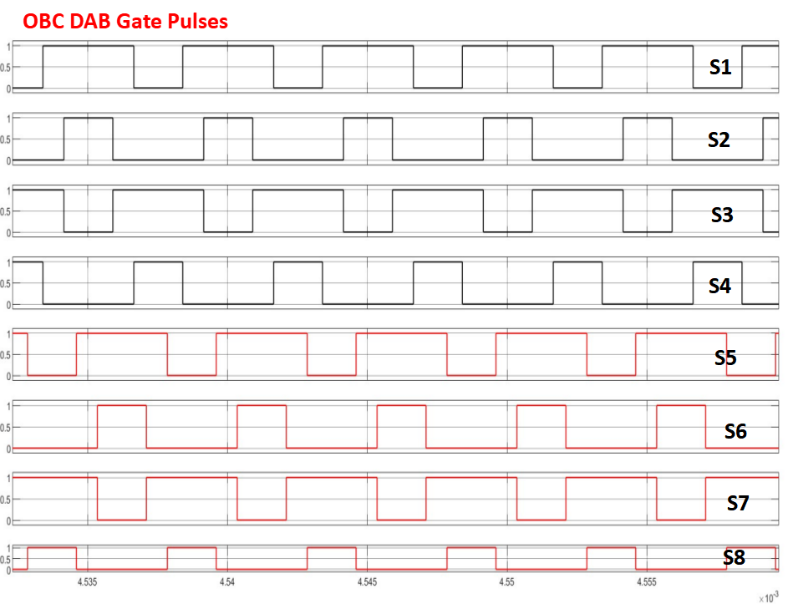
Voltage (V)
Time (s)
Figure 40 Gate pulses obtained from OBC DAB control scheme.

9.6 Software logic for implementing flying capacitor
Software logic for implementing Flying capacitors is currently a work in progress activity. The details will be updated during the pre-proto testing phase.

List of variables
Note: All relevant variables are declared at the global scope and follow MISRA C 2004 / 2012 naming conventions.

ADC INPUT
# | Variable Name | Type | Register Value |  | Sensor Value |  | ADC Resolution |  |  | Usage
 |  |  | Min | Max | Output Range | Input Range | Analog Value | ADC Value
1 | U16 AI_I_AC; | Integer | 2048 | 3646 | 2.5V to 4.45V | 0 to 65A | 30mv/1A | 24.57/1A | Analog AC input current sensor reading
2 | U16 AI_V_AC; | Integer | 0 | 819 | 0V to 1V | 0 to 500V | 2mV/V | 1.638/1V | Analog AC input Voltage sensor reading
3 | U16 AI_V_PFC_FC; | Integer | 0 | 819 | 0V to 1V | 0 to 500V | 2mV/V | 1.638/1V | Voltage monitoring circuit of the Flying Capacitor in PFC
4 | U16 AI_TEMP_PFC; | Integer | 123 | 3768 | 0.15V to 4.6V | -40°C to 150°C | 0.024 V/°C | 19.656/°C | ADC reading of the temperature sensor on PFC
5 | U16 AI_V_OBC_FC_PRI; | Integer | 0 | 1638 | 0V to 2V | 0 to 1000 | 2mV/V | 1.638/1V | Store the ADC reading of the flying capacitor voltage on the primary side of the OBC
6 | U16 AI_V_DC_LINK; | Integer | 0 | 1638 | 0V to 2V | 0 to 1000 | 2mV/V | 1.638/1V | Store the ADC reading of the DC link voltage
7 | U16 AI_V_OBC_PRI; | Integer | 0 | 1638 | 0V to 2V | 0 to 1000 | 2mV/V | 1.638/1V | Store the ADC reading of the primary-side voltage of the OBC
8 | U16 AI_I_OBC_PRI; | Integer | 2048 | 3645 | 2.5V to 4.45V | 0 to 75A | +/-26.6mV =+/-1A | 21.294/1A | Store the ADC reading of the primary-side Current of the OBC
9 | U16 AI_TEMP_OBC_PRI; | Integer | 123 | 3768 | 0.15V to 4.6V | -40°C to 150°C | 0.024 V/°C | 19.656/°C | Store the ADC reading of the temperature sensor on the primary side of the OBC
10 | U16 AI_TEMP_OBC_Xmer; | Integer | 123 | 3768 | 0.15V to 4.6V | -40°C to 150°C | 0.024 V/°C | 19.656/°C | Store the ADC reading of the Temperature sensor on the OBC Transformer
11 | U16 AI_V_OBC_FC_SEC; | Integer | 0 | 1638 | 0V to 2V | 0 to 1000 | 2mV/V | 1.638/1V | Store the ADC reading of the flying capacitor voltage on the secondary side of the OBC
12 | U16 AI_V_OBC_SEC; | Integer | 0 | 1638 | 0V to 2V | 0 to 1000 | 2mV/V | 1.638/1V | Store the ADC reading of the output voltage on the secondary side of the OBC
13 | U16 u16_AI_I_OBC_SEC; | Integer | 2048 | 3686 | 2.5V to 4.5V | 0 to 20A | +/-100mV=+/-1A | 81.9/1A | Store the ADC reading of the output current on the secondary side of the OBC
14 | U16 u16_AI_TEMP_OBC_SEC; | Integer | 123 | 3768 | 0.15V to 4.6V | -40°C to 150°C | 0.024 V/°C | 19.656/°C | Store the ADC reading of the temperature sensor on the secondary side of the OBC
15 | U16 AI_V_DCDC_PRI; | Integer | 0 | 1638 | 0V to 2V | 0 to 1000 | 2mV/V | 1.638/1V | Store the ADC reading of the input voltage on the primary side of the DC-DC converter
16 | U16 AI_I_DCDC_PRI; | Integer | 2048 | 3686 | 2.5V to 4.5V | 0 to 20A | +/-100mV = +/-1A | 81.9/1A | Store the ADC reading of the input current on the primary side of the DC-DC converter
17 | U16 AI_TEMP_DCDC_PRI; | Integer | 123 | 3768 | 0.15V to 4.6V | -40°C to 150°C | 0.024 V/°C | 19.656/°C | Store the ADC reading of the temperature sensor on the primary side of the DC-DC converter
18 | U16 AI_TEMP_DCDC_Xm; | Integer | 123 | 3768 | 0.15V to 4.6V | -40°C to 150°C | 0.024 V/°C | 19.656/°C | Store the ADC reading of the temperature sensor on the transformer of the DC-DC converter
19 | U16 AI_V_DCDC_SEC; | Integer | 0 | 82 | 0V to 0.1V | 0 to 50V | 2mV/V | 1.638/1V | Store the ADC reading of the output voltage on the secondary side of the DC-DC converter
20 | U16 AI_I_DCDC_SEC; | Integer | 2048 | 3686 | 2.5V to 4.5V | 0 to 400A | +/-5mV = +/-1A | 4.095/1A | Store the ADC reading of the output current on the secondary side of the DC-DC converter
21 | U16 AI_TEMP_DCDC_SEC; | Integer | 123 | 3768 | 0.15V to 4.6V | -40°C to 150°C | 0.024 V/°C | 19.656/°C | Store the ADC reading of the temperature sensor on the secondary side of the DC-DC converter
22 | U16 AI_TEMP_DC_DC_CONN; | Integer | 123 | 3768 | 0.15V to 4.6V | -40°C to 150°C | 0.024 V/°C | 19.656/°C | Store the ADC reading of the temperature sensor at the DC-DC connector interface
23 | U16 AI_V_IGNTION; | Integer | 0 | 66 | 0V to 0.08V | 0 to 40V | 2mV/V | 1.638/1V | Store the ADC reading of the ignition voltage signal

PWM OUTPUT
# | Variable Name | Type | Period/Compare  Register Value |  | Frequency/Duty  Register Value |  |  | Range
 |  |  | Min | Max | value | Max | Min |  | Max
24 | U16 PWM_OBC_PRI_GAN_1_Freq; | Integer | 12.4 | 24 | 71111 | 355555.6 | 100kHz |  | 500kHz | Store the PWM frequency value applied to GaN switch 1 on the primary side of the OBC
25 | U16 PWM_OBC_PRI_GAN_1_Duty; | Integer | 12.5 | 25 | 10 | 100 | 10% |  | 100% | Store the PWM duty cycle value for GaN switch 1 on the primary side of the OBC
26 | U16 PWM_OBC_PRI_GAN_2_Freq; | Integer | 12.4 | 24 | 71111 | 355555.6 | 100kHz |  | 500kHz | Store the PWM frequency value for GaN switch 2 on the primary side of the OBC
27 | U16 PWM_OBC_PRI_GAN_2_Duty; | Integer | 12.5 | 25 | 10 | 100 | 10% |  | 100% | Store the PWM duty cycle value for GaN switch 2 on the primary side of the OBC
28 | U16 PWM_OBC_PRI_GAN_3_Freq; | Integer | 12.4 | 24 | 71111 | 355555.6 | 100kHz |  | 500kHz | Store the PWM frequency value for GaN switch 3 on the primary side of the OBC
29 | U16 PWM_OBC_PRI_GAN_3_Duty; | Integer | 12.5 | 25 | 10 | 100 | 10% |  | 100% | Store the PWM duty cycle value for GaN switch 3 on the primary side of the OBC
30 | U16 PWM_OBC_PRI_GAN_4_Freq; | Integer | 12.4 | 24 | 71111 | 355555.6 | 100kHz |  | 500kHz | Store the PWM frequency value for GaN switch 4 on the primary side of the OBC
31 | U16 PWM_OBC_PRI_GAN_4_Duty; | Integer | 12.5 | 25 | 10 | 100 | 10% |  | 100% | Store the PWM duty cycle value for GaN switch 4 on the primary side of the OBC
32 | U16 PWM_OBC_SEC_GAN_1_Freq; | Integer | 12.4 | 24 | 71111 | 355555.6 | 100kHz |  | 500kHz | Store the PWM frequency value for GaN switch 1 on the secondary side of the OBC
33 | U16 PWM_OBC_SEC_GAN_1_Duty; | Integer | 12.5 | 25 | 10 | 100 | 10% |  | 100% | Store the PWM duty cycle value for GaN switch 1 on the secondary side of the OBC
34 | U16 PWM_OBC_SEC_GAN_2_Freq; | Integer | 12.4 | 24 | 71111 | 355555.6 | 100kHz |  | 500kHz | Store the PWM frequency value for GaN switch 2 on the secondary side of the OBC
35 | U16 PWM_OBC_SEC_GAN_2_Duty; | Integer | 12.5 | 25 | 10 | 100 | 10% |  | 100% | Store the PWM duty cycle value for GaN switch 2 on the secondary side of the OBC
36 | U16 PWM_OBC_SEC_GAN_3_Freq; | Integer | 12.4 | 24 | 71111 | 355555.6 | 100kHz |  | 500kHz | Store the PWM frequency value for GaN switch 3 on the secondary side of the OBC
37 | U16 PWM_OBC_SEC_GAN_3_Duty; | Integer | 12.5 | 25 | 10 | 100 | 10% |  | 100% | Store the PWM duty cycle value for GaN switch 3 on the secondary side of the OBC
38 | U16 PWM_OBC_SEC_GAN_4_Freq; | Integer | 12.4 | 24 | 71111 | 355555.6 | 100kHz |  | 500kHz | Store the PWM frequency value for GaN switch 1 on the secondary side of the OBC
39 | U16 PWM_OBC_SEC_GAN_4_Duty; | Integer | 12.5 | 25 | 10 | 100 | 10% |  | 100% | Store the PWM duty cycle value for GaN switch 4 on the secondary side of the OBC
40 | U16 PWM_PFC_GAN_1_Freq; | Integer | 12.4 | 24 | 71111 | 355555.6 | 100kHz |  | 500kHz | Store the PWM frequency value for GaN switch 1 in the PFC
41 | U16 PWM_PFC_GAN_1_Duty; | Integer | 12.5 | 25 | 10 | 100 | 10% |  | 100% | Store the PWM duty cycle value for GaN switch 1 in the PFC
42 | U16 PWM_PFC_GAN_2_Freq; | Integer | 12.4 | 24 | 71111 | 355555.6 | 100kHz |  | 500kHz | Store the PWM frequency value for GaN switch 2 in the PFC
43 | U16 PWM_PFC_GAN_2_Duty; | Integer | 12.5 | 25 | 10 | 100 | 10% |  | 100% | Store the PWM duty cycle value for GaN switch 2 in the PFC
44 | U16 PWM_PFC_GAN_3_Freq; | Integer | 12.4 | 24 | 71111 | 355555.6 | 100kHz |  | 500kHz | Store the PWM frequency value for GaN switch 3 in the PFC
45 | U16 PWM_PFC_GAN_3_Duty; | Integer | 12.5 | 25 | 10 | 100 | 10% |  | 100% | Store the PWM duty cycle value for GaN switch 4 in the PFC
46 | U16 PWM_PFC_GAN_4_Freq; | Integer | 12.4 | 24 | 71111 | 355555.6 | 100kHz |  | 500kHz | Store the PWM frequency value for GaN switch 4 in the PFC
47 | U16 PWM_PFC_GAN_4_Duty; | Integer | 12.5 | 25 | 10 | 100 | 10% |  | 100% | Store the PWM duty cycle value for GaN switch 4 in the PFC
48 | U16 PWM_PFC_SIC_1_Freq; | Integer | 12.4 | 24 | 71111 | 355555.6 | 100kHz |  | 500kHz | Store the PWM frequency value for SiC switch 1 in the PFC
49 | U16 PWM_PFC_SIC_1_Duty; | Integer | 12.5 | 25 | 10 | 100 | 10% |  | 100% | Store the PWM duty cycle value for SiC switch 1 in the PFC
50 | U16 PWM_PFC_SIC_2_Freq; | Integer | 12.4 | 24 | 71111 | 355555.6 | 100kHz |  | 500kHz | Store the PWM frequency value for SiC switch 2 in the PFC
51 | U16 PWM_PFC_SIC_2_Duty; | Integer | 12.5 | 25 | 10 | 100 | 10% |  | 100% | Store the PWM duty Cycle value for SiC switch 2 in the PFC
52 | U16 PWM_DCDC_PRI_SIC_1_Freq; | Integer | 12.4 | 24 | 71111 | 355555.6 | 100kHz |  | 500kHz | Store the PWM frequency value for SiC switch 1 on the primary side of the DC-DC converter
53 | U16 PWM_DCDC_PRI_SIC_1_Duty; | Integer | 12.5 | 25 | 10 | 100 | 10% |  | 100% | Store the PWM duty cycle value for SiC switch 1 on the primary side of the DC-DC converter
54 | U16 PWM_DCDC_PRI_SIC_2_Freq; | Integer | 12.4 | 24 | 71111 | 355555.6 | 100kHz |  | 500kHz | Store the PWM frequency value for SiC switch 2 on the primary side of the DC-DC converter
55 | U16 PWM_DCDC_PRI_SIC_2_Duty; | Integer | 12.5 | 25 | 10 | 100 | 10% |  | 100% | Store the PWM duty cycle value for SiC switch 2 on the primary side of the DC-DC converter
56 | U16 PWM_DCDC_PRI_SIC_3_Freq; | Integer | 12.4 | 24 | 71111 | 355555.6 | 100kHz |  | 500kHz | Store the PWM frequency value for SiC switch 3 on the primary side of the DC-DC converter
57 | U16 PWM_DCDC_PRI_SIC_3_Duty; | Integer | 12.5 | 25 | 10 | 100 | 10% |  | 100% | Store the PWM duty cycle value for SiC switch 3 on the primary side of the DC-DC converter
58 | U16 PWM_DCDC_PRI_SIC_4_Freq; | Integer | 12.4 | 24 | 71111 | 355555.6 | 100kHz |  | 500kHz | Store the PWM frequency value for SiC switch 4 on the primary side of the DC-DC converter
59 | U16 PWM_DCDC_PRI_SIC_4_Duty; | Integer | 12.5 | 25 | 10 | 100 | 10% |  | 100% | Store the PWM duty cycle value for SiC switch 4 on the primary side of the DC-DC converter
60 | U16 PWM_DCDC_SEC_GAN_1_Freq; | Integer | 12.4 | 24 | 71111 | 355555.6 | 100kHz |  | 500kHz | Store the PWM frequency value for GaN switch 1 on the secondary side of the DC-DC converter
61 | U16 PWM_DCDC_SEC_GAN_1_Duty; | Integer | 12.5 | 25 | 10 | 100 | 10% |  | 100% | Store the PWM duty cycle value for GaN switch 1 on the secondary side of the DC-DC converter
62 | U16 PWM_DCDC_SEC_GAN_2_Freq; | Integer | 12.4 | 24 | 71111 | 355555.6 | 100kHz |  | 500kHz | Store the PWM frequency value for GaN switch 2 on the secondary side of the DC-DC converter
63 | U16 PWM_DCDC_SEC_GAN_2_Duty; | Integer | 12.5 | 25 | 10 | 100 | 10% |  | 100% | Store the PWM duty cycle value for GaN switch 2 on the secondary side of the DC-DC converter
64 | U16 PWM_DCDC_SEC_GAN_3_Freq; | Integer | 12.4 | 24 | 71111 | 355555.6 | 100kHz |  | 500kHz | Store the PWM frequency value for GaN switch 3 on the secondary side of the DC-DC converter
65 | U16 PWM_DCDC_SEC_GAN_3_Duty; | Integer | 12.5 | 25 | 10 | 100 | 10% |  | 100% | Store the PWM duty cycle value for GaN switch 3 on the secondary side of the DC-DC converter
66 | U16 PWM_DCDC_SEC_GAN_4_Freq; | Integer | 12.4 | 24 | 71111 | 355555.6 | 100kHz |  | 500kHz | Store the PWM frequency value for GaN switch 4 on the secondary side of the DC-DC converter
67 | U16 PWM_DCDC_SEC_GAN_4_Duty; | Integer | 12.5 | 25 | 10 | 100 | 10% |  | 100% | Store the PWM duty cycle value for GaN switch 4 on the secondary side of the DC-DC converter
Table 7 - List of Analog and PWM variables table

Digital Input
Sr. No | Variable Name | Type | Min Value | Max Value
68 | bool b_DI_MODE_1; | Boolean | TRUE | FALSE
69 | bool b_DI_MODE_2; | Boolean | TRUE | FALSE
Digital Output
70 | bool b_DO_MCU_SIC_DRV_1_ENA; | Boolean | TRUE | FALSE
71 | bool b_DO_MCU_SIC_DRV_2_ENA; | Boolean | TRUE | FALSE
72 | bool b_DO_MCU_Shutdown; | Boolean | TRUE | FALSE
73 | bool b_DO_MCU_EEPROM_WPB; | Boolean | TRUE | FALSE
74 | bool b_DO_MCU_FLASH_WPB; | Boolean | TRUE | FALSE
75 | bool b_DO_MCU_DCDC_GAN_ENA; | Boolean | TRUE | FALSE
76 | bool b_DO_MCU_DCDC_DRV_ENA; | Boolean | TRUE | FALSE
77 | bool b_DO_MCU_OBC_PRI_ENA; | Boolean | TRUE | FALSE
78 | bool b_DO_MCU_PFC_GAN_ENA; | Boolean | TRUE | FALSE
79 | bool b_DO_MCU_PFC_SIC_DRV_ENA; | Boolean | TRUE | FALSE
80 | bool b_DO_MCU_SIC_PFC_DRV_ENA; | Boolean | TRUE | FALSE
81 | bool b_DO_CAN_ENA | Boolean | TRUE | FALSE
Table 8 - List of digital input and output variable table

Communication
Sr.No | Variable Name | Type | Min Value | Max Value
82 | U32 CAN_RxData[2]; | Integer | 0x00000000 | 0xFFFFFFFF
83 | bool b_CAN_RxFlag; | Boolean | TRUE | FALSE
84 | U8 LIN_dataID; | Integer | 0x00 | 0xFF
85 | U8 LIN_dataSize; | Integer | 0x00 | 0xFF
86 | U8 LIN_data[8]; | Integer | 0x00 | 0xFF
87 | U8 SPI_dataSize; | Integer | 0x00 | 0xFF
88 | U8 SPI_data[8]; | Integer | 0x00 | 0xFF
89 | U8 I2C_dataSize; | Integer | 0x00 | 0xFF
90 | U8 I2C_data[8]; | Integer | 0x00 | 0xFF
Table 9 - List of communication variable table

