ACC Phase 3 Software Design Document
About this document
Scope and purpose
This document provides software design-related information for the ACC concept design project. The main purpose is to capture all the details required by the software development team to proceed with the coding activity.
The scope is listed below:
To capture the mapping of the SRS (System Requirements Specifications) and SDD (Software Design Document) to explain how the software requirements are derived from the system level requirements
To create high-level state flow diagram
To explain the overall software architecture and components
To describe high-level functionality using flowcharts and sequence diagrams
To elaborate granular level details (function list, global variables list, microcontroller configuration, memory utilization, interrupt table, and CAN Matrix)
Additional details
As this is a very large document, the following table provides a summary and logical grouping of all the chapters.
Summary Table
Sr. No | Grouping of Chapters | Summary
1 | Chapter 1 | High-level requirements
2 | Chapter 2 | High-level block diagram
3 | Chapter 3 | System block diagram
4 | Chapter 4 | High-level state flow diagram
5 | Chapter 5 | Software components
6 | Chapter 6 | Software Architecture
7 | Chapter 7 | High-level functionality description
8 | Chapter 8 | List of variables
9 | Chapter 9 | List of functions and descriptions
10 | Chapter 10 | Start-up sequence
11 | Chapter 11 | Shut-down sequence
12 | Chapter 12 | Function sequence diagram
13 | Chapter 13 | Microcontroller configurations
14 | Chapter 14 | Interrupt table
15 | Chapter 15 | CAN Matrix
16 | Chapter 16 | SRS reference in SDD
17 | Chapter 17 | Common abbreviations list
18 | Chapter 18 | Appendix 1 – details of the Microcontroller configurations from the datasheet (for reference)

Pending Items
Sr. No | Pending Item | Target Completion Date
1 | Chapter 5 – Workflow for re-enabling ACC Buck converter after being disabled due to previous fault condition.  SRS does not have clarity on the same, hence discussion with TICO Team is needed. | Phase 4
2 | Chapter 12 – CAN matrix finalization | Phase 4
3 | I2C configurations for USBACC project may change depending upon the findings in the integration testing and any additional updates revealed post discussion with MPS (India / Japan). | Phase 4
4 | Whether to change naming conventions for Auto generated code to match MISRA rules, will be decided based on consultation with TICO team | Phase 4
5 | Code restructuring and automotive production-level code improvement | Phase 4
6 | File structure creation | Phase 4
7 | Temperature hysteresis addition in code and SDD | Phase 4
8 | Code changes to be updated - For details of pending code changes see apendix1 | Phase 4

Intended audience
This document is to be used as input information for the software development activity.
Reference documents
S. No | Description | Referred File Name with Version
1 | Requirements received from TICO | SRS (System Requirements Specifications)  ACC USB_SRS_V01_Traceability.xlsx  (Version 0.1 dated 27-Jun-2025)
2 | HSIS (Hardware Software Interface Specifications) | TICO_ACC_PH2_HSIS.xlsx  (Version 1.1 – 21-Oct-2025)

Revision history
Version No. | Date | Change description | Prepared By | Reviewed By | Approved By
0.1 | 09-Jan-2026 | Initial creation | Dipali | Sarup | Jaywant  Koustubh  Matsunaga Toshihiro
1.0 | 18-Feb-2026 | Post coding updates  TICO comments | Dipali | Sarup | Jaywant  Koustubh  Matsunaga Toshihiro
1.1 | 24-Feb-2026 | Updates based on  TICO Konno-san comments | Dipali | Sarup | Jaywant  Koustubh  Matsunaga Toshihiro
1.2 | 11-Mar-2026 | Functions and variables updated as per the code | Dipali | Sarup | Jaywant  Koustubh  Matsunaga Toshihiro
1.3 | 20-Mar-2026 | Konno-san comments related updates | Dipali | Sarup | Koustubh  Matsunaga Toshihiro

Table of contents
1. High-level requirements 7
2. High-level block diagram 8
Isolated DCDC converter 8
Control block 8
4 Channel USB PD3.1 charging port 8
3 Channel Auxiliary port 11
3. System block diagram 12
4. High-level state flow diagram 13
5. Software components 15
6. Software Architecture 16
Application Layer 16
Scheduler Layer 16
Middleware Layer 17
Hardware Abstraction Layer 17
Low Level Drivers 17
7. High-level functionality description 18
System Initialization 18
Main Routine 21
Normal Mode 28
ACC Mode 31
Fault Loop 34
8. List of variables 37
9. List of functions and descriptions 43
Initialization functions 48
main() 48
r_main_userinit() 48
Voltage/Current/Temperature reading functions 48
Read_ACC1_Current_Sense () 48
Read_ACC2_Current_Sense () 49
Read_ACC3_Current_Sense() 50
Read_IG_Current () 50
Read_Current_Sensors() 50
Read_IGBT_Temperature_Sense () 51
Read_Flyback_Temperature_Sense () 51
Read_Buck_Temperature_Sense () 51
Read_Temperature_Sensors () 52
Read_LV_Voltage_Sense () 52
Read_12V_Voltage_Sense () 52
Read_IG_Voltage_Sense () 53
Read_Voltage_Sensors () 53
Read_Enable_Signal () 53
Read_IG_Signal () 54
Read_R1_R2_Digital_Signal () 54
Read_Power_Good1_Signal () 54
Read_Power_Good2_Signal () 55
Read_Power_Good3_Signal () 55
Read_Power_Good4_Signal () 55
Read_MCU_Buck_PG_Signal() 56
Read_Switch_Signal() 56
Read_UsbPd_NegotiatedCurrent() 56
Mode-management functions 57
Main_Routine () 57
Normal_Mode() 57
ACC_Mode() 57
Fault_Loop() 58
Status and Diagnostics Functions 58
Get_MPF52000_Diagnostics () 58
MPF_Read16() 58
CAN communication functions 59
Send_CAN_Data () 59
Receive_CAN_Data () 59
Send_Usb_Pd_Status () 59
Send_USB_PD_Current_Feedback () 60
Send_Fault_Status() 60
Send_Temperature_Sensors_Feedback() 61
Send_Current_Sensors_Feedback() 61
Enable Functions 62
Enable_HV () 62
Disable_HV () 62
Pwm_Set_Duty_Percent () 62
Control_Fan () 63
Enable_Buck_converter () 63
Disable_Buck_converter () 63
Buck_Boost_Enable () 64
Buck_Boost_Disable () 64
Count_5ms_Operation() 64
10. Start-up sequence 65
11. Shut-down sequence 66
12. Function sequence diagram 67
13. Microcontroller Settings 68
Clocking and Reset 68
I/O Configurations 69
Timer 70
A/D Converter (ADC) 71
I2C 72
CAN 73
Memory utilization summary (CPU, RAM, Flash/ROM) 74
USB-PD Controller (MPF52000) and Buck-Boost (MPQ4208) 75
14. Interrupt table 76
15. CAN Matrix 79
16. SRS reference in SDD 88
17. Common abbreviations list 91
Appendix 1 92
Pending list for Phase 4 correction 92
Microcontroller configurations 93
Clocking and Reset 93
I/O Configurations 99
Timer 107
A/D Converter (ADC) 110
I2C 119
CAN 125
Memory utilization summary (CPU, RAM, Flash/ROM) 129
USB-PD Controller (MPF52000) and Buck-Boost (MPQ4208) 130

High-level requirements
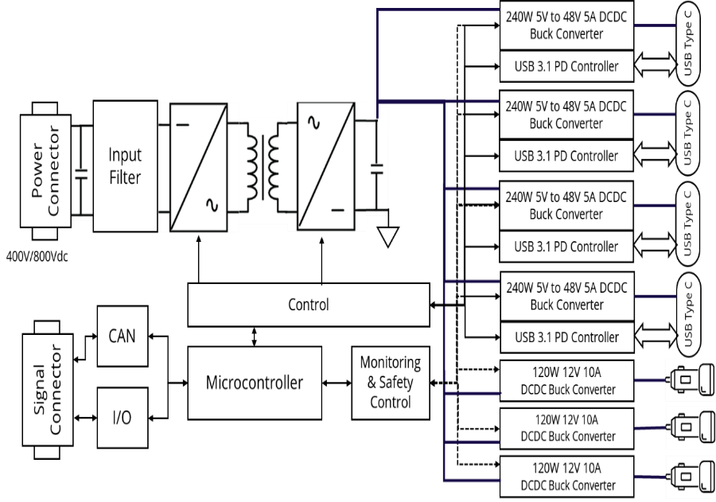
Figure 1 Product specification diagram
Items |  |  | (Target Spec.)
Input |  | High voltage input  (operational range) | Lo : 130～240V  Mid : 144～322V  Hi : 200～428V
 |  | High voltage input (maximum rated) | 650V  The product shall not fail when the Maximum rated voltage is input. (No operation required)
 |  | Low voltage input (operational range) | IG 10～16V
Output | USB | Output Power | Max 240W (48V,5A) / Port  (supports PD3.1 standard or higher)
 |  | Output Port | 4 Ports
 |  | Communication | USB-CC
 | 12V | Output Current | Max 10A / Port
 |  | Output Voltage | 13±1.0V
 |  | Output Port | 3 Ports
 |  | Output Current Limit | Each Port can be configured by microcontroller
 | System total Output Power |  | Max 1350W
Isolation |  | Insulation resistance | 40MΩ or more at DC1000V (HV-GND)
 |  | Withstand voltage | AC2500V 1min (DC input-GND, DC input- USB output, DC input- ACC output)
Communication to vehicle |  |  | CAN 2.0B
Cooling system |  |  | Fan cooling (Fan speed can be controlled) – reuse from 1500W
Dimensions |  |  | L 195 mm: can be changed (as small as possible)  W 178 mm: fixed  H 45 mm: fixed  (Baseline from 1500W)
Ambient temperature |  |  | -30℃~65℃
Table 1 Product specification requirement

High-level block diagram
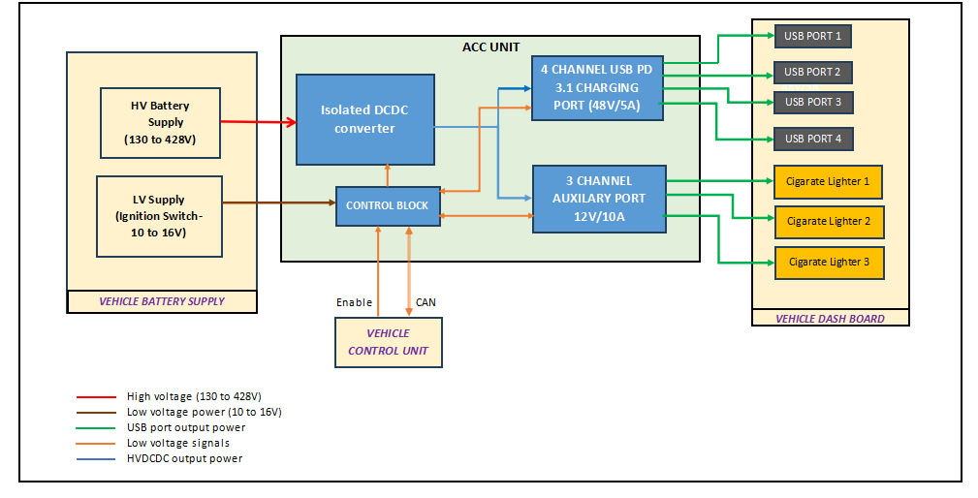
Figure 2 High-level block diagram

Isolated DCDC converter
A HW unit which converts Input voltage
Lo: 130～240V, Mid: 144～322V, Hi: 200～428V to Output voltage of 60VDC.
There is no software control or associated functionality; therefore, it is not covered in this SDD.
The software only monitors the input voltage and current through analog pins

Control block
The MCU (Renesas RH850F1KM-S1) acts as the central messaging centre. It manages the communication with USB-C PD controller, Isolated DCDC converter, and other peripherals using I²C, GPIO and CAN interfaces. The MCU monitors system status, and communicates with the external system via CAN.

4 Channel USB PD3.1 charging port
It takes an Input voltage of 60V and provides Output voltage 5V/9V/12V/15V/20V/28V/36V/48V as required at the PD output
Comprises of 2 sub-sections
USB PD Controller
Buck-Boost Power controls

1.USB PD Controller
USB PD controller negotiates USB Type-C PD contracts and manages CC1/CC2 detection. It manages the Buck-Boost converter and communicates system status and faults to the MCU using I2C. One PD controller manages two Type-C ports hence 2 PD controllers are used for the 4 USB ports
USB PD Controller operations
Talks on CC1/CC2 pins to detect cable orientation, role, and negotiate PD contracts
Requests the Buck-Boost stage to set the required VBUS voltage/current
Reports status/faults over I²C to the MCU

2.Buck-Boost Power controls
Controls the output voltage to USB output as per input of VBUS to 5V/9V/12V/15V/20V/28V/36V/48V
Input: LV+ / LV-
Output: VBUS to USB connector
If LV bus is below required VBUS, it enables the boost circuit
If LV bus is above required VBUS, it enables the buck circuit
So, the port can supply 5V/9V/12V/15V/20V/28V/36V/48V even if LV bus voltage varies.
USB PD + Buck-Boost operations
Precursor
Power-up
5V regulator powers MCU.
MCU keeps port power OFF by default (EN low).
MCU initializes I²C
Set bus speed (100 kHz or 400 kHz typical)

USB PD + Buck-Boost operations
Device plugs in
PD controller detects cable/device using CC1/CC2.
PD negotiation happens on CC (not I²C).
PD contract is established
PD controller now knows the required VBUS.
Power stage is commanded
PD controller directly commands the Buck-Boost controller, and MCU only monitors the same
MCU reads requested voltage/current over I²C

Enable + verify
EN goes active
MCU/PD reads PG (Power Good) feedback
Continuous monitoring
If over-current happens, a fault/OC may trigger.
MCU reads detailed fault messages of PD controller through i2c and sends the fault message on CAN bus.
MCU detects fault of ACC port and disables the Buck converter and additionally sends fault message on CAN bus.

3 Channel Auxiliary port
A HW unit that uses a high-current step-down Buck converter from LV+ to an accessory rail (ACC1–ACC3).
It takes an Input voltage of 60V and provides Output voltage 12V +/- 1 volts, along with maximum current of 10A for (ACC1–ACC3).
There is no software control or functionality and hence it is not covered in this SDD
The software monitors the output voltage and current through GPIO pins and transmits fault status information via the CAN bus.

System block diagram
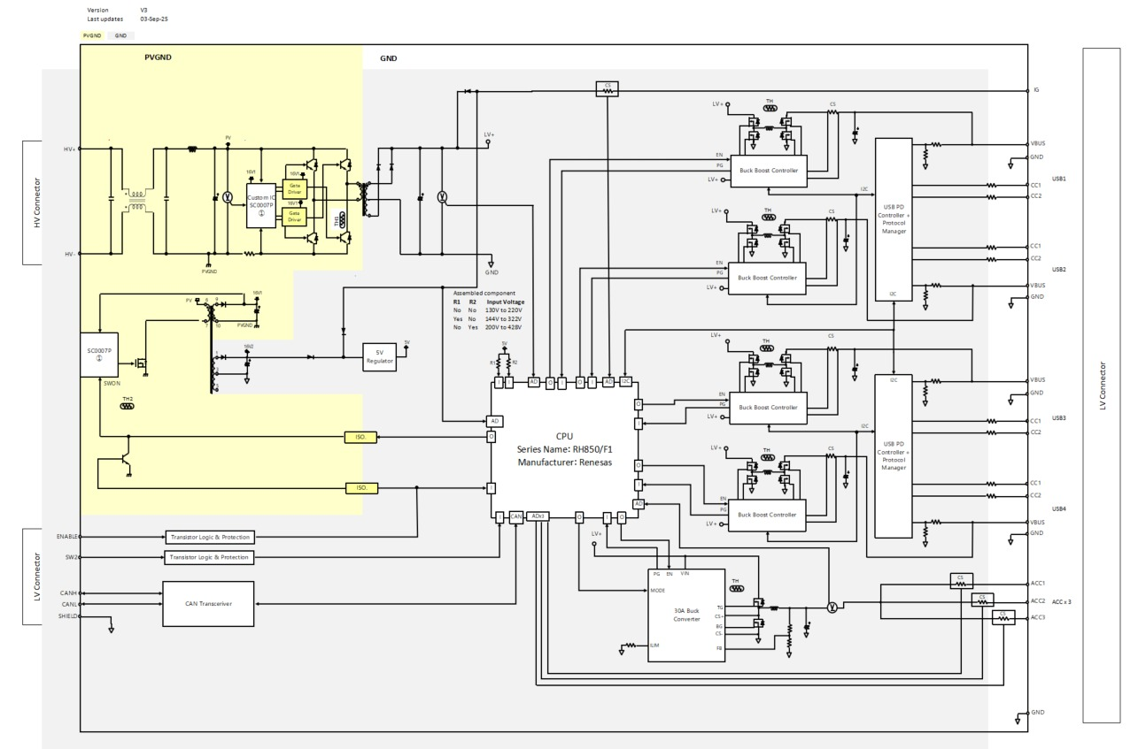
Figure 3 System block diagram

High-level state flow diagram
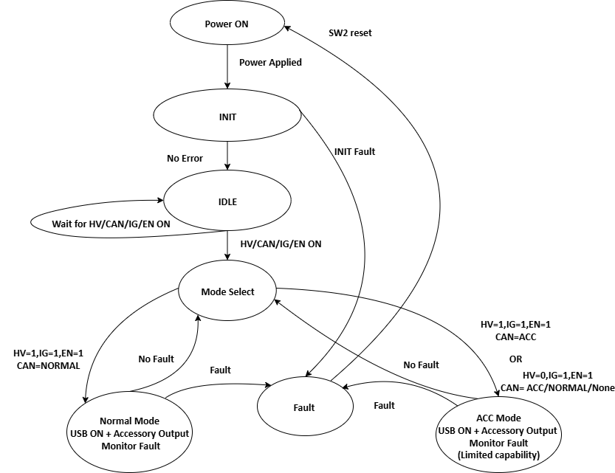
Figure 4 High-level state flow diagram

The controller powers up through a fixed sequence, selects the appropriate mode based on inputs, and operates either in Normal Mode or ACC Mode. Any unsafe electrical condition results in transitioning to the Fault state for protection. Resetting the power restarts the entire sequence.
Power ON (Power Applied)
The system starts when power is applied, initiating the initialization process.
INIT (Initialization)
The system enters the INIT state, performing initialization checks. If no error is detected, the system transitions to the IDLE state. If an error occurs, the system enters the Fault state
.
IDLE
The system is in IDLE mode, waiting for input signals from HV, CAN, IG, and ENABLE to decide which operational mode to enter.
Mode Select
Based on the conditions of HV, CAN, IG, and ENABLE signals, the system decides the mode:
If HV=1, IG=1, EN=1, CAN= NORMAL, the system enters Normal Mode.
If HV=1, IG=1, EN=1, CAN= ACC, the system enters ACC Mode.
If HV=0, IG=1, EN=1, CAN= NORMAL/ACC/None, the system enters ACC Mode.
Normal Mode
The system enters Normal Mode, providing the following functionality:
USB ON: In Normal Mode, USB charging can be enabled and powered by the system.
Accessory Output: The system provides the accessory power output to connected accessories.
If a fault occurs in Normal Mode, the system enters the Fault state.
In case of No fault, the system goes back to mode select.
ACC Mode
The system enters ACC Mode, providing the following functionality:
USB ON: The system enters ACC Mode to charge USB devices.
When USB is ON in ACC Mode, the output power is restricted to reduce power consumption. As a result, USB output capability is limited compared to Normal Mode.
Accessory Output: The system provides the accessory power output to connected accessories.
If any fault is detected in ACC Mode, the system enters the Fault state.
In case of No fault, the system goes back to mode select.
Note: For the respective modes (Normal Mode and ACC Mode) – the details are mentioned in the Chapter 7 – High-level functionality description.

Fault
Fault Handling: The system goes into the fault loop, disables all the outputs, and waits for the reset switch (SW2).

Software components
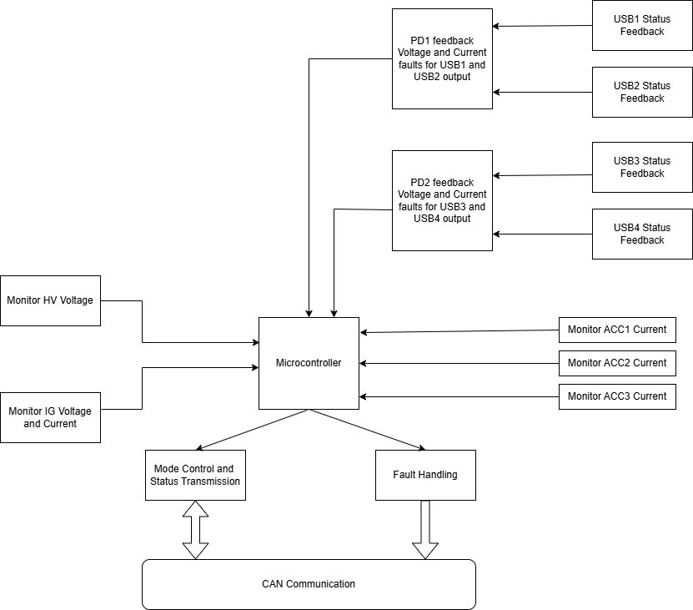
Figure 5 Software components

Software Architecture
Application Layer

Scheduler Layer

Middleware Layer
Hardware Abstraction Layer
Low Level Drivers

Microcontroller unit

Figure 6 Software architecture
Note : Operating system is not used in the USB ACC project.

Application Layer
Responsibilities:
The application layer contains the main software logic for the device, such as control routines and decision-making processes. It uses APIs from lower layers to interact with hardware but does not access hardware directly. Its main jobs are to run control algorithms, manage different operating states, and handle any faults or errors in the system.
Components:
Control logic: Modules for algorithms like decision trees, or rule-based systems to handle system dynamics.
State machines: Structures to oversee modes and state transitions triggered by events or conditions, maintaining system coherence.
Fault handling: Detects and responds to lower-layer errors through logging, alerts, or safe fallback actions to maintain safety compliance.

Scheduler Layer
Responsibilities:
The scheduler layer manages task execution, resource allocation, and timing in real-time embedded systems, ensuring deterministic behaviours by prioritizing tasks. It handles interrupts and scheduling policies like priority-based or round-robin to meet deadlines in constrained environments.
Components:
Scheduler algorithms: Implement priority-based or time-slice scheduling to determine task execution order.
Task management services: Include task creation, suspension, resumption, and synchronization primitives.
Interrupt and timer handlers: Manage hardware interrupts and periodic timers to enforce real-time constraints and event-driven responses.

Middleware Layer
Responsibilities:
The middleware layer acts as a bridge between the application layer and lower software layers. It handles diagnostics, data abstraction, and communication processing or filtering, enabling efficient data flow and resource coordination without direct hardware dependencies. This layer supports real-time communication, error handling, and scalability.
Components:
Diagnostic handlers: Manage Diagnostic Trouble Codes (DTCs) as reading or clearing DTCs, and interface with fault detection modules for system health monitoring and recovery.
Data abstraction: Provides decoupled interfaces for data access, including buffers for temporary storage, signal filtering to reduce noise, unit conversions for compatibility, and scaling to normalize values across layers.
Middleware communication: Handles buffering and routing of signals or messages between layers via standardized interfaces.

Hardware Abstraction Layer
Responsibilities:
Provides hardware-independent APIs to access hardware functionalities. Insulates higher layers from direct hardware access, making the software portable across different MCUs.
Components:
Peripheral interfaces: APIs for modules like GPIO, timers, or communication ports to abstract hardware access.
Configuration managers: Routines for initializing and setting up devices.
Resource access controls: Mechanisms for safe, shared hardware usage, including interrupts for efficient data handling.

Low Level Drivers
Responsibilities:
Low-level drivers handle direct peripheral control through register manipulation and interrupt management. They ensure precise timing, data integrity, and fault prevention in resource-limited settings, forming the bridge to physical hardware.
Components:
Peripheral specific modules: Code for individual devices, such as I/O readers, managing registers and signals like data polling or error detection.
Error and optimization utilities: Built-in checks for exceptions and performance tweaks to minimize latency in critical paths.

High-level functionality description

System Initialization
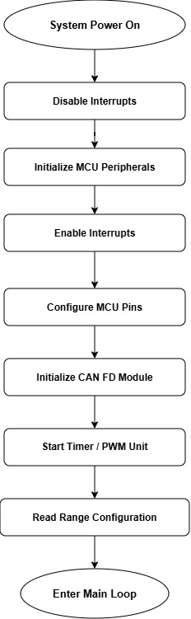
Figure 7 System initialization

Description:
When the MCU powers on or resets, the system executes a fixed, sequential initialization sequence before entering the main loop. The purpose is to configure all hardware peripherals, communication interfaces, and read hardware configuration inputs so the system is ready for real-time operation.
Step 1 — Disable Interrupts
Function: r_main_userinit() → internally calls DI()
Process: The MCU disables all maskable interrupts to ensure no ISR fires while peripherals are being configured.
Step 2 — Initialize MCU Core Peripherals
Function: r_main_userinit() → internally calls R_Systeminit()
Process: This Renesas Smart Configurator generated function initializes the MCU clock tree, watchdog timer, port default states, ADC module (ADCA0), I2C module (RIIC0), and timer module (TAUD0). All peripheral registers are written to their configured values.
Step 3 — Re-enable Interrupts
Function: r_main_userinit() → internally calls EI()
Process: Interrupts are re-enabled so the 5ms timer tick ISR and I2C completion ISR can begin operating normally.
Step 4 — Configure MCU Pins
Function: main() → calls R_Pins_Create()
Process: Sets the direction (input/output), pull-up/pull-down, and alternate function for every GPIO pin used in the system. This includes:
Output pins: Buck enable (P0_7), Buck-Boost channels 1-4 (P0_1 to P0_4), HV enable (P0_13)
Input pins: Switch (P8_4), Enable signal (P10_7), Power Good signals (P10_4, P10_5, P10_15, P10_0), MCU_REG_1 (P0_8), MCU_REG_2 (P0_9)
Step 5 — Initialize CAN FD Communication
Function: main() → calls R_RSCAN0FD_Init()
Process: Configures the RSCAN0 CAN FD module with baud rate settings, acceptance filters, transmit buffers, and receive buffers. After this call, the CAN controller is ready to send and receive frames on Channel 3.
Step 6 — Start Timer / PWM Unit
Function: main() → calls R_Config_TAUD0_Start()
Process: Starts the TAUD0 timer unit which provides:
A periodic 5ms interrupt that sets the Operation_5ms flag (used by the main loop for sensor sampling)
PWM output on CDR10 register for fan speed control via Pwm_Set_Duty_Percent()
Step 7 — Read Hardware Range Configuration
Function: main() → calls Read_R1_R2_Digital_Signal()
Process: Reads two digital input pins to determine the system's voltage operating range:
Reads PORT.PPR0 bit 8 → updates mcu_reg_1 (0 or 1)
Reads PORT.PPR0 bit 9 → updates mcu_reg_2 (0 or 1)
These values are later used by Main_Routine() to set under_voltage and over_voltage thresholds
Step 8 — Enter Main Loop
After all initialization is complete, execution enters the infinite main loop.
Calling Hierarchy
main()
├── r_main_userinit()
│ ├── DI() — Disable interrupts
│ ├── R_Systeminit() — Init clocks, ADC, I2C, timers
│ └── EI() — Enable interrupts
├── R_Pins_Create() — Configure all GPIO
├── R_RSCAN0FD_Init() — Init CAN FD
├── R_Config_TAUD0_Start() — Start timer/PWM
├── Read_R1_R2_Digital_Signal() — Read range config pins
└── for(;;) { ... } — Enter main loop [PHASE 4: change to while(TRUE)]

Main Routine
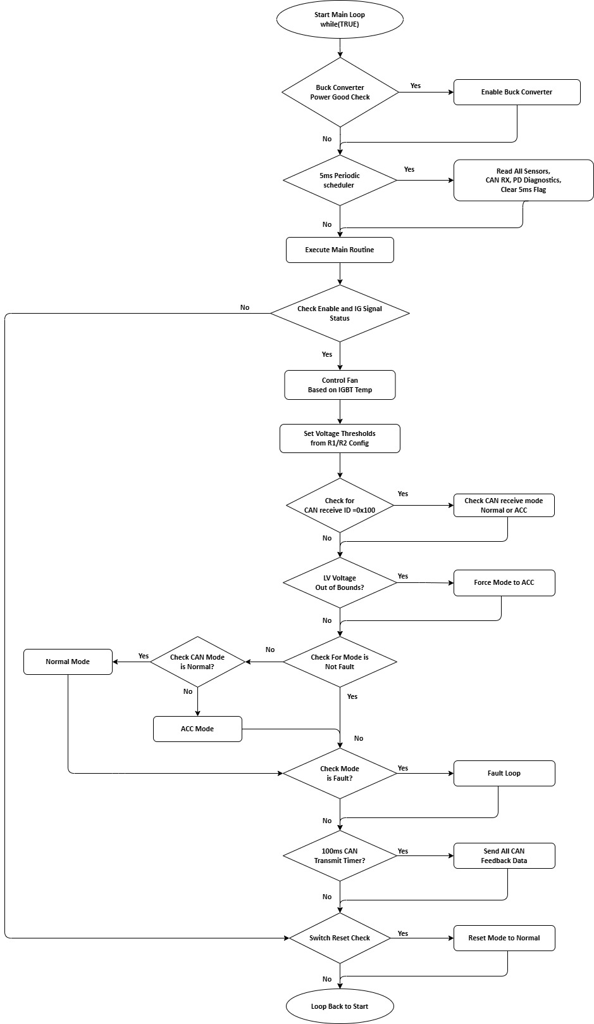
Figure 8 Main Routine

Main Loop & Main_Routine
The main loop runs continuously. On every iteration it checks two conditions: whether the buck converter's power-good signal is active, and whether the 5ms periodic timer has completed. When the 5ms flag is set, it reads all system sensors and inputs. Then it calls Main_Routine() which is the decision control — it evaluates enable/IG conditions, manages fan control, determines the operating mode (Normal, ACC, or Fault), and periodically sends CAN feedback.
Step-by-Step Process
Step 1 — Buck Converter Power Good Check
Condition: pg_buck_converter == 1
Function called: Enable_Buck_converter()
Internal operation: Sets GPIO PORT.P0bit 7 HIGH to enable the main 12V buck converter output
Purpose: Ensures the buck converter stays enabled whenever its PG signal is valid
Note: Due to pg_buck_converter never being updated (see Section 7.3, Step 6 correction), this condition is currently always false and Enable_Buck_converter()is never called from the main loop PG check path.
Step 2 — 5ms Periodic Sensor Sampling
Condition: Operation_5ms == 1(set by TAUD0 timer ISR every 5ms)
Function called: Count_5ms_Operation()
Internal operations — this function calls the following sub-functions in sequence:
2a. Read_IG_Current()
Calls: R_Config_ADCA0_ScanGroup1_Start()→ R_Config_ADCA0_ScanGroup1_OperationOn()→ R_Config_ADCA0_ScanGroup1_GetResult(adc_data, 10)
Process: Reads ADC channel 8, converts raw count to voltage using (adc_data[8] / 4095) × 5.0V, then calculates current using (voltage - 2.5V) / 0.0667 + 0.30A. Clamps negative values to 0.
Fault logic (current code, line 818): If ai_ig_current <= current_limit AND mode == mode_acc, increments count_100ms; if counter reaches 20 (100ms), sets g_ig_overcurrent_fault = 1 and transitions to mode_fault.
[PHASE 4 — CODE CORRECTION C-01, CRITICAL]:The comparison operator is inverted. Current code uses <=which triggers the over current fault when current is at or below the limit (i.e., during normal operation). This must be changed to >=so the fault only triggers when current exceeds the 10A limit. [PHASE 4 — SDD UPDATE]:SDD already states ai_ig_current >= 10A(correct). No SDD change needed; the code will be updated to match.
2b. Read_Current_Sensors() — calls three sub-functions:
Read_ACC1_Current_Sense(): Reads ADC channel 2, computes current same formula. If ai_acc1_current >= 10Afor 10ms (count reaches 2), calls Disable_Buck_converter()and sets g_acc1_overcurrent_fault = 1
Read_ACC2_Current_Sense(): Reads ADC channel 3, same OCP logic → g_acc2_overcurrent_fault
Read_ACC3_Current_Sense(): Reads ADC channel 4, same OCP logic → g_acc3_overcurrent_fault
2c. Read_Voltage_Sensors() — calls three sub-functions:
Read_12V_Voltage_Sense(): Reads ADC channel 0, converts using (adc_data[0] × 5.0 / 4095) / 0.03356to get actual 12V rail voltage. If ai_mcu_12V_vtg < 12V, sets g_usb_dcdc_fault = 1.
Note: The fault flag is only set, never cleared when voltage recovers.
Read_LV_Voltage_Sense(): Reads ADC channel 1, same voltage divider formula → updates ai_mcu_lv_vtg.
Note: Current code contains placeholder voltage range checks with empty bodies Read_IG_Voltage_Sense(): Reads ADC channel 9, same formula → updates ai_mcu_ig_vtg
PHASE 4 — CODE CORRECTION :Read_LV_Voltage_Sense()contains dead placeholder code (empty ifblocks and a stray {...}. This dead code must be removed. The actual LV range check belongs in Main_Routine()(see Step 3d).
PHASE 4 — SDD UPDATE:Add note in SDD Section 9.2.11 that g_usb_dcdc_fault is cleared when voltage returns above 12V. Add note in SDD Section 9.2.10 that Read_LV_Voltage_Sense()only updates the global variable; range checking is performed by Main_Routine().
2d. Read_Temperature_Sensors() — calls three sub-functions:
Read_Buck_Temperature_Sense(): Reads ADC channel 5, computes NTC resistance from voltage divider R_ntc = 6200 × (V_adc / (5.0 - V_adc)), then applies Beta equation T = 1 / (1/298.15 + (1/4360) × ln(R_ntc/100000))to get temperature in °C → updates buck_temp_c
Read_IGBT_Temperature_Sense(): Reads ADC channel 6, same NTC calculation → updates igbt_temp_c
Read_Flyback_Temperature_Sense(): Reads ADC channel 7, same NTC calculation → updates flyback_temp_c
2e. Read_Switch_Signal()
Reads GPIO PORT.PPR8bit 4; if LOW (active) → mcu_sw2 = 1, else mcu_sw2 = 0
2f. Read_Enable_Signal()
Reads GPIO PORT.PPR10bit 7; if LOW (active) → enable_signal = 1, else enable_signal = 0
2g. Receive_CAN_data()
Calls Canfd_ReadRxBuffer(&rx_frame)to copy latest received CAN frame into rx_framestruct
2h. Read_IG_Signal()
Checks if ai_mcu_ig_vtgis between 12V and 16V; if yes → ig_signal = 1, else → ig_signal = 0
2i. Get_MPF52000_diagnostics()
Calls MPF_Read16(0x26, 0x12)→ reads PD0 Port0 status register via I2C; extracts OCP/OVP/OTP bits → updates g_usb1_power_fault
Calls MPF_Read16(0x26, 0x32)→ PD0 Port1 → updates g_usb2_power_fault
Calls MPF_Read16(0x27, 0x12)→ PD1 Port0 → updates g_usb3_power_fault
Calls MPF_Read16(0x27, 0x32)→ PD1 Port1 → updates g_usb4_power_fault
Each MPF_Read16()internally calls R_Config_RIIC0_Master_Send()then R_Config_RIIC0_Master_Receive()with blocking wait on riic0_slave_receiveend_flag
2j. Increments count100ms_CAN++ and clears Operation_5ms = 0
Step 3 — Main_Routine() Execution
Function called: Main_Routine()
Gate condition: enable_signal == ONAND ig_signal == 1— if either is false, the entire routine is skipped
3a. Fan Control
Function: Control_Fan()
Process: Reads igbt_temp_cand computes fan PWM duty:
≤ 65°C→ duty = 0% (fan OFF)
66°C – 84°C→ duty = 20% to 99% (linear ramp: 20 + (temp-65) × 80 / 20)
≥ 85°C→ duty = 100%, forces mode = mode_acc
≥ 100°C→ duty = 100%, forces mode = mode_fault
Calls: Pwm_Set_Duty_Percent(duty)which writes TAUD0.CDR10 = period × duty / 100
mathematically, with this formula, the ramp is 4% per degree
3b. Voltage Range Selection
Process: Based on mcu_reg_1and mcu_reg_2values read earlier:
(0,0)→ under=28V, over=48V
(1,0)→ under=26V, over=58V
(0,1)→ under=25V, over=53V
(1,1)→ mode = mode_fault(invalid configuration)
3c. CAN Mode Selection
Condition: rx_frame.ID == 100
Process: If rx_frame.DB[1] == 1→ can_mode = can_mode_normal; else → can_mode = can_mode_acc
3d. LV Voltage Protection Override
NOT IMPLEMENTED in current code — The code proceeds directly from CAN mode selection (Step 3c) to mode dispatch (Step 3e) without checking whether ai_mcu_lv_vtgis within the validunder_voltage, over_voltage]range.
PHASE 4 — CODE CORRECTION C-05, HIGH PRIORITY]:Add LV voltage protection override after CAN mode decode. Required logic: c if ((mode != mode_fault) && (over_voltage > under_voltage) && ((ai_mcu_lv_vtg < under_voltage) || (ai_mcu_lv_vtg > over_voltage))) { can_mode = can_mode_acc; } This prevents Normal Mode operation at unsafe LV voltage levels.
[PHASE 4 — SDD UPDATE]:SDD Section 7.2 step 3d already describes this correctly. No SDD text change needed; the code will be updated to match.
3e. Mode Dispatch
Current code behavior (no fault-mode guard):
can_mode == can_mode_normal→ sets mode = mode_normal, calls Normal_Mode()
else → sets mode = mode_acc, calls ACC_Mode()
After mode execution: checks if (mode == mode_fault)→ calls Fault_loop()
Issue: The mode dispatch does not check whether mode is already mode_fault before overwriting it. If Control_Fan()(Step 3a) or the R1/R2 configuration check (Step 3b) sets mode = mode_fault, the mode dispatch immediately overwrites it with mode_normal or mode_acc.
PHASE 4 — CODE CORRECTION ]:Wrap the Normal/ACC mode dispatch inside if (mode != mode_fault)so that a fault state set by Control_Fan()or R1/R2 validation is not overwritten: c if (mode != mode_fault) { if (can_mode == can_mode_normal) { mode = mode_normal; Normal_Mode(); } else { mode = mode_acc; ACC_Mode(); } } if (mode == mode_fault) { Fault_loop(); }
PHASE 4 — SDD UPDATE]:SDD Section 7.2 mode dispatch already describes the guarded behavior correctly. No SDD text change needed; the code will be updated to match.
3f. Periodic CAN Transmission
Condition: count100ms_CAN == 20(every 100ms)
Function: Send_CAN_Data()— internally calls:
Send_Fault_Status()→ transmits CAN ID 0x200with 12 packed fault bits
Send_Usb_Pd_Status()→ transmits CAN ID 0x104with USB PD fault flags
Send_USB_PD_Current_Feedback()→ calls Read_UsbPd_NegotiatedCurrent()(4× MPF_Read16), converts mA→A, transmits CAN ID 0x103
Send_Current_Sensors_Feedback()→ transmits CAN ID 0x101with ACC1/ACC2/ACC3/IG current + usb_set_current
Send_Temperature_Sensors_Feedback()→ transmits CAN ID 0x102with flyback/IGBT/buck temperatures
PHASE 4 — CODE CORRECTION C-02, CRITICAL]:Send_Temperature_Sensors_Feedback()(lines 1783–1785) incorrectly clamps all three temperature values against ai_acc1_current(a current variable) instead of the individual temperature variables, and casts to UI8instead of UI16. Corrected code: c flyback = (flyback_temp_c > 255U) ? 255U : (UI16)flyback_temp_c; igbt = (igbt_temp_c > 255U) ? 255U : (UI16)igbt_temp_c; buck = (buck_temp_c > 255U) ? 255U : (UI16)buck_temp_c; PHASE 4 — SDD UPDATE]:Update SDD Section 9.5.6 / Table 45 to explicitly state each temperature variable must be individually clamped and cast to UI16for 2-byte CAN packing.
Step 4 — Switch Reset Check
Condition: mcu_sw2 == 1(switch pressed)
Action: mode = mode_normal— allows manual recovery from fault state
Step 5 — Read Temperature Sensors (additional call)
Current code calls Read_Temperature_Sensors()at the end of every main loop iteration, outside the 5ms scheduler, in addition to the call inside Count_5ms_Operation().
PHASE 4 — CODE CORRECTION C-08]:Remove the extra Read_Temperature_Sensors()call from line 430 of the main loop body. Temperature sensors should only be read inside Count_5ms_Operation()(Step 2d) to maintain a consistent 5ms sampling rate. The extra call causes temperature reads at an uncontrolled rate and wastes CPU/ADC cycles.
PHASE 4 — SDD UPDATE]:SDD Section 7.2 does not mention this extra call — it correctly describes temperature reading only within the 5ms task. No SDD change needed; the code will be updated to match.
────────────────────────────────────────────────────────────────────────────────
Calling Hierarchy (as implemented in r_cg_main.c)
for(;;) [PHASE 4: change to while(TRUE)]
├── Enable_Buck_converter() — if pg_buck_converter == 1 (currently always false)
├── Count_5ms_Operation() — every 5ms
│ ├── Read_IG_Current() [PHASE 4: fix <= to >=]
│ │ ├── R_Config_ADCA0_ScanGroup1_Start()
│ │ ├── R_Config_ADCA0_ScanGroup1_OperationOn()
│ │ └── R_Config_ADCA0_ScanGroup1_GetResult()
│ ├── Read_Current_Sensors()
│ │ ├── Read_ACC1_Current_Sense() — ADC ch2, OCP → Disable_Buck_converter()
│ │ ├── Read_ACC2_Current_Sense() — ADC ch3, OCP → Disable_Buck_converter()
│ │ └── Read_ACC3_Current_Sense() — ADC ch4, OCP → Disable_Buck_converter()
│ ├── Read_Voltage_Sensors()
│ │ ├── Read_12V_Voltage_Sense() — ADC ch0 → g_usb_dcdc_fault [PHASE 4: add else-clear]
│ │ ├── Read_LV_Voltage_Sense() — ADC ch1 [PHASE 4: remove dead code]
│ │ └── Read_IG_Voltage_Sense() — ADC ch9
│ ├── Read_Temperature_Sensors()
│ │ ├── Read_Buck_Temperature_Sense() — ADC ch5, NTC Beta eq
│ │ ├── Read_IGBT_Temperature_Sense() — ADC ch6, NTC Beta eq
│ │ └── Read_Flyback_Temperature_Sense() — ADC ch7, NTC Beta eq
│ ├── Read_Switch_Signal() — GPIO P8_4
│ ├── Read_Enable_Signal() — GPIO P10_7
│ ├── Receive_CAN_data()
│ │ └── Canfd_ReadRxBuffer()
│ ├── Read_IG_Signal() — validate 12V-16V
│ └── Get_MPF52000_diagnostics()
│ └── MPF_Read16() × 4
│ ├── R_Config_RIIC0_Master_Send()
│ └── R_Config_RIIC0_Master_Receive()
├── Main_Routine()
│ ├── Control_Fan()
│ │ └── Pwm_Set_Duty_Percent()
│ ├── [Voltage threshold logic — R1/R2]
│ ├── [CAN mode parsing — ID 100]
│ ├── [LV voltage override] — NOT IMPLEMENTED [PHASE 4: add guard]
│ ├── Normal_Mode() OR ACC_Mode() — NO fault guard [PHASE 4: add if(mode!=fault)]
│ ├── Fault_loop() — if mode == mode_fault
│ └── Send_CAN_Data() — every 100ms
│ ├── Send_Fault_Status() → CAN 0x200
│ ├── Send_Usb_Pd_Status() → CAN 0x104
│ ├── Send_USB_PD_Current_Feedback() → CAN 0x103
│ │ └── Read_UsbPd_NegotiatedCurrent()
│ │ └── MPF_Read16() × 4
│ ├── Send_Current_Sensors_Feedback() → CAN 0x101
│ └── Send_Temperature_Sensors_Feedback()→ CAN 0x102 [PHASE 4: fix clamp vars]
├── [mcu_sw2 reset check]
└── Read_Temperature_Sensors() — EXTRA call [PHASE 4: remove]

Normal Mode
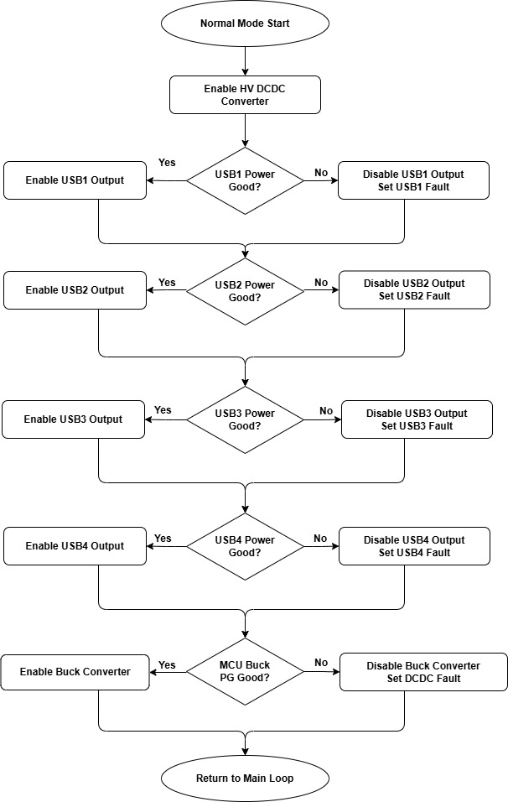
Figure 9 Normal Mode

Normal Mode
Normal Mode is the full-power operating state. The HV DCDC converter is enabled, all four USB ports are individually managed based on their Power Good (PG) signals, and the main buck converter is also controlled by its PG pin. Each USB channel uses a dedicated Read_Power_GoodX_Signal() function that reads a GPIO input, enables/disables the corresponding buck-boost output, and updates the fault flag.
Step-by-Step Process
Step 1 — Enable High Voltage DCDC
Function: Enable_HV()
Internal operation: Sets PORT.P0 bit 13 HIGH
Purpose: Powers on the HV domain which supplies the USB buck-boost converters
Step 2 — USB1 Power Good Check
Function: Read_Power_Good1_Signal()
Process: Reads GPIO PORT.PPR10 bit 4
If LOW (PG active) → calls Buck_Boost_Enable(1) which sets PORT.P0 bit 1 HIGH, and sets usb1_pd_fault = 0
If HIGH (PG inactive) → calls Buck_Boost_Disable(1) which sets PORT.P0 bit 1 LOW, and sets usb1_pd_fault = 1
Step 3 — USB2 Power Good Check
Function: Read_Power_Good2_Signal()
Process: Reads GPIO PORT.PPR10 bit 5
If LOW → calls Buck_Boost_Enable(2) (P0_2 HIGH), usb2_pd_fault = 0
If HIGH → calls Buck_Boost_Disable(2) (P0_2 LOW), usb2_pd_fault = 1
Step 4 — USB3 Power Good Check
Function: Read_Power_Good3_Signal()
Process: Reads GPIO PORT.PPR10 bit 15
If LOW → calls Buck_Boost_Enable(3) (P0_3 HIGH), usb3_pd_fault = 0
If HIGH → calls Buck_Boost_Disable(3) (P0_3 LOW), usb3_pd_fault = 1
Step 5 — USB4 Power Good Check
Function: Read_Power_Good4_Signal()
Process: Reads GPIO PORT.PPR10 bit 0
If LOW → calls Buck_Boost_Enable(4) (P0_4 HIGH), usb4_pd_fault = 0
If HIGH → calls Buck_Boost_Disable(4) (P0_4 LOW), usb4_pd_fault = 1
Note: Current code on line 1367 has a double semicolon: Buck_Boost_Enable(4);; ⚠️PHASE 4 — CODE CORRECTION C-12]: Remove the extra semicolon.
Step 6 — Main Buck Converter PG Check
Function: Read_MCU_Buck_PG_Signal()
Process: Reads GPIO PORT.PPR0 bit 7
If LOW (PG active) → calls Enable_Buck_converter() (P0_7 HIGH), sets g_acc_dcdc_fault = 0
If HIGH (PG inactive) → calls Disable_Buck_converter() (P0_7 LOW), sets g_acc_dcdc_fault = 1
Note: Current code does not update pg_buck_converter in either branch.
PHASE 4 — CODE CORRECTION C-06, HIGH PRIORITY]: Add pg_buck_converter = 1U in the PG-active branch and pg_buck_converter = 0U in the PG-inactive branch. Without this update, pg_buck_converter remains at its initial value (0) and the main loop's buck converter PG check (Step 1 of Section 7.2) will never enable the buck converter via that path.
[PHASE 4 — SDD UPDATE]: SDD Section 7.3 already correctly states sets pg_buck_converter = 1 and sets pg_buck_converter = 0. No SDD change needed; the code will be updated to match.
Step 7 — Return to Main Loop
Calling Hierarchy
Normal_Mode()
├── Enable_HV() — P0_13 HIGH
├── Read_Power_Good1_Signal() — P10_4
│ ├── Buck_Boost_Enable(1) OR Buck_Boost_Disable(1) — P0_1
│ └── [update usb1_pd_fault]
├── Read_Power_Good2_Signal() — P10_5
│ ├── Buck_Boost_Enable(2) OR Buck_Boost_Disable(2) — P0_2
│ └── [update usb2_pd_fault]
├── Read_Power_Good3_Signal() — P10_15
│ ├── Buck_Boost_Enable(3) OR Buck_Boost_Disable(3) — P0_3
│ └── [update usb3_pd_fault]
├── Read_Power_Good4_Signal() — P10_0 [PHASE 4: fix ;; typo]
│ ├── Buck_Boost_Enable(4) OR Buck_Boost_Disable(4) — P0_4
│ └── [update usb4_pd_fault]
└── Read_MCU_Buck_PG_Signal() — P0_7
├── Enable_Buck_converter() OR Disable_Buck_converter()
└── [update g_acc_dcdc_fault] — pg_buck_converter NOT updated [PHASE 4: add]

ACC Mode

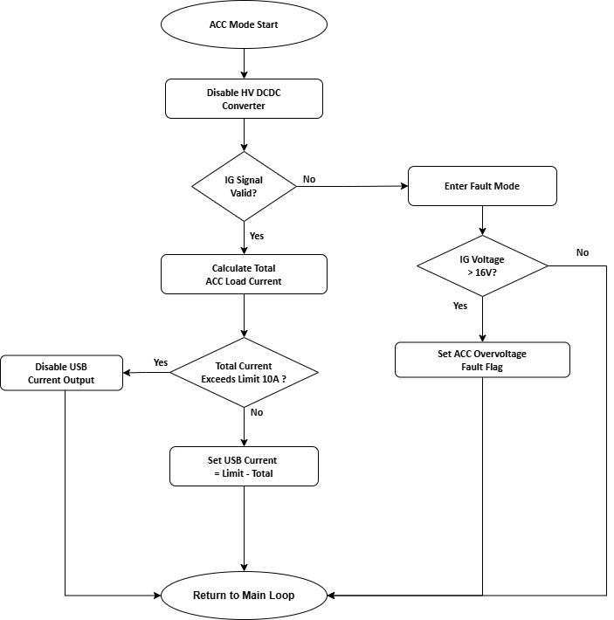
Figure 10 ACC Routine

ACC Mode
ACC (Accessory) Mode is a reduced-power state where the HV DCDC converter is turned off to conserve energy. The system monitors the IG (ignition) signal voltage and manages current sharing between the three ACC output channels and USB ports. The total current budget is capped at 10A (current_limit). Whatever current the ACC channels consume is subtracted from the available budget for USB ports. If IG voltage goes out of range, the system transitions to Fault mode.
Step-by-Step Process
Step 1 — Disable High Voltage DCDC
Function: `Disable_HV()`
Internal operation: Sets `PORT.P0` bit 13 LOW
Purpose: Cuts off the HV power domain to reduce power consumption in ACC mode
Step 2 — Validate IG Signal
Condition: `ig_signal == 1` (IG voltage is between 12V and 16V, checked earlier by `Read_IG_Signal()`)
If YES → proceed to current budgeting (Step 3)
If NO → go to fault path (Step 6)
Step 3 — Calculate Total ACC Load Current
Process: `acc_total_current = ai_acc1_current + ai_acc2_current + ai_acc3_current`
These values were computed during `Count_5ms_Operation()` by `Read_ACC1_Current_Sense()`, `Read_ACC2_Current_Sense()`, and `Read_ACC3_Current_Sense()` using ADC channels 2, 3, and 4
Step 4 — Check Against Current Limit
Condition: `acc_total_current >= current_limit` (10A)
If YES → `usb_set_current = 0` — no current budget remains for USB ports
If NO → proceed to Step 5
Step 5 — Compute Remaining USB Current Budget
Process: `usb_set_current = current_limit - acc_total_current`
Clamping: If `usb_set_current > 255` → clamp to `255` (UI8 maximum)
Otherwise: Cast to `UI8` type
Note: In current code (line 1542), `usb_set_current` is declared as a local variable (`UI32 usb_set_current;`) inside `ACC_Mode()`. This shadows the static global `usb_set_current` that is used by `Send_Current_Sensors_Feedback()`. As a result, the computed value is stored in the local variable which goes out of scope when the function returns, and the global `usb_set_current` remains at 0.
**⚠️PHASE 4 — CODE CORRECTION C-03, CRITICAL]:** Remove the local `UI32 usb_set_current;` declaration on line 1542 of `rmain.c`. The function must write directly to the global `usb_set_current` so that the computed USB current budget is transmitted correctly in CAN ID `0x101` byte 4. Without this fix, byte 4 always transmits 0 regardless of actual ACC load. **📝PHASE 4 — SDD UPDATE]:** SDD Section 7.4 correctly states "This value is later transmitted via CAN ID 0x101 byte 4". Add clarification that `usb_set_current` must be the global (module-scope) variable, not a local.
Step 6 — Fault Path (IG Signal Invalid)
Action: `mode = mode_fault` — system transitions to fault state
Additional check: If `ai_mcu_ig_vtg > 16V` → sets `g_acc_overvoltage_fault = 1` (IG overvoltage detected)
This fault flag is packed into bit 3 of CAN ID `0x200` by `Send_Fault_Status()`
Step 7 — Return to Main Loop
Calling Hierarchy
ACC_Mode()
├── Disable_HV() — P0_13 LOW
├── [Check ig_signal]
│ ├── YES path:
│ │ ├── [Calculate acc_total_current]
│ │ ├── [Compare against current_limit]
│ │ └── [Set usb_set_current] — writes to LOCAL variable [PHASE 4: remove local decl]
│ └── NO path:
│ ├── mode = mode_fault
│ └── [Check ai_mcu_ig_vtg > 16V]
│ └── g_acc_overvoltage_fault = 1
└── return

Fault Loop
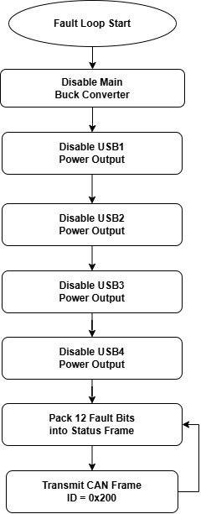
Figure 11 Fault Loop

Process Description
The Fault Loop is the system's emergency shutdown handler. When any fault condition triggers mode = mode_fault (overcurrent, overvoltage, overtemperature, or invalid hardware configuration), this function immediately disables all power outputs to protect the hardware and connected devices. It then broadcasts the fault status over CAN so that other ECUs on the network are informed of the failure. The fault loop executes repeatedly on every main loop iteration until the user presses the reset switch (mcu_sw2), which resets mode back to mode_normal.
Fault Conditions That Enter This Loop
ACC Overcurrent (10ms debounce): Any of `Read_ACC1/2/3_Current_Sense()` detects current ≥ 10A for 2 consecutive 5ms samples
IG Overcurrent (100ms debounce): `Read_IG_Current()` — in current code, this triggers when `ai_ig_current <= current_limit` (see [PHASE 4 CORRECTION C-01] in Section 7.2). The intended behavior is ≥ 10A for 20 consecutive 5ms samples while in ACC mode.
IG Overvoltage: `ACC_Mode()` detects `ig_signal == 0` (IG voltage outside 12V–16V range)
Overtemperature: `Control_Fan()` detects `igbt_temp_c >= 100°C` — Note: this fault may be overwritten by the unguarded mode dispatch (see [PHASE 4 CORRECTION C-04] in Section 7.2, Step 3e).
Invalid R1/R2 Config: `Main_Routine()` finds `mcu_reg_1 == 1` AND `mcu_reg_2 == 1` — Note: this fault may also be overwritten by the unguarded mode dispatch.
Step-by-Step Process
Step 1 — Disable Main Buck Converter
Function: `Disable_Buck_converter()`
Internal operation: Sets `PORT.P0` bit 7 LOW
Purpose: Cuts off the main 12V ACC power rail that feeds ACC1/ACC2/ACC3 outputs
Step 2 — Disable USB1 Buck-Boost Channel
Function: `Buck_Boost_Disable(1)`
Internal operation: Switch-case selects channel 1, sets `PORT.P0` bit 1 LOW
Purpose: Cuts power to USB port 1
Step 3 — Disable USB2 Buck-Boost Channel
Function: `Buck_Boost_Disable(2)`
Internal operation: Switch-case selects channel 2, sets `PORT.P0` bit 2 LOW
Purpose: Cuts power to USB port 2
Step 4 — Disable USB3 Buck-Boost Channel
Function: `Buck_Boost_Disable(3)`
Internal operation: Switch-case selects channel 3, sets `PORT.P0` bit 3 LOW
Purpose: Cuts power to USB port 3
Step 5 — Disable USB4 Buck-Boost Channel
Function: `Buck_Boost_Disable(4)`
Internal operation: Switch-case selects channel 4, sets `PORT.P0` bit 4 LOW
Purpose: Cuts power to USB port 4
Step 6 — Transmit Fault Status Over CAN
Function: `Send_Fault_Status()`
Internal operation:
Packs 12 individual fault flags into a 16-bit `status_bits` variable:
Bit 0: `g_acc1_overcurrent_fault` — ACC1 channel overcurrent
Bit 1: `g_acc2_overcurrent_fault` — ACC2 channel overcurrent
Bit 2: `g_acc3_overcurrent_fault` — ACC3 channel overcurrent
Bit 3: `g_acc_overvoltage_fault` — ACC/IG overvoltage
Bit 4: `g_usb1_power_fault` — USB1 PD controller fault (OCP/OVP/OTP)
Bit 5: `g_usb2_power_fault` — USB2 PD controller fault
Bit 6: `g_usb3_power_fault` — USB3 PD controller fault
Bit 7: `g_usb4_power_fault` — USB4 PD controller fault
Bit 8: `g_ig_overvoltage_fault` — IG overvoltage
Bit 9: `g_acc_dcdc_fault` — ACC buck DCDC power-good failure
Bit 10: `g_usb_dcdc_fault` — USB 12V rail below 12V
Bit 11: `g_ig_overcurrent_fault` — IG channel overcurrent (100ms)
Builds CAN frame: `tx_frame.ID = 0x200`, `DLC = 8`, Standard ID
Packs `status_bits` into `DataByte[0]` (LSB) and `DataByte[1]` (MSB), remaining bytes zeroed
Calls `R_RSCAN0FD_C3TrmByTxBuf(0, &tx_frame)` to transmit on CAN Channel 3 TX Buffer 0
Recovery: The only way to exit the fault loop is by pressing the hardware switch (mcu_sw2 == 1), which resets mode = mode_normal in the main loop after Main_Routine() returns.
Calling Hierarchy
Fault_loop()
├── Disable_Buck_converter() — P0_7 LOW (main ACC rail off)
├── Buck_Boost_Disable(1) — P0_1 LOW (USB1 off)
├── Buck_Boost_Disable(2) — P0_2 LOW (USB2 off)
├── Buck_Boost_Disable(3) — P0_3 LOW (USB3 off)
├── Buck_Boost_Disable(4) — P0_4 LOW (USB4 off)
└── Send_Fault_Status()
├── [Pack 12 fault bits → status_bits]
├── [Build CAN frame ID=0x200, DLC=8]
└── R_RSCAN0FD_C3TrmByTxBuf(0, &tx_frame) — Transmit on CAN

List of variables
Note: All relevant variables are declared at the global scope and follow MISRA naming conventions. Details regarding variables will be added during the coding and testing phase

ADC INPUT
Sr.no | Variable name | Type | Register value |  | Sensor value |  | ADC resolution |  | Usage
 |  |  | Min value | Max value | Output range | Input range | Sensitivity | ADC value
1 | ai_acc1_current | Unsigned Integer | 0 | 4096 | 0 to 5V | 0 to 30A | 66.7mv/A | 136.53/A | Analog ACC1 current sensor reading
2 | ai_acc2_current | Unsigned Integer | 0 | 4096 | 0 to 5V | 0 to 30A | 66.7mv/A | 136.53/A | Analog ACC2 current sensor reading
3 | ai_acc3_current | Unsigned Integer | 0 | 4096 | 0 to 5V | 0 to 30A | 66.7mv/A | 136.53/A | Analog ACC3 current sensor reading
4 | ai_ig_current | Unsigned Integer | 0 | 4096 | 0 to 5V | 0 to 30A | 66.7mv/A | 136.53/A | Analog IG current sensor reading
5 | flyback_temp_c | Unsigned Integer | 0 | 4096 | 0 to 5V | -40°C to 125°C | 0.030 V/°C | 24.82/°C | ADC reading of the temperature sensor On Fly back CAP
6 | buck_temp_c | Unsigned Integer | 0 | 4096 | 0 to 5V | -40°C to 125°C | 0.030 V/°C | 24.82/°C | ADC reading of the temperature sensor On Buck Temp
7 | igbt_temp_c | Unsigned Integer | 0 | 4096 | 0 to 5V | -40°C to 125°C | 0.030 V/°C | 24.82/°C | ADC reading of the temperature sensor on IGBT Temp
8 | ai_mcu_12V_vtg | Unsigned Integer | 0 | 4096 | 0 to 12V | 0 to 5V | 27.5/V | 0.403V | Analog 12VTG voltage sensor reading Buck output
9 | ai_mcu_lv_vtg | Unsigned Integer | 0 | 4096 | 0 to 12V | 0 to 5V | 27.5/V | 0.403V | Analog LV_VTG voltage sensor reading
10 | ai_mcu_ig_vtg | Unsigned Integer | 0 | 4096 | 0 to 12V | 0 to 5V | 27.5/V | 0.403V | Analog IG_VTG voltage sensor reading
Table 2 List of Analog value variables

General Variables
Sr. No | Variable Name | Type | Value | Usage
11 | under_voltage | Unsigned Integer | — | Used for under-voltage thresholds limit variable
12 | over_voltage | Unsigned Integer | — | Used for over-voltage thresholds limit
13 | count_100ms | Unsigned Integer | — | current value exceed for 100ms
14 | can_mode | Unsigned Integer | — | Normal CAN mode(Initial CAN mode)
15 | adc_data | Unsigned Integer | — | ADC data storage
16 | ig_signal | Unsigned Integer | — | IG voltage present
17 | riic0_slave_receiveend_flag | Unsigned Integer | — | I2C receive flag Wait until send/receive end flag becomes 1
18 | pg_buck_converter | Unsigned Integer | — | Buck converter power is good
19 | g_acc1_overcurrent_fault | Unsigned Char | — | ACC1 over-current fault flag (Fault Status CAN bit 0).
20 | g_acc2_overcurrent_fault | Unsigned Char | — | ACC2 over-current fault flag (Fault Status CAN bit 1).
21 | g_acc3_overcurrent_fault | Unsigned Char | — | ACC3 over-current fault flag (Fault Status CAN bit 2).
22 | g_acc_overvoltage_fault | Unsigned Char | — | ACC over-voltage fault flag (Fault Status CAN bit 3).
23 | g_usb1_power_fault | Unsigned Char | — | USB1 power fault flag (Fault Status CAN bit 4).
24 | g_usb2_power_fault | Unsigned Char | — | USB2 power fault flag (Fault Status CAN bit 5).
25 | g_usb3_power_fault | Unsigned Char | — | USB3 power fault flag (Fault Status CAN bit 6).
26 | g_usb4_power_fault | Unsigned Char | — | USB4 power fault flag (Fault Status CAN bit 7).
27 | g_ig_overvoltage_fault | Unsigned Char | — | IG over-voltage fault flag (Fault Status CAN bit 8).
28 | g_acc_dcdc_fault | Unsigned Char | — | ACC DC-DC converter fault flag (Fault Status CAN bit 9).
29 | g_usb_dcdc_fault | Unsigned Char | — | USB DC-DC converter fault flag (Fault Status CAN bit10).
30 | g_ig_overcurrent_fault | Unsigned Char | — | IG over-current fault flag (Fault Status CAN bit 11).
31 | usb1_pd_fault | Unsigned Integer | — | USB port 1 PD fault status.
32 | usb2_pd_fault | Unsigned Integer | — | USB port 2 PD fault status
33 | usb3_pd_fault | Unsigned Integer | — | USB port 3 PD fault status
34 | usb4_pd_fault | Unsigned Integer | — | USB port 4 PD fault status
35 | acc_total_current | Unsigned Integer | — | Calculate total ACC load current from three ACC channels
36 | usb_set_current | Unsigned Integer | — | USB set current
37 | count_10ms_ACC1 | Unsigned Integer | — | Flag for 10ms operation for ACC1
38 | count_10ms_ACC2 | Unsigned Integer | — | Flag for 10ms operation for ACC2
39 | count_10ms_ACC3 | Unsigned Integer | — | Flag for 10ms operation for ACC3
40 | count100ms_CAN | Unsigned Integer | — | send feedback through CAN periodic 100ms
41 | period | Unsigned Integer | — | Store PWM period value read and determines PWM frequency
Table 3 List of General variables

Digital Output
Sr. No | Variable name | Type | Min value | Max value | Usage
42 | mcu_reg_2 | Unsigned Char | TRUE | FALSE | 1 = mcu_reg_2 digital input signal active
 |  |  |  |  | 0 = mcu_reg_2 digital input signal inactive
43 | mcu_sw2 | Unsigned Char | TRUE | FALSE | 1 = switch active
 |  |  |  |  | 0 = inactive
44 | enable_signal | Unsigned Char | TRUE | FALSE | 1 = enable_signal active
 |  |  |  |  | 0 = inactive
45 | mcu_reg_1 | Unsigned Char | TRUE | FALSE | 1 = mcu_reg_1 digital input signal active
 |  |  |  |  | 0 = mcu_reg_1 digital input signal inactive
46 | mode | system_mode_t | TRUE | FALSE | 1 = DO mode active
 |  |  |  |  | 0 = DO mode inactive
47 | operation_5ms | Unsigned Char | TRUE | FALSE | 1 = 5mS Flag active  0 = 5mS Flag inactive
Table 4 List of Digital Input and Output variables
Note: system_mode_t is Enum (system_mode_t) with values mode_normal(0), mode_acc(1), mode_fault(2).

Communication
Sr.no | Variable name | Type | Min value | Max value | Usage
49 | rx_frame | Canfd_REC_FrameType | 0x00000000 | 0xFFFFFFFF | Buffer to store received CAN message. Holds the CAN decoded data for further processing
50 | tx_frame | Canfd_REC_FrameType | 0x00000000 | 0xFFFFFFFF | Data to transmit CAN message. Holds the CAN decoded data for further processing
Table 5 List of Communication variables

List of functions and descriptions
Note: 1. All relevant functions are declared at the global scope and follow MISRA naming conventions. However, Whether to change naming conventions for Auto generated code to match MISRA rules, will be decided based on consultation with TICO team
Sr. no | Function Name | Return type | Parameter type | Parameter Name | Description
9.1 | Initialization Functions
9.1.1 | void main(void) | void | — | — | Function is the entry point of program. It is where the program starts executing.
9.1.2 | void r_main_userinit(void) | void | — | — | Run user initialization: disable/enable interrupts around system init and prepare MCU runtime before the main loop application logic starts executing
9.2 | Voltage/Current/Temperature reading function
9.2.1 | void Read_ACC1_Current_Sense(void) | void | — | — | Reads ACC1 current sensor via ADC and updates ai_acc1_current.
9.2.2 | void Read_ACC2_Current_Sense(void) | void | — | — | Reads ACC2 current sensor via ADC and updates ai_acc2_current.
9.2.3 | void Read_ACC3_Current_Sense(void) | void | — | — | Reads ACC3 current sensor via ADC and updates ai_acc3_current.
9.2.4 | void Read_IG_Current(void) | void | — | — | Reads IG current sensor via ADC and updates ai_ig_current_a.
9.2.5 | void Read_Current_Sensors(void) | void | — | — | Read all current sensing channels (ACC1/ACC2/ACC3) and update variables.
9.2.6 | void Read_IGBT_Temperature_Sense(void) | void | — | — | Reads IGBT temperature sensor via ADC and updates igbt_temp_c.
9.2.7 | void Read_Flyback_Temperature_Sense(void) | void | — | — | Reads Flyback temperature sensor via ADC and updates flyback_temp_c.
9.2.8 | void Read_Buck_Temperature_Sense(void) | void | — | — | Reads Buck temperature sensor via ADC and updates buck_temp_c.
9.2.9 | void Read_Temperature_Sensors(void) | void | _ | _ | Read all temperature sensing channels and update temperature variables.
9.2.10 | void Read_LV_Voltage_Sense(void) | void | — | — | Reads LV voltage via ADC and updates ai_mcu_lv_vtg.
9.2.11 | void Read_12V_Voltage_Sense(void) | void | — | — | Reads 12V voltage via ADC and updates ai_mcu_12V_vtg.
9.2.12 | void Read_IG_Voltage_Sense(void) | void | — | — | Reads IG voltage via ADC and updates ai_mcu_ig_vtg.
9.2.13 | void Read_Voltage_Sensors(void) | void | — | — | Read all voltage sensing channels (LV, 12V, IG) and update variables
9.2.14 | void Read_Enable_Signal(void); | void | — | — | Reads ENABLE input pin and updates enable_signal status.
9.2.15 | void Read_IG_Signal(void) | void | — | — | Reads IG voltage range (12–16 V) and updates IG_Signal status.
9.2.16 | void Read_R1_R2_Digital_Signal(void) | void | — | — | Reads R1 and R2 input pins and updates mcu_reg_1 and mcu_reg_2 status.
9.2.17 | void Read_Power_Good1_Signal(void) | void | — | — | Reads USB1 PG input and updates BuckBoost1 output and usb1_pd_fault status.
9.2.18 | void Read_Power_Good2_Signal(void) | void | — | — | Reads USB2 PG input and updates BuckBoost2 output and usb2_pd_fault status.
9.2.19 | void Read_Power_Good3_Signal(void) | void | — | — | Reads USB3 PG input and updates BuckBoost3 output and usb3_pd_fault status.
9.2.20 | void Read_Power_Good4_Signal(void) | void | — | — | Reads USB4 PG input and updates BuckBoost4 output and usb4_pd_fault status.
9.2.21 | void Read_MCU_Buck_PG_Signal(void) | void | — | — | Reads Buck converter Power-Good (PG) input and controls Buck converter output.
9.2.22 | void Read_Switch_Signal(void) | void | — | — | Read switch input pin and update mcu_sw2 state
9.2.23 | void Read_UsbPd_NegotiatedCurrent (UI16 *u1, UI16 *u2, UI16 *u3, UI16 *u4) | Void | Unsigned Short pointer(UI16*) | (u1,u2,u3,u4) | Read negotiated USB-PD output current for USB1–USB4 from MPF52000 controllers.
9.3 | Mode Management function
9.3.1 | void Main_Routine(void) | void | — | — | Main control logic: mode selection, checks, control outputs, send CAN.
9.3.2 | void Normal_Mode(void) | void | — | — | Actions that are executed in Normal mode.
9.3.3 | void ACC_Mode(void) | void | — | — | Actions that are executed in ACC mode.
9.3.4 | void Fault_loop(void) | void | — | — | Fault handling: disable outputs and repeatedly send fault status.
9.4 | Status and Diagnostics Functions
9.4.1 | void Get_MPF52000_Diagnostics(void); | void | — | — | Retrieves chip-level faults, voltage, current, and internal register data for analysis.
9.4.2 | UI16 MPF_Read16(UI8 dev, UI8 reg) | Unsigned Short(UI16) | Unsigned Char(UI8) | (dev, reg) | Read 16-bit MPF register via I2C
9.5 | CAN communication functions
9.5.1 | void Send_CAN_Data(void) | void | — | — | Transmit a CAN frame
9.5.2 | void Receive_CAN_data(void) | void | — | — | Read received CAN frame
9.5.3 | void Send_Usb_Pd_Status(void) | void | — | — | Pack USB port PD fault/status flags into CAN frame and transmit.
9.5.4 | void Send_USB_PD_Current_Feedback(void) | void | — | — | Pack current readings into CAN frame and transmit to network.
9.5.5 | void Send_Fault_Status(void) | void | — | — | Pack system fault bits into CAN frame (status message) and transmit.
9.5.6 | void Send_Temperature_Sensors_Feedback(void) | void | — | — | Pack temperature reading feedback into CAN frame and transmit to network.
9.5.7 | void Send_Current_Sensors_Feedback(void) | void | — | — | Pack current reading feedback into CAN frame and transmit to network.
9.6 | Enable / Control Output Functions
9.6.1 | void Enable_HV(void) | void | — | — | Enable HV DC-DC Converter
9.6.2 | void Disable_HV(void) | void | — | — | Disable HV DC-DC Converter
9.6.3 | void Pwm_Set_Duty_Percent  (UI8 duty_percent); | void | Unsigned Char(UI8) | duty_percent | Set PWM duty for control Fan
9.6.4 | void Control_Fan(void); | void | — | — | Fan control function based on temperature thresholds / PWM duty.
9.6.5 | Void Enable_Buck_converter(void); | void | — | — | Enable the Buck converter.
9.6.6 | void Disable_Buck_converter(void); | void | — | — | Disable the Buck converter.
9.6.7 | void Buck_Boost_Enable(UI8 channel); | void | Unsigned Char(UI8) | channel | Enable the Buck-Boost 1,2,3,4
9.6.8 | void Buck_Boost_Disable(UI8 channel); | void | Unsigned Char(UI8) | channel | Disables the selected Buck-Boost converter output channel.
9.6.9 | void Count_5ms_Operation(void); | void | — | — | Execute all periodic monitoring/communication tasks every 5ms and clear the 5ms scheduler flag.
Table 6 List of Functions

Initialization functions
Field | Description
Prototype | void main(void)
Purpose | This function implements main function. User initialization code is followed by the application-specific logic, which runs in an infinite loop.
Parameter | None
Output | Keep running the application logic.
Pre-condition | Startup code configure.
Post-condition | Stays in the infinite loop executing the application logic.
Error Handling | Handled in called functions.

main()

Table 7 main() function description table

r_main_userinit()
Field | Description
Prototype | void r_main_userinit(void)
Purpose | r_main_userinit() is a user-defined initialization function that is typically generated in Renesas microcontroller projects when using the Renesas Code Generator. It is called before the main() function starts executing, allowing the user to insert custom hardware or variable initialization code without modifying the auto-generated system startup code.
Parameter | None
Output | User-defined system settings initialization.
Pre-condition | Execution has entered main().
Post-condition | Required user-level init is complete.
Error Handling | No error handling
Table 8 r_main_userinit() function table

Voltage/Current/Temperature reading functions

Read_ACC1_Current_Sense ()
Field | Description
Prototype | void Read_ACC1_Current_Sense(void);
Purpose | Read ACC1 current-sense ADC, calculate current (A), update global current value, and detect overcurrent.
Parameter | None
Output | Updates ai_acc1_current (integer amps). Sets g_acc1_overcurrent_fault and calls Disable_Buck_converter() If overcurrent is detected for more than 10ms.
Pre-condition | ADC Scan Group 1 configured,  adc_data[2] mapped to ACC1 current-sense,  calibration values and current_limit initialized.
Post-condition | ai_acc1_current updated (clamped to 0 if negative).  Overcurrent for 10 ms triggers buck shutdown and fault flag.
Error Handling | No explicit ADC error check, negative computed current is clamped to 0.

Table 9 Read_ACC1_Current_Sense () function description table

Read_ACC2_Current_Sense ()
Field | Description
Prototype | void Read_ACC2_Current_Sense(void);
Purpose | Read ACC2 current-sense ADC, calculate current (A), update global current value, and detect overcurrent.
Parameter | None
Output | Updates ai_acc2_current (integer amps). Sets g_acc2_overcurrent_fault and calls Disable_Buck_converter() If overcurrent is detected for more than 10ms.
Pre-condition | ADC Scan Group 1 configured,  adc_data[3] mapped to ACC2 current-sense,  calibration values and current_limit initialized.
Post-condition | ai_acc2_current updated (clamped to 0 if negative).  Overcurrent for 10 ms triggers buck shutdown and fault flag.
Error Handling | No explicit ADC error check, negative computed current is clamped to 0.
Table 10 Read_ACC2_Current_Sense () function description table

Read_ACC3_Current_Sense()
Field | Description
Prototype | void Read_ACC3_Current_Sense(void);
Purpose | Read ACC3 current-sense ADC, calculate current (A), update global current value, and detect overcurrent.
Parameter | None
Output | Updates ai_acc3_current (integer amps). Sets g_acc3_overcurrent_fault and calls Disable_Buck_converter() If overcurrent is detected for more than 10ms.
Pre-condition | ADC Scan Group 1 configured,  adc_data[4] mapped to ACC1 current-sense,  calibration values and current_limit initialized.
Post-condition | ai_acc3_current updated (clamped to 0 if negative).  Overcurrent for 10 ms triggers buck shutdown and fault flag.
Error Handling | No explicit ADC error check, negative computed current is clamped to 0.
Table 11 Read_ACC3_Current_Sense() function description table

Read_IG_Current ()
Field | Description
Prototype | void Read_IG_Current(void);
Purpose | Read IG current-sense ADC, calculate current, update global IG current, and set fault if overcurrent condition persists.
Parameter | None
Output | Updates ai_ig_current. May set g_ig_overcurrent_fault and change mode to mode_fault.
Pre-condition | ADC Scan Group 1 configured, adc_data[8] mapped to IG current - sense, sensor_offset, sensor_sensitivity, current_offset, current_limit initialized, function called periodically (5ms if 20 counts = 100 ms).
Post-condition | ai_ig_current updated (clamped to 0 if negative). If condition persists for 100 ms in ACC mode, fault flag is set and mode changes to fault.
Error Handling | No explicit ADC error check, negative computed current is clamped to 0.
Table 12 Read_IG_Current () function description table

Read_Current_Sensors()
Field | Description
Prototype | void Read_Current_Sensors(void);
Purpose | Reads all ACC current sensor channels and updates current variables and fault counters.
Parameter | None
Output | Updates ai_acc1_current, ai_acc2_current, ai_acc3_current and related fault counters/flags (via called functions).
Pre-condition | ADC initialized; ACC1/ACC2/ACC3 current-sense channels configured and mapped; calibration values and limits initialized.
Post-condition | Latest ACC current values and fault status are updated.
Error Handling | No explicit error handling in this wrapper function; handled inside individual sensor read functions.
Table 13 Read_Current_Sensors () function description table

Read_IGBT_Temperature_Sense ()
Field | Description
Prototype | void Read_IGBT_Temperature_Sense(void);
Purpose | Reads ADC value of IGBT NTC sensor, calculates temperature, and updates global temperature variable.
Parameter | None
Output | Updates igbt_temp_c (temperature in °C, integer).
Pre-condition | ADC initialized; channel adc_data[6] mapped to IGBT temperature sensor; v_ref, adc_max_value, and r_pullup_ohm configured.
Post-condition | igbt_temp_c updated. If sensor open/invalid or temperature ≤ 0, value set to 0.
Error Handling | No explicit ADC error handling; invalid ADC reading (near Vref) forces temperature = 0.

Table 14 Read_IGBT_Temperature_Sense () function description table

Read_Flyback_Temperature_Sense ()
Field | Description
Prototype | void Read_Flyback_Temperature_Sense(void);
Purpose | Reads ADC value of flyback NTC sensor, calculates temperature, and updates global temperature variable.
Parameter | None
Output | Updates flyback_temp_c (temperature in °C, integer).
Pre-condition | ADC initialized; channel adc_data[7] mapped to flyback temperature sensor; v_ref, adc_max_value, and r_pullup_ohm configured.
Post-condition | flyback_temp_c updated. If sensor open/invalid or temperature ≤ 0, value set to 0.
Error Handling | No explicit ADC error handling; invalid ADC reading (near Vref) forces temperature = 0.
Table 15 Read_Flyback_Temperature_Sense () function description table

Read_Buck_Temperature_Sense ()
Field | Description
Prototype | void Read_Buck_Temperature_Sense(void);
Purpose | Reads buck NTC sensor ADC, calculates temperature, and updates global buck temperature value.
Parameter | None
Output | Updates buck_temp_c (°C, integer).
Pre-condition | ADC initialized; adc_data[5] mapped to buck temperature sensor; v_ref, adc_max_value, r_pullup_ohm configured correctly.
Post-condition | buck_temp_c updated; set to 0 if sensor is invalid (ADC near Vref) or calculated temperature ≤ 0.
Error Handling | No explicit ADC error check; invalid ADC input near Vref forces temperature = 0 to avoid divide-by-zero.
Table 16 Read_Buck_Temperature_Sense () function description table

Read_Temperature_Sensors ()
Field | Description
Prototype | void Read_Temperature_Sensors(void);
Purpose | Reads all temperature sensor channels and updates temperature variables.
Parameter | None
Output | Updates buck_temp_c, igbt_temp_c, and flyback_temp_c (via called functions).
Pre-condition | ADC initialized; buck/IGBT/flyback temperature channels configured and mapped; NTC parameters (v_ref, adc_max_value, r_pullup_ohm) set correctly.
Post-condition | Latest temperature values are updated.
Error Handling | No explicit error handling in this wrapper function; handled inside individual temperature read functions.
Table 17 Read_Temperature_Sensor () function description table

Read_LV_Voltage_Sense ()
Field | Description
Prototype | void Read_LV_Voltage_Sense(void);
Purpose | Reads LV voltage ADC, converts it to LV voltage value, and checks under/over voltage conditions.
Parameter | None
Output | No return value; currently no global update shown (only local calculation and checks).
Pre-condition | ADC initialized; adc_data[1] mapped to LV voltage sense; Vref = 5.0 V; scaling factor (0.03356) matches voltage divider.
Post-condition | LV voltage is calculated locally; under/over voltage conditions are evaluated .
Error Handling | No explicit ADC error handling.
Table 18 Read_LV_Voltage_Sense () function description table

Read_12V_Voltage_Sense ()
Field | Description
Prototype | void Read_12V_Voltage_Sense(void);
Purpose | Reads 12V sense ADC channel, converts it to 12V voltage, and updates global variable.
Parameter | None
Output | Updates ai_mcu_12V_vtg (12V voltage in volts).
Pre-condition | ADC initialized; adc_data[0] mapped to 12V sense; Vref = 5.0 V; scaling factor 0.03356 matches hardware divider.
Post-condition | ai_mcu_12V_vtg updated with the latest measured 12V value.
Error Handling | No explicit ADC error handling.
Table 19 Read_12V_Voltage_Sense () function description table

Read_IG_Voltage_Sense ()
Field | Description
Prototype | void Read_IG_Voltage_Sense(void);
Purpose | Reads IG voltage ADC channel, converts it to IG voltage, and updates a global variable.
Parameter | None
Output | Updates ai_mcu_ig_vtg (IG voltage in volts).
Pre-condition | ADC initialized; adc_data[9] mapped to IG voltage sense; Vref = 5.0 V; scaling factor 0.03356 matches hardware divider.
Post-condition | ai_mcu_ig_vtg updated with the latest IG voltage value.
Error Handling | No explicit ADC error handling.
Table 20 Read_IG_Voltage_Sense () function description table

Read_Voltage_Sensors ()
Field | Description
Prototype | void Read_Voltage_Sensors(void);
Purpose | Reads all voltage sensor channels and updates voltage variables.
Parameter | None
Output | Updates ai_mcu_lv_vtg, ai_mcu_12V_vtg, and ai_mcu_ig_vtg (via called functions).
Pre-condition | ADC initialized; LV, 12V, and IG voltage channels configured and mapped; scaling factors configured correctly.
Post-condition | Voltage values are updated.
Error Handling | No explicit error handling in this wrapper function; handled inside individual voltage read functions.
Table 21 Read_Voltage_Sensors () function description table

Read_Enable_Signal ()
Field | Description
Prototype | void Read_Enable_Signal(void);
Purpose | Reads ENABLE input pin and updates enable signal status.
Parameter | None
Output | Updates enable_signal (1 = ON, 0 = OFF).
Pre-condition | ENABLE GPIO configured as digital input.
Post-condition | enable_signal updated according to pin state (active LOW).
Error Handling | No explicit error handling.
Table 22 Read_Enable_Signal () function description table

Read_IG_Signal ()
Field | Description
Prototype | void Read_IG_Signal(void);
Purpose | Determines IG ON/OFF by verifying IG voltage is within 12–16 V range.
Parameter | None
Output | Updates global ig_signal (1 = IG ON, 0 = IG OFF).
Pre-condition | ai_mcu_ig_vtg already updated by IG voltage measurement function.
Post-condition | ig_signal reflects ignition status based on voltage range.
Error Handling | Voltage outside 12–16 V treated as IG OFF.
Table 23 Read_IG_Signal () function description table

Read_R1_R2_Digital_Signal ()
Field | Description
Prototype | void Read_R1_R2_Digital_Signal(void);
Purpose | Reads digital input pins P0_8 and P0_9 and updates MCU register status variables.
Parameter | None
Output | Updates mcu_reg_1 and mcu_reg_2 (1 = active, 0 = inactive).
Pre-condition | P0_8 and P0_9 configured as digital input GPIO pins.
Post-condition | mcu_reg_1 and mcu_reg_2 reflect current input states (active LOW logic).
Error Handling | No explicit error handling.
Table 24 Read_R1_R2_Digital_Signal () function description table

Read_Power_Good1_Signal ()
Field | Description
Prototype | void Read_Power_Good1_Signal(void);
Purpose | Reads USB1 Power-Good (PG) input and controls Buck-Boost1 output accordingly.
Parameter | None
Output | Calls Buck_Boost_Enable(1) / Buck_Boost_Disable(1)and updates usb1_pd_fault (0 = no fault, 1 = fault).
Pre-condition | PG1 pin configured as digital input (PPR10, pin mask _PORT_PMn4_MODE_INPUT); Buck-Boost1 control functions available.
Post-condition | Buck-Boost1 state and usb1_pd_fault reflect the current PG1 input status (active LOW).
Error Handling | No explicit error handling.
Table 25 Read_Power_Good1_Signal () function description table

Read_Power_Good2_Signal ()
Field | Description
Prototype | void Read_Power_Good2_Signal(void);
Purpose | Reads USB2 Power-Good (PG) input and controls Buck-Boost2 output accordingly.
Parameter | None
Output | Calls Buck_Boost_Enable(2) / Buck_Boost_Disable(2) and updates usb2_pd_fault (0 = no fault, 1 = fault).
Pre-condition | PG2 pin configured as digital input (PPR10, pin mask _PORT_PMn5_MODE_INPUT); Buck-Boost2 control functions available.
Post-condition | Buck-Boost2 state and usb2_pd_fault reflect the current PG2 input status (active LOW).
Error Handling | No explicit error handling.
Table 26Read_Power_Good2_Signal () function description table

Read_Power_Good3_Signal ()
Field | Description
Prototype | void Read_Power_Good3_Signal(void);
Purpose | Reads USB3 Power-Good (PG) input and controls Buck-Boost3 output accordingly.
Parameter | None
Output | Calls Buck_Boost_Enable(3) / Buck_Boost_Disable(3) and updates usb3_pd_fault (0 = no fault, 1 = fault).
Pre-condition | PG3 pin configured as digital input (PPR10, pin mask _PORT_PMn15_MODE_INPUT); Buck-Boost3 control functions available.
Post-condition | Buck-Boost3 state and usb3_pd_fault reflect the current PG3 input status (active LOW).
Error Handling | No explicit error handling.
Table 27Read_Power_Good3_Signal () function description table

Read_Power_Good4_Signal ()
Field | Description
Prototype | void Read_Power_Good4_Signal(void);
Purpose | Reads USB4 Power-Good (PG) input and controls Buck-Boost4 output accordingly.
Parameter | None
Output | Calls Buck_Boost_Enable(4) / Buck_Boost_Disable(4) and updates usb4_pd_fault (0 = no fault, 1 = fault).
Pre-condition | PG4 pin configured as digital input (PPR10, pin mask _PORT_PMn0_MODE_INPUT); Buck-Boost4 control functions available.
Post-condition | Buck-Boost4 state and usb4_pd_fault reflect the current PG4 input status (active LOW).
Error Handling | No explicit error handling.
Table 28 Read_Power_Good4_Signal () function description table

Read_MCU_Buck_PG_Signal()
Field | Description
Prototype | void Read_MCU_Buck_PG_Signal(void);
Purpose | Reads Buck converter Power-Good (PG) input and controls Buck converter output while updating fault status.
Parameter | None
Output | Calls Enable_Buck_Converter() / Disable_Buck_converter() and updates g_acc_dcdc_fault (0 = OK, 1 = fault).
Pre-condition | Buck PG pin (P0_7) configured as digital input; Buck converter control functions available.
Post-condition | Buck converter state and g_acc_dcdc_fault reflect the current PG input status (active LOW).
Error Handling | No explicit error handling.
Table 29 Read_MCU_Buck_PG_Signal() function description table

Read_Switch_Signal()
Field | Description
Prototype | void Read_Switch_Signal(void);
Purpose | Read switch input pin and update mcu_sw2 state.
Parameter | None
Outputs | Updates global/state variable mcu_sw2 (1U = switch active, 0U = inactive).
Pre-condition | Switch pin configured as input.
Post-condition | mcu_sw2 reflects current switch pin status.
Error Handling | None.
Table 30 void Read_Switch_Signal() function description table

Read_UsbPd_NegotiatedCurrent()
Field | Description
Prototype | void Read_UsbPd_NegotiatedCurrent(UI16 *u1, UI16 *u2, UI16 *u3, UI16 *u4)
Purpose | Read negotiated USB-PD output current (mA) for USB1–USB4 from MPF52000 controllers.
Parameter | u1,u2,u3,u4: pointers to store negotiated current for USB1..USB4 (mA).
Outputs | Writes 16-bit current values into *u1..*u4 from MPF registers.
Pre-condition | I2C initialized.
Post-condition | Read Negotiated Current from PD1 and PD2.
Error Handling | None; no NULL-pointer check; no I2C read status check (depends on MPF_Read16).
Table 31 void Read_UsbPd_NegotiatedCurrent () function description table

Mode-management functions

Main_Routine ()
Field | Description
Prototype | void Main_Routine(void);
Purpose | Executes main control logic based on ENABLE, IG, CAN mode, and protection conditions.
Parameter | None
Output | Controls operating mode (mode_normal, mode_acc, mode_fault), updates voltage limits, controls converters, checks power-good signals, and triggers periodic CAN transmission.
Pre-condition | enable_signal and ig_signal updated; sensor readings and CAN frame (rx_frame) available; mode variables initialized.
Post-condition | System operates in Normal/ACC/Fault mode, converter outputs updated, protection conditions evaluated, and status transmitted over CAN periodically.
Error Handling | Fault conditions force mode_fault and execute Fault_loop().
Table 32 Main_Routine () function description table

Normal_Mode()
Field | Description
Prototype | void Normal_Mode(void);
Purpose | Executes system actions in Normal operating mode.
Parameter | None
Output | Enables HV output and evaluates all power-good signals to control converters and updates fault status.
Pre-condition | mode set to mode_normal; ENABLE and IG conditions valid.
Post-condition | HV enabled, Buck/Boost channels controlled based on PG inputs, and fault flags updated.
Error Handling | Fault conditions force mode_fault and execute Fault_loop().
Table 33 Normal_Mode () function description table

ACC_Mode()
Field | Description
Prototype | void ACC_Mode(void);
Purpose | Executes ACC mode logic by calculating total ACC load current and determining the remaining USB current budget or enters fault mode if IG is invalid.
Parameter | None
Output | Updates acc_total_current, updates usb_set_current (local calculation for USB current allocation), and may set mode = mode_fault and g_acc_overvoltage_fault.
Pre-condition | ig_signal updated; ai_acc1_current, ai_acc2_current, ai_acc3_current, ai_mcu_ig_vtg, and current_limit updated/initialized.
Post-condition | If IG is valid, remaining USB current budget is computed based on ACC load. If IG is invalid, system mode is set to fault and overvoltage flag may be set.
Error Handling | Sets mode_fault when IG is out of valid range; sets g_acc_overvoltage_fault when ai_mcu_ig_vtg > 16V.
Table 34 ACC_Mode () function description table

Fault_Loop()
Field | Description
Prototype | void Fault_Loop(void);
Purpose | Executes fault handling by disabling all power outputs and reporting fault status over CAN.
Parameter | None
Output | Turns OFF Buck converter and all Buck/Boost channels; transmits system fault status using Send_Status_CAN().
Pre-condition | mode set to mode_fault due to a detected protection or operating error.
Post-condition | All power outputs disabled and fault status broadcast on CAN bus.
Error Handling | Ensures safe shutdown of outputs and continuous fault reporting.
Table 35 Fault_Loop () function description table

Status and Diagnostics Functions

Get_MPF52000_Diagnostics ()
Field | Description
Prototype | void Get_MPF52000_Diagnostics(void);
Purpose | Reads PD_STATUS registers from both MPF52000 USB-PD controllers and updates USB power fault status for all USB ports.
Parameter | None
Outputs | Updates global fault flags: g_usb1_power_fault, g_usb2_power_fault, g_usb3_power_fault, g_usb4_power_fault.
Pre-condition | I2C interface initialized and MPF52000 controllers (PD0 at address 0x26, PD1 at address 0x27) are powered and accessible.
Post-condition | USB power fault flags are set to 1 if any protection condition (OCP, OVP, or OTP) is active for the corresponding USB port; otherwise cleared to 0.
Error Handling | No explicit error handling. Fault status is determined solely from PD_STATUS register bits. Communication errors are assumed to be handled at the I2C driver level.
Table 36 Get_MPF52000_Diagnostics () function description table

MPF_Read16()
Field | Description
Prototype | UI16 MPF_Read16(UI8 dev, UI8 reg);
Purpose | Read 16-bit MPF register via I2C (write reg pointer, then read 2 bytes).
Parameter | dev: I2C address, reg: register address.
Outputs | Returns UI16 = ((UI16)buf[0] << 8) | buf[1].
Pre-condition | RIIC0 initialized; device powered/accessible; riic0_slave_receiveend_flag works.
Post-condition | Flag cleared after send/receive; 16-bit value returned.
Error Handling | None; waits can block if flag never sets.
Table 37 MPF_Read16 () function description table

CAN communication functions

Send_CAN_Data ()
Field | Description
Prototype | void Send_CAN_Data(void);
Purpose | Transmits all periodic CAN feedback messages to vehicle
Parameter | None
Output | Sends multiple CAN frames: fault/status (0x200), USB-PD status (0x104), USB-PD current (0x103), current feedback (0x101), and temperature feedback (0x102).
Pre-condition | CAN initialized; all sensor values and fault flags updated before calling.
Post-condition | All periodic feedback CAN messages are transmitted on the CAN bus.
Error Handling | No explicit error handling.
Table 38 Send_CAN_Data () function description table

Receive_CAN_Data ()
Field | Description
Prototype | void Receive_CAN_Data(void);
Purpose | Reads a CAN FD receive buffer and updates the global receive frame structure.
Parameter | None
Output | Updates rx_frame with the latest received CAN frame (via Canfd_ReadRxBuffer()).
Pre-condition | CAN FD module is initialized; RX buffer configured; rx_frame structure available.
Post-condition | rx_frame contains the most recent CAN message read from the RX buffer.
Error Handling | No explicit error handling in this function; handled inside Canfd_ReadRxBuffer().
Table 39 Receive_CAN_Data () function description table

Send_Usb_Pd_Status ()
Field | Description
Prototype | void Send_Usb_Pd_Status(void);
Purpose | Packs USB PD fault status of all four USB ports into a CAN frame and transmits it.
Parameter | None
Output | Transmits CAN ID = 0x104 (Standard ID), DLC = 8 containing USB1–USB4 PD fault status.
Data Format | DataByte[0]=USB1 fault (bit0), DataByte[1]=USB2 fault (bit0), DataByte[2]=USB3 fault (bit0), DataByte[3]=USB4 fault (bit0), DataByte[4..7]=0.
Pre-condition | CAN initialized; usb1_pd_fault -usb4_pd_fault updated before calling.
Post-condition | USB PD status frame (ID 0x104) is transmitted on CAN bus.
Table 40 Send_Usb_Pd_Status () function description table

Send_USB_PD_Current_Feedback ()
Field | Description
Prototype | void Send_USB_PD_Current_Feedback(void);
Purpose | Reads negotiated USB PD currents for all ports, converts to 1A/bit format, and transmits over CAN.
Parameter | None
Output | Transmits CAN ID = 0x103 (Standard ID), DLC = 8 containing USB1–USB4 negotiated current values.
Data Format | Byte2-3 = USB1 current (16-bit, 1A/bit), Byte4 = USB2 current (1A/bit), Byte5 = USB3 current (1A/bit), Byte6 = USB4 current (1A/bit), remaining bytes = 0. Values limited to 0–30A.
Pre-condition | CAN initialized; Read_UsbPd_NegotiatedCurrent() provides valid mA values.
Post-condition | USB PD negotiated current feedback frame (ID 0x103) transmitted on CAN bus.
Table 41 Send_Usb_Pd_Status () function description table

Send_Fault_Status()
Field | Description
Prototype | void Send_Fault_Status(void);
Purpose | Packs system fault flags into a status bitfield and transmits the fault status over CAN.
Parameter | None
Output | Transmits CAN ID = 0x200 (Standard ID), DLC = 8 with fault status bits in DataByte[0..1].
Data Format | DataByte[0] = status_bits[7:0], DataByte[1] = status_bits[15:8], DataByte[2..7] = 0. Bit mapping: b0 g_acc1_overcurrent_fault, b1 g_acc2_overcurrent_fault, b2 g_acc3_overcurrent_fault, b3 g_acc_overvoltage_fault, b4 g_usb1_power_fault,  b5 g_usb2_power_fault, b6 g_usb3_power_fault,  b7 g_usb4_power_fault, b8 g_ig_overvoltage_fault, b9 g_acc_dcdc_fault, b10 g_usb_dcdc_fault, b 11 g_ig_overcurrent_fault.
Pre-condition | CAN initialized; fault flags (g_acc1_overcurrent_fault g_ig_overcurrent_fault) updated before calling.
Post-condition | Fault status frame (ID 0x200) transmitted on CAN bus.
Table 42 Send_Fault_Status () function description table

Send_Temperature_Sensors_Feedback()
Field | Description
Prototype | void Send_Temperature_Sensors_Feedback(void);
Purpose | Packs buck, IGBT, and flyback temperature readings into a CAN frame and transmits it.
Parameter | None
Output | Transmits CAN ID = 0x102 (Standard ID), DLC = 8 with temperature values in DataByte[0..5].
Data Format | Byte0-1 = Flyback temp (16-bit, 1°C/bit), Byte2-3 = IGBT temp (16-bit, 1°C/bit), Byte4-5 = Buck temp (16-bit, 1°C/bit), Byte6-7 = 0. Values limited to 0..255 before packing.
Pre-condition | CAN initialized; flyback_temp_c, igbt_temp_c, buck_temp_c updated before calling.
Post-condition | Temperature feedback frame (ID 0x102) transmitted on CAN bus.
Table 43 Send_Temperature_Sensors_Feedback() function description table

Send_Current_Sensors_Feedback()
Field | Description
Prototype | void Send_Current_Sensors_Feedback(void);
Purpose | Pack current sensor values (ACC1/ACC2/ACC3/IG) into a CAN frame and transmit on RSCAN0FD.
Parameter | None
Outputs | Transmits CAN frame ID=0x101, DLC=8; updates tx_frame.DataByte[0..7].
Pre-condition | CAN peripheral initialized.
Post-condition | Data bytes [0..3] contain saturated (0–255) sensor values; bytes [4..7]=0; transmit request issued via R_RSCAN0FD_C3TrmByTxBuf(0U, &tx_frame).
Error Handling | None; no check of transmit return/status; saturation only limits values >255 to 255.
Table 44 void Send_Current_Sensors_Feedback()function description table

Enable Functions

Enable_HV ()
Field | Description
Prototype | void Enable_HV(void);
Purpose | Enables the High-Voltage (HV) output by setting the control pin HIGH.
Parameter | None
Output | Sets P0_13 output to HIGH.
Pre-condition | P0_13 is configured as a digital output pin.
Post-condition | HV output is enabled.
Error Handling | No explicit error handling.
Table 45 Enable_HV () function description table

Disable_HV ()
Field | Description
Prototype | void Disable_HV(void);
Purpose | Disables the High-Voltage (HV) output by setting the control pin LOW.
Parameter | None
Output | Sets P0_13 output to LOW.
Pre-condition | P0_13 is configured as a digital output pin.
Post-condition | HV output is disabled.
Error Handling | No explicit error handling.
Table 46 Disable_HV () function description table

Pwm_Set_Duty_Percent ()
Field | Description
Prototype | void Pwm_Set_Duty_Percent(UI8 duty_percent);
Purpose | Sets the PWM duty cycle as a percentage of the configured timer period.
Parameter | Unsigned Char(UI8) duty_percent
Output | Updates PWM compare register TAUD0.CDR10.
Pre-condition | TAUD0 PWM timer configured and running; TAUD0.CDR0 contains a valid period value.
Post-condition | PWM duty cycle updated according to duty_percent.
Error Handling | No explicit error handling; assumes duty_percent is within 0–100.
Table 47 Pwm_Set_Duty_Percent () function description table

Control_Fan ()
Field | Description
Prototype | void Control_Fan(void);
Purpose | Controls cooling fan speed based on IGBT temperature and enforces thermal protection actions.
Parameter | None
Output | Updates fan PWM duty cycle; may update mode (mode_acc or mode_fault).
Pre-condition | igbt_temp_c updated; PWM timer configured; Pwm_Set_Duty_Percent() available.
Post-condition | Fan duty cycle set according to temperature; system mode updated if thermal thresholds are exceeded.
Table 48 Control_Fan() function description table

Enable_Buck_converter ()
Field | Description
Prototype | void Enable_Buck_converter(void);
Purpose | Enable the Buck converter functionality.
Parameter | None
Outputs | None
Pre-condition | System start
Post-condition | Enable the Buck converter
Error Handling | No specific error handling, as it is a direct control action.
Table 49 Enable_Buck_converter () function description table

Disable_Buck_converter ()
Field | Description
Prototype | void Disable_Buck_converter(void);
Purpose | Disable the Buck converter functionality.
Parameter | None
Outputs | None
Pre-condition | Current greater than 10A
Post-condition | Disables the Buck converter, ensuring it no longer supplies power.
Error Handling | No specific error handling, as it is a direct control action.
Table 50 Disable_Buck_Converter () function description table

Buck_Boost_Enable ()
Field | Description
Prototype | void Buck_Boost_Enable(UI8 channel);
Purpose | Enables the selected Buck-Boost converter output channel.
Parameter | channel – Buck-Boost output selector (1 = USB1 / P0_1, 2 = USB2 / P0_2, 3 = USB3 / P0_3, 4 = USB4 / P0_4).
Outputs | None
Pre-condition | GPIO pins P0_1 to P0_4 are configured as digital outputs. Buck-Boost power domain is available, and no active fault condition is present.
Post-condition | The MCU GPIO corresponding to the selected channel is set HIGH, enabling the Buck-Boost output.
Error Handling | No explicit error handling. Invalid channel values are ignored (no action).
Table 51 Buck_Boost_Enable () function description table

Buck_Boost_Disable ()
Field | Description
Prototype | void Buck_Boost_Disable(UI8 channel);
Purpose | Disables the selected Buck-Boost converter output channel.
Parameter | channel – Buck-Boost output selector (1 = USB1 / P0_1, 2 = USB2 / P0_2, 3 = USB3 / P0_3, 4 = USB4 / P0_4).
Outputs | None
Pre-condition | GPIO pins P0_1 to P0_4 are configured as digital outputs.
Post-condition | The MCU GPIO corresponding to the selected channel is set LOW, disabling the Buck-Boost output.
Error Handling | No explicit error handling. Invalid channel values are ignored (no action).
Table 52 Buck_Boost_Disable () function description table

Count_5ms_Operation()
Field | Description
Prototype | void Count_5ms_Operation(void);
Purpose | Execute all periodic monitoring/communication tasks every 5ms and clear the 5ms scheduler flag.
Parameter | None
Outputs | Calls multiple read/receive routines; increments count100ms_CAN; clears Operation_5ms to 0U.
Pre-condition | 5ms flag mechanism active (Operation_5ms set before call).
Post-condition | All listed 5ms tasks executed once, count100ms_CAN incremented; Operation_5ms = 0.
Error Handling | None; relies on called functions to handle their own errors.
Table 53 void Count_5ms_Operation()function description table

Start-up sequence
The Start-up sequence is handled as part of the “System Initialization” sequence and all the details are described in section 7.1 “System Initialization”.

Shut-down sequence
In the ACC project, there is no need to shut down the microcontroller. Basically, the need is to disable the following sub-systems as explained below.
Sr.No. | Sub-system | Disable condition | Disable logic implementation details
1 | Buck converter | Normal mode / ACC mode - Any of the ACC ports exceed 10A current for more than 100ms | In both ACC mode and Normal mode logic
2 | HV DCDC Converter | While entering the ACC mode (Disable HV DCDC converter - High voltage domain cut-off in ACC mode) | ACC mode logic
3 | Buck-Boost Controllers (1,2,3,4) | Depending on the Power Good condition of individual Buck-Boost Controllers. | In both ACC mode and Normal mode logic
4 | Buck converter +  Buck-Boost Controllers (1,2,3,4) | When IG voltage is outside the allowed range  Abnormal temperature conditions reached (Temperature shutdown threshold 100°C.).  IG input current exceeds 10A for more than 100ms in ACC mode  Product variant mismatch against the actual input voltage(Based on R1,R2 resistor values and actual input voltage value comparison) | Fault Loop handling logic
Table 54 Shut-down sequence
Respective disable logic explanation is present in chapter 7.

Function sequence diagram
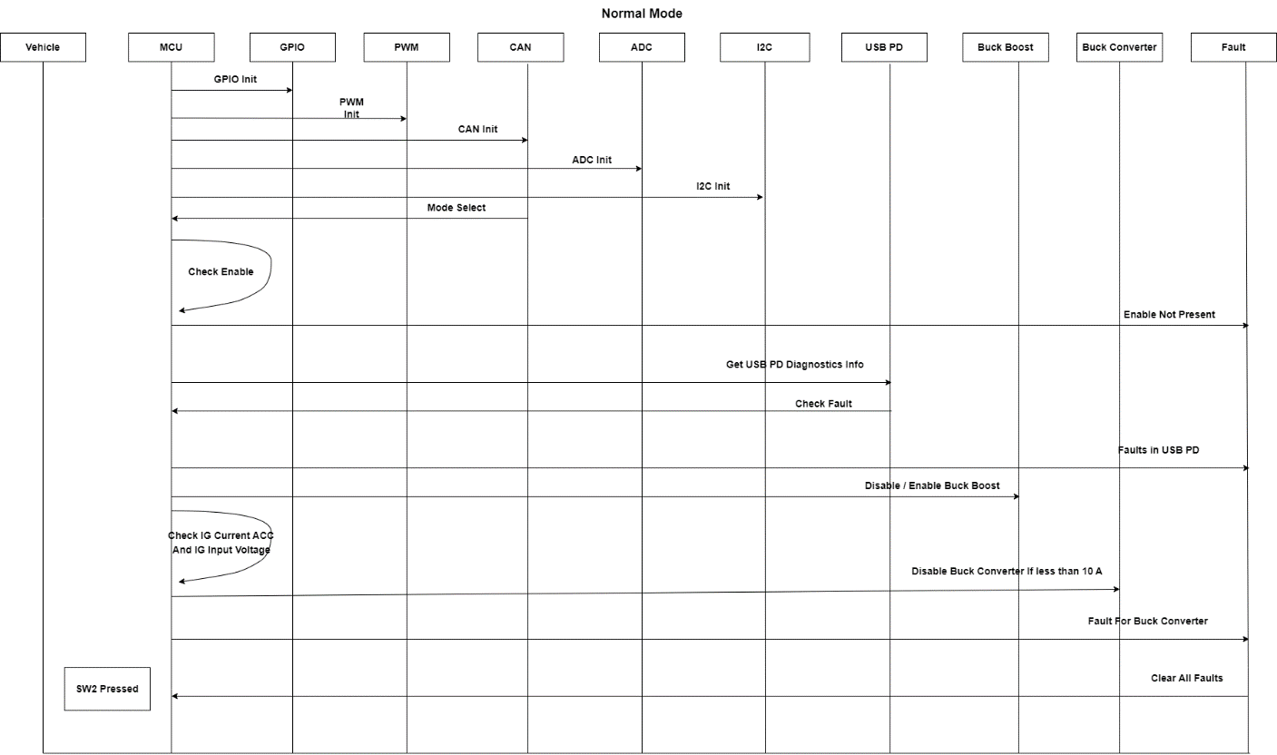
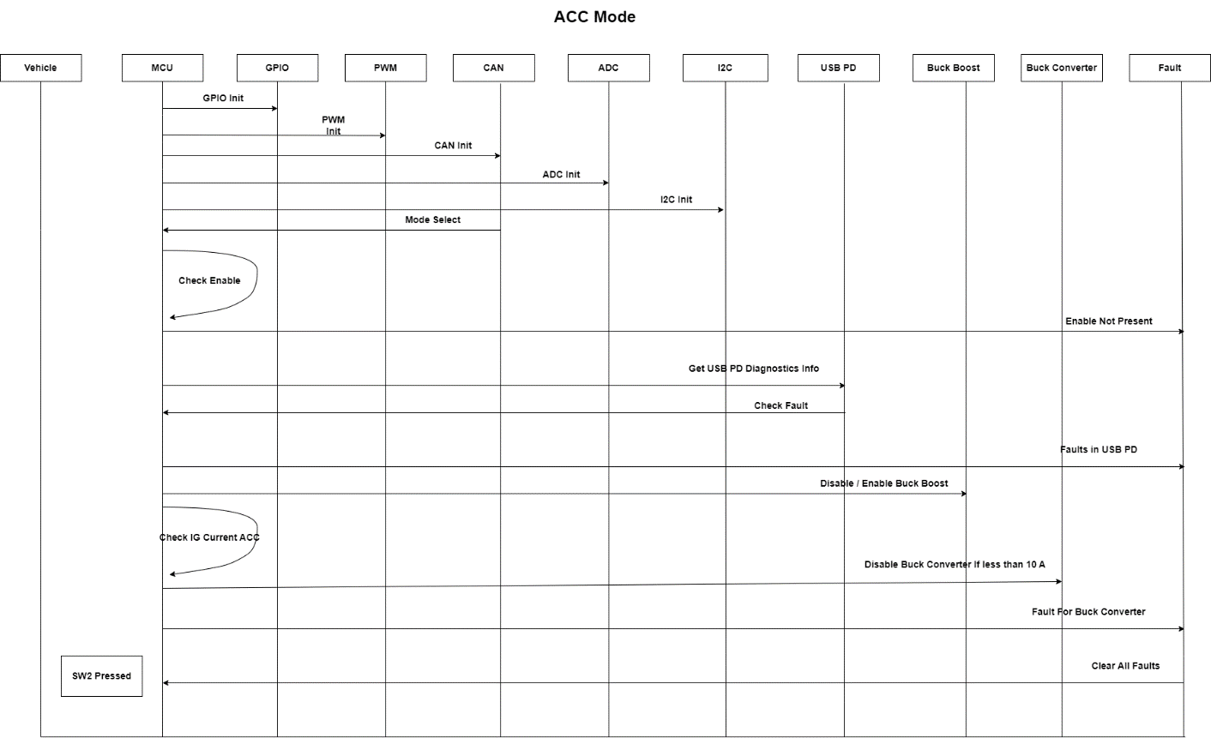

Microcontroller Settings
Note: The configurations are based on Renesas RH850/F1KH/KM user manual Rev.1.30 dated Sep 2021
For details see Appendix 1

Clocking and Reset
Registers and Settings:
Register | Setting Used | Bit Value to be set
MOSCE.MOSCENTRG | MainOSC start / enable | 1
CKSC_PPLLCLKS_CTL.PPLLCLKSCSID[1:0] | PPLLCLK source select | 01 = EMCLK
CKSC_CPUCLKD_CTL.CPUCLKDPLL[2:0] | CPU clock divider select | 01 = /1
CKSC_AWDTAD_CTL.AWDTADCSID[1:0] | AWDT clock divider select | 01 = LS IntOSC/128
Following are the clock configurations used for different peripherals
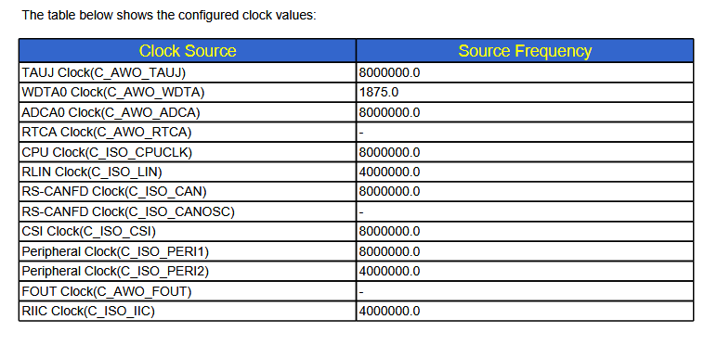
Figure 12 CPU clock setting

I/O Configurations
General-Purpose I/O (GPIO): Pins that can be configured as either inputs or outputs for general digital signals. Up to 81 I/O ports in 100-pin version.
I/O Configuration Setting
Register | Setting Used | Bit Value to be set
PMCn | Port Mode Enabled | 0
PMCSRn | Port Mode Set | 0
PIPCn | Software I/O Control | 0
PMn | Mixed (Input/Output) | 0 = Output1 = Input
PMSRn | Not Used | —
PPRn | Read Only | 0/1 (runtime)
Pn | Output Initialized Low | 0
PDSCn | Low Drive Strength | 0
PODCn | Push-Pull (Default) | 0
PBDCn | Mode Disabled | 0
PUn | Disabled | 0
PDn | Disabled | 0
Table 55 I/O configuration table
I/O Pin table with port information

Sr. No. | GPIO Signal | Port Name | Description
1 | Enable_Signal | P10_7 | Digital Input
2 | Buck_Boost1 | P0_1 | Digital Output
3 | Buck_Boost2 | P0_2 | Digital Output
4 | Buck_Boost3 | P0_3 | Digital Output
5 | Buck_Boost4 | P0_4 | Digital Output
6 | Buck_Converter | P0_7 | Digital Output
8 | MCU_Reg_1 | P0_8 | Digital Input
9 | MCU_REG_2 | P0_9 | Digital Input
10 | MCU_Buck_PG | P0_7 | Digital Input
12 | MCU_SW2 | P8_4 | Digital Input
13 | Power_Good1 | P10_4 | Digital Input
14 | Power_Good2 | P10_5 | Digital Input
15 | Power_Good3 | P10_15 | Digital Input
16 | Power_Good4 | P10_0 | Digital Input
Table 56 I/O Pin table with port information

Timer
Timer configuration settings
Register | Setting Used | Bit Value to be set
OSTMnCMP | Compare value for 5ms period | 32-bit(0x00030D3F)
OSTMnTS | Start trigger | 1
OSTMnTT | Stop trigger | 1
OSTMnTE | Counter enable status | 1
Table 57 Timer configuration table

A/D Converter (ADC)
A/D configuration settings
Register | Setting Used | Bit Value to be set
SMPCR | Sampling time | 0x0000018
SFTCR.RDCLRE | Not used | 0
SFTCR.ULEIE | Not used | 0
SFTCR.OWEIE | Not used | 0
ULLMTBR0 | Threshold table set | 0
DGCTL0.PSEL | Self-diagnosis level 0 | 0
SGCR1.SCANMD | Multicycle scan | 0
SGCR1.ADIE | Scan end interrupt | 1
SGCR1.SCT | Channel repeat times | 0
SGCR1.TRGMD | Hardware trigger | 0
SGVCSP1 | Start pointer | 0
SGVCEP1 | End pointer | 0x00000008
SGMCYCR1.MCYC | Multicycle number | 0
Table 58 A/D configuration table

I2C
I2C Configuration Setting
Note : I2C configurations for ACC USB may change depending upon the findings in the integration testing and any additional updates revealed post discussion with MPS (India / Japan).
Register | Setting Used | Bit Value to be set
RIICnCR1.ICE | I2C Enabled | 1
RIICnCR2.MST | Master Mode | 1
RIICnCR2.TRS | Transmit/Receive | 0/1 (runtime)
RIICnMR1.CKS | Internal Clock Select | 010 (PCLK/4)
RIICnSARy.FSy | Address Format | 0
RIICnBRH | Bit Rate High Period | 0x000000E0
RIICnCR2.ST | Start Condition | 1
RIICnCR2.SP | Stop Condition | 1
RIICnCR2.RS | Restart Condition | 1
RIICnDRT | Transmit Data Register | 8-bit data
RIICnDRR | Receive Data Register | 8-bit data
Table 59 I2C Configuration table

CAN
CAN Configuration Setting
Register | Setting Used | Bit Value to be set
RCFDCnCFDCmFDCFG.CLOE | Classical CAN only mode | 1
RCFDCnCFDGCFG.DCS | CAN clock source select | 0
RCFDCnCFDGCFG.TSSS | Timestamp clock source select | 1
RCFDCnCFDCmNCFG.NBRP | Nominal prescaler | 2
RCFDCnCFDCmNCFG.NSJW | Nominal SJW | 1
RCFDCnCFDCmNCFG.NTSEG1 | Nominal TSEG1 | 8
RCFDCnCFDCmNCFG.NTSEG2 | Nominal TSEG2 | 3
RCFDCnCFDRMNB.RMPLS | RX payload size select | 0
RCFDCnCFDTMIDp.TMRT | Data | 0
RCFDCnCFDTMIDp.TMIDE | Std | 0
Table 60 CAN Configuration table

Memory utilization summary (CPU, RAM, Flash/ROM)
Memory | Value in Bytes / Configuration | Total % is approximate
RAM Total | 160 KB | —
RAM Used (.data + .bss + stack) | 780 B (0.76 KB) | 0.47%
RAM Free | ~159.2 KB | 99.5%
Flash Total | 1056 KB | —
Flash Used | 76 KB | 7%
Flash Free | ~980 KB | 93%
Table 61 Memory utilization summary

USB-PD Controller (MPF52000) and Buck-Boost (MPQ4208)

USB-PD Controller (MPF52000) and Buck-Boost (MPQ4208) Configuration setting related information is explained in HDD as there is no configuration to be done from software side. The respective firmware for USB-PD Controller (MPF52000) and Buck-Boost (MPQ4208) will be provided by the chip vendor.

Interrupt table
Note: Details regarding interrupt will be updated during the coding and testing phase
The High-level and Low-level Interrupt priority - we need to decide based on the safety + timing and critical functions such as,
High Priority: Assigned high priority because any delay can cause unsafe power behaviour or loss so the ISR does only quick actions to minimize latency.
Low Priority: Assigned low priority because delays are acceptable and not safety-critical, so the work is handled in a background task to avoid blocking important interrupt
Sr. No | Interrupt | Source | Used or not used | priority level (0 - 15) 0 has highest priority and 15 has lowest | Usage
1 | INTOSTM0 | OSTM0 | Used | 0 | Time-based Event Scheduling. It is used for precise timing, periodic tasks, and efficient event scheduling
2 | INTOSTM1 | OSTM1 | Not Used | — | —
3 | INTOSTM2 | OSTM2 | Not Used | — | —
4 | INTOSTM3 | OSTM3 | Not Used | — | —
5 | INTOSTM4 | OSTM4 | Not Used | — | —
6 | INTP0 | External interrupt | Used | 3 | It is used to handle events triggered by external signals.
7 | INTP1 | External interrupt | Used | 4 | It is used to handle events triggered by external signals such as sensor outputs.
8 | INTP2 | External interrupt | Used | 5 | It is used to handle events triggered by external signals.
9 | INTP3 | External interrupt | Not Used | — | —
10 | INTP4 | External interrupt | Not Used | — | —
11 | INTP5 | External interrupt | Not Used | — | —
12 | INTADCA0I0 | ADCA0 scan group 1 (SG1) end interrupt | Used | 2 | This interrupt enables event-driven processing of the ADC0 data and used to real-time analog data monitoring
13 | INTADCA0I1 | ADCA0 scan group 2 (SG2) end interrupt | Not Used | —
14 | INTADCA1I0 | ADCA1 scan group 1 (SG1) end interrupt | Used | 1 | This interrupt enables event-driven processing of the ADC1 data and used to real-time analog data monitoring
15 | INTADCA1I1 | ADCA1 scan group 2 (SG2) end interrupt | Not Used | — | —
16 | INTRCAN0REC | CAN0 transmit/receive complete interrupt | Used | 8 | It is used to handle received messages efficiently
17 | INTRCAN0TRX | CAN0 transmit interrupt | Used | 9 | This interrupt can be used to trigger the next message transmission or to perform error handling and status updates.
18 | INTRIIC0TEE | RIIC0 receive error/event interrupt | Not Used | — | —
19 | INTRIIC0RI | RIIC0 receive complete Interrupt | Used | 6 | It is used to handle data reception in an interrupt-driven manner
20 | INTRIIC0TEI | RIIC0 transmit complete Interrupt | Used | 7 | It is used to handle data transmission in an interrupt-driven manner
Table 62 Interrupt Table

CAN Matrix
Note1 for SRS-045/046/047/048/049/050/051/052/053 :
Since there is no storage / recording provision / recording capability in the current hardware , fault information is sent over the CAN bus for further processing (storage/retrieval).
Message Name : Mode Control CAN Matrix
Message ID : 0x100
Extended / Standard : Standard(11bit)
Direction : Input (Receive)
DLC : 8 bytes
Cycle Time : Event based
Event / Cyclic / Mixed : Event
Endian : Little Endian
Transmitter : Vehicle
Receiver : USBACC
Timeout / Alive counter /CRC : Not Used
Comment : This message is used to control operating modes such as Reset, Normal Mode, and ACC Mode

Signal Name | Start [Bit] | Length [Bit] | Value type (signed/unsigned) | Unit | Resolutions | Maximum | Minimum | Offset | Initial value | Comments  Note – Details regarding fault response will be updated during coding (TBD)
Reset | 0 | 1 | Unsigned | Value | 1 | 1 | 0 | 0 | 0 | 0 = OFF  1 = ON
Mode | 0 | 1 | Unsigned | Value | 1 | 1 | 0 | 0 | 0 | 0 = ACC Mode  1 = Normal Mode
Table 63 Mode Control CAN Matrix
Message Name : Current Feedback CAN Matrix
Message ID : 0x101
Extended / Standard : Standard(11bit)
Direction : Output (Transmit)
DLC : 8 bytes
Cycle Time : 100ms
Event / Cyclic / Mixed : Periodic
Endian : Little Endian
Transmitter : USBACC
Receiver : Vehicle
Timeout / Alive counter /CRC : Not Used.
Comment : This message transmits feedback of ACC and IG input current sensor values
Signal Name | Start [Bit] | Length [Bit] | Value type (signed/unsigned) | Unit | Resolutions | Minimum | Maximum | Offset | Initial value | Comments
ACC1 Current Sensor | 0 | 8 | Signed | A | 1 / bit | 0 | 30 | 0 | 0 | ACC input current Value
ACC2 Current Sensor | 8 | 8 | Signed | A | 1 / bit | 0 | 30 | 0 | 0 | ACC input current Value
ACC3 Current Sensor | 16 | 8 | Signed | A | 1 / bit | 0 | 30 | 0 | 0 | ACC input current Value
IG Current Sensor | 24 | 8 | Signed | A | 1 / bit | 0 | 30 | 0 | 0 | IG input current Value
Table 64 Current Feedback CAN Matrix
Message Name : Temperature Feedback CAN Matrix
Message ID : 0x102
Extended / Standard : Standard(11bit)
Direction : Output (Transmit)
DLC : 8 bytes
Cycle Time : 100ms
Event / Cyclic / Mixed : Periodic
Endian : Little Endian
Transmitter : USBACC
Receiver : Vehicle
Timeout / Alive counter /CRC : Not Used.
Comment : This message transmits temperature feedback of power electronics components
Signal Name | Start [Bit] | Length [Bit] | Value type (signed/unsigned) | Unit | Resolutions | Maximum | Minimum | Offset | Initial value | Comments
Fly back Temp Sensor | 0 | 16 | Signed | °C | 1 / bit | 125 | -40 | 0 | 0 | Fly back temp value
IGBT Temp Sensor | 16 | 16 | Signed | °C | 1 / bit | 125 | -40 | 0 | 0 | IGBT temp value
BUCK Temp Sensor | 32 | 16 | Signed | °C | 1 / bit | 125 | -40 | 0 | 0 | Buck temp value
Table 65 Temperature Feedback CAN Matrix

Message Name : USB-PD Feedback CAN Matrix
Message ID : 0x103
Extended / Standard : Standard(11bit)
Direction : Output (Transmit)
DLC : 8 bytes
Cycle Time : 100ms
Event / Cyclic / Mixed : Periodic
Endian : Little Endian
Transmitter : USBACC
Receiver : Vehicle
Timeout / Alive counter /CRC : Not Used.
Comment : This message provides negotiated USB-PD voltage and current feedback
Signal Name | Start [Bit] | Length [Bit] | Value type (signed/unsigned) | Unit | Resolutions | Minimum | Maximum | Offset | Initial value | Comments
ACC_ Negotiate Voltage | 0 | 16 | Unsigned | V | 1 / bit | 0 | 14 | 0 | 0 | ACC Voltage
USB1_PD Negotiate Current | 16 | 16 | Signed | A | 1 / bit | 0 | 30 | 0 | 0 | USB1 _PD Current
USB2_PD Negotiate Current | 32 | 8 | Signed | A | 1 / bit | 0 | 30 | 0 | 0 | USB2 _PD Current
USB3_PD Negotiate Current | 40 | 8 | Signed | A | 1 / bit | 0 | 30 | 0 | 0 | USB3_PD Current
USB4_PD Negotiate Current | 48 | 8 | Signed | A | 1 / bit | 0 | 30 | 0 | 0 | USB4 _PD Current
Table 66 USB-PD Feedback CAN Matrix
Message Name : USB-PD Port Status CAN Matrix
Message ID : 0x104
Extended / Standard : Standard(11bit)
Direction : Output (Transmit)
DLC : 8 bytes
Cycle Time : 100ms
Endian : Little Endian
Transmitter : USBACC
Receiver : Vehicle
Timeout / Alive counter /CRC : Not Used.
Comment : This message indicates the operational status of each USB-PD port
Signal Name | Start [Bit] | Length [Bit] | Value type (signed/unsigned) | Unit | Resolutions | Maximum | Minimum | Offset | Initial value | Comments
USB1_PD_Status | 0 | 8 | Unsigned | - | - | 1 | 0 | 0 | 0 | USB1 PD
USB2_PD_Status | 8 | 8 | Unsigned | - | - | 1 | 0 | 0 | 0 | USB2 PD
USB3_PD_Status | 16 | 8 | Unsigned | - | - | 1 | 0 | 0 | 0 | USB3 PD
USB4_PD_Status | 24 | 8 | Unsigned | - | - | 1 | 0 | 0 | 0 | USB4 PD
Table 67 : USB-PD Port Status CAN Matrix

Message Name : Fault feedback CAN matrix
Message ID : 0x200
Extended : Standard(11bit)
Direction : Output (Transmit)
DLC : 8 bytes
Cycle Time : Event based (On fault change)
Event / Cyclic : Event Based
Endian : Little Endian
Transmitter : USBACC
Receiver : Vehicle
Timeout / Alive counter /CRC : Not Used.
Comment : This message reports system fault status bits for ACC, USB, and IG power paths

Signal Name | Start [Bit] | Length [Bit] | Value type (signed/unsigned) | Unit | Resolutions | Minimum | Maximum | Offset | Initial value | Comment
ACC1 over current fault status | 0 | 1 | Unsigned | - | 1 | 0 | 1 | 0 | 0 | 0 = No Fault  1 = Fault
ACC2 over current fault status | 1 | 1 | Unsigned | - | 1 | 0 | 1 | 0 | 0 | 0 = No Fault  1 = Fault
ACC3 over current fault status | 2 | 1 | Unsigned | - | 1 | 0 | 1 | 0 | 0 | 0 = No Fault  1 = Fault
ACC over voltage fault status | 3 | 1 | Unsigned | - | 1 | 0 | 1 | 0 | 0 | 0 = No Fault  1 = Fault
USB1 power fault status | 4 | 1 | Unsigned | - | 1 | 0 | 1 | 0 | 0 | 0 = No Fault  1 = Fault
USB2 power fault status | 5 | 1 | Unsigned | - | 1 | 0 | 1 | 0 | 0 | 0 = No Fault  1 = Fault
USB3 power fault status | 6 | 1 | Unsigned | - | 1 | 0 | 1 | 0 | 0 | 0 = No Fault  1 = Fault
USB4 power fault status | 7 | 1 | Unsigned | - | 1 | 0 | 1 | 0 | 0 | 0 = No Fault  1 = Fault
IG overvoltage fault status | 8 | 1 | Unsigned | - | 1 | 0 | 1 | 0 | 0 | 0 = No Fault  1 = Fault
ACC DCDC converter faults | 9 | 1 | Unsigned | - | 1 | 0 | 1 | 0 | 0 | 0 = No Fault  1 = Fault
USB DCDC converter faults | 10 | 1 | Unsigned | - | 1 | 0 | 1 | 0 | 0 | 0 = No Fault  1 = Fault
IG overcurrent fault status | 11 | 1 | Unsigned | - | 1 | 0 | 1 | 0 | 0 | 0 = No Fault  1 = Fault
Table 68 Fault feedback CAN matrix

Message Name : Mode change CAN matrix
Message ID : 0x201
Extended : Standard(11bit)
Direction : Output (Transmit)
DLC : 8 bytes
Cycle Time : Event based (On status change)
Event / Cyclic : Event Based
Endian : Little Endian
Transmitter : USBACC
Receiver : Vehicle
Timeout / Alive counter /CRC : Not Used.
Comment : This message is used to change mode such as Normal Mode to ACC Mode and ACC Mode to Normal Mode.

Signal Name | Start [Bit] | Length [Bit] | Value type (signed/unsigned) | Unit | Resolutions | Minimum | Maximum | Offset | Initial value | Comment | Fault Response
Mode | 0 | 1 | Unsigned | Value | 1 | 1 | 0 | 0 | 0 | 0 = ACC Mode  1 = Normal Mode | Mode

SRS reference in SDD

Req. No | Requirement | Category | Document
SRS-001 | ACC unit have High voltage DC Input with 3 different voltage ranges | Electrical | Refer SDD Chapter 7
SRS-002 | Lo Operation range of the ACC unit is 130V to 220V DC input | Electrical | Refer SDD Chapter 7
SRS-003 | Mid Operation range of the ACC unit is 144V to 322V DC input | Electrical | Refer SDD Chapter 7
SRS-004 | Hi Operation range of the ACC unit is 200V to 428V DC input | Electrical | Refer SDD Chapter 7
SRS-007 | ACC unit shall have same software for all 3 operating ranges | Functional | Refer SDD Chapter 7
SRS-008 | Required software configuration may be selected by using resistor setting change in BOM | Functional | Refer SDD Chapter 7
SRS-009 | Unit shall stop output if operating voltage is below given operating voltage range | Electrical and Functional | Refer SDD Chapter 7
SRS-010 | Unit shall stop output if operating voltage is above given operating voltage range | Electrical and Functional | Refer SDD Chapter 7
SRS-012 | Low voltage IG pin operating voltage is between 10 to 16V DC | Electrical | Refer SDD Chapter 7
SRS-013 | Low voltage IG pin shall be able to supply 10A current continuously in ACC mode | Electrical | Refer SDD Chapter 7
SRS-014 | Low voltage IG pin voltage shall be monitored by microcontroller for under voltage and over voltage condition. Behaviour to be decided. | Electrical and Functional | Refer SDD Chapter 7
SRS-015 | Low voltage IG pin current shall be monitored by microcontroller for overcurrent condition | Electrical and Functional | Refer SDD Chapter 7
SRS-028 | If any of the USB output have fault, all other USB outputs shall remain functional with full functionality | Functional | Refer SDD Chapter 7
SRS-034 | Each 12V output shall have independent current sensor measurement by microcontroller | Electrical and Functional | Refer SDD Chapter 7
SRS-035 | If any of the 12V output crosses 10A current for 10mS time, 12V DCDC converter shall be switched OFF and so all 3 x 12V output will be shut down | Electrical and Functional | Refer SDD Chapter 7
SRS-036 | Each output 12V port over current shutdown shall be configurable by microcontroller based on current sensor feedback | Electrical and Functional | Refer SDD Chapter 7
SRS-037 | There shall be a mechanism for detecting loss of HVDC voltage input by microcontroller | Electrical and Functional | Refer SDD Chapter 7
SRS-038 | Unit shall switch between High voltage battery mode and ACC mode based on CAN communication from vehicle | Functional | Refer SDD Chapter 7
SRS-039 | Unit shall switch off HV DCDC converter upon receiving request on CAN bus from vehicle to switch to ACC mode | Functional | Refer SDD Chapter 7
SRS-040 | In ACC mode power shall be taken from the IG pin | Electrical | Refer SDD Chapter 7
SRS-041 | In ACC mode IG pin current is limited to 10A continuous | Electrical | Refer SDD Chapter 7
SRS-042 | ACC unit shall not be operable in case of under voltage or absence of IG input - stop mode | Electrical and Functional | Refer SDD Chapter 7
SRS-043 | In ACC mode If any of the IG input current crosses 10A current for 100mS time, unit shall be entering in Fault mode and all outputs on the unit shall be turned OFF | Functional | Refer SDD Chapter 7
SRS-044 | To come out of the Fault mode, unit shall be turned OFF and ON again | Functional | Refer SDD Chapter 7
SRS-045 | Unit shall monitor and log each USB communication fault status by microcontroller | Functional | Refer SDD Chapter 7
SRS-046 | Unit shall monitor and log each USB power fault status by microcontroller | Functional | Refer SDD Chapter 7
SRS-047 | Unit shall monitor and log IG overvoltage fault status by microcontroller | Functional | Refer SDD Chapter 7
SRS-048 | Unit shall monitor and log IG overcurrent fault status by microcontroller | Functional | Refer SDD Chapter 7
SRS-049 | Unit shall monitor and log each ACC overcurrent fault status by microcontroller | Functional | Refer SDD Chapter 7
SRS-050 | Unit shall monitor and log all faults related to internal chip to chip communication with microcontroller by microcontroller | Functional | Refer SDD Chapter 7
SRS-051 | Unit shall monitor and log ACC DCDC converter faults by microcontroller | Functional | Refer SDD Chapter 7
SRS-052 | Unit shall monitor and log USB DCDC converter faults by microcontroller | Functional | Refer SDD Chapter 7
SRS-053 | Unit shall monitor and log any CAN communication related fault by microcontroller | Functional | Refer SDD Chapter 7
SRS-064 | Fan speed shall be controllable by microcontroller based on thermal performance of the unit | Functional | Refer SDD Chapter 7
SRS-066 | Unit shall monitor temperature at HVDCDC primary power devices (1 for full bridge) | Electrical and Functional | Refer SDD Chapter 7
SRS-067 | Unit may monitor temperature at HVDCDC secondary power devices (1 for diode bridge) | Electrical and Functional | Refer SDD Chapter 7
SRS-068 | Unit shall monitor temperature at each USB DCDC Converter | Electrical and Functional | Refer SDD Chapter 7
SRS-069 | Unit shall monitor temperature at ACC DCDC Converter | Electrical and Functional | Refer SDD Chapter 7
SRS-070 | Unit shall have one Digital input: SW2 going to microcontroller | Electrical and Functional | Refer SDD Chapter 7
SRS-075 | Microcontroller shall be functional and CAN communication enabled even though unit power output is disabled by ENABLE pin | Electrical and Functional | Refer SDD Chapter 7
SRS-076 | Microcontroller shall monitor ENABLE pin to understand the status and take necessary action | Electrical and Functional | Refer SDD Chapter 7
Table 69 SRS Mapping

Common abbreviations list
Abbreviation | Full Form
ADC | Analog-to-Digital Converter
CAN | Controller Area Network
CANH | CAN High Line
CANL | CAN Low Line
GND | Ground
HV | High Voltage
HVDC | High Voltage Direct Current
ESD | Electrostatic Discharge
EPR | Extended Power Range
SPR | Standard Power Range
I2C | Inter-Integrated Circuit
IG | Ignition
LV | Low Voltage
TBD | To Be Discussed
MCU | Microcontroller Unit
NTC | Negative Temperature Coefficient
OCP | Over Current Protection
OTP | Over Temperature Protection
OVP | Over Voltage Protection
PD | USB Power Delivery
ACC | Accessory Power
USB | Universal Serial Bus
UVP | Under Voltage Protection
VBUS | Bus Voltage
VCC | Voltage at the Common Collector (supply voltage)
SDD | Software Design Document
SRS | System Requirement Specification
Table 70 Common abbreviations

Appendix 1

Pending list for Phase 4 correction (Architecture level changes)
Architecture changes | Root Cause | Fix Description
File System / Modularization | Monolithic r_cg_main.c (1974 lines) limits testability & scalability | Split into Application and Hardware Abstraction (HAL) layers.
Sensor Guards / Modes | Voltage inputs and PG pins trigger instantaneous state changes | Implement debouncing and explicit upper/lower threshold hysteresis.
Application Code base | Implicit casts, and UI8 used for booleans | Standardize on <stdbool.h>, exact-width types (int32_t), and remove dead/unreachable code.

Appendix 2

Pending list for Phase 4 correction (Code findings )
Function | Root Cause | Fix Description
Count_5ms_Operation() | Inconsistent sensor reading and tight polling loops | Implement non-blocking fixed-rate scheduler guaranteeing 5ms ADC execution without duplicates.
Read_IG_Current() | Wrong operator <= | Change <= to >= in limit check
Send_Temperature_Sensors_Feedback() | Wrong variable used for clamping + cast to UI8 | Clamp against respective temperature variables and cast to UI16 instead of UI8
ACC_Mode() | Local variable shadows global usb_set_current | Remove the local UI32 declaration in ACC_Mode
Send_Current_Sensors_Feedback() | Loop starts at 4, overwriting byte 4 | Change loop start from 4U to 5U
Global Declarations | Unsigned type used for temperatures (-30 to 125C) | Change buck, igbt, flyback_temp_c from UI32 to int32_t
Main_Routine() | No fault guard before NORMAL/ACC mode dispatch | Wrap can_mode branching in if (mode != mode_fault)
Main_Routine() | LV voltage bounds not checked before mode entry | Force ACC mode when LV voltage out of range
Read_MCU_Buck_PG_Signal() | pg_buck_converter flag is never updated | Set pg_buck_converter = 1U/0U in the PG conditional branches
Control_Fan() / Send_Fault_Status() | No IGBT over temperature fault flag declared or sent | Add g_igbt_overtemp_fault at bit 12 and set it at 100C
Read_12V_Voltage_Sense() | No else-clear for the fault bit | Add else { g_usb_dcdc_fault = 0U; }
main() | Redundant Read_Temperature_Sensors call | Remove extra temperature call from main loop body
Control_Fan() | Per degree /duty changes | Per degree /duty changes need to be corrected as per logic and fan datasheet
Control_Fan() | Need to be improvised | Control fan code robustness and readability of the control logic will be improved by using temperature latching,
main() | Uses for(;;) instead of while(TRUE) | Replace for(;;) with while(TRUE) and define TRUE
Global declarations | UI8 used for Boolean flags | Change UI8 flags to _Bool type
main() prototype | Syntax error void int main(void); | Change to int main(void);
Read_Power_Good4_Signal() | Double semicolon ;; | Remove extra semicolon

Appendix 3

Microcontroller configurations
Note: The configurations are based on Renesas RH850/F1KH/KM user manual Rev.1.30 dated Sep 2021

Clocking and Reset
Four on-chip clock oscillators
Main Oscillator (MainOSC) with an oscillation frequency of 8, 16, 20, and 24 MHz
High Speed Internal Oscillator (HS IntOSC) with a nominal frequency of 8 MHz
Low Speed Internal Oscillator (LS IntOSC) with a nominal frequency of 240 kHz
PLL without SSCG (PLL1)
Set : Main Oscillator (MainOSC) with an oscillation frequency of 8 MHz
PLL:
The PLL circuits generate high speed operation clocks CPLL0OUT, CPLL1OUT and PPLLOUT for normal operation of the microcontroller.
The clocks supplied by the clock oscillators (X, XT, RH, RL, CPLL0OUT, CPLL1OUT, PPLLOUT) and their divided CPU Subsystem clocks.
(CPUCLK_H, CPUCLK_M, CPUCLK_L, CPUCLK_UL, PPLLCLK, PPLLCLK2, and PPLLCLK4).
MOSCE — MainOSC Enable Register:
This register is used to start and stop the MainOSC.
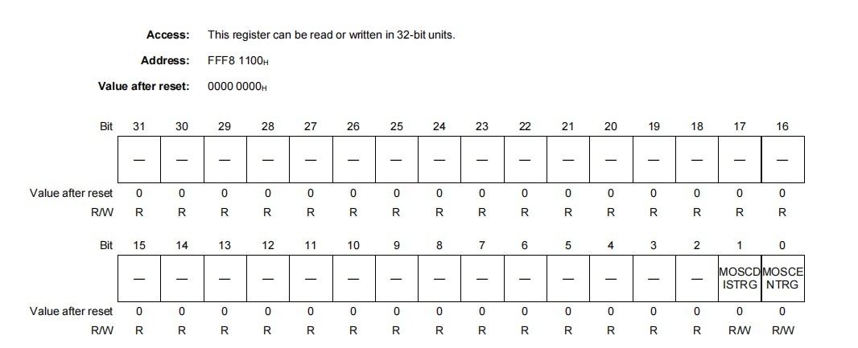

MOSCENTRG 0 BIT =
Bit | Meaning
0 | No function
1 | Start(enable) the Main oscillator
Set bit 1: We are starting or enabling the Main Oscillator (MainOSC).
This allows the external crystal or clock source to begin generating the main system clock.
PPLLCLK Source Clock Selection:
CKSC_PPLLCLKS_CTL — PPLLCLK Source Clock Selection Register
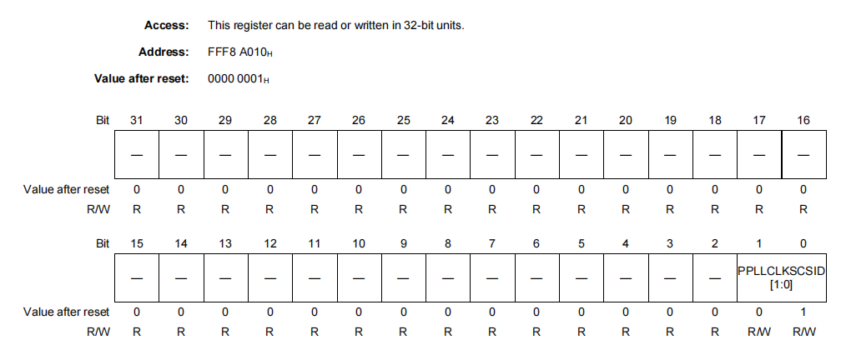
PPLLCLKSCSID [1:0] 1,0 BITS =
Bit | Meaning
00 | Setting prohibited
01 | EMCLK (default)
02 | MainOSC
03 | PPLLOUT

Set bit 01: Uses the EMCLK (default) External Main Clock input. A direct external clock signal (not through MainOSC).
PLL1 Circuit: Provides high-speed clocks (CPLL0OUT, CPLL1OUT, PPLLOUT) for microcontroller operation.

CKSC_CPUCLKD_CTL — C_ISO_CPUCLK clock divider selection register:
The correct write sequence using the PROTCMD1 register is required in order to update this register.
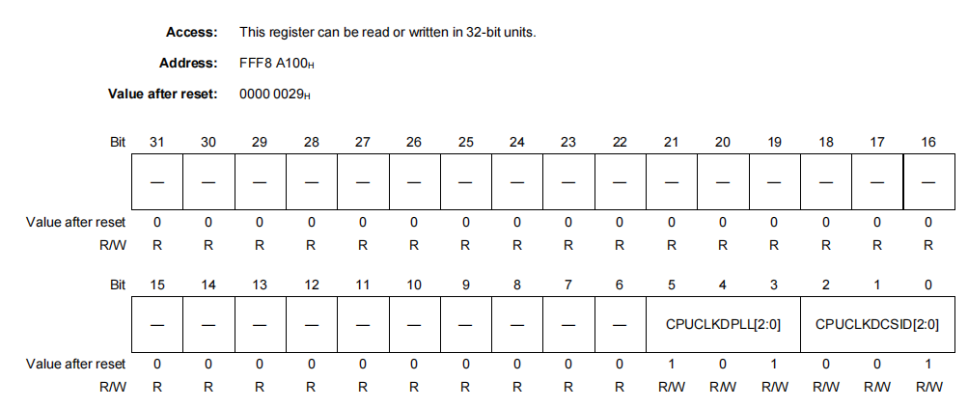
CPUCLKDPLL [2:0] 0 to 2 =
Bit | Meaning
000 | Setting prohibited
001 | CKSC_CPUCLKS_CTL selection /1 (Default)
010 | CKSC_CPUCLKS_CTL selection /2
011 | CKSC_CPUCLKS_CTL selection /4
100 | CKSC_CPUCLKS_CTL selection /8

Set bit 001: Uses the CKSC_CPUCLKS_CTL selection /1 (Default)

Clock Selector Control Register:
CKSC_AWDTAD_CTL — C_AWO_WDTA clock divider selection register:
The correct write sequence using the PROTCMD0 register is required in order to update this register.

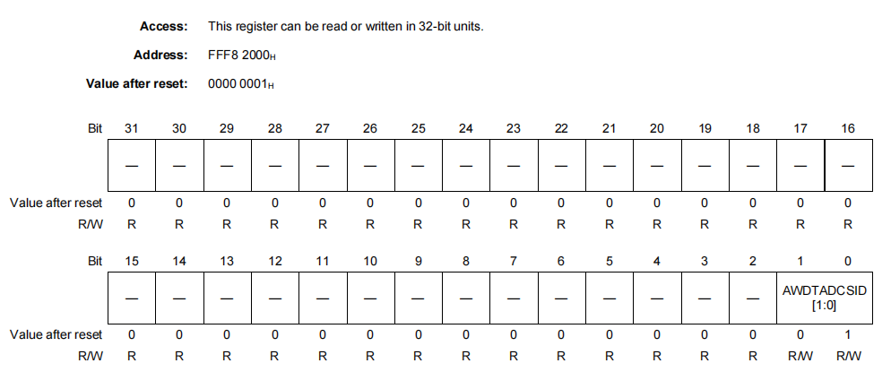

AWDTADCSID [1:0] 1,0 =
Bit | Meaning
00 | Setting prohibited
01 | LS IntOSC / 128 (default)
10 | LS IntOSC / 1
11 | Setting prohibited

Set bit 01: Use the LS IntOSC / 128 (default) Low-Speed Internal Oscillator divided by 128 (slower, low-power

Clock Settings
Following are the clock configurations used for different peripherals

Figure 13 CPU clock setting

I/O Configurations
General-Purpose I/O (GPIO): Pins that can be configured as either inputs or outputs for general digital signals. Up to 81 I/O ports in 100-pin version.
PMCn / JPMC0 — Port Mode Control Register
This register specifies whether the individual pins of port group n are in port mode or in alternative mode.
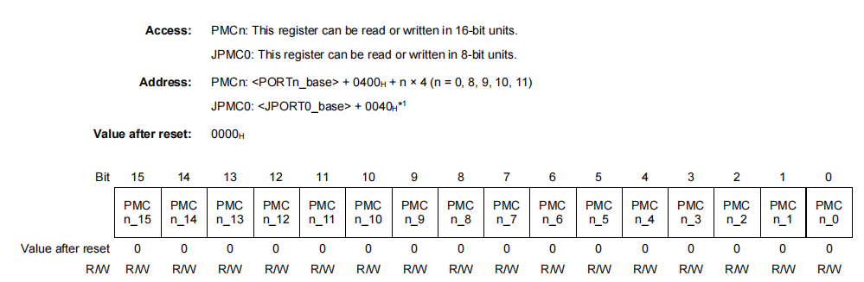
PMCn [15:0] Specifies the operation mode of the corresponding pin.
0: Port mode
1: Alternative mode
This bit is set to 0: Then Port mode is Enable
PMCSRn / JPMCSR0 — Port Mode Control Set/Reset Register
This register provides an alternative method to write data to the PMCn register.
The upper 16 bits of PMCSRn act as a mask which specifies whether or not the value of PMCn. PMCn_m is set by the corresponding bit in the lower 16 bits of PMCSRn.
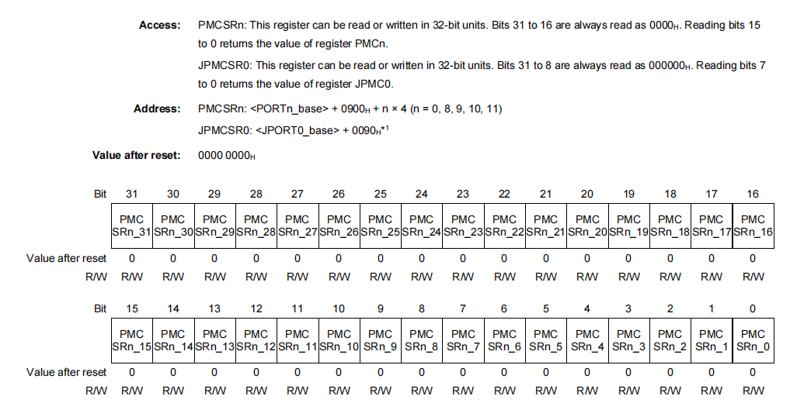
PMCSRn_ [15:0]
Data bits that specify the value of PMCn_m if PMCSRn_m of the corresponding upper bit
0: PMCn_m is 0.Port mode is Reset
1: PMCn_m is 1.Port mode is Set
This bit is set to 1: Then Port mode is Set
PIPCn — Port IP Control Register
This register specifies whether the I/O direction of the Pn_m pin is controlled by the port mode register PMn. PMn_m or by an alternative function. If the Pn_m pin is operated in alternative mode (PMCn.PMCn_m = 1) and the alternative function requires direct control of the I/O direction, then PIPCn. PIPCn_m must be set to 1 as well. This transfers I/O control to the alternative function and overrules the PMn.PMn_m setting.
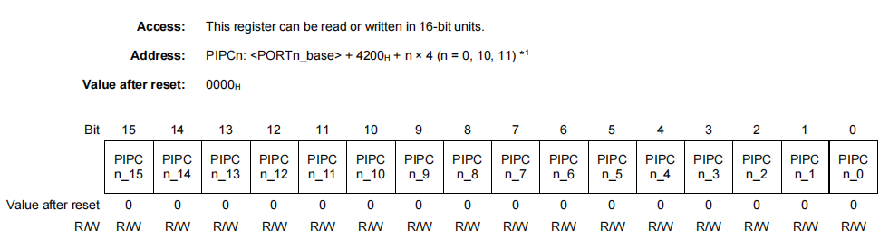
PIPCn [15:0] Specifies the I/O mode.
0: I/O mode is selected by PMn.PMn_m (software I/O control).
1: I/O mode is selected by the peripheral function (direct I/O control).
This bit is set to 0: Then I/O mode is selected by PMn.PMn_m (software I/O control).

PMn / APMn / JPM0 — Port Mode Register
This register specifies whether the individual pins of the port group n are in input mode or in output mode.
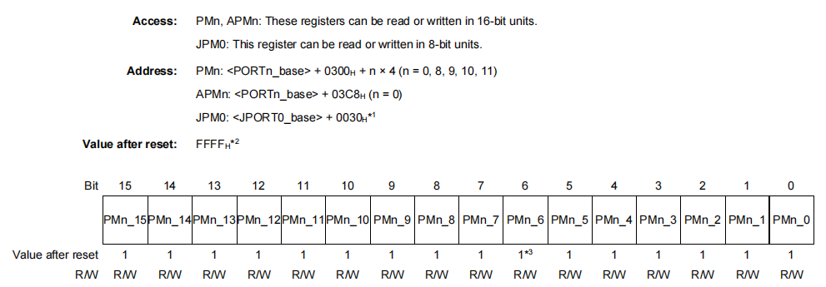
PMn [15:0] Specifies input/output mode of the corresponding pin.
0: Output mode (output enabled)
1: Input mode (output disabled)
This bit is set to 0: Then Output mode (output enabled)

PMSRn / APMSRn / JPMSR0 — Port Mode Set/Reset Register
This register provides an alternative method to write data to the PMn register.
The upper 16 bits of PMSRn act as a mask which specifies whether or not the value PMn.PMn_m is set by the corresponding bit in the lower 16 bits of PMSRn.
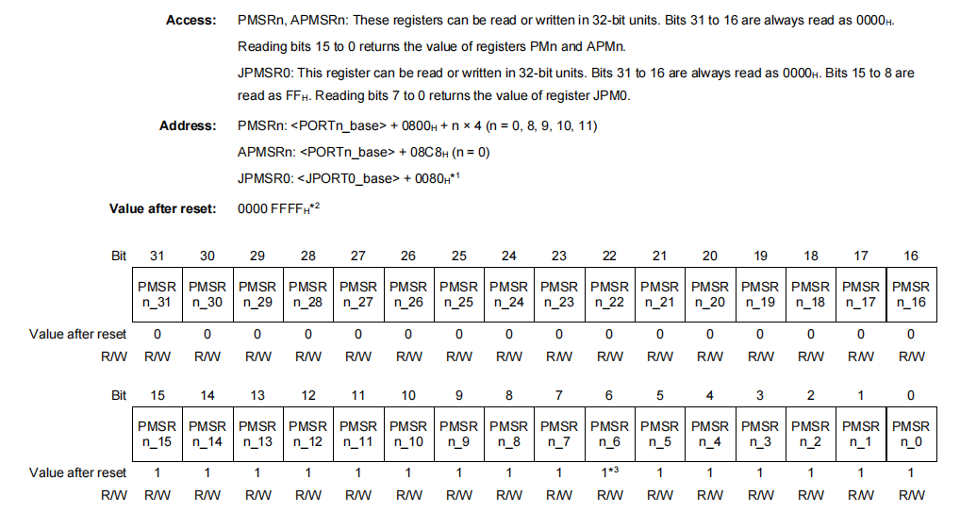
PMSRn_ [31:16]
Enable bits that specify whether the value of the corresponding lower bit PMSRn_m
(PMSRn_ [15:0]) is written to PMn_m.
0: PMn_m is not affected by PMSRn_m.
1: PMn_m is PMSRn_m.
For,
If PMSRn.PMSRn_31 = 1, the value of bit PMSRn.PMSRn_15 is written to bit PMn.
PMSRn_ [15:0]
Data bits that specify the value of PMn_m if PMSRn_m of the corresponding upper bit
(PMSRn_ [31:16]) is 1.
0: PMn_m is 0.
1: PMn_m is 1.

PPRn / APPRn / JPPR0 — Port Pin Read Register
This register reflects the actual level of the Pn_m pin, whether it is the value of the Pn. Pn_m bit or the level of an alternative output function.
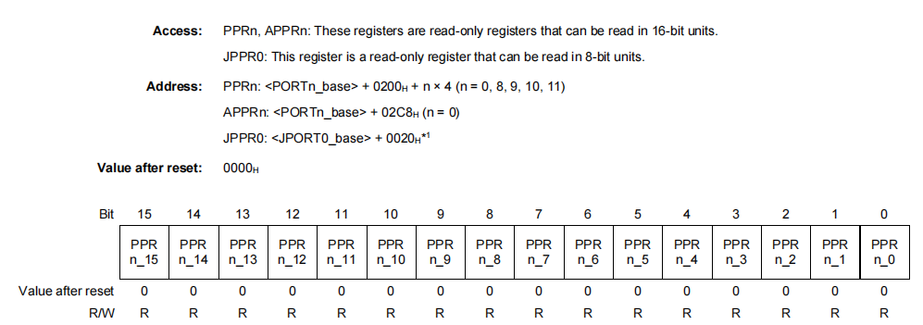
PPRn_ [15:0] - The Pn_m Pin, Pn. Pn_m value or alternative function output.
Pn / APn / JP0 — Port Register
This register holds the Pn. Pn_m data to be output via the related Pn_m port in output port mode (PMCn.PMCn_m = 0 and PMn.PMn_m = 0).
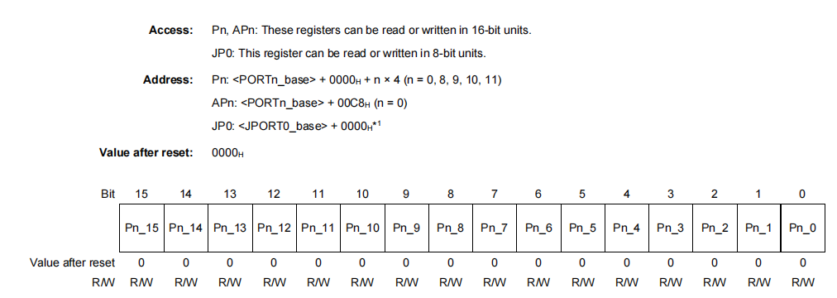
Pn_ [15:0]
Sets the output level of the Pn_m pin (m = 0 to 15).
0: Outputs low level
1: Outputs high level
This bit is set to 1: Then Outputs high level

Register Configuration: PDSCn / JPDSC0 — Port Drive Strength Control Register: This register specifies the output driver strength of the port pin. This function selects the fast mode (high drive strength) or slow mode (low drive strength) of the output buffer.
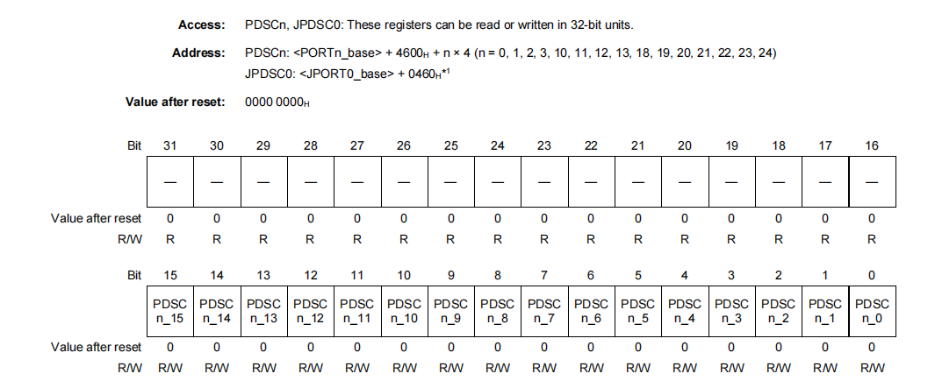
PDSCn [15:0] 0 to 15 BITS: Specifies the port drive strength of the output buffer of the port pin.
Pin 0: Lower drive strength (when the frequency output from the is 10 MHz
pin 1: High drive strength (when the frequency output from the p is 40 MHz
This bit is set to 0: Then Lower drive strength (when the frequency output from the pin is 10MHz
PODCn / JPODC0 — Port Open Drain Control Register:
This register selects push-pull or open-drain as output buffer function. The correct write sequence using the PPCMDn is required in order to update this register.
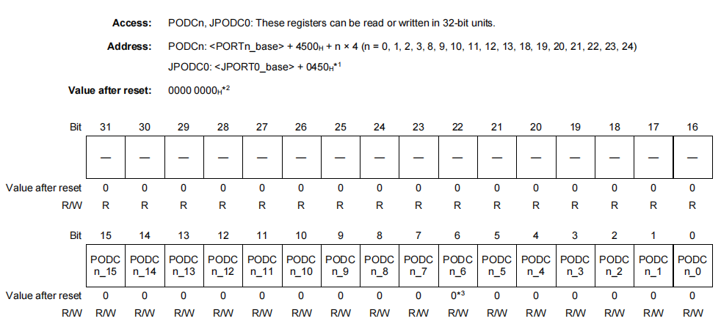
PODCn [15:0] 0 to 15 BITS = Specifies the output buffer function.
0: Push-pull
1: Open-drain
This bit is set to 0: Then Push - pull ON
PBDCn / APBDCn / JPBDC0 — port bidirectional control register:
This register enables the input buffer in output mode and sets the port to bidirectional mode. In bidirectional mode, the level of the signal on a pin can be read from PPRn.PPRn_m.
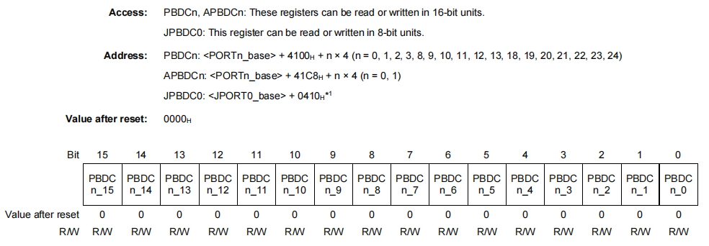
PBDCn [15:0] 0 to 15 BITS =
Enables/disables bidirectional mode of the corresponding pin.
0: Bidirectional mode disabled
1: Bidirectional mode enable
This bit is set to 0: Then Bidirectional mode disabled
I/O Configuration Setting
Register | Setting Used | Bit Value to set
PMCn | Port Mode Enabled | 0
PMCSRn | Port Mode Set | 0
PIPCn | Software I/O Control | 0
PMn | Mixed (Input/Output) | 0 = Output1 = Input
PMSRn | Not Used | —
PPRn | Read Only | 0/1 (runtime)
Pn | Output Initialized Low | 0 (initially)
PDSCn | Low Drive Strength | 0
PODCn | Push-Pull (Default) | 0
PBDCn | Mode Disabled | 0
PUn | Disabled | 0
PDn | Disabled | 0
Table 71 I/O Configuration table

I/O Pin table with port information

Sr. No. | GPIO Signal | Port Name | Description
1 | Enable_Signal | P10_7 | Digital Input
2 | Buck_Boost1 | P0_2 | Digital Output
3 | Buck_Boost2 | P0_3 | Digital Output
4 | Buck_Boost3 | P0_4 | Digital Output
5 | Buck_Boost4 | P0_5 | Digital Output
6 | Buck_Converter | P0_6 | Digital Output
8 | MCU_Reg_1 | P0_8 | Digital Input
9 | MCU_REG_2 | P0_9 | Digital Input
10 | MCU_Buck_PG | P0_7 | Digital Input
12 | MCU_SW2 | P8_4 | Digital Input
13 | Power_Good1 | P10_4 | Digital Input
14 | Power_Good2 | P10_5 | Digital Input
15 | Power_Good3 | P10_15 | Digital Input
16 | Power_Good4 | P11_0 | Digital Input
Table 72 I/O Pin table with port information

Timer
OS Timer OSTMn
The timer counting operation in OSTMn uses PCLK, which is connected to CPUCLK_L.
Clock Supply:
Unit Name | Unit Clock Name | Supply Clock Name | Description
OSTMn | PCLK | CPUCLK_L | Timer count clock
 | Register access clock | CPUCLK_L | Bus clock used to access registers
Interrupt requests:
This is the interrupt signal generated by the OSTM0 (OS Timer Channel 0). when it finishes counting (timer overflow). It is also known as OSTMTINT 84 (INTOSTM0). When the timer reaches the target count (timeout), it triggers an interrupt. The interrupt controller Interrupt #84 and calls your interrupt handler. OSTMTINT is triggered when OSTM0 timer expires.
OSTMnCMP — OSTMn Compare Register:
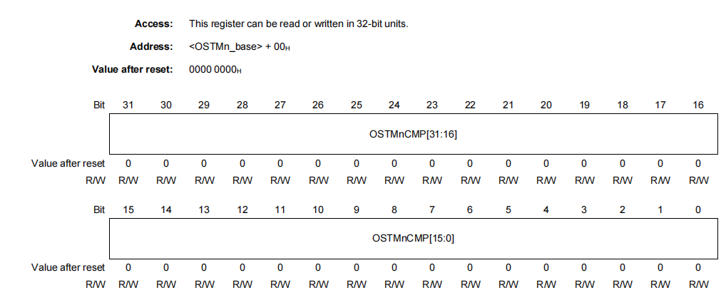
OSTMnCMP [31:0]
Bit | Meaning
[31:0] | In interval timer mode: start value of the down-counter
 | In free-run compare mode: compare value
The timer counts up from 0 continuously. When the counter value matches OSTMnCMP, it generates an interrupt. Timer does not stop or reset — it keeps running. You can use this mode like a stopwatch or to detect when a specific time has passed.
In free-run compare mode: compare value

OSTMnCNT — OSTMn Counter Register:
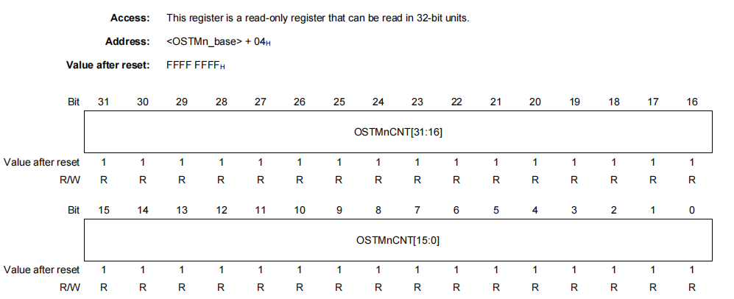
OSTMnCNT [31:0]:
Bit | Meaning
[31:0] | Timer counter value
This register holds the current count value of the OSTM (One-Shot Timer or Interval Timer). It increments or decrements depending on how the timer is configured:
Interval mode: (down-counter)
Free- running mode: (Up-Counter)
OSTMnTE — OSTMn count enable status register:
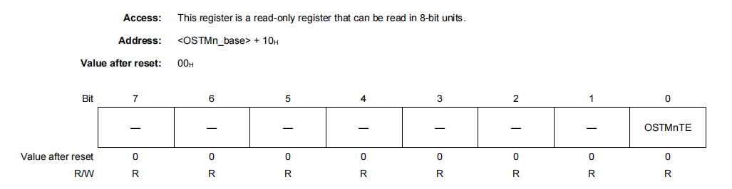
OSTMnTE = 0: Counter disabled
1: Counter enabled
This bit is set to 1 in response to OSTMnTS timer is running.

OSTMnTS — OSTMn Count Start Trigger Register:
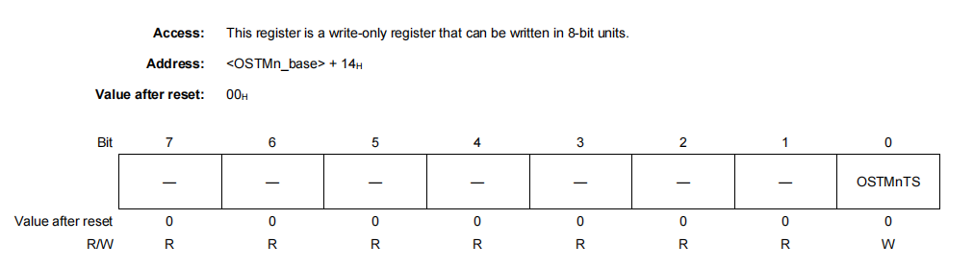
OSTMnTE = 0: This setting is invalid.
1: Stops the counter and clears the OSTMnTE. OSTMnTE bit.
This bit is set to 1 Stops the timer and clears OSTMnTE to 0.
OSTMnCTL — OSTMn Control Register:
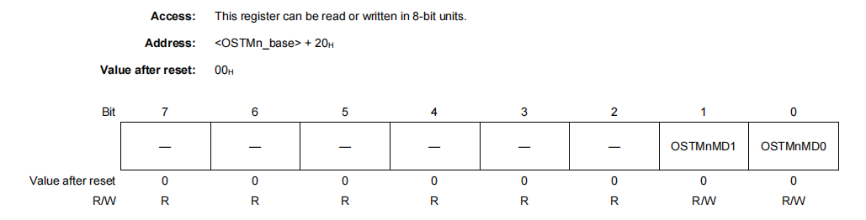
OSTMnMD1 = 0: Interval timer mode
1: Free-run compare mode
This bit is set to 1: Counter starts from 0 and counts up
OSTMnMD0 = 0: Interrupts when counting starts are disabled.
1: Interrupts when counting starts are enabled.
This bit is set to 1: Generate an interrupt immediately when timer starts.
USB ACC project Timer configuration
Timer configuration settings
Register | Setting Used | Bit Value to set
OSTMnCMP | Compare value for 5ms period | 32-bit(0x00030D3FUL)
OSTMnTS | Start trigger | 1
OSTMnTT | Stop trigger | 1
OSTMnTE | Counter enable status | 1
Table 73 Timer configuration table

A/D Converter (ADC)
ADCA0 - Total 36 channel (12-bit resolution: 16 channels + 10-bit resolution: 20 channel)
Clock Supply:
Unit Name | Unit Clock Name | Supply Clock Name | Description
ADCA0 | ADCLK | CKSCLK_IPERI1 | Module clock
 | Register access clock | CPUCLK_L, CKSCLK_AADCA | Bus clock
ADCAnSMPCR — Sampling Control Register:
ADCAnSMPCR controls the sampling time for SG4 and SG1 to SG3.
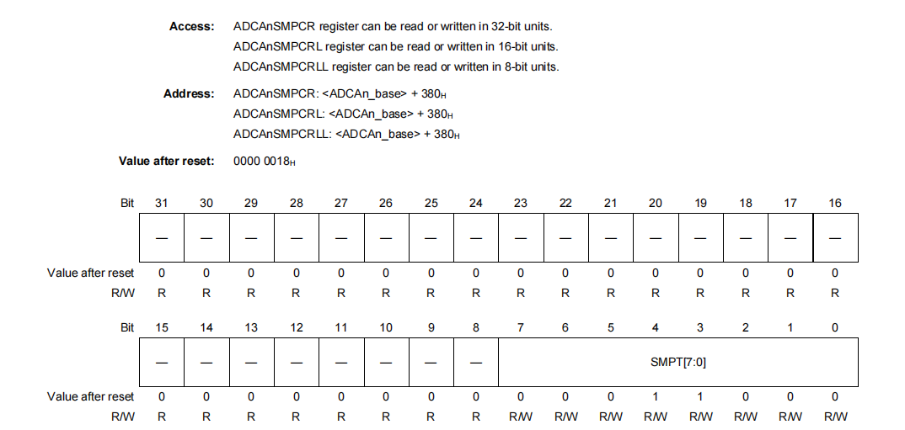
ADCAnSMPCR [7:0] = These bits are used to set the sampling time (number of cycles).
12H: 18 cycles (ADCLK = 8 MHz to 32 MHz)
18H: 24 cycles (ADCLK = 8 MHz to 40 MHz)

Set bit :18H: 24 cycles (ADCLK = 8 MHz to 40 MHz)

When we select the higher number of cycles allows more time for the sampling capacitor to charge, which may improve accuracy, especially when the input impedance is high.

ADCAnMPXSTBTR0 to 7 — MPX Stabilization Time Setting Register 0 to 7:
This register is used to set the stabilization time when external multiplexer is used. Stabilization time of corresponded physical channels which is selected by ADCAnMPXSTBTSEL0 to 4 register is set by setting this register.
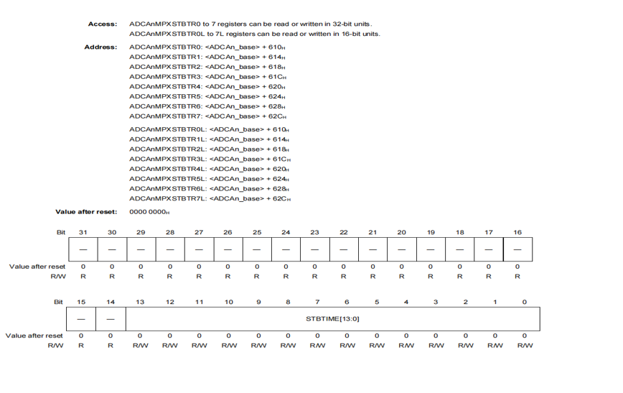
STBTIME [13:0] = Specify the analog input stabilization time when an external analog multiplexer is used only. When these bits are all “0” (reset value), wait time of one A/D conversion is inserted. Other than all “0”, wait time is inserted before A/D conversion according to the calculation below.
Calculation formula: STBTIME [13:0] / ADCLK
Example: STBTIME = 0x0800 = 2048
ADCLK = 16 MHz
Wait time = 2048/16,000,000 = 128 μs

ADCAnSFTCR — Safety Control Register: This is a register for safety control.
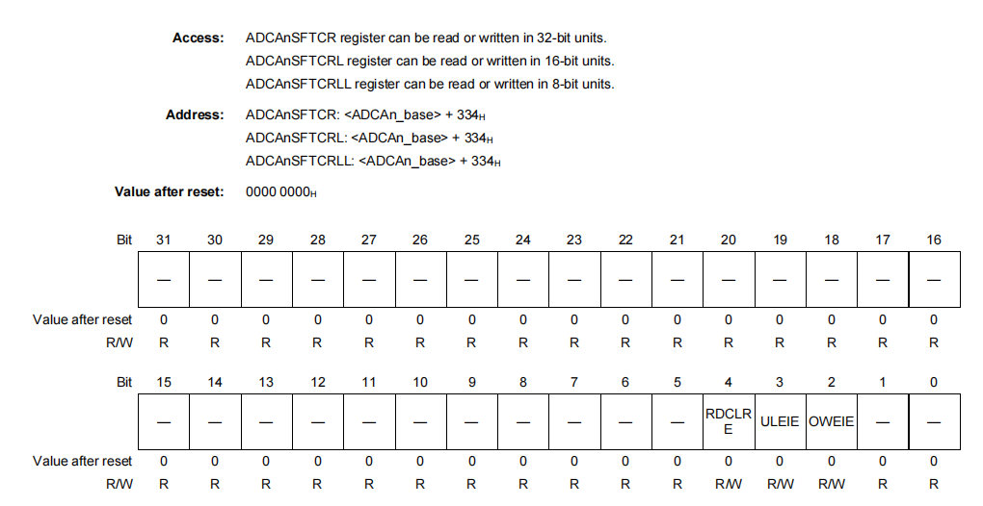

ADCAnSFTCR [31:0]
RDCLRE 4 = Read and Clear Enable -
When the A/D conversion result is read, this bit selects whether the A/D conversion result is cleared by hardware.
0: ADCAnPWDTSNDR/ADCAnDRj and ADCAnPWDDIR/ADCAnDIRj are not cleared when ADCAnPWDTSNDR/ADCAnDRj or ADCAnPWDDIR/ADCAnDIRj is read.
1: ADCAnPWDTSNDR/ADCAnDRj and ADCAnPWDDIR/ADCAnDIRj are cleared when ADCAnPWDTSNDR/ADCAnDRj or ADCAnPWDDIR/ADCAnDIRj is read.
This bit is set to 0: must manually clear the result if needed.
ULEIE 3 = A/D Error Interrupt (INT_ADE) Enable on Upper/Lower Limit Error Detection
0: Disabled
1: Enabled
This bit is set to 1, INT_ADE interrupt will be triggered if the ADC result goes outside the defined upper/lower threshold limits.
OWEIE 2 = A/D Error Interrupt (INT_ADE) Enable on Overwrite Error Detection
0: Disabled
1: Enabled
This bit is set to 1: Generates INT_ADE interrupt on overwrite error

ADCAnULLMTBR 0 to 7 — Upper Limit/Lower Limit Table Register 0 to 7:
These registers are used to set the threshold for detection of an upper limit or lower limit error in the A/D converted value. Any of ADCAnULLMTBR0 to ADCAnULLMTBR7 is specified by setting ADCAnPWDVCR.ULS [3:0] and ADCAnVCRj.ULS [3:0] and compared with ADCAnPWDTSNDR and ADCAnDRj.
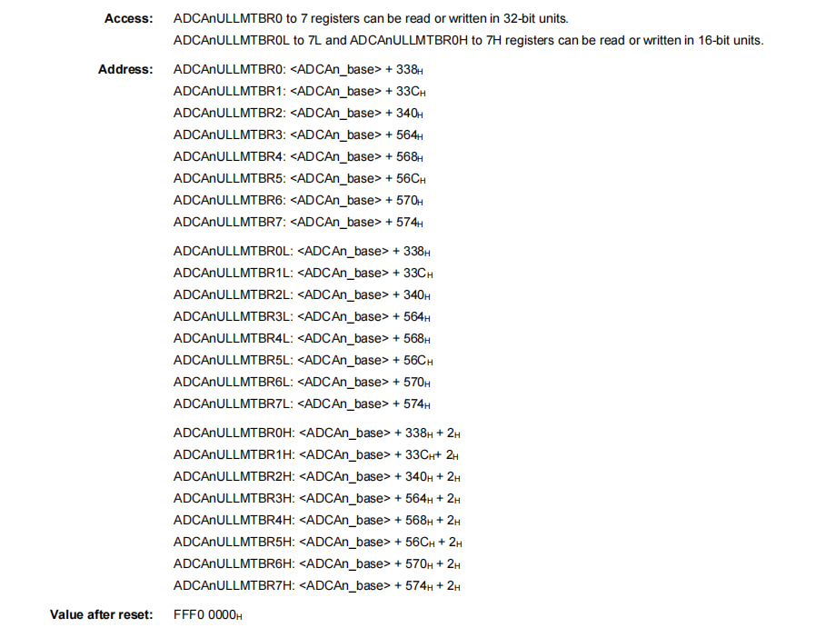

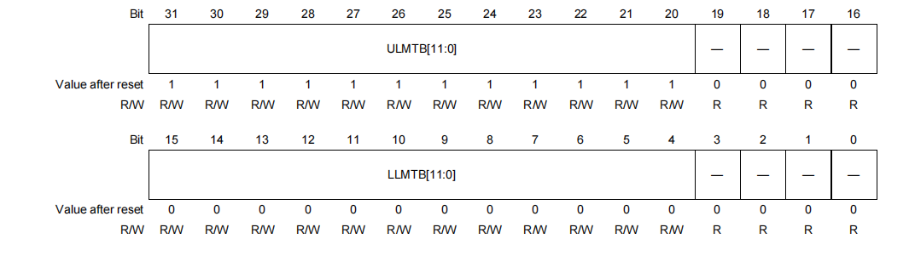
ULMTB [11:0] 31 to 20 = Upper Limit Table
Specify the threshold for detection of an upper limit error in the A/D converted value. The upper limit error (ADCAnULER.UE) is set when the following condition is met: ULMTB [11:0] < A/D converted value

ADCAnSGCRx — Scan Group x Control Register: This register controls scan group x.
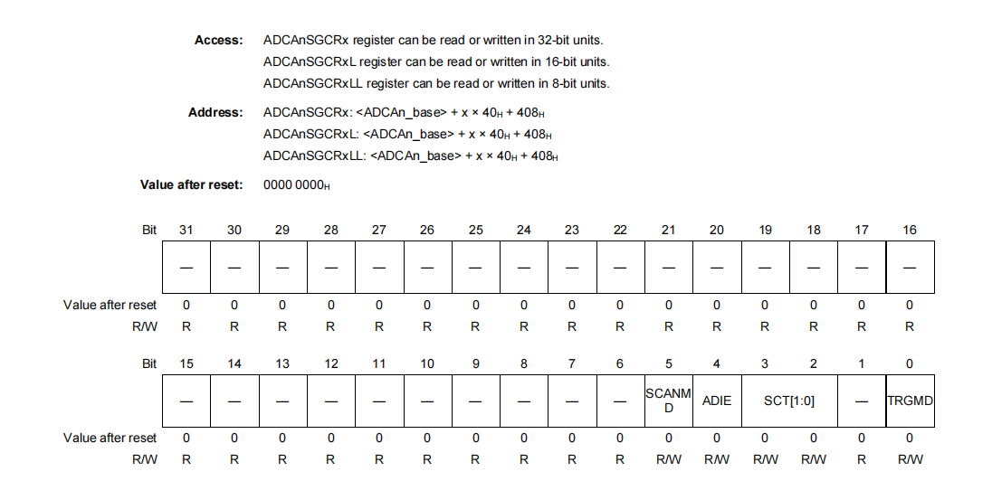
SCANMD 5 = Scan Mode
0: Multicycle scan mode
1: Continuous scan mode
This bit is set to 1: Continuous scan mode

ADIE 4 = Scan End Interrupt Enable
0: INT_SGx is not output when the scan for SGx ends.
1: INT_SGx is output when the scan for SGx ends.
This bit is set to 1: Lets the system know when all conversions in the scan group are finished.

SCT [1:0] 3,2 = Channel Repeat Times Select
00: The selected number of channel repeat times is one.
01: The selected number of channel repeat times is two.
10: The selected number of channel repeat times is four.
11: Setting prohibited.
This bit is set to 00: Allows averaging or repeated conversions for noise filtering.

TRGMD 0 = Trigger Mode
0: Trigger input to SGx TRG is disabled (Hardware trigger disabled).
1: SGx TRG start trigger or hold complete trigger A/B is selected for the trigger input to SGx.
This bit is set to 1: Determines whether conversion starts via hardware or software Trigge
ADCAnSGVCSPx — Scan Group x Start Virtual Channel Pointer: This register specifies the start pointer of a virtual channel.
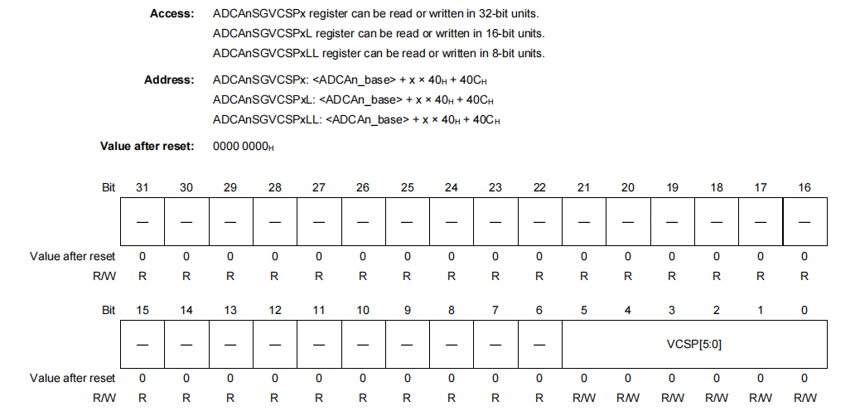
VCSP [5:0] 5 to 0 = Start Virtual Channel Pointer
These bits are used to specify the virtual channel from which the SGx scan is to be started. Scanning will proceed from the VCSP value through the enabled virtual channels in the scan group table (often configured in SGTSEL registers).

ADCAnSGMCYCRx — Scan Group x Multicycle Register:
This register is a 32/16/8-bit read/write register that indicates the number of scan time in multicycle scan mode.
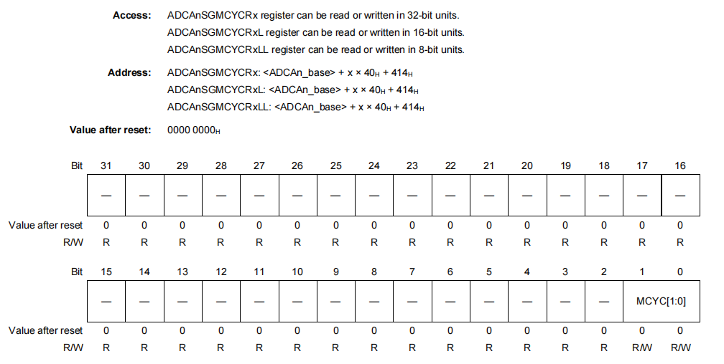
MCYC [1:0] 1,0 = Multicycle Number Specification
These bits are used to specify the number of scan times in multicycle scan mode.
00B: Number of scans = 1
01B: Number of scans = 2
10B: Setting prohibited
11B: Number of scans = 4
This bit is set to 00: A single scan per trigger.

ADCAnDGCTL0 — self-diagnosis control registers 0:
This register controls the self-diagnostic voltage level.
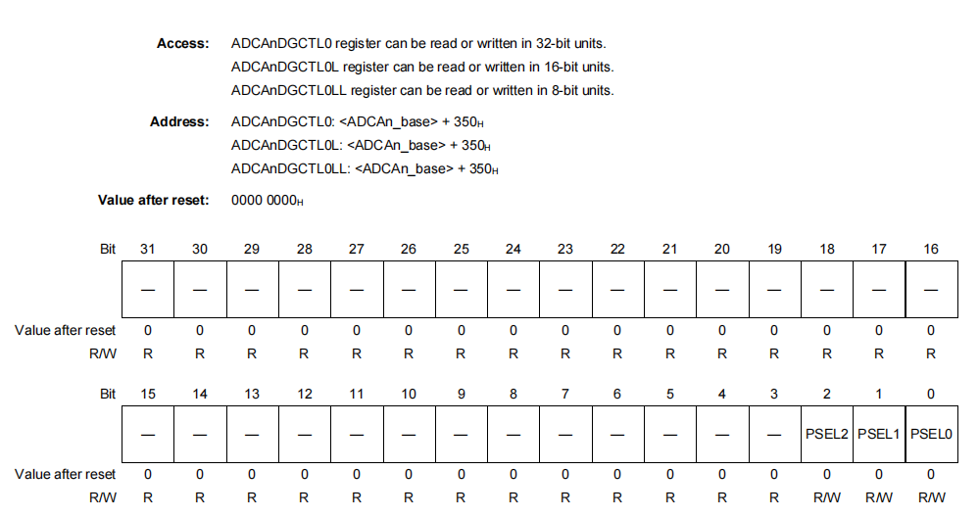
PSEL [2:0] 2 to 0 =
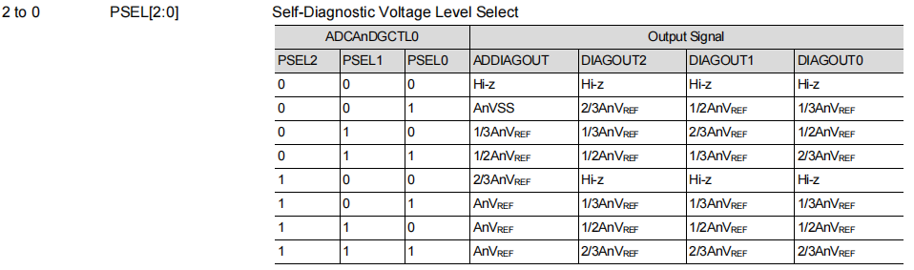
ADC_SELF_DIAG_VOLTAGE_LEVEL_0

A/D configuration settings
Register | Setting Used | Bit Value to set
SMPCR | Sampling time | 0x0000018
SFTCR.RDCLRE | Not used | 0
SFTCR.ULEIE | Not used | 1
SFTCR.OWEIE | Not used | 1
ULLMTBR0 | Threshold table set | 0
DGCTL0.PSEL | Self-diagnosis level 0 | 0
SGCR1.SCANMD | Multicycle scan | 0
SGCR1.ADIE | Scan end interrupt | 1
SGCR1.SCT | Channel repeat times | 0
SGCR1.TRGMD | Hardware trigger | 0
SGVCSP1 | Start pointer | 0
SGVCEP1 | End pointer | 0x00000008
SGMCYCR1.MCYC | Multicycle number | 0
Table 74 A/D configuration table

I2C
RIICnCR1 — I2C Bus Control Register 1
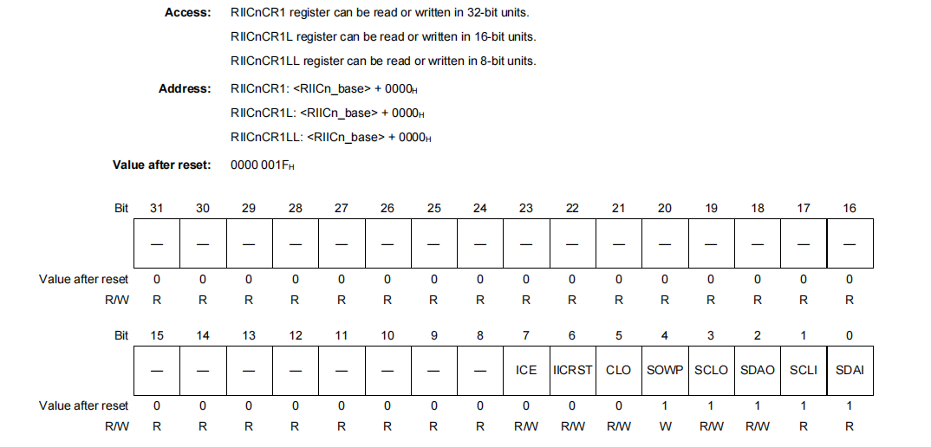
ICE = 1 I2C Bus Interface Enable
0: Disabled (the RIICnSCL and RIICnSDA pins are not driven).
1: Enabled (the RIICnSCL and RIICnSDA pins are driven).
Set bit1: Enabled (the RIICnSCL and RIICnSDA pins are driven).
RIICnCR2 — I2C Bus Control Register 2
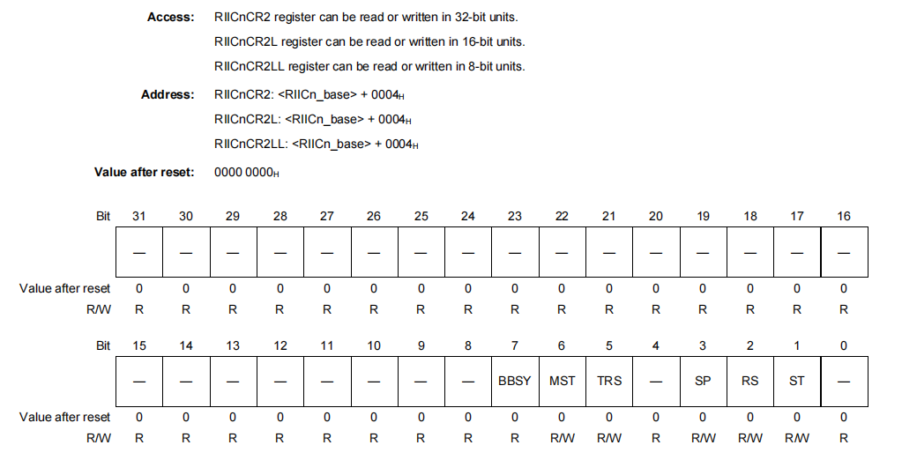
TRS = Transmit/Receive Mode
0: Receive mode
1: Transmit mode
Set bit 1: Transmit mode
MST = Master/Slave Mode
0: Slave mode
1: Master mode
Set bit 1: Master mode
RIICnMR1 — I2C Bus Mode Register 1
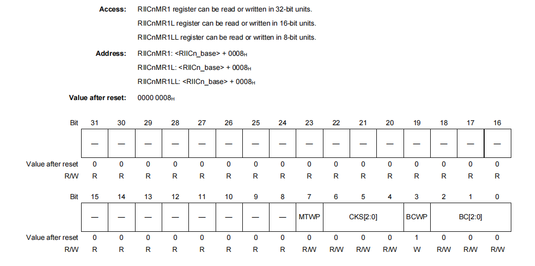
BC [2:0] = 0
These bits function as a counter that indicates the number of bits remaining to be transferred at the detection of a rising edge on the SCL line. Although these bits are writable and readable, it is not necessary to access these bits under normal conditions.
CKS [2:0] = 2 Internal Reference Clock Selection (IICϕ)
0 0 0: PCLK/1 clock
0 0 1: PCLK/2 clock
0 1 0: PCLK/4 clock
0 1 1: PCLK/8 clock
1 0 0: PCLK/16 clock
1 0 1: PCLK/32 clock
1 1 0: PCLK/64 clock
1 1 1: PCLK/128 clock
Set bit 0 1 1 : PCLK/8 clock
MTWP=1 MST/TRS Write Protect
0: Disables writing to the RIICnCR2.MST and TRS bits.
1: Enables writing to the RIICnCR2.MST and TRS bits
Set bit 1: Enables writing to the RIICnCR2.MST and TRS bits

RIICnSARy — I2C Slave Address Register y (y = 0 to 2)
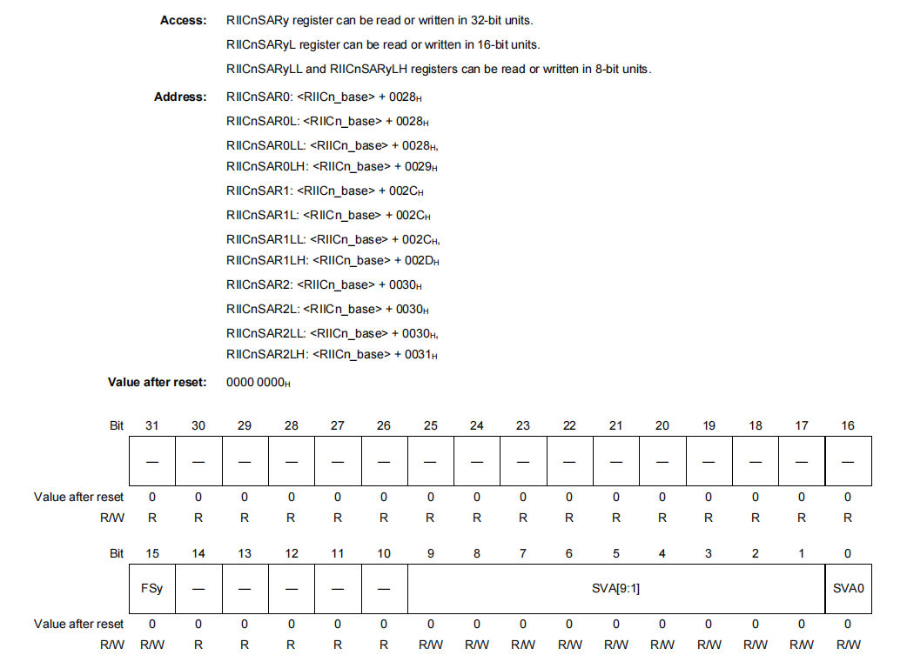
FSy = 0: This bit is used to select 7-bit address or 10-bit address for slave address y (in RIICnSARy). When the RIICnSER.SARy bit is set to 1. (RIICnSARy enabled) and the RIICnSARy.FSy bit is 0, the 7-bit address format is selected for slave address.
SVA [9:1] = A slave address is set.
When the FSy bit is 0 (7-bit address format), the SVA [7:1] bits are valid and form a 7-bit slave address.
When the FSy bit is 1 (10-bit address format), SVA [9:1] bits form a 10-bit slave address

RIICnBRH — I2C Bus Bit Rate High-Level Register
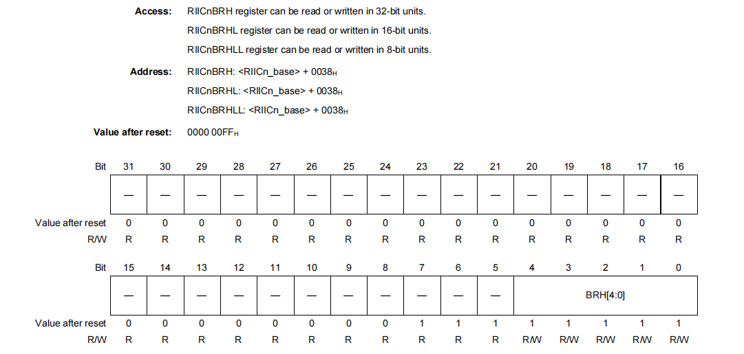
BRH [4:0] = 0 (set to 400 kbps)
Bit Rate High - Level Period
High - level period of SCL clock
Set bit High - level period of SCL clock

RIICnBRH is a 5-bit register to set the high-level period of SCL clock. RIICnBRH is valid in master mode. If the RIIC is used only in slave mode, this register need not set the high-level period.
RIICnBRH counts the high-level period with the internal reference clock source (IICϕ) specified by the RIICnMR1.CKS [2:0] bits.
RIICnDRT — I2C Bus Transmit Data Register
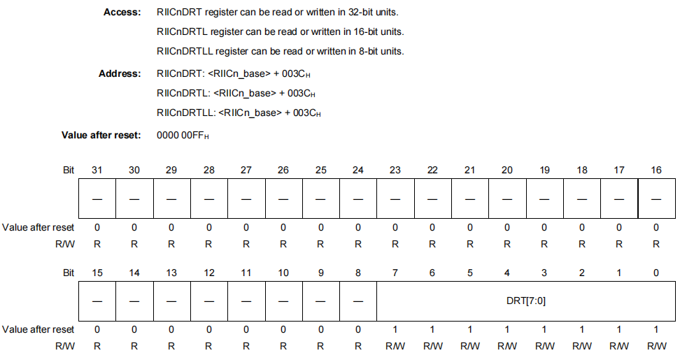
When RIICnDRT detects a space in the I2C bus shift register (RIICnDRS), it transfers the transmit data that has been written to RIICnDRT to RIICnDRS and starts transmitting data in transmit mode. The double-buffer structure of RIICnDRT and RIICnDRS allows continuous transmit operation if the next transmit data has been written to RIICnDRT while the RIICnDRS data is being transmitted. RIICnDRT can always be read and written. Write transmit data to RIICnDRT once when a transmit data empty interrupt (INTRIICnTI) request is generated. When writing bit 31 to 8, write the value after reset.
RIICnDRR — I 2C Bus Receive Data Register
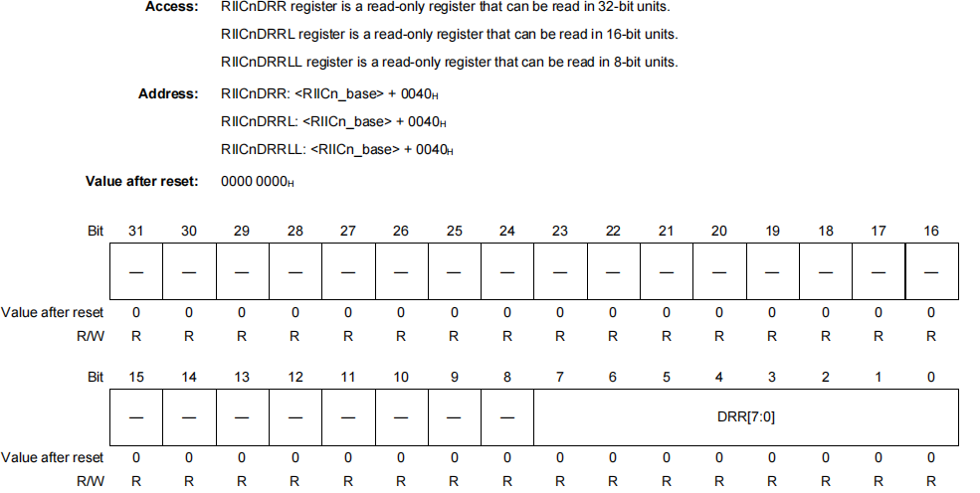
When 1 byte of data has been received, the received data is transferred from the I2 C bus shift register (RIICnDRS) to RIICnDRR to enable the next data to be received. The double-buffer structure of RIICnDRS and RIICnDRR allows continuous receiving operation if the received data has been read from RIICnDRR while RIICnDRS is receiving data. RIICnDRR cannot be written. Read data from RIICnDRR once when a receive complete interrupt (INTRIICnRI) request is generated. If RIIC receives the next receive data before the current data is read from RIICnDRR (while the RIICnSR2.RDRF flag is 1), the RIIC automatically holds the SCL clock low one cycle before the RDRF flag is set to 1.
USB ACC project I2C configuration
I2C Configuration Setting
I2C configuration for ACC USB is not finalized yet.

CAN
RCFDCnCFDCmFDCFG — Channel CAN FD Configuration Register
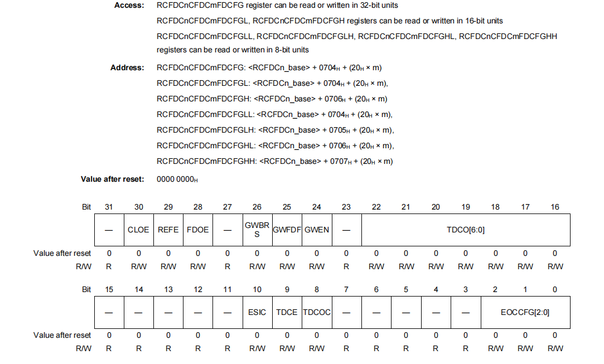
CLOE = 1
Setting this bit to 1 enables Classical CAN only mode. When data is transmitted, a classical CAN frame will be sent.
RCFDCnCFDGCFG — Global Configuration Register
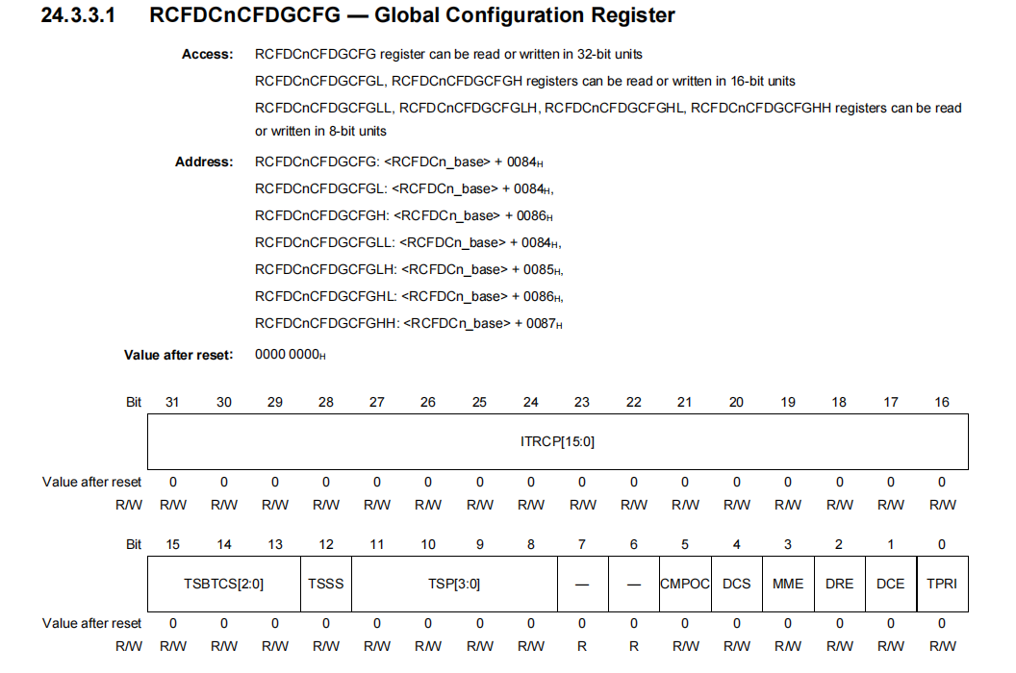
DCS = 0 - When this bit is set to 0, clkc is used as the clock source of the CAN clock (fCAN).
1 -When this bit is set to 1, clk_xincan is used as the clock source of the CAN clock (fCAN).
Set bit 0: When this bit is set to 0, clkc is used as the clock source of the CAN clock (fCAN).
TSSS =1 0: pclk/2*1
1: Nominal bit time clock
This bit is used to select a clock source of the timestamp counter. Select pclk if there is no channel that handles only classical CAN frames.
Set bit 1: Nominal bit time clock
RCFDCnCFDCmNCFG — Channel Nominal Bit Rate Configuration Register
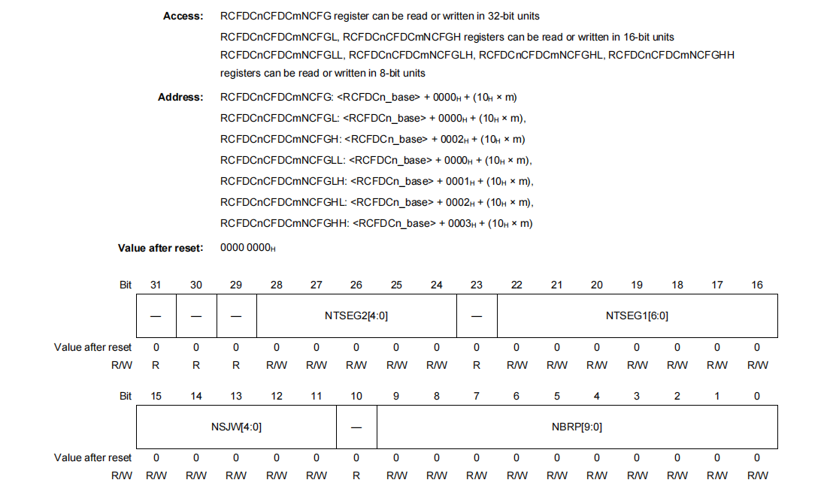
NBRP [9:0] = 2 (Nominal Bit Rate Prescaler Division Ratio Setting)
The clock obtained by dividing the CAN clock (fCAN) by the nominal bit rate Prescaler ((NBRP [9:0]) + 1) becomes CANmTq(N) clock (fCANTQ(N)m). One clock of the CANmTq(N) clock becomes one Time Quantum (Tq).
NSJW [4:0] = 1
Nominal Bit Rate Re-Synchronization Jump Width Control and it should be 0 to 32tq. These bits specify the re-synchronization jump width of nominal bit rate as a Tq value. Possible values are 1 to 32 Tq.
NTSEG1[6:0] = 8
These bits specify the total length of propagation segment (PROP_SEG) and phase segment 1 (PHASE_SEG1) of nominal bit rate as a Tq value. Possible values are 4 to 128 Tq.
NTSEG2[4:0] = 3
These bits specify a Tq value for the length of phase segment 2 (PHASE_SEG2) of nominal bit rate. Possible values are 2 Tq to 32 Tq, inclusive.
RCFDCnCFDRMNB — Receive Buffer Number Register
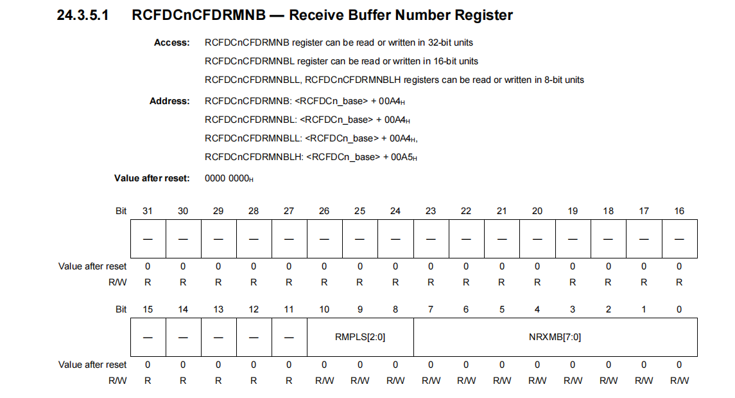
RMPLS [2:0] = 0 (Payload 0 to 64 Bytes)
Set bit 0 = Payload 0 to 64 Bytes
These bits are used to select the maximum payload size that can be stored in the receive buffer.
RCFDCnCFDTMIDp — Transmit Buffer ID Register
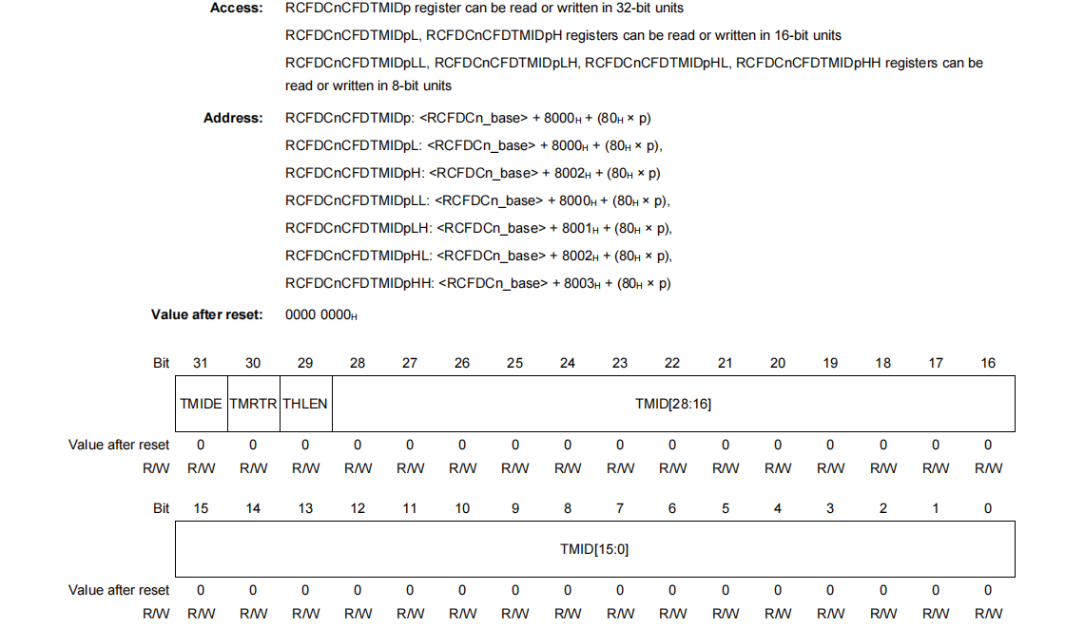

TMRTR = 0
0: Data frame
1: Remote frame
Set bit 0: Data frame.
This bit is used to set the data format of the message to be transmitted from the transmit buffer.
TMIDE = 0
0: Standard ID
1: Extended ID
Set bit 0: Standard ID
This bit is used to set the ID format of the message to be transmitted from the transmit buffer.
CAN Configuration Setting
Register | Setting Used | Bit Value to set
RCFDCnCFDCmFDCFG.CLOE | Classical CAN only mode | 1
RCFDCnCFDGCFG.DCS | CAN clock source select | 0
RCFDCnCFDGCFG.TSSS | Timestamp clock source select | 1
RCFDCnCFDCmNCFG.NBRP | Nominal prescaler | 2
RCFDCnCFDCmNCFG.NSJW | Nominal SJW | 1
RCFDCnCFDCmNCFG.NTSEG1 | Nominal TSEG1 | 8
RCFDCnCFDCmNCFG.NTSEG2 | Nominal TSEG2 | 3
RCFDCnCFDRMNB.RMPLS | RX payload size select | 0
RCFDCnCFDTMIDp.TMRTR | Data | 0
RCFDCnCFDTMIDp.TMIDE | Std | 0
Table 75 CAN configuration table

Memory utilization summary (CPU, RAM, Flash/ROM)
Note: Details regarding memory utilization will be updated during the coding and testing phase
Memory | Value in Bytes / Configuration | Total % is approximate
RAM Total | 160 KB | —
RAM Used (.data + .bss + stack) | 780 B (0.76 KB) | 0.47%
RAM Free | ~159.2 KB | 99.5%
Flash Total | 1056 KB | —
Flash Used | 76 KB | 7%
Flash Free | ~980 KB | 93%
CPU | RH850 G3KH @120 MHz | —
Table 76 Memory utilization summary

USB-PD Controller (MPF52000) and Buck-Boost (MPQ4208)

USB-PD Controller (MPF52000) and Buck-Boost (MPQ4208) Configuration setting related information is explained in HDD as there is no configuration to be done from software side. The respective firmware for USB-PD Controller (MPF52000) and Buck-Boost (MPQ4208) will be provided by chip vendor.

