INDIRA COLLEGE OF ENGINEERING AND MANAGEMENT

Approved By AICTE New Delhi, DTE (MS) and affiliated to Pune University (Id-No. PU/PN/Eng./282/2007)



**STQA Mini Project**

SUBMITTED

BY:

Aniket Uttekar (24130)

Mayur Kharmate (24131)

Yash Kudale (24132)

B.E

IN

COMPUTER ENGINEERING

**COVID-19 TESTING MANAGEMENT SYSTEM**

**Aim:**

Creating the Dynamic website of covid-19 information using HTML, CSS, JAVASCRIPT And PHP, MySQL database to store user account, comment, and registration form details. Regular Expression testcases for testing purpose

**Hardware Requirements:**

Processor: Intel core i5 or above

Hard Disk: 500GB HDD or more

RAM: 4GB or more

Network Connection: WIFI/Ethernet

**Software Requirements:**

Designing Languages: CSS

Designing Framework: BOOTSTRAP

Back-end tool: MYSQL

Server-Side Language: PHP 5.5

Code Editors: Sublime text

Server software: XAMPP

Database: MYSQL 5.X

Browser Scripting Languages: JavaScript

**Introduction:**

COVID19 Testing Management System is web-based technology which brings up various diagnosis works online. Here patients are first allowed to

register on the website and provide personal, test information. Once registered with their address and contact details, the patients may now see a variety

of tests conducted by the lab. The patient will select the required test and book appointment after that lab center send a lab boy at registered address to

collect a sample. After successful sample collection patient can track their test history using the name, order and registered mobile number. The system

allows admin to attach a copy of the report into the system and automatically shown on user side so user can download report. In COVID19 Testing

Management System we use PHP and MySQL database.

**What is Regular Expression?**

A regular expression (sometimes called a rational expression) is a sequence of characters that define a search pattern, mainly for use in pattern matching with strings, or string matching, i.e. “find and replace”-like operations.

Regular expressions are a generalized way to match patterns with sequences of characters. It is used in every programming language like C++, Java and Python

**Following table shows Regex operations:**

**Purpose:**

The main purpose of COVID-19 Testing Management System to provide a platform where patient can book the test online and get their COVID-19 test

done at home. With the help of this project we are bringing the use of technology in the field of medical diagnosis where patients can avail all the

diagnosis facilities at their door steps. Another purpose for developing this application is to generate the report automatically at the end of the session

or in the between of the session

**Scope:**

Today also we have to go to the COVID19 Test Lab centre, wait in the queue to get our COVID19 test done. As Technology is growing rapidly, we are

also moving to a technical world where everything we want to be online. So, with the help of this project we are bringing the use of technology in the

field of medical diagnosis where patients can avail all the diagnosis facilities at their door steps. This project makes the diagnosis process easy and

reduces the burden of patients. At a same time, its help the diagnostic center to track all their patients details with their test reports. This access friendly

software provides quick and effective services which helps the diagnostic center to increase their sales and profit.

**Design and Analysis:**

Today also we have to go to the diagnostic center, wait in the queue to get our COVID-19 test done. As Technology is growing rapidly, we are also

moving to a technical world where everything we want to be online. So, with the help of this project we are bringing the use of technology in the field

of medical diagnosis where patients can avail all the diagnosis facilities at their door steps. This project makes the diagnosis process easy and reduces

the burden of patients.

|  |  |  |
| --- | --- | --- |
| **Sr/no** | **Test Cases** | **Yes/No** |
| 1 | Is the login page visible? | Yes |
| 2 | Are we able to Enter the Email and Password? | Yes |
| 3 | Does the Password hides after we write it? | Yes |
| 4 | Does Login button redirects to proper page after we click on it? | Yes |
| 5 | Does Full Name Textbox takes only Character String as input? | Yes |
| 6 | Does Mobile Number Takes only 10 Numbers and gives right prompt if we Enter wrong format? | Yes |
| 7 | Are we able to Select Date of Birth? | Yes |

**Possible Test Cases for our Website**:

|  |  |  |
| --- | --- | --- |
| 8 | Does Aadhar Card No Takes only 12 Numbers and gives right prompt if we Enter wrong format? | Yes |
| 9 | Are we able to fill Address , State ? | Yes |
| 10 | Are we able to Select Test type and Time slot? | Yes |
| 11 | Is submit Button working Properly and gives us proper Prompt? | Yes |
| 12 | Are we able to enter the patient name / Mobile No. to search details? | Yes |
| 13 | Are we getting the proper search result after clicking search button? | Yes |
| 14 | Are we able to see details after clicking on detail button? | Yes |

## Implementation of Regular Expression:

## Regular Expression for Mobile Number:-

* **Regular Expression for Email Id:-**

* **Regular Expression for Email Id:-**

**Evaluation: -**

**1)** **Login page of Covid-19 Testing Management System:**

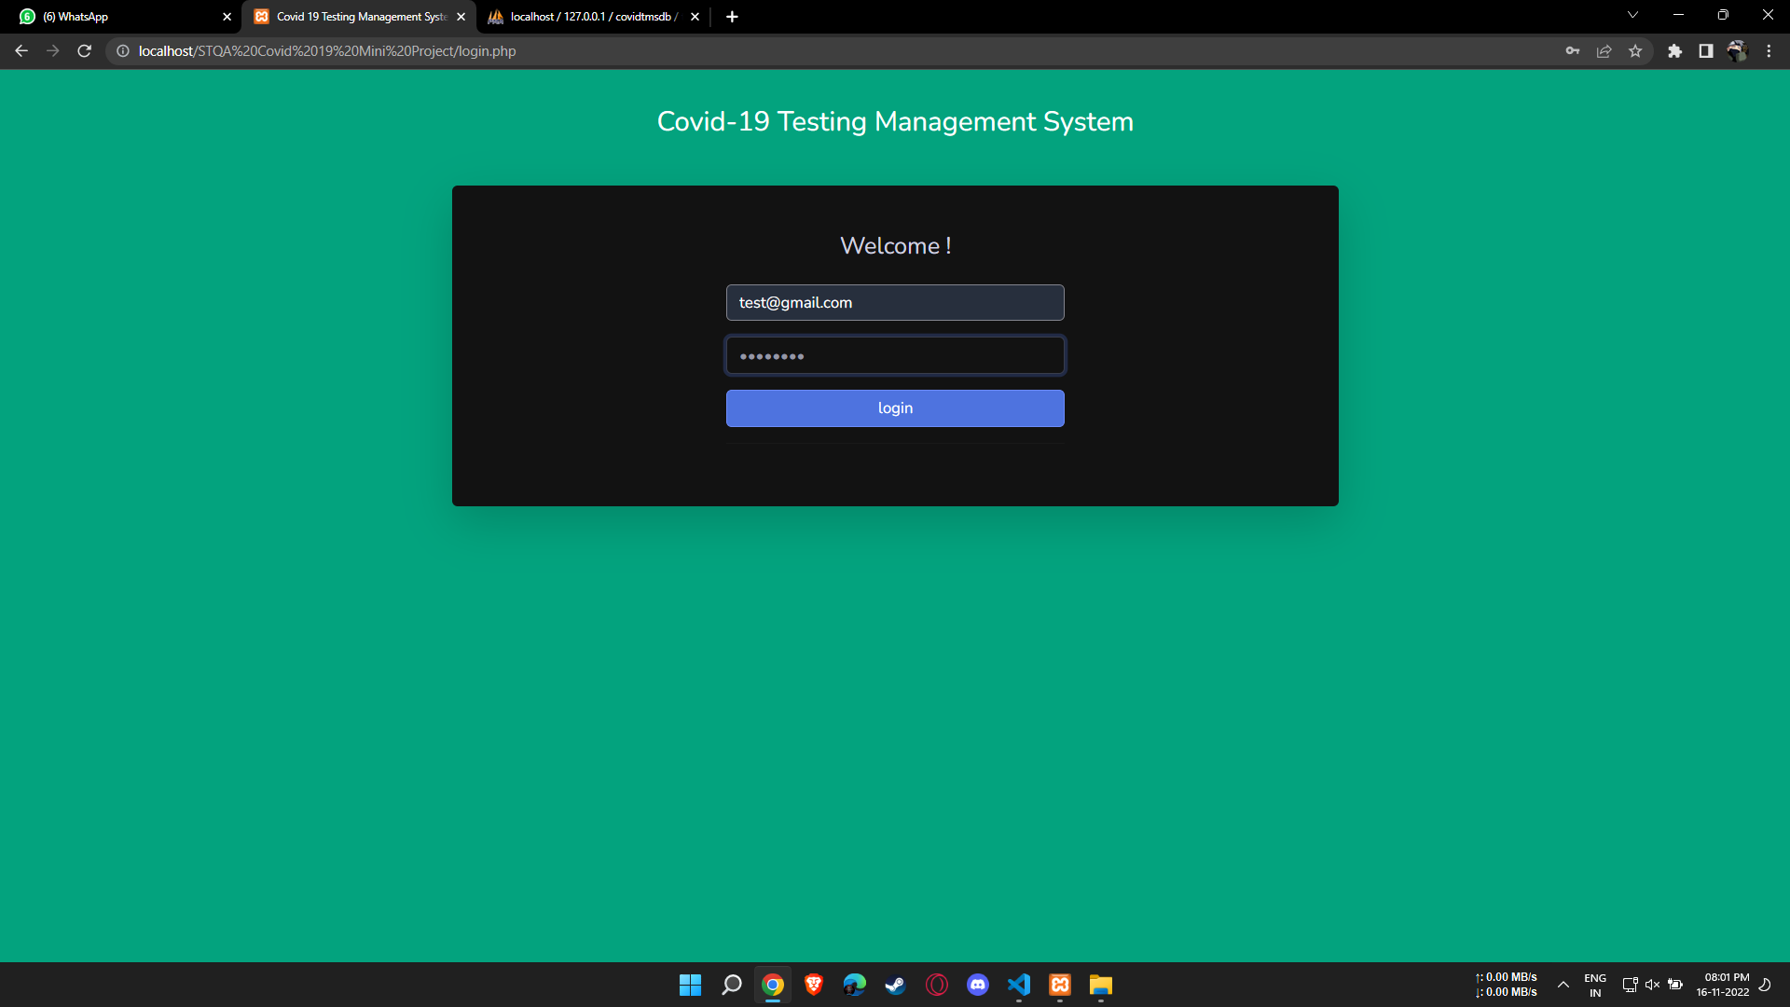

**2)Registration Form:**

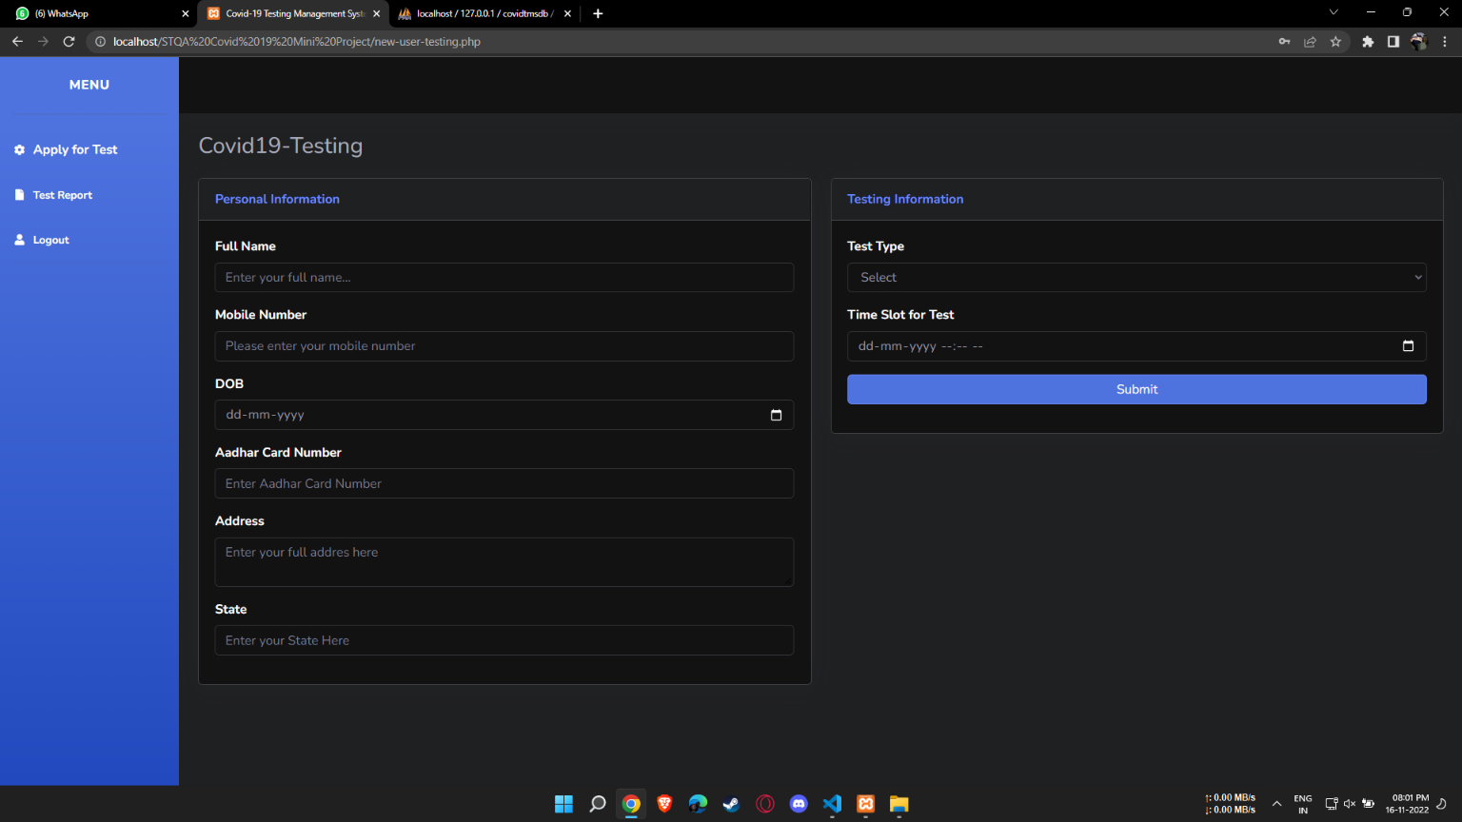

**3)** **Full Name Regular Expression:**  **[A-Za-z ]+**

**4) Mobile Number Regular Expression: [0-9]{10}**

**5) Filling the whole form and submitting it:**

**6) Searching the details of test:**

**7)** **Output of Search:**

**8) Test Detail Search Output:**

**Advantages:**

* The system allows automate diagnosis system. Allows for faster service.
* Allows increased sales and profits for diagnostic labs.
* Report generation will help made it easy to analyse the performance.

**Disadvantages:**

* NOT USER FRIENDLY: The present system not user friendly because data is not stored in structure and proper format.
* MANUAL CONTROL: All report calculation is done manually so there is a chance of error.
* LOTS OF PAPER WORK: Visitors maintain in the register so lots of paper require. storing details.

**Conclusion: -**

COVID19 Testing Management System is very much graceful and lively. Users must register to the portal by giving their details and then they can take appointment through online with minimal effort. The Phlebotomist comes to patient address to collect the sample. Once test is done and test report is generated patient can download the report by logged in to the portal. This system can be implemented in diagnostic labs and clinics.