Name: Prashant Ranjan Roll No: 24mc3035
Sol 1:

#include <iostream>
#include <vector>
#include <iomanip>
using namespace std;

int main() {
auto separateChaining = [](int m, const vector<int>& keys) {
vector<vector<int>> hashTable(m);
for (int key : keys) {
int index = key % m;
hashTable[index].push_back(key);
}
cout << "\nHash Table (m = " << m << "):\n";
for (int i = 0; i < m; ++i) {
cout << setw(2) << i << " -> ";
for (int val : hashTable[i]) cout << val << " -> ";
cout << "NULL\n";
}
};

vector<int> keys = {75, 88, 28, 33, 55, 95, 31, 65, 42, 10, 21, 99, 108, 105};
separateChaining(10, keys);
separateChaining(13, keys);
return 0;
}

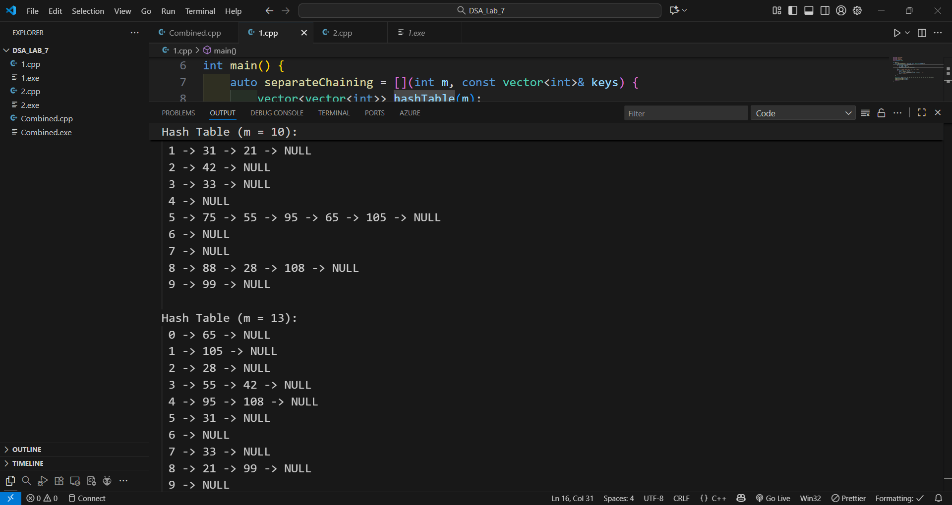

Sol 2:
#include <iostream>
#include <vector>
#include <iomanip>
using namespace std;

int quadraticProbing(int m, const vector<int>& keys, vector<int>& table) {
int collisions = 0;
for (int key : keys) {
int h = key % m;
int i = 0, pos = h;
while (table[pos] != -1) {
collisions++;
i++;
pos = (h + i * i) % m;
}
table[pos] = key;
}
return collisions;
}

int doubleHashing(int m, int R, const vector<int>& keys, vector<int>& table) {
int collisions = 0;
for (int key : keys) {
int h1 = key % m;
int h2 = R - (key % R);
int i = 0, pos = h1;
while (table[pos] != -1) {
collisions++;
i++;
pos = (h1 + i * h2) % m;
}
table[pos] = key;
}
return collisions;
}

void display(const vector<int>& table, string title) {
cout << "\n" << title << ":\n";
for (int i = 0; i < table.size(); ++i) {
cout << setw(2) << i << " -> ";
if (table[i] == -1) cout << "NULL\n";
else cout << table[i] << "\n";
}
}

int main() {
int m = 27, R = 23;
vector<int> keys = {75, 88, 28, 33, 55, 95, 31, 65, 42, 10, 21, 99, 108, 105};
vector<int> tableQuad(m, -1), tableDouble(m, -1);
int quadCollisions = quadraticProbing(m, keys, tableQuad);
int doubleCollisions = doubleHashing(m, R, keys, tableDouble);
display(tableQuad, "Quadratic Probing Hash Table");
display(tableDouble, "Double Hashing Hash Table");
cout << "\nCollision Comparison:\n";
cout << "Quadratic Probing Collisions = " << quadCollisions << "\n";
cout << "Double Hashing Collisions = " << doubleCollisions << "\n";
return 0;
}

