Name: Prashant Ranjan Roll: 24MC3035

Sol 1:
#include <iostream>
using namespace std;

class Number {
int a, b;
void display() {
cout << "a = " << a << ", b = " << b << endl;
}
public:
void setValues(int x, int y) {
a = x;
b = y;
display();
}
};

int main() {
Number obj;
obj.setValues(10, 20);
return 0;
}

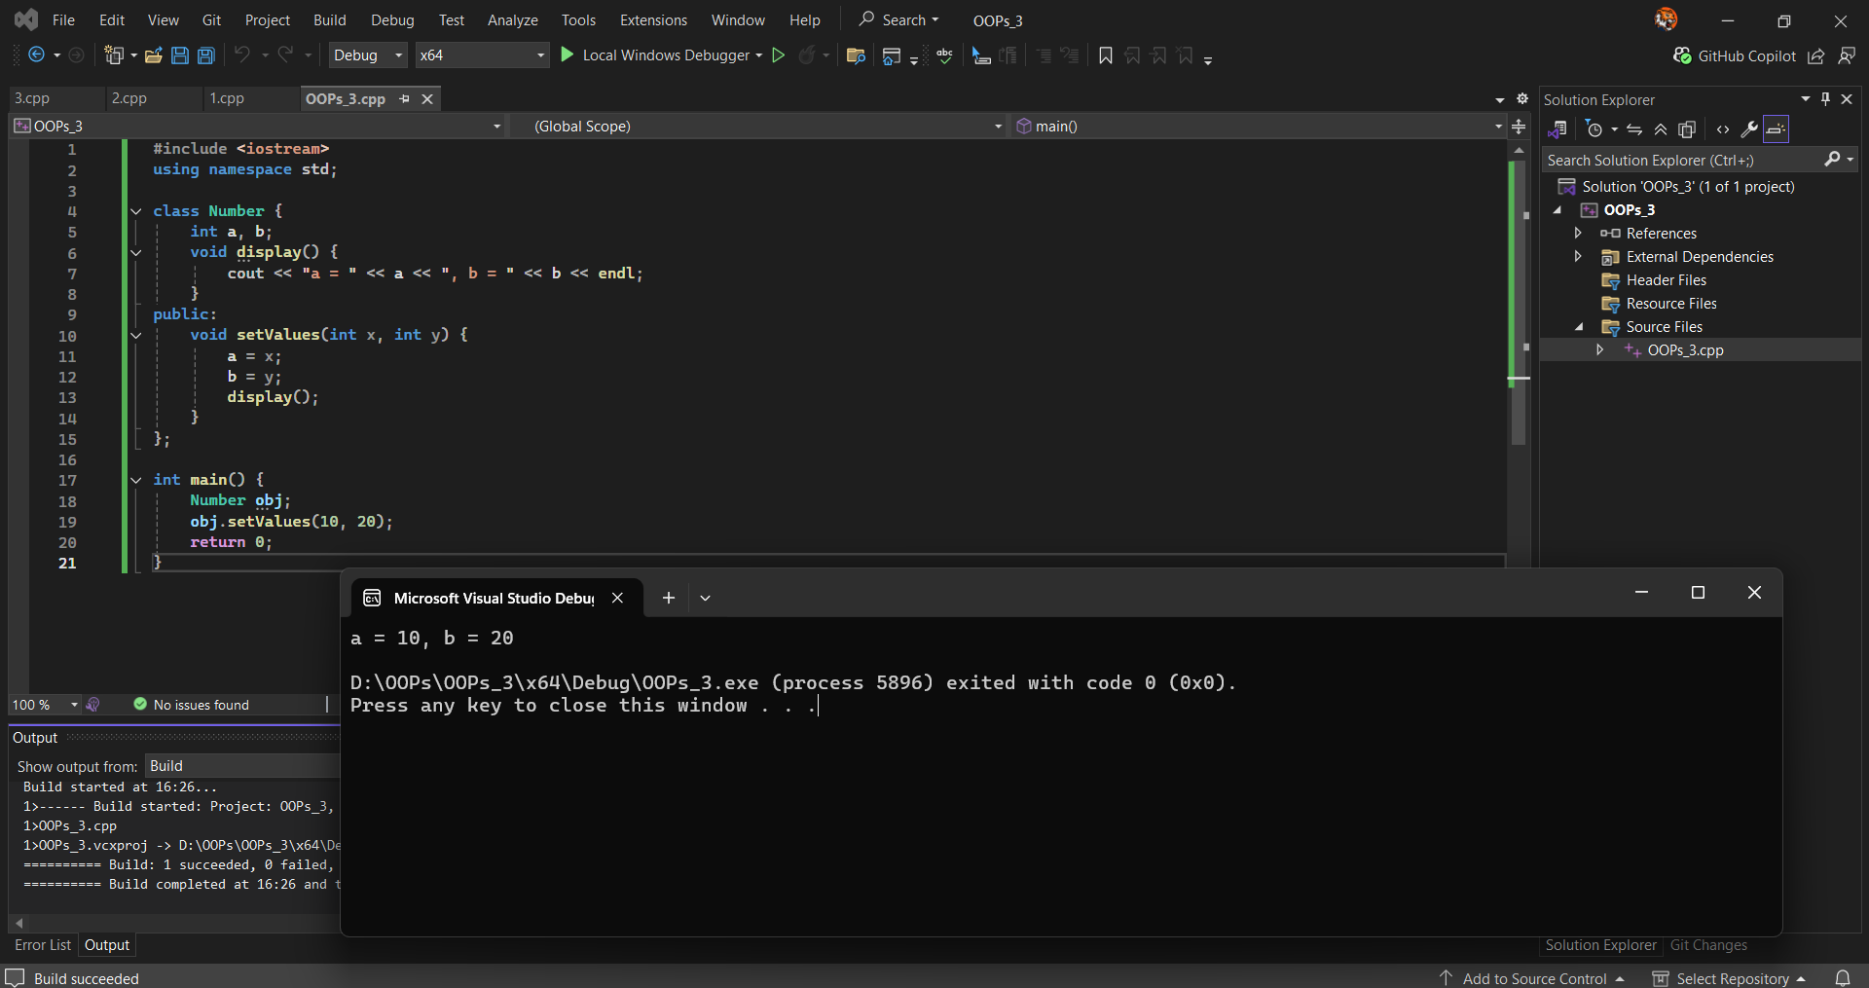
Output:
a = 10, b = 20

D:\OOPs\OOPs_3\x64\Debug\OOPs_3.exe (process 5896) exited with code 0 (0x0).
Press any key to close this window . . .

Sol 2:
#include <iostream>
using namespace std;

class Processor {
int a;
float b;
public:
void process(float num) {
float square = num * num;
a = static_cast<int>(num);
b = num - a;
int c = (a * a) + (b * b);
cout << "Square: " << square << endl;
cout << "Integer part: " << a << endl;
cout << "Fractional part: " << b << endl;
cout << "Sum of squares: " << c << endl;
}
};

int main() {
Processor obj;
float num;
cout << "Enter a float number: ";
cin >> num;
obj.process(num);
return 0;
}

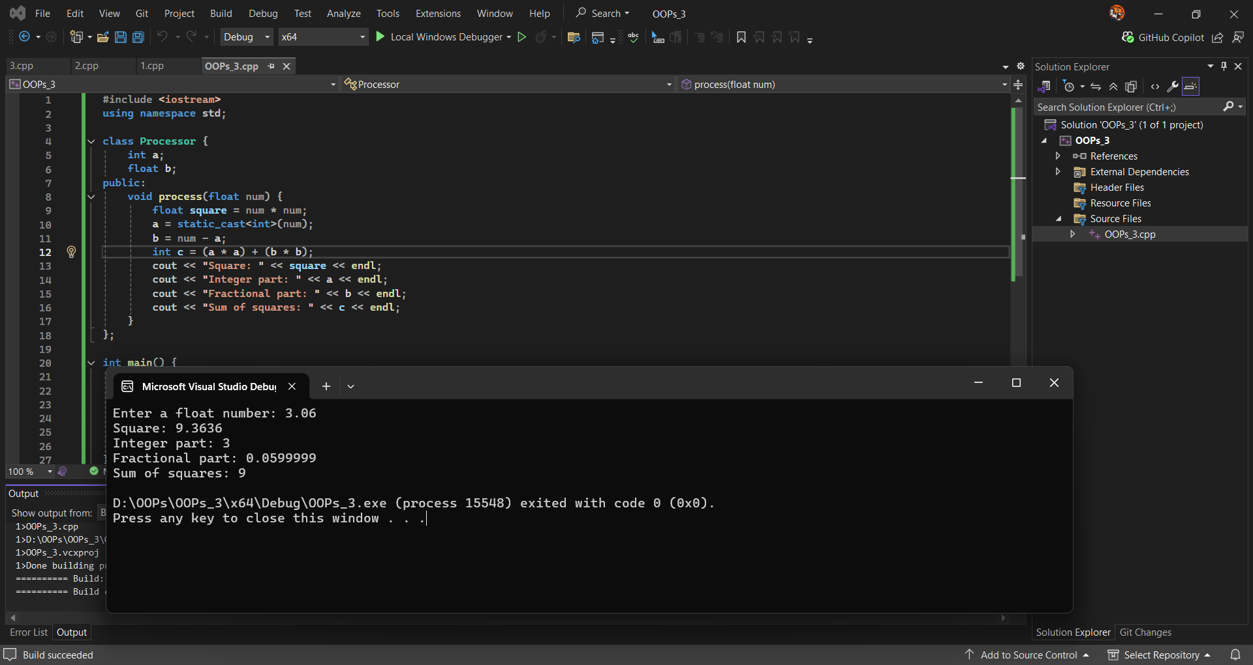
Output:
Enter a float number: 3.06
Square: 9.3636
Integer part: 3
Fractional part: 0.0599999
Sum of squares: 9

D:\OOPs\OOPs_3\x64\Debug\OOPs_3.exe (process 15548) exited with code 0 (0x0).
Press any key to close this window . . .

Sol 3:

#include <iostream>
using namespace std;

int main() {
int num, sum = 0;
cout << "Enter a 5-digit number: ";
cin >> num;

while (num > 0) {
sum += num % 10;
num /= 10;
}

cout << "Sum of digits: " << sum << endl;
return 0;
}

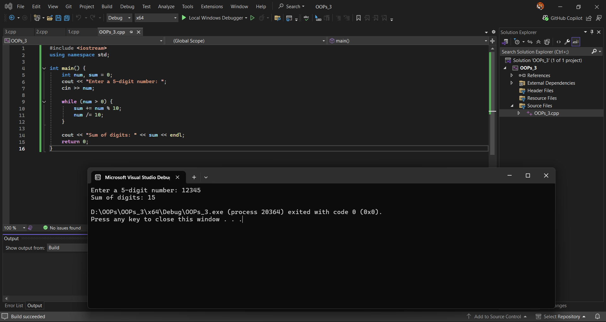
Output:
Enter a 5-digit number: 12345
Sum of digits: 15

D:\OOPs\OOPs_3\x64\Debug\OOPs_3.exe (process 19700) exited with code 0 (0x0).
Press any key to close this window . . .

