Name: Prashant Ranjan 24MC3035
Sol1:
#include <iostream>
using namespace std;

struct Node {
char data;
Node* prev;
Node* next;
Node(char val) {
data = val;
prev = next = NULL;
}
};

class DoublyLinkedList {
Node* head;
Node* tail;
int size;

public:
DoublyLinkedList() {
head = tail = NULL;
size = 0;
}

void insertEnd(char val) {
Node* newNode = new Node(val);
if (!head) {
head = tail = newNode;
}
else {
tail->next = newNode;
newNode->prev = tail;
tail = newNode;
}
size++;
}

void insertBegin(char val) {
Node* newNode = new Node(val);
if (!head) {
head = tail = newNode;
}
else {
newNode->next = head;
head->prev = newNode;
head = newNode;
}
size++;
}

void insertBeforePos(int pos, char val) {
if (pos < 1 || pos > size + 1) {
cout << "Invalid position: " << pos << endl;
return;
}

if (pos == 1) {
insertBegin(val);
return;
}

Node* temp = head;
for (int i = 1; i < pos; i++) {
temp = temp->next;
}

Node* newNode = new Node(val);
newNode->next = temp;
newNode->prev = temp->prev;
temp->prev->next = newNode;
temp->prev = newNode;
size++;
}

void deleteBegin() {
if (!head) return;
Node* temp = head;
head = head->next;
if (head) head->prev = NULL;
else tail = NULL;
delete temp;
size--;
}

void deleteEnd() {
if (!tail) return;
Node* temp = tail;
tail = tail->prev;
if (tail) tail->next = NULL;
else head = NULL;
delete temp;
size--;
}

void deletePos(int pos) {
if (pos < 1 || pos > size) {
cout << "Invalid deletion position: " << pos << endl;
return;
}

if (pos == 1) {
deleteBegin();
return;
}

if (pos == size) {
deleteEnd();
return;
}

Node* temp = head;
for (int i = 1; i < pos; i++) {
temp = temp->next;
}

temp->prev->next = temp->next;
temp->next->prev = temp->prev;
delete temp;
size--;
}

void display() {
Node* temp = head;
cout << "List (" << size << " elements): ";
while (temp) {
cout << temp->data << " ";
temp = temp->next;
}
cout << endl;
}

int getSize() { return size; }
};

int main() {
DoublyLinkedList dll;

cout << "Inserting A-J at end: ";
for (char ch = 'A'; ch <= 'J'; ch++) {
dll.insertEnd(ch);
cout << ch << " ";
}
cout << endl;
dll.display();

cout << "Inserting K-T at beginning: ";
for (char ch = 'T'; ch >= 'K'; ch--) {
dll.insertBegin(ch);
cout << ch << " ";
}
cout << endl;
dll.display();

int positions[] = { 4, 8, 12, 16, 20 };
char chars[] = { 'U', 'V', 'W', 'X', 'Y' };

cout << "Inserting U-Y before positions 4,8,12,16,20: ";
for (int i = 0; i < 5; i++) {
dll.insertBeforePos(positions[i], chars[i]);
cout << chars[i] << " before " << positions[i] << " ";
}
cout << endl;

dll.insertEnd('Z');
cout << "Inserting Z at end" << endl;

cout << "Final list after all insertions: ";
dll.display();

int originalSize = dll.getSize();

cout << "Deleting from beginning and end" << endl;
dll.deleteBegin();
dll.deleteEnd();
dll.display();

int delPositions[] = { 3, 6, 9, 12 };

for (int i = 0; i < 4; i++) {

int adjustedPos = delPositions[i] - i;
cout << "Deleting position " << adjustedPos << " (original position " << delPositions[i] << ")" << endl;
dll.deletePos(adjustedPos);
dll.display();
}

dll.display();

return 0;
}

Output:
Inserting A-J at end: A B C D E F G H I J
List (10 elements): A B C D E F G H I J
Inserting K-T at beginning: T S R Q P O N M L K
List (20 elements): K L M N O P Q R S T A B C D E F G H I J
Inserting U-Y before positions 4,8,12,16,20: U before 4 V before 8 W before 12 X before 16 Y before 20
Inserting Z at end
Final list after all insertions: List (26 elements): K L M U N O P V Q R S W T A B X C D E Y F G H I J Z
Deleting from beginning and end
List (24 elements): L M U N O P V Q R S W T A B X C D E Y F G H I J
Deleting position 3 (original position 3)
List (23 elements): L M N O P V Q R S W T A B X C D E Y F G H I J
Deleting position 5 (original position 6)
List (22 elements): L M N O V Q R S W T A B X C D E Y F G H I J
Deleting position 7 (original position 9)
List (21 elements): L M N O V Q S W T A B X C D E Y F G H I J
Deleting position 9 (original position 12)
List (20 elements): L M N O V Q S W A B X C D E Y F G H I J
List (20 elements): L M N O V Q S W A B X C D E Y F G H I J

D:\DSA_3\x64\Debug\DSA_3.exe (process 9756) exited with code 0 (0x0).
Press any key to close this window . . .

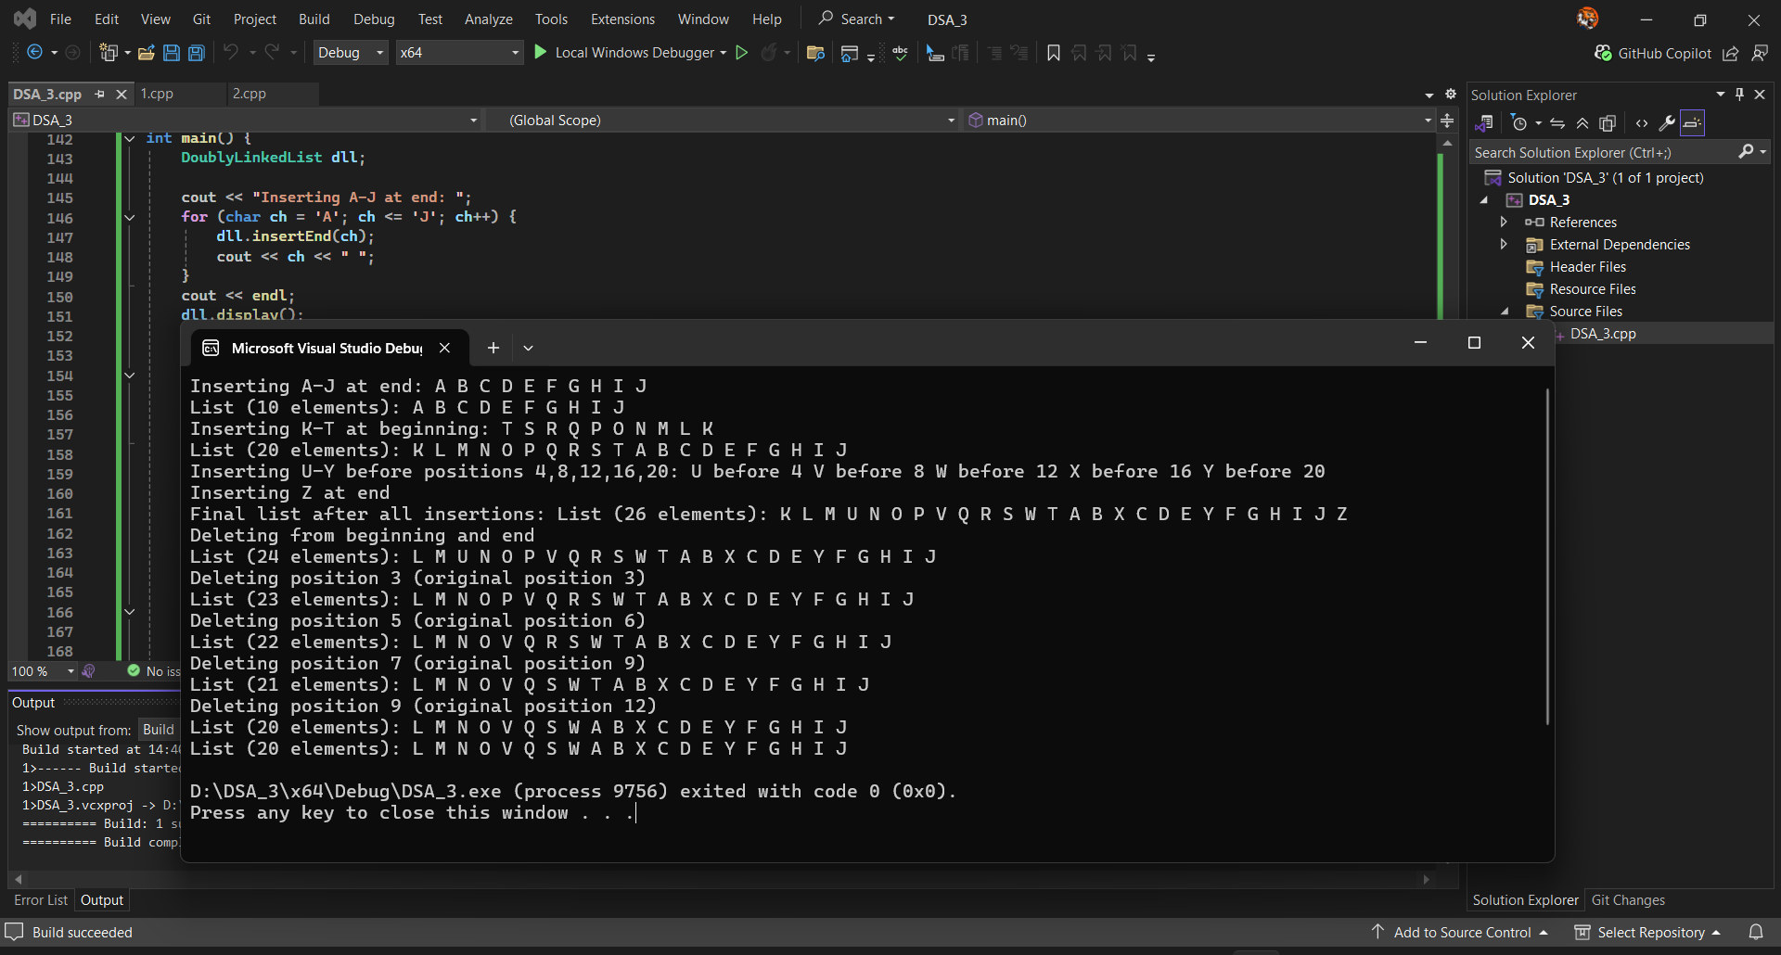

Sol2.

#include <iostream>

using namespace std;

struct Node {

int data; Node* next;

Node(int d) :data(d), next(NULL) {}

};

class SLL {

Node* head = NULL;

public:

Node* getHead() { return head; }

void insertEnd(int d) {

Node* n = new Node(d);

if (!head) head = n;

else { Node* t = head; while (t->next) t = t->next; t->next = n; }

}

void show() {

for (Node* t = head; t; t = t->next) cout << t->data << " ";

cout << "\n";

}

// Create list from array

void build(int arr[], int n) { for (int i = 0; i < n; i++) insertEnd(arr[i]); }

};

Node* Union(Node* a, Node* b) {

Node dummy(0); Node* t = &dummy;

while (a && b) {

if (a->data == b->data) { t->next = new Node(a->data); a = a->next; b = b->next; }

else if (a->data < b->data) { t->next = new Node(a->data); a = a->next; }

else { t->next = new Node(b->data); b = b->next; }

t = t->next;

}

while (a) { t->next = new Node(a->data); a = a->next; t = t->next; }

while (b) { t->next = new Node(b->data); b = b->next; t = t->next; }

return dummy.next;

}

Node* Intersection(Node* a, Node* b) {

Node dummy(0); Node* t = &dummy;

while (a && b) {

if (a->data == b->data) { t->next = new Node(a->data); t = t->next; a = a->next; b = b->next; }

else if (a->data < b->data) a = a->next;

else b = b->next;

}

return dummy.next;

}

void showList(Node* h) { while (h) { cout << h->data << " "; h = h->next; } cout << "\n"; }

int main() {

// Test Case 1 (Given)

int A1[] = { 3,5,78,90,91,95,105,106,150,170,190,200,205,210 };

int B1[] = { 2,3,5,98,106,107,190,201,204,222,250 };

SLL s1, s2; s1.build(A1, 14); s2.build(B1, 11);

cout << "S1: "; s1.show();

cout << "S2: "; s2.show();

Node* u1 = Union(s1.getHead(), s2.getHead());

Node* i1 = Intersection(s1.getHead(), s2.getHead());

cout << "Union: "; showList(u1);

cout << "Intersection: "; showList(i1);

// Test Case 2

int A2[] = { 1,4,7,10 };

int B2[] = { 2,4,6,10,12 };

SLL s3, s4; s3.build(A2, 4); s4.build(B2, 5);

cout << "\nS3: "; s3.show();

cout << "S4: "; s4.show();

cout << "Union: "; showList(Union(s3.getHead(), s4.getHead()));

cout << "Intersection: "; showList(Intersection(s3.getHead(), s4.getHead()));

// Test Case 3

int A3[] = { 11,22,33,44 };

int B3[] = { 55,66,77 };

SLL s5, s6; s5.build(A3, 4); s6.build(B3, 3);

cout << "\nS5: "; s5.show();

cout << "S6: "; s6.show();

cout << "Union: "; showList(Union(s5.getHead(), s6.getHead()));

cout << "Intersection: "; showList(Intersection(s5.getHead(), s6.getHead()));

}

Output:
S1: 3 5 78 90 91 95 105 106 150 170 190 200 205 210
S2: 2 3 5 98 106 107 190 201 204 222 250
Union: 2 3 5 78 90 91 95 98 105 106 107 150 170 190 200 201 204 205 210 222 250
Intersection: 3 5 106 190

S3: 1 4 7 10
S4: 2 4 6 10 12
Union: 1 2 4 6 7 10 12
Intersection: 4 10

S5: 11 22 33 44
S6: 55 66 77
Union: 11 22 33 44 55 66 77
Intersection:

D:\DSA_3\x64\Debug\DSA_3.exe (process 18372) exited with code 0 (0x0).
Press any key to close this window . . .

