Name: Prashant Ranjan Roll: 24MC3035
// Q.1: Given a singly linked list having n nodes, write a program to find out the kth node from the end of the linked list, considering the following solution cases:
// (I) Without a hash table in a single pass/traversal of the linked list
// (II) Using a hash table

// (I): Without Hash Table — Single Pass Solution

#include <iostream>
using namespace std;

struct Node {
int data;
Node* next;
Node(int val) : data(val), next(nullptr) {}
};

Node* findKthFromEnd(Node* head, int k) {
Node* first = head;
Node* second = head;

// Move first k steps ahead
for (int i = 0; i < k; i++) {
if (!first) return nullptr; // if k > n
first = first->next;
}

// Move both until first reaches end
while (first) {
first = first->next;
second = second->next;
}

return second; // kth node from end
}

int main() {
// Example Linked List: 10 -> 20 -> 30 -> 40 -> 50
Node* head = new Node(10);
head->next = new Node(20);
head->next->next = new Node(30);
head->next->next->next = new Node(40);
head->next->next->next->next = new Node(50);

int k = 2;
Node* res = findKthFromEnd(head, k);

if (res)
cout << "Kth node from end: " << res->data << endl;
else
cout << "K is greater than number of nodes" << endl;

return 0;
}

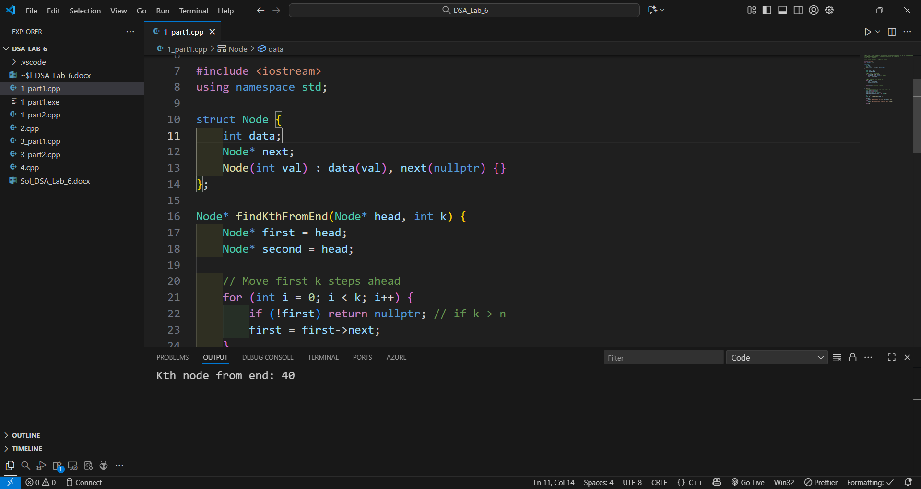

// (II): Using a Hash Table

#include <iostream>
#include <unordered_map>
using namespace std;

struct Node {
int data;
Node* next;
Node(int val) : data(val), next(nullptr) {}
};

Node* findKthFromEndHash(Node* head, int k) {
unordered_map<int, Node*> mp;
Node* temp = head;
int index = 0;

// Store each node with index
while (temp) {
mp[index++] = temp;
temp = temp->next;
}

int n = index; // total number of nodes
if (k > n) return nullptr; // invalid k

return mp[n - k];
}

int main() {
Node* head = new Node(10);
head->next = new Node(20);
head->next->next = new Node(30);
head->next->next->next = new Node(40);
head->next->next->next->next = new Node(50);

int k = 3;
Node* res = findKthFromEndHash(head, k);

if (res)
cout << "Kth node from end: " << res->data << endl;
else
cout << "K is greater than number of nodes" << endl;

return 0;
}
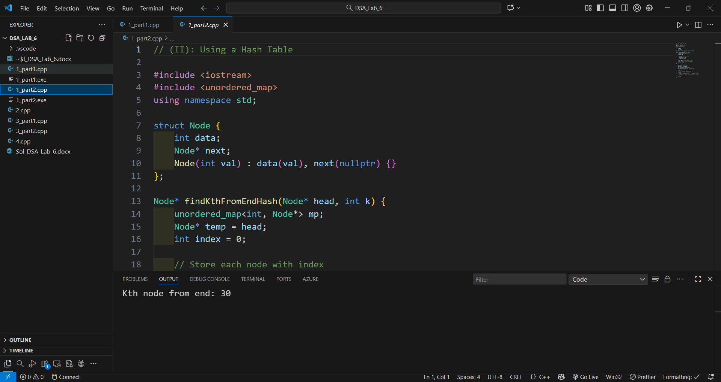

// Q.2: Write a program to find the cycle in a singly linked list using hashing.

#include <iostream>
#include <unordered_set>
using namespace std;

struct Node {
int data;
Node* next;
Node(int val) : data(val), next(nullptr) {}
};

// Function to detect cycle using hashing
bool detectCycle(Node* head) {
unordered_set<Node*> visited;
Node* temp = head;

while (temp) {
// If current node already seen, cycle exists
if (visited.find(temp) != visited.end()) {
return true;
}

// Mark current node as visited
visited.insert(temp);
temp = temp->next;
}

return false; // no cycle
}

int main() {
// Create linked list: 10 -> 20 -> 30 -> 40 -> 50
Node* head = new Node(10);
head->next = new Node(20);
head->next->next = new Node(30);
head->next->next->next = new Node(40);
head->next->next->next->next = new Node(50);

// Create a cycle: 50 -> 30
head->next->next->next->next->next = head->next->next;

if (detectCycle(head))
cout << "Cycle detected in the linked list!" << endl;
else
cout << "No cycle detected." << endl;

return 0;
}
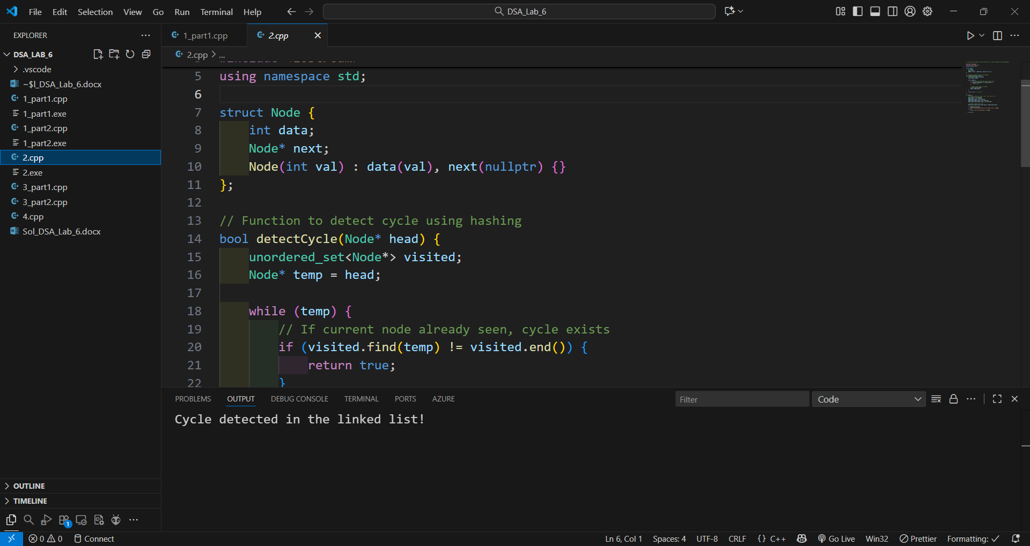

// Q.3: Given a singly linked list having integer values, write a program to remove the duplicate values from the linked list, considering the following solution cases:
// (I) Without using a hash table (not sorting)
// (II) Using a hash table
// e.g., input values of the nodes in a linked list: 5 6 3 3 8 5 6 9 7 2 3, output: 5 6 3 8 9 7 2

// (I) Without using a hash table (not sorting)
#include <iostream>
using namespace std;

struct Node {
int data;
Node* next;
Node(int val) : data(val), next(nullptr) {}
};

// Function to remove duplicates without hash table
void removeDuplicates_NoHash(Node* head) {
Node* current = head;

while (current != nullptr) {
Node* runner = current;
while (runner->next != nullptr) {
if (runner->next->data == current->data) {
// Duplicate found — remove it
Node* dup = runner->next;
runner->next = runner->next->next;
delete dup;
} else {
runner = runner->next;
}
}
current = current->next;
}
}

// Utility function to print the linked list
void printList(Node* head) {
Node* temp = head;
while (temp) {
cout << temp->data << " ";
temp = temp->next;
}
cout << endl;
}

int main() {
// Input: 5 6 3 3 8 5 6 9 7 2 3
Node* head = new Node(5);
head->next = new Node(6);
head->next->next = new Node(3);
head->next->next->next = new Node(3);
head->next->next->next->next = new Node(8);
head->next->next->next->next->next = new Node(5);
head->next->next->next->next->next->next = new Node(6);
head->next->next->next->next->next->next->next = new Node(9);
head->next->next->next->next->next->next->next->next = new Node(7);
head->next->next->next->next->next->next->next->next->next = new Node(2);
head->next->next->next->next->next->next->next->next->next->next = new Node(3);

cout << "Original list: ";
printList(head);

removeDuplicates_NoHash(head);

cout << "List after removing duplicates: ";
printList(head);

return 0;
}
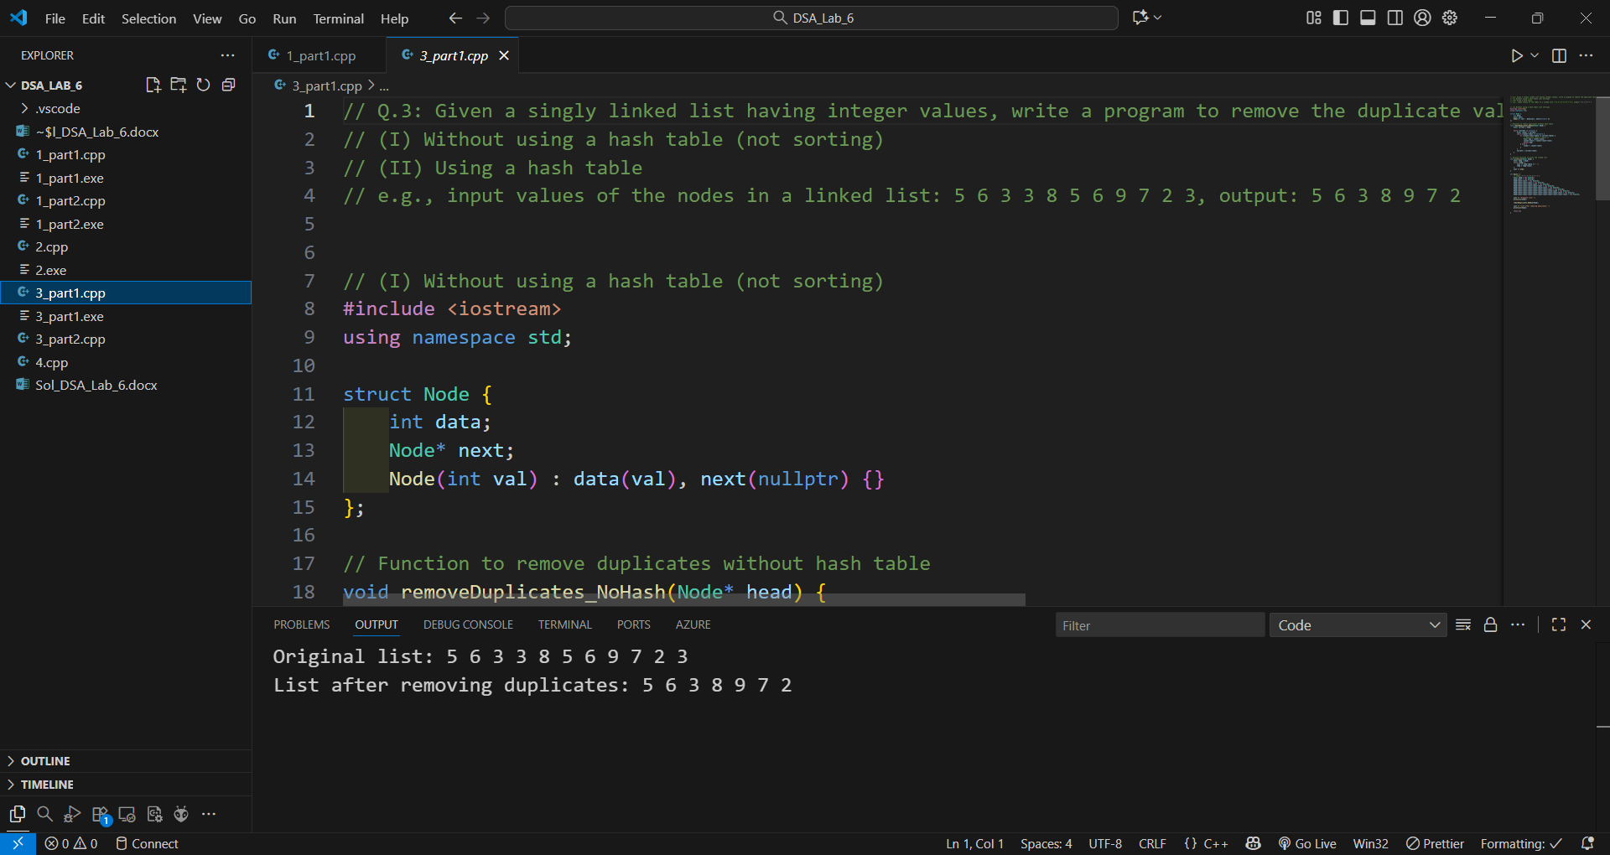

// (II) Using a hash table
#include <iostream>
#include <unordered_set>
using namespace std;

struct Node {
int data;
Node* next;
Node(int val) : data(val), next(nullptr) {}
};

// Function to remove duplicates using hash table
void removeDuplicates_Hash(Node* head) {
unordered_set<int> seen;
Node* current = head;
Node* prev = nullptr;

while (current != nullptr) {
if (seen.find(current->data) != seen.end()) {
// Duplicate found — remove node
prev->next = current->next;
delete current;
} else {
seen.insert(current->data);
prev = current;
}
current = prev->next;
}
}

// Utility function to print linked list
void printList(Node* head) {
Node* temp = head;
while (temp) {
cout << temp->data << " ";
temp = temp->next;
}
cout << endl;
}

int main() {
// Input: 5 6 3 3 8 5 6 9 7 2 3
Node* head = new Node(5);
head->next = new Node(6);
head->next->next = new Node(3);
head->next->next->next = new Node(3);
head->next->next->next->next = new Node(8);
head->next->next->next->next->next = new Node(5);
head->next->next->next->next->next->next = new Node(6);
head->next->next->next->next->next->next->next = new Node(9);
head->next->next->next->next->next->next->next->next = new Node(7);
head->next->next->next->next->next->next->next->next->next = new Node(2);
head->next->next->next->next->next->next->next->next->next->next = new Node(3);

cout << "Original list: ";
printList(head);

removeDuplicates_Hash(head);

cout << "List after removing duplicates: ";
printList(head);

return 0;
}
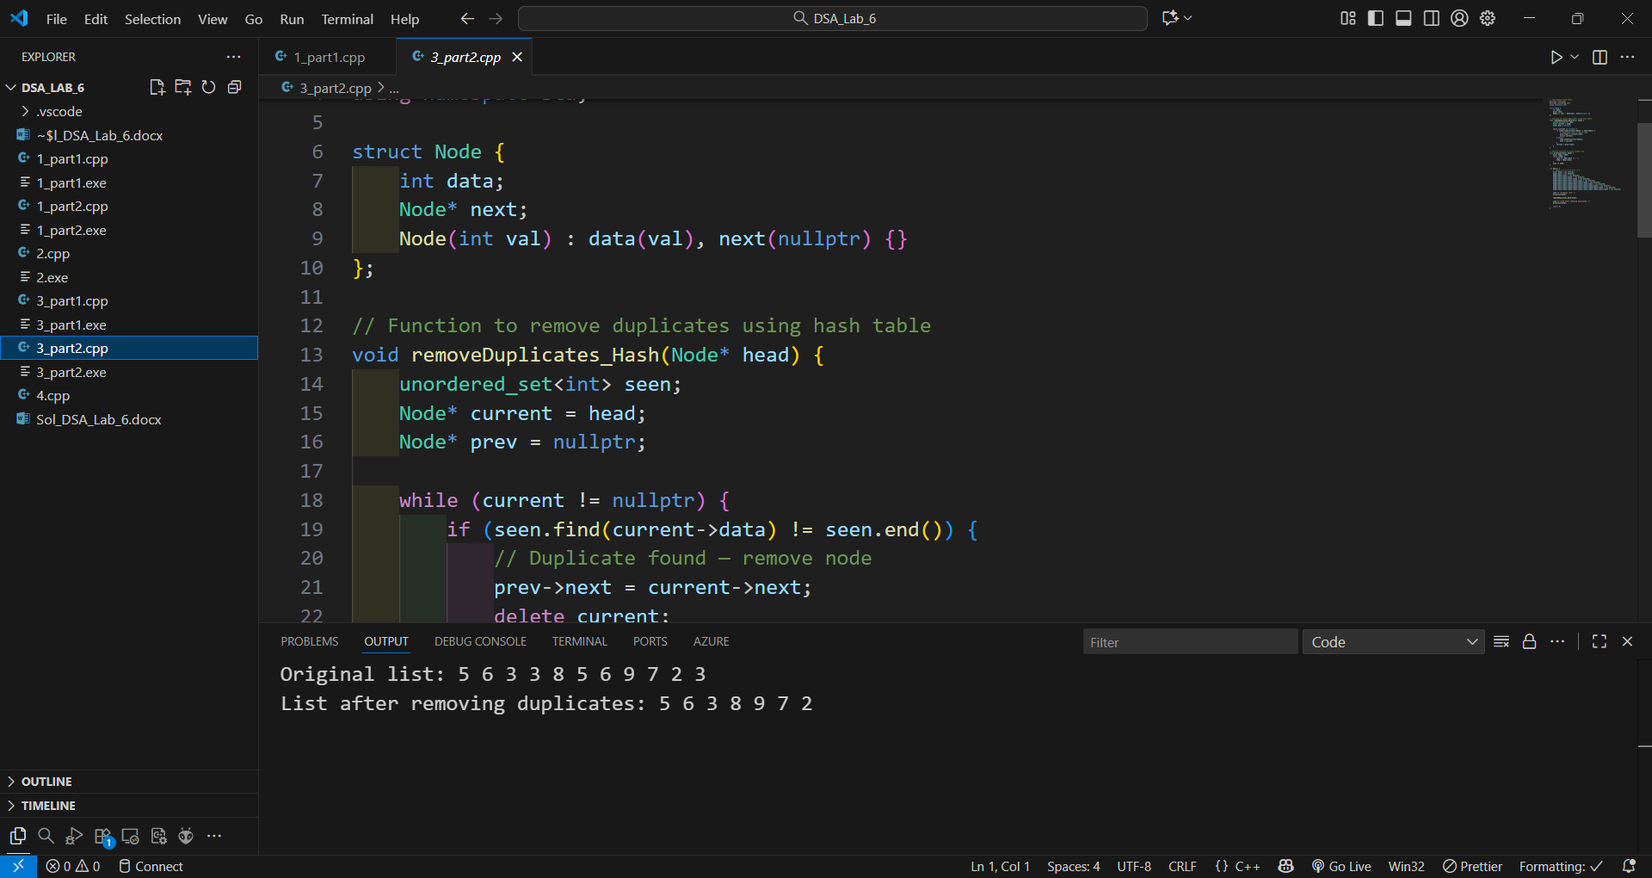

// Q.4: Given a list of integer pairs, where first element of
// each pair is unique, write a program to detect the symmetric pairs,
// e.g., given list {(10,20), (5,6), (8,9), (20,10), (2,3), (3,1)} has (10, 20) and (20,10)
// symmetric pairs. [Use hashing to solve the problem.]

#include <iostream>
#include <unordered_map>
#include <vector>
using namespace std;

// Function to find symmetric pairs
void findSymmetricPairs(vector<pair<int, int>> pairs) {
unordered_map<int, int> mp;

for (auto p : pairs) {
int first = p.first;
int second = p.second;

// Check if symmetric pair exists (second, first)
if (mp.find(second) != mp.end() && mp[second] == first) {
cout << "Symmetric pair found: (" << first << ", " << second
<< ") and (" << second << ", " << first << ")" << endl;
} else {
mp[first] = second; // store current pair
}
}
}

int main() {
vector<pair<int, int>> pairs = {
{10, 20},
{5, 6},
{8, 9},
{20, 10},
{2, 3},
{3, 1}
};

findSymmetricPairs(pairs);

return 0;
}
