Name: Prashant Ranja (24MC3035)
// Question 1:

#include <iostream>
#include <iomanip>
using namespace std;

int main() {
double length, breadth, costPerSqMeter;

cout << "Enter the length of the room (in meters): ";
cin >> length;

while (length <= 0) {
cout << "Error: Length must be a positive value. Please enter again: ";
cin >> length;
}

cout << "Enter the breadth of the room (in meters): ";
cin >> breadth;

while (breadth <= 0) {
cout << "Error: Breadth must be a positive value. Please enter again: ";
cin >> breadth;
}

cout << "Enter the cost per square meter of the carpet: ";
cin >> costPerSqMeter;

while (costPerSqMeter <= 0) {
cout << "Error: Cost must be a positive value. Please enter again: ";
cin >> costPerSqMeter;
}

double area = length * breadth;

double totalCost = area * costPerSqMeter;

cout << fixed << setprecision(2);
cout << "Room dimensions: " << length << "m x " << breadth << "m" << endl;
cout << "Area of the room: " << area << " square meters" << endl;
cout << "Cost per square meter: $" << costPerSqMeter << endl;
cout << "Total cost of carpeting: $" << totalCost << endl;

return 0;
}

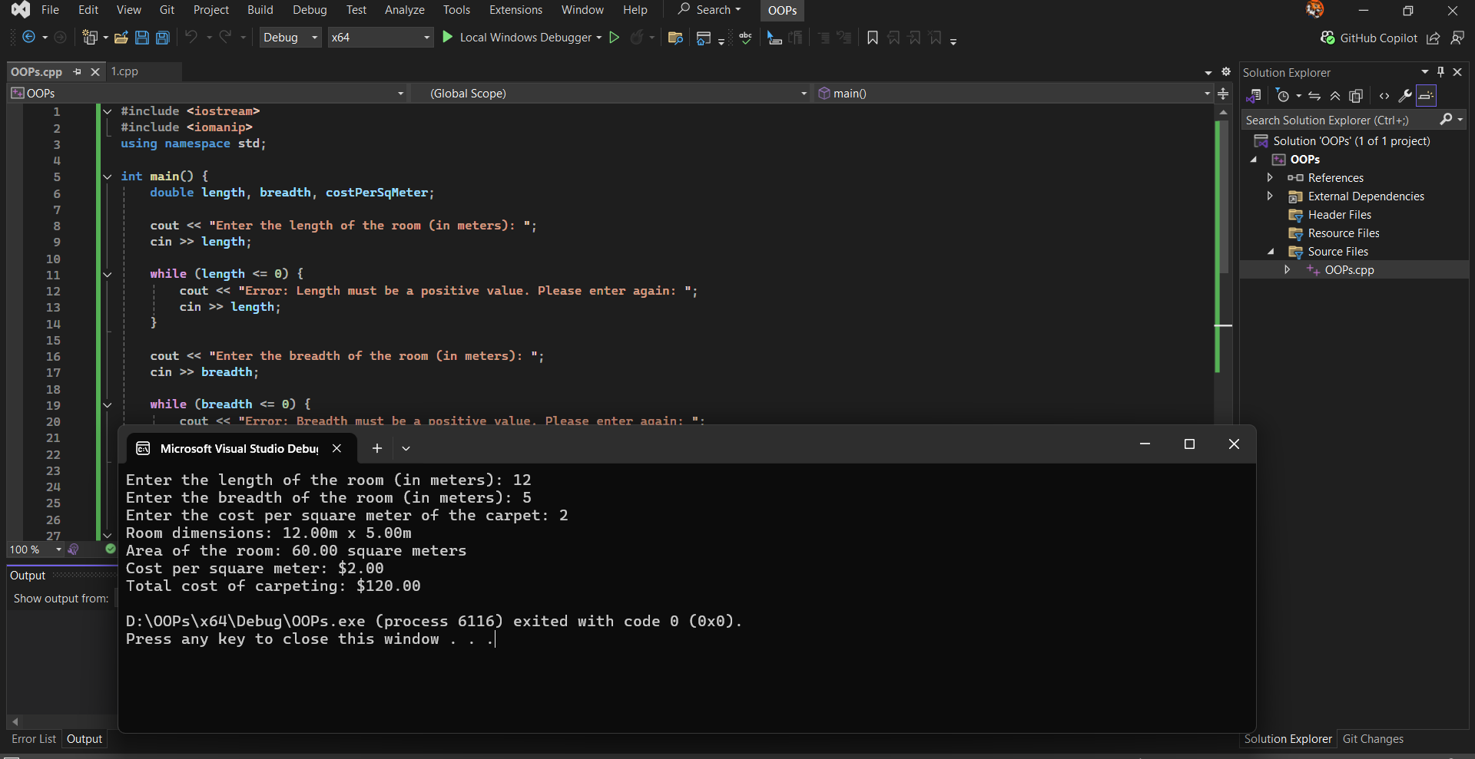

//Question 2:
#include <iostream>
#include <cstdlib>
#include <ctime>
#include <limits>
using namespace std;

int main() {
srand(time(0));
int actualNumber = rand() % 100 + 1;
int guess;
int trials = 3;

cout << "I'm thinking of a number between 1 and 100." << endl;
cout << "You have " << trials << " trials to guess it!" << endl << endl;

for (int attempt = 1; attempt <= trials; attempt++) {
cout << "Trial " << attempt << ": Enter your guess (1-100): ";

// Input validation
while (!(cin >> guess) || guess < 1 || guess > 100) {
cin.clear();
cin.ignore(numeric_limits<streamsize>::max(), '\n');
cout << "Invalid input! Please enter a number between 1 and 100: ";
}

if (guess == actualNumber) {
cout << "Congratulations! You guessed the correct number: " << actualNumber << endl;
break;
}
else if (guess > actualNumber) {
cout << "Your guess is HIGHER than the actual number." << endl;
}
else {
cout << "Your guess is LOWER than the actual number." << endl;
}

if (attempt == trials) {
cout << "Game over! You've used all your trials." << endl;
cout << "The actual number was: " << actualNumber << endl;
}
else {
cout << "Try again!" << endl << endl;
}
}

return 0;
}

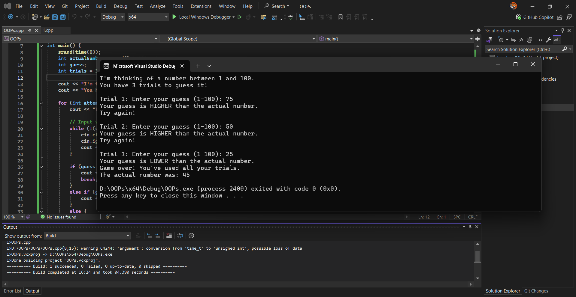

// Question 3
#include <iostream>
using namespace std;

int main() {
int n;

cout << "Enter a positive integer: ";
cin >> n;

while (n <= 0) {
cout << "Error: Please enter a positive integer: ";
cin >> n;
}

cout << "Sequence generated from " << n << ":" << endl;
cout << n << " ";
int count = 1;
while (n != 1) {
if (n % 2 == 0) {
n = n / 2;
}
else {
n = n * 3 + 1;
}

cout << n << " ";
count++;
if (count % 10 == 0) {
cout << endl;
}
}
cout << endl << "Sequence length: " << count << " numbers" << endl;
return 0;
}

